**DAY-5**

**NAME: AYESHA SHAFI**

**ROLL NO: 00399732**

**DAY: FRIDAY 09:00AM-12:00PM**

Test Case: TC001

Description: Verify the homepage loads correctly.

Test Steps: 1.

Navigate to the homepage of the website.

Expected Result:Homepage is displayed properly with all elements in place.

Status:Passed

Severity: Low

Remarks: No issues were found during the test.

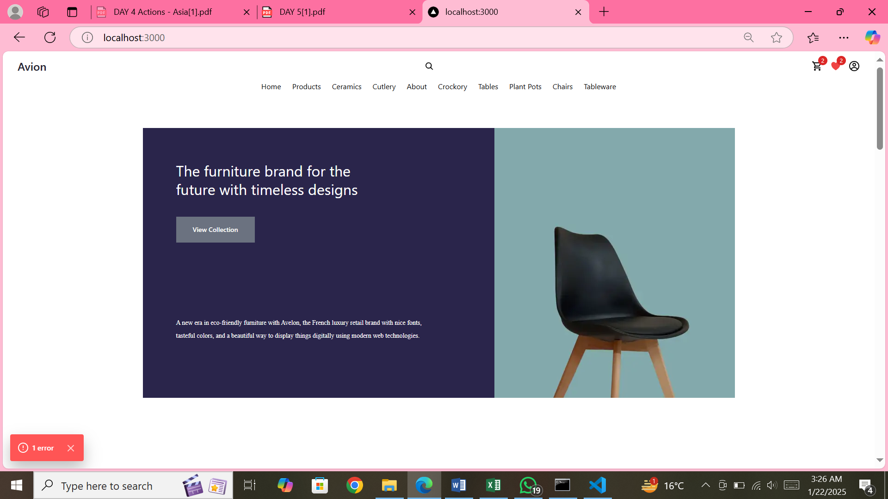

Test Case ID: TC002

Description: Verify that the product list page loads correctly.

Test Steps:

1. Open the product list page of the website.

2. Check that all product items are displayed.

3. Ensure that each product shows its image, name, and price.

Expected Result: All products should load correctly with their respective details.

Status: Passed

Severity: Medium

Remarks: No issues found during the test.



Test Case ID: TC003

Description: Verify that the product details page is functioning properly.

Test Steps:

1. Click on any product from the list to view its details.

2. Verify that the product details page opens.

3. Check for the product's full description, images, and price.

4. Ensure that the "Add to Cart" button is visible and working.

Expected Result: The product details page should display correct product details and allow the user to add the product to the cart.

Status: Passed

Severity: High

Remarks: No issues found during the test.

Test Case ID: TC004

Description: Verify the correct API response for fetching product data.

Expected Result: The API should return a 200 status with the correct product data.

Status: Passed

Severity: High

Remarks: API is responding correctly with the product data.

Test Case ID: TC005

Description: Verify that the cart page displays the correct products.

Test Steps:

1. Expected Result: The cart page should display the correct products and allow the user to remove items.

Status: Passed

Severity: Medium

Remarks: No issues found during the test.

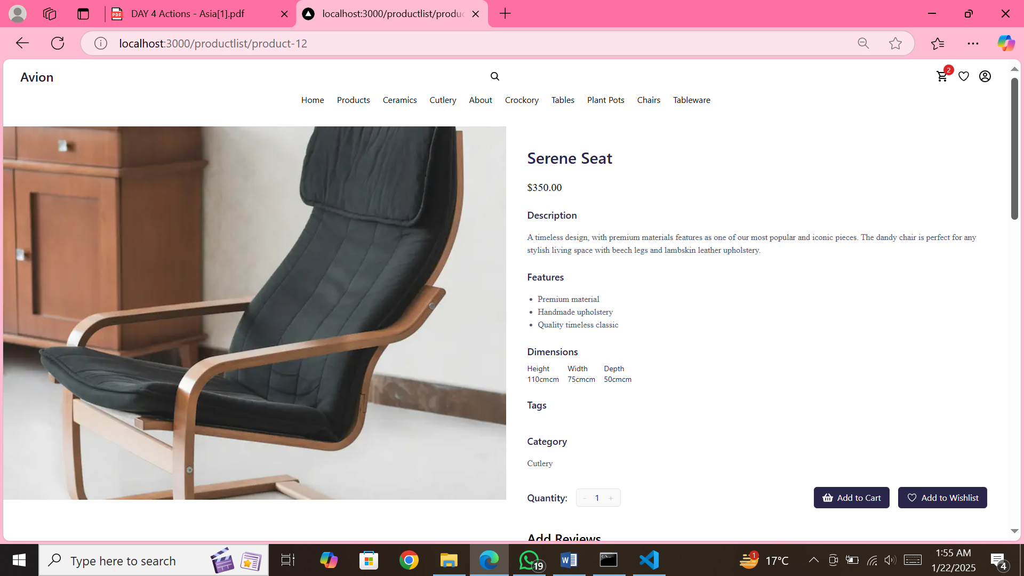

Product Display Page Load Efficiency

Description: Validate the speed and accuracy of loading the product list page.

1. Expected Result: The page should load in under 2 seconds and all elements should display without any errors or delays.

Status: Passed

Severity: Medium

Remarks: No issues found during the performance test.

Description: Check the performance and accuracy of the product details page.

1. Expected Result: The product details page should load quickly and display accurate information.

Status: Passed

Severity: High

Remarks: The page loaded efficiently with all details intact.

Description: Test the API response time and data consistency for fetching product information.

1. Expected Result: The API should return data within an acceptable time frame and maintain accuracy. Status: Passed

Severity: medium

Remarks: API response was timely and accurate.

Description: Ensure that the cart page loads correctly and functions smoothly.

Expected Result: The cart page should load efficiently and allow seamless updates.

Status: Passed

Severity: Medium

Remarks: The cart functioned well and updated promptly without performance issues.

Description: Evaluate the performance of the homepage loading and content rendering .

1. Expected Result: Homepage should load in under 3 seconds with all content rendering correctly. Status: Passed

Severity: Low

Remarks: Homepage loaded quickly, and there were no performance issues.

Description: Verify the product search functionality on the website.

Expected Result:

• For valid product names: Relevant product(s) should be displayed with proper details (e.g., product name, price, image, etc.).

• For invalid product names: A message such as "No products found" should be displayed.

• The search should handle case sensitivity and partial matches correctly.

Status: Passed

Severity: High

Remarks:

• Valid search results displayed correctly.

Description: Verify responsive design on mobile view.

Expected Result: The Full layout adjusts correctly with appropriate font sizes and Images for mobile view.

Status: Passed

Severity: high

Remarks: No layout issues found on mobile devices.

Description: Verify error handling when an invalid URL is accessed.

Expected Result: The user should be redirected to a 404 error page or see a message indicating the page is not found.

Status: Passed

Severity: High

Remarks: The error page loads as expected with the proper error message.