IT5092 - Lab Sheet 7: Neuronal Decoding and Encoding
Student ID: MS26901626

Exercise 1 - Bayesian Decoder
Results table (even spike counts):
R | P(Left|R) | P(Fwd|R) | P(Right|R) | MAP
0 | 0.963 | 0.037 | 0.000 | Left
2 | 0.894 | 0.105 | 0.000 | Left
4 | 0.736 | 0.263 | 0.001 | Left
6 | 0.475 | 0.516 | 0.008 | Forward
8 | 0.224 | 0.740 | 0.036 | Forward
10 | 0.080 | 0.800 | 0.120 | Forward
12 | 0.022 | 0.672 | 0.306 | Forward
14 | 0.005 | 0.418 | 0.577 | Right
16 | 0.001 | 0.192 | 0.807 | Right
18 | 0.000 | 0.073 | 0.927 | Right
20 | 0.000 | 0.025 | 0.975 | Right

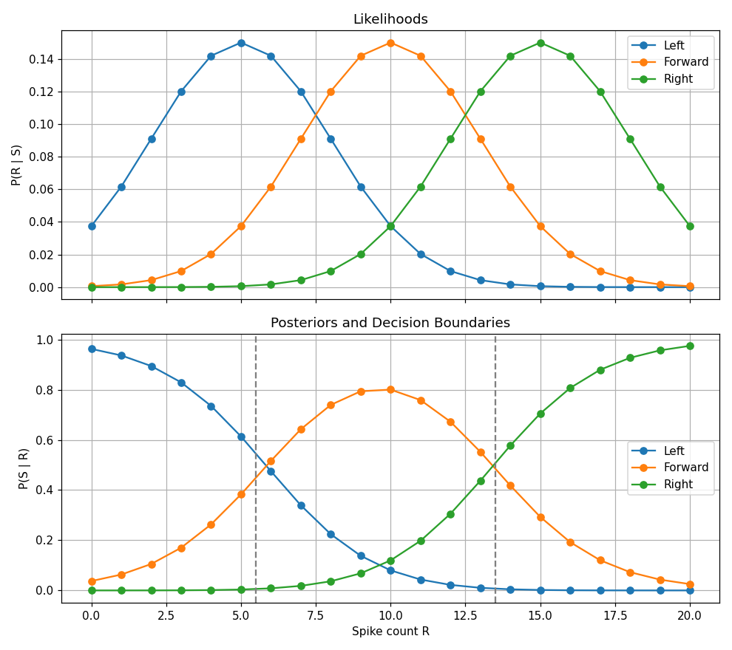
Q1. Where do decision boundaries occur?
The boundaries are where the MAP choice switches. Left changes to Forward between R = 5 and R = 6, and Forward changes to Right between R = 13 and R = 14. Solving for the exact point where the posterior curves cross gives R ≈ 5.85 and R ≈ 13.42. These are the dashed lines in the bottom plot.
Q2. How do priors affect results?
They move the boundaries. If all three priors were equal, the boundaries would sit halfway between the likelihood peaks, at 7.5 and 12.5. Forward has the biggest prior here (0.5), so its region stretches from 6 up to 13 and it wins spike counts that the likelihood alone would give to Left or Right. Left has the smallest prior (0.2) and loses the most ground. So the decoder leans toward the stimulus it expects to see more often.
Q3. Is the decoder confident at spike count = 10?
Mostly, yes. P(Forward | R = 10) is 0.80, the highest Forward value anywhere on the curve. That still leaves 0.12 for Right and 0.08 for Left, so about 1 time in 5 the true stimulus could be something else.

Exercise 2 - Gaussian Tuning Curve Fitting
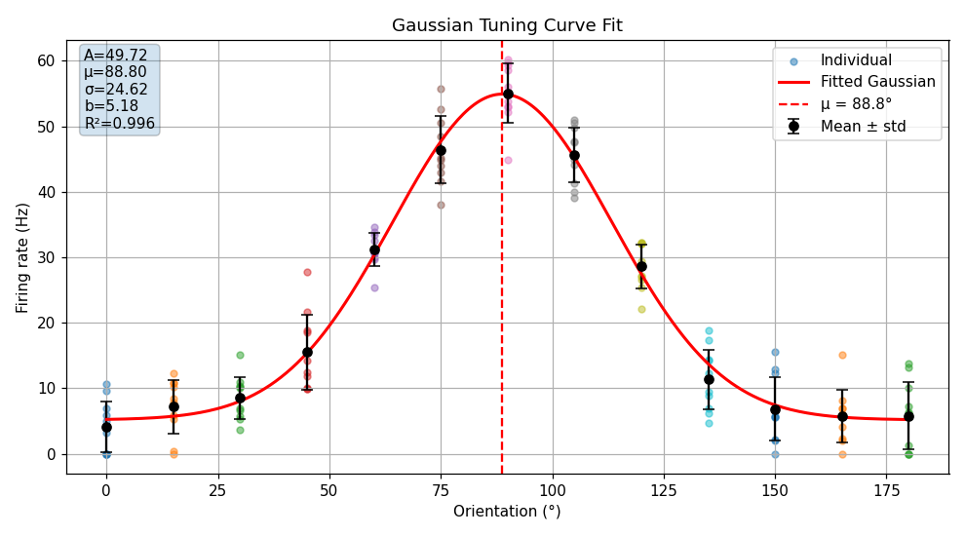
Q1. Fitted parameters vs true values (noise_std = 6 Hz)
Parameter | True value | Fitted value | Absolute error
A (amplitude, Hz) | 50.0 | 49.72 | 0.28
mu (preferred orient., °) | 90.0 | 88.80 | 1.20
sigma (width, °) | 25.0 | 24.62 | 0.38
b (baseline, Hz) | 5.0 | 5.18 | 0.18

All four fitted values land close to the true ones. The biggest miss is mu, off by 1.2°.
Q2. What is your R² value? What does it mean?
R² = 0.9965. The fitted Gaussian explains about 99.6% of the variance in the mean firing rates, so the model matches the neuron's tuning curve very closely. The 0.35% left over is mostly noise.
Q3. Increase noise_std to 20 Hz and re-run. How do the fitted parameters and R² change?
The fit gets worse. I got A = 45.61, mu = 86.67, sigma = 23.09, b = 8.92 and R² = 0.9725. Every parameter is further from the true value than before (A is off by 4.39 and b by 3.92). Noisier trials make the mean rates less reliable, so curve_fit has less to work with. The baseline goes up for a separate reason: negative rates get clipped to 0, and with 20 Hz noise around a 5 Hz baseline a lot of trials come out negative, so clipping them pushes the average at the flanks up to roughly 10 Hz.

Exercise 3 - Population Vector Decoding
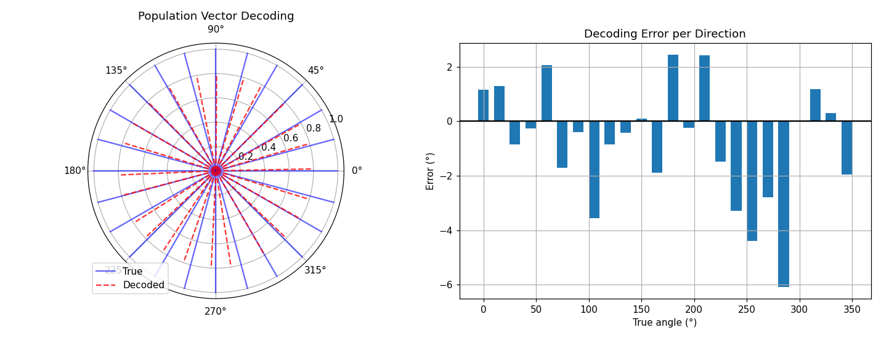
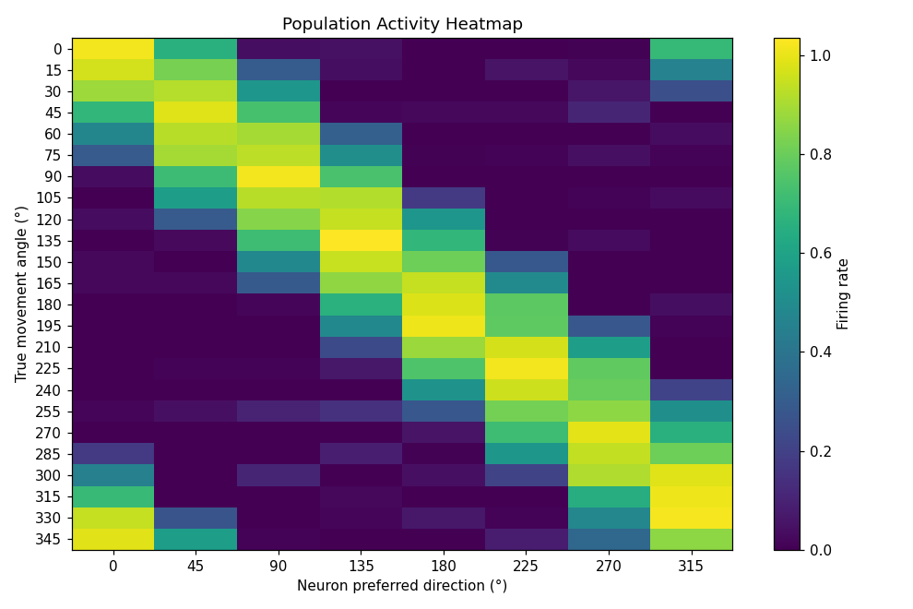
Q1. What is your mean absolute decoding error?
Mean absolute error = 1.71° and max absolute error = 6.08°, using 8 neurons and noise = 0.05.
Q2. How does neuron count affect accuracy?
More neurons, smaller error. At noise 0.2 the mean error dropped from 9.84° with 4 neurons to 7.96° (8), 5.40° (16), 5.32° (32) and 2.50° with 64 neurons. Each neuron's noise is independent, so adding more neurons averages it out.
Q3. How does noise affect decoding?
Noise makes decoding worse quickly. With 8 neurons the mean error went from 1.71° at noise 0.05 to 7.96° at 0.2 and 22.37° at 0.5. At 0.5 the worst direction was off by 137°, which is close to pointing the opposite way. Small populations suffer the most.

Reflection Questions
Q1. Which of the three approaches is most biologically plausible?
Population vector decoding. A downstream neuron could compute it with a weighted sum of its inputs, and those weights are just synapses. Georgopoulos found this kind of code in monkey motor cortex in the 1980s, so there is real data behind it. Bayesian decoding gives the best possible answer, but it needs the full likelihood for every stimulus plus the priors, and it is hard to see how neurons would store and normalise all of that. The tuning curve is an encoding model. It describes how one neuron responds, so it needs a decoder on top before it can read anything out.
Q2. How would population vector decoding behave if the number of neurons increases significantly, or neurons have non-uniform preferred directions? What challenges arise in real neural populations?
If the number of neurons goes up a lot, the error keeps falling because independent noise averages out. In my runs it went from 1.71° with 8 neurons to 0.63° with 64. The gains get smaller as N grows, since the error falls roughly with 1/√N. If preferred directions are bunched together, the population vector gets pulled toward the crowded directions and the decoded angle is biased. You would have to correct for that, for example by giving less weight to neurons in crowded directions. Real brains are messier. Tuning curves differ in shape and peak rate, noise is correlated between neighbouring neurons (so it averages out less), tuning drifts over days, and electrodes only pick up a small sample of the population.
Q3. How might the Gaussian model need to change for real neural recordings?
Real recordings give spike counts, and spike count noise looks more like Poisson, where the variance grows with the firing rate. The constant Gaussian noise assumption would need to go, for example by using a Poisson likelihood or a weighted fit. Orientation is circular (0° and 180° are the same), so a von Mises function fits the edges better than a plain Gaussian. Real neurons can also have asymmetric curves or two peaks, and their responses adapt over repeated trials. With only a few trials per orientation, the fit should report confidence intervals on the parameters too.

