VISVESVARAYA TECHNOLOGICAL UNIVERSITY

“Jnana Sangama”, Machhe, Belagavi, Karnataka-590018
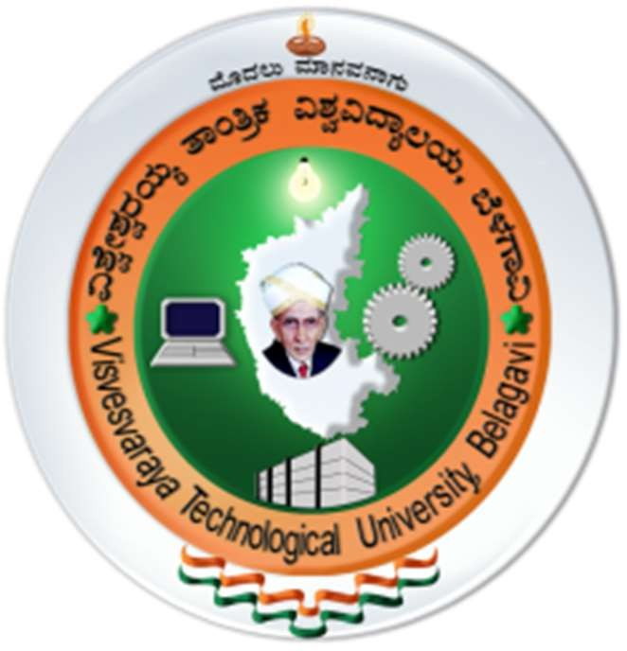
Lab Experiment Record
Project Management with Git [BCSL58C]
Submitted in partial fulfillment towards AEC of 3rd semester of

Bachelor of Engineering

in
Computer Science and Engineering
(Artificial Intelligence & Machine Learning)
Submitted by
AYESHA BANU

4GW25CI402

DEPARTMENT OF CSE (Artificial Intelligence & Machine Learning)
GSSS INSTITUTE OF ENGINEERING & TECHNOLOGY FOR WOMEN

(Affiliated to VTU, Belagavi, Approved by AICTE, New Delhi & Govt. of Karnataka)
K.R.S ROAD, METAGALLI, MYSURU-570016, KARNATAKA

(Accredited by NAAC) 2025-2026
Project Management with Git – Practical Experiments
Experiment 1: Setting Up and Basic Git Commands

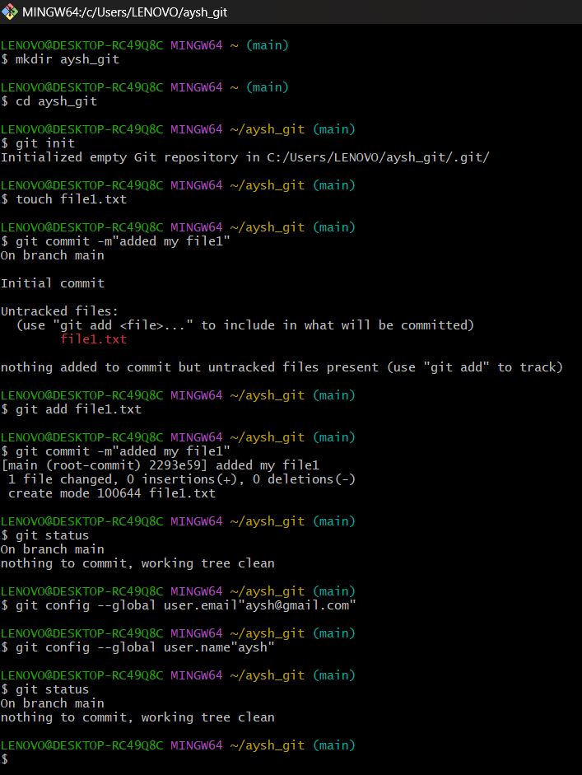

Experiment 2: Creating and Managing Branches
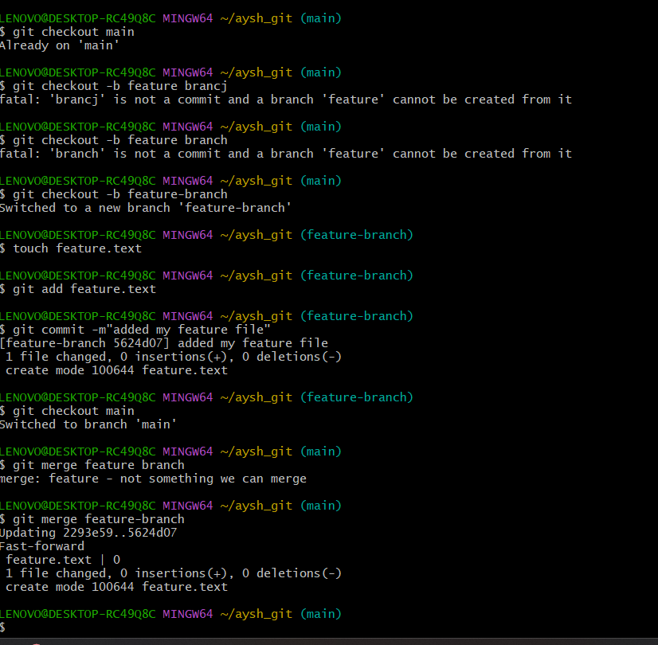
Experiment 3: Stashing and Applying Changes

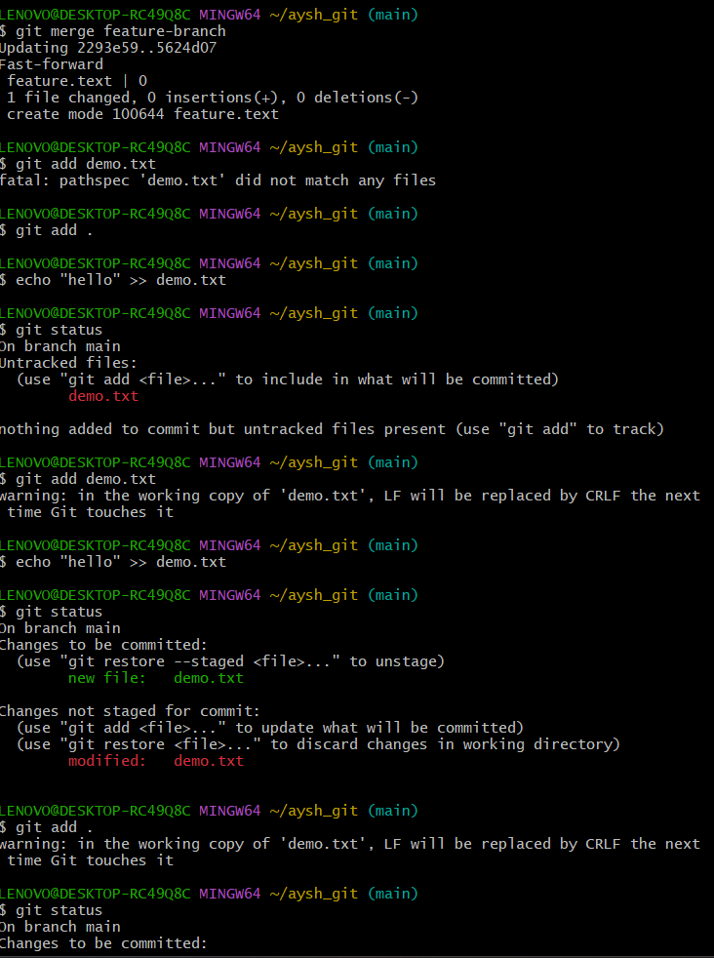
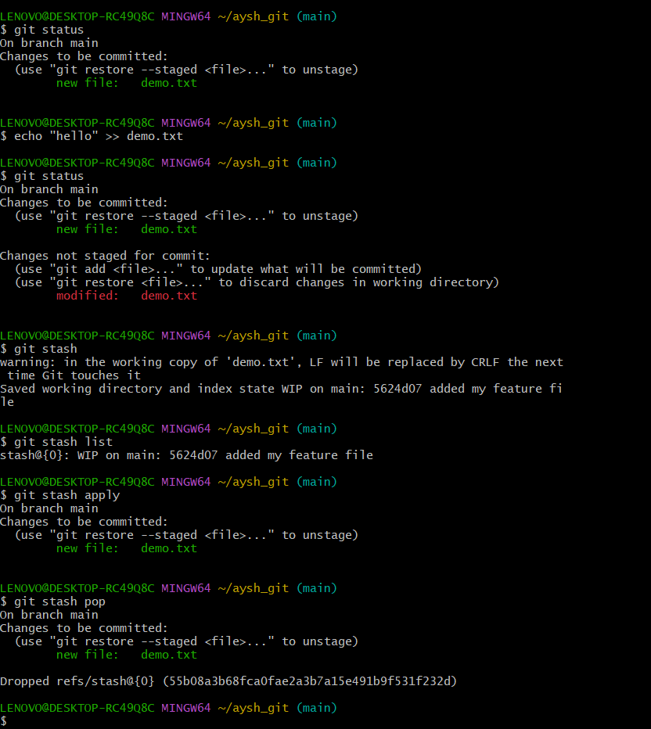

Experiment 4: Collaboration and Remote Repositories Clone
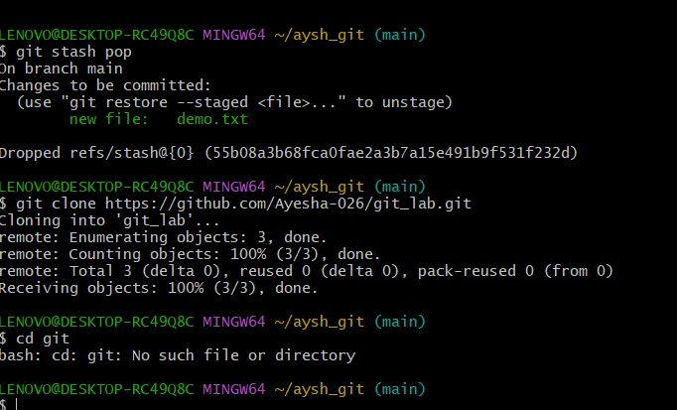

Experiment 5: Collaboration and Remote Repositories – Fetch and Rebase

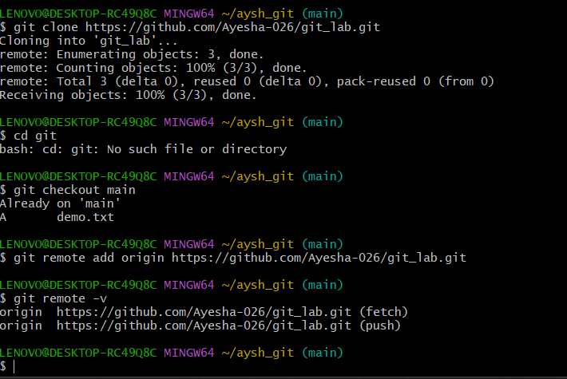

Experiment 6: Collaboration and Remote Repositories Merge with Commit
Message
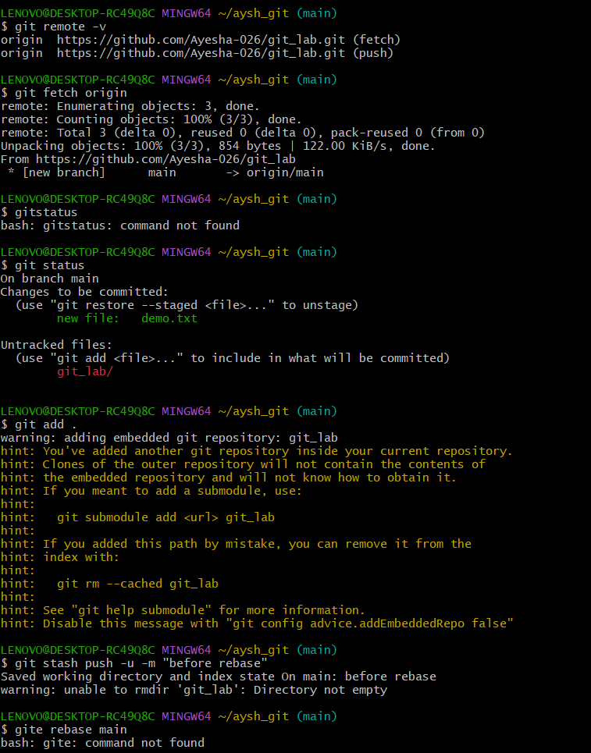
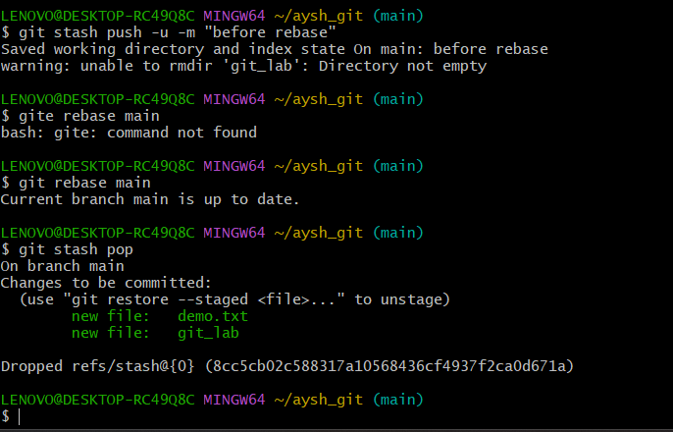

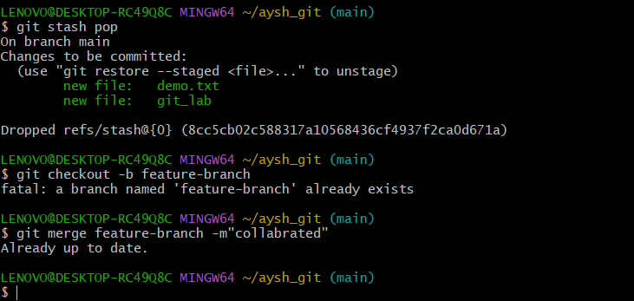

Experiment 7: Git Tags and Releases
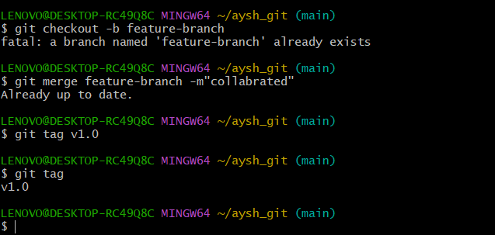

Experiment 8: Advanced Git Operations
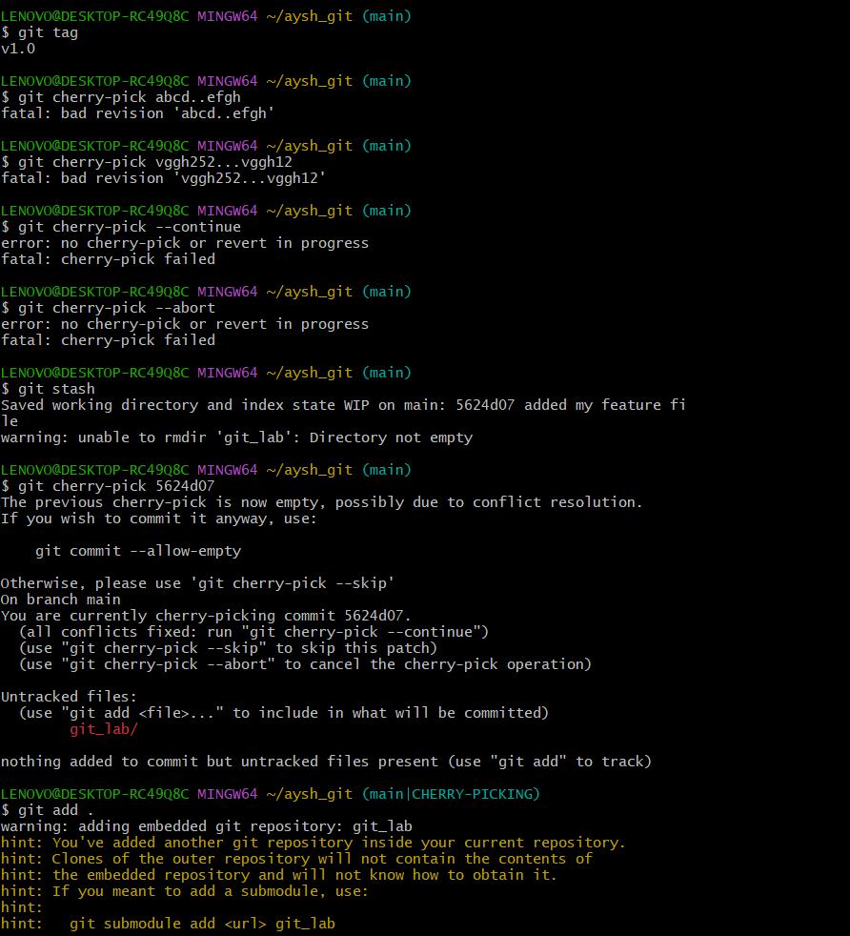

Experiment 9: Analysing and Changing Git History – Viewing Commit Details
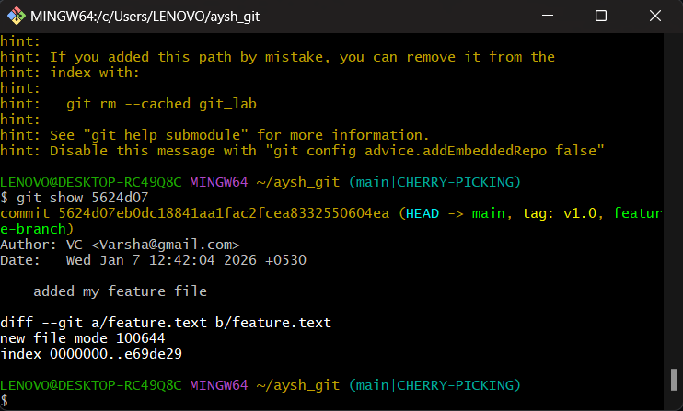

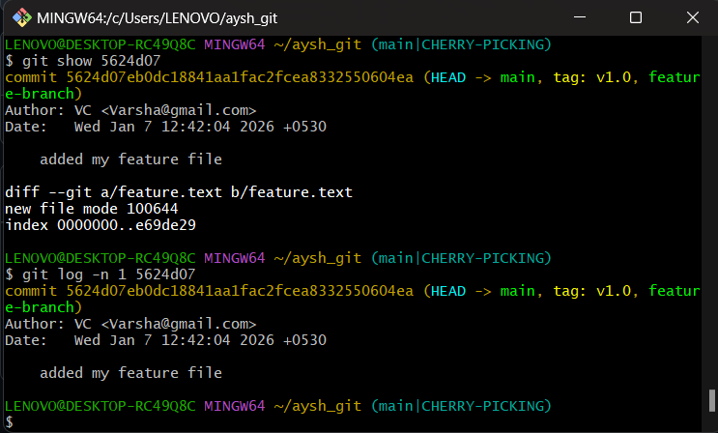

Experiment 10: Analysing and Changing Git History – Author-wise Commits

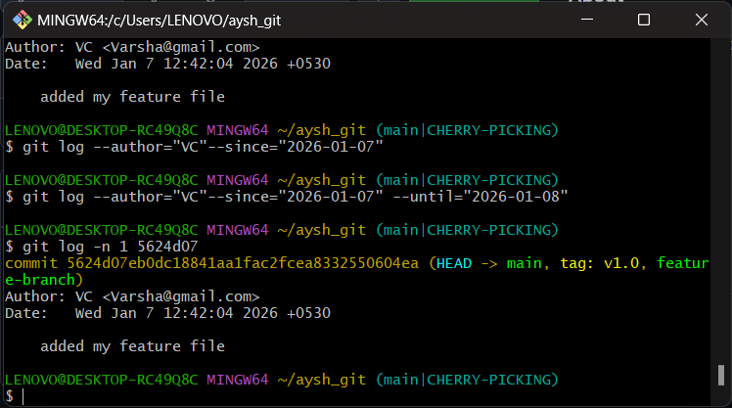

Experiment 11: Analysing and Changing Git History – Displaying Recent
Commits

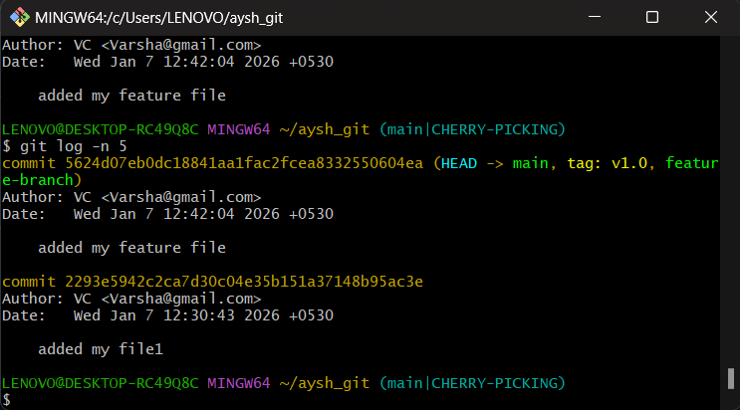

Experiment 12: Analysing and Changing Git History – Undoing Changes

