Fundamentals of Computer Programming

Lab 01: Introduction to Programming & Algorithms

Use the latest IDEs and other supplementary tools to aid implementation and code management.

Name: Ayesha Ahmer Khan
CMS id: 570438

Instructor: Mr. Ubaid Ullah

Lab Engineer: Ms. Zainab Zahid

Official Lab Conduct, Attendance & Submission Policy
All students are strictly required to follow the rules mentioned below. Violations will lead to academic penalties without exception.

- Attendance Requirement – Minimum 75%
  - Students must maintain at least 75% attendance in all lab sessions to be eligible for grading and final evaluation.
  - Late arrival or habitual late coming will result in deduction of marks and may be marked as absent at the discretion of the Lab Engineer/TA.
Authenticity of Work
  - Each student must complete their own lab tasks. Discussions for conceptual clarity are permitted, but copying code, content, or solutions is strictly prohibited.
- AI & Unauthorized Tools Prohibited
  - Use of ChatGPT, other AI tools, or unauthorized online resources for generating lab content is strictly forbidden.
  - Any violation will result in:
    - Immediate cancellation of lab marks, and
    - Reporting to the concerned department for disciplinary action.
- Submission Rules
  - All tasks must be submitted before leaving the lab.
  - Late submissions will not be accepted or marked.
- Grading Policy
  - After submission, students must present their work to the Lab Engineer/TA, the submitted solution can get a maximum of 5 marks.
  - A short viva may be conducted to assess understanding. Failure to attend or pass the viva may result in zero marks. The viva has a weightage of 5 marks
  - You must also submit this Word document with attached output screenshots and a short description of how you completed it, along with the code file on Google Classroom. In case of any problems with submissions, email your Lab assignments to Zainab.zahid2002@gmail.com.

PRE-LAB READING ASSIGNMENT
Introduction to Computer Programming
Problem example: | A computer program is a series of instructions written in some computer language that performs a particular task. The language code is frequently the only thing that new students focus on, but great software can only be produced after a rigorous design that identifies the needs, data, method, and anticipated consequences. For this reason, before attempting to create a high-quality program students must master sound design principles. An algorithm, which is a strategy for taking on a problem, directs design. A recipe for a cake, a study plan for an exam, or the specs of a rocket engine are all examples of tasks that require algorithms.  Pseudocode is an artificial and informal language that helps programmers develop algorithms. Pseudocode is a "text-based" detail (algorithmic) design tool. The rules of Pseudocode are reasonably straightforward. All statements showing "dependency" are to be indented. These include while, do, for, if, and switch. The examples below will illustrate this notion.  Create an algorithm to find the average of seven paper marks  An algorithm usually begins with a general broad statement of the problem. Find the average of Five Test Grades From here we can further refine the statement by listing commands that will accomplish our goal.  Read in the paper Marks Find the Average Write out the Average  Each box (called a node) may or may not be refined further depending on its clarity to the user. For example: Finding the Average may be as refined as an  Experienced programmer needs to accomplish the task of finding an average; however, students learning how to compute averages for the first time may need more refinement about how to accomplish the goal. This refinement process continues until we have a listing of steps understandable to the user to accomplish the task. For example, Find the Average may be refined into the following two nodes.  Total=sum of 7 paper Average=Total/7  Starting from left to right, a node that has no refinement becomes part of the algorithm. The actual algorithm (steps in solving the above program) is listed in bold.  Find the Average of seven paper marks  - Read in the marks  - Find the Average  - Total = sum of 7 papers  - Average = Total / 7  - Write Out the Average  From this algorithm, a program can be written in C++.
Process of Translation | Computers do not understand human languages. In fact, at the lowest level, Computers only understand sequences of numbers that represent operational codes (op codes for short). On the other hand, it would be very difficult for humans to write programs in terms of op codes. Therefore, programming languages were invented to make it easier for humans to write computer programs.
Compiled languages (e.g. C, C++) | Programming languages are for humans to read and understand. The program (source code) must be translated into machine language so that the computer can execute the program (as the computer only understands machine language). The way that this translation occurs depends on whether the programming language is a compiled language or an interpreted language.  The following illustrates the programming process for a compiled programming language.  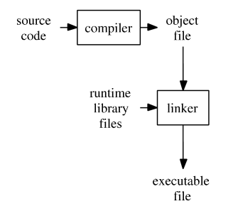  A compiler takes the program code (source code) and converts the source code to a machine language module (called an object file). Another specialized program called a linker, combines this object file with other previously compiled object files (in particular run-time modules) to create an executable file.

Control Structures  The Sequence Structure  The Selection Structure  C++  Why Learn C++? | All computer programs are written using one or more of three basic control structures: sequence, repetition, and selection. Another term used for control structures is logic structures because they control the logic flow of the program.  While in every program that is written the sequence structure will be used, in almost all programs all three control structures will be used  - The sequence structure directs the computer to process the program instructions, one after another, in the order in which they are listed in the program  - An algorithm is a finite number of step-by-step instructions that accomplish a task  - Example: Making a cup of tea and filling petrol at a petrol pump.  - The selection structure directs the computer to make a decision (evaluate a condition), and then take appropriate action based upon that decision  - The selection structure allows the programmer to evaluate data, therefore properly controlling the logic flow of the program  - Another name for the selection structure is the decision structure  - Example: stopping or going at a signal light  - The repetition structure, commonly called iteration or looping, directs the computer to repeat one or more program instructions until some condition is met  - This condition may be checked at the beginning or end of the set of instructions to be processed dependent upon the language being used  - The repetition structure allows the programmer to repeatedly process a set of instructions, while only typing them in once  C++ is a general-purpose, object-oriented programming language widely used in software development. Every C++ program contains at least one function called main(), where execution starts. To display output, cout is used, and to take input, cin is used. ends each statement. A semicolon (;)  #include <iostream>  using namespace std;  int main()  {  cout << "Hello World!\n";  }  C++ is one of the most important programming languages for beginners and professionals because:  - Widely Used in Core Systems: It is used to develop operating systems, embedded systems, and graphical software.  - High Performance: C++ programs run very fast, making it useful in fields like competitive programming and high-performance applications.  - Flexible Features: It allows both low-level control (like memory management) and high-level programming (like Object-Oriented Programming).  - Easy to Transition: Its syntax is similar to C, Java, and C#, so learning other languages later becomes easier.
Lab 1.1  Installing IDE for C++ | In order to install Dev-C++, we need to first download it. To download Dev-C++ please refer to its Official Website.
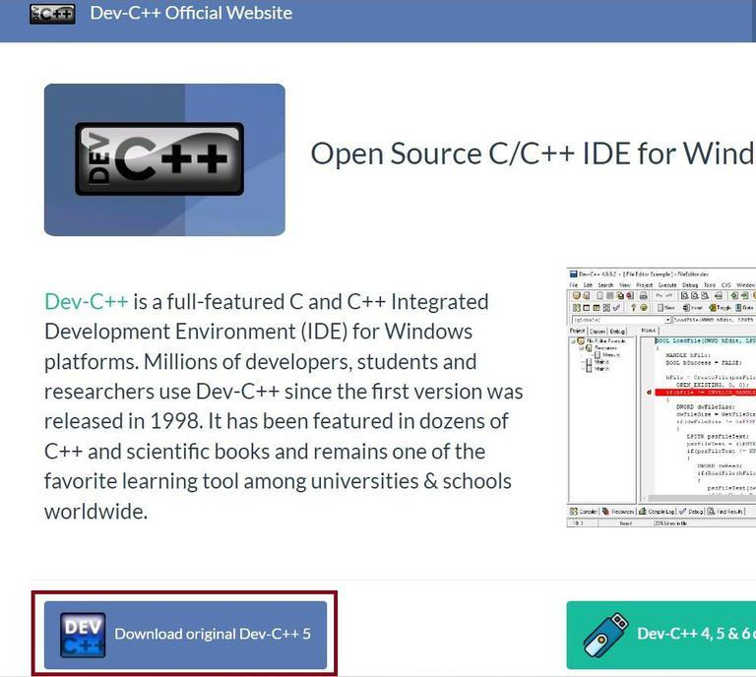

Once we have downloaded the Dev-C++ software. We need to follow the following steps to install it. Below are the steps for the installation,
Step 1: | Getting Started. Click the OK button to start the installation. 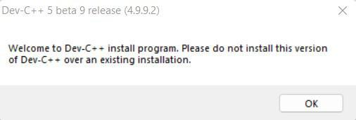
 | Note: Please make, there is no any other version of Dev-C++ is already installed. If any other version of Dev-C++ is already installed then we need to first uninstall it and then install the new version. 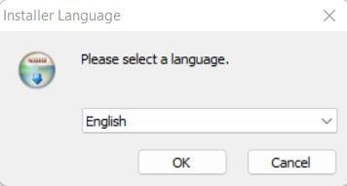
Step 2: | Now, accept the License Terms & Agreement by clicking “I Agree”. 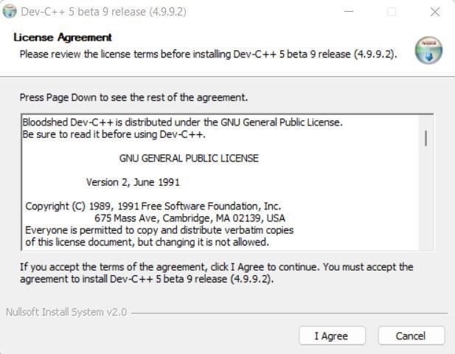
Step 3: | Choosing Components To Be Installed. 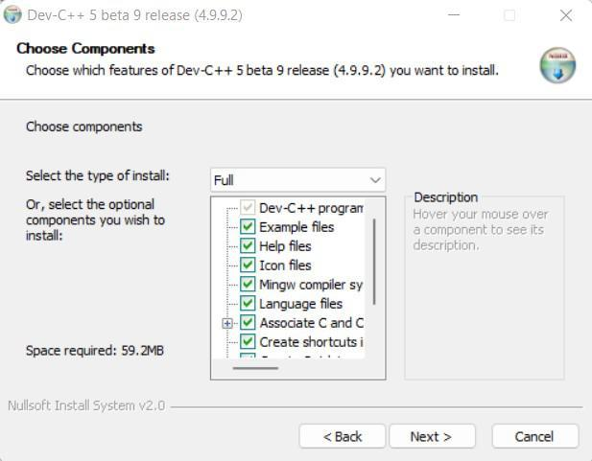
Step 4: | Specify the Location. 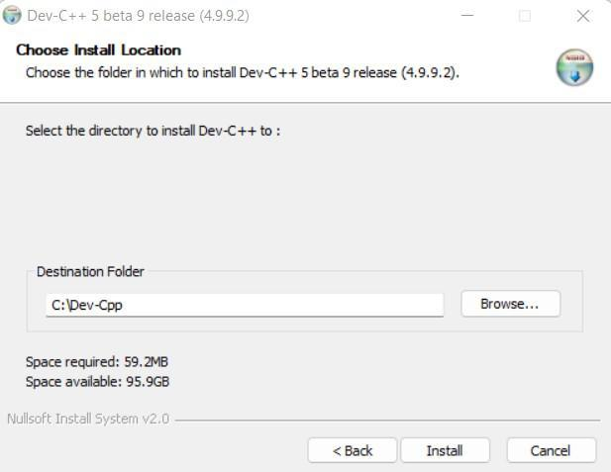
Step 5: | Installing Libraries. 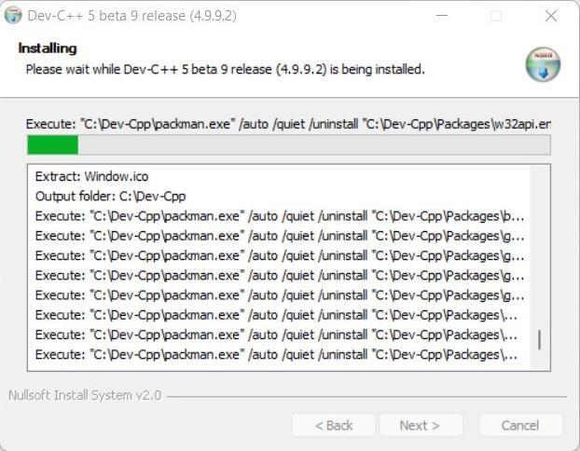
Step 6: | Installation Completion. 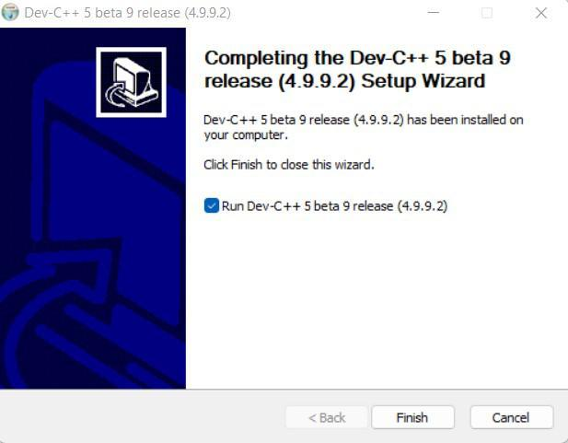

Fill in the blanks | - Compilers detect ___program_____________ errors.  - Usually the most difficult errors to correct are the ___random_____________ errors since they are not detected in the compilation process.  - Attaching other pre-written routines to your program is done by the  ___linker_____________ process.  - ___machine_____________ code is the machine code consisting of ones and zeroes that is read by the computer.  - Dividing by zero is an example of a ___undefined_____________ error.

Lab 1.2 | Lab Tasks

Task 1: First, review the algorithm in the box below, then respond to the questions.
repeat for (each person buying a burger)
enter the exact price of the burger
15% of the original price is multiplied to determine the reduction/discount.
The balance is determined by deducting the discount from the purchase price.
Print a bill with the purchase price, the discount, and the total amount owed.
end repeat

  - Which control structures are used in the algorithm? (LOOP)
  - When the burger costs $21 what will the algorithm print? (purchase price 21 , discount 3.15, total amount owed 17.85) (discount=15% of 21=15/100 * 20= $3.15)
  - How would you change the algorithm so that just the first 10 burger buyers may use it? (we will update the loop and set to loop to run for 10 times)
  - How would you change it such that the user may also enter the discount rate, which would then be used to calculate the discount?(we will ask the user to enter the discount rate by making changes in the program and adding input so that user inputs discount )

Task 2: Read in a number that shows the number of Hours. The output will convert this hour to minutes. 1 Hour = 60 minutes. Design an algorithm for the above problem

Output:
Start
Input a number (the number shows hours)
Convert the hours in minutes by formula 1h=60 minutes
Multiply number of hours by 60(eg : 2,,,, 2 * 60=120 minutes)
Print output
stop

Task 3: Write a program to print your name and department.

Output:

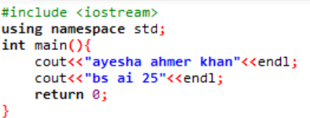

Task 4: Modify the program to print your name on one line and your registration number on the next.
Output:

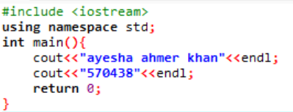

Task 5: What will be the output of given program

#include <iostream>

using namespace std;

int main()

{
cout<< "Welcome to CS110!!\nWelcome to \”NBC\” ";

system(“pause”);

return 0;

}

Output:

code exited with errors (it was related to the system(“pause”); statement)

