Fundamentals of Computer Programming

Lab 11: Functions in C++

Recursion

Name: Ayesha Ahmer Khan
CMS: 570438

Instructor: Mr. Ubaid Ullah

Lab Engineer: Ms. Zainab Zahid

Official Lab Conduct, Attendance & Submission Policy
All students are strictly required to follow the rules mentioned below. Violations will lead to academic penalties without exception.

1. Attendance Requirement – Minimum 75%
- Students must maintain at least 75% attendance in all lab sessions to be eligible for grading and final evaluation.
- Late arrival or habitual late coming will be marked as absent

Authenticity of Work
o Each student must complete their own lab tasks. Discussions for conceptual clarity are permitted, but copying code, content, or solutions is strictly prohibited.
- AI & Unauthorized Tools Prohibited o Use of ChatGPT, other AI tools, or unauthorized online resources for generating lab content is strictly forbidden.
  - Any violation will result in:
▪ Immediate cancellation of lab marks
- Submission Rules o All tasks must be submitted before leaving the lab.
  - Late submissions will not be accepted or marked.
- Grading Policy o After submission, students must present their work to the Lab Engineer/TA, the submitted solution can get a maximum of 5 marks. o A short viva may be conducted to assess understanding. Failure to attend or pass the viva may result in zero marks. The viva has a weightage of 5 marks
  - You must also submit this Word document with attached output screenshots and a short description of how you completed it, along with the code file on Google Classroom. In case of any problems with submissions, email your Lab assignments to Zainab.zahid2002@gmail.com.

Learning Objectives
- Understand the Concept of Recursion
- Identify Base Case and Recursive Case
- Trace recursive functions
- Implement simple recursive functions
- Understand Memory and Efficiency Concerns
- Apply Recursion to Problem-Solving
- Develop Debugging Skills for Recursive Code
PRE-LAB READING ASSIGNMENT

C++ Recursion
Recursion is a programming technique where a function calls itself repeatedly until a specific base condition is met. A function that performs such self-calling behavior is known as a recursive function, and each instance of the function calling itself is called a recursive call. A function that calls itself, and doesn’t perform any task after function call, is known as tail recursion. In tail recursion, we generally call the same function with a return statement.
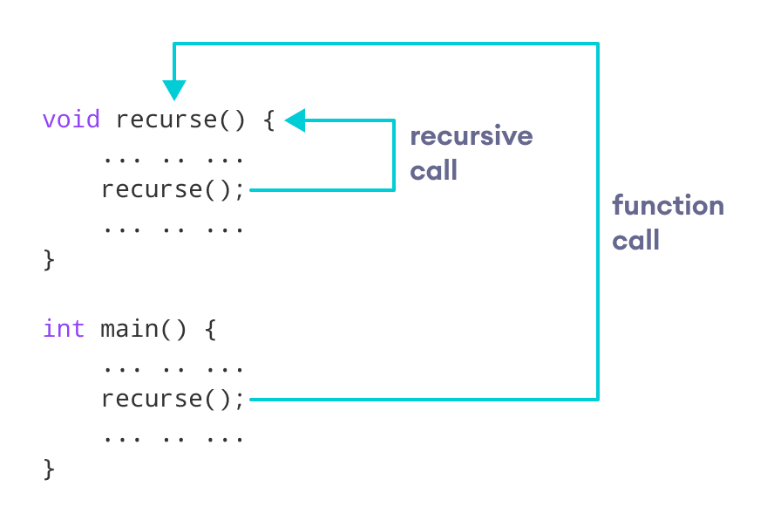
A recursive function consists of two portions

- Base Case:
The base case is also called a stopping condition for recursive calls. It is very important to have a base case for every recursive code. Without base cases the recursive calls will be made again and again many times till the Stack space allocated is filled with these recursive calls which will result in Stack overflow error.

For example: if you are writing a code to print the factorial of a number then the least possible answer would be 0! Which is 1 so you will write the base case as when the given number reaches less than or equal to zero then return 1.

- Recursive Case:
  - The recursive case is the part where the function calls on itself
  - It breaks the problem into smaller sub-problems that eventually reach the base case.
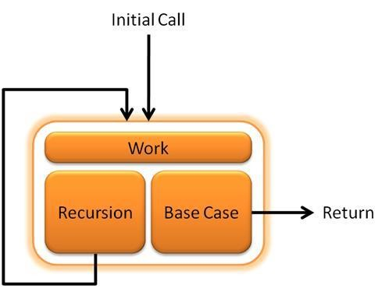

Example: Factorial of a number using Recursion

// Factorial of n = 1*2*3*...*n

#include <iostream> using namespace std;

int factorial(int);
int main() { int n, result;

cout << "Enter a non-negative number: "; cin >> n;

result = factorial(n);
cout << "Factorial of " << n << " = " << result; return 0;
}
int factorial(int n) { if (n > 1) {
return n * factorial(n - 1);
} else { return 1;
} }

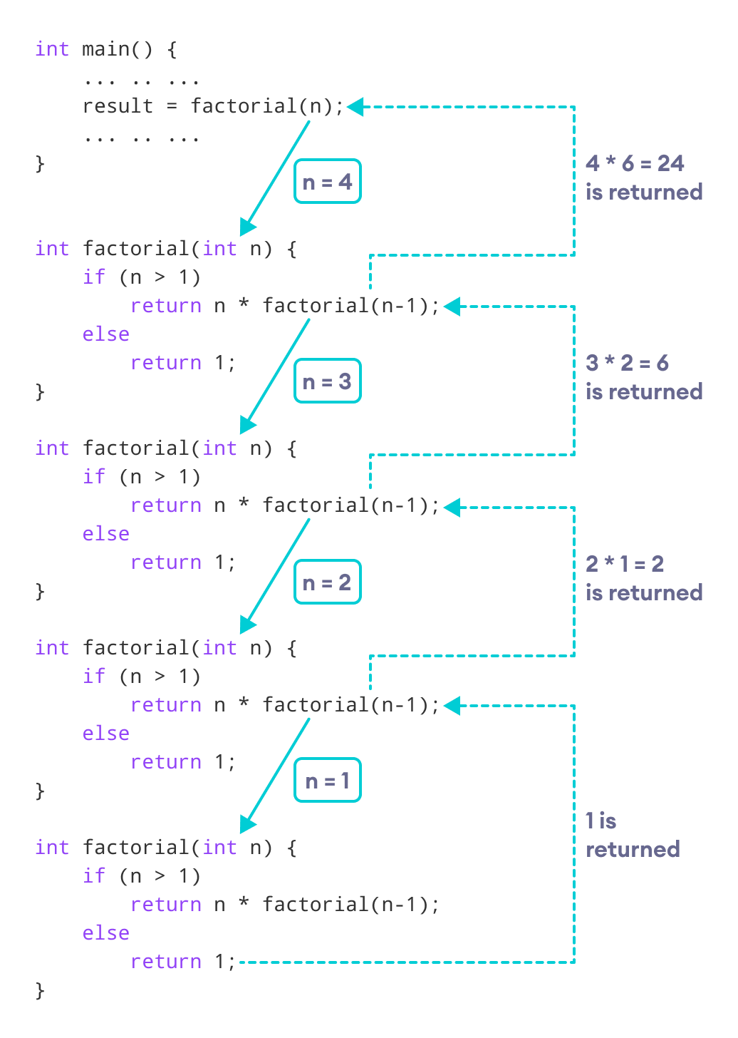

C++ Function Overloading
Function Overloading is defined as the process of having two or more functions with the same name, but different in parameters is known as function overloading in C++. In function overloading, the function is redefined by using either different types of arguments or a different number of arguments. It is only through these differences compiler can differentiate between the functions.
The advantage of Function overloading is that it increases the readability of the program because you don’t need to use different names for the same action.
Example: changing the number of arguments of the add() method

// Program of function overloading with different types of // arguments. #include <iostream> using namespace std;
int mul(int, int);
float mul(float, int);

int mul(int a, int b) { return a * b; } float mul(double x, int y) { return x * y; } int main()
{
int r1 = mul(6, 7); float r2 = mul(0.2, 3); cout << "r1 is : " << r1 << endl; cout << "r2 is : " << r2 << endl; return 0;
}

Lab Tasks
- Write a C++ program to calculate the sum of N natural numbers using recursion.
Sample Output:
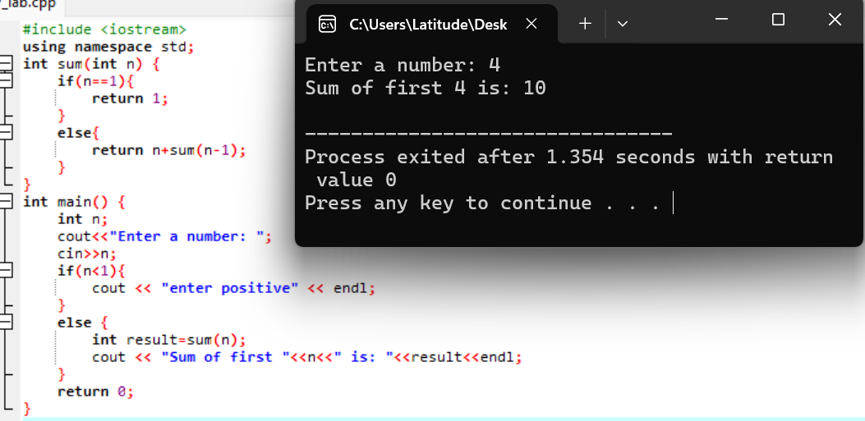

- Write a C++ program that takes an integer as input and reverses its digits using recursion
Sample Output:
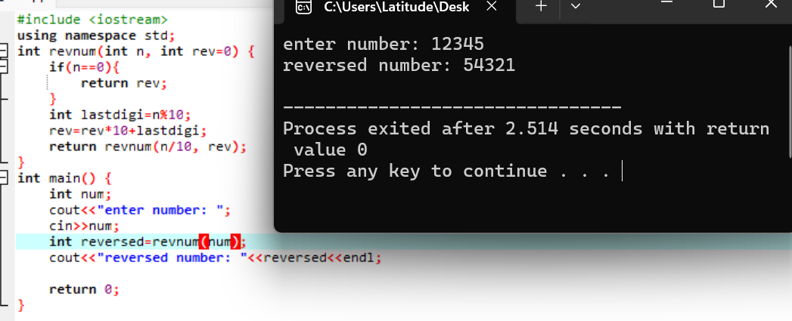

- Chocolate Sharing Game:
Meliodas and Ban are sharing chocolates.
Meliodas has X chocolates, and Ban has Y chocolates.
Each turn:
- The one with more chocolates gives 1 chocolate to the one with fewer chocolates.
- This continues until they both have the same number of chocolates.
- Write a recursive program to find how many chocolates they will have each at the end.
Sample Output:
- Input: X = 2, Y = 5
- Process:
Step 1: Meliodas = 2, Ban = 5 → Ban gives 1 → Meliodas = 3, Ban = 4
Step 2: Meliodas = 3, Ban = 4 → Ban gives 1 → Meliodas = 4, Ban = 3
Step 3: Meliodas = 4, Ban = 3 → Meliodas gives 1 → Meliodas = 3, Ban = 4
Step 4: Repeat… until both = 4
- Output: Each will have 4 chocolates.

- Calculate the power of a number using recursion.
Sample Output:
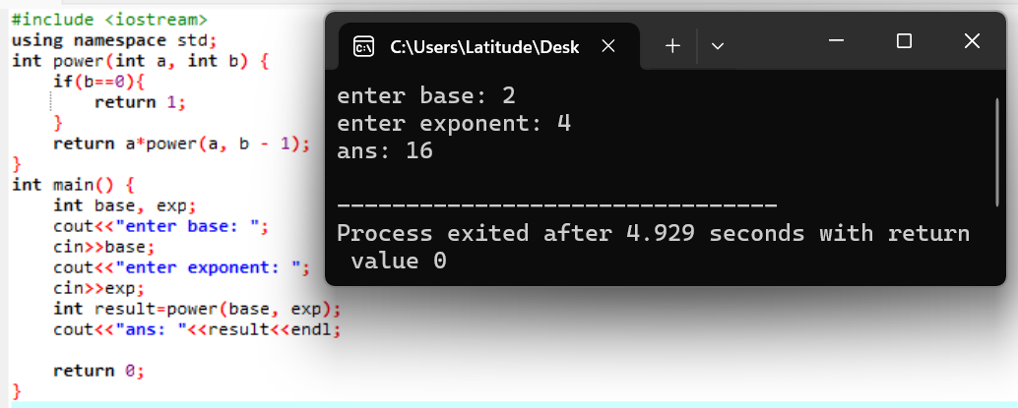

- Given an input string of numbers, find all combinations of numbers that can be formed using digits in the same order.
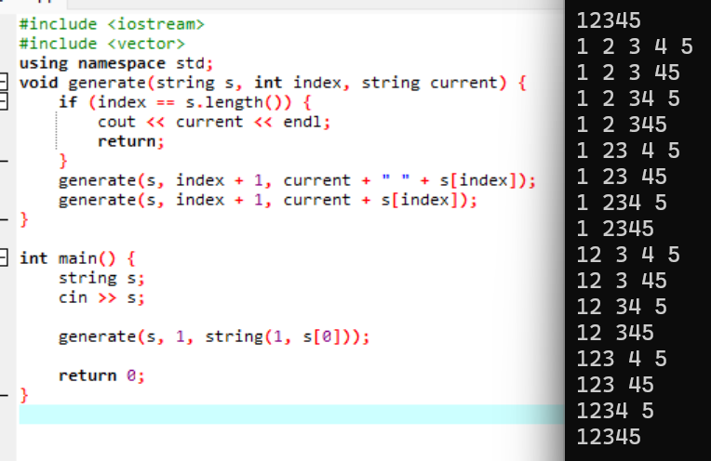

Balochistan Campus (NBC), Department of Computer Science

