Fundamentals of Computer Programming

Lab 08: Introduction to Arrays

1D Arrays

Name: Ayesha Ahmer Khan
CMS ID: 570438

Instructor: Mr. Ubaid Ullah

Lab Engineer: Ms. Zainab Zahid

Official Lab Conduct, Attendance & Submission Policy
All students are strictly required to follow the rules mentioned below. Violations will lead to academic penalties without exception.

1. Attendance Requirement – Minimum 75%
- Students must maintain at least 75% attendance in all lab sessions to be eligible for grading and final evaluation.
- Late arrival or habitual late coming will be marked as absent

Authenticity of Work
o Each student must complete their own lab tasks. Discussions for conceptual clarity are permitted, but copying code, content, or solutions is strictly prohibited.
- AI & Unauthorized Tools Prohibited o Use of ChatGPT, other AI tools, or unauthorized online resources for generating lab content is strictly forbidden.
  - Any violation will result in:
▪ Immediate cancellation of lab marks
- Submission Rules o All tasks must be submitted before leaving the lab.
  - Late submissions will not be accepted or marked.
- Grading Policy o After submission, students must present their work to the Lab Engineer/TA, the submitted solution can get a maximum of 5 marks. o A short viva may be conducted to assess understanding. Failure to attend or pass the viva may result in zero marks. The viva has a weightage of 5 marks
  - You must also submit this Word document with attached output screenshots and a short description of how you completed it, along with the code file on Google Classroom. In case of any problems with submissions, email your Lab assignments to Zainab.zahid2002@gmail.com.

Learning Objectives
- Understand the concept of arrays (one-dimensional).
- Learn how to declare, initialize, and access array elements.
- Practice using loops with arrays.
- Perform basic operations like input, output, summing, and finding max/min.

What is Array C++ provides a data structure, the array, which stores a fixed-size sequential collection of elements of the same type. An array is used to store a collection of

data, but it is often more useful to think of an array as a collection of variables of
the same type.
Instead of declaring individual variables, such as number0, number1, ..., and number99, you declare one array variable such as numbers and use numbers [0],

numbers [1], and ..., numbers [99] to represent individual variables. An index
accesses a specific element in an array.
All arrays consist of contiguous memory locations. The lowest address
corresponds to the first element and the highest to the last element.

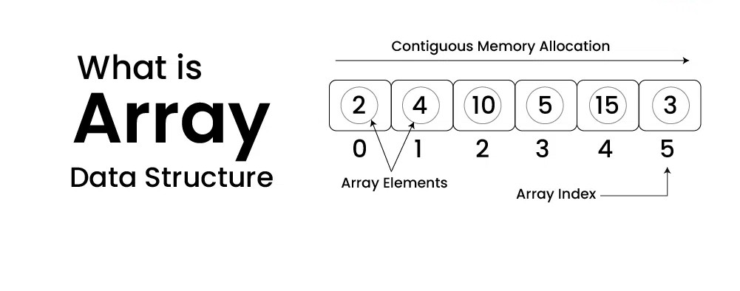
C++ Arrays Declaration | To declare an array in C++, the programmer specifies the type of the elements and the number of elements required by an array as follows − type arrayName [ arraySize ];  This is called a single-dimension array. The arraySize must be an integer constant greater than zero and type can be any valid C++ data type. For
example, to declare a 9-element array called balance of type double, use this statement −
double balance[9];

You can initialize C++ array elements either one by one or using a single
Initializing Arrays statement as follows –
double balance[5] = {900.0, 2.0, 3.4, 17.0, 50.0};

The number of values between braces { } can not be larger than the number of
elements that we declare for the array between square brackets [ ]. Following is an example of assigning a single element of the array −

If you omit the size of the array, an array just big enough to hold the initialization is created. Therefore, if you write –
double balance[] = {900.0, 2.0, 3.4, 17.0, 50.0};

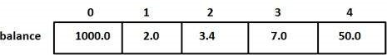

Accessing Array An element is accessed by indexing the array name. This is done by placing the Elements index of the element within square brackets after the name of the array. For
example −
double salary = balance[9];

Pre lab writing assignment

Fill in the blanks | - To store a collection of data of the same type called array  - A specific element in an array is accessed by an index  - The arraySize must be an integer constant greater than zero  - An element is accessed by using the array name

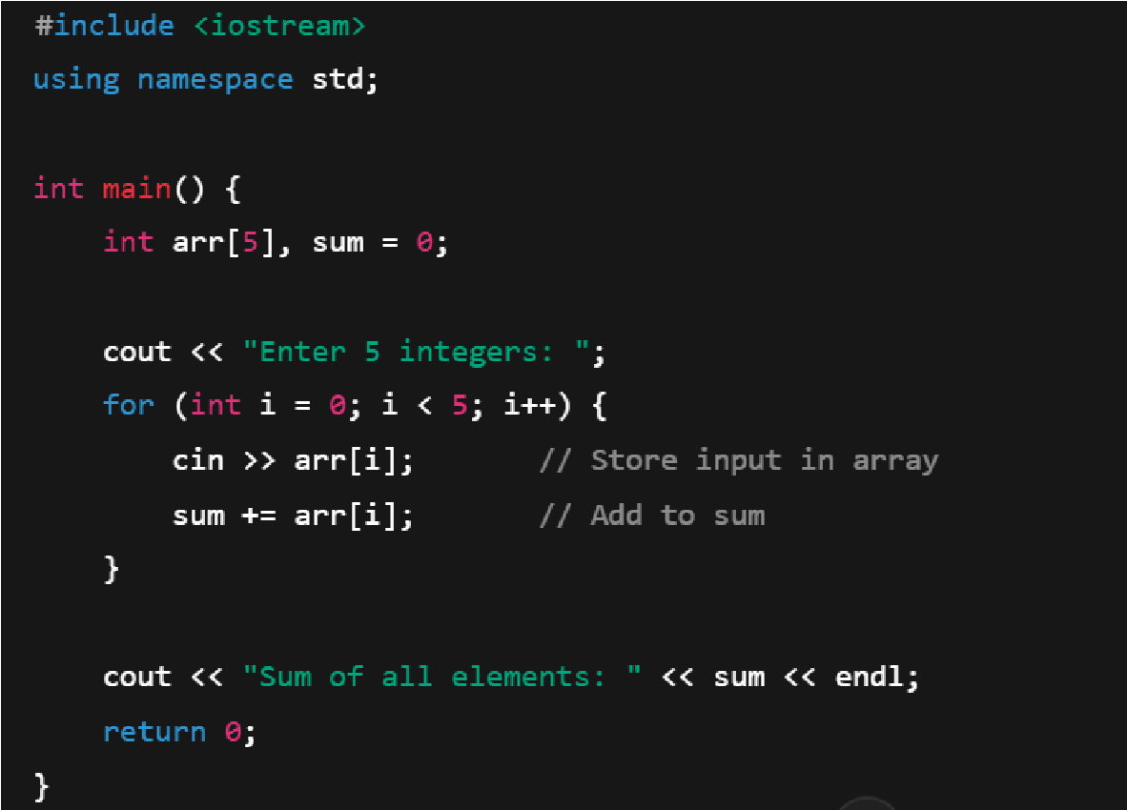
What is the output of the program shown?

Output:
Sum of all elements: 15

Lab Tasks:
- Write a C++ program to find the largest element of a given array of integers

Output:
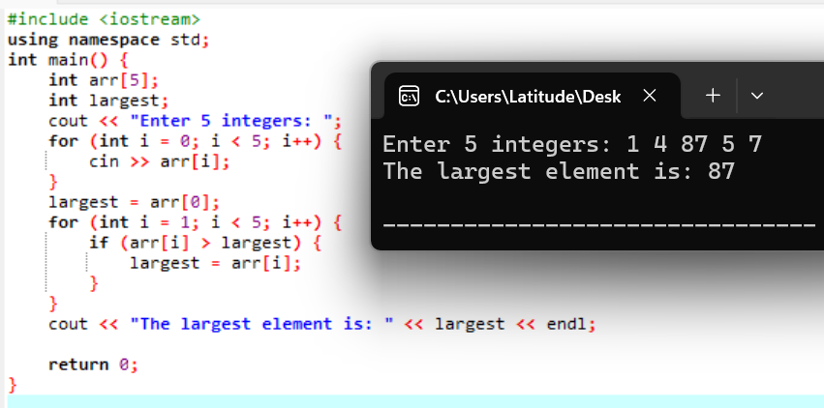

- Twenty-five numbers are entered from the keyboard into an array. The number to be searched is entered through the keyboard by the user. Write a program to find if the number to be searched is present in the array and if it is present, display the number of times it appears in the array.

Output:
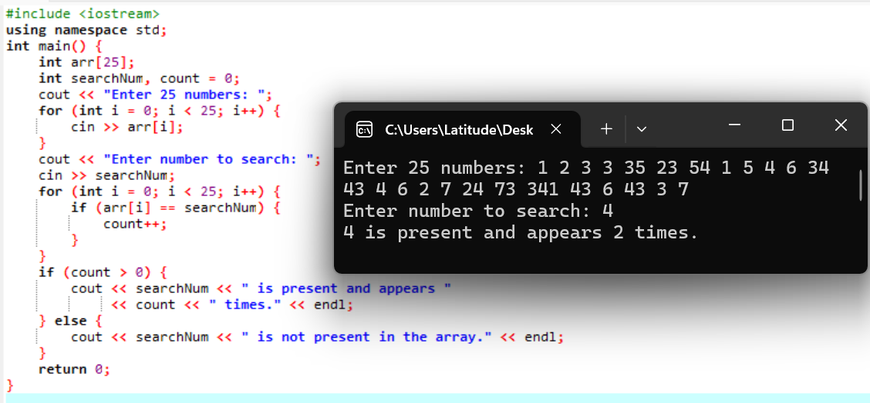
- Write a C++ program to move all negative elements of an array of integers to the end of the array without changing the order of positive elements and negative elements.
Output:
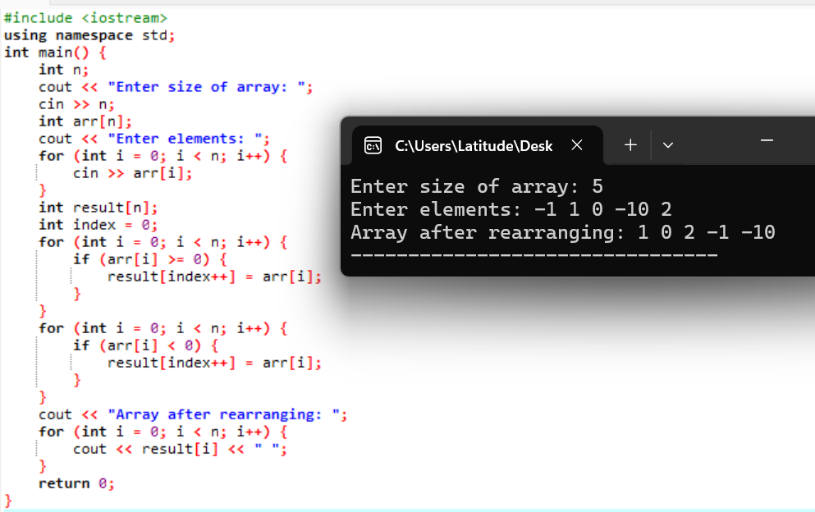

Q4. What will be the output of the program shown below

int main() { int num[26], temp; num[0] = 100; num[25] = 200; temp = num[25]; num[25] = num[0]; num[0] = temp; cout << num[0] << " " << num[25] << endl; return 0;
}

Output:
200 100

Q5. Write a C++ program to take n number of inputs and sort a given unsorted array of integers, in wave form. Note: An array is in wave form when array[0] >= array[1] <= array[2] >= array[3] <= array[4] >=

Output:
