Fundamentals of Computer Programming

Lab 09: Multi Dimensional Arrays in C++

2-Dimensional and 3-Dimensional Arrays

Name: Ayesha Ahmer Khan
CMS ID: 570438

Instructor: Mr. Ubaid Ullah

Lab Engineer: Ms. Zainab Zahid

Official Lab Conduct, Attendance & Submission Policy
All students are strictly required to follow the rules mentioned below. Violations will lead to academic penalties without exception.

- Attendance Requirement – Minimum 75%
  - Students must maintain at least 75% attendance in all lab sessions to be eligible for grading and final evaluation.
  - Late arrival or habitual late coming will be marked as absent
Authenticity of Work
  - Each student must complete their own lab tasks. Discussions for conceptual clarity are permitted, but copying code, content, or solutions is strictly prohibited.
- AI & Unauthorized Tools Prohibited o Use of ChatGPT, other AI tools, or unauthorized online resources for generating lab content is strictly forbidden.
  - Any violation will result in:
▪ Immediate cancellation of lab marks
- Submission Rules o All tasks must be submitted before leaving the lab.
  - Late submissions will not be accepted or marked.
- Grading Policy o After submission, students must present their work to the Lab Engineer/TA, the submitted solution can get a maximum of 5 marks. o A short viva may be conducted to assess understanding. Failure to attend or pass the viva may result in zero marks. The viva has a weightage of 5 marks
  - You must also submit this Word document with attached output screenshots and a short description of how you completed it, along with the code file on Google Classroom. In case of any problems with submissions, email your Lab assignments to Zainab.zahid2002@gmail.com.

Learning Objectives
By the end of this lab, students should be able to:
- Understand the concept and memory structure of 2D (matrix) and 3D arrays.
- Declare, initialize, and access elements of 2D and 3D arrays.
- Perform operations like input, output, sum of elements, row-wise and column-wise sum.
- Understand nested loops in relation to multidimensional arrays.
- Practice real-world applications of 2D and 3D arrays (e.g., matrices, grids, or simple data cubes).

PRE-LAB READING ASSIGNMENT Two Dimensional Arrays:
A 2D array is also known as a matrix (a table of rows and columns).
The first dimension represents the number of rows , while the second dimension represents the number of columns
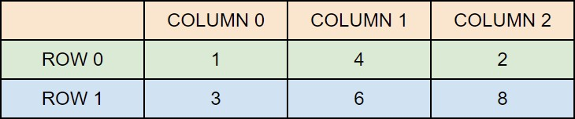
Accessing the elements of a 2D Array:
To access any element of a multi-dimensional Array, you must specify the index of both the row and the column.

For example:
int matrix[2][3] = { {1, 4, 2}, {3, 6, 8} }; // creates a matrix of 2 rows and 3 columns

cout << " " << matrix[0][2];

Output: 2

Change Elements in a 2D Array
To change the value of an element, refer to the index number of the element in each of the dimensions:
int matrix[2][3] = { {1, 4, 2}, {3, 6, 8} }; matrix[1][2]=10;

Output:
{1 4 2 } ,{3,6,10}

Looping through a 2D Array:
// Loop through rows
for (int i = 0; i < ROWS; i++) { // Loop through columns for (int j = 0; j < COLS; j++) { cout << arr[i][j] << " ";
}
cout << endl; // move to next row }

Three-Dimensional Arrays:
A 3-D array is a data structure that stores elements in three dimensions—rows, columns, and depth—like a cube of data
Creating a 3D Array
int example[2][4][3]; //

This creates a 3D array with:
- 2 blocks (first index)
- 4 rows per block (second index)
- 3 columns per row (third index)
Accessing the elements of a 3d Array
int cube[2][3][4] // declaring a 3D Array
cout << "Element at [1][2][3]: " << cube[1][2][3] << endl;
Cube 1 is the second block4th column ([3])
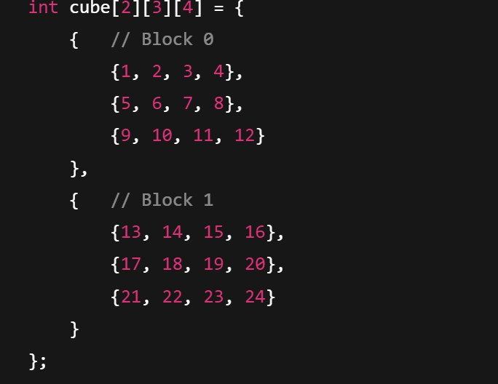
Cube 1 is t
he
second block

[1]

3
rd

Row [2]

4
th

column [3]

cube[2][3][4] means:
- 2 blocks (like layers)
- 3 rows in each block
- 4 columns in each row
Output: 24

Looping through a 3D Array:
// Looping through the 3D array
for (int i = 0; i < 2; i++) { // Depth (number of blocks) for (int j = 0; j < 3; j++) { // Rows for (int k = 0; k < 4; k++) { // Columns
cout << "cube[" << i << "][" << j << "][" << k << "] = " << cube[i][j][k] << endl;
}
}
}

Lab Tasks
- Write a program to calculate the sum of all elements in a 2D array. You cannot use any built-in library.
Output:
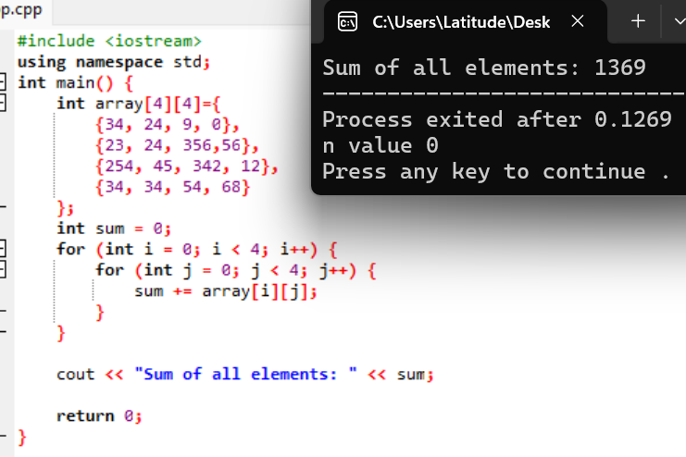

- Create a program to manage student grades using a 2-dimensional array. Each row of the array represents a student, and each column represents a subject. The program should perform the following tasks:
Input:
- Accept the number of students and the number of subjects from the user.
- For each student and subject, input the student's grade (an integer between 0 and 100).
Calculations:
- Calculate the average grade for each student.
- Calculate the average grade for each subject.
Output:
- Display the grades in a tabular format.
- Display the average grade for each student.
- Display the average grade for each subject.
Constraints:
- The number ofstudents and subjects should be between 1 and 10.
Output:
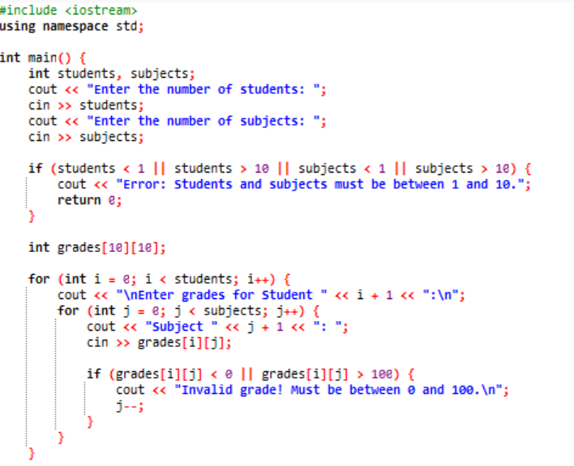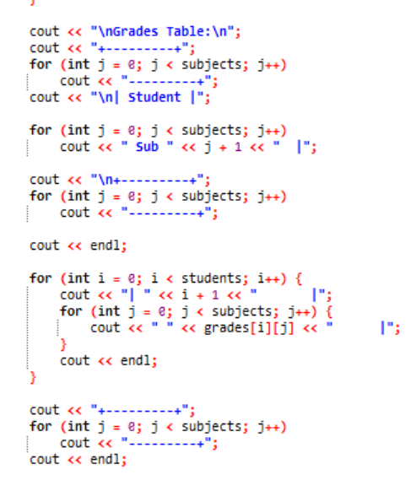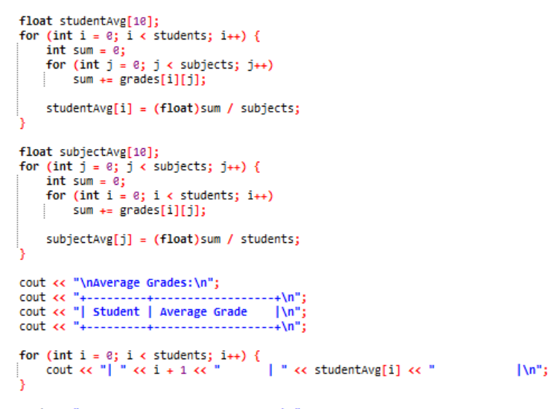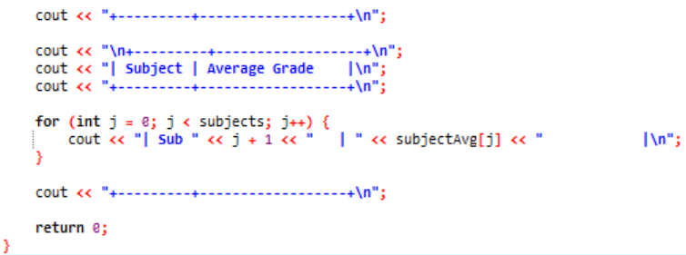

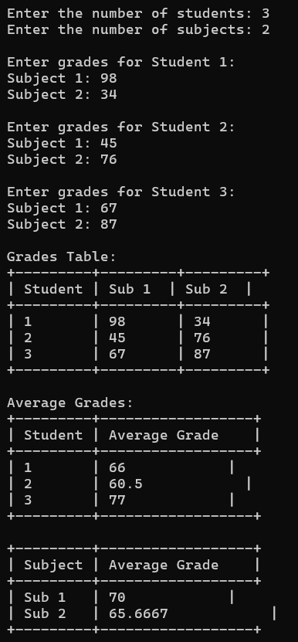
Hint:
- Use nested loops for input and output.
- You can use a 2-dimensional array to store student grades.
- Calculate averages row-wise for student averages and column-wise for subject averages.

- Write a C++ program to multiply 3x3 matrix
Output:
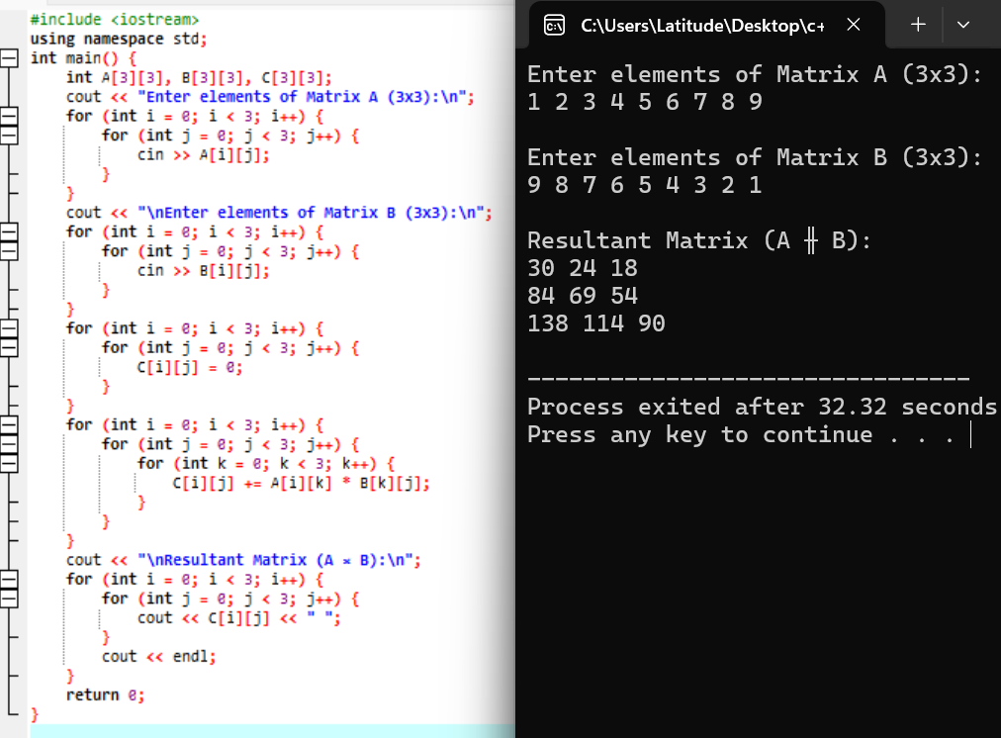

- Write a program to find the largest element in a 3×3 matrix.
Output:
