Fundamentals of Computer Programming
Lab 13: Strings
String Operations
Name: Ayesha Ahmer Khan
CMS ID: 570438
Instructor: Mr. Ubaid Ullah
Lab Engineer: Ms. Zainab Zahid
Official Lab Conduct, Attendance & Submission Policy
All students are strictly required to follow the rules mentioned below. Violations will lead to academic penalties without exception.
- Attendance Requirement – Minimum 75% o Students must maintain at least 75% attendance in all lab sessions to be eligible for grading and final evaluation.
  - Late arrival or habitual late coming will be marked as absent
Authenticity of Work
  - Each student must complete their own lab tasks. Discussions for conceptual clarity are permitted, but copying code, content, or solutions is strictly prohibited.
- AI & Unauthorized Tools Prohibited o Use of ChatGPT, other AI tools, or unauthorized online resources for generating lab content is strictly forbidden.
  - Any violation will result in:
▪ Immediate cancellation of lab marks
- Submission Rules o All tasks must be submitted before leaving the lab.
  - Late submissions will not be accepted or marked.
- Grading Policy o After submission, students must present their work to the Lab Engineer/TA, the submitted solution can get a maximum of 5 marks.
  - A short viva may be conducted to assess understanding. Failure to attend or pass the viva may result in zero marks. The viva has a weightage of 5 marks
  - You must also submit this Word document with attached output screenshots and a short description of how you completed it, along with the code file on Google Classroom. In case of any problems with submissions, email your Lab assignments to Zainab.zahid2002@gmail.com.
Learning Objectives
By the end of this lab students will be able to:
- Process strings character-by-character, identifying boundaries, spaces, and words without using built-in functions.
- Apply ASCII-based comparisons to detect alphabetical order, uppercase/lowercase status, and character equivalent
- Implement manual algorithms such as word extraction, string comparison, and ordering using loops and indexing only
- Integrate array and string concepts, storing multiple words and manipulating them like rows in a 2D structure.
- Analyze and debug logical errors arising from nested loops, incorrect indexing, or boundary conditions.
- How real-world string operations (search, sort, compare, tokenize) work internally without built-in shortcuts.

INTRODUCTION TO STRINGS
A string in C++ represents a sequence of characters and is widely used for handling text-based data such as names, messages, addresses, passwords, file paths, and user inputs.
In modern C++, the string class (defined in <string>) provides an easy and flexible way to store and manipulate text.
Although internally a string behaves like a character array, it offers safer memory handling, dynamic resizing, and convenient access through indexing (s[i]). In this lab, however, we focus on core logic by performing operations manually, without built-in functions.

WHY STRINGS ARE IMPORTANT
Strings are foundational in nearly every software system:
Everyday applications of strings:
- Usernames, passwords, email IDs
- Searching keywords in search engines
- Chat messages, social media posts
- Reading and writing files
- Database fields (name, address, department)
- Captcha, OTP, and validation logic
- Encryption and text transformation
Programming tasks requiring strings:
- Input validation
- Counting words and characters
- Formatting output
- Parsing data
- Processing text line-by-line
Understanding strings builds a bridge from arrays to real-world text handling.

HOW C++ STORES STRINGS
Index | 0 | 1 | 2 | 3 | 4
Value | h | e | l | l | o

ASCII CONCEPT (American Standard Code for Information Interchange)
ASCII assigns a unique number to every character. You must understand:
Characte  r | ASCII
A–Z | 65–90
a–z | 97–12  2
0–9 | 48–57
Space | 32
ASCII gives every character a fixed numeric value (0–127). So text becomes representable inside memory.
ASCII allows manual operations such as:
- converting case
- checking alphabet or digit
- comparing characters
- shifting characters
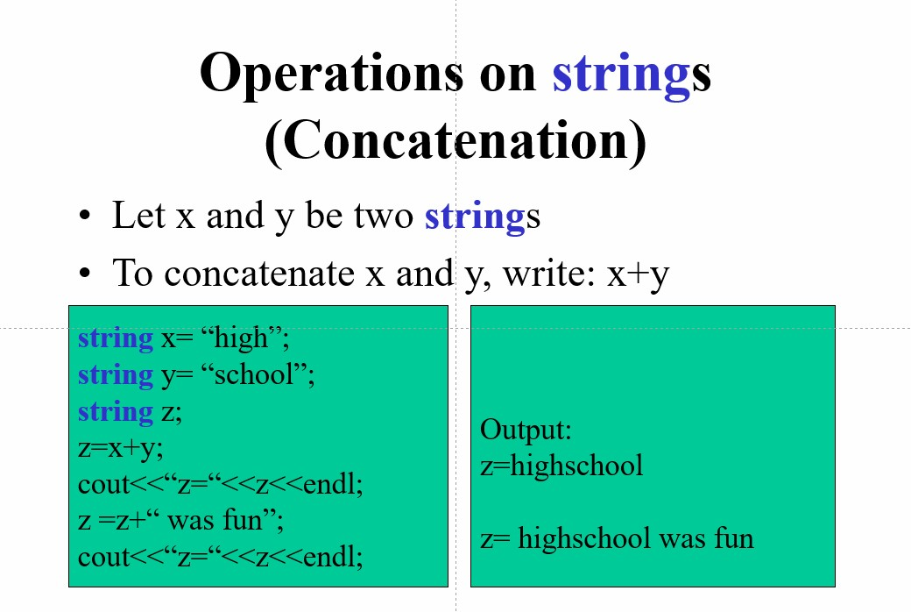

Comparison Operators for String Objects
- We can compare two strings x and y using the following operators: ==, !=, <, <=, >, >=
- The comparison is alphabetical
- The outcome of each comparison is: true or false
- The comparison works as long as at least x or y is a string object. The other string can be a string object, a C-style string variable, or a double-quoted string.

1- How Indexing Works in Strings
Code:
#include <iostream> #include <string> using namespace std;
int main() {
string s = "HELLO";
cout << "Character at index 0: " << s[0] << endl; cout << "Character at index 3: " << s[3] << endl;
return 0;
}
Output:
Character at index 0: H
Character at index 3: L
2- Show ASCII values of every character
Code:
string s = "Hi";
for (int i = 0; s[i]; i++) {
cout << s[i] << " -> " << (int)s[i] << endl; }
Output: H -> 72 i -> 105

3- Cin vs getline()
string name, sentence;
cout << "Enter your name: "; cin >> name; cin.ignore(); // remove leftover newline
cout << "Enter a full sentence: "; getline(cin, sentence);
cout << "\nName: " << name; cout << "\nSentence: " << sentence;
- Changing One Character
Code:
string s = "cat"; s[0] = 'b'; // replace 'c' with 'b' cout << s;
Output:
Bat
- Swapping two characters
Code:
string s = "hello"; char temp = s[0]; s[0] = s[4]; s[4] = temp;
cout << s; Output: oellh

Built-in String Functions using String Library in C++
Function | Description | Example
s.length() | returns number of characters | s.length()
s.size() | same as length | s.size()
s.empty() | check if string is empty | s.empty()
s.clear() | remove all characters | s.clear()
s.append(str) | add at end | s.append("abc")
s += str | concatenate | s += "xyz"
s.substr(pos, len) | extract substring | s.substr(1,3)
s.find(str) | find substring position | s.find("cat")
s.rfind(str) | search from the end | s.rfind("a")
s.compare(str) | compare strings | s.compare("abc")
s.insert(pos, str) | insert text | s.insert(2,"hi")
s.erase(pos, len) | remove portion | s.erase(1,2)
s.replace(pos, len, str) | replace part | s.replace(0,3,"Hi"  )
s.front() | first character | s.front()
s.back() | last character | s.back()
s.pop_back() | remove last char | s.pop_back()
s.push_back(c) | add one char at end | s.push_back('!')
getline(cin, s) | read full line | getline(cin, s)

Lab Tasks:

Task 1: TASK — Search a Word in a Sentence
Write a C++ program to input a sentence and a word, and check (using loops only) whether the word exists in the sentence.
Output:
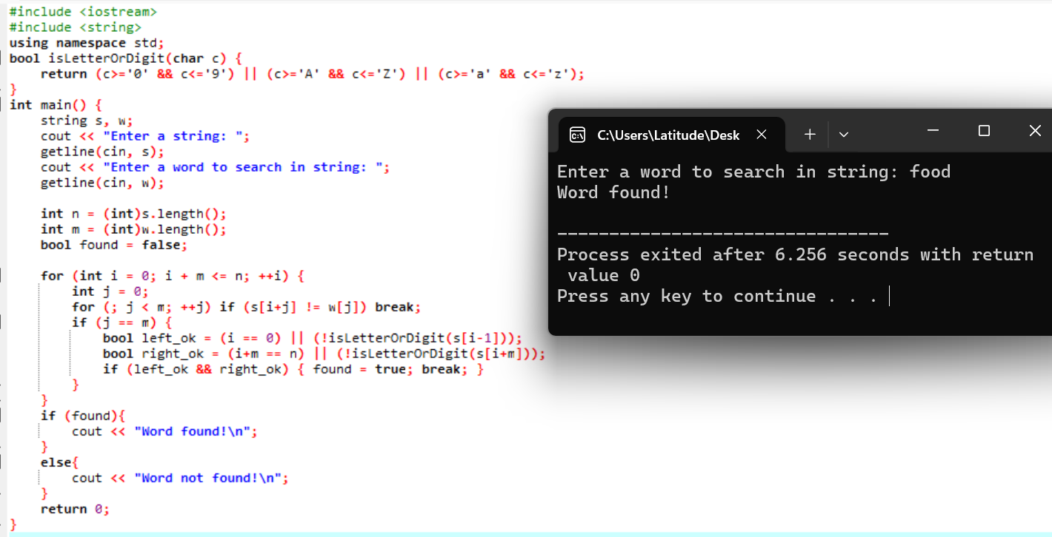

TASK 2 : Longest Word in a Sentence
Write a C++ program to input a full sentence from the user and determine the longest word in the sentence without using any built-in string functions.
Hint: Traverse the sentence character by character, manually count the length of each word until a space is encountered, and keep track of the word with the maximum length. Print the longest word at the end.
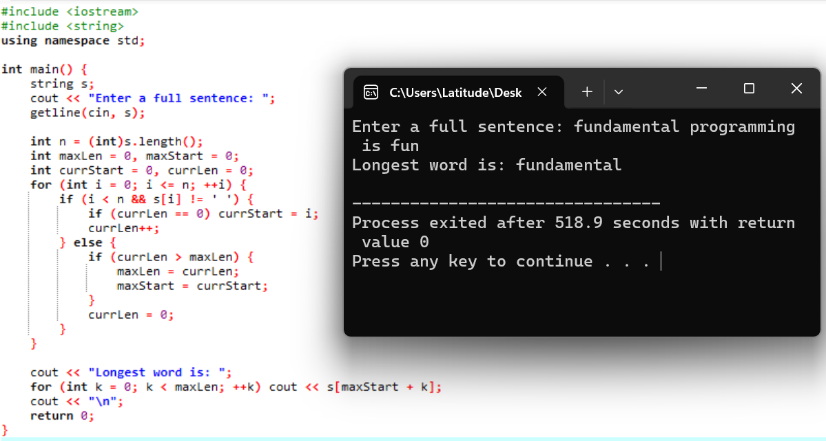

Task 3: Reverse a string
Write a C++ program that takes a sentence as input and prints each word in reverse order, while keeping the overall sentence structure the same.
Output:
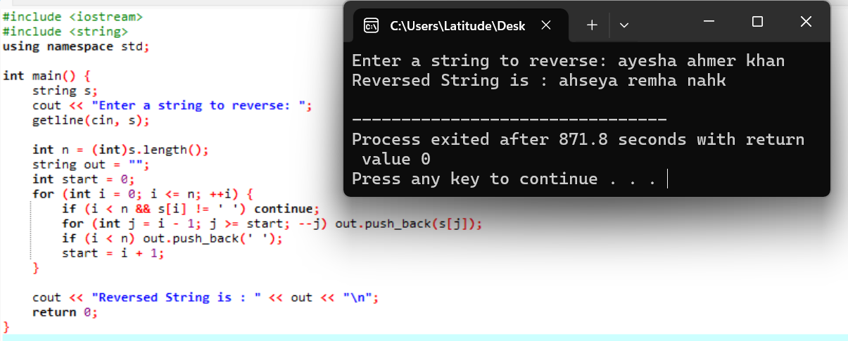
You must process characters manually, detect word boundaries, reverse each word using index pointers, and reset boundaries after every space.
Do not use built-in functions like substr(), reverse(), or length().

Task 4: Remove Duplicate Characters
Write a C++ program that removes all duplicate characters from a given string without using built-in functions.
Output:
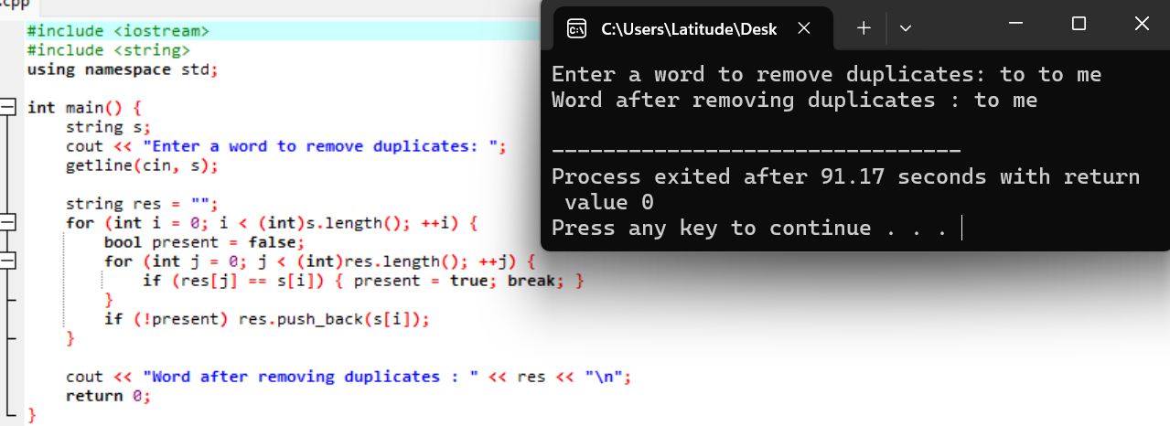
You must create a new result string and, for each character in the original string, manually check whether it already exists in the result. Only append characters that are not already present

Task 5: Character Frequency Table
Write a C++ program to display a frequency table of all characters that appear in an input string.
You must identify each unique character manually and count its occurrences by scanning the string again. Print each character along with the number of times it appears.
You are not allowed to use arrays of size 256, maps, built-in count() functions, or ASCII frequency arrays. Logic must rely solely on loops, comparisons, and indexing.
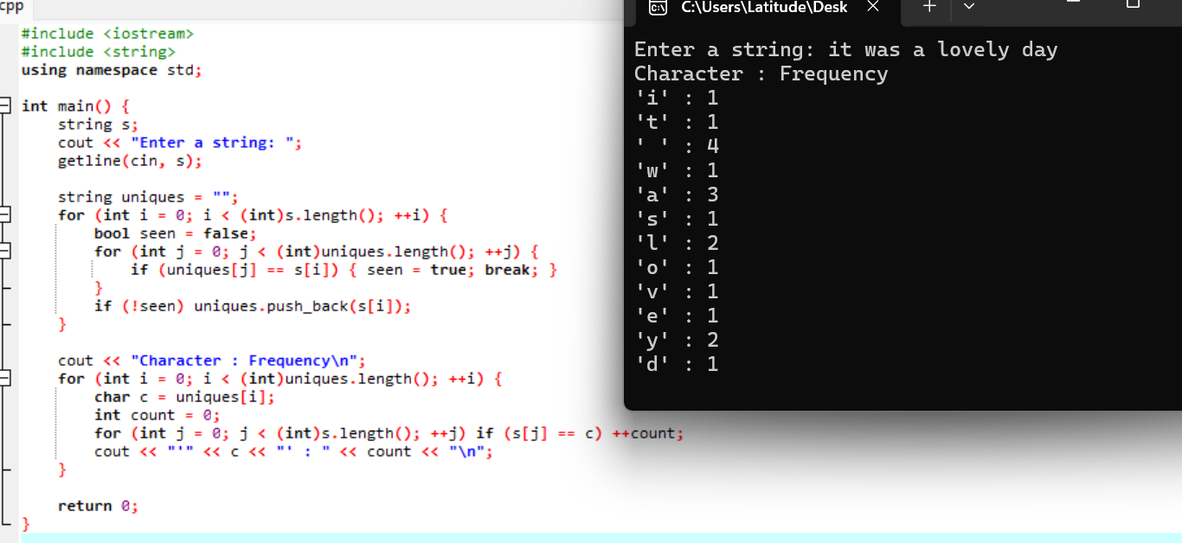

Task 6: Extract the Middle Word
Write a C++ program that takes a sentence from the user and prints the middle word of the sentence.
You must manually count spaces, identify the total number of words, and then locate the middle one by scanning character-by-character.
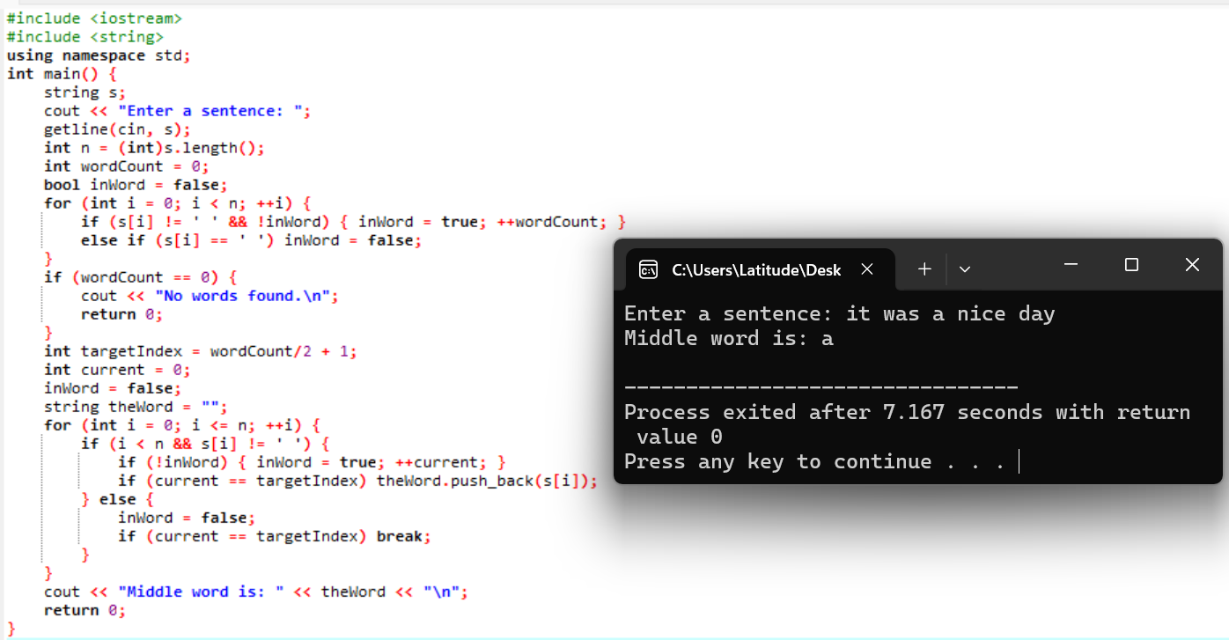

TASK 7 : Sort All Words of a Sentence Alphabetically
Write a C++ program that inputs a full sentence, extracts all words manually, and sorts them alphabetically WITHOUT using any built-in string functions such as substr(), find(), length(), compare(), or sort().
You must:
- Manually extract each word from the sentence by detecting spaces.
- Store words in a char array []
- Manually compare two words character by character using ASCII values.
- Manually swap words when needed
- Print all words in sorted order.
Output:
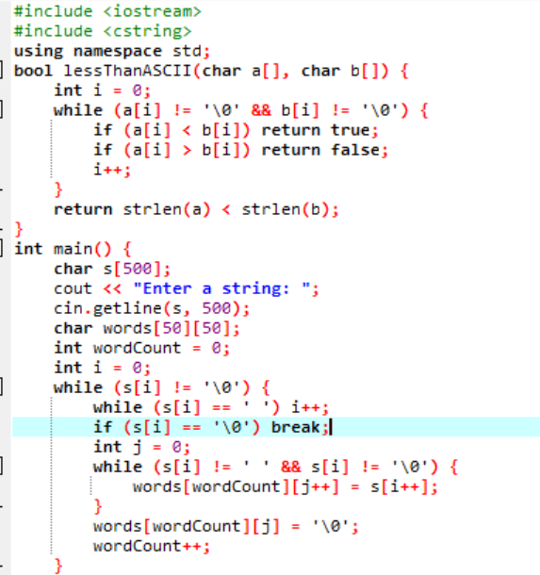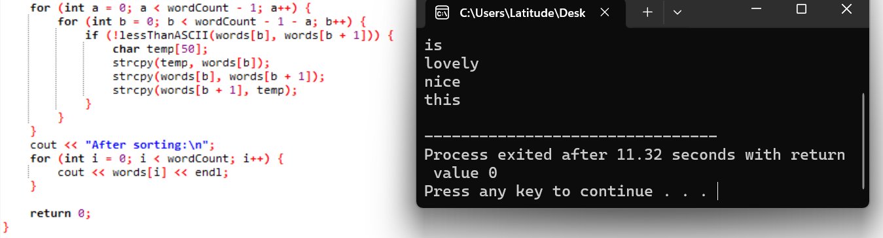
Note: Please attach both code and output screenshots in the word file and submit .cpp files for each task along with your word file on LMS.

