Fundamentals of Computer Programming

Lab 14: File Handling in C++

File Streams in C++

Name: Ayesha Ahmer Khan
CMS id: 570438

Instructor: Mr. Ubaid Ullah

Lab Engineer: Ms. Zainab Zahid

Official Lab Conduct, Attendance & Submission Policy
All students are strictly required to follow the rules mentioned below. Violations will lead to academic penalties without exception.

1. Attendance Requirement – Minimum 75%
- Students must maintain at least 75% attendance in all lab sessions to be eligible for grading and final evaluation.
- Late arrival or habitual late coming will be marked as absent

Authenticity of Work
o Each student must complete their own lab tasks. Discussions for conceptual clarity are permitted, but copying code, content, or solutions is strictly prohibited.
- AI & Unauthorized Tools Prohibited o Use of ChatGPT, other AI tools, or unauthorized online resources for generating lab content is strictly forbidden.
  - Any violation will result in:
▪ Immediate cancellation of lab marks
- Submission Rules o All tasks must be submitted before leaving the lab.
  - Late submissions will not be accepted or marked.
- Grading Policy o After submission, students must present their work to the Lab Engineer/TA, the submitted solution can get a maximum of 5 marks. o A short viva may be conducted to assess understanding. Failure to attend or pass the viva may result in zero marks. The viva has a weightage of 5 marks
  - You must also submit this Word document with attached output screenshots and a short description of how you completed it, along with the code file on Google Classroom. In case of any problems with submissions, email your Lab assignments to Zainab.zahid2002@gmail.com.

Learning Objectives
- Understand file streams: ifstream, ofstream, and fstream.
- Learn how to create, read, write, and append files.
- Practice handling text files with basic operations.

PRE-LAB READING ASSIGNMENT
File Handling in C++
In C++, input and output are done in the form of a sequence of bytes called streams. For example, cin and cout are the objects associated with the standard input and output streams. These streams are represented by different classes provided in the <iostream> library.
Similarly, C++ also provides file stream classes to perform input and output operations on files that are defined inside <fstream> header file.
File Handling Operations
There are mainly three main steps in file handling:
- Opening a File
- Read/Write Operations
- Closing a File
Opening a File
Before reading from or writing to a file, we first need to open it. Opening a file loads that file in the RAM. In C++, we open a file by creating a stream to it using the fstream class that represent the file stream i.e. stream for input and output to the file.
Syntax:
fstream str("filename.ext", mode);
where,
- str: Name given to the stream
- filename: Name of the file
- mode: Represents the way in which we are going to interact with the file.

File Opening Modes
File opening mode indicate file is opened for reading, writing, or appending. Below is the list of all file modes in C++:
Mode | Description
ios::in | File open for reading. If file does not exists,
ios::out | File open for writing: the internal stream buffer supports output operations.
ios::binary | Operations are performed in binary mode rather than text.
ios::ate | The output position starts at the end of the file.
ios::app | All output operations happen at the end of the file, appending to its existing contents.
ios::trunc | Any contents that existed in the file before it is open are discarded.

Other File Streams fstream is not the only file stream provided by C++. There are two more specialized streams:
- ifstream: Stands for input file stream. It is equivalent to open fstream in ios::in mode.
- ofstream: Stands for output file stream. It is equivalent to opening fstream in ios::out mode.
The above modes are default modes for these streams. These modes cannot be changed but can be clubbed together with other modes.

Input:
ifstream filein("file.txt");

Output:
ofstream fileout("file.txt");

Write Data to a file:
Once the file is opened in the write mode using either fstream or ofstream, we can perform the write operation in similar way as with cout using << operator.
#include <bits/stdc++.h> using namespace std;

int main() {

// Open a file in read mode ifstream file("GFG.txt"); string s;

// Read string from the file file >> s;

cout << "Read String: " << s;

return 0;
}

Read Data from a File:
Once the file is opened in the read mode using either fstream or ifstream, we can perform the write operation in similar way as with cin using >> operator.
#include <bits/stdc++.h> using namespace std;

int main() {

// Open a file in read mode ifstream file("GFG.txt"); string s;

// Read string from the file file >> s;

cout << "Read String: " << s;

return 0;
}

Output: welcome

Closing the File
Closing the file means closing the associated stream and free the resources that we being used. It is important to close the file after you are done with it, especially in the long running programs to avoid memory leaks, data loss, etc.
In C++, the files are closed using the close() member function that is present in all file streams.
#include <bits/stdc++.h> using namespace std;

int main() {

// Open a file in read mode ifstream file("GFG.txt"); string s;

// Read string from the file getline(file, s);

cout << "Read String: " << s;

// Close the file file.close();

return 0;
}

Output:
Read String: Welcome to GeeksforGeeks.

Errors in File Handling
Many different types of errors can occur in file handling such as file not found, disk full, etc. Our programs should expect common errors and should be able to handle them properly. Following are some common errors that can occur during file handling:

1. File Open Failure
There can be cases in which the file is not opened due to various reasons such as it doesn't exists, or the program does not have permission to open it, etc. In this case, we can use the is_open() member function of the file stream classes to check whether the file is opened sucessfullly or not.

2. Failure to Read/Write Data
Another common error is failure to read or write data for reasons such as incorrect mode, etc. In this case, we can validate operations after each read/write attempt. For example, reading using getline() can be validated

3. End-of-File (EOF) Error
Trying to read beyond the end of the file can cause an EOF error. This can happen when you don't check for the end of the file before reading. We can check for EOF using eof() member function

Lab Tasks:
- Write a C++ program to create a new text file. Write your name, roll number, and department into the file using ofstream.

Output:
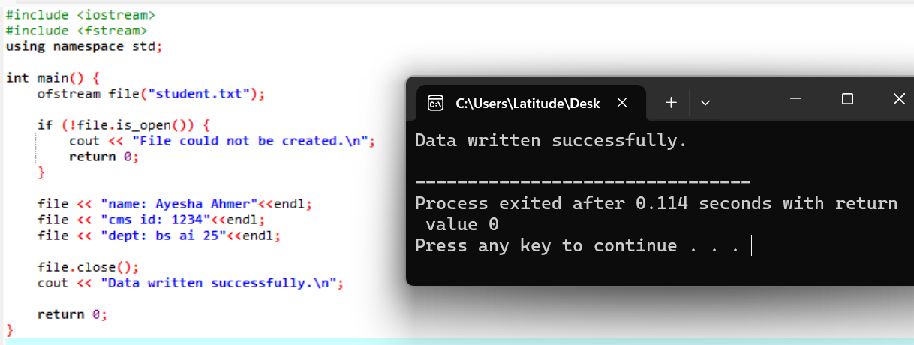

- Write a C++ program to open an existing text file and display its contents on the console.
Output:
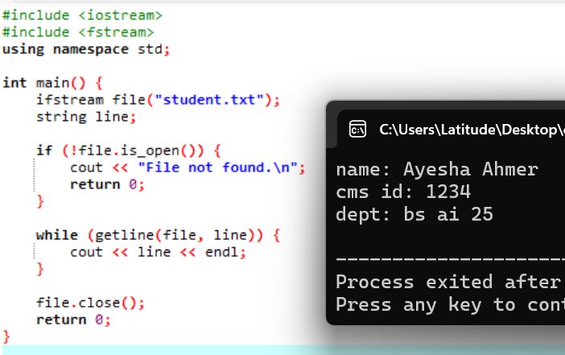

- Write a C++ program to copy the contents of one text file to another.
Output:
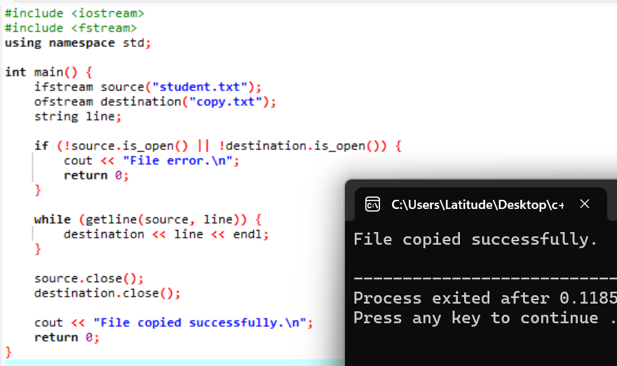

- Write a C++ program to search for a specific string in a text file and display its line number(s).
Output:
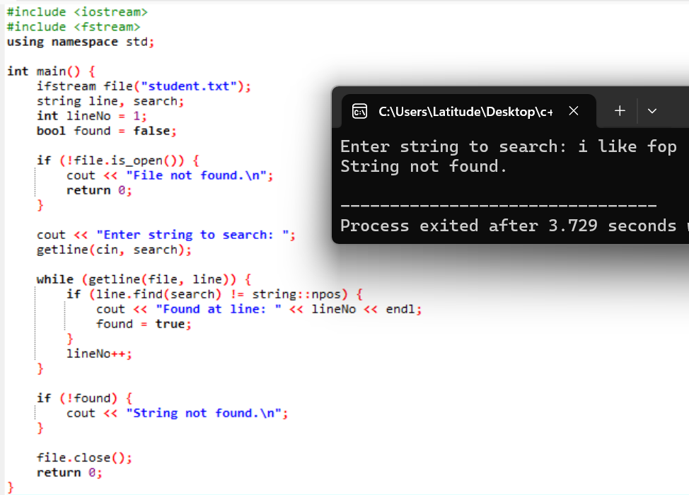

- Write a C++ program to sort the lines of a text file in alphabetical order.
Output:
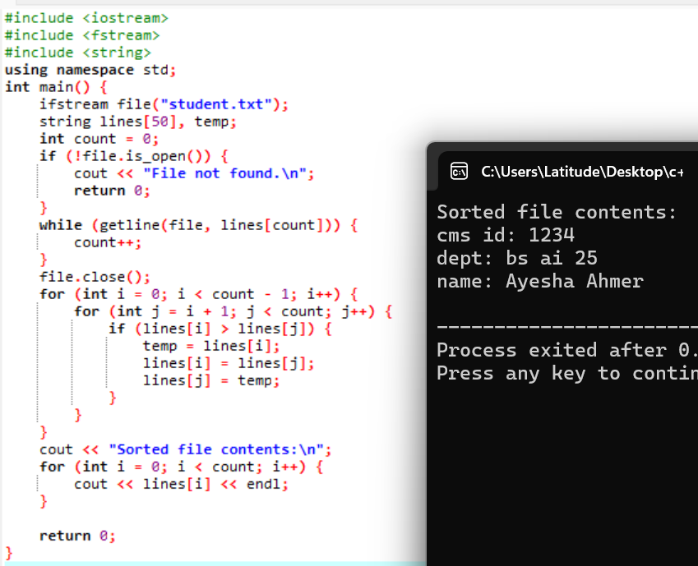

National University of Sciences & Technology (NUST)
Balochistan Campus (NBC), Department of Computer Science

