Fundamentals of Computer Programming

Lab 12: Pointers in C++

Pointers

Name: Ayesha Ahmer Khan
CMS ID: 570438

Instructor: Mr. Ubaid Ullah

Lab Engineer: Ms. Zainab Zahid

Official Lab Conduct, Attendance & Submission Policy
All students are strictly required to follow the rules mentioned below. Violations will lead to academic penalties without exception.

1. Attendance Requirement – Minimum 75%
- Students must maintain at least 75% attendance in all lab sessions to be eligible for grading and final evaluation.
- Late arrival or habitual late coming will be marked as absent

Authenticity of Work
o Each student must complete their own lab tasks. Discussions for conceptual clarity are permitted, but copying code, content, or solutions is strictly prohibited.
- AI & Unauthorized Tools Prohibited o Use of ChatGPT, other AI tools, or unauthorized online resources for generating lab content is strictly forbidden.
  - Any violation will result in:
▪ Immediate cancellation of lab marks
- Submission Rules o All tasks must be submitted before leaving the lab.
  - Late submissions will not be accepted or marked.
- Grading Policy o After submission, students must present their work to the Lab Engineer/TA, the submitted solution can get a maximum of 5 marks. o A short viva may be conducted to assess understanding. Failure to attend or pass the viva may result in zero marks. The viva has a weightage of 5 marks
  - You must also submit this Word document with attached output screenshots and a short description of how you completed it, along with the code file on Google Classroom. In case of any problems with submissions, email your Lab assignments to Zainab.zahid2002@gmail.com.

Learning Objectives
- Understand what pointers are and why they are used in C/C++.
- Learn the syntax of declaring and initializing pointers.
- Differentiate between pointer and normal variables.
- Explore the concept of address-of (&) and dereference ()* operators.
- Understand pointer arithmetic and its significance.
- Recognize the role of pointers in functions (call by reference).
- Learn about pointers and arrays relationship.
- Understand NULL pointers and dangling pointers.
PRE-LAB READING ASSIGNMENT

C++ Pointers
A pointer is a special variable that holds the memory address of another variable, rather than storing a direct value itself. Pointers allow programs to access and manipulate data in memory efficiently, making them a key feature for system-level programming and dynamic memory management. When we access a pointer directly, we get the address it holds not the actual data stored at that location.
Create Pointer
A pointer can be declared in the same way as any other variable but with an asterisk symbol (*) as shown:

data_type *name;

Here, data_type is the type of data that the pointer is pointing to, and name is the name assigned to the pointer.
The * symbol is also called dereference operator.
Int *ptr;

Addressof operator (&) : The addressof operator (&) determines the address of any variable in C++. This address can be assigned to the pointer variable to initialize it.
Deferencing Pointer
The process of accessing the value present at the memory address pointed by the pointer is called dereferencing.
#include <iostream> using namespace std;

int main() { int var = 10;

// Store the address of
// var variable int* ptr = &var;

// Access value using (*)
// operator cout << *ptr; return 0;
}

Output: 10

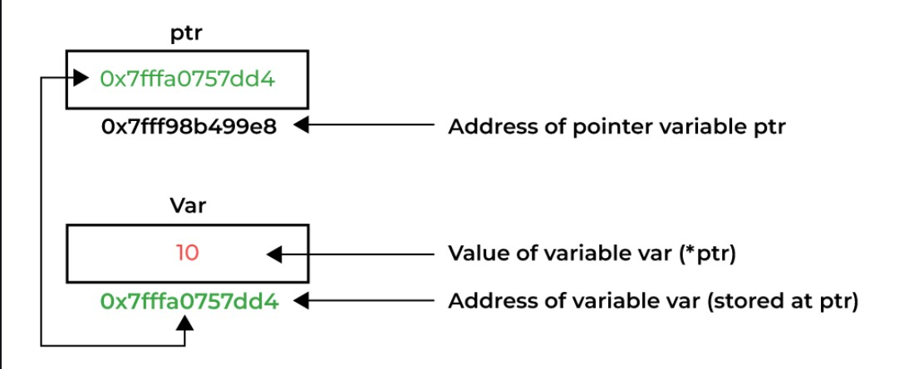
Modify Address:
The pointer can be modified to point to another memory address if its is of the same type.
Output:
include <iostream> using namespace std;
int main() { int a = 10; int b = 99;

int* ptr = &a; cout << *ptr << endl;

// Changing the address stored ptr = &b; cout << *ptr;

return 0;
}

Output:
10
99
Size of Pointers:
In C++, the size of a pointer does not depend on the data type it points to (e.g., int*, char*, double*), but rather on the system architecture because the pointer only stores an address in memory.
Why does the size differ between 32-bit and 64-bit systems?
- Pointer stores a memory address o A pointer holds the address of a variable or memory location. o The size of a pointer depends on how many bytes are needed to store this address.
- 32-bit system o A 32-bit CPU uses 32 bits (4 bytes) to represent a memory address.
  - It can address up to 2³² bytes = 4 GB of memory.
  - So, every pointer (no matter what it points to) is 4 bytes.
- 64-bit system o A 64-bit CPU uses 64 bits (8 bytes) to represent a memory address.
  - It can theoretically address 2⁶⁴ bytes = 16 exabytes of memory (though practically limited by hardware/OS). o Hence, every pointer is 8 bytes
Special Types of Pointers
There are 4 special types of pointers that used or referred to in different contexts:

1. Wild Pointer
When a pointer is created, it just contains a random address that may or may not be valid. This type of pointer is called wild pointer.

// Wild pointer int* ptr;

2. Void Pointers
A void pointer (void*) is a special type of pointer in C++ that has no associated data type. It can hold the address of any data type, making it useful for generic programming. However, since the type is unknown, the compiler doesn't know how many bytes to read or how to interpret the data. Therefore, a void pointer cannot be directly dereferenced. It must first be explicitly typecast to the appropriate pointer type.
#include <iostream> using namespace std;

int main() { int cs = 42;
// void pointer holding address of an int-> named cs void* nbc = &x;

// Error: cannot dereference void pointer
// cout << *nbc;

// Typecast before dereferencing
cout << "Value pointed by void pointer: " << *(static_cast<int*>(nbc))
<< endl;

return 0; }

3. NULL Pointer
A NULL pointer is a pointer that does not point to any valid memory location but NULL. It is often used to initialize a pointer when you do not want it to point to any object.
int* ptr;

4. Dangling Pointers
A dangling pointer is a pointer that refers to memory which has already been freed or is no longer valid. This typically happens when:
- A pointer points to a local variable that has gone out of scope
- Dynamically allocated memory is deallocated using delete, but the pointer still holds the old address
int* getPointer() { int x = 10;
// returning address of local variable return &x;
}

int main() {

// ptr becomes dangling here int* ptr = getPointer();
// Undefined behavior // cout << *ptr; return 0;

5. Pointer Arithmetic
Pointer Arithmetic refers to the operations that C++ allows on the pointers. They include:
- Incrementing and Decrementing
- Addition of Integer
- Subtraction of Integer
- Subtraction of Two Pointers of the Same Type
- Comparison of Pointers and NULL
#include <iostream> using namespace std;

int main() {
int arr[5] = { 10, 20, 30, 40, 50 };
int* ptr = arr; // Pointer pointing to the first element

cout << "Original pointer points to: " << *ptr << endl;

ptr++; // Incrementing the pointer (moves to next element)
cout << "After incrementing, pointer points to: " << *ptr << endl;

ptr = ptr + 2; // Adding integer to pointer (moves 2 steps ahead) cout << "After adding 2, pointer points to: " << *ptr << endl;

ptr--; // Decrementing the pointer (moves one step back) cout << "After decrementing, pointer points to: " << *ptr << endl;

return 0; }

Functions and Pointers:
Pointers are often used with functions in two ways:
- call by value
- call by reference
Call by Value:
In call by value, a copy of the value is passed to the function. Changes inside the function don't affect the original variable:
void increment(int x) {
x++; // This doesn't affect the original variable }
int main() { int num = 5; increment(num);
cout << num; // Still prints 5 return 0;
}

Call by Reference:
In call by reference, the memory address is passed, allowing the function to modify the original variable
void increment(int& x) {
x++; // This modifies the original variable
}
int main() { int num = 5; increment(num); cout << num; // Prints 6 return 0;
}

Lab Tasks:
Q1-Write a C program to find the max of an integral data set. The program will ask the user to input the number of data values in the set and each value. The program prints on screen a pointer that points to the max value.
Output:
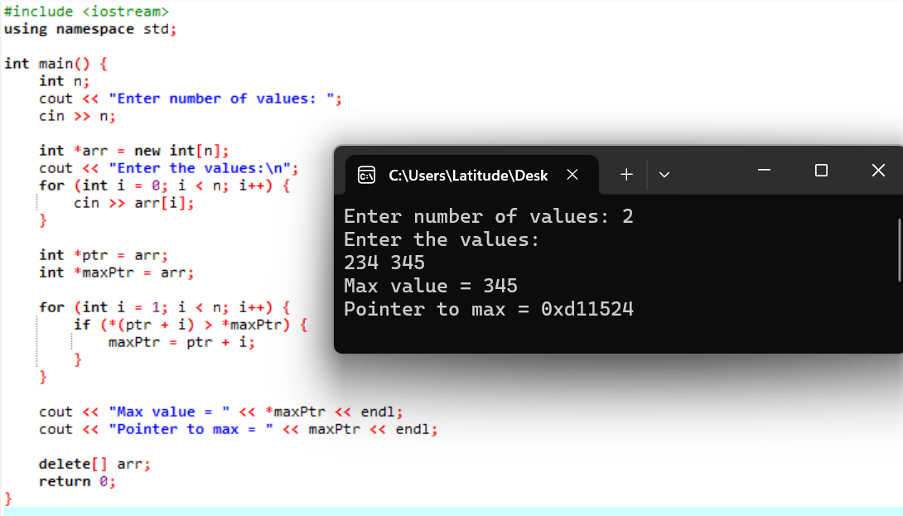

Q2-Given the string "A string." Print on one line the letter on the index 0, the pointer position and the letter t. up date the pointer to pointer +2. Then, in another line print the pointer and the letters r and g of the string (using the pointer).
Output:

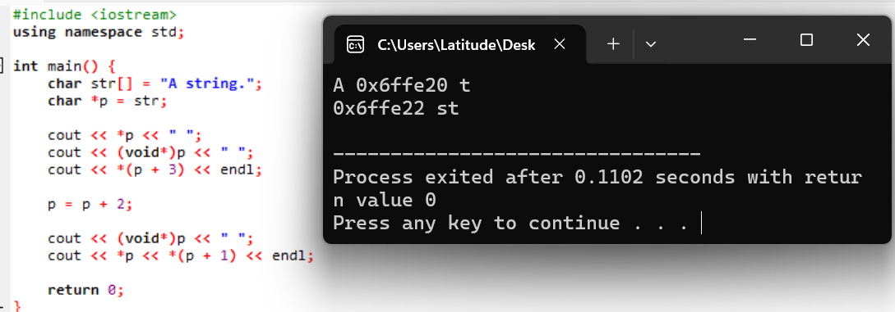

Q3- Write the outputs of the following C++ codes.
1.
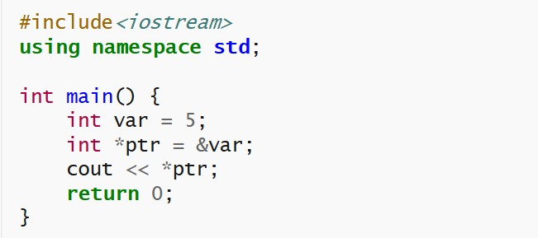

Output:
5

2.
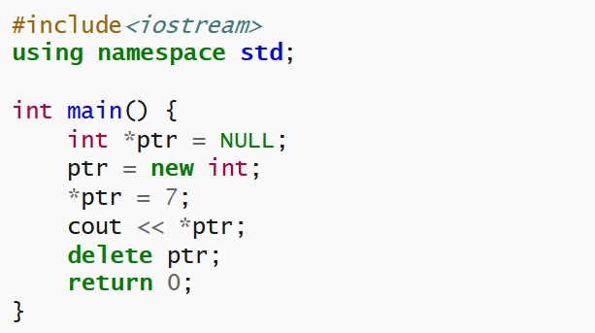
Output:
7

3.
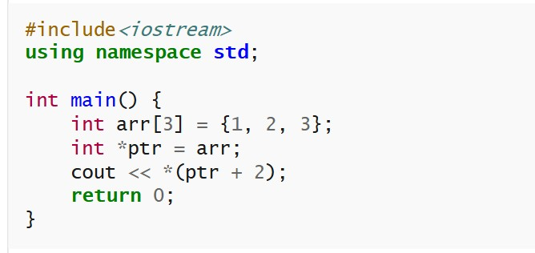
Output:
3

Q4.Write a C++ program to swap two numbers using pointers with call by value. Analyze why the values in the main function do not change after the function call.
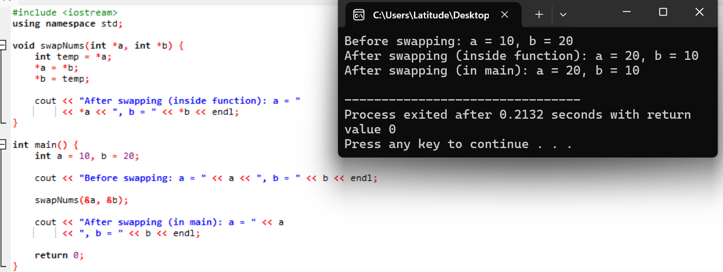

Q5.Write a C++ program to update the marks of a student using call by reference with pointers.
- The program should take the student's marks as input.
- Then pass the address of marks to a function that increases them by 10%.
- Finally, display the updated marks in the main function.

