Fundamentals of Computer Programming
Lab 05: Loops in C++
For , while and do while loop
NAME: Ayesha Ahmer Khan
CMS: 570438
Instructor: Mr. Ubaid Ullah
Lab Engineer: Ms. Zainab Zahid
Official Lab Conduct, Attendance & Submission Policy
All students are strictly required to follow the rules mentioned below. Violations will lead to academic penalties without exception.

Attendance Requirement – Minimum 75%
- Students must maintain at least 75% attendance in all lab sessions to be eligible for grading and final evaluation.
- Late arrival or habitual late coming will be marked as absent

Authenticity of Work
o Each student must complete their own lab tasks. Discussions for conceptual clarity are permitted, but copying code, content, or solutions is strictly prohibited.
- AI & Unauthorized Tools Prohibited o Use of ChatGPT, other AI tools, or unauthorized online resources for generating lab content is strictly forbidden.
  - Any violation will result in:
▪ Immediate cancellation of lab marks
- Submission Rules o All tasks must be submitted before leaving the lab.
  - Late submissions will not be accepted or marked.
- Grading Policy o After submission, students must present their work to the Lab Engineer/TA, the submitted solution can get a maximum of 5 marks.
  - A short viva may be conducted to assess understanding. Failure to attend or pass the viva may result in zero marks. The viva has a weightage of 5 marks
  - You must also submit this Word document with attached output screenshots and a short description of how you completed it, along with the code file on Google Classroom. In case of any problems with submissions, email your Lab assignments to Zainab.zahid2002@gmail.com.
Learning Objectives
- Understand the syntax and flow of while and do-while loops in C++.
- Differentiate between while and do-while loops in terms of execution flow.
- Develop problem-solving skills using iteration for simple, intermediate, and complex problems.
- Practice debugging common logical errors in loops. Pre-Reading Assignment
Loops in programming:
Loops in programming are control flow structures that enable the repeated execution of a set of instructions or code block as long as a specified condition is met. Loops are fundamental to the concept of iteration in programming, enhancing code efficiency, readability and promoting the reuse of code logic.
There are two types of loops in programming
- Entry Controlled
- Exit Controlled
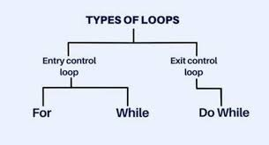
Entry Controlled Loops:
In an entry-controlled loop, the condition to enter the loop is evaluated before the loop body is executed. This means that the loop is only entered if the condition evaluates to true initially. If the condition is false from the outset, the loop is bypassed entirely. The condition is evaluated at the beginning of each iteration, and if it becomes false at any point, the loop terminates.
Entry Controlled Loops Include:
- For Loop
- While Loop
For Loop:
For loop in programming is a control flow structure that iterates over a sequence of elements, such as a range of numbers, items in a list, or characters in a string.
When you know exactly how many times you want to loop through a block of code
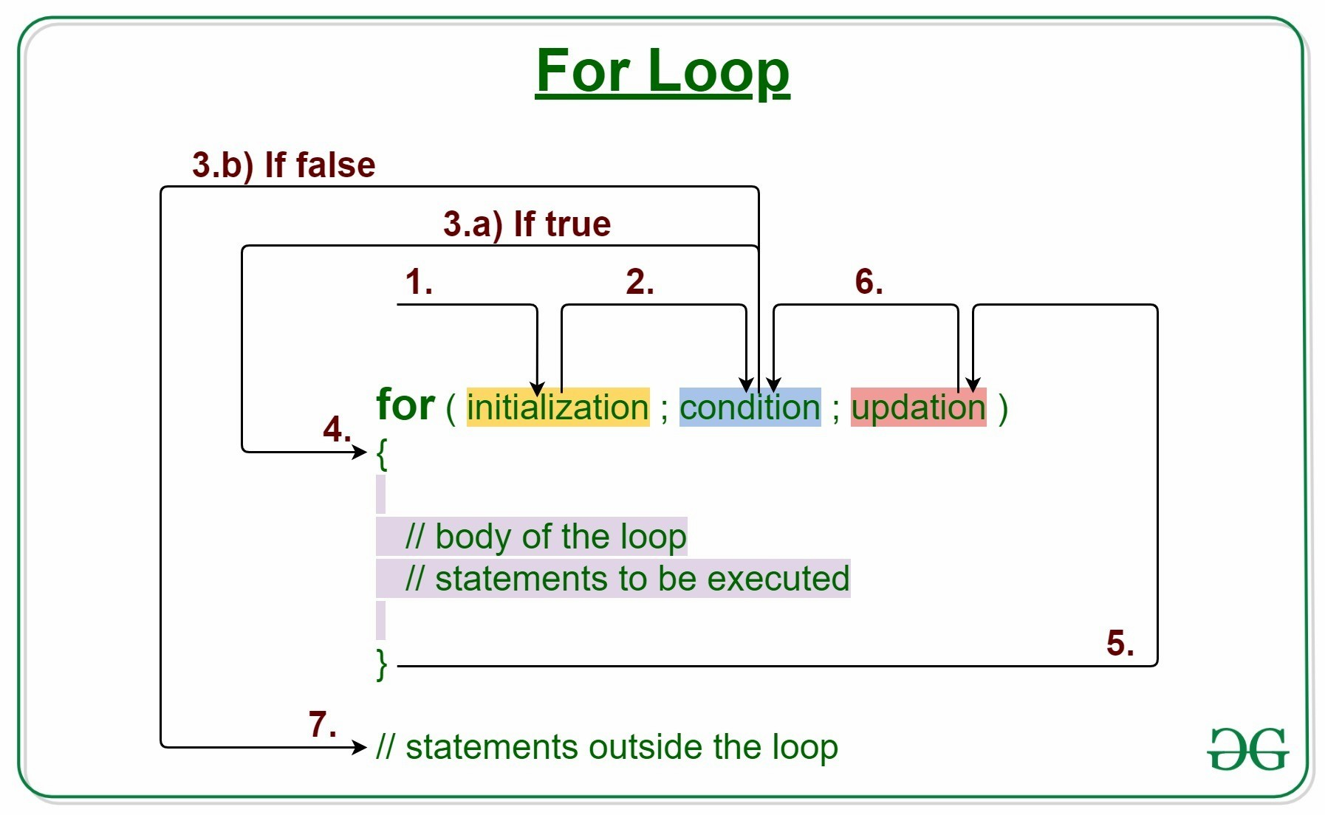
Syntax:
for (statement 1; statement 2; statement 3) {
// code block to be executed }
Where
Statement 1 is executed (one time) before the execution of the code block.
Statement 2 defines the condition for executing the code block.
Statement 3 is executed (every time) after the code block has been executed.
Example:
for(int i = 0; i < 5; i++) {
cout << i << "\n";
}
This loop starts from 0 because array indexing and counting in C++ usually begin at zero, making it standard practice. It runs until i < 5, printing numbers 0 to 4, as the loop stops before reaching 5.
Output: 0 1 2 3 4
While Loop:
While loop in programming is an entry-controlled control flow structure that repeatedly executes a block of code as long as a specified condition is true. The loop continues to iterate while the condition remains true, and it terminates once the condition evaluates to false.
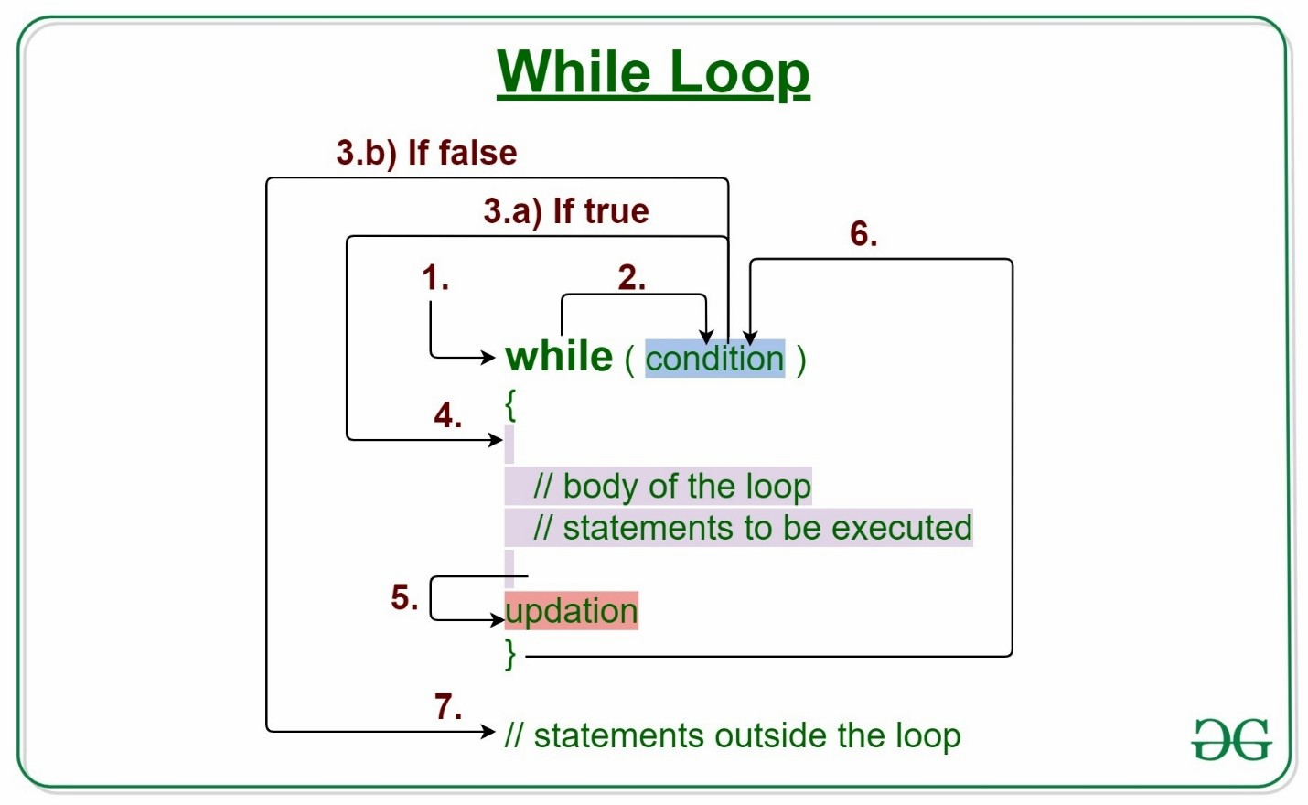
Syntax:
while (condition) {
// code block to be executed
}
Example:
int i = 0; while (i < 5) { cout << i << "\n"; i++; }
Note: Do not forget to increase the variable used in the condition (i++), otherwise the loop will never end!
Output:
0 1 2 3 4
Exit Controlled Loops:
An exit-controlled loop evaluates its condition after executing the loop body. This means that the loop body is executed at least once, regardless of the condition. After each iteration, the condition is evaluated, and if it becomes false, the loop terminates.
Includes
1. Do-while Loop
Do-While loop:
Do-while loop in programming is an exit-controlled control flow structure that executes a block of code at least once and then repeatedly executes the block as long as a specified condition remains true. The distinctive feature of a do-while loop is that the condition is evaluated after the code block, ensuring that the block is executed at least once, even if the condition is initially false.
The basic syntax for a for loop includes a block of code followed by a condition which is checked after each iteration and if the condition evaluates to true, the next iteration takes place otherwise the loop gets terminated.
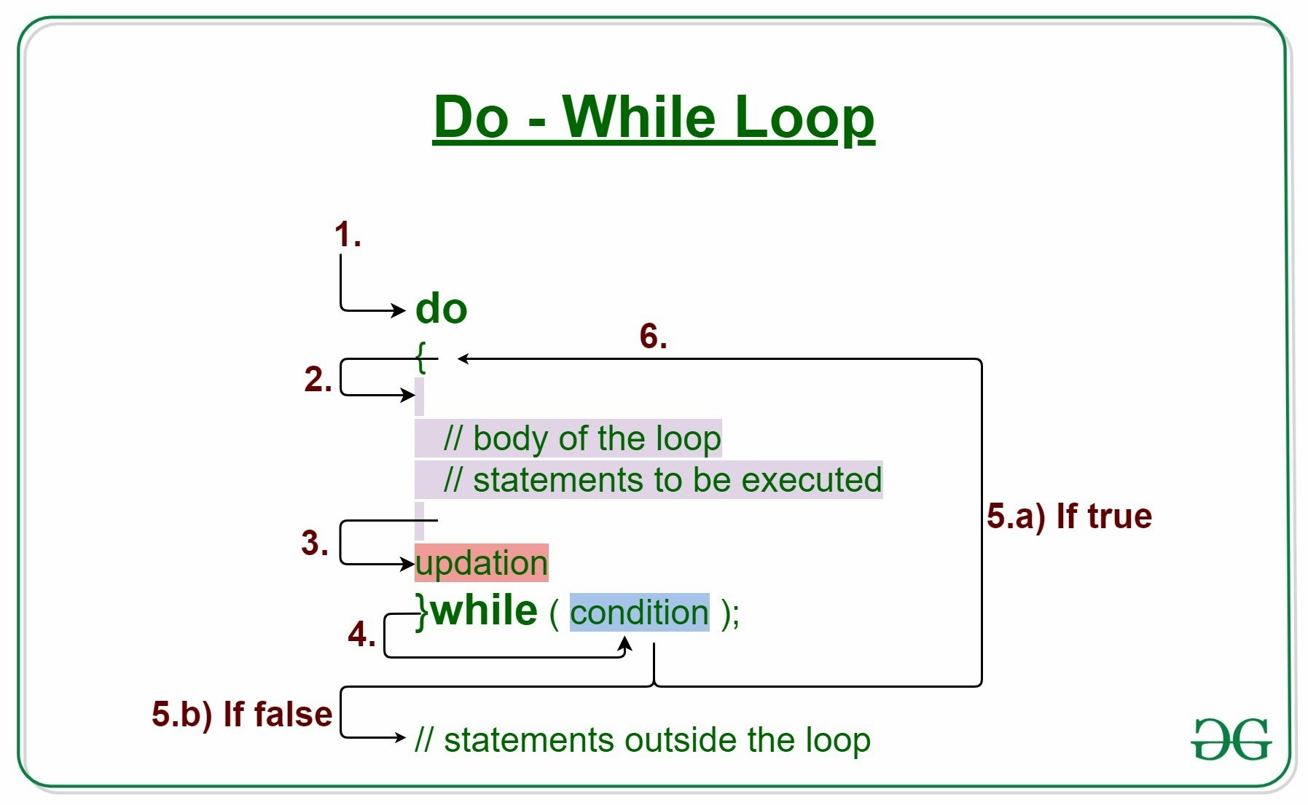
Syntax:
do { // code block to be executed } while (condition); Example:
int i = 0; do { cout << i << "\n"; i++; } while (i < 5);
- Initially, i = 0.
- The loop runs first, prints 0, and then increases i by 1.
- This process repeats until i becomes 5, at which point the condition (i < 5) fails and the loop stops.
Output:
0 1 2 3 4
Example 2:
int i = 10; do { cout << "i is " << i << "\n"; i++; } while (i < 5);
The variable i starts at 10, so the condition i < 5 is false immediately - yet the do/while loop still runs once
Output:
i is 10

Lab Tasks:
While Loop:

Q1-A Number-Guessing Game
Write a program that plays a number-guessing game. The user will try to guess the secret number until they get it right. That means it will keep looping as long as the guess is different from the secret number. You must store the secret number in a variable and use that variable throughout for checks. Use any of the loops to run it multiple times

Sample output
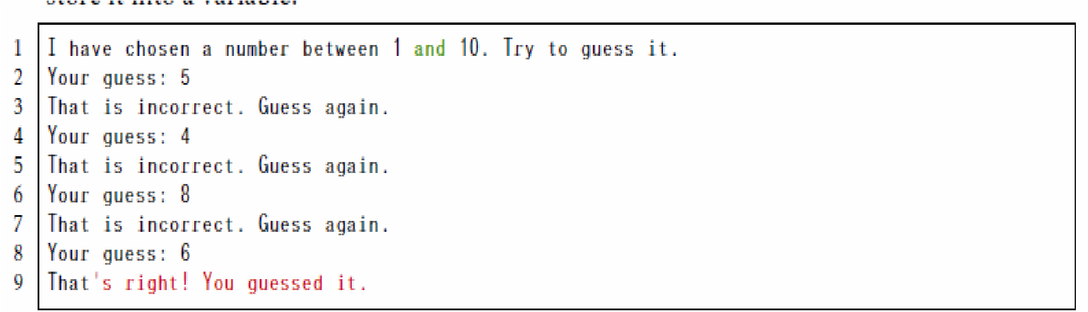
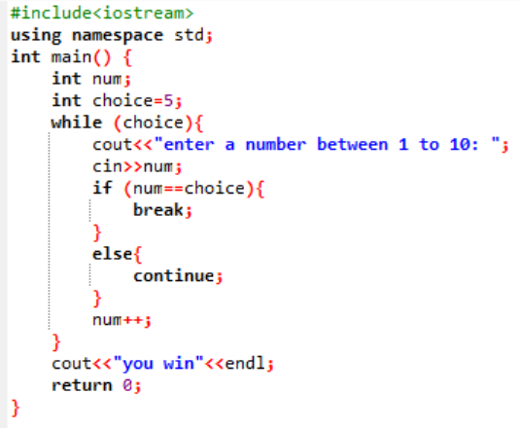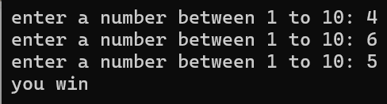
Q2-Write a C++ program that implements a program to check if a given number is a palindrome using a while loop
Palindrome: a word, phrase, or sequence that reads the same backwards as forwards, e.g. madam or nurses run.
Sample output:
Enter word: Madam Madam is a palindrome!
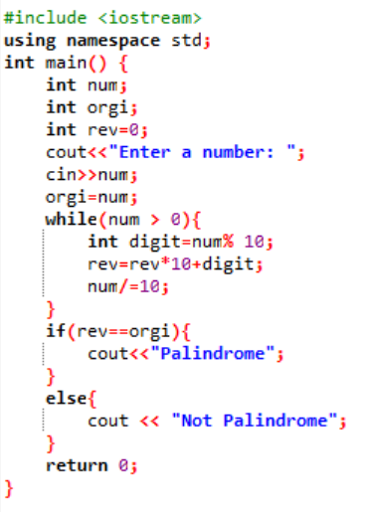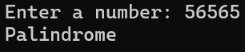

Do while:
Write a C++ program to reverse a given number using a do-while loop.
Sample Output:
Enter a number: 345
Reverse : 543

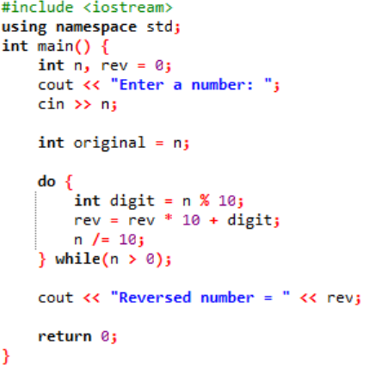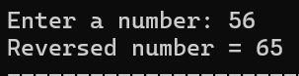
National University of Sciences & Technology (NUST)
Balochistan Campus (NBC), Department of Computer Science

