Fundamentals of Computer Programming

Lab 05: Conditional Statements in C++

Switch Statement

NAME: Ayesha Ahmer Khan
CMS: 570438

Instructor: Mr. Ubaid Ullah

Lab Engineer: Ms. Zainab Zahid

Official Lab Conduct, Attendance & Submission Policy
All students are strictly required to follow the rules mentioned below. Violations will lead to academic penalties without exception.

- Attendance Requirement – Minimum 75%
  - Students must maintain at least 75% attendance in all lab sessions to be eligible for grading and final evaluation.
  - Late arrival or habitual late coming will be marked as absent
Authenticity of Work
  - Each student must complete their own lab tasks. Discussions for conceptual clarity are permitted, but copying code, content, or solutions is strictly prohibited.
- AI & Unauthorized Tools Prohibited o Use of ChatGPT, other AI tools, or unauthorized online resources for generating lab content is strictly forbidden.
  - Any violation will result in:
▪ Immediate cancellation of lab marks
- Submission Rules o All tasks must be submitted before leaving the lab.
  - Late submissions will not be accepted or marked.
- Grading Policy o After submission, students must present their work to the Lab Engineer/TA, the submitted solution can get a maximum of 5 marks. o A short viva may be conducted to assess understanding. Failure to attend or pass the viva may result in zero marks. The viva has a weightage of 5 marks
  - You must also submit this Word document with attached output screenshots and a short description of how you completed it, along with the code file on Google Classroom. In case of any problems with submissions, email your Lab assignments to Zainab.zahid2002@gmail.com.

Learning Objectives
- Understand the purpose and syntax of the switch statement in C++.
- Learn when to use switch vs. if-else.
- Practice using break and default keywords effectively.
- Implement nested decision-making structures where appropriate.
- Strengthen logic building through real-world style problems.
PRE-LAB READING ASSIGNMENT
C++ Switch Statement:
The switch statement allows us to execute a block of code among many alternatives. Switch statements can be used as an alternative for multiple if else statements.
Syntax:
switch (expression)
{ case x: // code block break; case y: // code block break; default: // code block
}

How do switch statements work?
- The switch expression is evaluated once
- The value of the expression is compared with the values of each case
- If there is a match, the associated block of code is executed

Break keyword:
- When C++ reaches a break keyword, it breaks out of the switch block.
- This will stop the execution of more code and case testing inside the block.
- When a match is found and the job is done, it's time for a break. There is no need for more testing.
Default Keyword:
The default keyword specifies some code to run if there is no case match Flowchart of Switch Statement:
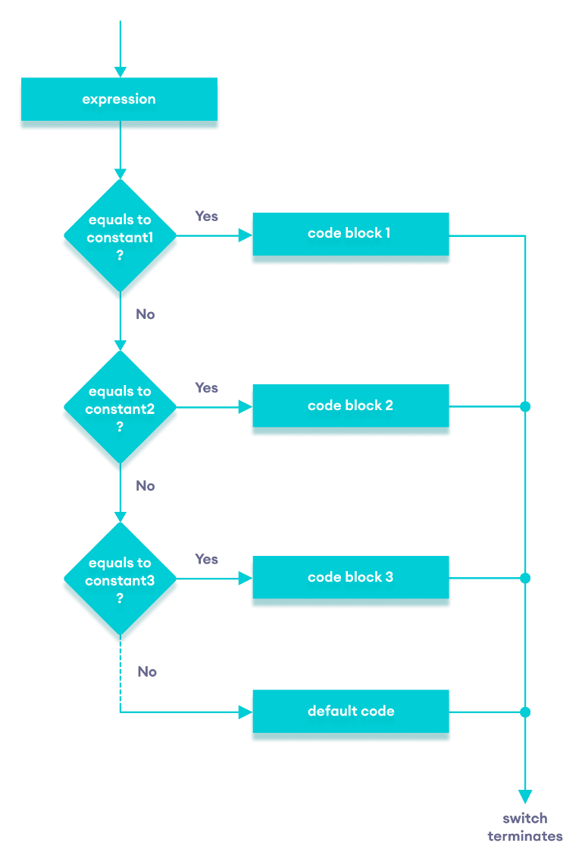

Example of Switch Statement:
int day = 4; switch (day) { case 1: cout << "Monday"; break; case 2: cout << "Tuesday"; break; case 3: cout << "Wednesday"; break; case 4: cout << "Thursday"; break; case 5: cout << "Friday"; break; case 6: cout << "Saturday"; break; case 7: cout << "Sunday"; break;
}
Output:
Thursday

Example of Default Keyword:
int day = 4; switch (day) {
case 5: cout << "Friday"; break; case 6: cout << "Saturday"; break; case 7: cout << "Sunday"; break; default: cout << "Looking forward to the Weekend";
}

In this example, the value of day does not match any of the specified cases (5, 6, or 7). Since no case condition is true, the program executes the statements inside the default block.
Output: Looking Forward to the Weekend

Difference between if-else and Switch Statements:
- switch is better suited for situations where a single variable/expression is compared against multiple constant values.
- if-else is more flexible because it can handle:
- Ranges (e.g., if (x > 10 && x < 20))
- Complex conditions with logical operators
- switch, improves readability and execution speed in cases with many discrete values.

Lab Tasks:
1.Create a Calculator using the switch Statement
Output:
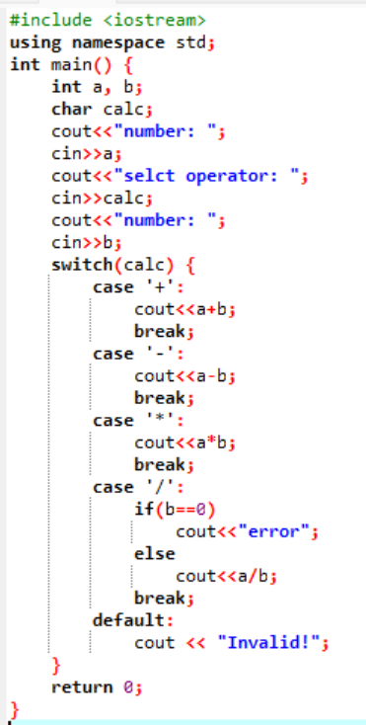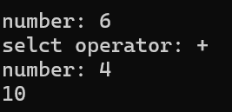

- Write a C++ program that asks the user three true /false questions.
  - The user enters A for True or B for False.
  - Use a switch statement to check the answers.
  - Count how many answers are wrong and display the total wrong answers at the end.
Output:
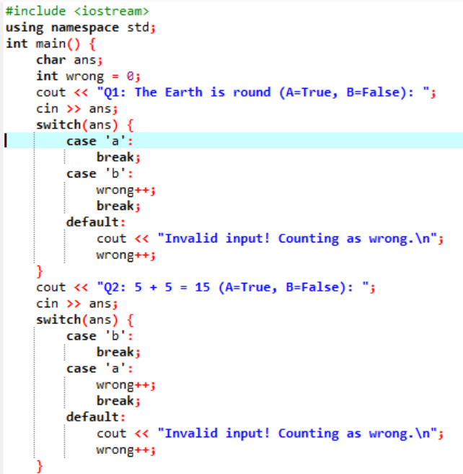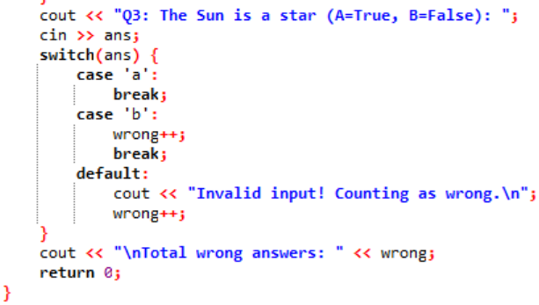

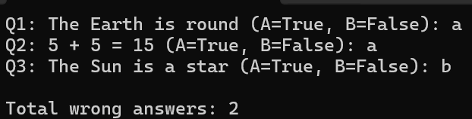

- A cinema wants a program that allows users to select a movie type and then a seat category.
Scenario:
  - The user first selects the movie type:
    - → Action
    - → Comedy
  - Based on the movie type, the program asks the user to select a seat:
o Action: 1 → Regular, 2 → VIP o Comedy: 1 → Balcony, 2 → Premium Code:
int movie, seat; cin >> movie; switch (movie)
{ case 1: cout << "Select seat: 1.Regular 2.VIP"; cin >> seat; switch (seat)
{ case 1:
cout << "Regular seat selected"; case 2:
cout << "VIP seat selected";
} case 2:
cout << "Select seat: 1.Balcony 2.Premium"; cin >> seat; switch (seat)
{ case 1: cout << "Balcony seat selected"; break; case 2: cout << "Premium seat selected"; break; }
Task
- Identify the logical errors
- Correct the code so it runs properly
Output (error + debugged code):
Errors:
Break is missing in the outer switch; after case 1, it also enters case 2
Break is missing in the first inner switch; both cases will get printed
Default cases are missing in the switches

Corrected Output:
#include <iostream>
using namespace std;
int main() {
int movie, seat;
cout << "Select movie type: 1.Action 2.Comedy"<<endl;
cin >> movie;
switch (movie) {
case 1:
cout << "Select seat: 1.Regular 2.VIP"<<endl;
cin >> seat;
switch (seat) {
case 1:
cout << "Regular seat selected";
break;
case 2:
cout << "VIP seat selected";
break;
default:
cout << "Invalid seat choice";
}
break;
case 2:
cout << "Select seat: 1.Balcony 2.Premium"<<endl;
cin >> seat;
switch (seat) {
case 1:
cout << "Balcony seat selected";
break;
case 2:
cout << "Premium seat selected";
break;
default:
cout << "Invalid seat choice";
}
break;
default:
cout << "Invalid movie type";
}
return 0;
}

Case Study: Cafeteria Meal Selector
NBC University wants to create an automated Cafeteria Meal Selector for its students.
Scenario:
The cafeteria offers multiple meal types, and each meal type has several options. A student will first select the meal type and then choose a specific item from that meal.
Requirements:
- The program should first ask the student to choose a meal type (e.g., Breakfast, Lunch, Snacks, Dinner).
- Based on the chosen meal type, the program should display a list of items available for that meal.
- The student then selects one item from the list.
- The program finally displays a message showing the selected meal and item.
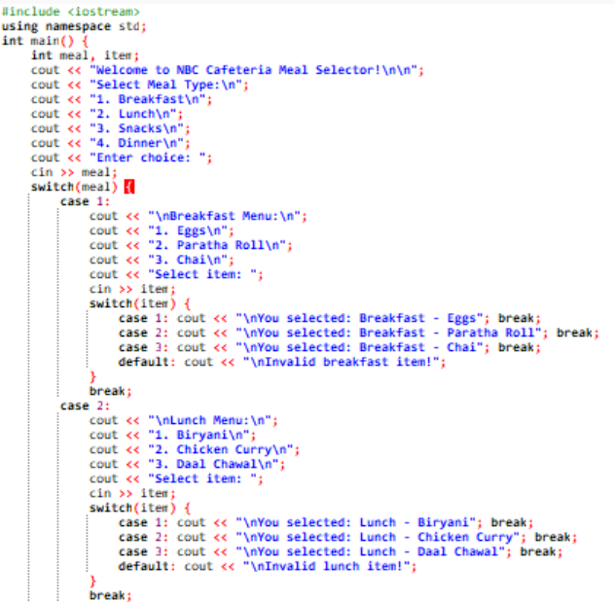
Output:
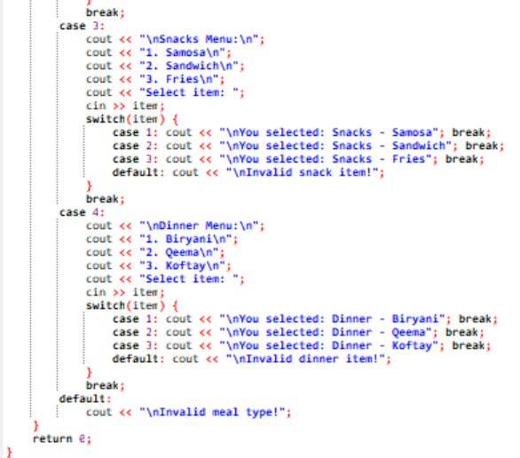

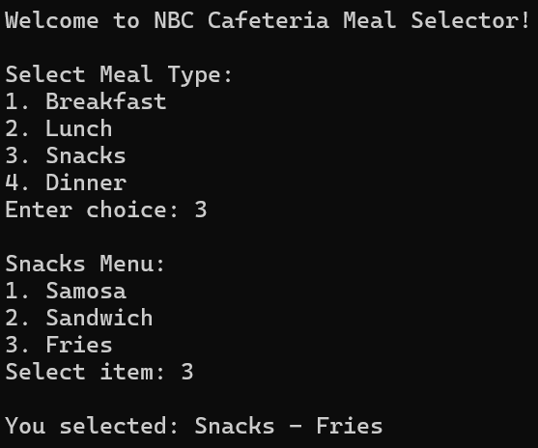

National University of Sciences & Technology (NUST)
Balochistan Campus (NBC), Department of Computer Science

