Fundamentals of Computer Programming

Lab 09: Functions in C++

Introduction to Functions

Name: Ayesha Ahmer Khan
CMS: 570438

Instructor: Mr. Ubaid Ullah

Lab Engineer: Ms. Zainab Zahid

Official Lab Conduct, Attendance & Submission Policy
All students are strictly required to follow the rules mentioned below. Violations will lead to academic penalties without exception.

1. Attendance Requirement – Minimum 75%
- Students must maintain at least 75% attendance in all lab sessions to be eligible for grading and final evaluation.
- Late arrival or habitual late coming will be marked as absent

Authenticity of Work
o Each student must complete their own lab tasks. Discussions for conceptual clarity are permitted, but copying code, content, or solutions is strictly prohibited.
- AI & Unauthorized Tools Prohibited o Use of ChatGPT, other AI tools, or unauthorized online resources for generating lab content is strictly forbidden.
  - Any violation will result in:
▪ Immediate cancellation of lab marks
- Submission Rules o All tasks must be submitted before leaving the lab.
  - Late submissions will not be accepted or marked.
- Grading Policy o After submission, students must present their work to the Lab Engineer/TA, the submitted solution can get a maximum of 5 marks. o A short viva may be conducted to assess understanding. Failure to attend or pass the viva may result in zero marks. The viva has a weightage of 5 marks
  - You must also submit this Word document with attached output screenshots and a short description of how you completed it, along with the code file on Google Classroom. In case of any problems with submissions, email your Lab assignments to Zainab.zahid2002@gmail.com.

Learning Objectives
- Understand the purpose and usage of Functions.
- Awareness of functions with syntax and rules.
- Introduction to recursion and its usage

Pre Lab Reading Assignment
Functions  Types of functions  User defined  Functions | A function is a set of statements that take inputs, do some specific computation, and produce output. The idea is to put some commonly or repeatedly done tasks together and make a function so that instead of writing the same code again and again for different inputs, we can call the function. In simple terms, a function is a block of code that only runs when it is called.  Dividing a complex problem into smaller chunks makes our program easy to understand and reusable.  Standard Library Functions: Predefined in C++  User-defined Function: Created by users  C++ allows the programmer to define their function.  A user-defined function groups code to perform a specific task and that group of code is given a name (identifier).  When the function is invoked from any part of the program, it executes the codes defined in the body of the function.

C++ Function Declaration | The syntax to declare a function is:  returnType functionName (parameter1, parameter2,...) { // function body  }
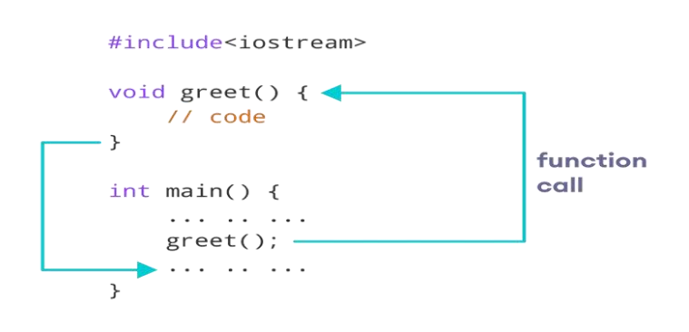

Calling a Function

Function  Parameters | As mentioned above, a function can be declared with parameters (arguments). A parameter is a value that is passed when declaring a function.  For example, let us consider the function below:  void printNum(int num) { cout << num;  }  Here, the int variable num is the function parameter.  We pass a value to the function parameter while calling the function.
Function  Prototype | int main() { int n = 7;  // calling the function  // n is passed to the function as argument printNum(n); return 0;  }  In C++, the code of function declaration should be before the function call. However, if we want to define a function after the function call, we need to use the function prototype. For example,  // function prototype void add(int, int); int main() {  // calling the function before declaration.  add(5, 3); return 0;  }  // function definition void add(int a, int b) {
cout << (a + b); }

Pre Defined  Functions in C++ | In the above code, the function prototype is: void add(int, int);  This provides the compiler with information about the function name and its parameters. That's why we can use the code to call a function before the function has been defined.  C++ comes with many built-in functions that you can use right away.  Here are some common categories:
- Input/Output Functions: cout, cin, setprecision
- Mathematical Functions: sqrt(), abs(), pow(), ceil(), floor()
- Memory Operators: new, delete
- Time Functions: time(), ctime(), difftime()
- File Handling Functions: fopen(), fclose(), fread(), fwrite()

Pre-lab writing assignment

Fill in the blanks | - Function is a block of code that only runs when it is called  - Function divides a complex problem into smaller chunks make our program easy to understand and maintain  - function with the same name, but different in parameters is known as function overloading  - A function that calls itself, and doesn’t perform any task after
function call, is known as tail recursion.

Lab 12

Lab Tasks
1. Create a new project with new file with name lab9_2.cpp extension, copy the following code it and try to fill the missing code of the program. Observe the output that appears and write it in the box given below
#include<iostrem> using namespace std; int fact(int n) {
int factorial = 1; for (int i = 2; i <= n; i++) {
factorial *= i;
}
return factorial;
} int main() { int n; cin >> n; int ans = fact(n);
cout << ans << endl;
return 0;

Output:
This code will calculate factorial.
So if we give 5 as an input, we will get its factorial that is, 120
n = 5
ans = fact(5)
fact(5):
factorial = 1
i = 2 >> factorial = 1 * 2 = 2
i = 3 >> factorial = 2 * 3 = 6
i = 4 >> factorial = 6 * 4 = 24
i = 5 >> factorial = 24 * 5 = 120

return 120

Output:
120
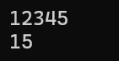
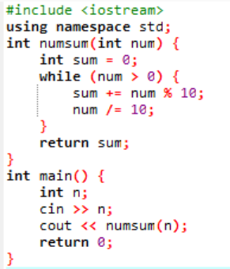
2. 5-digit positive integer is entered through the keyboard, write a function to calculate sum of digits of the 5-digit number

3.Write a program to find maximum and minimum of three numbers using functions

Sample Output:
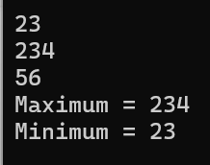
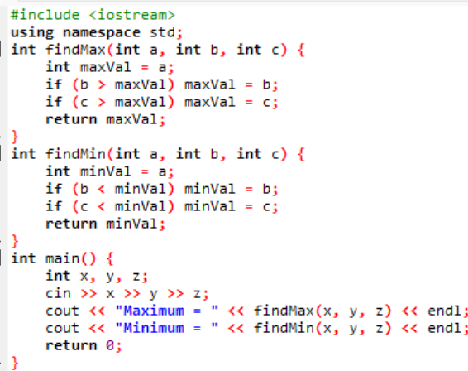

4.Find the Average of 10 numbers passed to an array, using function. The Array should be controlled by while loop.

Output:

- Create a program that:
  - Implements a square function.
  - Implements a squareAndDouble function that uses the square function.
  - Calls squareAndDouble from main and prints the result.

Output:
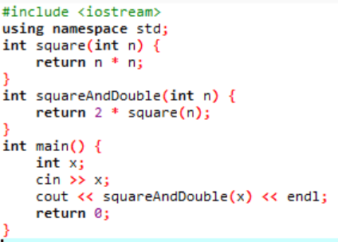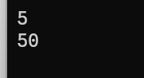

- In a programming contest, new users get different ratings based on their performance. Your task is to calculate how many users will receive a rating and how many will get a rating above 1000.
Sample Output:

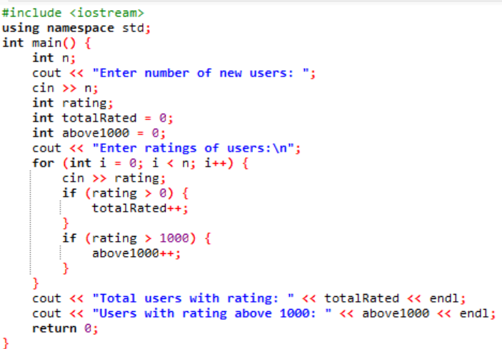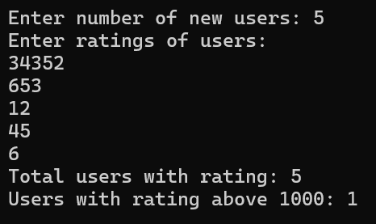

- Chef made a typo in his first program. Instead of printing A + B, it prints A × B. Calculate the absolute difference between the correct answer and the program's output.
Sample Output:
