

**LAB TASK 3**

**Name: Ayesha Aleem**

**ROLL-No:SP19-BCS-017**

**Section: B**

**1.The code for database**

**Solution:**

create(t1:teacher{name:"Farukh",department:"ComputerScience",course:"IntroToDS"}),(t2:teacher{name:"fareeha",department:"Mechanical",course:"Assembly"}),(t3:teacher{name:"Saira",department:"Psychology",course:"CriticalThinking"}),(t4:teacher{name:"Zeeshan Gillani",department:"SoftwareEnginnering",course:"DAA"}),(t6:teacher{name:"Waqas",department:"ComputerScience",course:"OS"}),(t5:teacher{name:"Neelam",department:"ChemicalEngineering",course:"Chemistry"}),(p1:person{name:"Ayesha",department:"Mechanical",tittle:"Student",course:"Assembly"}),(p2:person{name:"Fabiha",department:"Psychology",tittle:"Student",course:"CriticalThinking"}),(p3:person{name:"Aneela",department:"SoftwareEngineering",tittle:"Student",course:"Chemistry"}),(p4:person{name:"neha",department:"CompuerScience",tittle:"Student",course:"DAA"}),(p5:person{name:"Kaleem",department:"ChemicalEngineering",tittle:"Student",course:"Chemistry"}) return t1,t2,t3,t4,t5,t6,p1,p2,p3,p4,p5

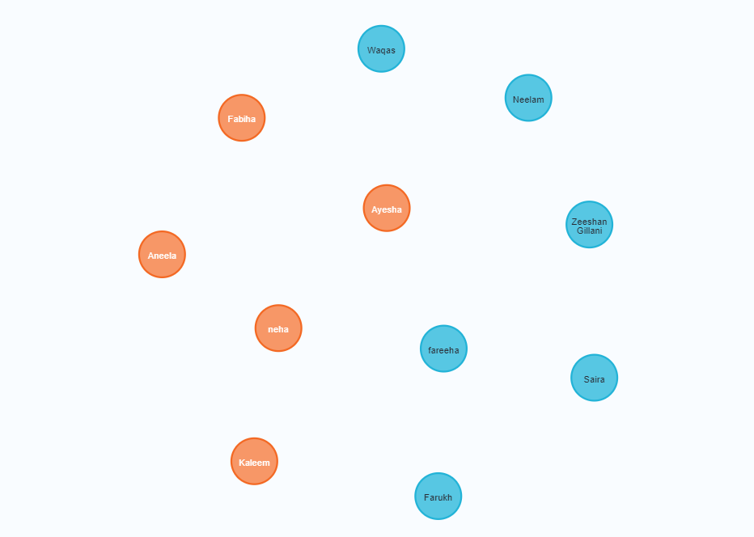

**2.Graph representation after relationships**

**Solution:**

match (p),(t)  where t.name = "Zeeshan Gillani" and p.name = "Aneela" create (p)-[r:student_of]-> (t)

match (p),(t)  where t.name = "Waqas" and p.name = "neha" create (p)-[r:student_of]-> (t)

match (p),(t)  where t.name = "Saira" and p.name = "Fabiha" create (p)-[r:student_of]-> (t)

match (p),(t)  where t.name = "Farukh" and p.name = "Ayesha" create (p)-[r:student_of]-> (t)

match (p),(t)  where t.name = "Neelam" and p.name = "Kaleem" create (p)-[r:student_of]-> (t)

match (p),(t)  where t.name = "Waqas" and p.name = "Kaleem" create (p)-[r:student_of]-> (t)

match (p),(t)  where t.name = "Zeeshan Gillani" and p.name = "neha" create (p)-[r:student_of]-> (t)

match (p),(t)  where t.name = "fareeha" and p.name = "Ayesha" create (p)-[r:student_of]-> (t)

match (p),(t)  where t.name = "fareeha" and p.name = "Ayesha" create (p)-[r:student_of]-> (t)

match (p),(t)  where t.name = "fabiha" and p.name = "Waqas" create (p)-[r:student_of]-> (t)

match (p),(t)  where t.name = "Saira" and p.name = "Kaleem" create (p)-[r:student_of]-> (t)

match (p),(t)  where t.name = "Waqas" and p.name = "Ayesha" create (p)-[r:student_of]-> (t)

match (p),(t)  where t.name = "Farukh" and p.name = "Kaleem" create (p)-[r:student_of]-> (t)

match (p),(t)  where t.name = "Neelam" and p.name = "Aneela" create (p)-[r:student_of]-> (t)

match (p),(t)  where t.name = "Neelam" and p.name = "Fabiha" create (p)-[r:student_of]-> (t)

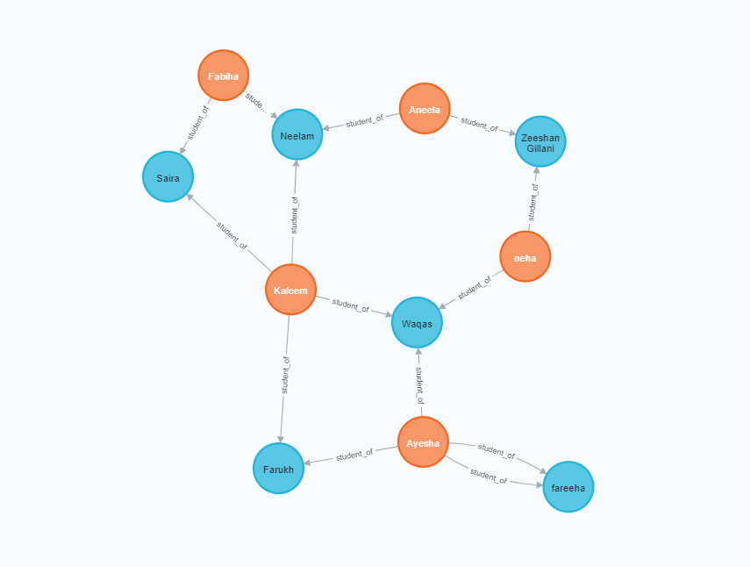

**3.Query – That represent the teachers names who are giving lectures to students**

**Solution:**

MATCH(p:person)-[:student_of]->(t:teacher) RETURN t.name AS Teachers

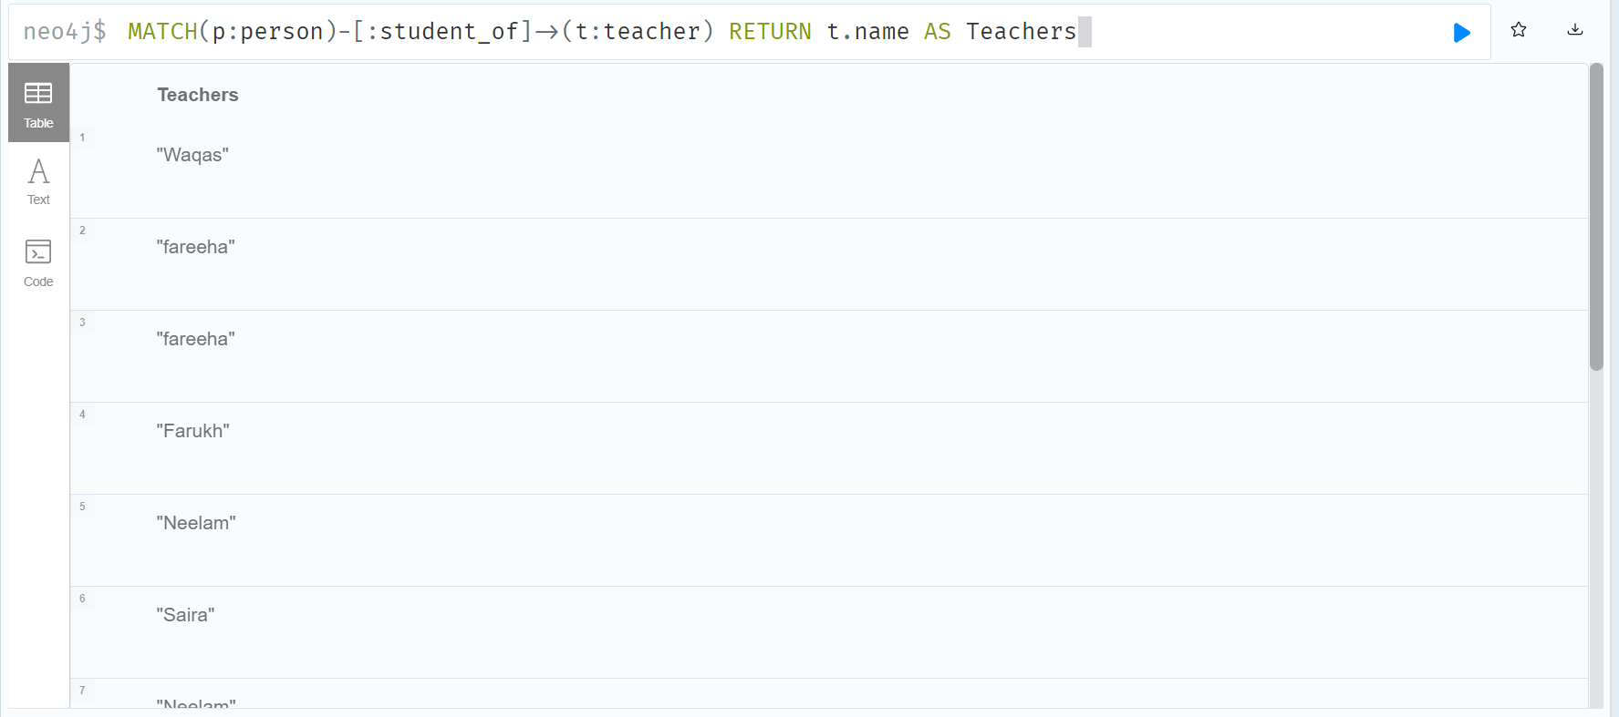

**4.Query-Students Information**

**Solution:**

Match(p:person)-[:student_of]->(t:teacher) where p.course="Chemistry"  return p.name t.name AS teacher,Students

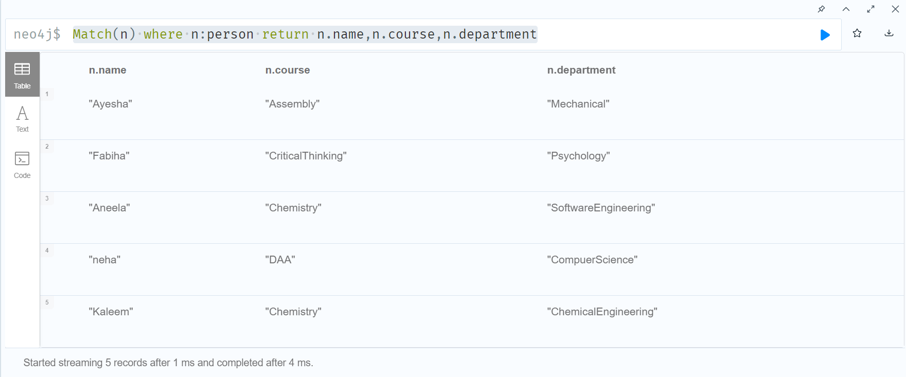

**5.Query-Teachers Information**

**Solution:**

Match(n) where n:teacher return n.name,n.course,n.department

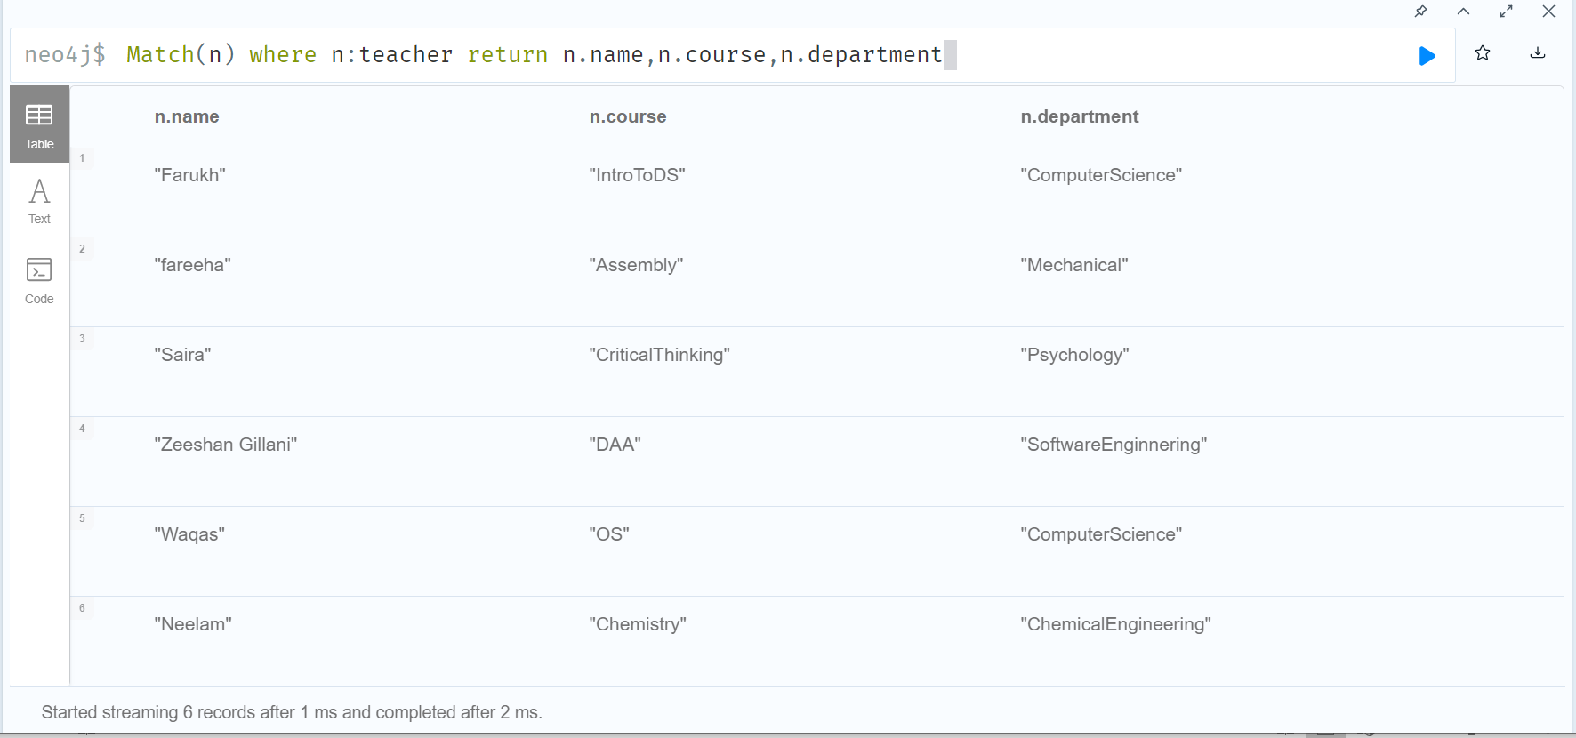

**6.Query-Total Number of course that are available**

**Solution:**

Match(n) where n:teacher return n.name,n.course,n.department

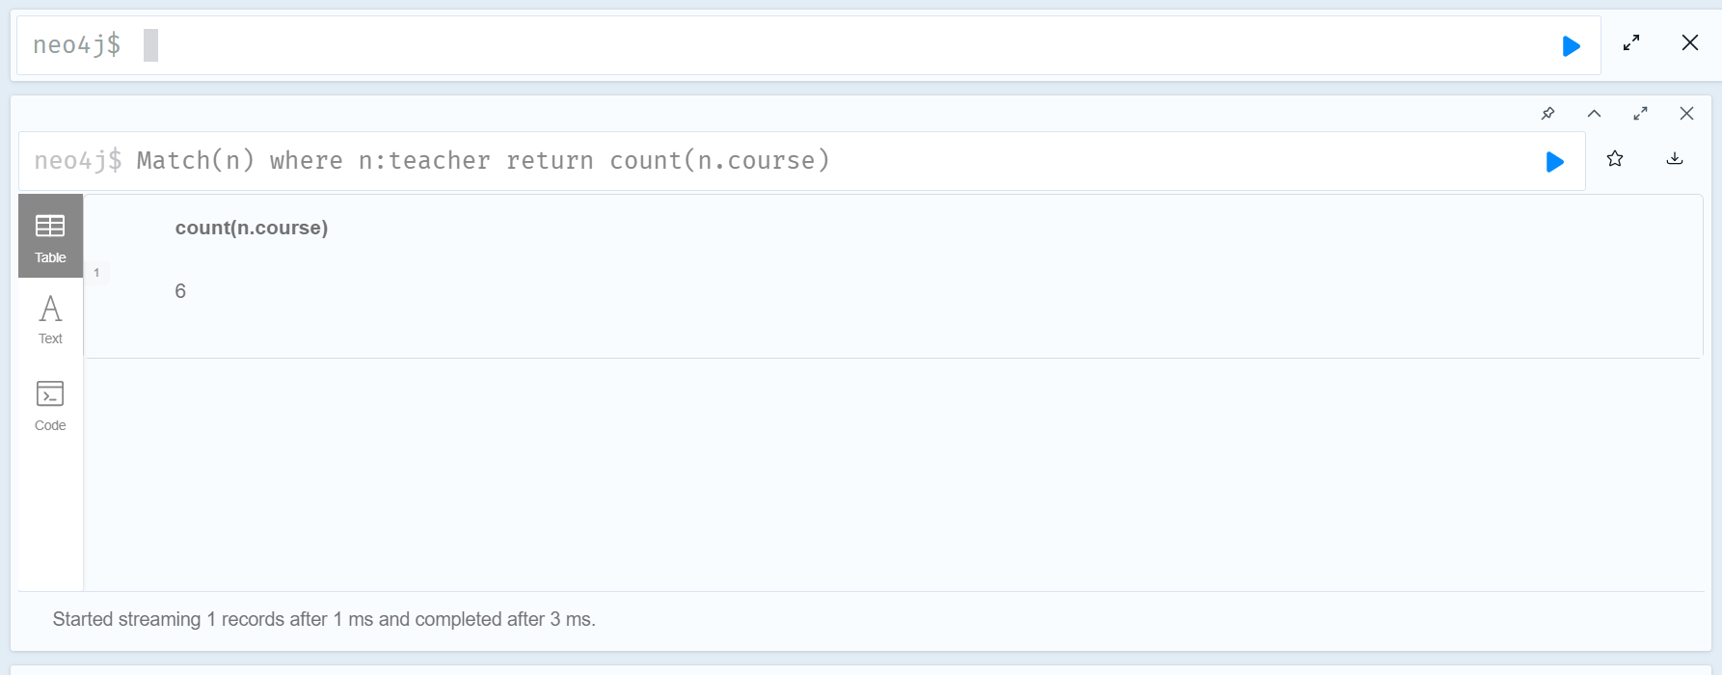

**7.Query-That return the name of teachers who belong from CS depart**

**Solution:**

Match (k:teacher) where k.department="ComputerScience" return k.name

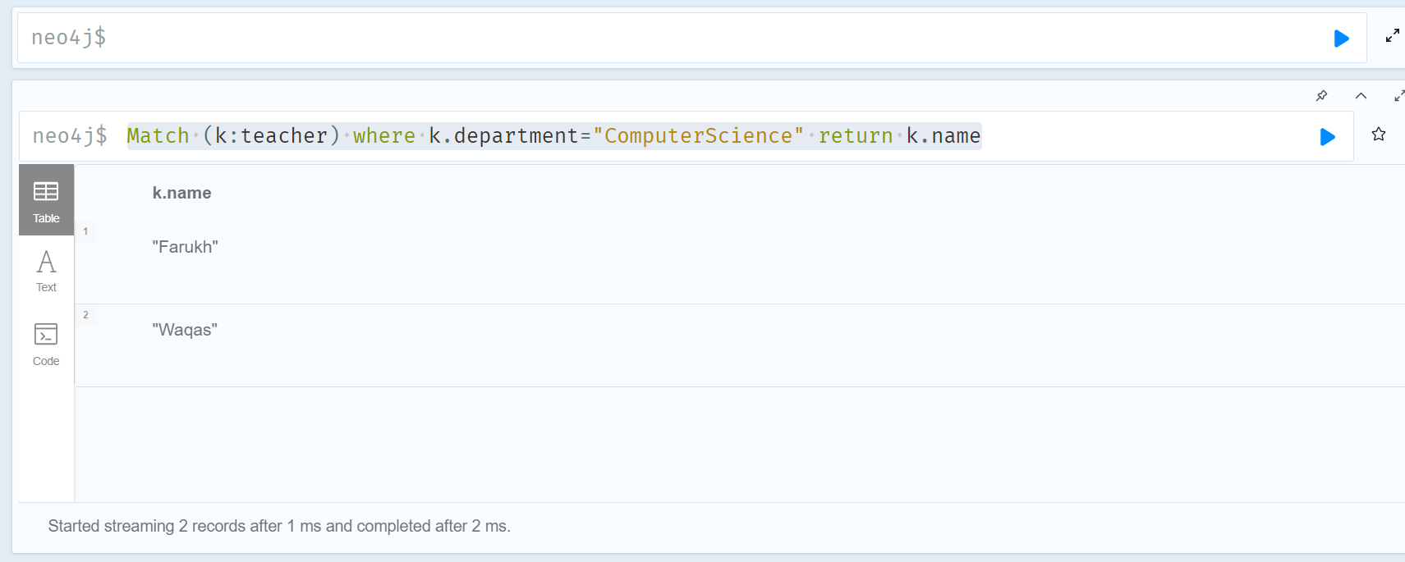

**8.Query-total relationships of teacher teaching students**

**Solution:**

Match(p:person)-[:student_of]->(t:teacher) return count(t.course)

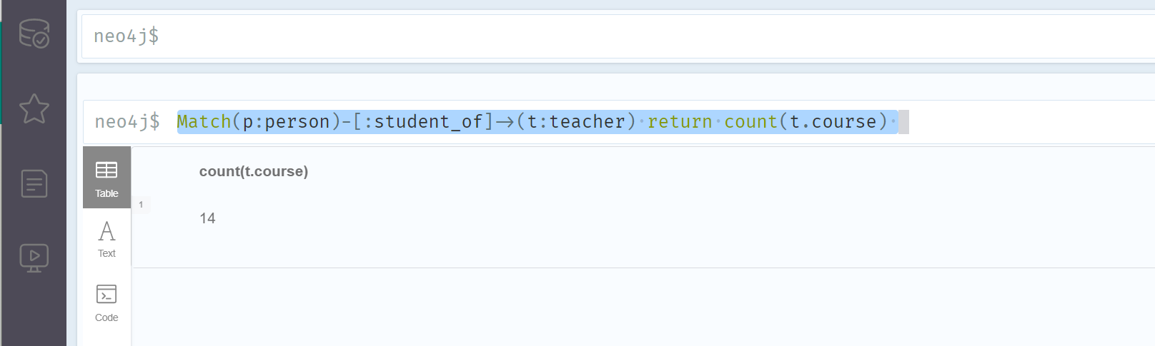

**9.Query-Student Taking lectures from individuals teachers**

**Solution:**

Match(p:person)-[:student_of]->(t:teacher) return t.name,t.course,p.name

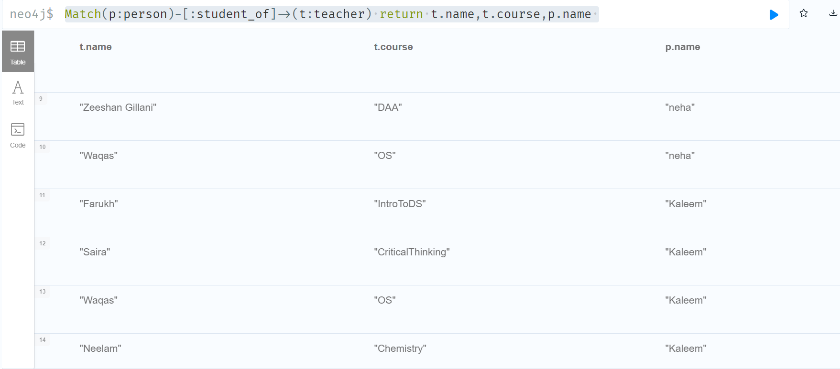

**10.Query-Student Taking lectures in totality from individual teacher**

**Solution:**

Match(s:person)-[r:student_of]->(t:teacher)

RETURN s.name, count(t) as Total_Teachers_Teaching

ORDER BY Total_Teachers_Teaching

