Course Name: Numerical Computing (Lab)
Submitted By: M. Ali raza
CMS ID 1868_2023
Program: BSCS-05
Submitted To: Dr. Sajid Shafiq
Department: FEST
Institute: Hamdard University Islamabad

Dated: 13 October, 2025

BISECTION
TASK 1

Finding the Root of a Function using Bisection Method
Objective:
TowriteaMATLAB program that finds the approximate root of a nonlinear equation using the Bisection
Method.
Theory:
The Bisection Method is a numerical technique used to find the real root of a function f(x)=0f(x) = 0f(x)=0.
It is based on the principle that if a continuous function changes sign between two points a and b, then a root
exists between them.
Algorithm:
1. Start
2. Define the function f(x)
3. Input initial guesses a and b such that f(a)∗f(b)<0
4. Set maximum iterations n and tolerance e
5. Repeat the following steps:
o Find midpoint c=(a+b)/2
o Check error: if |c - a|<e or |c – b|<e, stop
o If f(a)∗f(c)<0 set b = c
o Else, set a = c
6. Display the root value
7. End
Implementation
Display result :
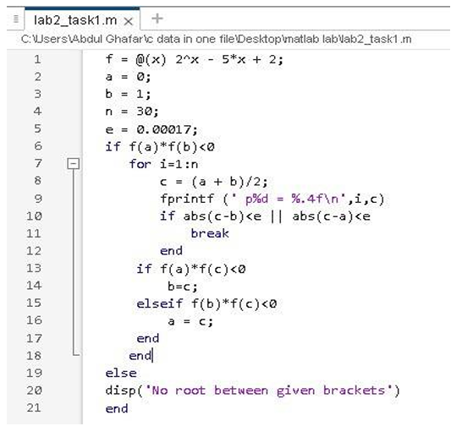
Display output :
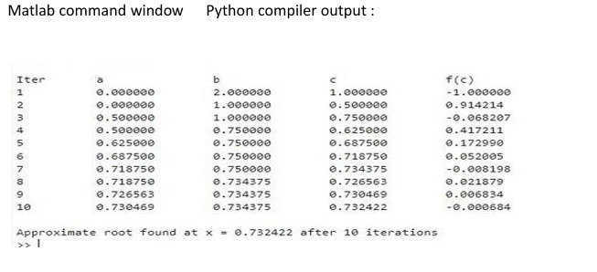
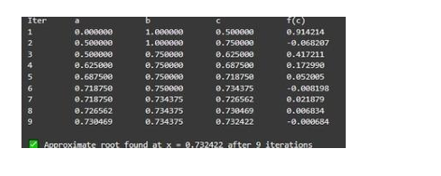
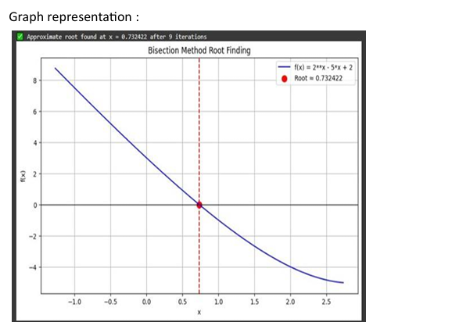

TASK 2:

GRAPH:
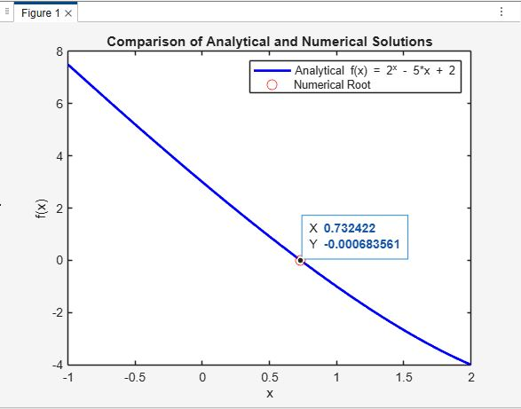

Given the function f(x) = 2^x - 5*x + 2, use the Bisection method to find its root in the interval [0, 1].
Part 1 (MATLAB):
1. Write a MATLAB script to implement the Bisection method to find the root of f(x) in the given interval.
2. Plot the function f(x) and mark the numerical root on the graph.
Part 2 (Python):
1. Write a Python code using NumPy and Matplotlib to implement the Bisection method to find the root of f(x) in the given interval.
2. Plot the function f(x) and mark the numerical root on the graph.
Comparison and Analysis:
1. Compare the numerical roots obtained from MATLAB and Python.
2. Analyze the accuracy of the Bisection method in finding the root of f(x)

% Define the function
f = @(x) 2.^x - 5*x + 2;
% Define the interval [a, b]
a = 0;
b = 1;
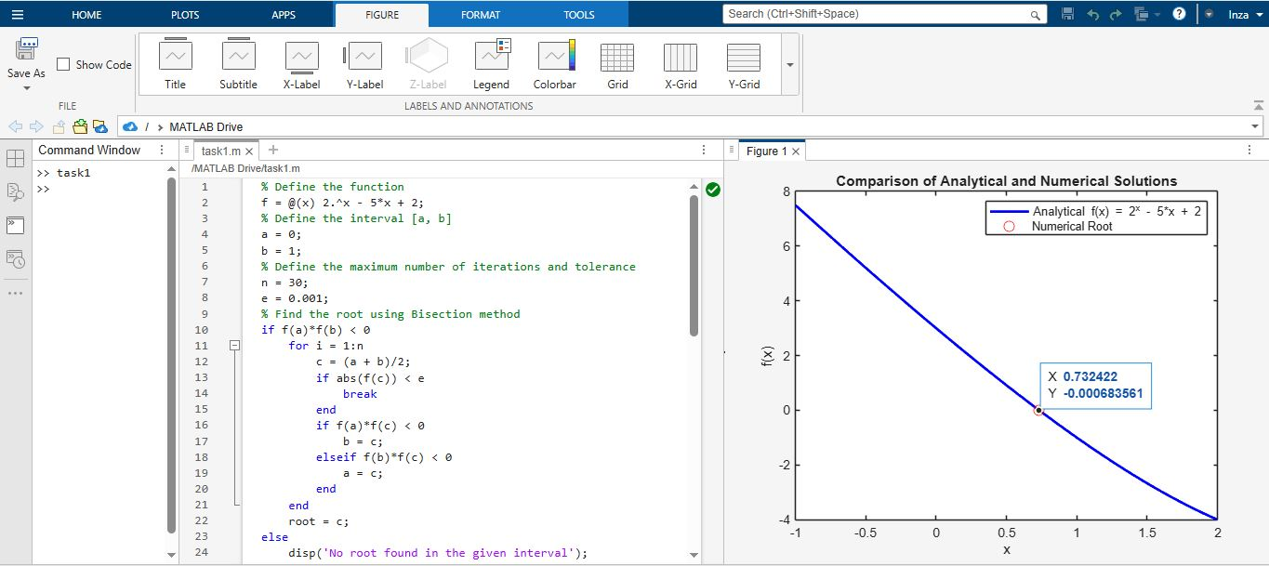
% Define the maximum number of iterations and tolerance
n = 30;
e = 0.001;

% Find the root using Bisection method
if f(a)*f(b) < 0
for i = 1:n
c = (a + b)/2;
if abs(f(c)) < e
break
end
if f(a)*f(c) < 0
b = c;
elseif f(b)*f(c) < 0
a = c;
end
end
root = c;
else
disp('No root found in the given interval');
end

% Plot the function (analytical representation)
x = linspace(-1, 2, 400);
y = f(x);
plot(x, y, 'b', 'LineWidth', 2);
hold on;

% Plot the numerical solution
plot(root, f(root), 'ro', 'MarkerSize', 8);
xlabel('x');
ylabel('f(x)');
title('Comparison of Analytical and Numerical Solutions');
legend('Analytical f(x) = 2^x - 5*x + 2', 'Numerical Root');

CODE IN PYTHON:
import numpy as np
import matplotlib.pyplot as plt

f = lambda x: 2**x - 5*x + 2
a, b = 0, 1
tol, max_iter = 1e-3, 30

for _ in range(max_iter):
c = (a + b)/2
if abs(b - a)/2 < tol or f(c) == 0:
break
if f(a)*f(c) < 0:
b = c
else:
a = c

root = (a + b)/2
print(f'Root ≈ {root:.6f}, f(root) ≈ {f(root):.6f}')

x = np.linspace(0, 1, 400)
plt.plot(x, f(x), label='f(x)')
plt.axhline(0, color='gray', linestyle='--')
plt.plot(root, f(root), 'ro', label='Root')
plt.legend()
plt.grid()
plt.show()

