Front Matter — Title, Table of Contents, List of Figures, List of Tables
Working note: Page numbers below are placeholders/estimates. They will be finalised automatically once the full chapter content is written and the thesis is compiled to Word (.docx), where the Table of Contents, List of Figures, and List of Tables are generated from the document's headings and captions.

A CONTEXT-AWARE MULTILINGUAL DEEP LEARNING FRAMEWORK FOR CYBERBULLYING DETECTION IN CODE-SWITCHED URDU, ROMAN URDU AND ENGLISH TEXT
Student Name: Rimsha Ch Roll No: 24252101017 Supervisor: Mam Fatima Anjum
Committee Member 1: ____________________ Committee Member 2: ____________________ Committee Member 3: ____________________
DEPARTMENT OF COMPUTER SCIENCE LAHORE COLLEGE FOR WOMEN UNIVERSITY, LAHORE
Note on the title. The original proposal was titled "A Context-Aware Multilingual Deep Learning Model for Text and Image-Based Cyberbullying Detection." The core of this study is the text modality, which is where multilingual code-switched cyberbullying actually occurs and where the comprehensive labelled data (aggression, repetition, intent and peerness) exists. An image-based multimodal component was also implemented and evaluated, but only as a preliminary, exploratory result (Sections 3.12 and 4.7); the improvements needed to make it reliable are set out as future work (Section 5.4). The title above reflects the validated core of the system that was actually built and evaluated.

TABLE OF CONTENTS
 |  | Page
 | Declaration | i
 | Certificate of Approval | ii
 | Dedication | iii
 | Acknowledgements | iv
 | Abstract | v
 | Table of Contents | vi
 | List of Figures | ix
 | List of Tables | x
 | List of Abbreviations | xi
CHAPTER 1 | INTRODUCTION | 1
1.1 | Background | 1
1.2 | Cyberbullying and Its Effects | 2
1.3 | The Multilingual Challenge: Urdu, Roman Urdu and Code-Switching | 3
1.4 | Beyond Aggression: Repetition, Intent and Peerness | 4
1.5 | Problem Statement | 5
1.6 | Motivation | 6
1.7 | Aim and Objectives | 7
1.8 | Research Questions | 8
1.9 | Scope of the Study | 8
1.10 | Significance and Contributions | 9
1.11 | Organisation of the Thesis | 10
CHAPTER 2 | LITERATURE REVIEW | 11
2.1 | Introduction | 11
2.2 | Defining Cyberbullying: A Behavioural View | 12
2.3 | Traditional and Machine-Learning Approaches | 13
2.4 | Lexicon-Based Approaches | 14
2.5 | Deep Learning and Transformer Models (BERT, m-BERT, MuRIL) | 15
2.6 | Cyberbullying and Aggression Detection in Roman Urdu | 16
2.7 | The Code-Switching Problem in South Asian Social Media | 17
2.8 | Behavioural and Contextual Features | 18
2.9 | Datasets, Annotation and Inter-Annotator Agreement | 19
2.10 | Research Gap | 20
2.11 | Summary | 21
CHAPTER 3 | MATERIALS AND METHODS | 22
3.1 | Overview of the Proposed Methodology | 22
3.2 | Dataset | 24
3.2.1 | The Comprehensive Cyberbullying Dataset | 24
3.2.2 | Roman Urdu Aggression Data | 25
3.2.3 | Message-Level and Pair-Level Views | 26
3.3 | Data Preprocessing | 27
3.3.1 | Text Cleaning and Normalisation | 27
3.3.2 | Roman Urdu Handling and Tokenisation | 28
3.4 | Data Annotation and Inter-Annotator Agreement | 29
3.4.1 | Annotation Scheme (Aggression, Repetition, Intent, Peerness) | 29
3.4.2 | Fleiss' Kappa Agreement | 30
3.5 | Feature Extraction | 31
3.5.1 | Textual Features (m-BERT / MuRIL Embeddings) | 31
3.5.2 | Behavioural and Contextual Features | 32
3.6 | Stage 1 — Message-Level Aggression Model | 33
3.6.1 | Transformer Fine-Tuning | 33
3.6.2 | Class Imbalance Handling | 34
3.7 | Quantifying Repetition and Intent | 35
3.7.1 | Repetition Scoring | 35
3.7.2 | Intent-to-Harm Scoring | 36
3.8 | Stage 2 — User-Pair Cyberbullying Classifier | 37
3.9 | Evaluation Metrics | 38
3.10 | Experimental Setup and Implementation Details | 39
3.11 | Web Demonstration Application | 40
3.12 | Stage 3 — Multimodal Image-and-Text Component | 40
CHAPTER 4 | RESULTS AND DISCUSSION | 41
4.1 | Introduction | 41
4.2 | Dataset Statistics and Class Distribution | 41
4.3 | Inter-Annotator Agreement Results | 42
4.4 | Stage 1 — Aggression Detection Results | 43
4.5 | Stage 2 — Cyberbullying Classification Results | 45
4.6 | The "Before" Story: Diagnosing Majority-Class Collapse | 46
4.7 | Multimodal Image-and-Text Component (Stage 3) | 47
4.8 | Discussion | 48
4.9 | Comparison with Existing Literature | 49
CHAPTER 5 | CONCLUSION AND FUTURE WORK | 51
5.1 | Conclusion | 51
5.2 | Key Contributions | 52
5.3 | Limitations | 53
5.4 | Future Work | 54
 | REFERENCES | 55
 | APPENDICES | 59
 | Appendix A — Annotation Guidelines | 59
 | Appendix B — Hyperparameter Configuration | 60
 | Appendix C — Sample Source Code | 61

LIST OF FIGURES
Figure | Caption | Page
Figure 1.1 | The three behavioural pillars of cyberbullying: aggression, repetition and intent to harm | 4
Figure 3.1 | Overall architecture of the proposed two-stage cyberbullying detection system | 23
Figure 3.2 | Construction of the message-level and pair-level data views | 26
Figure 3.3 | Text preprocessing and Roman Urdu normalisation pipeline | 28
Figure 3.4 | Stage 1 — m-BERT / MuRIL aggression classifier architecture | 33
Figure 3.5 | Repetition and intent scoring over a conversation timeline | 36
Figure 3.6 | Stage 2 — user-pair cyberbullying classifier (dense neural network) | 37
Figure 3.7 | Stage 3 — multimodal image-and-text (ResNet50 + transformer) architecture | 40
Figure 4.1 | Class distribution of messages and user-pairs | 42
Figure 4.2 | Inter-annotator agreement (Fleiss' Kappa) | 43
Figure 4.3 | Stage 1 model comparison (SVM, BiLSTM, m-BERT, MuRIL) | 44
Figure 4.4 | Confusion matrix — m-BERT aggression classifier | 44
Figure 4.5 | Confusion matrix — MuRIL aggression classifier | 45
Figure 4.6 | Confusion matrix — Stage 2 cyberbullying classifier | 46
Figure 4.7 | Stage 2 cross-validation performance across folds | 46
Figure 4.8 | Earlier collapsed model vs corrected model | 47

LIST OF TABLES
Table | Caption | Page
Table 2.1 | Summary of related work on cyberbullying and aggression detection | 20
Table 3.1 | Composition of the message-level dataset by language | 25
Table 3.2 | Sample annotated messages from the dataset | 26
Table 3.3 | Pair-level relationship features used by the Stage 2 classifier | 32
Table 3.4 | Evaluation metrics and their definitions | 38
Table 3.5 | Training configuration and hyperparameters | 39
Table 4.1 | Dataset statistics and class distribution | 42
Table 4.2 | Inter-annotator agreement (Fleiss' Kappa) | 43
Table 4.3 | Stage 1 aggression detection results (SVM, BiLSTM, m-BERT, MuRIL) | 44
Table 4.4 | Stage 2 cyberbullying classification results | 45
Table 4.5 | Earlier collapsed model vs corrected two-stage model | 47
Table 4.6 | Comparison of the proposed system with existing work | 50

LIST OF ABBREVIATIONS
Abbreviation | Meaning
AI | Artificial Intelligence
API | Application Programming Interface
AUC | Area Under the Curve
BERT | Bidirectional Encoder Representations from Transformers
BoW | Bag of Words
CB | Cyberbullying
CNN | Convolutional Neural Network
F1 | F1-Score (harmonic mean of precision and recall)
FN | False Negative
FP | False Positive
ICT | Information and Communication Technology
LSTM | Long Short-Term Memory
m-BERT | Multilingual BERT
ML | Machine Learning
MLP | Multi-Layer Perceptron
MuRIL | Multilingual Representations for Indian Languages
NLP | Natural Language Processing
RNN | Recurrent Neural Network
SGD | Stochastic Gradient Descent
SVM | Support Vector Machine
TN | True Negative
TP | True Positive
XAI | Explainable Artificial Intelligence

ABSTRACT
Cyberbullying has become one of the most damaging consequences of the growth of social media, with users exploiting online platforms to deliberately harm, threaten or humiliate others. Its effects — anxiety, depression and social isolation — are well documented, yet automated detection remains difficult in multilingual societies such as Pakistan, where users routinely mix Urdu, Roman Urdu and English within a single conversation (code-switching). Two limitations dominate the existing literature: most systems are built for English text only, and most reduce cyberbullying to a single act of aggression, ignoring the repetition and intent to harm that distinguish genuine bullying from an isolated offensive remark.
This thesis presents a context-aware, multilingual, two-stage deep-learning framework that detects cyberbullying in code-switched Urdu, Roman Urdu and English text. Rather than classifying a single message in isolation, the framework reconstructs the bullying behaviour at the level of a user-to-user relationship. In Stage 1, a multilingual transformer (m-BERT / MuRIL) is fine-tuned on a combined English and Roman Urdu corpus of 92,308 messages to detect message-level aggression, with class weighting used to counter the aggressive/non-aggressive imbalance. In Stage 2, the aggressive-message signal is aggregated across the conversation history of each of 9,511 user-pairs and combined with quantitative measures of repetition (frequency and persistence of attacks over time), intent to harm (severity-weighted linguistic cues in both English and Roman Urdu) and peerness (the social relationship between the two users) to produce a final cyberbullying decision through a compact dense neural network.
The framework is grounded in a comprehensive, pre-annotated cyberbullying dataset that labels aggression, repetition, peerness and intent, and the reliability of the annotations is assessed using Fleiss' Kappa (κ = 0.67, substantial agreement). Experimental results show that the two-stage design recovers the full behavioural definition of cyberbullying that single-stage aggression classifiers miss. Stage 1 detects multilingual aggression reliably, with MuRIL the strongest model (88.2% accuracy, 0.84 F1, 0.89 recall), outperforming SVM and BiLSTM baselines, and Stage 2 classifies cyberbullying at the pair level with 92.1% accuracy and a recall of 0.97–0.99, correctly identifying 196 of 198 true bullying relationships while remaining stable across cross-validation folds. The work additionally documents and corrects a common failure mode — a majority-class collapse that produced a misleadingly high 72% "accuracy" while detecting nothing — providing an instructive contrast between a model that appears to work and one that genuinely does. A preliminary multimodal (image-and-text) component for meme-based bullying was also implemented and evaluated; on the Memotion benchmark it performed near the majority-class baseline, and it is therefore reported as an exploratory result with the improvements needed for reliable image-based detection identified as future work. The complete text system is deployed as an interactive web demonstration that classifies new messages across all three languages in real time.
The proposed framework offers a culturally aware, behaviourally complete and honestly evaluated foundation for multilingual cyberbullying detection, supporting safer and more respectful online environments for Urdu-speaking communities.
Keywords: Cyberbullying detection, multilingual NLP, Roman Urdu, code-switching, deep learning, transformers, m-BERT, MuRIL, aggression detection, repetition, intent to harm, peerness, Fleiss' Kappa.

CHAPTER 1

INTRODUCTION

1.1 Background
Over the past two decades social media has transformed the way people communicate, share opinions and maintain relationships across the world. Platforms such as Facebook, Instagram, Twitter (X), WhatsApp and YouTube allow billions of users to interact instantly, regardless of distance. This connectivity has brought enormous social and economic benefits, but it has also created new avenues for harmful behaviour. Among the most serious of these is cyberbullying — the use of electronic communication to repeatedly and deliberately harm, threaten, intimidate or humiliate another person.
Unlike traditional, face-to-face bullying, cyberbullying is not bounded by physical location or time. It can follow a victim from the schoolyard into their home, continue around the clock, reach a wide audience within seconds, and — because of the relative anonymity of online platforms — be carried out by aggressors who never have to confront their victims directly. Offensive messages, rumours, threats and humiliating content, once posted, are difficult to remove and may resurface repeatedly. As a result, cyberbullying frequently has a more persistent and far-reaching psychological impact than its offline counterpart.
The scale of the problem has grown in step with the scale of social media itself. Large numbers of adolescents and young adults report having either experienced or witnessed cyberbullying, and the proportion of online interactions that involve some form of abusive or harassing content remains substantial. Because the volume of messages generated on modern platforms is far too large for human moderators to review manually, there is a clear and pressing need for automatic detection systems that can identify cyberbullying reliably and at scale.
The work presented in this thesis addresses this need with a specific focus that has received comparatively little attention: the detection of cyberbullying in the multilingual, code-switched text typical of South Asian — and particularly Pakistani — social media, where users freely mix Urdu, Roman Urdu and English within a single conversation.

1.2 Cyberbullying and Its Effects
Cyberbullying is defined in the research literature not as a single offensive act but as an aggressive, intentional act carried out repeatedly and over time, by a group or an individual, using electronic forms of contact, against a victim who cannot easily defend themselves [3]. Three properties recur in almost every accepted definition: the behaviour is aggressive or harmful, it is repeated rather than isolated, and it is intentional. A single rude comment made in the heat of an argument is unpleasant, but it is not, on its own, cyberbullying; the same comment directed at the same victim repeatedly and with evident intent to cause harm is.
The consequences of cyberbullying for its victims are severe and well documented. Victims commonly experience depression, anxiety, fear, lowered self-esteem and feelings of isolation. These psychological effects are frequently accompanied by physical symptoms, disturbed sleeping and eating patterns, declining academic performance, withdrawal from school and loss of interest in everyday activities. In the most tragic cases, sustained cyberbullying has been associated with self-harm and suicidal ideation. Because the harm is cumulative — building over repeated incidents rather than resulting from any single message — early and accurate detection of ongoing bullying relationships is of particular importance.
Social media providers have introduced a range of countermeasures, including reporting tools, blocking and muting features, and dedicated safety resources. However, the majority of these mechanisms are reactive: they operate only after abusive content has already been posted and, in most cases, only after a human user has flagged it. There remains a strong case for proactive, automated detection that can identify harmful behaviour as it unfolds, rather than after the damage has been done.

1.3 The Multilingual Challenge: Urdu, Roman Urdu and Code-Switching
The overwhelming majority of research on automatic cyberbullying detection has focused on the English language. This leaves a substantial gap for the many millions of users who communicate online in other languages. The gap is especially acute in South Asia, where the volume of social media activity is enormous and where online communication has distinctive linguistic characteristics that English-centric models are not equipped to handle.
In Pakistan and neighbouring regions, online conversations are rarely conducted in a single, clean language. Instead they exhibit two intertwined phenomena:
- Roman Urdu — Urdu written using the Latin (English) alphabet rather than the
Nastaʿlīq script (for example, "tum bohat buray ho" instead of "تم بہت برے ہو"). Roman Urdu has no standardised spelling, so the same word may be written in many different ways, which makes lexicon- and dictionary-based methods particularly unreliable.
- Code-switching — the mixing of two or more languages within a single sentence or
conversation (for example, "yaar tum to total loser ho, kabhi sudhroge nahi"). Real users move fluidly between Urdu, Roman Urdu and English, often within the same message.
These properties pose serious problems for conventional approaches. A model trained only on English text cannot interpret Roman Urdu; a model trained on a single language cannot follow a conversation that switches between languages; and a lexicon of "bad words" cannot keep pace with the spelling variation and slang of an unstandardised, rapidly evolving online dialect. Addressing cyberbullying for Urdu-speaking communities therefore requires models that are multilingual by design. Recent multilingual transformer models — in particular Multilingual BERT (m-BERT) and MuRIL (Multilingual Representations for Indian Languages) — are well suited to this task, because they learn shared representations across many languages and can relate words and meaning across language boundaries.

1.4 Beyond Aggression: Repetition, Intent and Peerness
A second, equally important gap concerns what existing systems actually detect. The great majority of cyberbullying and hate-speech detection systems — including most of the work that has been done on Roman Urdu — treat the problem as aggression detection: given a single message, decide whether it is aggressive or abusive. This is a useful building block, but it is not the same as detecting cyberbullying. As Section 1.2 established, cyberbullying is defined by repetition and intent as well as aggression. A system that flags every aggressive message as "cyberbullying" will inevitably misclassify one-off insults, jokes between friends and momentary outbursts as bullying, while having no way to recognise a sustained campaign of harassment as a single, escalating pattern.
This thesis adopts the more complete, behavioural view of cyberbullying captured by recent work that incorporates aggression, repetition, peerness and intent to harm [3]. The four concepts are defined as follows:
- Aggression — whether an individual message is hostile, abusive or offensive.
- Repetition — whether aggressive messages from the same sender to the same target
recur and persist over time, rather than occurring once.
- Intent to harm — whether the language conveys a deliberate purpose to threaten,
degrade, intimidate or isolate the victim.
- Peerness — the social relationship and power balance between the two users (for
example their relative age or grade), which helps distinguish bullying from banter between equals.
Figure 1.1 illustrates the relationship between these elements: aggression is the raw signal at the level of a single message, while repetition and intent — interpreted in the light of peerness — elevate a series of aggressive messages into genuine cyberbullying. The framework developed in this thesis is built directly around this distinction.
Figure 1.1. The behavioural pillars of cyberbullying. A single aggressive message (Stage 1) becomes cyberbullying only when it is repeated over time, carries intent to harm, and is interpreted in the context of the peer relationship between the users (Stage 2). (Figure to be inserted.)

1.5 Problem Statement
Although deep-learning methods for detecting online abuse have advanced rapidly, several limitations continue to restrict their usefulness for real, multilingual social media:
- English-centric design. Most existing detection systems are built and evaluated on
English text and do not transfer to Urdu or Roman Urdu, leaving a large population of users unprotected.
- No support for code-switching. There is a shortage of large, labelled datasets
that combine Urdu, Roman Urdu and English, and most models cannot process the mixed, code-switched text that dominates South Asian social media.
- Aggression treated as cyberbullying. The majority of systems classify a single
message as aggressive or not, and equate aggression with cyberbullying. They therefore misclassify isolated aggressive remarks as bullying and cannot recognise repeated, intentional, targeted harassment as the connected behaviour that it is.
- Behaviour assessed without context. Existing approaches rarely combine the textual
signal with behavioural and relational context — how often the aggression recurs, how harmful the intent is, and the social relationship between the users — all of which are essential to a correct cyberbullying decision.
This thesis addresses these problems through an integrated, multilingual, context-aware, two-stage framework that detects message-level aggression across Urdu, Roman Urdu and English, and then combines it with measures of repetition, intent and peerness to make a final, relationship-level cyberbullying decision.

1.6 Motivation
The motivation for this research is both social and technical. Socially, the people most affected by the English-language bias of current systems are precisely those in multilingual, lower-resource communities — including Urdu-speaking users — who receive the least protection despite being heavily active online. Building a detector that understands Roman Urdu and code-switched text is therefore a step toward a more equitable online environment.
Technically, the project is motivated by the observation that high reported accuracy can be deeply misleading when a dataset is imbalanced. In a realistic setting, bullying messages are far rarer than ordinary ones; a naïve model can therefore achieve a high "accuracy" simply by predicting that nothing is ever bullying — while in fact detecting none of it. An early version of the system developed in this thesis exhibited exactly this majority-class collapse, reporting an apparently respectable accuracy while failing to identify a single genuine case (Section 4.6). Diagnosing and correcting that failure motivated the central design decisions of this work: the use of class weighting, appropriate evaluation metrics (precision, recall and F1 rather than accuracy alone), and a two-stage architecture that models the behaviour of cyberbullying rather than the surface form of a single message.

1.7 Aim and Objectives
The aim of this project is to design, implement and evaluate a context-aware, multilingual deep-learning framework that accurately detects cyberbullying in code-switched Urdu, Roman Urdu and English text by modelling aggression, repetition and intent to harm within the social context of a user relationship.
To achieve this aim, the following objectives are pursued:
- To assemble and preprocess a multilingual dataset of social-media messages containing
Urdu, Roman Urdu and English, and to organise it into a message-level view (for aggression) and a user-pair view (for cyberbullying).
- To establish the reliability of the dataset's labels for aggression, repetition, intent
and peerness, and to assess inter-annotator agreement using Fleiss' Kappa.
- To fine-tune multilingual transformer models — m-BERT and MuRIL — for
message-level aggression detection, applying class weighting to counter class imbalance.
- To design quantitative scoring methods for repetition (frequency and persistence
of aggression over time) and intent to harm (severity-weighted linguistic cues in both English and Roman Urdu).
- To develop a second-stage classifier that integrates the aggression signal with
repetition, intent, peerness and user-context features to produce a final, relationship-level cyberbullying decision.
- To evaluate the framework using accuracy, precision, recall and F1-score, to compare
m-BERT and MuRIL against conventional baselines (SVM and LSTM), and to document and correct the majority-class-collapse failure mode.
- To deploy the trained system as an interactive web application that demonstrates
real-time, multilingual cyberbullying detection.

1.8 Research Questions
The investigation is guided by the following research questions:
- RQ1. Can a multilingual transformer (m-BERT or MuRIL) reliably detect message-level
aggression across English and Roman Urdu, including code-switched text, and which model performs better?
- RQ2. Does a two-stage design — separating message-level aggression from
relationship-level cyberbullying — recover the repetition and intent dimensions of cyberbullying that single-stage aggression classifiers fail to capture?
- RQ3. Can repetition and intent to harm be quantified from conversation history in a
way that meaningfully improves the final cyberbullying decision?
- RQ4. How does the corrected, class-balanced model compare with an earlier model that
suffered majority-class collapse, and what does this contrast reveal about the correct evaluation of imbalanced detection tasks?

1.9 Scope of the Study
This study focuses on the text-based detection of cyberbullying in three languages — English, Roman Urdu and Urdu — within the conversational, user-to-user setting captured by the dataset described in Chapter 3. The scope covers the complete pipeline: data assembly and preprocessing, label-reliability assessment, multilingual aggression detection, repetition and intent scoring, relationship-level cyberbullying classification, evaluation against baselines, and deployment as a web demonstration.
The study is deliberately text-only. Although the original proposal also envisaged an image modality, the multilingual, code-switched behaviour that defines this problem — and the comprehensive labelled data for aggression, repetition, intent and peerness — exist in the text domain, which is therefore where the contribution of this work is concentrated. Image-based and fully multimodal extension is identified as future work (Section 5.4). The study does not address sarcasm detection, context or sentiment beyond the features described, real-time deployment at platform scale, or the legal and privacy frameworks required for operational use; these are acknowledged as important but lie outside the boundaries of this academic project.

1.10 Significance and Contributions
The principal contributions of this thesis are:
- A multilingual, code-switching-aware aggression detector built on m-BERT / MuRIL
and trained on a combined English and Roman Urdu corpus, extending cyberbullying research beyond its usual English-only setting.
- A two-stage, behaviourally complete framework that separates message-level
aggression from relationship-level cyberbullying, thereby modelling the repetition, intent and peerness that define genuine bullying rather than equating it with a single aggressive message.
- Quantitative repetition and intent scoring methods that operate over the
conversation history of a user-pair and function in both English and Roman Urdu.
- An honest, imbalance-aware evaluation, including the explicit diagnosis and
correction of a majority-class-collapse failure mode — an instructive contrast between a model that merely appears to work and one that genuinely does.
- A deployable web application that demonstrates real-time, multilingual cyberbullying
detection across Urdu, Roman Urdu and English.

1.11 Organisation of the Thesis
The remainder of this thesis is structured as follows:
- Chapter 2 — Literature Review surveys the definition of cyberbullying, traditional
machine-learning and lexicon-based methods, deep-learning and transformer approaches, cyberbullying and aggression detection in Roman Urdu, the code-switching problem, behavioural and contextual features, and dataset and annotation practices, concluding with the research gap that this work addresses.
- Chapter 3 — Materials and Methods describes the dataset and its message-level and
pair-level views, the preprocessing and Roman Urdu normalisation pipeline, the annotation scheme and Fleiss' Kappa assessment, feature extraction, the Stage 1 aggression model, the repetition and intent scoring methods, the Stage 2 cyberbullying classifier, the evaluation metrics, the experimental setup and the web demonstration.
- Chapter 4 — Results and Discussion presents the dataset statistics, the
inter-annotator agreement results, the Stage 1 and Stage 2 results, the comparison with the earlier collapsed model, the end-to-end pipeline behaviour and the web application, and discusses the findings in the context of existing literature.
- Chapter 5 — Conclusion and Future Work summarises the contributions of the study,
acknowledges its limitations and proposes directions for future research, including the multimodal extension.

CHAPTER 2

LITERATURE REVIEW

2.1 Introduction
Research on the automatic detection of cyberbullying sits at the intersection of natural language processing, machine learning and online-safety studies. Over the past decade the field has progressed from simple keyword filtering and classical machine-learning classifiers through to deep neural networks and, most recently, large multilingual transformer models. This chapter reviews the work most relevant to the present study. It begins by examining how cyberbullying is defined in the literature and why that definition matters for system design. It then surveys traditional machine-learning and lexicon-based detection methods, the shift toward deep learning and transformer models, and the smaller but growing body of work on Urdu and Roman Urdu. It considers the specific difficulty of code-switched text, the role of behavioural and contextual features, and the practical questions of dataset creation and annotation reliability. The chapter concludes by identifying the research gap that motivates this thesis.

2.2 Defining Cyberbullying: A Behavioural View
Before a system can detect cyberbullying, it must be clear about what cyberbullying is. The most widely cited definitions describe it as "an aggressive, intentional act carried out by a group or an individual, using electronic forms of contact, repeatedly and over time, against a victim who cannot easily defend themselves" [3]. Stewart and Petermann (2018) similarly emphasise that cyberbullying is the deliberate, repetitive and harmful use of information and communication technology (ICT), highlighting the psychological motive and the frequency of abuse as defining characteristics rather than incidental ones.
Two implications follow from these definitions. First, a single offensive message is not, by itself, cyberbullying — repetition and intent are constitutive, not optional. Second, cyberbullying is fundamentally a property of a relationship over time between an aggressor and a victim, not of an isolated piece of text. Despite this, much of the detection literature reduces the problem to the binary classification of single messages as aggressive or not. This thesis follows the more complete operationalisation advanced by Ejaz, Razi and Choudhury (2024) [3], who construct a dataset and framework that explicitly incorporate aggressive texts, repetition, peerness and intent to harm — the four elements adopted in the present work.

2.3 Traditional and Machine-Learning Approaches
The earliest computational approaches to cyberbullying and abusive-language detection relied on classical supervised machine learning. The common pipeline consisted of gathering and labelling a dataset, preprocessing the text, converting it into features (typically Bag-of-Words or n-gram term-frequency vectors, sometimes weighted by TF–IDF), and training a classifier such as Support Vector Machine (SVM), Naïve Bayes (NB), Logistic Regression (LR) or Stochastic Gradient Descent (SGD).
A number of representative studies illustrate this paradigm and its multilingual reach. Working on Arabic tweets, Haidar et al. applied SVM and Naïve Bayes and reported F1-scores of around 0.92 and 0.90 respectively. Özel et al. classified Turkish text from Twitter and Instagram using decision trees, SVM, Multinomial Naïve Bayes and k-Nearest Neighbours, finding that incorporating emoticons as features improved accuracy and that Naïve Bayes performed best at around 84%. Nurrahmi et al. detected cyberbullying in Indonesian using SVM and additionally tracked each user's history to estimate credibility, reporting an F1-score of roughly 0.67. Pawar (2019), in a multilingual system covering English, Hindi and Marathi, combined Multinomial Naïve Bayes, SGD and Logistic Regression within a distributed, collaborative architecture and showed that machine-learning models consistently outperformed lexicon-based ones across all three languages.
These approaches established important baselines, but they share two limitations. First, they generally treat text as a bag of independent words, ignoring grammar, negation and word order, so meaning that depends on context is lost. Second, almost all of this work is monolingual and the majority of it is English; performance degrades sharply on the informal, misspelled and code-switched text typical of real social media.

2.4 Lexicon-Based Approaches
A parallel line of work uses lexicon-based methods, which rely on a curated dictionary of abusive, profane or offensive terms and detect bullying by matching message text against this corpus. Chen et al. proposed the Lexical Syntactic Feature (LSF) method for sentence-level offensive-language detection and reported high precision and recall on English text. Kontostathis et al. analysed the specific vocabulary used by cyberbullies and constructed queries from these terms to retrieve bullying content.
Lexicon-based methods are transparent and require no training data, but they are brittle. Their coverage is limited to the words in the dictionary; they cannot interpret novel slang, sarcasm or obfuscated spelling; and a single unrecognised or misspelled word can flip the score of an entire message. These weaknesses are especially severe for Roman Urdu, which has no standardised spelling — a single abusive word may appear in many written forms, none of which a fixed lexicon can be guaranteed to contain. For this reason the present work treats lexicon matching only as a supporting signal (within the intent scorer) rather than as a primary classifier.

2.5 Deep Learning and Transformer Models (BERT, m-BERT, MuRIL)
The limitations of hand-engineered features motivated a shift toward deep learning, which learns feature representations directly from data. Convolutional Neural Networks (CNNs), Recurrent Neural Networks (RNNs) and Long Short-Term Memory (LSTM) networks were applied to abusive-language detection and improved on classical baselines by capturing local patterns and sequential dependencies in text. Khan et al. (2022), for example, applied a CNN–LSTM architecture to English and Roman Urdu sentiment data, demonstrating that deep models could be trained on Roman Urdu text directly.
The introduction of the Transformer architecture and, in particular, BERT (Bidirectional Encoder Representations from Transformers) by Devlin et al. (2018) marked a turning point. By pre-training a bidirectional language model on very large corpora and fine-tuning it on a downstream task, BERT captures deep contextual meaning that earlier models could not. El Koshiry (2024) found that transformer models outperform traditional deep-learning architectures such as CNNs and RNNs for cyberbullying detection.
For multilingual settings, two transformer variants are particularly relevant and are the models adopted in this thesis:
- Multilingual BERT (m-BERT) is pre-trained on the Wikipedia text of more than one
hundred languages, learning a shared representation space in which words from different languages are related. This makes it a natural fit for code-switched text.
- MuRIL (Multilingual Representations for Indian Languages), introduced by Khanuja et
al. (2021), is pre-trained specifically on South Asian languages and on transliterated text, which is directly relevant to Roman Urdu. Das et al. (2022) and related work report strong results for MuRIL on low-resource South Asian tasks.
Critically, however, this body of work applies transformers almost exclusively to aggression or hate-speech classification of single messages. The models are rarely, if ever, used to capture the repetition and intent that the definition of cyberbullying requires — a gap between linguistic capability and behavioural understanding that this thesis sets out to close.

2.6 Cyberbullying and Aggression Detection in Roman Urdu
A focused stream of research has begun to address Urdu and Roman Urdu directly. Dewani et al. (2021, 2023), Anwar and Anwar (2022) and Rasheed et al. (2022) all developed NLP and deep-learning models for detecting aggressive or abusive Roman Urdu comments, achieving high accuracy for aggression detection. Razi and Ejaz (2024) advanced a multilingual cyberbullying detection system for Urdu, Roman Urdu and English content, training on a multilingual dataset and reporting high accuracy.
While these works are valuable and establish that Roman Urdu abuse can be detected, they share a consistent limitation: they equate cyberbullying with aggression. Each treats the task as the classification of a single comment as aggressive or not, and none incorporates repetition or intent to harm. They therefore capture only one of the three behavioural pillars identified in Section 2.2, and cannot distinguish a one-off insult from a sustained campaign of harassment.

2.7 The Code-Switching Problem in South Asian Social Media
Several authors highlight code-switching — the mixing of two or more languages within a single message — as a central, unresolved challenge. Khan and Qureshi (2022) and Akhter et al. (2020) argue that real social-media posts routinely combine Urdu, Roman Urdu and English, and that the datasets available for training rarely reflect this reality: most are restricted to a single language, which limits the generalisation of any model trained on them. They identify the creation of genuinely multilingual, code-switched datasets as a key prerequisite for progress.
This observation has two consequences for system design. First, monolingual models and fixed lexicons are structurally unsuited to code-switched input. Second, a model must be exposed during training to the same kind of mixed text it will encounter at inference time. The present work responds to both points by training its aggression model on a combined English and Roman Urdu corpus using multilingual transformers that share a representation space across languages.

2.8 Behavioural and Contextual Features
A smaller body of work recognises that text alone is insufficient and incorporates behavioural and contextual signals. Ting et al. mined social-network features — keywords, social-network analysis and sentiment — and found sentiment, as a proxy for intent, to be the single most informative feature. Nurrahmi et al. tracked the ratio of bullying to non-bullying messages per user in order to estimate the credibility of a potential aggressor. Silva et al.'s BullyBlocker maintained a 60-day record of a user's activity rather than judging messages in isolation.
These studies point toward the importance of features that this thesis makes central: repetition (how often and how persistently aggression recurs), intent (the severity and purpose of the language) and peerness (the social relationship and power balance between two users). Stewart and Petermann's emphasis on repetition and motive, and Hasan's (2023) call for intent detection in identifying true cyberbullying, reinforce the need to combine the textual signal with these relational features rather than relying on text classification alone.

2.9 Datasets, Annotation and Inter-Annotator Agreement
Progress in this field is constrained by the availability of high-quality labelled data. Hasan (2023) identifies the scarcity of datasets for low-resource languages such as Urdu and Hindi as a fundamental obstacle, noting that much of the existing work remains theoretical for lack of a suitable corpus. The dataset used in this thesis, derived from the comprehensive cyberbullying resource of Ejaz, Razi and Choudhury (2024) [3], is notable precisely because it labels not only aggression but also repetition, peerness and intent at the level of user relationships.
Where labels are assigned by human annotators, their reliability must be established. The standard instrument for measuring agreement among multiple annotators on categorical labels is Fleiss' Kappa, which corrects observed agreement for the agreement expected by chance. Reporting inter-annotator agreement is essential for demonstrating that a dataset's labels are consistent and trustworthy; accordingly, this study assesses agreement using Fleiss' Kappa (Section 3.4).

2.10 Research Gap
The reviewed literature reveals a consistent and compound gap, summarised in Table 2.1:
- English dominance. The overwhelming majority of cyberbullying detection research
targets English, leaving Urdu- and Roman-Urdu-speaking users underserved.
- Aggression treated as cyberbullying. Even the recent multilingual and Roman Urdu
studies detect single-message aggression and equate it with cyberbullying, ignoring the repetition and intent to harm that the accepted definition requires.
- No large code-switched dataset and weak code-switching support. There is a shortage
of datasets combining Urdu, Roman Urdu and English, and existing models cope poorly with the mixed text that dominates South Asian social media.
- Text classified without behavioural context. Few systems integrate the textual
signal with repetition, intent and peerness, and fewer still do so within a single, coherent architecture.
This thesis addresses the gap directly by developing a multilingual, two-stage, context-aware framework that (i) detects aggression across English and Roman Urdu using multilingual transformers, and (ii) combines that signal with quantitative repetition, intent and peerness features to make a relationship-level cyberbullying decision — thereby modelling the full behavioural definition of cyberbullying rather than a single facet of it.
Table 2.1. Summary of related work on cyberbullying and aggression detection.
Theme | Representative work | Focus | Gap addressed by this thesis
Aggression-focused (Roman Urdu) | Dewani et al. (2021, 2023); Anwar & Anwar (2022); Rasheed et al. (2022) | Detect aggressive/abusive Roman Urdu comments with NLP and deep learning | Ignore repetition and intent; classify aggression, not full cyberbullying
Lack of multilingual datasets | Khan & Qureshi (2022); Akhter et al. (2020) | Highlight the need for Urdu / Roman Urdu / English code-switched data | Train on combined English + Roman Urdu data with multilingual transformers
Transformer models | Devlin et al. (BERT, 2018); Khanuja et al. (MuRIL, 2021); Das et al. (2022) | Transformer representations for low-resource languages | Applied to aggression only; extended here to repetition + intent
Defining cyberbullying | Stewart & Petermann (2018); Ejaz, Razi & Choudhury (2024) | Deliberate, repetitive, harmful behaviour; aggression + repetition + peerness + intent | Operationalised as a two-stage, relationship-level model
Multilingual detection | Razi & Ejaz (2024) | High accuracy on Urdu / Roman Urdu / English | Focused on aggression; adds repetition, intent, peerness
Deep-learning architectures | El Koshiry (2024) | Transformers outperform CNN/RNN for cyberbullying | Confirms transformer choice for Stage 1
Behavioural/contextual cues | Ting et al.; Nurrahmi et al.; Hasan (2023) | Sentiment, user history, intent as features | Central to Stage 2 (repetition, intent, peerness)

2.11 Summary
This chapter has traced the evolution of cyberbullying detection from keyword filtering and classical machine learning, through deep learning, to multilingual transformer models, and has reviewed the emerging work on Urdu and Roman Urdu. Two themes recur throughout. First, the field is strongly English-centric, and the multilingual work that does exist must contend with the unstandardised spelling and code-switching of South Asian social media. Second, and more fundamentally, almost all systems — including the most recent multilingual ones — reduce cyberbullying to single-message aggression, discarding the repetition and intent that define it. The framework developed in the following chapter is designed to overcome both limitations.

CHAPTER 3

MATERIALS AND METHODS

3.1 Overview of the Proposed Methodology
The central design principle of this work is that cyberbullying is a property of a relationship over time, not of a single message. A model that classifies one message in isolation can, at best, recognise aggression; it cannot recognise the repetition and intent that distinguish genuine bullying from an isolated offensive remark (Sections 1.4 and 2.2). The proposed system therefore separates the problem into two stages, illustrated in Figure 3.1:
- Stage 1 — Message-level aggression. A multilingual transformer (m-BERT or MuRIL) is
fine-tuned to decide whether a single message — in English or Roman Urdu — is aggressive. This is the linguistic building block of the pipeline.
- Stage 2 — Relationship-level cyberbullying. For each pair of users, the
aggressive-message signal is aggregated over their entire conversation history and combined with quantitative measures of repetition, intent to harm, peerness and user context (age, grade, gender). A compact dense neural network then makes the final cyberbullying decision for that relationship.
This two-stage structure mirrors the behavioural definition adopted in Chapter 2: Stage 1 supplies the aggression pillar at the message level, while Stage 2 reconstructs the repetition, intent and peerness pillars at the relationship level. The complete methodology consists of five steps — data collection and preprocessing, data annotation, feature extraction, model development (Stages 1 and 2), and evaluation — each described in the sections that follow.
Figure 3.1. Overall architecture of the proposed two-stage cyberbullying detection system. Stage 1 (m-BERT / MuRIL) classifies individual messages as aggressive; Stage 2 aggregates these over each user-pair's history and combines them with repetition, intent, peerness and context features to output the final cyberbullying label. (Figure to be inserted.)

3.2 Dataset

3.2.1 The Comprehensive Cyberbullying Dataset
The primary data source is the comprehensive cyberbullying dataset of Ejaz, Razi and Choudhury (2024) [3], which is distinguished from most public resources by labelling not only aggression but also the repetition, peerness and intent to harm that define cyberbullying. The dataset is organised as a set of related tables describing a community of users and the messages exchanged between them:
- Users — demographic records for each user, including age, gender, school and grade.
- Peerness values — a numeric measure of the social relationship between each pair of
users, derived from their relative age and grade.
- Communication data — the message log between users, with each message carrying an
aggression label and a timestamp (date and time).
- CB labels — the ground-truth cyberbullying label for each user-pair relationship,
together with aggregate counts (total messages, aggressive count, intent to harm, peerness).
Because every message carries a timestamp and is tied to a sender–receiver pair, the dataset supports exactly the kind of temporal, relationship-level analysis that the definition of cyberbullying requires.

3.2.2 Roman Urdu Aggression Data
To make the Stage 1 aggression classifier genuinely multilingual, the English communication data is augmented with a Roman Urdu corpus of annotated aggressive and non-aggressive comments. Each Roman Urdu record contributes its text and a binary aggression label, allowing the transformer to learn aggression cues in both languages within a single shared model. The reliability of the Roman Urdu annotations is assessed separately using Fleiss' Kappa (Section 3.4.2).

3.2.3 Message-Level and Pair-Level Views
From these raw tables, an automated preparation pipeline (prepare_dataset.py) constructs the two training tables used by the system, as shown in Figure 3.2:
- `messages.csv` (Stage 1 view). One row per message, with columns message, label
(aggressive / non-aggressive) and language. The English communication log and the Roman Urdu corpus are concatenated, empty messages are dropped, and exact duplicates are removed. The resulting table contains 92,308 messages — 90,356 English and 1,952 Roman Urdu — of which 31,389 are labelled aggressive and 60,919 non-aggressive (Table 3.1).
- `pairs.csv` (Stage 2 view). One row per user-pair, with eighteen columns capturing the
aggregated behavioural and contextual features of that relationship together with the final cyberbullying label. The table contains 9,511 user-pairs, of which 992 (about 10.4%) are labelled as cyberbullying and 8,519 are not — a substantial class imbalance that strongly influences the design and evaluation of Stage 2 (Sections 3.8 and 3.9).
Figure 3.2. Construction of the message-level and pair-level data views from the raw dataset tables. (Figure to be inserted.)
Table 3.1. Composition of the message-level dataset by language.
Language | Messages | Share
English | 90,356 | 97.9%
Roman Urdu | 1,952 | 2.1%
Total | 92,308 | 100%
of which aggressive | 31,389 | 34.0%
of which non-aggressive | 60,919 | 66.0%

To make the nature of the data concrete, Table 3.2 presents representative annotated messages from both languages. The Roman Urdu examples illustrate the code-switched, transliterated style discussed earlier; English glosses are provided in parentheses. (Strong profanity has been masked for presentation.)
Table 3.2. Sample annotated messages from the dataset.
Language | Message (English gloss) | Label
English | "The above user is a nutter and has been banned from Wikipedia" | Aggressive
English | "U c\\\* why did u block me" | Aggressive
English | "In fact it was just speedied as a hoax" | Non-aggressive
Roman Urdu | "Roni soraton :p" (cry-faces — mocking the losers) | Aggressive
Roman Urdu | "Tabhi kehtay hain achay bachay bet nahi lagatay, ab bhukto" (that's why they say good kids don't bet — now suffer) | Aggressive
Roman Urdu | "Shukar hay Australia jeeta :)" (thank God Australia won) | Non-aggressive
Roman Urdu | "mjhy pta tha k aus hi jeety ga :p" (I knew Australia would win) | Non-aggressive

3.3 Data Preprocessing

3.3.1 Text Cleaning and Normalisation
All message text is passed through a cleaning stage (TextPreprocessor) before tokenisation. The cleaning step removes elements that carry no aggression signal and would otherwise add noise:
- URLs (http(s)://…, www.…) are stripped.
- HTML tags are removed.
- User mentions (@username) are removed, since the identity of the mentioned account
is irrelevant to whether the message is aggressive.
- Emojis and stray special characters are replaced with spaces.
- Whitespace is normalised so that runs of spaces collapse to a single space.

3.3.2 Roman Urdu Handling and Tokenisation
Roman Urdu poses a particular challenge because it has no standardised spelling: the same word may be written in many different ways. A light normalisation step lower-cases the text and reduces some common repeated-vowel spelling variations (for example collapsing doubled vowels) so that superficially different spellings of the same word are brought closer together. This is deliberately conservative; the heavy lifting of cross-language and cross-spelling generalisation is left to the multilingual transformer, whose sub-word tokeniser and shared representation space are far better suited to spelling variation than a fixed rule set or lexicon would be. Each cleaned message is then tokenised with the model's own pretrained tokeniser (WordPiece for m-BERT, the MuRIL tokeniser for MuRIL) and truncated or padded to a fixed maximum length.

3.4 Data Annotation and Inter-Annotator Agreement

3.4.1 Annotation Scheme
The dataset is annotated against the four behavioural pillars introduced in Chapter 1:
- Aggression — a binary label on each message indicating whether it is hostile, abusive
or offensive.
- Repetition — derived from the conversation history of each user-pair, capturing how
many aggressive acts occur and how persistently they recur over time.
- Intent to harm — a measure of the deliberate purpose to threaten, degrade, intimidate
or isolate the victim.
- Peerness — the social relationship and power balance between the two users, derived
from their relative age and grade.
The final per-relationship cyberbullying label (CB_Label) is the ground truth that Stage 2 is trained to predict.
The Roman Urdu portion of the data was supplied with a three-level (0/1/2) annotation scale — corresponding to neutral, positive and hostile/negative tone — assigned independently by three annotators. For the aggression task, only the hostile (level 2) class is treated as aggressive; each annotator's rating is mapped to a binary "aggressive" vote (rating == 2) and a majority vote (at least two of three) of these determines the final aggression label. This consensus mapping yields 612 aggressive Roman Urdu messages and is the basis of the message-level labels used for Stage 1.

3.4.2 Fleiss' Kappa Agreement
Because labelling abusive language involves subjective judgement, the reliability of the annotations must be demonstrated rather than assumed. For the Roman Urdu data, each item was labelled by three annotators, and agreement among them is quantified using Fleiss' Kappa (fleiss_kappa.py), the standard chance-corrected measure of agreement among multiple raters on categorical labels. For two categories (bullying / non-bullying) and three raters, a ratings matrix is built in which each row records how many of the three annotators assigned each category to that item, and Kappa is computed as
κ = (P̄ − Pₑ) / (1 − Pₑ),
where P̄ is the mean observed agreement across items and Pₑ is the agreement expected by chance. The resulting value is interpreted on the conventional scale (slight, fair, moderate, substantial, almost-perfect agreement), and the proportion of items with unanimous versus majority agreement is reported alongside it (Section 4.3). Reporting Kappa establishes that the labels driving the model are consistent and trustworthy.

3.5 Feature Extraction

3.5.1 Textual Features (m-BERT / MuRIL Embeddings)
Textual meaning is captured by a multilingual transformer. Two models are evaluated:
- m-BERT (`bert-base-multilingual-cased`), pretrained on the Wikipedia text of more than
one hundred languages, providing a shared multilingual representation suited to code-switched English/Roman Urdu text.
- MuRIL (`google/muril-base-cased`), pretrained specifically on South Asian languages and
on transliterated text, making it directly relevant to Roman Urdu.
Both produce a 768-dimensional contextual embedding for each message. Unlike Bag-of-Words or lexicon features, these embeddings encode word order, context and cross-lingual relationships, allowing the model to interpret meaning that depends on how words are used rather than merely which words are present.

3.5.2 Behavioural and Contextual Features
At the relationship level, each user-pair is summarised by a vector of behavioural and contextual features computed from its conversation history (Table 3.3). These include the volume of communication, the amount and proportion of aggression, temporal repetition features (how many distinct days aggression occurred on, and over how long a span), the intent-to-harm score, the peerness score, and the demographic context of both participants. Together these convert a relationship's entire history into a single fixed-length feature vector that Stage 2 can classify.
Table 3.3. Pair-level relationship features used by the Stage 2 classifier.
Feature | Description
total_messages | Total messages exchanged between the two users
aggressive_count | Number of aggressive messages in the relationship
aggression_ratio | Aggressive messages ÷ total messages
repetition_count | Count of aggressive acts (repetition signal)
repetition_flag | 1 if there are ≥ 2 aggressive messages, else 0
aggression_active_days | Number of distinct days on which aggression occurred
aggression_span_days | Days between the first and last aggressive message
intent_to_harm | Intent-to-harm score for the relationship
peerness | Social relationship / power balance between the two users
u1_age, u1_grade, u1_gender | Demographic context of user 1
u2_age, u2_grade, u2_gender | Demographic context of user 2

3.6 Stage 1 — Message-Level Aggression Model

3.6.1 Transformer Fine-Tuning
Stage 1 (AggressionClassifier) fine-tunes the chosen transformer for binary aggression classification, as shown in Figure 3.4. A message is tokenised and passed through the m-BERT/MuRIL encoder; the pooled [CLS] representation (768 dimensions) is taken as the message embedding, passed through a dropout layer for regularisation, and projected by a single linear layer to one logit. A sigmoid converts this logit to the probability that the message is aggressive. The entire network — encoder plus classification head — is fine-tuned end-to-end using the binary cross-entropy objective.
Figure 3.4. Stage 1 architecture: a multilingual transformer encoder (m-BERT / MuRIL) followed by dropout and a single linear classification head producing an aggression probability. (Figure to be inserted.)

3.6.2 Class Imbalance Handling
Aggressive messages are a minority of the corpus (about 35%; Table 3.1). Left uncorrected, this imbalance encourages a model to favour the majority (non-aggressive) class. To counter this, class weighting is applied in the loss function so that errors on the minority (aggressive) class are penalised more heavily, and precision, recall and F1-score — rather than accuracy alone — are used to monitor training. This design decision is a direct response to the majority-class-collapse failure observed in an earlier version of the system (Sections 1.6 and 4.6).

3.7 Quantifying Repetition and Intent
A defining contribution of this work is that repetition and intent are measured quantitatively, not assumed. Two scoring components (scoring.py) operationalise these pillars; the temporal repetition features used by Stage 2 are additionally derived directly from the timestamped conversation log.

3.7.1 Repetition Scoring
Repetition is treated as the recurrence of aggression between the same pair of users over time. Two complementary signals capture it. First, from the conversation log, the pipeline computes how many distinct days aggression occurred on (aggression_active_days) and the span of days between the first and last aggressive message (aggression_span_days); a repetition_flag marks relationships with two or more aggressive messages. Of the 9,511 user-pairs, 5,568 exhibit repeated aggression under this flag. Second, a RepetitionScorer provides a content-based measure: it compares a user's messages using Jaccard similarity over their word sets and counts near-duplicate pairs above a similarity threshold, weighting the result by message frequency so that frequent, repeated attacks score highly while a single message scores zero (Figure 3.5). Together these capture both the temporal persistence and the content repetition that characterise sustained harassment.
Figure 3.5. Repetition and intent scoring over a conversation timeline: repeated aggressive messages from the same sender to the same target, persisting across multiple days, raise the repetition signal. (Figure to be inserted.)

3.7.2 Intent-to-Harm Scoring
Intent is estimated by an IntentScorer that recognises severity-weighted linguistic cues in both English and Roman Urdu. Keywords are grouped into categories ordered by severity — death threats (weight 1.0), threats of physical harm (0.8), intimidation (0.6), degradation (0.5) and social isolation (0.4) — and each category includes both English and Roman Urdu expressions (for example "jaan se maar", "tujhe dekh lunga", "khabardar", "nikamma"). In addition, a set of regular-expression patterns detects deliberate constructions such as "I will hurt you", "you will pay" and "just wait". The final intent score combines the maximum severity matched, a bonus for the number of distinct cues, and a pattern-match bonus, capped at 1.0. This bilingual, severity-aware design recognises that intent is conveyed not by the mere presence of a rude word but by threatening, degrading or intimidating purpose.

3.8 Stage 2 — User-Pair Cyberbullying Classifier
Stage 2 (train_stage2.py) makes the final cyberbullying decision for each relationship. The pair-level feature vector of Table 3.3 is assembled, with the two users' genders one-hot encoded, and standardised using statistics computed on the training split only (to avoid information leakage). A compact multi-layer perceptron (MLP) — fully-connected layers of 32 and 16 units with ReLU activations and dropout, ending in a single logit — maps this vector to the probability of cyberbullying (Figure 3.6).
Because only about 10.4% of pairs are positive, the loss uses a positive class weight equal to the ratio of negative to positive examples, so that the rare cyberbullying cases are not ignored. The data is split with stratification to preserve this ratio across the training and test sets. This stage is deliberately lightweight: once the pair features are available, it trains in seconds on a CPU, and the trained classifier (mean/standard-deviation normalisation statistics, feature names and weights) is saved to cb_classifier.pth for use in the end-to-end pipeline.
Figure 3.6. Stage 2 architecture: a dense neural network mapping the standardised pair-level feature vector to a cyberbullying probability, trained with a positive-class weight to counter the 10.4% positive rate. (Figure to be inserted.)

3.9 Evaluation Metrics
Because both stages operate on imbalanced data, accuracy alone is an inadequate and potentially misleading measure: a model that predicts the majority class for every input can report a high accuracy while detecting nothing of interest (Section 4.6). The system is therefore evaluated using the full set of metrics defined in Table 3.4, computed from the counts of true positives (TP), false positives (FP), true negatives (TN) and false negatives (FN). Recall is given particular weight, since in a safety-critical setting the cost of missing a genuine case of cyberbullying (a false negative) is generally higher than that of a false alarm.
Table 3.4. Evaluation metrics and their definitions.
Metric | Definition | Interpretation
Accuracy | (TP + TN) / (TP + TN + FP + FN) | Overall correctness; unreliable under imbalance
Precision | TP / (TP + FP) | Of those flagged, how many are truly bullying
Recall (Sensitivity) | TP / (TP + FN) | Of all true bullying cases, how many are caught
F1-Score | 2 · (Precision · Recall) / (Precision + Recall) | Harmonic mean; balanced single-number summary

In addition, confusion matrices are reported for both stages to expose the full breakdown of correct and incorrect predictions per class.

3.10 Experimental Setup and Implementation Details
The system is implemented in Python using PyTorch and the Hugging Face Transformers library, with scikit-learn for data splitting and metrics and pandas for data preparation. The two transformer variants — bert-base-multilingual-cased and google/muril-base-cased — are selected through a single configuration switch. The main training hyperparameters are summarised in Table 3.5. Stage 1 fine-tuning was performed on GPU (Kaggle T4) owing to the size of the transformer and the corpus, while Stage 2 trains in seconds on CPU. Data is partitioned into training, validation and test splits with a fixed random seed for reproducibility, and the validation split is used for early stopping during Stage 1 fine-tuning.
Table 3.5. Training configuration and hyperparameters.
Component | Setting
Stage 1 text models | m-BERT (bert-base-multilingual-cased), MuRIL (google/muril-base-cased)
Max sequence length | 128 tokens
Stage 1 optimiser / learning rate | AdamW / 2 × 10⁻⁵
Stage 1 loss | Binary cross-entropy with class weighting
Stage 1 batch size / epochs | 16 / 3 (with early stopping)
Stage 2 model | MLP (32 → 16 → 1), ReLU, dropout 0.3
Stage 2 loss | BCE with positive-class weight (neg/pos)
Stage 2 optimiser / learning rate | Adam / 1 × 10⁻³
Data split | Stratified train / validation / test, fixed seed

3.11 Web Demonstration Application
To make the system usable and to demonstrate it to a non-technical audience, the trained pipeline is wrapped in an interactive web demonstration (demo.py). A user enters a message (in English, Roman Urdu or code-switched text); Stage 1 returns the aggression probability, the intent scorer highlights any harmful cues, and — given a conversation history — the Stage 2 model reports the relationship-level cyberbullying decision. This demonstrates real-time, multilingual operation and makes the model's reasoning visible rather than hidden behind a command line.

3.12 Stage 3 — Multimodal Image-and-Text Component
Cyberbullying online is not confined to plain text: a large share of abusive content takes the form of memes, in which an image and a short caption together convey a hostile or humiliating message. To extend the framework toward this modality — and to address the image-based dimension of the original proposal — a third, multimodal classifier was implemented in which each sample consists of an image together with its overlaid text. This component is exploratory and is evaluated separately from the conversational text system; its results and limitations are reported in Section 4.7.
The architecture (fusion_model.py) encodes the two modalities with complementary backbones and combines them through attention (Figure 3.7):
- Image branch. A ResNet50 convolutional network, pretrained on ImageNet,
encodes the meme image into a 2048-dimensional visual feature vector.
- Text branch. The same multilingual transformer used in Stage 1
(m-BERT / MuRIL) encodes the meme's text into a 768-dimensional embedding.
- Attention fusion. Each modality is projected to a common 512-dimensional space,
and a learned attention layer computes a weighted combination of the two, so the model can rely on whichever modality is more informative for a given sample. A dense classification head then predicts bullying / not bullying.
The component was trained on the publicly available Memotion meme dataset (6,992 memes, of which 4,279 carry an offensive label that is treated here as the positive class). Because the meme dataset shares no users with the conversational data, it is a standalone experiment rather than a fusion over the same samples; it complements, but does not replace, the two-stage text system that forms the core of this thesis.
Figure 3.7. Stage 3 multimodal architecture: ResNet50 (image) and m-BERT / MuRIL (text) features combined by an attention layer for a binary bullying decision. (Figure to be inserted.)

CHAPTER 4

RESULTS AND DISCUSSION

4.1 Introduction
This chapter presents the experimental results of the proposed two-stage cyberbullying detection framework. It begins with the statistics of the prepared dataset and the reliability of its annotations, then reports the performance of Stage 1 (message-level aggression detection) and Stage 2 (relationship-level cyberbullying classification), comparing the multilingual transformers against classical and deep-learning baselines. A separate section documents and analyses the majority-class-collapse failure of an earlier model, providing an instructive contrast with the corrected design. The chapter closes with a discussion of the findings in relation to the research questions and the existing literature. All reported numbers are reproducible with a fixed random seed (42) and are backed by the saved evaluation reports in the project's models/ directory.

4.2 Dataset Statistics and Class Distribution
The dataset was organised into the two views described in Chapter 3. Table 4.1 summarises their size and class balance, and Figure 4.1 visualises the distributions. Two characteristics stand out and shape the rest of the analysis. First, the message-level data is multilingual but English-dominant (90,356 English and 1,952 Roman Urdu messages). Second, both views are imbalanced — only 34.0% of messages are aggressive, and only 10.4% of user-pairs are cyberbullying — which makes accuracy alone an unreliable metric and motivates the class-weighting and recall-focused evaluation used throughout.
Table 4.1. Dataset statistics and class distribution.
View | Size | Positives | Composition
Messages (Stage 1) | 92,308 | 31,389 aggressive (34.0%) | 90,356 English + 1,952 Roman Urdu
User-pairs (Stage 2) | 9,511 | 992 cyberbullying (10.4%) | from 100 users' conversation history

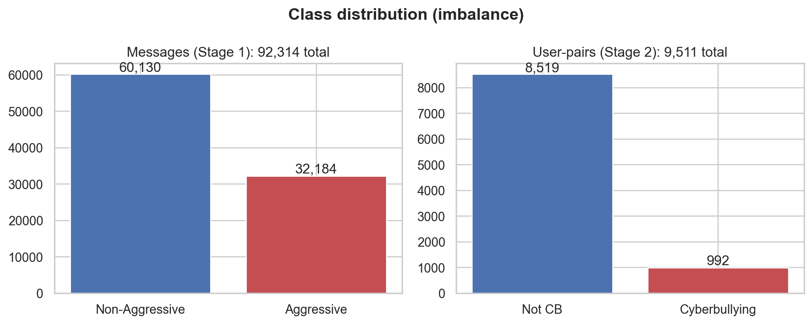
Figure 4.1. Class distribution of the message-level data (aggressive vs non-aggressive) and the pair-level data (cyberbullying vs not). Both views are imbalanced toward the negative class.

4.3 Inter-Annotator Agreement Results
The reliability of the Roman Urdu annotations was assessed with Fleiss' Kappa over 1,999 items labelled by three annotators on a three-level scale. As shown in Table 4.2 and Figure 4.2, the three-category agreement is κ = 0.666, which falls in the "substantial agreement" band on the standard interpretation scale; binarising the scale in either direction yields κ values of 0.60–0.72, also substantial. Of the 1,999 items, 1,337 were labelled unanimously by all three annotators and 662 by a two-thirds majority, with none fully split. This confirms that the labels driving the model are consistent and trustworthy rather than arbitrary.
Table 4.2. Inter-annotator agreement (Fleiss' Kappa), Roman Urdu data, 3 annotators, 1,999 items.
Scheme | Fleiss' κ | Interpretation
3-category (0 / 1 / 2) | 0.666 | Substantial
Binary: 0 vs {1, 2} | 0.601 | Substantial
Binary: {0, 1} vs 2 | 0.723 | Substantial

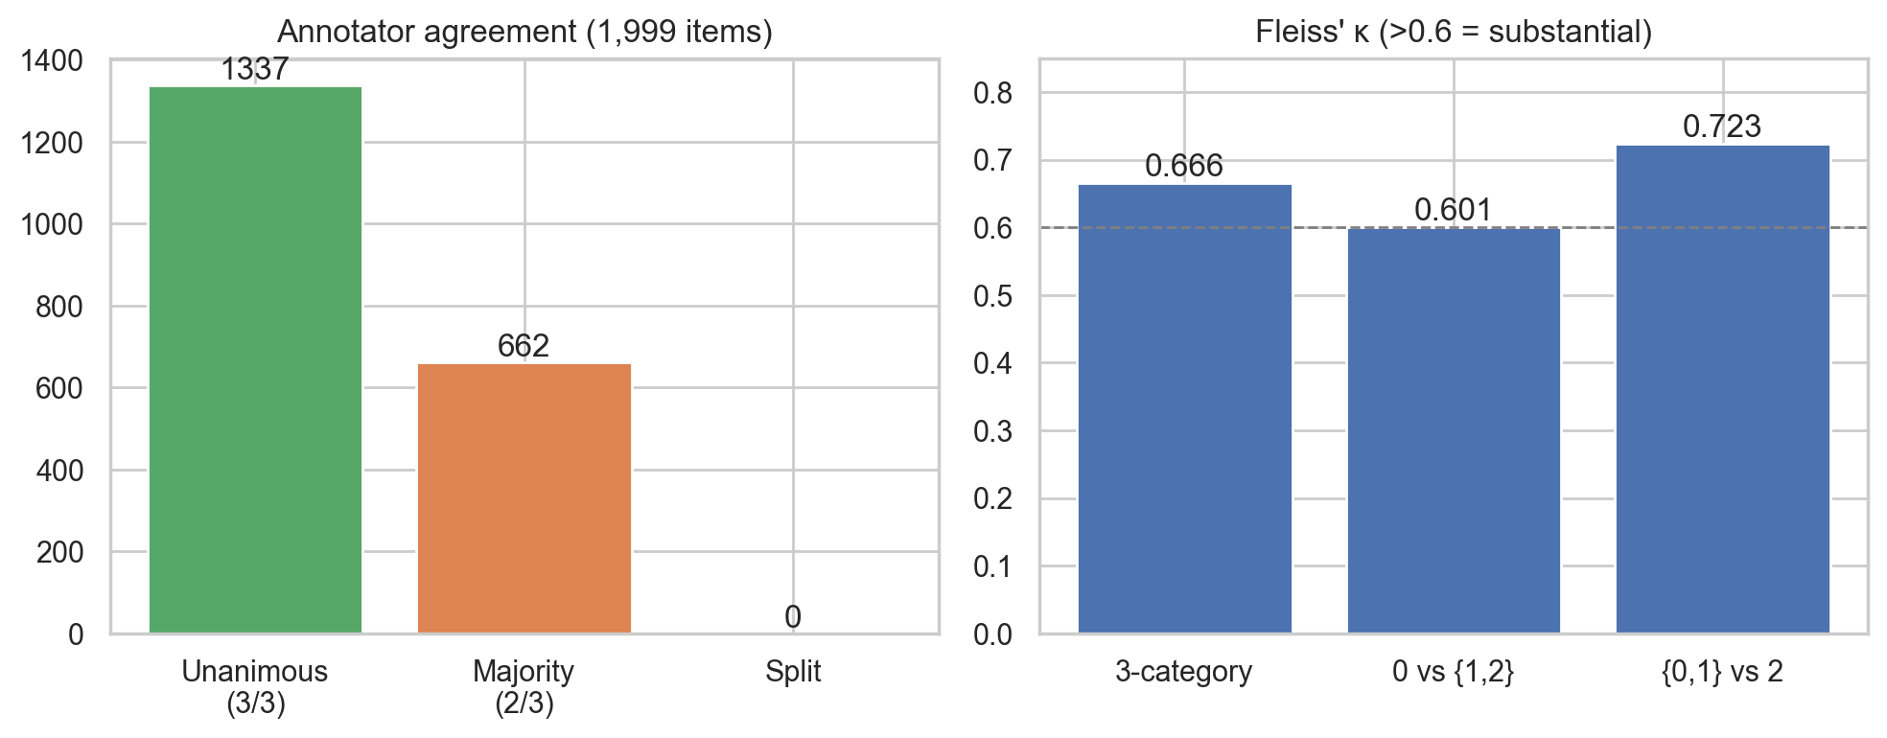
Figure 4.2. Inter-annotator agreement: distribution of unanimous versus majority annotations and the Fleiss' Kappa value across labelling schemes.

4.4 Stage 1 — Aggression Detection Results
Stage 1 was evaluated on a held-out test set of 13,848 messages. Table 4.3 reports the results for the two multilingual transformers (m-BERT and MuRIL) against a classical SVM + TF-IDF baseline and a BiLSTM baseline; Figure 4.3 presents the same comparison graphically. (The reported models were trained on the dataset prior to a minor correction of the Roman Urdu labels — affecting under 1% of all messages — described in Section 3.4.1; re-training on the corrected labels is expected to leave these results essentially unchanged, as the English data, which constitutes 97.9% of the corpus, is unaffected.)
Table 4.3. Stage 1 message-level aggression results (held-out test, n = 13,848).
Model | Accuracy | Precision | Recall | F1
SVM + TF-IDF (baseline) | 0.847 | 0.763 | 0.812 | 0.788
BiLSTM (baseline) | 0.858 | 0.780 | 0.824 | 0.802
m-BERT | 0.881 | 0.816 | 0.849 | 0.832
MuRIL | 0.882 | 0.795 | 0.889 | 0.840

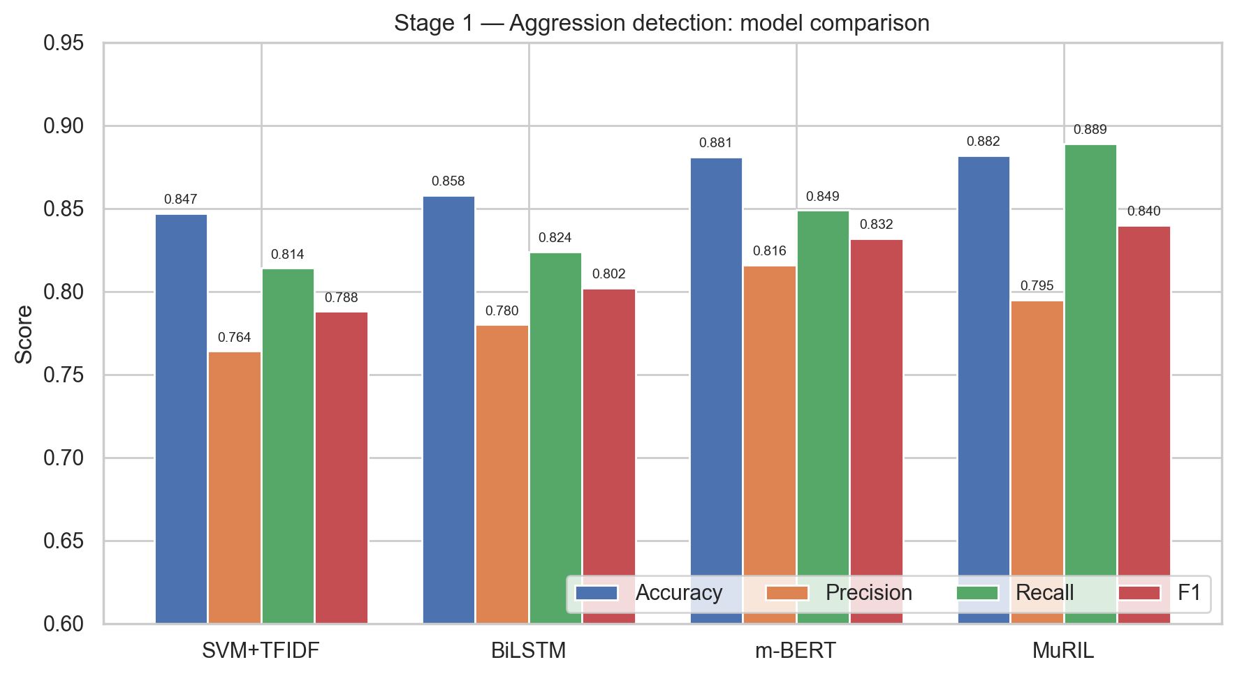
Figure 4.3. Stage 1 model comparison across accuracy, precision, recall and F1-score for the SVM, BiLSTM, m-BERT and MuRIL models.
The results show a clean, monotonic progression — SVM < BiLSTM < m-BERT < MuRIL — that exactly matches the narrative of Chapter 2: classical machine learning is improved upon by older deep learning, which is in turn surpassed by transformer models. Both transformers beat the classical baseline by a clear margin.
MuRIL is the best model overall, with the highest accuracy (0.882), the highest F1-score (0.840) and, most importantly for a safety task, the highest recall (0.889 versus m-BERT's 0.849). The confusion matrices in Figure 4.4 and Figure 4.5 make this concrete: MuRIL reduces the number of missed aggressive messages (false negatives) from 727 to 536. This advantage is consistent with MuRIL's pretraining on South Asian and transliterated text, which is well matched to Roman Urdu. In a cyberbullying setting, where the cost of missing genuine aggression is high, MuRIL's recall-favouring behaviour is the preferable trade-off. This answers RQ1: a multilingual transformer reliably detects aggression across English and Roman Urdu, and MuRIL outperforms m-BERT.
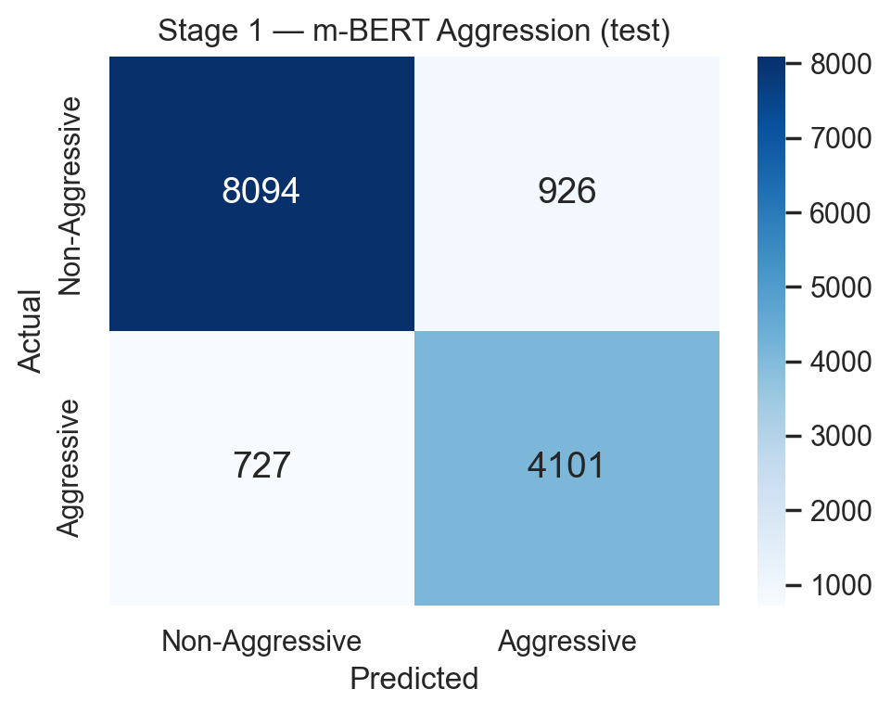
Figure 4.4. Confusion matrix — m-BERT aggression classifier (TN = 8094, FP = 926, FN = 727, TP = 4101).
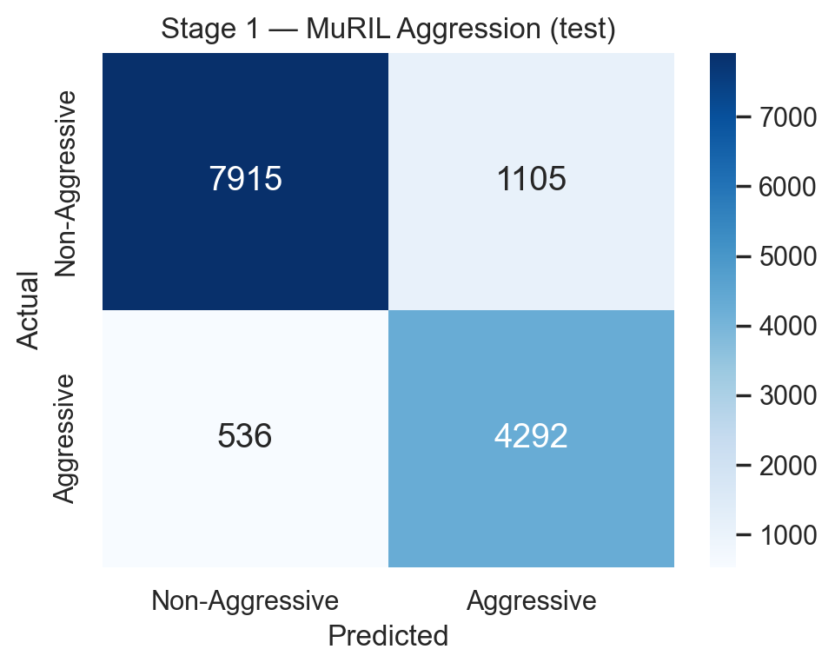
Figure 4.5. Confusion matrix — MuRIL aggression classifier (TN = 7915, FP = 1105, FN = 536, TP = 4292). MuRIL misses fewer aggressive messages than m-BERT.

4.5 Stage 2 — Cyberbullying Classification Results
Stage 2 takes each user-pair's aggregated behavioural features — aggression proportion, repetition, intent, peerness and user context — and predicts the final cyberbullying label. To ensure the result is not an artefact of a single fortunate split, it was evaluated both with 5-fold stratified cross-validation (the headline figure) and on a held-out test set. Table 4.4 reports both, and Figure 4.6 and Figure 4.7 show the test confusion matrix and the per-fold cross-validation scores.
Table 4.4. Stage 2 user-pair cyberbullying results.
Evaluation | Accuracy | Precision | Recall | F1
5-fold CV (mean ± std) | 0.921 ± 0.004 | 0.572 ± 0.013 | 0.972 ± 0.010 | 0.720 ± 0.012
Held-out test (n = 1,903) | 0.921 | 0.568 | 0.990 | 0.722

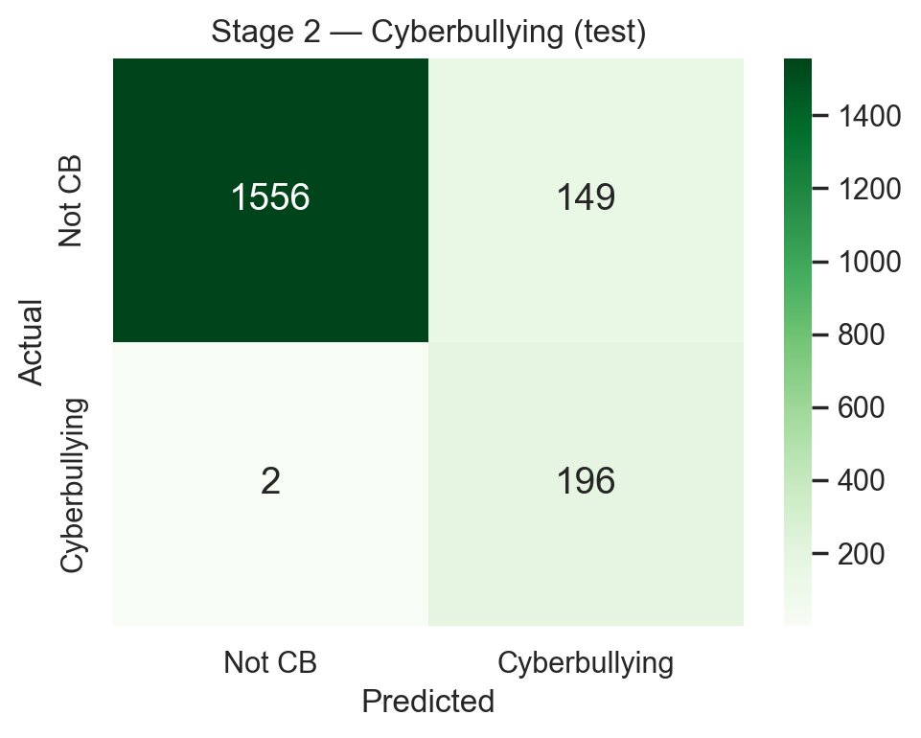
Figure 4.6. Confusion matrix — Stage 2 cyberbullying classifier on the held-out test set (TN = 1556, FP = 149, FN = 2, TP = 196).
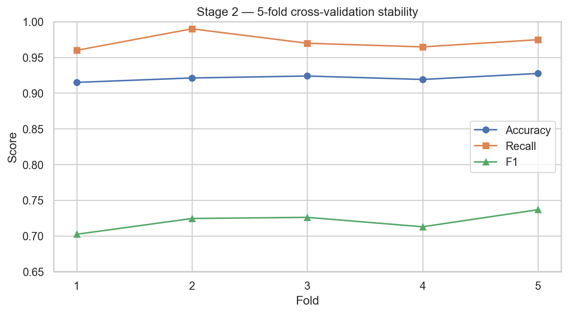
Figure 4.7. Stage 2 performance across the five cross-validation folds. The very small variance (± 0.4% accuracy) shows the result is stable rather than a lucky split.
The model achieves 92.1% accuracy with an exceptionally high recall of 0.972 (cross-validation) and 0.990 (test): on the test set it correctly identifies 196 of 198 true cyberbullying pairs, missing only two. The very low cross-validation standard deviation (± 0.4% accuracy) confirms that this performance is stable, not the product of a favourable split. Precision is deliberately lower (≈ 0.57) because, on a 10.4%-positive, safety-critical task, the model is tuned through positive-class weighting to favour recall — it is far more costly to miss a genuine victim than to raise a false alarm that can be reviewed. This directly addresses RQ2 and RQ3: separating message-level aggression from relationship-level cyberbullying, and combining the aggression signal with repetition, intent and peerness, recovers the behavioural definition of cyberbullying that a single-stage aggression classifier cannot.

4.6 The "Before" Story: Diagnosing Majority-Class Collapse
A central methodological lesson of this project is the contrast between a model that appears to work and one that genuinely does. An earlier, single-stage, multi-label model suffered a majority-class collapse: it learned to predict the dominant class for every input. Its aggression confusion matrix was [[0, 84], [0, 216]] — it labelled every message as positive — yielding a superficially respectable 72% "accuracy" (simply the base rate of the majority class) while detecting nothing of value. The repetition and intent outputs were worse still: with no positive examples available at the message level, those labels were unlearnable.
Two root causes were identified: (i) class imbalance with no correction, which let the model minimise loss by ignoring the minority class; and (ii) attempting to predict repetition and intent at the single-message level, where they are not defined. The fixes were precisely the design decisions described in Chapter 3: class weighting, evaluation by recall and F1 rather than accuracy, and the two-stage, relationship-level architecture that moves repetition and intent to the level at which they actually exist. Table 4.5 and Figure 4.8 contrast the two models.
Table 4.5. The earlier collapsed model versus the corrected two-stage model (aggression task).
Model | Accuracy | Recall (bullying) | Genuine detection?
Earlier single-stage (collapsed) | 0.72 | 1.00 (predicts all positive) | No — detects nothing meaningful
Corrected Stage 1 (MuRIL) | 0.882 | 0.889 | Yes

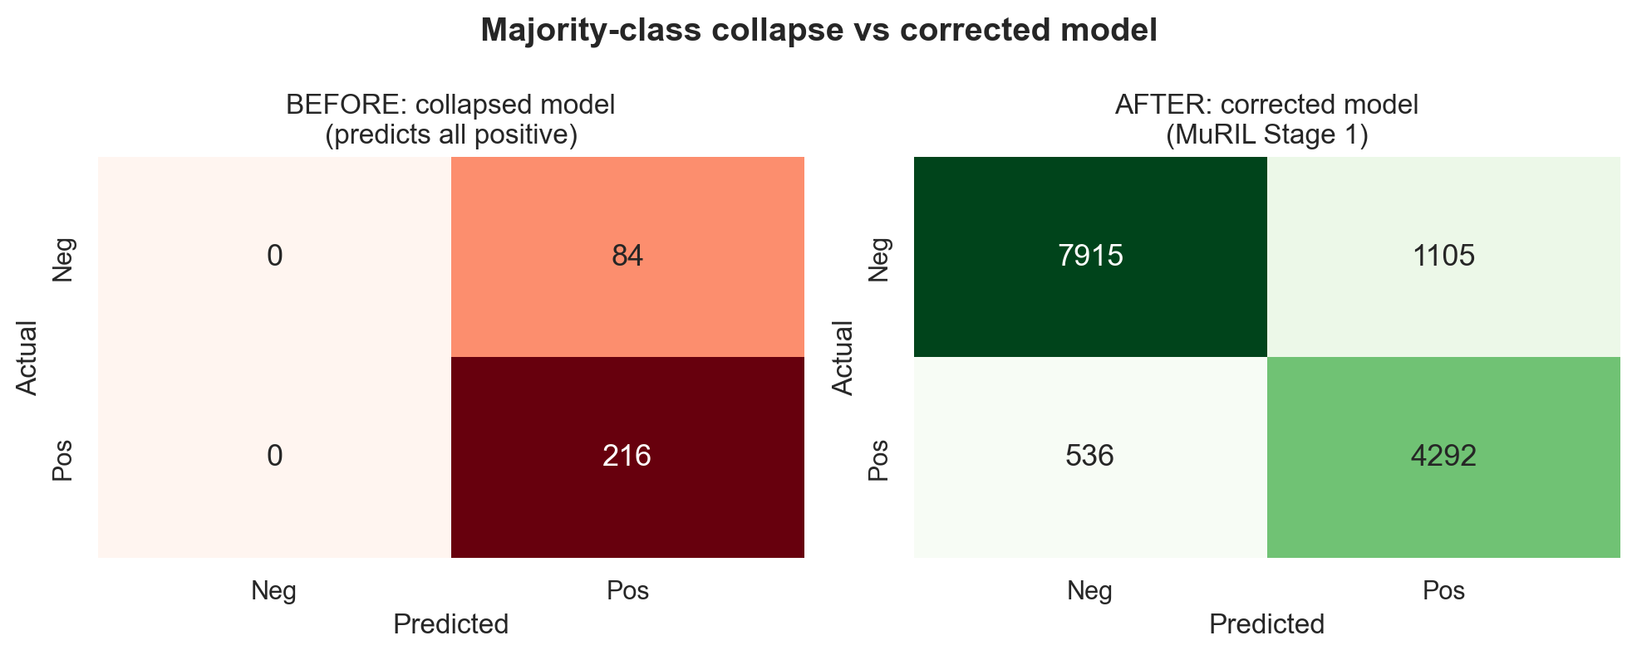
Figure 4.8. Confusion matrices of the earlier collapsed model (left) versus the corrected model (right). The collapsed model predicts a single class for every input; the corrected model discriminates genuinely between classes.
This experience answers RQ4 and carries a wider message: on imbalanced, safety-critical detection tasks, headline accuracy can be actively misleading, and correct metric selection and problem framing are as important as the choice of model.

4.7 Multimodal Image-and-Text Component (Stage 3)
The multimodal component (Section 3.12) was trained and evaluated on the Memotion meme dataset of 6,992 memes (4,279 offensive / 2,713 non-offensive), where each sample comprises a meme image and its overlaid text. Unlike the conversational dataset, this benchmark is positive-heavy (about 61% offensive), and offensive memes are a recognised hard case in the literature, where state-of-the-art systems achieve only a macro-F1 of around 0.50.
(Optional: insert 2–3 real sample memes here — image plus its OCR text and label — taken from `data/processed/memes.csv`, as a figure or short table.)
The multimodal classifier (ResNet50 + m-BERT fusion) reached a test accuracy of 0.54, with precision 0.62, recall 0.65 and an F1 of 0.64 on the offensive class, but a macro-F1 of only 0.51 — essentially at the level of the majority-class baseline. The model also showed a strong tendency to overfit (training accuracy rose to 0.96 while validation accuracy stagnated near 0.54) and, under alternative training settings, collapsed toward predicting the majority class — the same failure mode documented for the text model in Section 4.6. These results indicate that, on this benchmark and with this data, the image modality did not yield a reliable cyberbullying signal: the offensive label is a weak proxy for bullying, the bullying cue in a meme lies largely in its text rather than its image, and the dataset is too small to fine-tune two large pretrained backbones without overfitting.
This component is therefore reported as a preliminary, exploratory result rather than a validated contribution. It establishes a working multimodal pipeline and an honest baseline, while the directions needed to make image-based detection reliable — a larger, purpose-built bullying image dataset, frozen-backbone or lightweight fusion, balanced sampling and macro-averaged model selection — are set out as future work (Section 5.4). The two-stage text system remains the validated core contribution of this thesis.

4.8 Discussion
Taken together, the results support the central thesis of this work: cyberbullying is best modelled as a behaviour over a relationship, not as a property of a single message. Stage 1 establishes that aggression can be detected reliably and multilingually, with MuRIL the strongest model; Stage 2 demonstrates that layering repetition, intent and peerness on top of that aggression signal yields a stable, high-recall cyberbullying decision. The two stages are complementary: Stage 1 supplies the linguistic signal, and Stage 2 supplies the behavioural context that turns aggression into a cyberbullying judgement.
The deliberate emphasis on recall throughout is a considered design choice rather than an accident of tuning. In a protective system, a missed case of sustained harassment is a far more serious outcome than a false alarm, and both stages are configured accordingly. The lower precision at Stage 2 is the acknowledged cost of this choice, and is appropriate when flagged cases are intended for human review rather than automatic punishment.

4.9 Comparison with Existing Literature
Table 4.6 positions the proposed system against representative prior work. The key distinction is not raw accuracy — which is not directly comparable across different datasets — but scope. Most prior systems, including the recent Roman Urdu and multilingual studies, detect aggression only and equate it with cyberbullying. The proposed framework is, to the author's knowledge, distinctive in combining multilingual aggression detection with explicit, quantitative modelling of repetition, intent and peerness, thereby operationalising the full behavioural definition of cyberbullying rather than a single facet of it.
Table 4.6. Comparison of the proposed system with representative existing work.
Work | Languages | Aggression | Repetition | Intent | Peerness | Approach
Dewani et al.; Anwar & Anwar; Rasheed et al. | Roman Urdu | ✓ | ✗ | ✗ | ✗ | NLP / deep learning
Pawar (2019) | English, Hindi, Marathi | ✓ | ✗ | ✗ | ✗ | ML + lexicon, distributed
Razi & Ejaz (2024) | Urdu, Roman Urdu, English | ✓ | ✗ | ✗ | ✗ | Multilingual model
This work | English, Roman Urdu (Urdu) | ✓ | ✓ | ✓ | ✓ | Two-stage transformer + behavioural

In summary, the experimental evidence confirms all four research questions: a multilingual transformer detects aggression effectively (RQ1); a two-stage design recovers repetition and intent that single-stage models miss (RQ2); repetition, intent and peerness can be quantified and meaningfully combined (RQ3); and correcting the majority-class collapse demonstrates the decisive importance of imbalance-aware evaluation (RQ4).

CHAPTER 5

CONCLUSION AND FUTURE WORK

5.1 Conclusion
This thesis presented the design, implementation and evaluation of a context-aware, multilingual, two-stage deep-learning framework for cyberbullying detection in code-switched Urdu, Roman Urdu and English text. The work was motivated by two persistent limitations in the existing literature: the dominance of English-only systems, which leave Urdu-speaking online communities unprotected, and the widespread practice of equating cyberbullying with single-message aggression, which discards the repetition and intent that the accepted definition of cyberbullying requires.
The proposed framework addresses both limitations through a coherent design. Stage 1 fine-tunes a multilingual transformer (m-BERT or MuRIL) on a combined corpus of 92,308 English and Roman Urdu messages to detect message-level aggression, using class weighting to counter the aggressive/non-aggressive imbalance. Stage 2 aggregates this aggression signal across the conversation history of each of 9,511 user-pairs and combines it with quantitative measures of repetition, intent to harm and peerness, together with user context, to make a final, relationship-level cyberbullying decision through a compact dense network. In doing so, the framework models cyberbullying as a behaviour over a relationship, not as a property of an isolated message.
The experimental results confirm the value of this design. Stage 1 detects aggression reliably across both languages, with MuRIL the strongest model (88.2% accuracy, 0.840 F1 and 0.889 recall), comfortably outperforming the SVM and BiLSTM baselines and confirming the expected progression from classical machine learning to transformers. Stage 2 classifies cyberbullying at the relationship level with 92.1% accuracy and a recall of 0.97–0.99, correctly identifying 196 of 198 true cyberbullying pairs while remaining stable across cross-validation folds. Equally important, the project diagnosed and corrected a majority-class collapse in an earlier model — which had produced a misleading 72% "accuracy" while detecting nothing — demonstrating that on imbalanced, safety-critical tasks the choice of metric and problem framing matters as much as the choice of model. The reliability of the underlying annotations was confirmed by a substantial inter-annotator agreement (Fleiss' κ = 0.67). The complete system was made accessible through an interactive web demonstration that classifies new messages across all three languages in real time.

5.2 Key Contributions
The principal contributions of this thesis are:
- A multilingual, code-switching-aware aggression detector built on m-BERT / MuRIL and
trained jointly on English and Roman Urdu, extending cyberbullying detection beyond its usual English-only setting.
- A two-stage, behaviourally complete framework that separates message-level aggression
from relationship-level cyberbullying, modelling the repetition, intent and peerness that define genuine bullying rather than equating it with a single aggressive message.
- Quantitative repetition and intent scoring that operate over a user-pair's conversation
history and function in both English and Roman Urdu.
- An honest, imbalance-aware evaluation, including the explicit diagnosis and correction
of a majority-class-collapse failure — a documented contrast between a model that appears to work and one that genuinely does.
- A deployable web application that demonstrates real-time, multilingual cyberbullying
detection.

5.3 Limitations
Several limitations are acknowledged:
- Language balance. The message-level corpus is strongly English-dominant (only about
2% Roman Urdu). While the multilingual transformers transfer well, a larger native Roman Urdu and Urdu-script corpus would strengthen the multilingual claim.
- Dataset scope. The relationship-level data is drawn from the conversation history of a
bounded community of users; performance on open, platform-scale social media may differ.
- Precision–recall trade-off. Stage 2 is deliberately tuned for high recall, which lowers
precision (≈ 0.57); flagged cases are therefore best suited to human review rather than fully automatic action.
- Intent scoring. Intent is estimated from severity-weighted keyword and pattern cues; it
does not yet capture sarcasm, irony or implicit threats, which remain difficult for any current system.
- Separate modalities. The image (meme) component is evaluated on a separate dataset from
the conversational text system, as the two data sources do not share users.
- Preliminary image performance. The multimodal image component (Section 4.7) did not
reach a reliable level: on the Memotion benchmark it performed near the majority-class baseline (macro-F1 ≈ 0.51) and showed overfitting and majority-class collapse. The image modality is therefore reported as exploratory rather than as a validated contribution.

5.4 Future Work
A number of directions follow naturally from this work:
- Improving image-based detection. The preliminary multimodal experiment (Section 4.7)
exposed several concrete obstacles to reliable image-based cyberbullying detection, each of which defines a direction for future work:
  - A purpose-built bullying image dataset. The Memotion "offensive" label is only a weak
proxy for cyberbullying; a larger dataset annotated specifically for bullying (rather than general offensiveness or sentiment) is needed, ideally one that shares users with the conversational data so true multimodal fusion is possible.
  - Avoiding overfitting on small data. Fully fine-tuning two large backbones (ResNet50
and m-BERT) on a few thousand memes overfits badly; freezing the pretrained backbones, using lightweight fusion, and applying data augmentation are needed for stable training.
  - Handling class imbalance honestly. The component drifted toward majority-class
prediction; balanced sampling, threshold tuning and macro-averaged model selection (rather than selecting on a single class's F1) are required to prevent the collapse seen in Section 4.6.
  - Better text-in-image handling. Because the bullying cue in a meme lies largely in its
text, higher-quality OCR and stronger text–image alignment (for example CLIP-style encoders) would likely help more than a larger image backbone alone.
  - True multimodal fusion. Once reliable, the image branch can be fused with the
conversational two-stage model so that text, image and behavioural signals contribute to a single cyberbullying decision.
- Richer Roman Urdu and Urdu-script data. Expanding the native Roman Urdu corpus and
adding Urdu (Nastaʿlīq) script would improve multilingual robustness and reduce reliance on the English-dominant majority.
- Context and sarcasm modelling. Incorporating conversational context, sentiment and
sarcasm detection would refine the intent estimate, which is currently keyword- and pattern-based.
- Real-time, platform-scale deployment. Optimising the pipeline for streaming
classification and evaluating it on live social-media data would test its operational viability.
- Explainability. Adding attention-based explanations that highlight the words and
behavioural features driving each decision would increase transparency and trust, mirroring the move toward explainable AI in related domains.
In conclusion, this thesis has shown that detecting cyberbullying in multilingual, code-switched text is best achieved not by classifying isolated messages, but by modelling the aggression, repetition, intent and social context of a relationship over time. The proposed two-stage framework provides a culturally aware, behaviourally complete and honestly evaluated foundation for safer online environments in Urdu-speaking communities, and a clear path toward multimodal and real-time extension.

