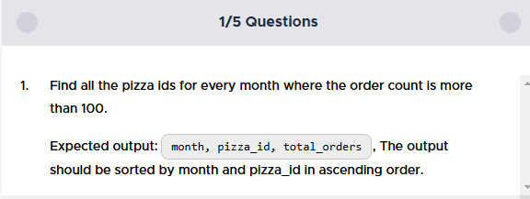

SELECT

 EXTRACT(MONTH FROM date) as month,

 OD.pizza_id,

 COUNT(O.order_id) as total_orders

 FROM ORDERS O

 LEFT JOIN ORDER_DETAILS OD ON

 O.order_id = OD.order_id

 LEFT JOIN PIZZAS P ON

 OD.pizza_id = P.pizza_id

 GROUP BY 1,2

 HAVING COUNT(O.order_id)>100

 ORDER BY 1,2

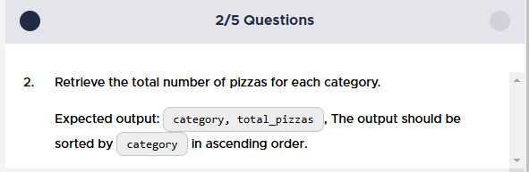

SELECT

 category,

 COUNT(OD.order_id) as total_pizzas

 FROM PIZZA_TYPES AS PT

 LEFT JOIN PIZZAS P ON

 PT.pizza_type_id = P.pizza_type_id

 LEFT JOIN ORDER_DETAILS OD ON

 OD.pizza_id = P.pizza_id

 GROUP BY 1

 ORDER BY 1

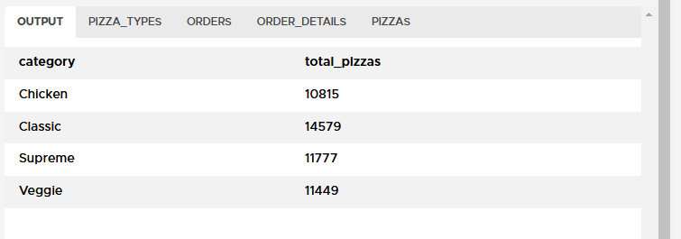



SELECT

 DISTINCT(order_id),

 (price*quantity) as order_amount

 FROM ORDER_DETAILS od

 JOIN PIZZAS p ON

 od.pizza_id = p.pizza_id

 ORDER BY 2 Desc

 limit 1

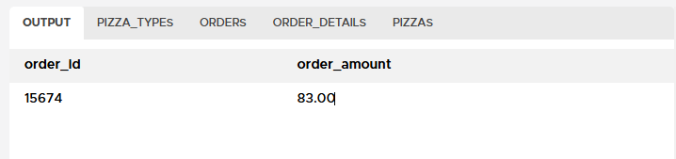

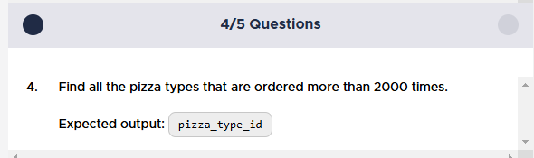

 SELECT

 pizza_type_id

 FROM ORDER_DETAILS od

 JOIN PIZZAS p ON

 od.pizza_id = p.pizza_id

 group by 1

 having count(pizza_type_id) > 2000

 order by 1

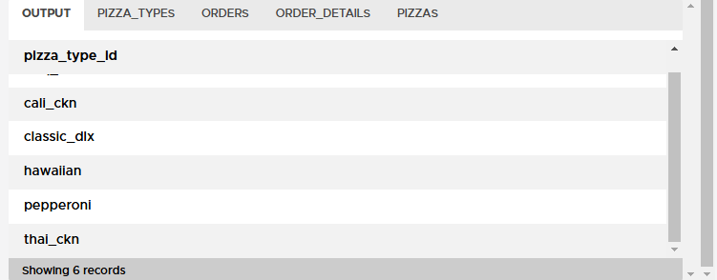

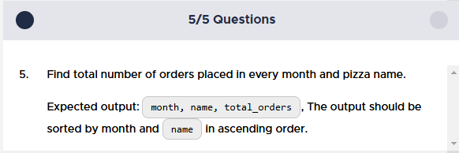

 SELECT

 EXTRACT(MONTH FROM o.date) as month,

 pt.name,

 COUNT(od.pizza_id) as total_orders

 FROM ORDERS o

 JOIN ORDER_DETAILS od ON

 o.order_id = od.order_id

 JOIN PIZZAS p ON

 od.pizza_id = p.pizza_id

 JOIN PIZZA_TYPES pt ON

 pt.pizza_type_id = p.pizza_type_id

 group by 1,2

 order by 1,2

