
Titel:
QR Code Scanner,Verification & Generator
Submitted by:
Rabiha Arshad:100056
Ayesha Muqeet:112649
Submitted to:
Mam Rimsha Kiran
Subject:
Digital image processing
Date:
February 2026
🟦 Abstract
This project presents a QR Code Scanner, Verification, and Generator system developed using Python. The system allows users to generate QR codes from text or links, verify the generated QR codes, and scan QR codes from images. Additionally, the project includes blur detection to identify whether an image is clear or blurry before scanning. The system uses OpenCV, Pyzbar, and QRCode libraries to ensure accurate detection and decoding. This project provides a simple and efficient solution for QR code processing.
🟦 Introduction
QR codes are widely used for storing and sharing information such as URLs, text, and digital data. They are commonly used in payments, authentication, and information sharing systems. However, scanning QR codes from low-quality or blurry images can cause errors.
This project focuses on generating QR codes, verifying their correctness, scanning QR codes from images, and detecting image blur to improve scanning accuracy. The system is implemented using Python and computer vision techniques.
🟦 Methodology
- The project works in the following steps:
- The user selects an option from the main menu.
- For QR generation, the user enters text or a link.
- A QR code is generated and saved as an image.
- The generated QR code is verified by decoding it and matching the data.
- For scanning, the user selects an image file.
- The system checks whether the image is blurry or clear.
- If a QR code is detected, the encoded data is extracted and displayed.
🟦 Algorithms Used
1. QR Code Generation Algorithm
The QR code generation algorithm takes user input and converts it into a QR code image using the QRCode library.
Code Snippet:
qr = qrcode.QRCode(version=1, box_size=10, border=5)
qr.add_data(text)
qr.make(fit=True)
img = qr.make_image(fill_color="black", back_color="white")
2. QR Code Verification Algorithm
After generating the QR code, the system decodes it and verifies whether the scanned data matches the original input.
Code Snippet:
decoded = pyzbar.decode(qr_image)
if scanned_text == text:
print("QR Verified Successfully")
3. Blur Detection Algorithm
Blur detection is performed using the Laplacian Variance method. If the variance value is below a threshold, the image is considered blurry.
Code Snippet:
laplacian_var = cv2.Laplacian(gray, cv2.CV_64F).var()
if laplacian_var < 100:
return True
4. QR Code Scanning Algorithm
The scanning algorithm detects and decodes QR codes from image files.
Code Snippet:
decoded_objects = pyzbar.decode(img)
for obj in decoded_objects:
data = obj.data.decode("utf-8")
🟦 Results and Discussion
The system successfully generates QR codes for user-provided input and verifies their correctness. QR codes are scanned accurately from clear images, while blurry images are detected and flagged. The results show that the blur detection algorithm improves scanning reliability. Screenshots of generated QR codes, verification messages, and scanned outputs demonstrate the correct working of the system.
Menu screen Choice 1
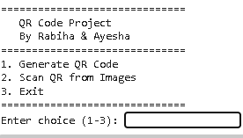
Generate Qr code
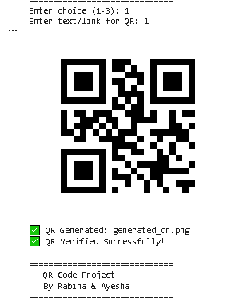
Choice 2 Scan Qr
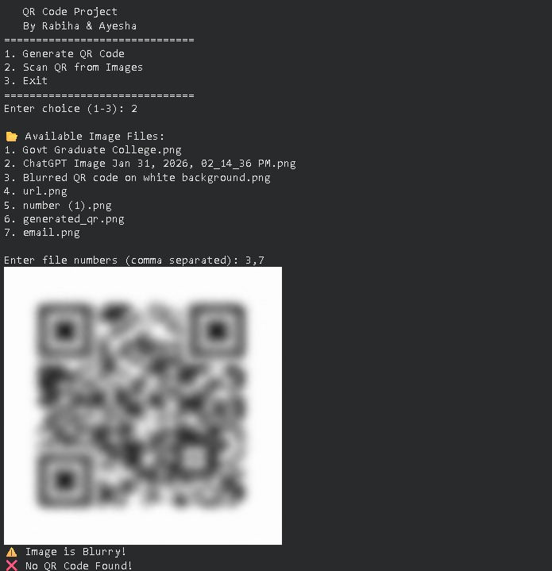
Choice 3
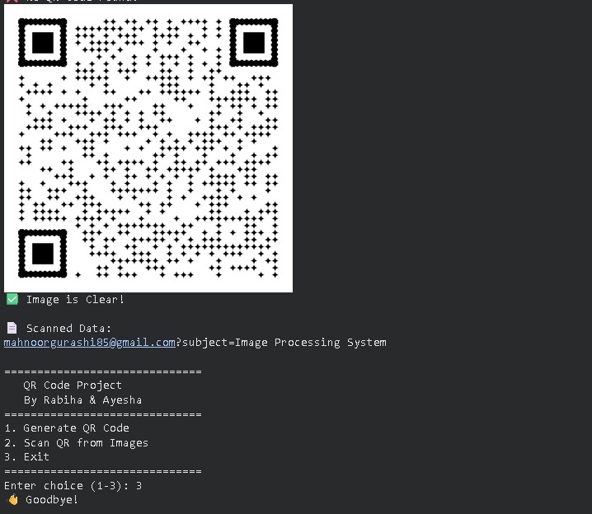

🟦 Conclusion
This project successfully implements a QR Code Scanner, Verification, and Generator system using Python. The integration of blur detection enhances scanning accuracy. The system is easy to use and can be applied in real-world applications such as secure data sharing and authentication systems. Future improvements may include real-time camera scanning and mobile application integration.
🟦 References
- OpenCV Documentation
- Pyzbar Library Documentation
- Python QRCode Library
- Official Python Documentation

