AIM: **Write SQL queries to perform KEY CONSTRAINTS (i.e. PRIMARY KEY, FOREIGN KEY, UNIQUE NOT NULL, CHECK, DEFAULT).**

**Types of SQL Constraints.**

1. NOT NULL - Ensures that a column cannot have a NULL value
2. UNIQUE - Ensures that all values in a column are different
3. PRIMARY KEY - A combination of a NOT NULL and UNIQUE. Uniquely I Identifies each row in a table
4. FOREIGN KEY - Uniquely identifies a row/record in another table
5. CHECK - Ensures that all values in a column satisfies a specific condition
6. DEFAULT - Sets a default value for a column when no value is specified

**1.NOT NULL Constraint Example:**

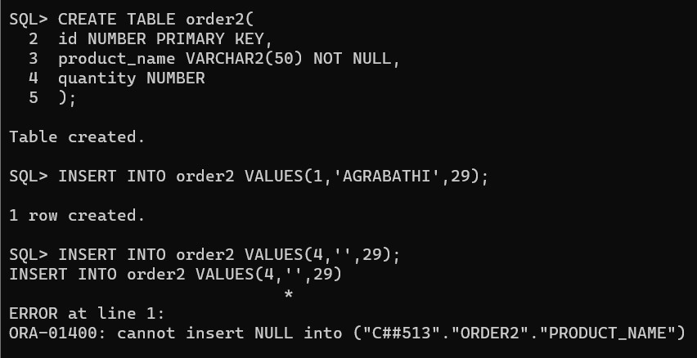

2.UNIQUE CONSTRAINT Example:

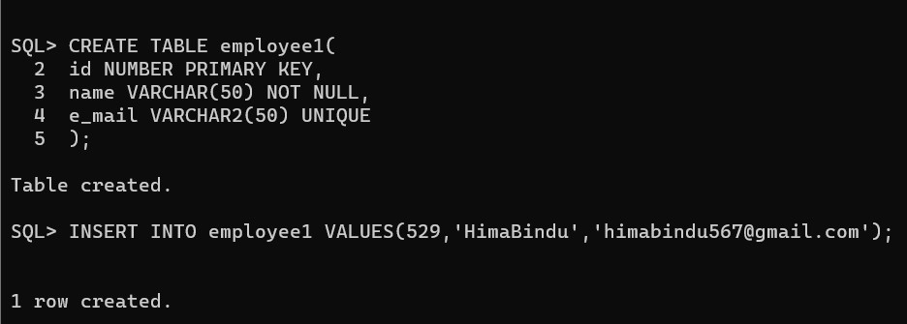

3.PRIMARY KEY CONSTRAINT Example:

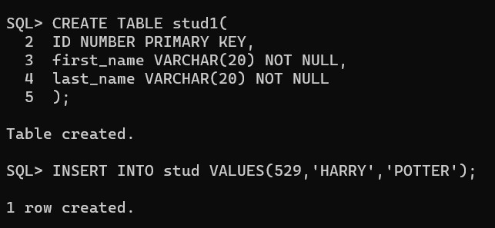

4.FORIEGN KEY CONSTRAINTS Example:

224G1A0529 HimaBindu

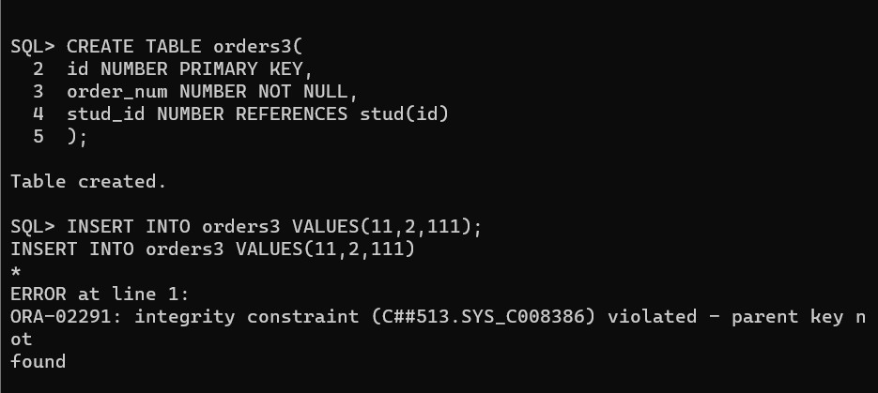

5.CHECK CONSTRAINTS Example:

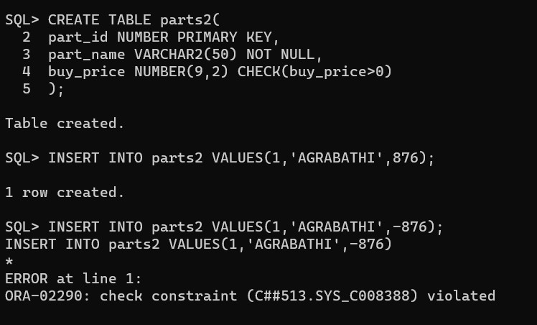

6.DEFAULT CONSTRAINTS Example:

