**COVID-19 Pakistan’s Statistics**



COVID-19 also called Corona Virus is a highly infectious respiratory disease. The disease was discovered in China in December 2019 and now spread around the world. In Pakistan, first case of this disease was discovered in February 2020 in Karachi and now spread around the whole country. The purpose of showing these visualizations is to inform about the current situation of Pakistan from COVID-19.

**Tool used:**

Tableau Public 2020.1 is used to create these visualizations. It is a free software that is available to the users to create the interactive visualizations easily from different types of files of datasets e.g. excel file, pdf file, Microsoft access file etc.

**Dataset:**

The link of Dataset used for creating these visuals is as follow:

[***Corona Virus Pakistan Dataset 2020***  
Corona Virus Pakistan Dataset 2020www.kaggle.com](https://www.kaggle.com/mesumraza/corona-virus-pakistan-dataset-2020)

**GitHub Repository:**

<https://github.com/Ayesha-Rehman1999/Ayesha-Rehman_006-Datascience-project-/pulse>

**Visualizations:**

1. **Current situation of country:**

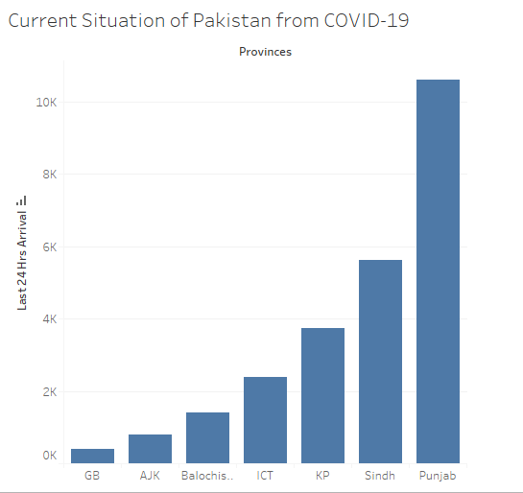

As it seems that different regions of Pakistan are badly effected by corona virus day by day. The situation of different regions of Punjab and Sindh is alarming as the large number of patients arrived at last 24 hours.

1. **Number of hospitals worked in Pakistan:**

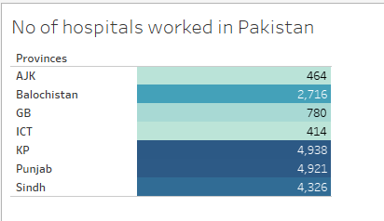

There are large number of hospitals that worked in different provinces to serve patients and fight against the corona virus.

1. **Quarantine Facilities Provided:**

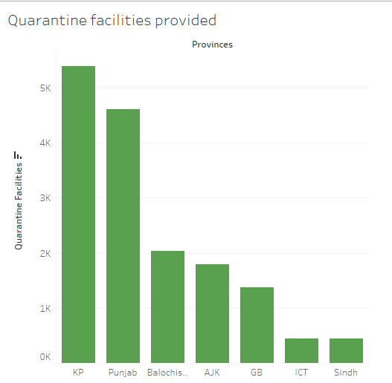

According to the current critical situation, it is very important for people to quarantine themselves. Government take actions and provide the quarantine facilities to the people. It seems from graph that province KPK and Punjab provided more quarantine facilities to the people and it is very good to cater this situation. As Sindh has the large number of affected people so its government should also take more actions to fight against this disease and provide more quarantine facilities.

1. **Total Test Taken:**

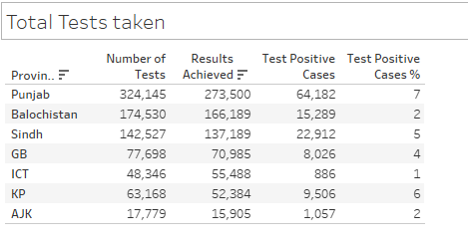

Large number of tests are taken in different provinces of Pakistan. It is clear from above visual that province Punjab has large number of people with positive test cases and higher percentage of positive results. Similarly, Sindh, KPK and GB also badly affected with this disease as the positive test cases percentage is also high there. It is very critical situation as number of patient increases day by day so we need more care about ourselves.

1. **Admitted Patients (Critical vs Stable):**

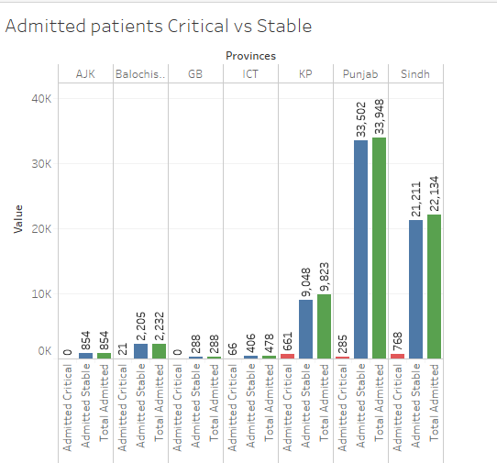

It is clear from above visual that large number of people are affected from COVID-19 and admit in hospital. However the number of critical patients are minimum in most provinces but in Sindh number of critical patients are maximum so people of Sindh need more care or government should provide more facilities to the hospitals for fight against this disease.

1. **Home Quarantined:**

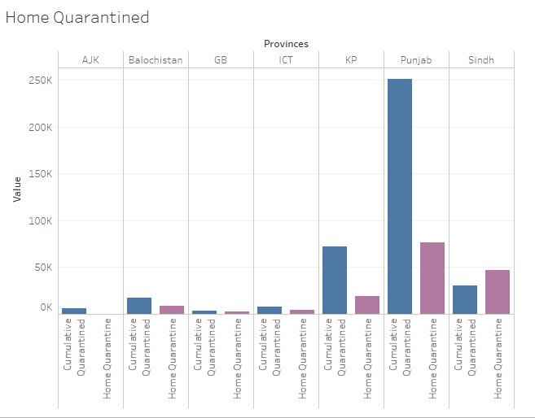

The above visual shows the people that quarantined themselves as well as the number of people that doctor advised to home quarantine. It sees from above visual that people of Punjab and KPK quarantined themselves at their houses. As we know that this disease spread from person to person so it is very important to stay at home or hospital if we need.

1. **Advised returnees to Quarantine:**

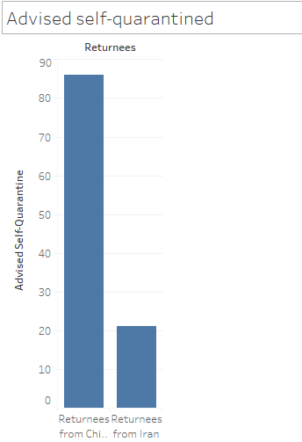

A lot of people returned from China and Iran. Due to corona virus, the doctors advised them to quarantine themselves at least 15 days. Government should provide them facilities in quarantine centers so that it will become easy for them to stay at quarantine centers to avoid spreading this virus.

1. **Death and Recovery Rate:**

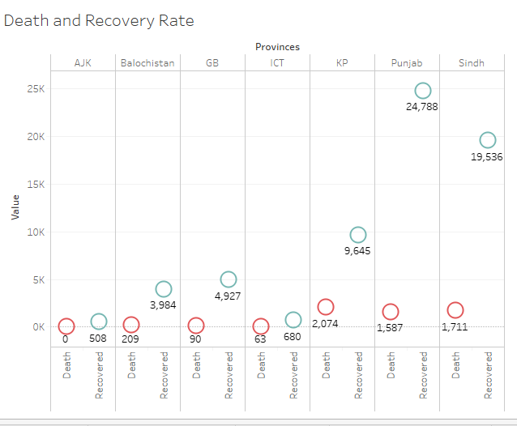

The above visual shows the death and recovery rate of people from COVID-19. As it seems that mostly patients are recovered from this disease and recovery rate is greater than death rate in each province. It is very good and a hope for people that we can overcome this disease but it is only possible if we take the precautionary measures and stay at home and keep social distancing.

1. **No of patients Discharged:**

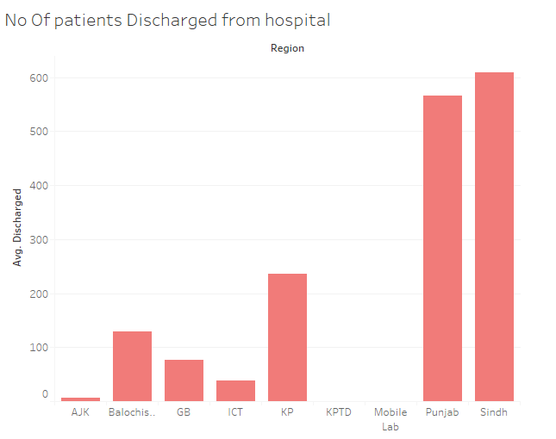

The above visual shows that large number of people are recovered and discharged from the hospitals. As the cases are increases in province Punjab and Sindh but it is clear from above visual that the more patients are recovered and discharged from the hospitals. So there is a hope that we can overcome this disease soon.

1. **No of patients still admit in hospital:**

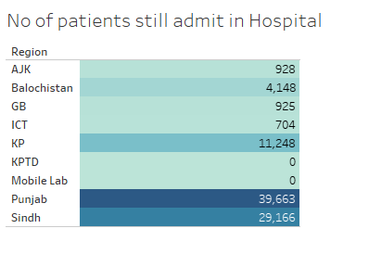

A lot of patients are still admit in hospital as shown in above visual. Punjab is the province that has large number of patients still admitted in hospital. The other regions has also large number of affected patients that still admitted in hospitals.

**Conclusion:**

As we see the condition of different regions of Pakistan is alarming. People are affected by this virus day by day. Especially Punjab and Sindh has more critical condition so these regions should take strict actions to fight against this disease. This condition is somehow due to the carelessness of people as most of the people cannot take this disease serious. For overcome this disease we should follow the precautionary measures and guidelines provided by the government and doctors. As this virus is transfer from person to person so social distancing and staying at home is very necessary. So if people wants to reduce the cases of corona virus so that they should stay at their homes and only go out from their homes when need arise.

Stay Home Stay Safe…………..