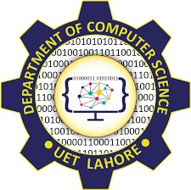
DSA Lab1

Department Of Computer Science
Name: Ayesha Shoukat
Roll No: 2025(S)-CS-52
Section: A
Instructor: Ma’am Sawera Naz

TASK1 &TASK2:
Write a C# program to demonstrate class and object using a Student class.
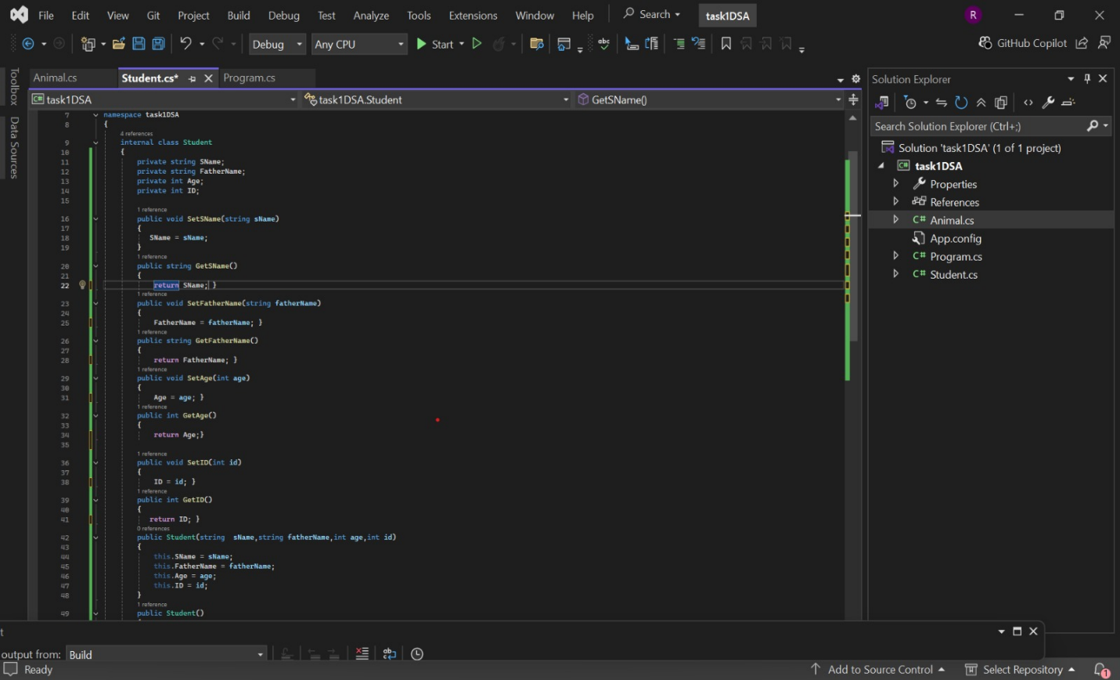
Write a C# program that shows encapsulation by using private data members with public methods.

TASK3 & TASK 4:
Write a C# program to demonstrate method overriding using virtual and override.
Write a C# program to demonstrate runtime polymorphism in C#.
