
Department of Computer Science

Name | Ayesha Azhar
Class | BSCS 5th
Section | A
Registration No | 24-NTU-CS-FL-1021
HomeWork | 2nd
Course Name | IOT

Homework 2
Dual-LED PWM Control with OLED Monitoring

1. Objective
In this homework I made an ESP32 project that fades two LEDs using two different PWM frequencies. The duty cycle and frequency of both LEDs are shown live on an SSD1306 OLED display. I first tested the project in the Wokwi simulator, then built it on the real ESP32 kit, and then uploaded everything to GitHub.

2. Components Used
Component | Quantity | Use
ESP32 DevKit board | 1 | Main controller, generates PWM
LED | 2 | Output (LED 1 and LED 2)
220 ohm resistor | 2 | One resistor for each LED to limit current
SSD1306 I2C OLED (128x64) | 1 | Shows duty cycle and frequency
Breadboard and jumper wires | - | Connections on hardware

3. Task 1: Dual-LED Fading with Different PWM Frequencies
Part | Connected to | Note
LED 1 (anode) via 220 ohm | GPIO 18 | Cathode goes to GND
LED 2 (anode) via 220 ohm | GPIO 19 | Cathode goes to GND
OLED SDA | GPIO 21 | I2C data
OLED SCL | GPIO 22 | I2C clock
OLED VCC | 3V3 | Check module voltage first
OLED GND | GND

3.2 PWM Settings
LED | Frequency | Resolution | Duty range
LED 1 | 1000 Hz | 10 bit | 0 to 1023
LED 2 | 5000 Hz | 10 bit | 0 to 1023

3.3 How the Code Works
- Two PWM outputs are created using the ESP32 LEDC peripheral.
- The variables duty1 and duty2 store the current duty value of each LED.
- In every loop, each duty value is increased by a step (4 for LED 1 and 8 for LED 2).
- When the duty reaches the maximum (1023), the step becomes negative and the LED fades down. At 0 it fades up again.
- Because the steps are different, the two LEDs fade at different speeds.
- The same duty1 and duty2 variables are used for the LEDs and for the OLED, so the display always matches the real values.

3.4 Technical Check: LEDC Timer Sharing
- The ESP32 LEDC has 16 PWM channels (8 high-speed and 8 low-speed), but only 4 timers in each group. Each channel is linked to one timer.
- In Arduino-ESP32 core 2.x, channel 0 and channel 1 share timer 0. Because of this, I used channel 0 for LED 1 and channel 2 for LED 2, so they use different timers. 3.5 Duty Cycle and Brightness
- PWM turns the LED fully ON and OFF very quickly. Duty cycle is the percentage of time the signal stays ON in one cycle. At 0% the LED is always off, at 50% it is ON for half of the time, and at 100% it is always on.

3.6 Effect of PWM Frequency
- Frequency is how many ON/OFF cycles happen in one second. LED 1 at 1000 Hz has a period of 1 ms, and LED 2 at 5000 Hz has a period of 0.2 ms. For the same duty cycle, both LEDs have almost the same brightness.

Task-01

Source code – Task 1 (src/main.cpp, before OLED)
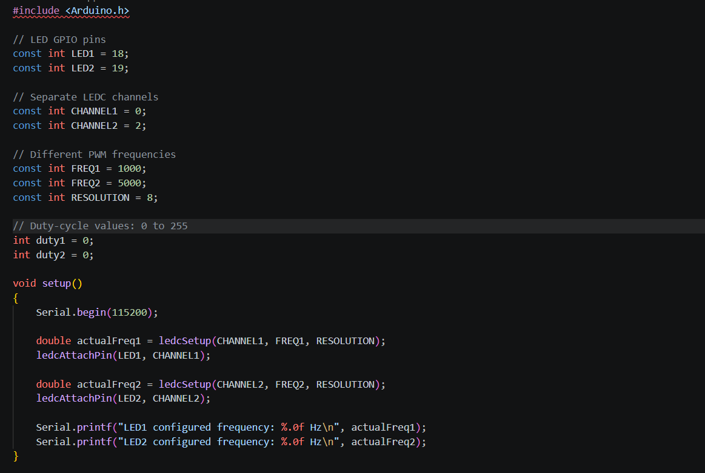

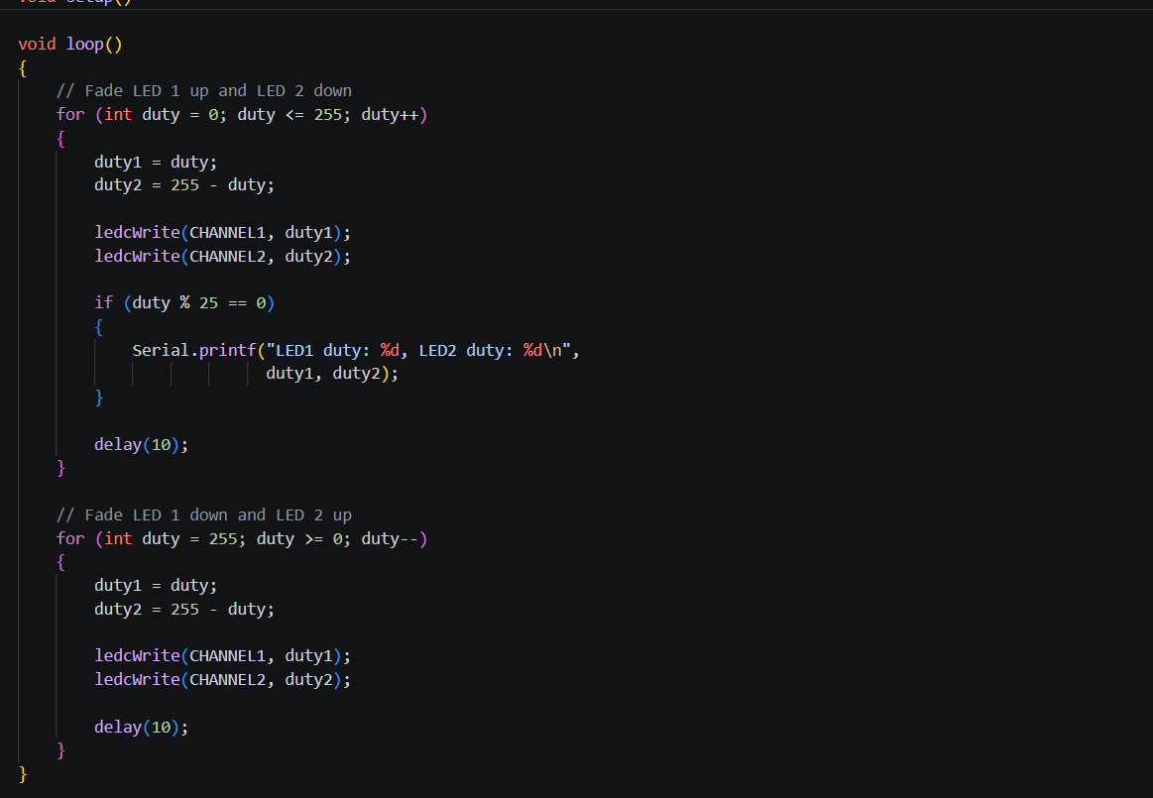

Wokwi Simulation
I updated diagram.json to include the ESP32, two LEDs, two separate resistors and the SSD1306 OLED. The program is written in src/main.cpp. In the simulation both LEDs fade up and down, and the OLED values change at the same time.
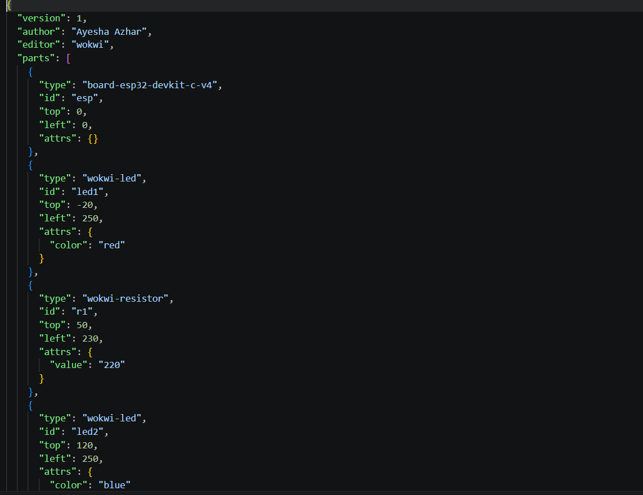
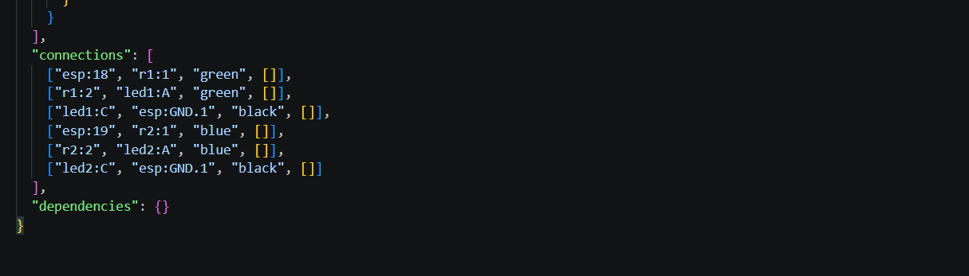

platformio.ini
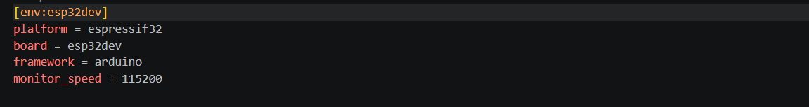

Wokwi,toml:
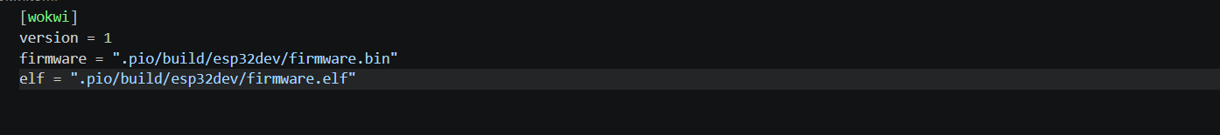

Complete circuit screenshot
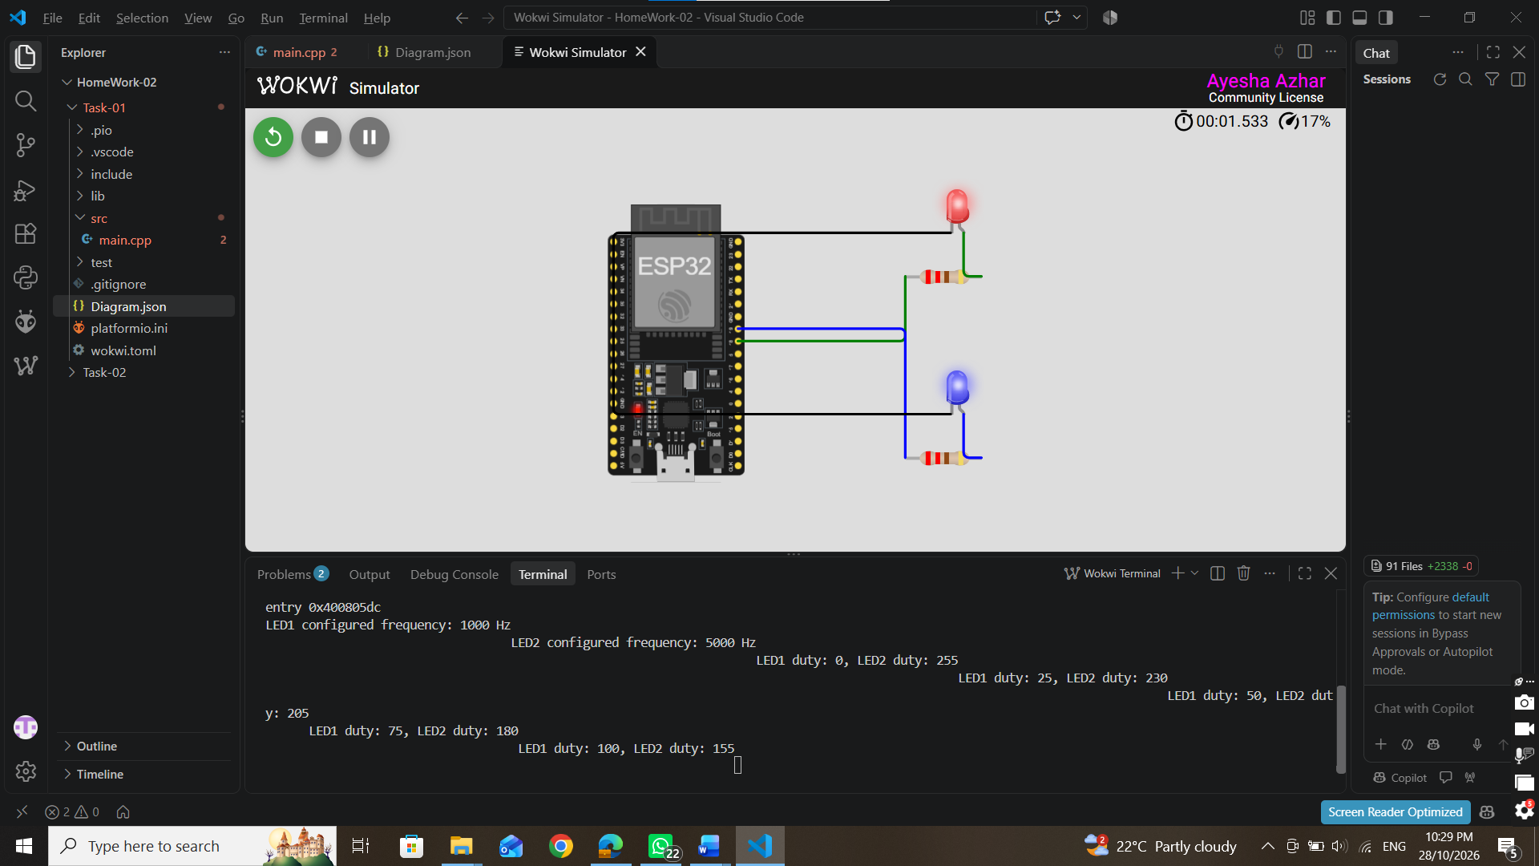

Physical Hardware Implementation:
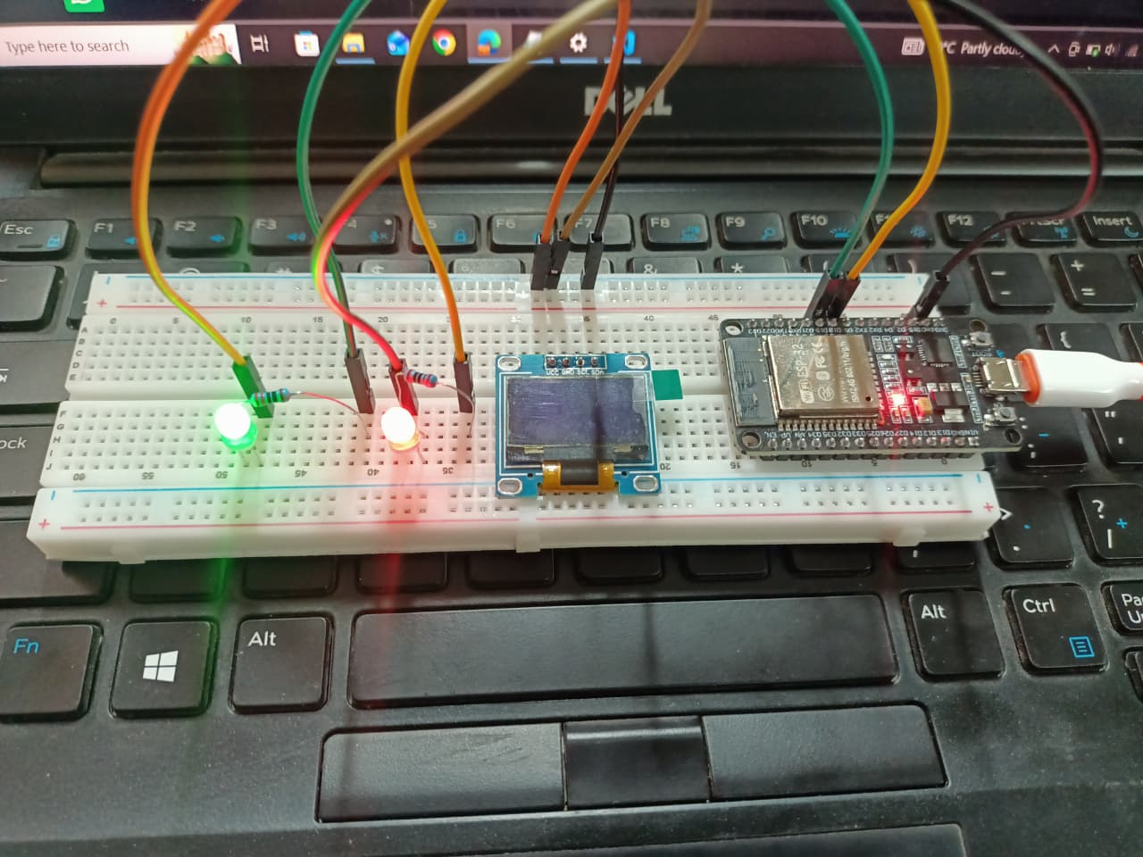

Task 2

Display PWM Values on the OLED
An SSD1306 I2C OLED (address 0x3C) was added. The Adafruit SSD1306 and Adafruit GFX libraries are used. The OLED is refreshed in every loop, right after the new duty values are applied to the LEDs. The display shows:
- Duty cycle of LED 1 in percent
- Configured frequency of LED 1
- Duty cycle of LED 2 in percent
- Configured frequency of LED 2

Complete Code (src/main.cpp)
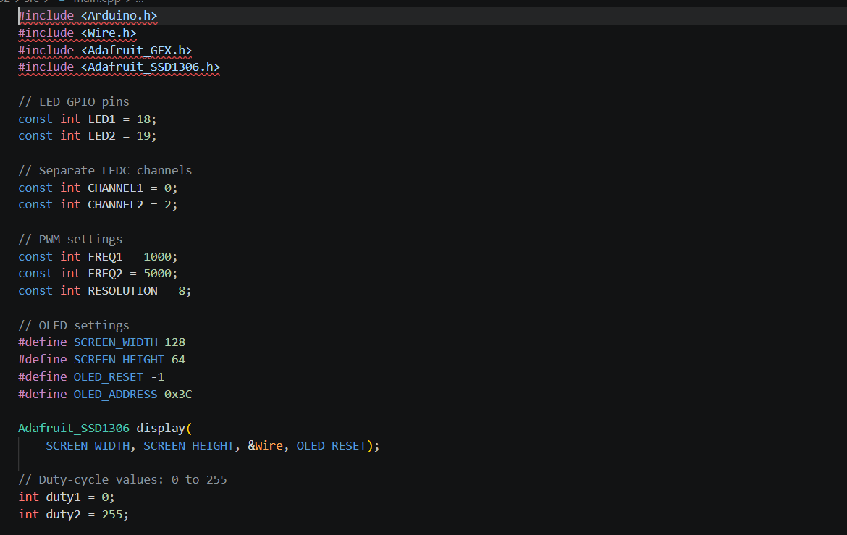
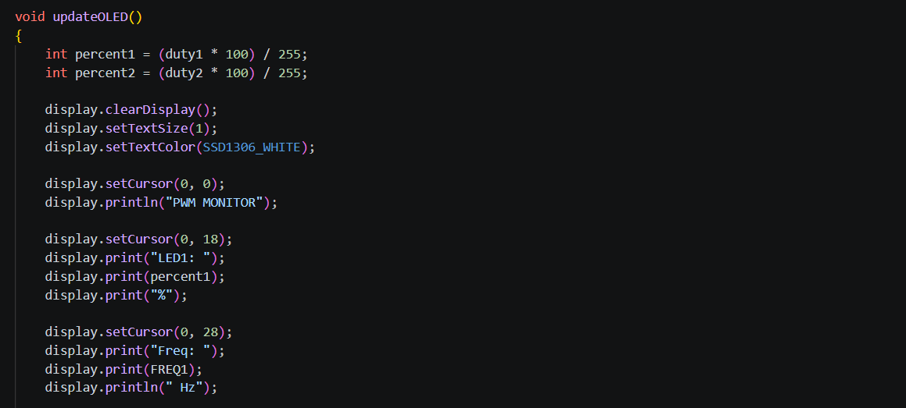
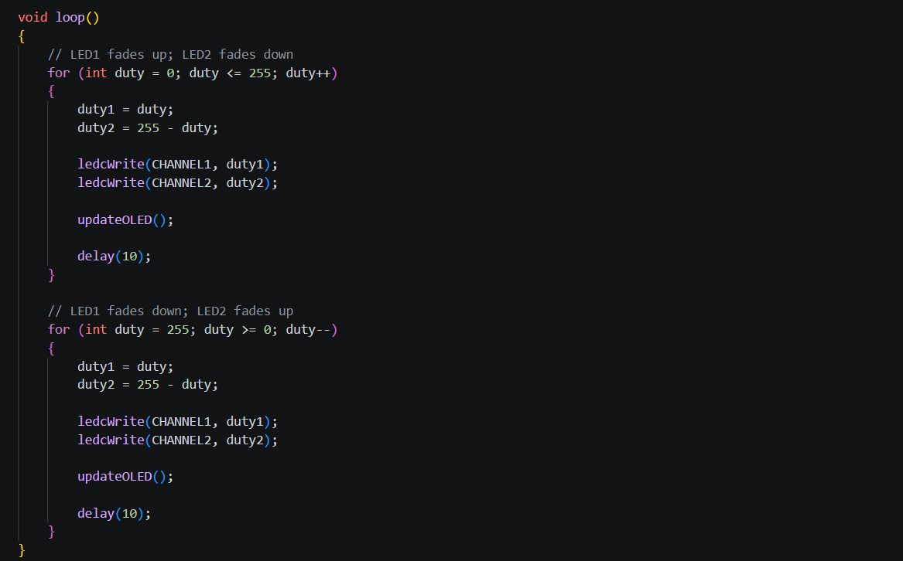

platformio.ini
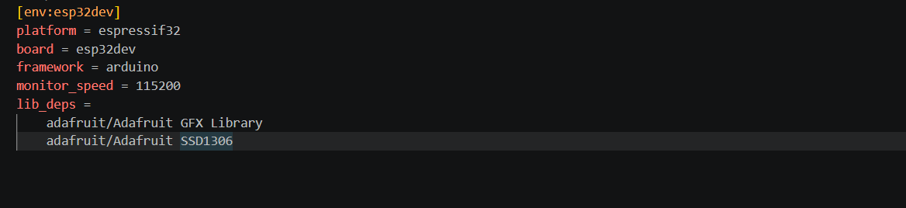

Wokwi Simulation
diagram.json (ESP32, two LEDs, two separate resistors, SSD1306 I²C OLED):
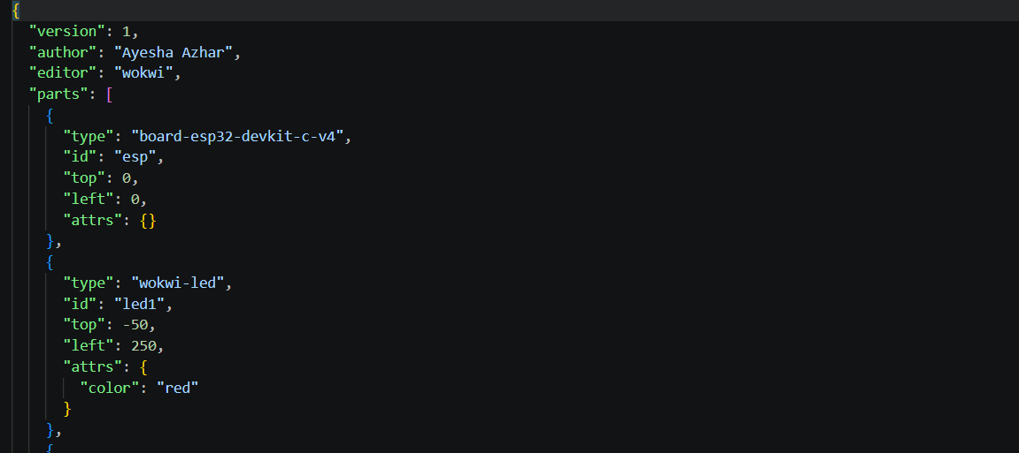
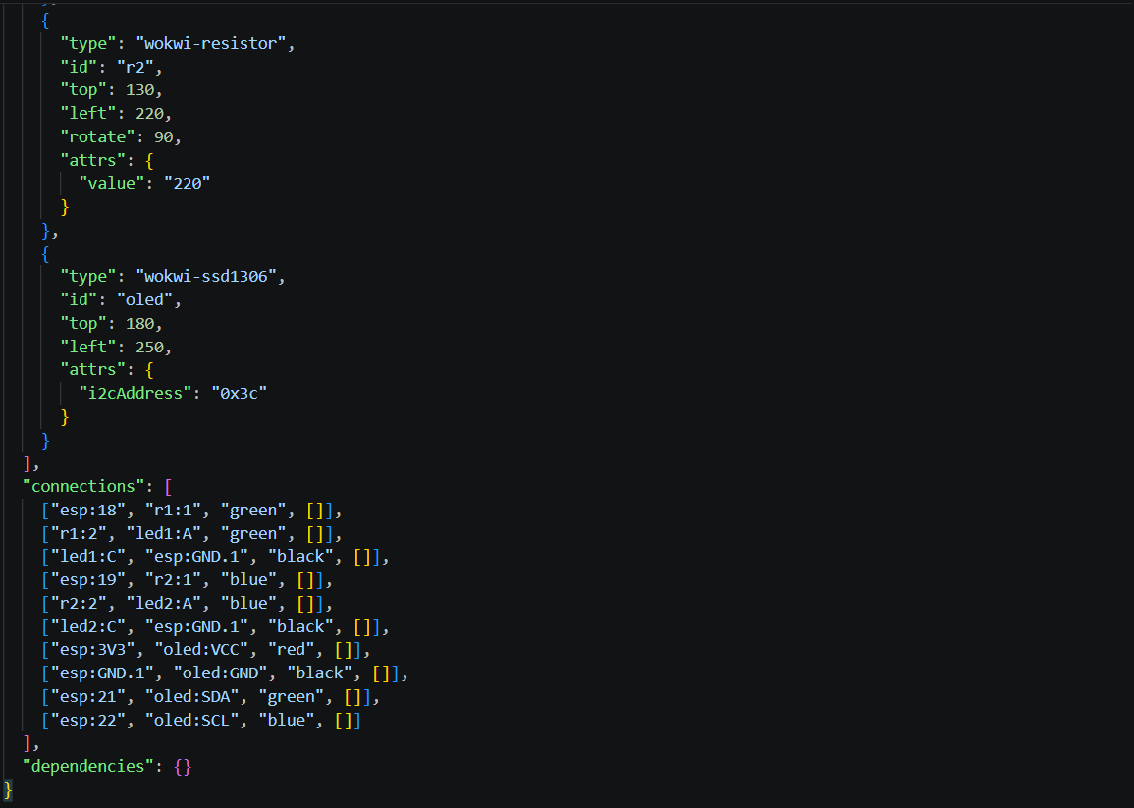
Platformio.ini:
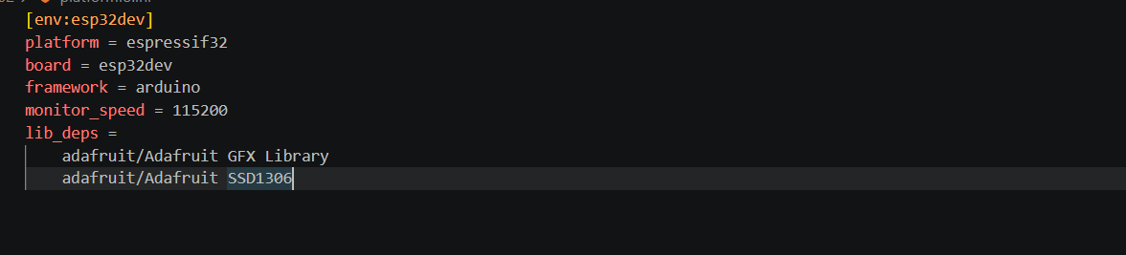

Wokwi.toml:
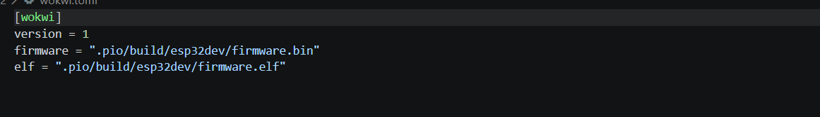

Complete circuit screenshot

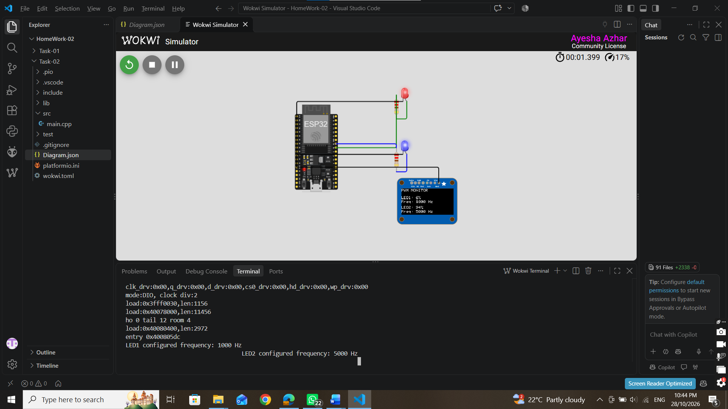

Physical Hardware Implementation

Components
- ESP32 development board (from the course kit)
- 2 × LEDs (e.g. green and red)
- 2 × 330 Ω current-limiting resistors (one per LED)
- SSD1306 128×64 I²C OLED (4-pin: GND, VCC, SCL, SDA)
- Breadboard and jumper wires
- USB cable
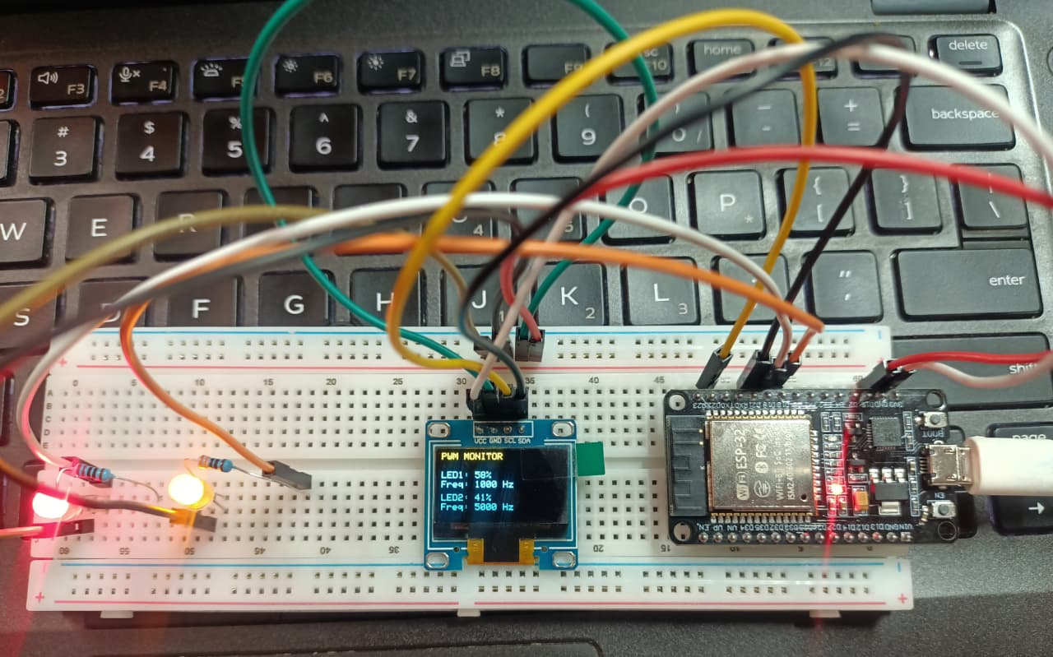

Hardware OLED output photograph:
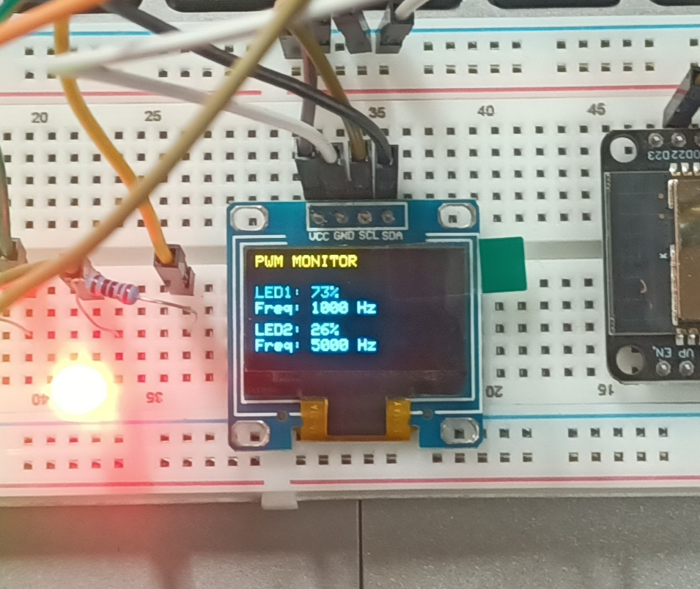
Photograph taken while the system is running, showing the OLED with changing duty cycles and configured frequencies and the LEDs lit.

Part C: GitHub Submission
Repository link: https://github.com/Ayesha-bano/IOT_24-NTU-CS-FL-1021
I used my existing course repository and pushed the work in two commits:
Order | Commit message | What was pushed
1 | task1 completed | Task 1 files: two-LED PWM fading, diagram.json, wokwi.toml, platformio.ini, main.cpp
2 | complete homework | OLED code, final files, screenshots, hardware photos and README.md

Conclusion:
In this homework I controlled two LEDs with two different PWM frequencies (1000 Hz and 5000 Hz) on the ESP32 using the LEDC peripheral. I learned that LEDC channels share timers, so channels must be chosen carefully when different frequencies are needed. I also learned how duty cycle controls brightness and how to show live values on an SSD1306 OLED. The project worked in Wokwi and on real hardware, and it was uploaded to GitHub with the required evidence.

