
Department of Computer Science

Name | Ayesha Azhar
Class | BSCS 5th
Section | A
Registration No | 24-NTU-CS-FL-1021
Homework | 1st
Course Name | Embeded-IOT

Embedded IoT Systems Homework
Part A

Q1. GPIO Configuration and Operation
Difference between the modes:
Mode | Meaning
INPUT | Pin only reads a signal. It has no internal resistor, so the pin can "float" (random values) if nothing is connected.
INPUT_PULLUP | Pin reads a signal and uses a built-in resistor connected to 3.3V. When nothing is pressed, the pin reads HIGH.
OUTPUT | Pin sends a signal out (HIGH or LOW) to control things like an LED.

Push button with INPUT_PULLUP:
- Connect one side of the button to the GPIO pin and the other side to GND.
- Not pressed: pin reads HIGH (pulled up by the internal resistor).
- Pressed: pin is connected to GND, so it reads LOW.
Example:
pinMode(4, INPUT_PULLUP);
if (digitalRead(4) == LOW) { // button pressed
// do something
}
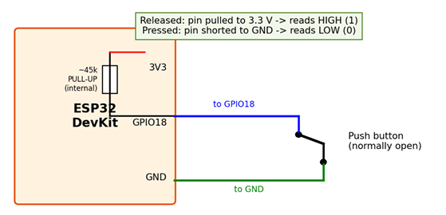
GPIO selection and voltage limits matter:
- Some ESP32 pins are special (boot pins, flash pins, GPIO 34–39 are input-only and have no internal pull-up).
- ESP32 pins work at 3.3V only. Connecting 5V can damage the board.
- Each pin can give only a small current, so use a resistor with LEDs.

Q2. Timers and Non-Blocking Design
Purpose of a timer:
A timer measures time so the program can do something after a set delay or at regular intervals.
Comparison:
Method | How it works
delay() | Stops (blocks) the whole program while waiting. Nothing else can run.
millis() | Returns time since start. You check if enough time has passed, and the program keeps running (non-blocking).
Hardware timer | ESP32's built-in timer triggers an event automatically after a set time. Very accurate.

Example (millis):

unsigned long last = 0;
void loop() {
if (millis() - last >= 1000) { // every 1 second
last = millis();
// update display
}
// button check and other tasks still run
}
Practical use:
Non-blocking timing lets the OLED display update every second, the button respond instantly, and another task (like blinking an LED) run at the same time. With delay(), the button would be missed while waiting.

Q3. Interrupts and ISR
- Interrupt: A signal that tells the CPU to stop what it is doing and handle an urgent event (e.g., a button press).
- ISR (Interrupt Service Routine): A special function that runs when the interrupt happens.
Sequence of events:
- Event occurs (e.g., button pressed).
- CPU pauses the main program.
- ISR runs.
- CPU returns to the main program where it stopped.
ISR good practices (ESP32 Arduino):
- Keep the ISR very short and fast.
- Use IRAM_ATTR before the ISR function so it runs from fast memory.
- Use volatile for variables shared with the main program.
- Set a flag in the ISR and do the real work in loop().
Example:
volatile bool pressed = false;
void IRAM_ATTR isr() { pressed = true; }

Display updates or Serial prints inside an ISR:
They take a long time and use interrupts and communication themselves. This can freeze or crash the ESP32 and make it miss other events.
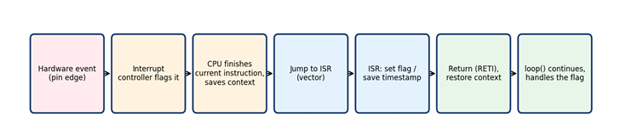

Q4. Switch Debouncing
- Bounce: When a button is pressed, its metal contacts vibrate for a few milliseconds. The signal quickly flips between HIGH and LOW, so one press can be read as many presses.
Comparison:
Method | Description
delay() debounce | Wait (e.g., 50 ms) after a change. Simple, but blocks the program.
millis() debounce | Check if enough time has passed since the last change. Non-blocking, program keeps running.

Reliable state-based method:
- Read the button and compare it with the last reading.
- If it changed, save the time (millis) and remember the new reading.
- Only if the reading stays the same for the debounce time (e.g., 50 ms), accept it as the real state.
- Count one press only when the stable state changes from not pressed to pressed.
- 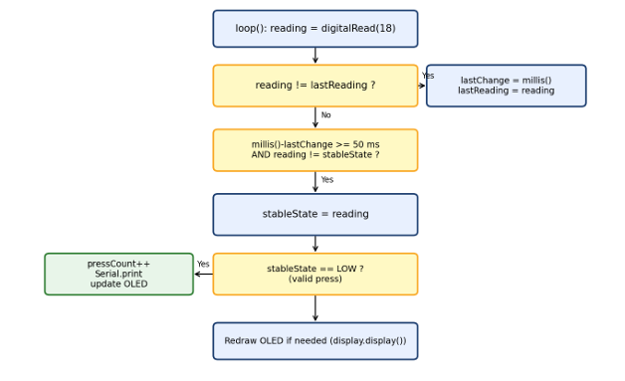

Q5. OLED Display and I²C
How SSD1306 OLED talks to ESP32:
It uses I²C, which needs only two wires: SDA (data) and SCL (clock). The ESP32 is the master and the OLED is the slave with an address (usually 0x3C).
Connections:
OLED Pin | ESP32 Pin | Purpose
VCC | 3.3V | Power
GND | GND | Ground
SDA | GPIO 21 | Data line
SCL | GPIO 22 | Clock line

Roles of display functions:
Function | Role
display.begin() | Starts the display and sets the I²C address (initialization).
display.clearDisplay() | Clears the old content from the screen buffer.
display.setCursor() / println() | Sets position and draws text or shapes into the buffer.
display.display() | Sends the buffer to the screen (refresh). Without this, nothing appears.

Example:
display.begin(SSD1306_SWITCHCAPVCC, 0x3C);
display.clearDisplay();
display.setTextSize(1);
display.setTextColor(WHITE);
display.setCursor(0, 0);
display.println("Hello ESP32");
display.display();

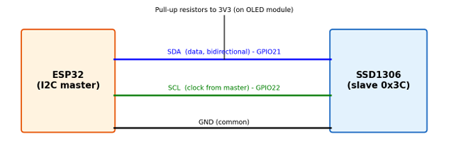

Part B — Practical Lab

- Project description:
The ESP32 runs an SSD1306 status screen. On start-up it shows the title, "Button: RELEASED" and "Count: 0". A push button on GPIO18 (INPUT_PULLUP, pressed = LOW) is debounced without delay() using millis(). Each accepted press increments the counter once, updates the OLED (PRESSED/RELEASED and the new count) and prints the accepted count on the Serial Monitor (115200 baud).

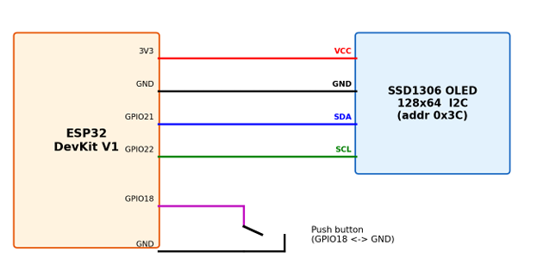2. Implementation explanation:

- Structure: platformio.ini (board esp32dev, Arduino framework, Adafruit GFX/SSD1306/BusIO libraries), src/main.cpp, diagram.json and wokwi.toml.
- setup(): starts Serial, sets GPIO18 to INPUT_PULLUP, starts I²C on GPIO21/22, initializes the OLED at 0x3C and draws the first screen (count = 0).
- loop(): reads the pin, restarts a stability timer whenever the raw value changes, accepts a new state only after 50 ms of stability, increments pressCount on the accepted HIGH→LOW transition, prints it to Serial and sets a flag so the OLED is redrawn only when something changed.
- No blocking delay: there is no delay() in loop(); debouncing uses millis() timestamps, so the system stays responsive.

- Source code (src/main.cpp):
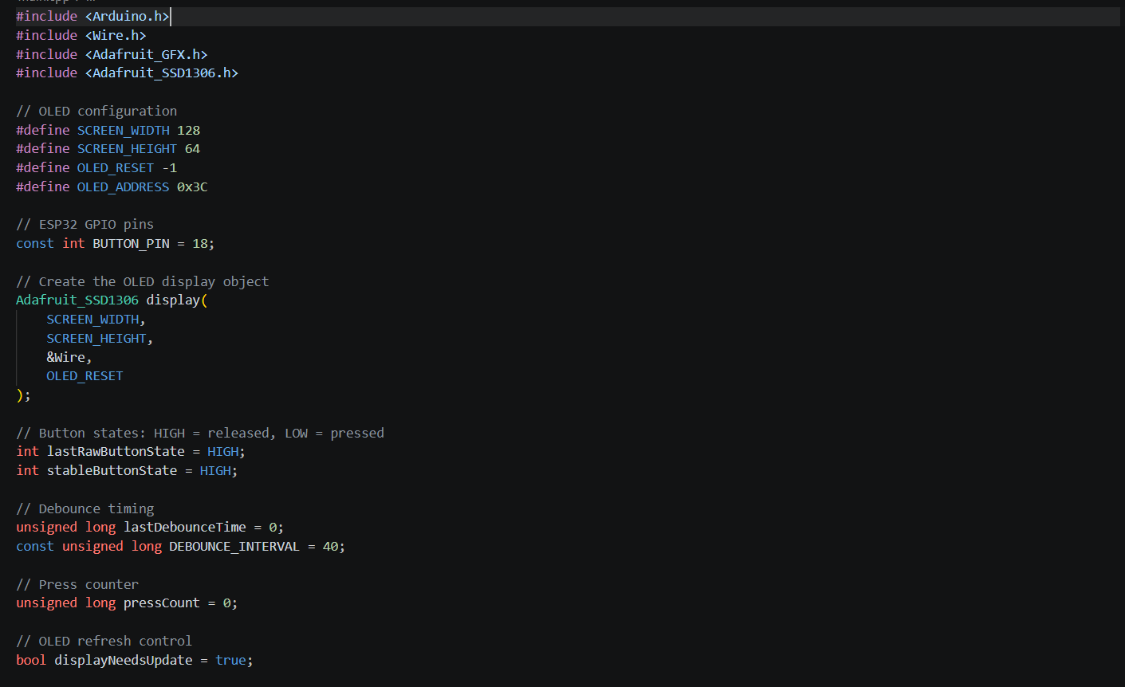

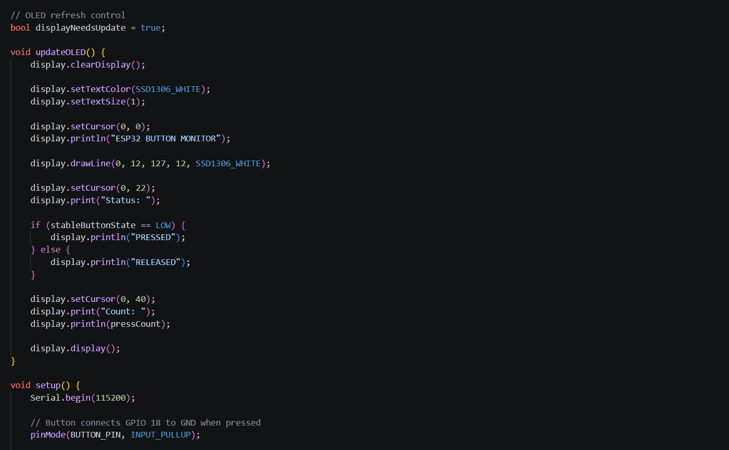

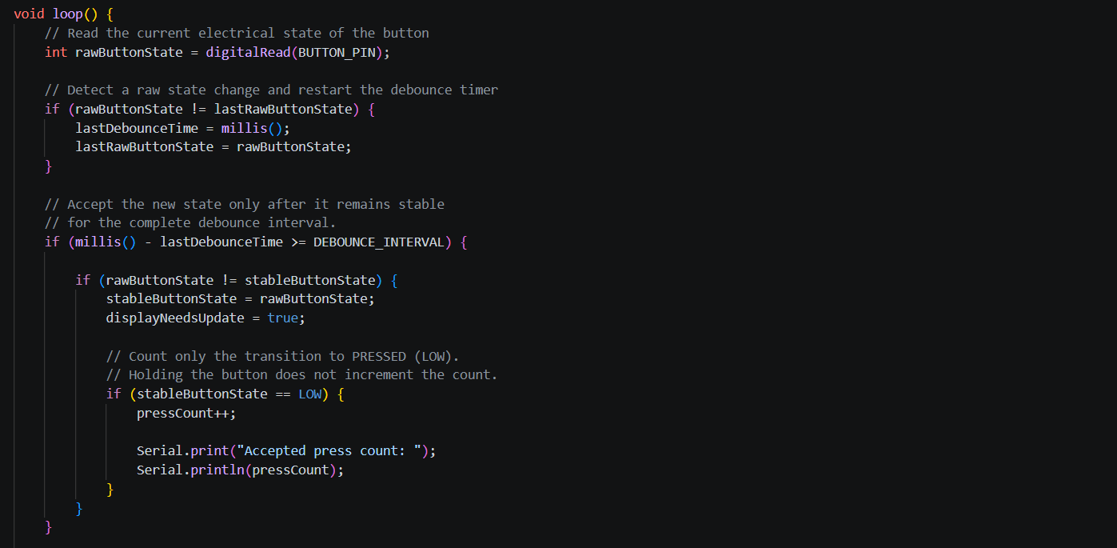

Plateformio.ini:
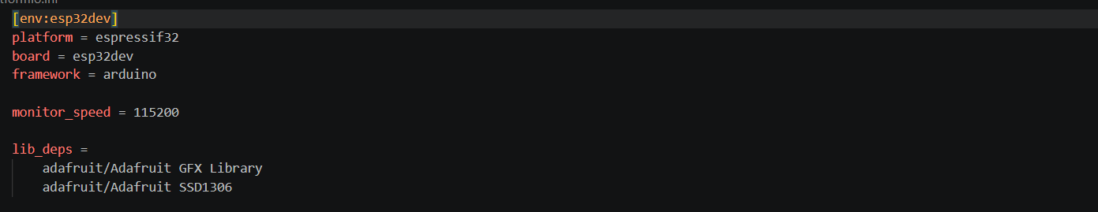

WokWi.toml:
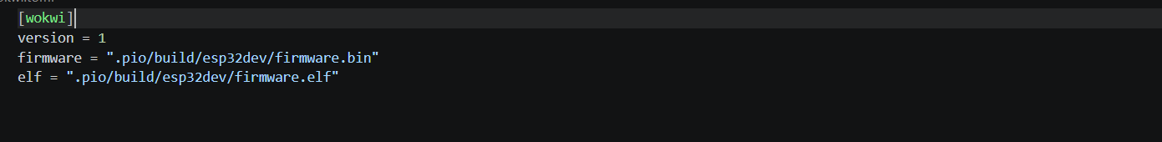

Evidence
Wokwi Circuit
Wokwi circuit showing the ESP32 connected to the OLED display and push button, with labeled components.
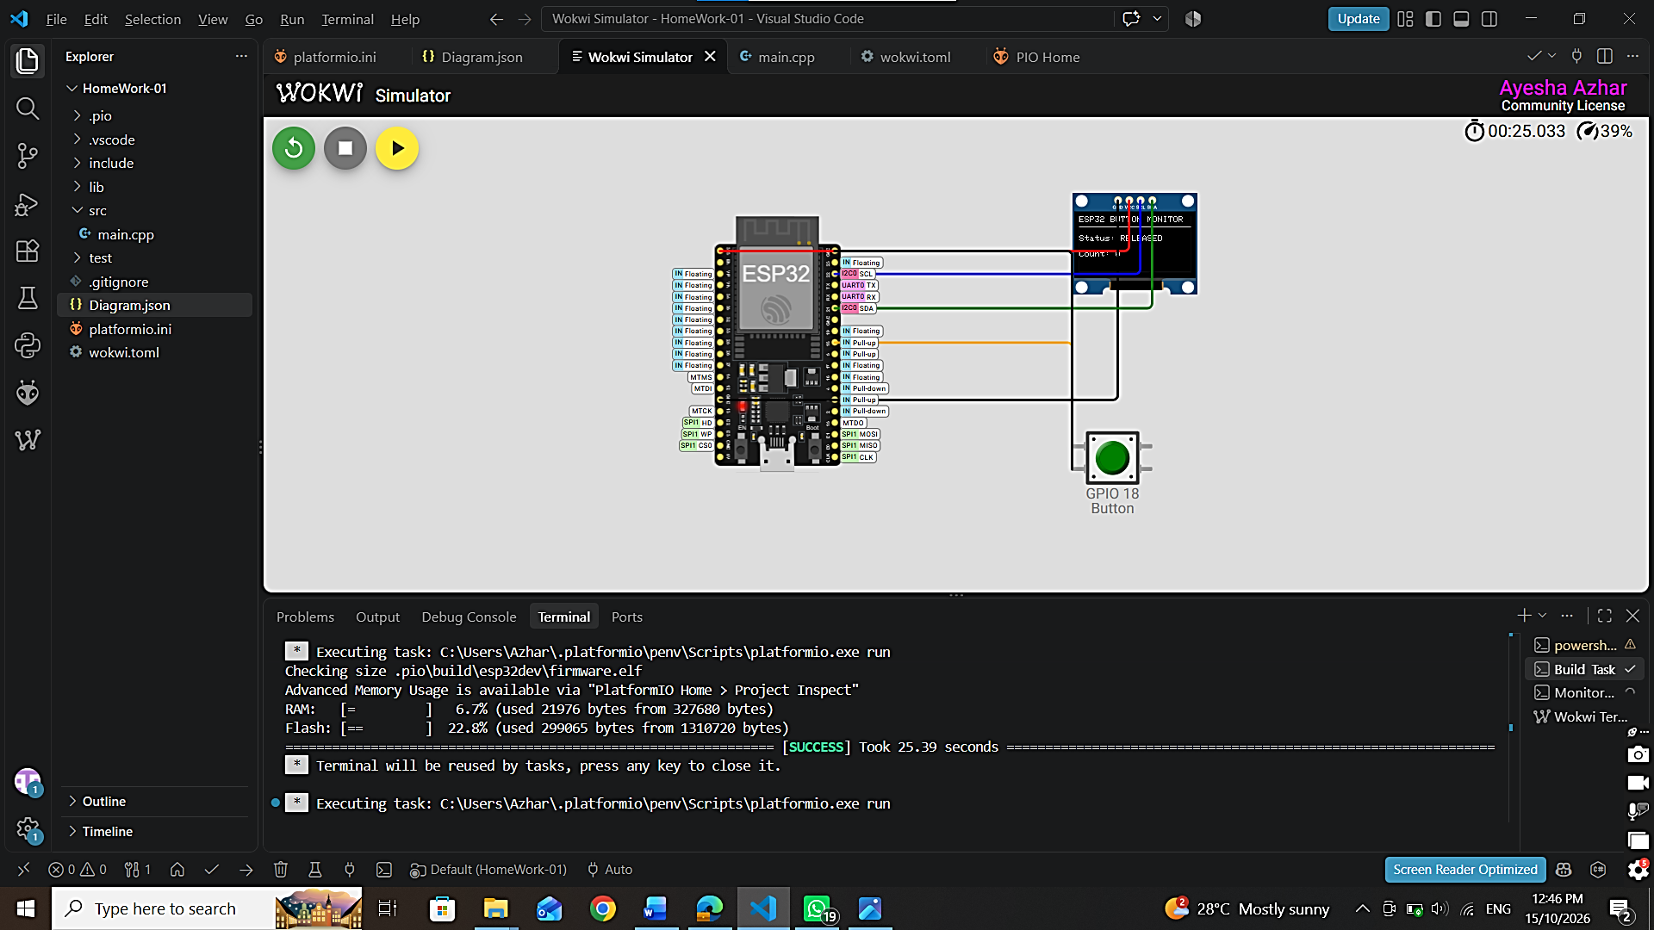

VS Code / PlatformIO
Wokwi circuit showing the ESP32 connected to the OLED display and push button, with labeled components.
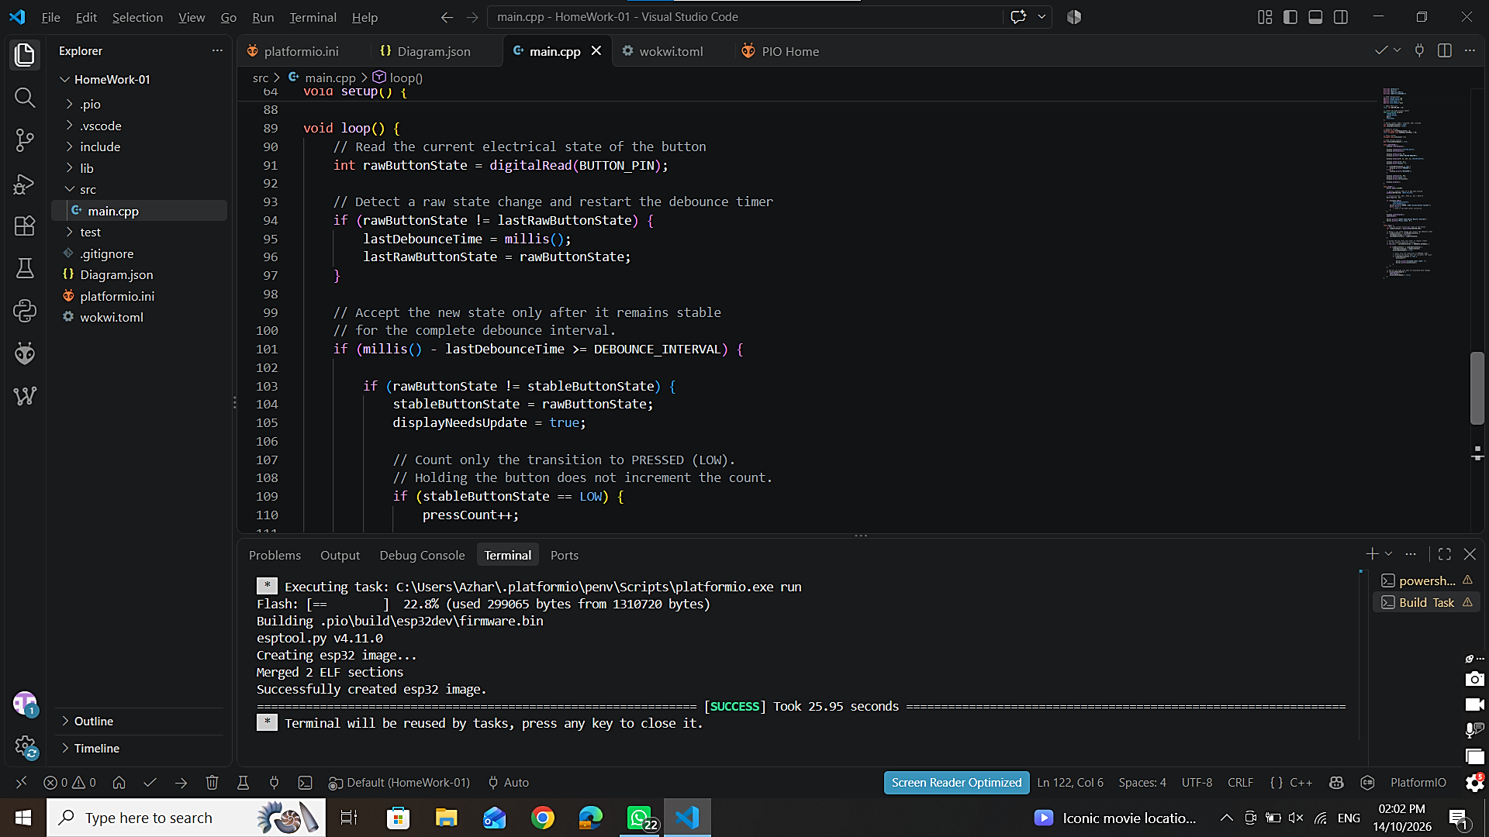

Hardware setup
Real OLED display showing the project title and a non-zero press count on the hardware.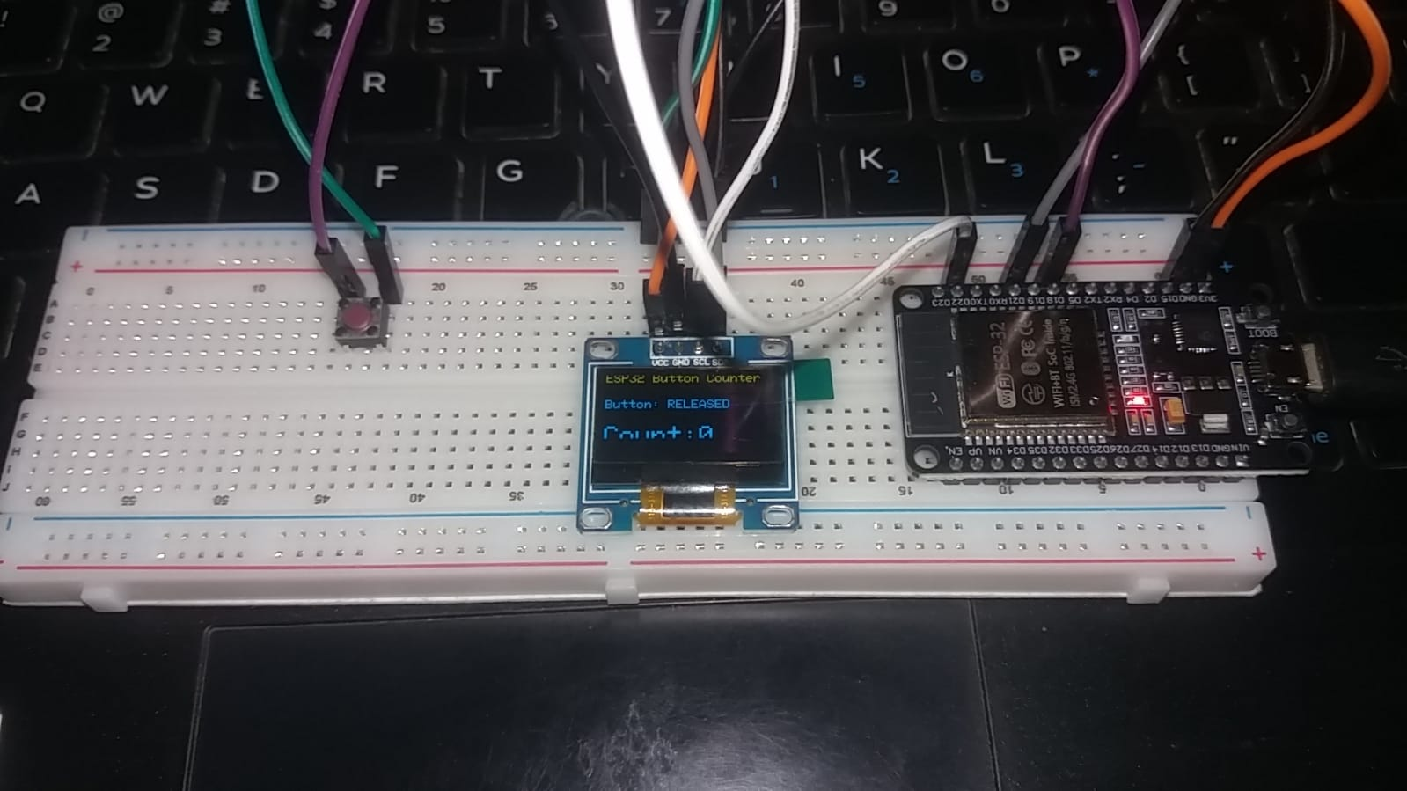

Hardware output
VS Code with PlatformIO showing the project files and a successful build message.
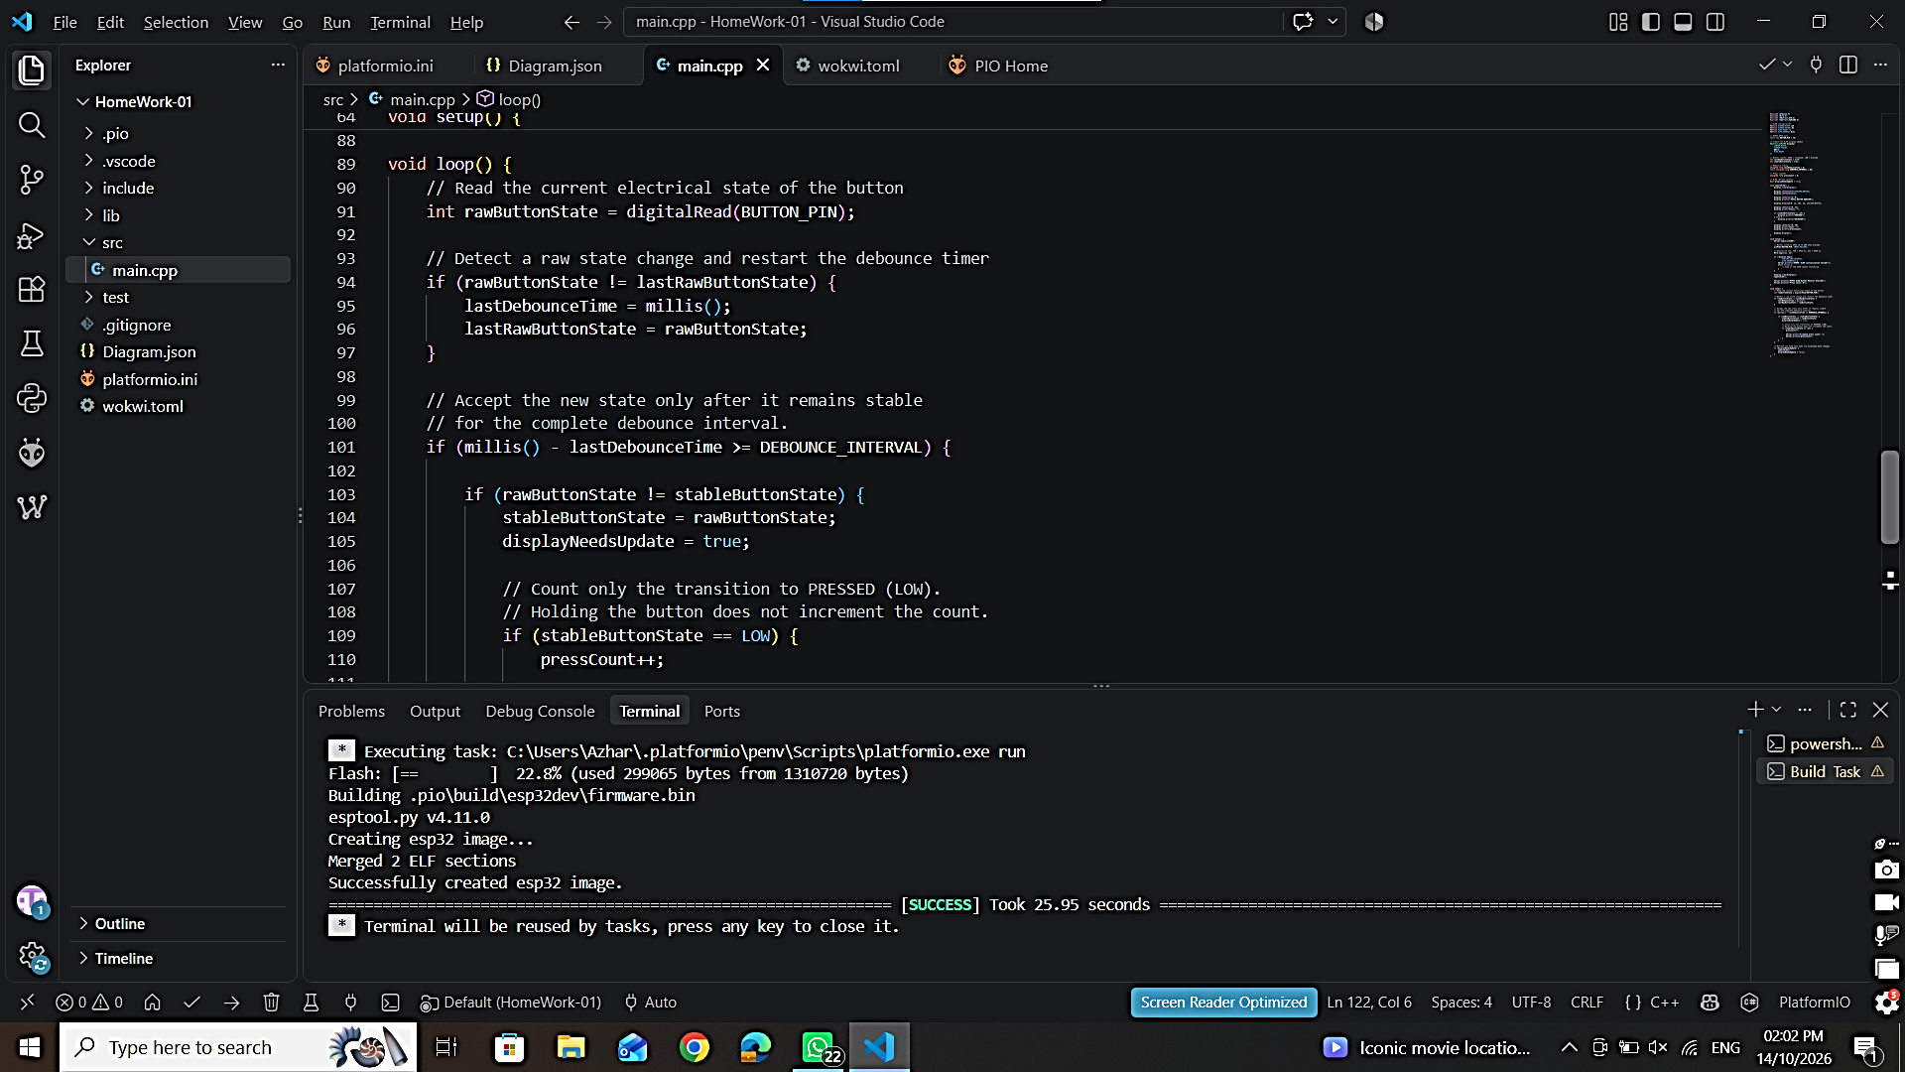

H2 Hardware Output:
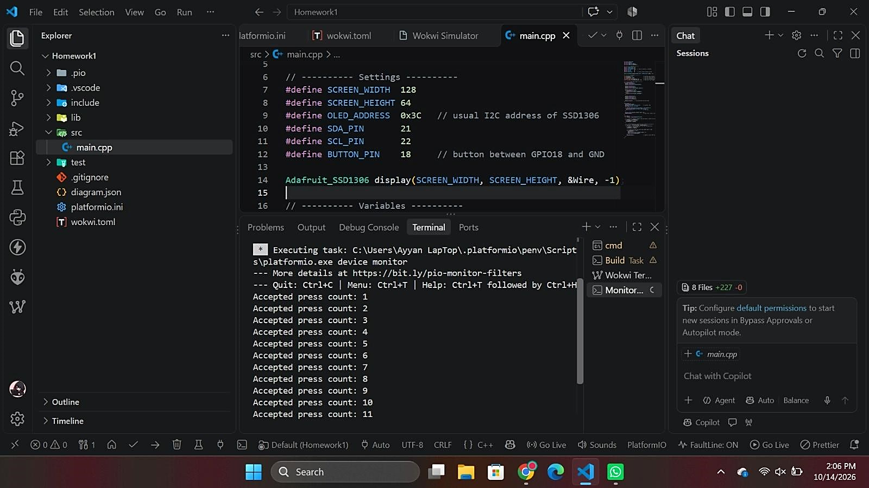

Hardware test
Serial Monitor output showing the button press count after several presses.
