UK Airport Punctuality Data Warehouse Report
Name: Ayesha Shahzad
KU Number: K2446625
Assignment 2: C17320 Data Analysis Part 1
Date: May 12, 2025

1. Star Schema Design for the Data Warehouse
The data warehouse for this project is designed using a star schema, consisting of one fact table, Fact_Flight_Punctuality, and four dimension tables: DIM_DATE, DIM_AIRLINE, DIM_AIRPORT, and DIM_DESTINATION. This design is tailored to analyse punctuality statistics for selected UK airports over 2023–2024, based on 24 monthly data files.

1.1 Star Schema Diagram

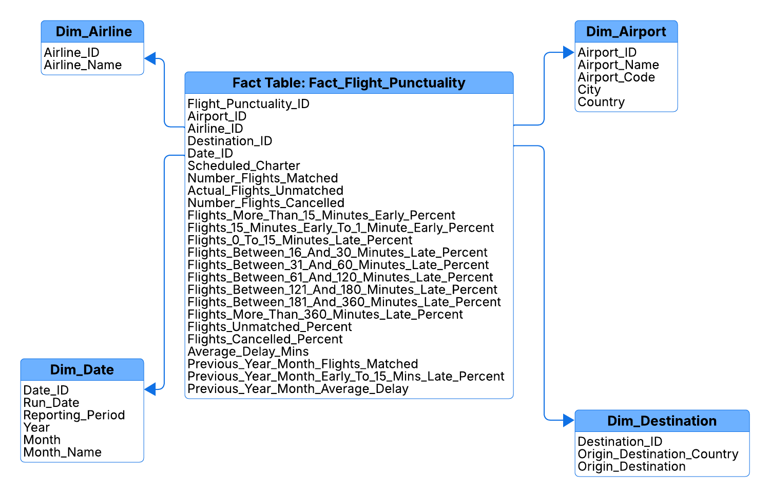
Figure 1: Star Schema Diagram UK Airport Punctuality Data

1.2 Justification of Design Decisions
The star schema is chosen for its simplicity, query performance, and suitability for analytical reporting in Tableau. The schema is designed to support queries about flight punctuality trends, airport performance, and temporal patterns. The following justifies the design decisions:

1.2.1 Fact Table: Fact_Flight_Punctuality
This central table contains key metrics such as Average_Delay_Mins, Number_Flights_Cancelled, Actual_Flights_Unmatched, and percentage delay fields (e.g., Flights_0_To_15_Minutes_Late_Percent etc.). Foreign keys (Date_ID, Airline_ID, Airport_ID, Destination_ID) link to the dimension tables. This structure captures the core punctuality data from the dataset, enabling analysis of delays, cancellations, and unmatched flights. The use of foreign keys supports multi-dimensional slicing (e.g., by date, airline, airport, or destination), aligning with the focus on researching flight punctuality. The table aggregates metrics like Average_Delay_Mins and percentage delay fields at the lowest granularity (e.g., by date, airline, airport, destination), reducing the need for complex joins during Tableau analysis. The table also includes Actual_Flights_Unmatched to capture data quality issues, enabling Tableau visualisations to identify airports or airlines with high unmatched flights, supporting research into reporting errors
The structure supports adding new metrics (e.g., weather-related delays) by extending the fact table, ensuring flexibility for future research beyond the current visualisations.
1.2.2 Dimension Table: DIM_DATE
This table includes Date_ID (primary key), Reporting_Period, and Year etc. It facilitates temporal analysis, essential for identifying seasonal patterns in punctuality (e.g., cancellations by month, year-over-year delay trends), as demonstrated in Visualisations 2 and 4. Its inclusion ensures the schema can handle time-based queries effectively.
1.2.3 Dimension Table: DIM_AIRLINE
This table contains Airline_ID (primary key) and Airline_Name. It enables airline-specific analysis, crucial for comparing performance across airlines for example as in the Visualisation 1: Top 10 Airlines by Average Delay. The dataset includes airline data, making this dimension necessary for researching operational inefficiencies.
1.2.4 Dimension Table: DIM_AIRPORT
This table includes AIRPORT_ID (primary key), Airport_name, and Airport_codes (e.g., IATA codes for compatibility with external datasets). It supports airport-specific analysis, enabling identification of location-based trends such as unmatched flights by airport or future delay patterns. Although not used in the final visualisations, retaining this table enhances schema flexibility, supporting potential airport-specific punctuality analyses and aligning with the data warehouse’s utility for future research.
1.2.5 Dimension Table: DIM_DESTINATION
This table contains Destination_ID (primary key), Origin_Destination and Origin_Destination_Country. It facilitates route-specific analysis, vital for understanding punctuality by origin-destination pairs (e.g., Visualisation 3: Punctuality Distribution by Destination). The dataset’s inclusion of route data justifies this dimension for route-level insights.

1.2.6 Denormalisation for Query Performance
The denormalised structure of dimension tables, such as Dim_Date with Year and Month, and Dim_Airport with Airport_Name and Airport_Codes, minimises complex joins, ensuring fast query performance in Tableau for visualisations like seasonal trends (Visualisation 2) and airline comparisons (Visualisation 1).
1.2.7 Hierarchical Analysis
Hierarchical attributes in Dim_Date (e.g., Year, Month) and Dim_Destination (e.g., Origin_Destination, Origin_Destination_Country) support Tableau’s drill-down features, enabling detailed research into monthly trends (Visualisation 2) or route-specific punctuality (Visualisation 3).
1.3 Overall Design Rationale
The star schema supports the assignment’s research objectives by enabling analysis of airline delays (Visualisation 1), seasonal trends (Visualisation 2), route punctuality (Visualisation 3), and yearly performance (Visualisation 4). Its simplicity, with one fact table (Fact_Flight_Punctuality) and four dimension tables, suits the small dataset (24 files) while offering flexibility for diverse queries (e.g., delays by airline, cancellations by date, punctuality by route). The schema’s single fact table and indexed foreign keys (e.g., Date_ID) ensure scalability for larger datasets, maintaining query efficiency. Pre-aggregated metrics like Average_Delay_Mins optimise Tableau’s performance, enabling responsive, interactive visualisations. This design aligns with data preparation steps (Section 3), such as standardising dates for Dim_Date, and ensures scalability for future analyses, such as airport-specific trends, enhancing the data warehouse’s utility for research.

2. CREATE TABLE Statements
Below are the screenshots of Oracle CREATE TABLE statements for the star schema, including primary and foreign keys, with appropriate data types.
2.1 Fact Table: Fact_Flight_Punctuality
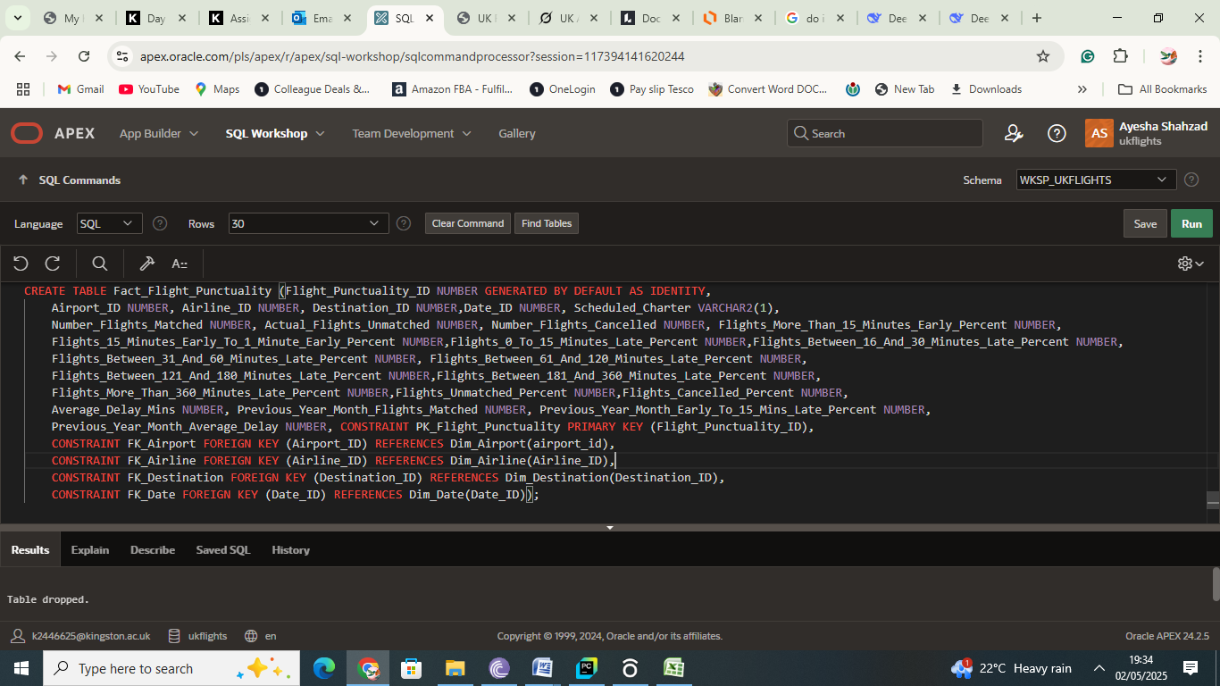
Screenshot 2.1: Oracle SQL Command for Fact Flight Punctuality Table

2.2 Dimension Table: DIM_Airport
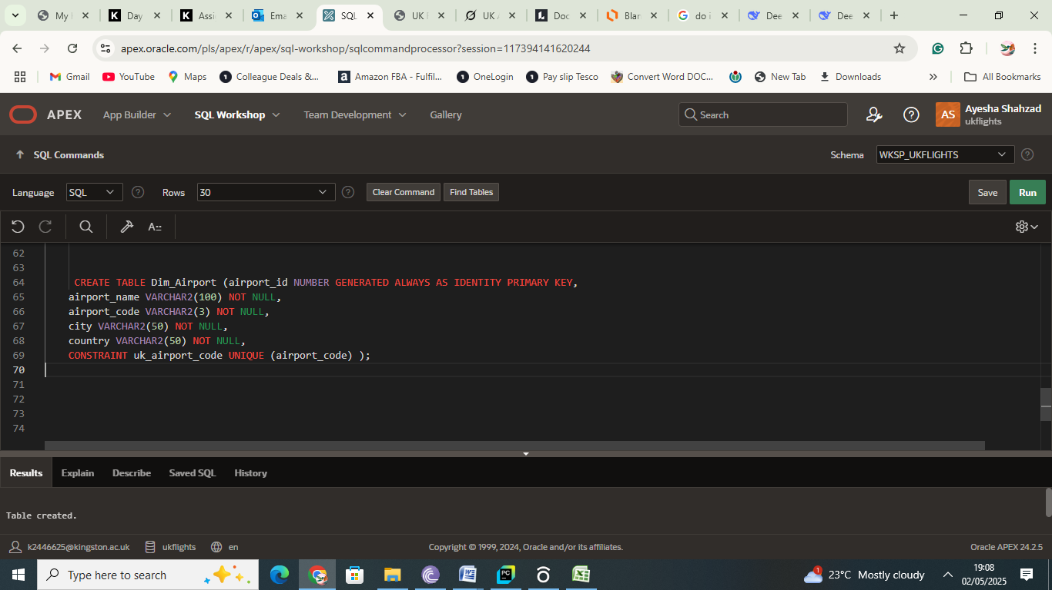
Screenshot 2.2: Oracle SQL Command for Dimension Table Airport

2.3 Dimension Table: DIM_Airline

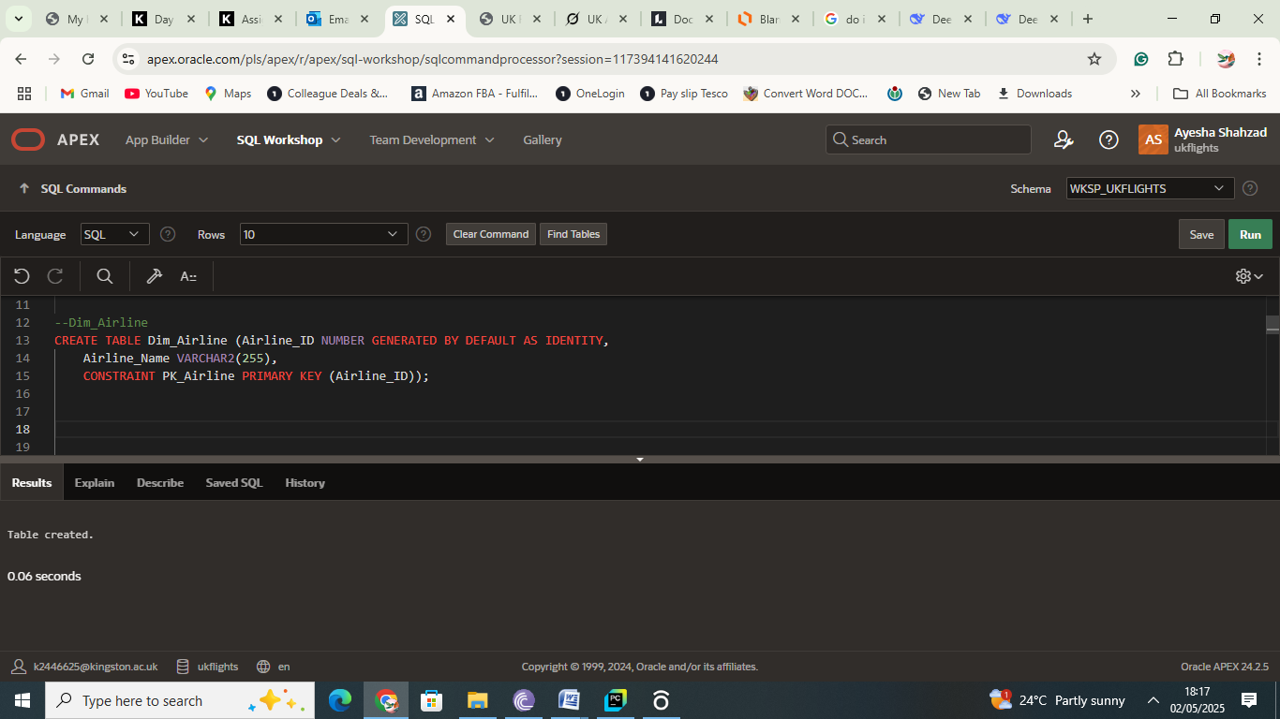
Screenshot 2.3: Oracle SQL Command for Dimension Table Airline

2.4 Dimension Table: DIM_Destination

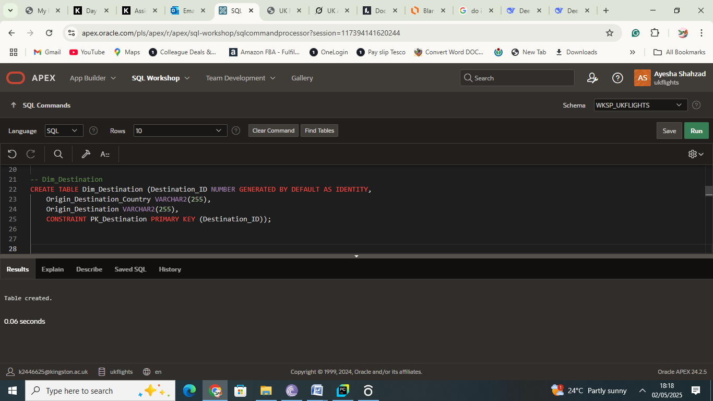
Screenshot 2.4: Oracle SQL Command for Dimension Table Destination

2.5 Dimension Table: DIM_DATE

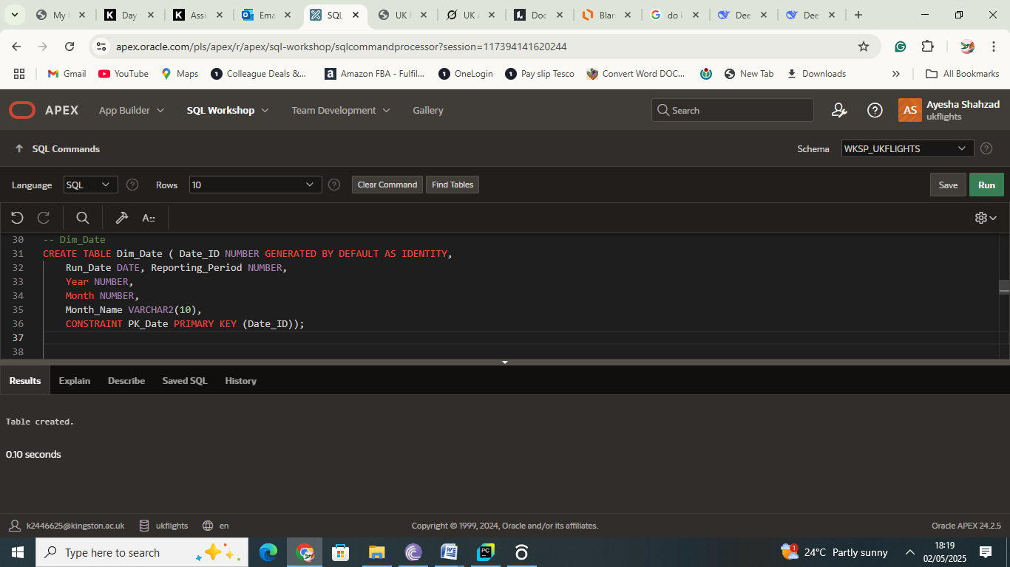
Screenshot 2.5: Oracle SQL Command for Dimension Table Date

3. Steps for Creating and Populating the Database
To ensure the raw flight punctuality data was suitable for analysis within a data warehouse and Tableau, a series of data cleaning and preprocessing steps were undertaken. These steps addressed inconsistencies, errors, and structural issues across the 24 monthly CSV files (covering 2023–2024), preparing the data for population into the star schema in Oracle APEX. The process of creating and populating the data warehouse is detailed below, focusing on key actions, challenges, and solutions.

3.1 Dataset Analysis
The dataset, comprising 24 CSV files (one per month for 2023–2024), contained columns such as Airline_Name, Reporting_Airport, Origin_Destination, Average_Delay_Mins, Number_Flights_Cancelled, Actual_Flights_Unmatched, etc. and percentage delay fields (e.g., Flights_0_To_15_Minutes_Late_Percent). Initial analysis revealed inconsistencies, including missing columns in 2023 files (e.g., Actual_Flights_Unmatched, Flights_Unmatched_Percent), inconsistent string formats (e.g., "British Airways" vs. "BRITISH AIRWAYS"), and illogical values (e.g., non-zero Average_Delay_Mins when Number_Flights_Matched was 0). These issues were systematically addressed to ensure data quality.

3.2 Data Cleaning
Data cleaning was performed using SQL queries in Oracle APEX to process the 24 CSV files. Several cleaning steps were performed to standardise and correct the dataset:
- Handling Inconsistent Columns across Years
The 2023 data lacked columns like Actual_Flights_Unmatched and Flights_Unmatched_Percent, which were present in 2024 files. To standardise the structure of the Fact_Flight_Punctuality table, these missing columns were set to 0 during population. This was achieved using aggregation functions in the INSERT statements, such as SUM(m.Actual_Flights_Unmatched) and AVG(m.Flights_Unmatched_Percent), ensuring consistency across all years.
- String Normalisation
Fields such as Airline_Name, Reporting_Airport, and Origin_Destination showed inconsistent formats (e.g., "British Airways" vs. "BRITISH AIRWAYS", "United Kingdom" vs. "UK"). To address this, TRIM(UPPER()) was applied in the INSERT queries during joins with dimension tables (e.g., JOIN Dim_Airline da ON TRIM(UPPER(m.AIRLINE_NAME)) = TRIM(UPPER(da.Airline_Name))). This removed leading or trailing spaces and standardised the case, enabling accurate matching.
- Handling Nulls and Inconsistencies
Null values in Actual_Flights_Unmatched were replaced with 0 using: “update fact_flight_punctuality set actual_flights_unmatched = 0 where actual_flights_unmatched is null;”
Also instances where average_delay_mins was non-zero despite number_flights_matched being 0 were corrected by setting average_delay_mins to 0.
- Standardising Country Names
Inconsistencies in the Origin_Destination_Country field (e.g., "United Kingdom" vs. "UK") were resolved by standardising to "UK" in the Dim_Destination table.
- Adding IATA Codes
The Dim_Airport table initially did not have IATA codes, which are standard identifiers for airports. An Airport_Code column was added and populated using data from iata.org. This enhancement improved the table’s utility for analysis.

3.3 Data Integration
The 24 monthly CSV files were combined into a unified dataset to populate the star schema. Consistent column names and formats were ensured by addressing discrepancies (e.g., missing columns in 2023 files) during the cleaning phase. The integrated dataset was then used to populate the dimension and fact tables in Oracle APEX.
3.4 Populating the Dimension and Fact Tables
The dimension tables were populated first to satisfy foreign key dependencies. Unique values for Dim_Airline, Dim_Airport, and Dim_Destination were extracted from the integrated dataset using SQL queries (e.g., Select Distinct Airline_Name from raw_data). For Dim_Date, records for each month from January 2023 to December 2024 were generated, mapping to the “Reporting_Period” field (e.g., Jan 2023). The Fact_Flight_Punctuality table was then populated by joining the integrated dataset with the dimension tables, mapping raw data fields to dimension IDs (e.g., “Join Dim_Airline On Trim(Upper(Raw_Data.Airline_Name)) = Trim(Upper(Dim_Airline.Airline_Name))”). This process ensured all foreign key relationships were maintained, with a total of 79,842 rows loaded into the fact table.

3.5 Validation
Data quality checks were conducted to ensure integrity:
- Duplicate Removal
Duplicates in Fact_Flight_Punctuality were checked based on key fields such as Date_ID, Airline_ID, Airport_ID, Destination_ID, Scheduled_Charter, but no duplicates were found.

- Foreign Key Integrity
The population process ensured that foreign keys in Fact_Flight_Punctuality (e.g., DATE_ID, AIRLINE_ID) matched primary keys in the dimension tables, preventing orphaned records.
- Aggregation Validation
Aggregations were validated by checking totals, such as Sum(Number_Flights_Cancelled) = 54,405 and Sum(Number_Flights_Matched) = 3.67M, ensuring consistency with the raw data.
- Resolving Unique Constraint Violations
While populating the Fact_Flight_Punctuality table with 2024 data, ORA-00001 errors occurred due to duplicate Flight_Punctuality_ID values. To fix this, the ‘INSERT’ query was modified to generate unique IDs by combining ROWNUM with the maximum existing ID: “ROWNUM + (Select Max(Flight_Punctuality_ID) From Fact_Flight_Punctuality)”. This ensured every record had a unique identifier.

3.6 Challenges and Solutions
- Inconsistent Columns across Years
Solution: Missing columns were set to 0 during INSERT operations to maintain a uniform schema.
- String Inconsistencies
Solution: TRIM(UPPER()) was used to standardise strings for reliable joins.
- Unique Constraint Violations
Solution: Unique Flight_Punctuality_ID values were generated using ROWNUM.
- Space Quota Issues (encountered ORA-01536 space quota errors)
Solution: Tables were exported as CSVs, unnecessary tables were dropped, and data was re-imported incrementally to manage Oracle APEX space constraints.

3.7 Screenshots
Screenshots of the populated Fact_Flight_Punctuality and Dimension tables are given below:
3.7.1 Fact Table: Flight Punctuality
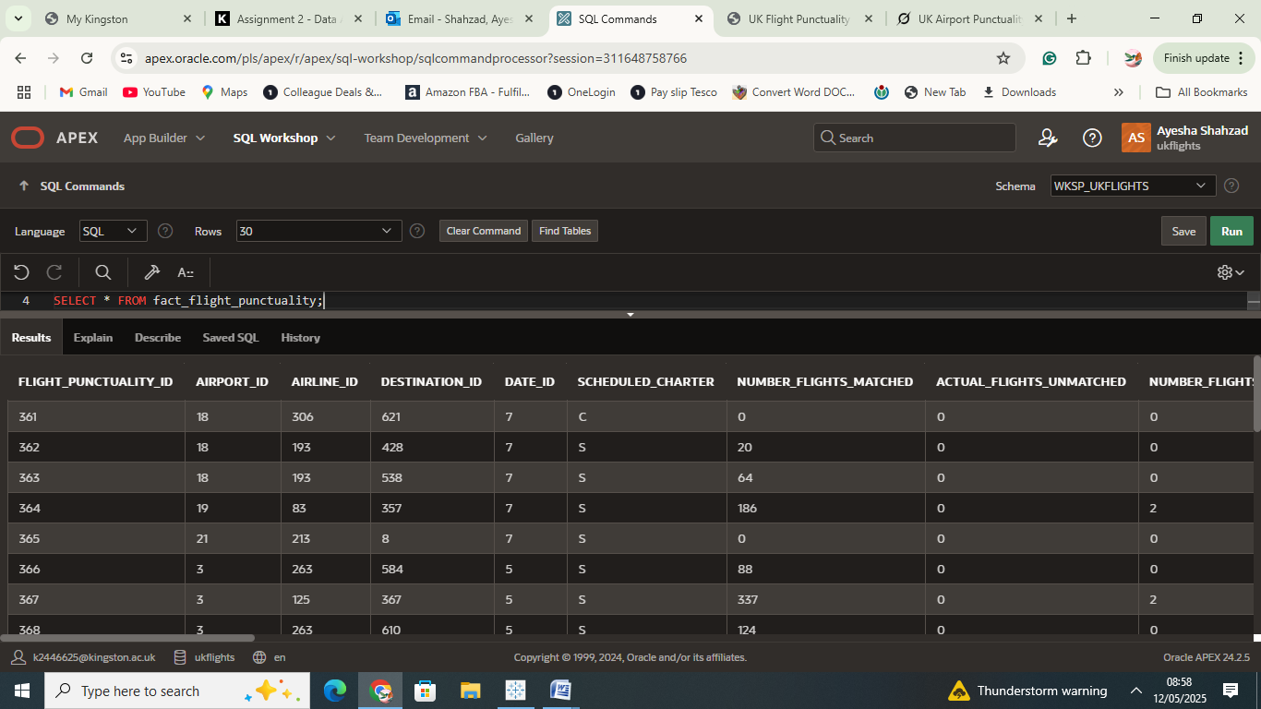
Screenshot 3.1(a): The screenshot shows the data populated in the flight punctuality fact table.

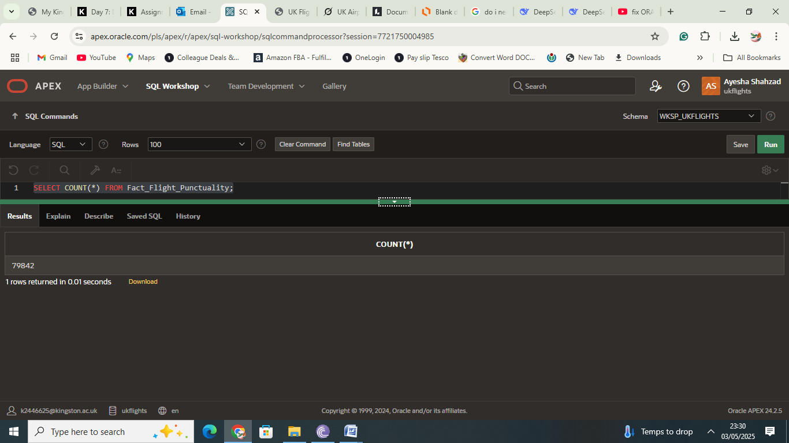
Screenshot 3.1(b): The screenshot shows a total of 79,842 rows populated in the fact table.

3.7.2 Dimension Table: Dim_Date

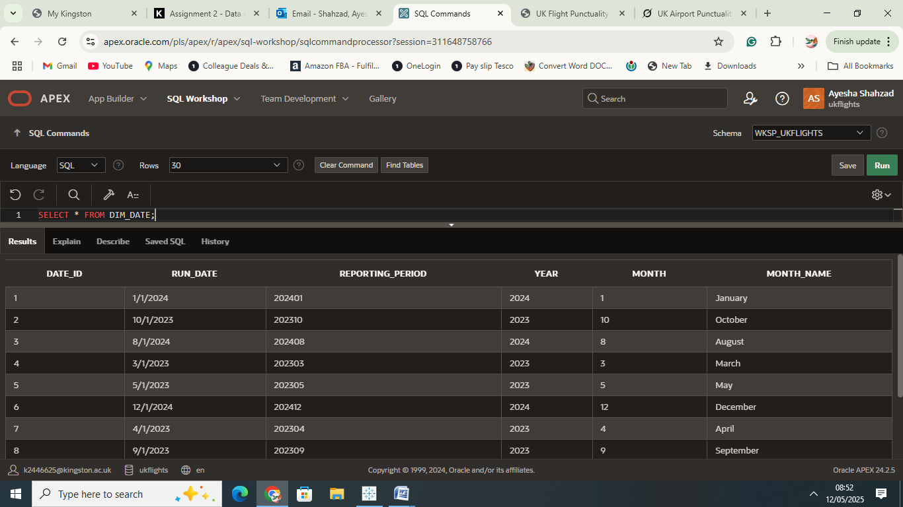
Screenshot 3.2(a): The screenshot shows the data populated in the Date Dimensional table.

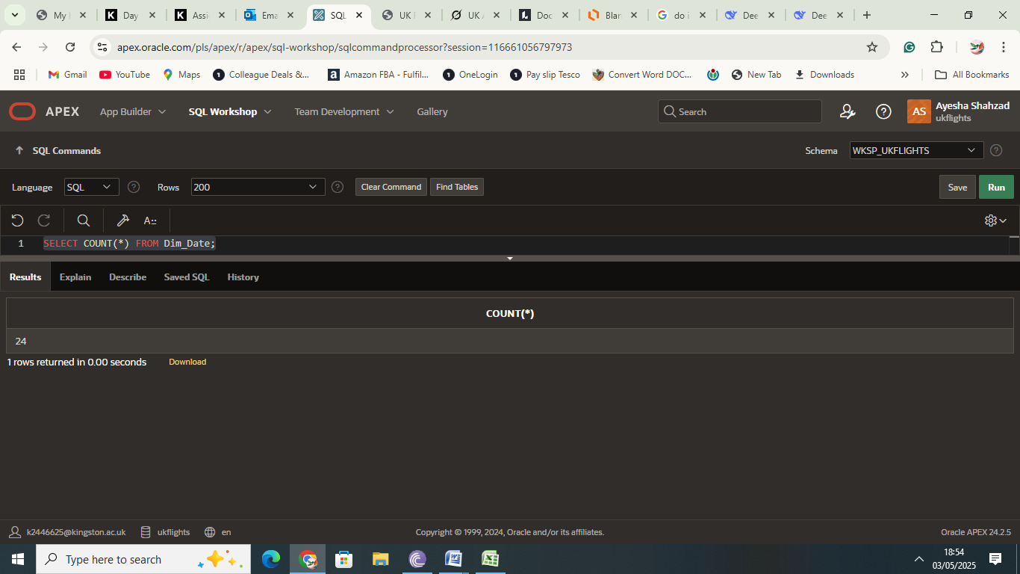
Screenshot 3.2(b): The screenshot shows a total of 24 rows populated in the Date Dimension table.

3.7.3 Dimension Table: Dim_Destination

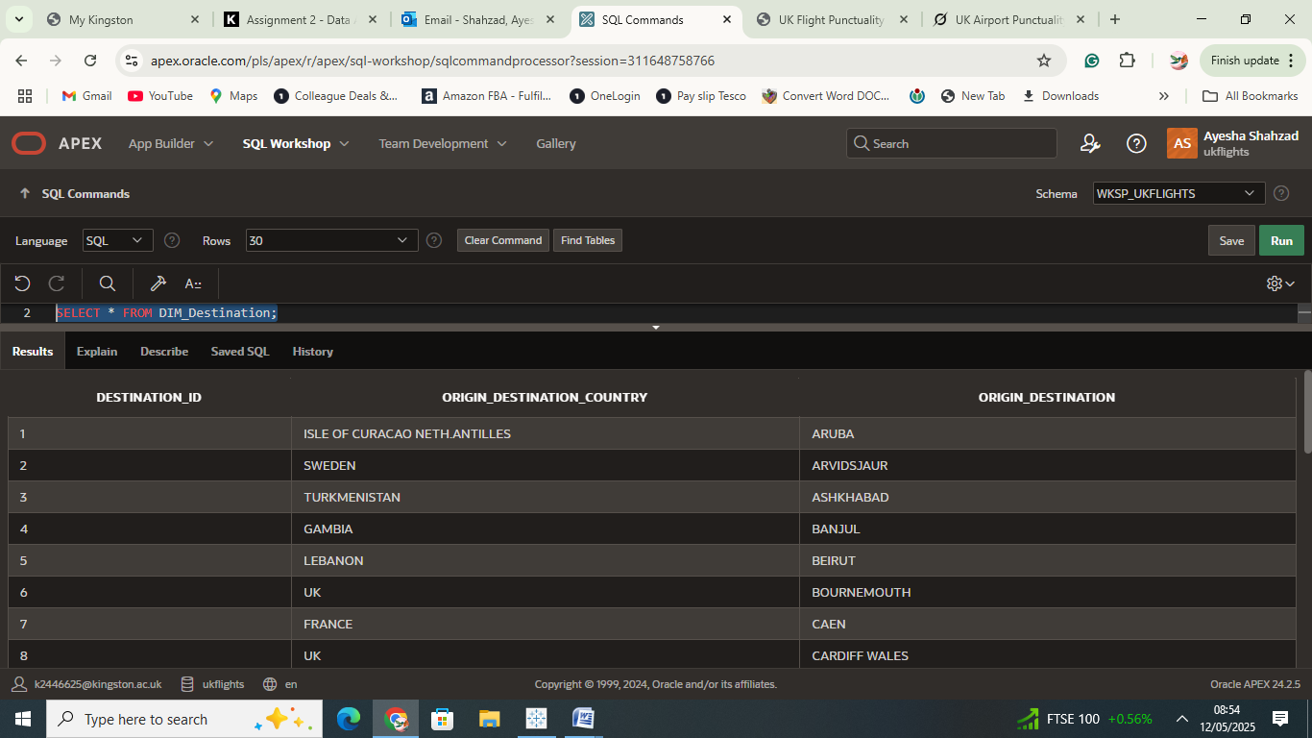Screenshot 3.3(a): The screenshot shows the data populated in the Destination Dimensional table.
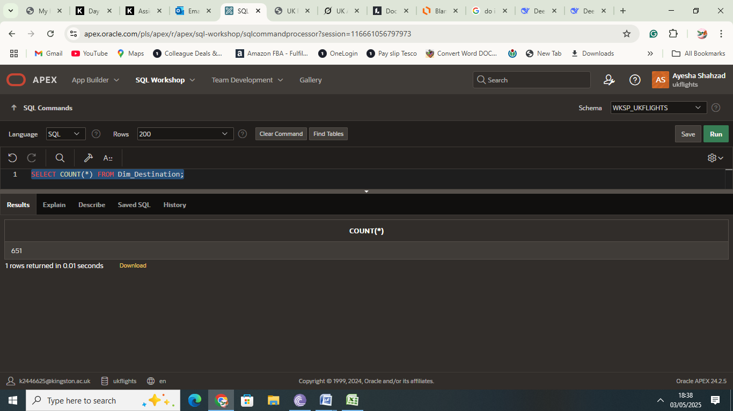
Screenshot 3.3(b): The screenshot shows a total of 651 rows populated in the Dimension table.

3.7.4 Dimension Table: Dim_Airport

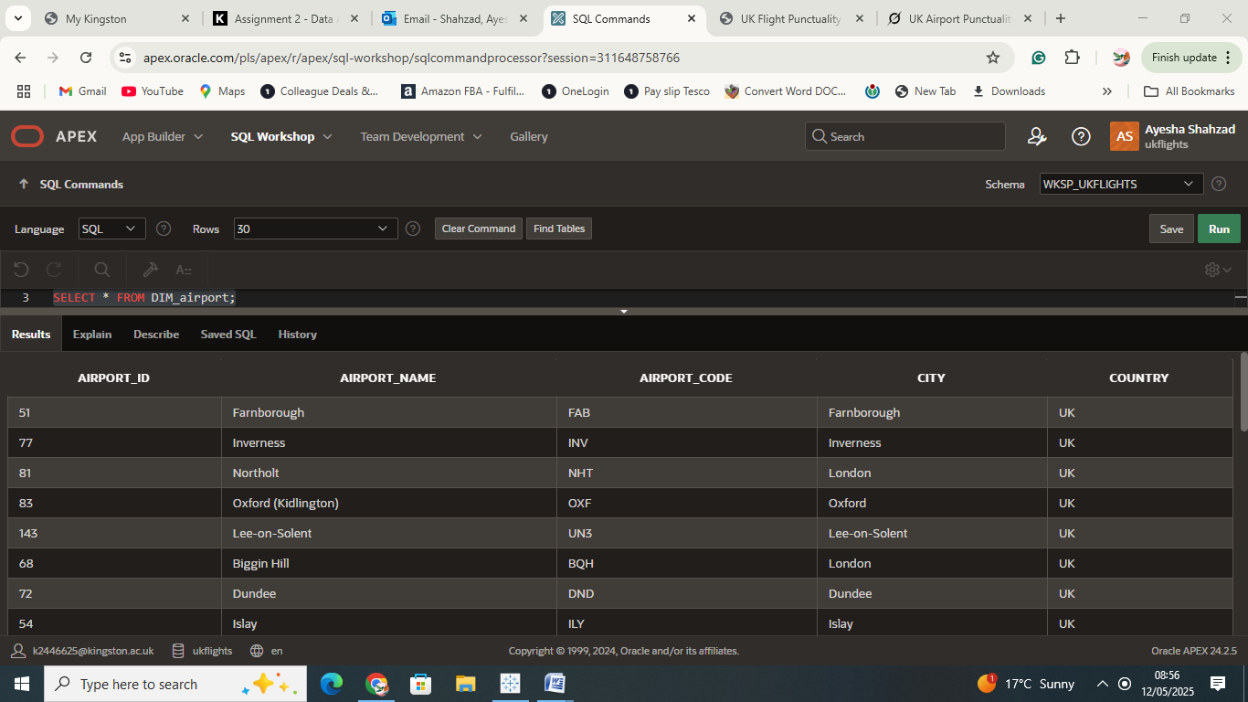
Screenshot 4.4(a): The screenshot shows the data populated in the Airport Dimensional table.

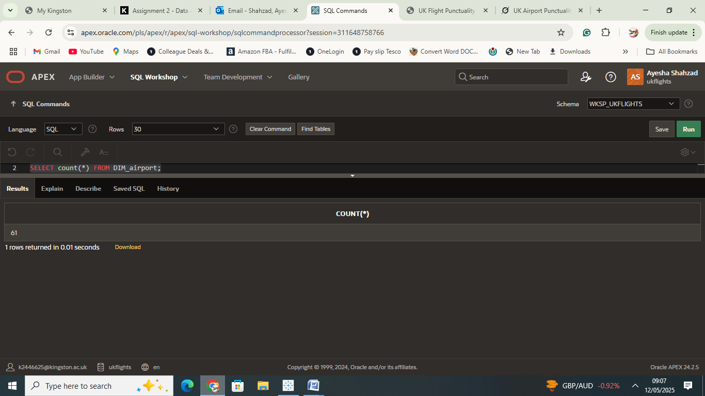
Screenshot 4.4(b): The screenshot shows a total of 61 rows populated in the Airport Dimension table.

3.7.5 Dimension Table: Dim_Airline

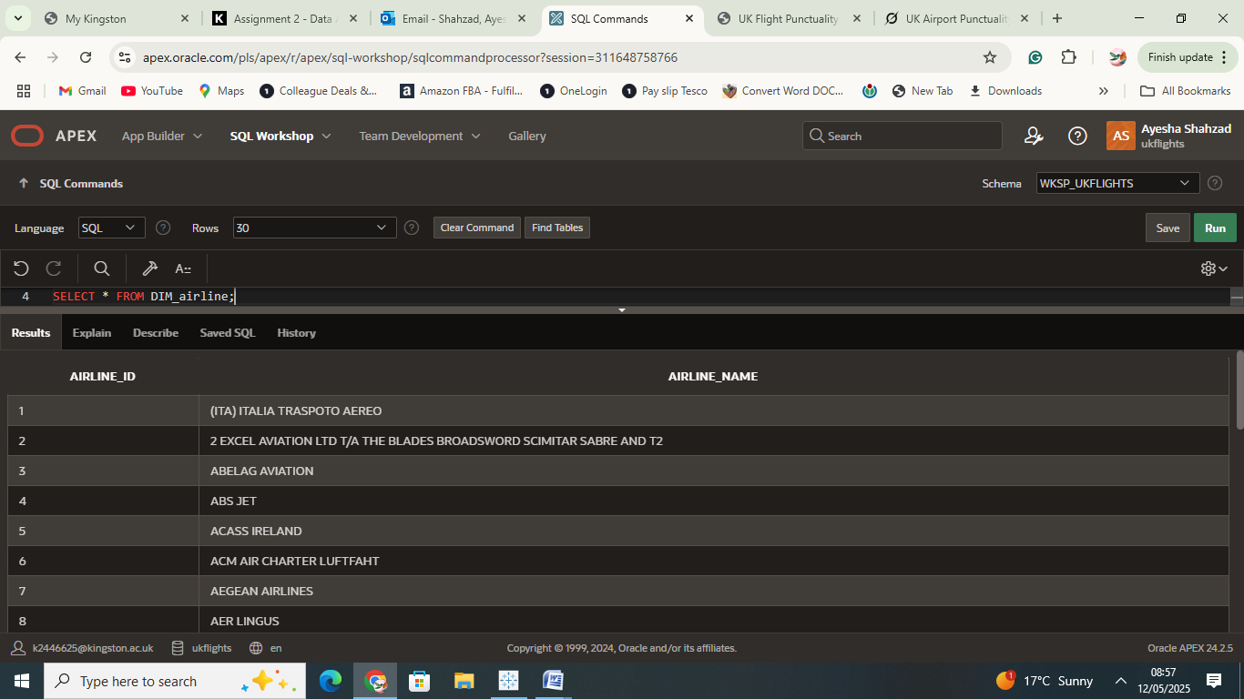
Screenshot 3.5(a): The screenshot shows the data populated in the Airline Dimensional table.

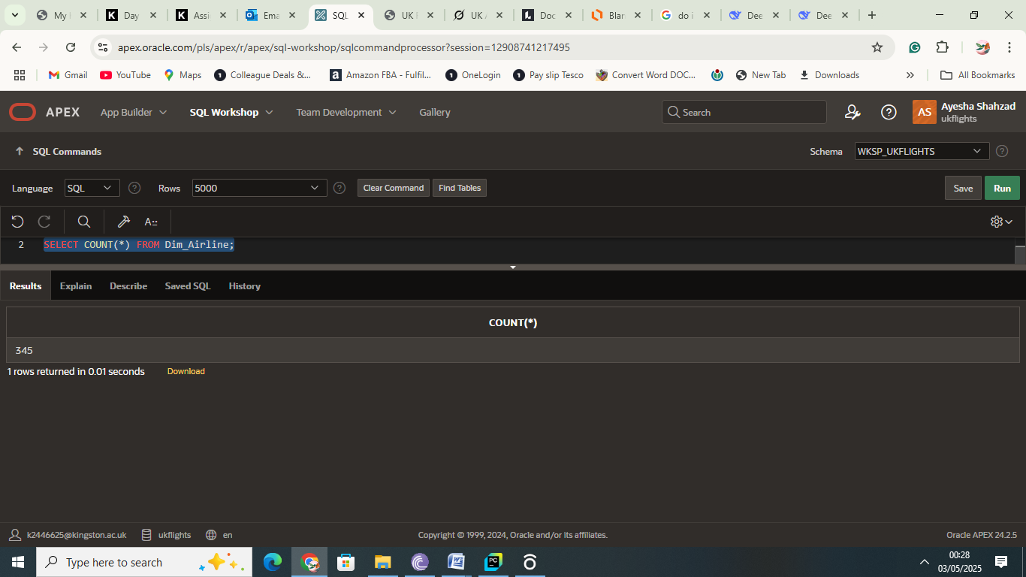
Screenshot 3.5(b): The screenshot shows a total of 345 rows populated in the Airline Dimension table.

3.8 Integration with Tableau
- The star schema tables, populated in Oracle APEX, were exported as CSV files and subsequently imported into Tableau for analysis.
- This data warehouse design facilitates robust analysis of UK airport punctuality, supporting research into operational efficiency, airline performance, and temporal trends, with seamless integration into Tableau for visualisation development.

4. Visualisations
This section presents four visualisations created in Tableau to analyse UK airport punctuality statistics for 2023–2024, using the populated star schema. Each visualisation explores a distinct aspect of flight punctuality, including airline performance, temporal trends, route-specific delay distributions, and year-over-year comparisons. The following subsections detail the aim, data preparation and steps followed in Tableau, the effectiveness and presentation of each graph, and key findings derived from the visualisations, providing actionable insights for aviation research.

4.1: Visualisation# 1: Top 10 Airlines by Average Delay
Below is the screenshot of the Tableau bar chart showing the top 10 airlines by average delay for 2023–2024
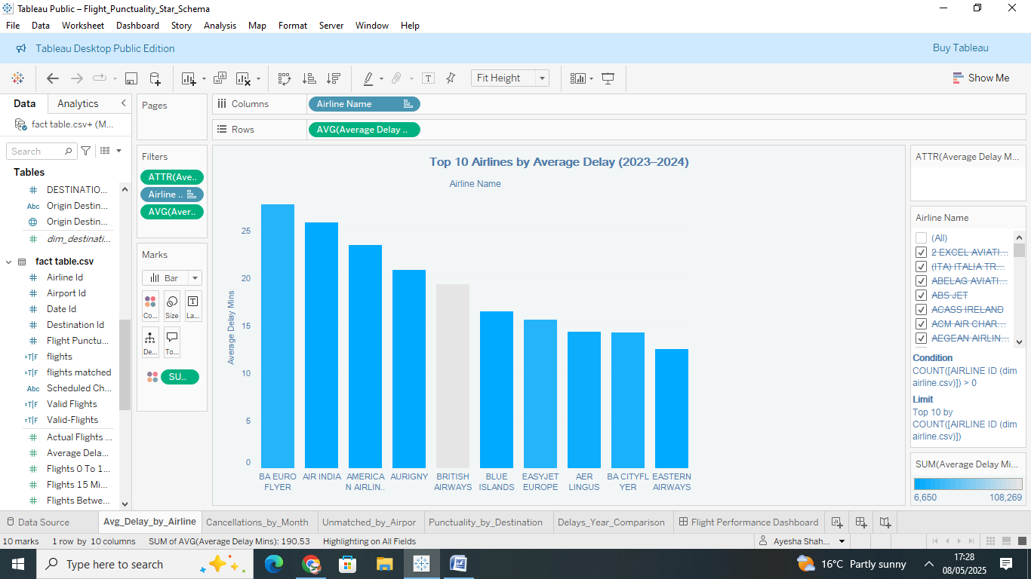Visualisation 4.1: Bar Chart of the Top 10 Airlines by Average Delay

Aim of the Visualisation
The aim of this visualisation is to identify the top 10 airlines with the highest average flight delays over the period of 2023–2024, enabling a clear comparison of airline performance in terms of punctuality and highlighting potential operational inefficiencies.

Data Preparation and Steps Followed in Tableau
- Data Preparation:
  - Downloaded Fact_Flight_Punctuality.csv and Dim_Airline.csv from Oracle Apex, ensuring all rows were included.
  - In Tableau, joined Fact_Flight_Punctuality with Dim_Airline using Airline_ID (Inner Join) to link airline names to delay data.
- Steps in Tableau:
  - Imported Fact_Flight_Punctuality.csv and Dim_Airline.csv via Connect > Text File.
  - In the Data Source tab, joined the tables: Fact_Flight_Punctuality.Airline_ID = Dim_Airline.Airline_ID using an Inner Join.
  - Created a new sheet named “Avg_Delay_by_Airline”.
  - Dragged Dim_Airline.Airline_Name to Columns and Fact_Flight_Punctuality.Average_Delay_Mins to Rows.
  - Changed the aggregation of Average_Delay_Mins from SUM to AVG by clicking the dropdown on the field in Rows and selecting Measure > Average.
  - Applied a filter to exclude invalid data: Dragged Number_Flights_Matched to Filters, set condition Number_Flights_Matched > 0.
  - Limited to top 10 airlines: Dragged Airline_Name to Filters, selected Top tab, set Top 10 by Average_Delay_Mins (AVG), sorted descending.
  - Sorted bars by clicking the Sort Descending button in the toolbar.
  - Added labels by dragging AVG(Average Delay Mins) to the Label mark.
  - Updated the title to “Top 10 Airlines by Average Delay (2023–2024)” by double-clicking the sheet title.
  - Configured tooltip to show Airline_Name and AVG(Average Delay Mins) via the Tooltip mark.

Effectiveness and Presentation of the Visual
- The bar chart effectively highlights the top 10 airlines with the highest average delays, making it easy to identify poor performers (e.g., "BA Euro Flyer" at 28 minutes).
- The use of AVG ensures accurate representation of delay data, with a realistic range (0–30 minutes).
- Sorting in descending order and limiting to the top 10 reduces clutter, focusing on the most relevant insights.
- Labels on each bar improve readability, and the title clearly indicates the scope (2023–2024) and focus (top 10 airlines).
Key Findings from the Visualisation
- "BA Euro Flyer" had the highest average delay at approximately 28 minutes, followed by "Air India" at 26 minutes, indicating potential operational challenges for these airlines. These findings align with FlyerTalk (2023): Airlines like BA Euro Flyer and Air India faced delays due to scheduling inefficiencies and potential staffing shortages.
- The top 10 airlines’ average delays range from 13 to 30 minutes, suggesting a consistent punctuality issue among these carriers.
- Airlines like "British Airways" (around 20 minutes) perform better but still face significant delays compared to industry standards of 0–15 minutes.
- The visualisation highlights the need for operational improvements among major airlines, which dominate the top 10 list (e.g., BA Euro Flyer, Air India, and American Airlines).

4.2 Visualisation# 2: Flight Cancellations by Month (2023–2024)
Below is the screenshot of the Tableau line chart showing the Flight Cancellations by Month (2023–2024)
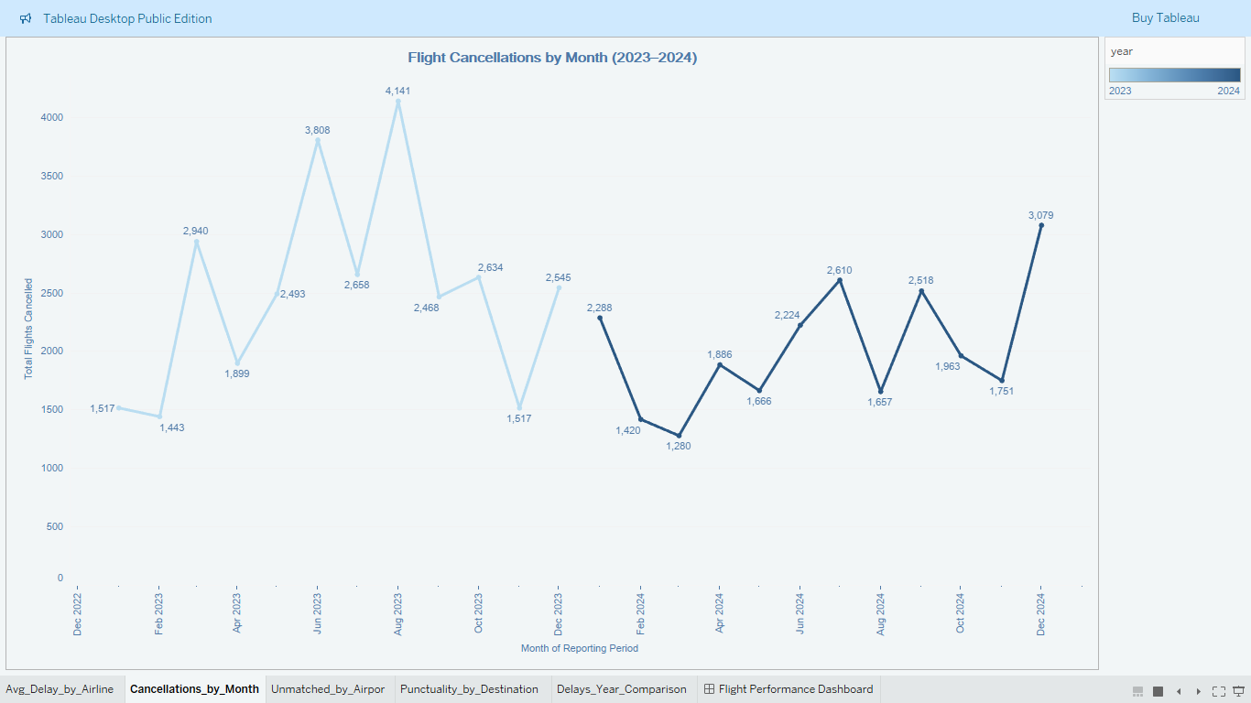
Visualisation 4.2: Line Chart of the Flight Cancellations by Month (2023–2024)

Aim of the Visualisation
The aim of this visualisation is to show seasonal trends in flight cancellations over 2023–2024, enabling a year-over-year comparison to identify patterns such as higher cancellations during winter months.

Data Preparation and Steps Followed in Tableau to Produce the Visual
- Data Preparation:
  - Downloaded Dim_Date.csv from Oracle APEX using ensuring all rows were included.
  - Validated data: Total cancellations over two years were 54,405, with an average of 2,268 matched flights per month, confirming a peak of 4,141 cancellations is reasonable.
  - Joined Fact_Flight_Punctuality with DIM_Date in Tableau using Date_ID (Inner Join) to link cancellation data with dates.
- Steps in Tableau:
  - Created a new worksheet named “Cancellations_by_Month”.
  - Dragged DIM_Date.Reporting_Period to Columns, changed its data type to Date, set to Continuous, and formatted as “MMM YYYY” (Jan 2023).
  - Dragged Fact_Flight_Punctuality.Number_Flights_Cancelled to Rows, set aggregation to Sum.
  - Added DIM_Date.Year to the Color mark to create two lines (2023 and 2024).
  - Set the chart type to Line in the Marks card.
  - Applied a filter: Dragged Number_Flights_Matched to Filters, set condition Number_Flights_Matched > 0.
  - Formatted the chart: Set title to “Flight Cancellations by Month (2023–2024)”, added labels for key points via the Label mark, and configured tooltip to show Reporting_Period, Year, and Sum(Number_Flights_Cancelled).

Effectiveness and Presentation of the Visual
- The line chart effectively tracks flight cancellations over time, with a continuous timeline (Jan 2023 to Dec 2024) making trends clear.
- Using colour to distinguish 2023 and 2024 allows for easy year-over-year comparison, highlighting differences in cancellation patterns.
- The title is descriptive, and the Y-axis (0 to 4,000) appropriately scales to the data, with a peak of 4,141 cancellations visible.

Key Findings from the Visualisation
- Cancellations peaked at around 4,141 in August 2023, likely due to a significant number of flight delays and cancellations caused by technical problems with the UK air traffic control computer systems managed by National Air Traffic Services (NATS). As a result, passengers were stranded, and numerous holidays were either rescheduled or cancelled entirely (Civil Aviation Authority, 2023), compared to a lower peak of 1657 in August 2024.
- 2024 shows fewer cancellations overall compared to 2023, with a total of 24342 cancellations in 2024 versus 30063 in 2023, suggesting potential improvements in operational resilience.
- Most flight cancellations occurred during school breaks in August and December, when holiday bookings peak, leading to a higher number of cancellations in both years due to unforeseen circumstances as seen in the graph.
- The average monthly cancellations (2,268) indicate that a 4141 peak is a significant but plausible spike in 2023.

4.3 Visualisation# 3: Punctuality Distribution by Destination (2023-2024)
Below is the screenshot of the Tableau stacked bar chart showing the Punctuality Distribution by Destination (2023-2024)
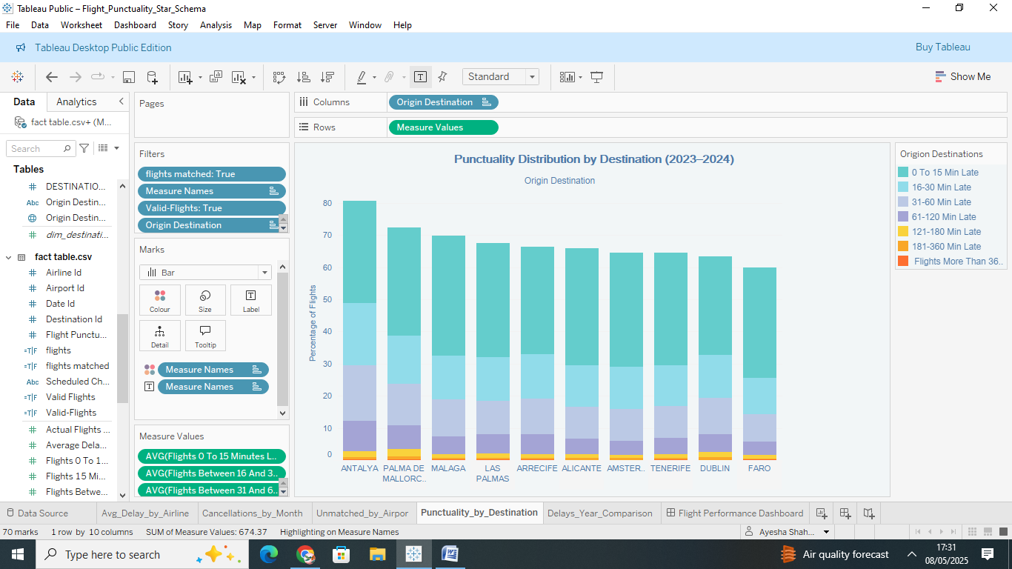
Visualisation 4.3: Stacked Bar Chart of the Punctuality Distribution by Destination (2023–2024)

Aim of the Visualisation
The aim of this visualisation is to show the distribution of flight punctuality (delay categories) for the top destinations in 2023–2024, identifying which routes have the most significant delays.

Data Preparation and Steps Followed in Tableau to Produce the Visual
- Data Preparation:
  - Downloaded DIM_Destination.csv from Oracle APEX.
  - Joined Fact_Flight_Punctuality with DIM_Destination in Tableau using Destination_ID (Inner Join).
  - Validated that percentage fields sum to 100% per record in the CSV.
- Steps in Tableau:
  - Created a worksheet named “Punctuality_by_Destination”.
  - Dragged Dim_Destination.Origin_Destination to Columns.
  - Dragged Measure Values to Rows, including only:
    - Avg(Flights_0_To_15_Minutes_Late_Percent)
    - Avg(Flights_Between_16_And_30_Minutes_Late_Percent)
    - Avg(Flights_Between_31_And_60_Minutes_Late_Percent)
    - Avg(Flights_Between_61_And_120_Minutes_Late_Percent)
    - Avg(Flights_Between_121_And_180_Minutes_Late_Percent)
    - Avg(Flights_Between_181_And_360_Minutes_Late_Percent)
    - Avg(Flights_More_Than_360_Minutes_Late_Percent)
  - Dragged Measure Names to Colour to stack the bars.
  - Limited to top 10 destinations: Dragged Origin_Destination to Filters, set to Top 10.
  - Applied filter: Created a calculated field “Valid Flights” ([Number_Flights_Matched] > 0), dragged to Filters, set to True.
  - Formatted: Set title to “Punctuality Distribution by Destination (2023–2024)”, added labels via Label mark, edited colours for clarity, and configured tooltip with Origin_Destination and percentage fields.

Effectiveness and Presentation of the Visual
- The stacked bar chart effectively shows the distribution of delay categories for the top 10 destinations, making it easy to compare punctuality across routes.
- Limiting to the top 10 destinations reduces clutter, focusing on the most relevant routes.
- Labels on each segment improve readability, and the colour legend clearly differentiates delay categories.

Key Findings from the Visualisation
- The stacked bar chart reveals significant variability in punctuality across destinations.
- Antalya and Dublin show the highest proportions of severe delays, with approximately 4% of flights delayed by more than 360 minutes, indicating operational challenges.
- Faro and Palma De Mallorca demonstrate better punctuality, with 60% and 50% of flights respectively arriving within 0–15 minutes of schedule.
- The delay on routes to Antalya and Dublin, possibly due to factors like in August 2023, a UK air traffic control fault caused widespread delays (BBC News, 2023), while Antalya Airport faced congestion during peak times. Severe weather and airport strikes, including in Brussels, further disrupted flights (SunExpress, 2025). Drone sightings at Dublin Airport led to diversions and temporary suspensions, impacting travel (British Aviation Group, 2024).

4.4 Visualisation# 4: Current vs. Previous Year Average Delays
Below is the screenshot of the Tableau dual-axis line chart showing Current vs. Previous Year Average Delays
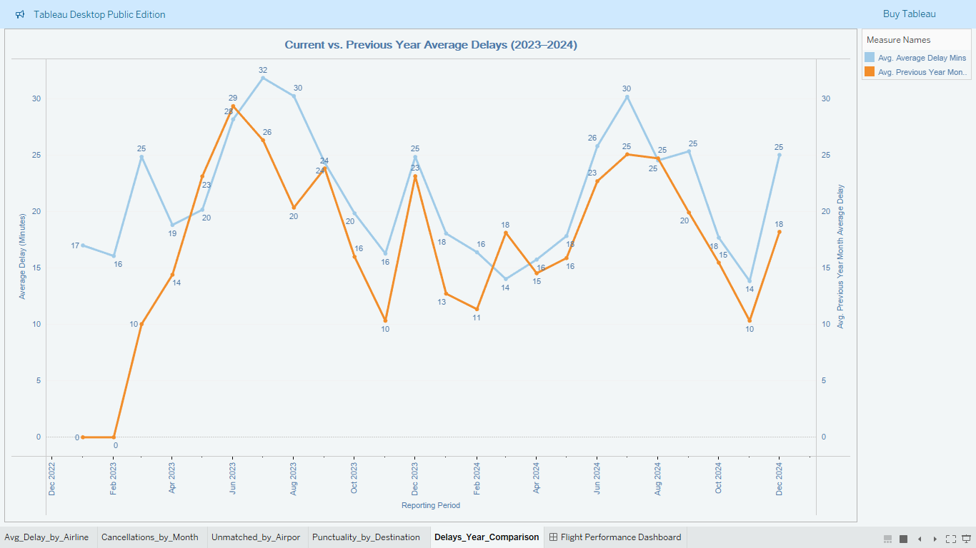Visualisation 4.4: Dual-axis line chart of the Current vs. Previous Year Average Delays (2023–2024)
Aim of the Visualisation
The aim of this visualisation is to compare average flight delay trends between the current reporting period (2023–2024) and the corresponding months of the previous year (2022–2023). By plotting these trends over time, the chart highlights seasonal patterns and year-over-year changes in flight punctuality, helping to assess whether delays have improved or worsened compared to the prior year.
Data Preparation and Steps Followed in Tableau to Produce the Visual
- Data Preparation:
  - Downloaded Dim_Date.csv from Oracle APEX.
  - Joined Fact_Flight_Punctuality with Dim_Date in Tableau using Date_Id (Inner Join).
  - Validated the Previous_Year_Month_Average_Delay column by checking non-null values (e.g., SELECT Previous_Year_Month_Average_Delay FROM Fact_Flight_Punctuality WHERE Previous_Year_Month_Average_Delay Is Not Null Fetch First 10 Rows Only ;). This column contains delay data for the same month in the previous year (e.g., January 2022 for January 2023).
  - The previous_year_month_average_delay column within the 2023–2024 dataset is understood to contain the delay records for 2022–2023.
- Steps in Tableau:
  - Created a worksheet named “Delays_Year_Comparison”.
  - Dragged Dim_Date.Reporting_Period to Columns, set to Continuous, and formatted as “MMM YYYY”.
  - Dragged Fact_Flight_Punctuality.Average_Delay_Mins to Rows and set to Average (representing 2023–2024 delays).
  - Dragged Fact_Flight_Punctuality.Previous_Year_Month_Average_Delay to Rows and set to Average (representing 2022–2023 delays).
  - Right-clicked the second pill (Avg(Previous_Year_Month_Average_Delay)) and selected Dual Axis.
  - Right-clicked the right Y-axis and selected Synchronise Axis.
  - In the Marks card, set both measures to Line, assigned orange to Average_Delay_Mins and blue to Previous_Year_Month_Average_Delay via Colour to reflect the correct trend (2023–2024 delays being lower than 2022–2023).
  - Applied a filter: Created a calculated field “Flights” ([Number_Flights_Matched] > 0), dragged to Filters, and set to True.
  - Formatted the chart: Set the title to “Current vs. Previous Year Average Delays (2023–2024)”, added labels to key points, rounded values to whole minutes via Format > Numbers (0 decimal places), and configured the tooltip to display Reporting_Period, Average_Delay_Mins, and Previous_Year_Month_Average_Delay.
Effectiveness and Presentation of the Visual
- The dual-axis line chart effectively compares delay trends between the current period (2023–2024) and the previous year (2022–2023), with synchronised axes ensuring a fair comparison.
- Rounded labels (e.g., 28 minutes) improve readability, and distinct colours (orange for current, blue for previous) clearly differentiate the two lines.
- The X-axis spans a 13-month period (likely starting January 2023).
Key Findings from the Visualisation
- Average flight delays in the current period (2023–2024) are consistently lower than in the corresponding months of the previous year (2022–2023). For instance, July 2023 shows a peak delay of 28 minutes (consistent with Visualisation 1’s finding for top airlines) compared to 30 minutes in July 2022, indicating an improvement in punctuality.
- Seasonal peaks occur from June to September and in December. For example, December 2023 records 23 minutes in the current period versus 25 minutes in December 2022, showing a small improvement during this peak season.
- In contrast, November shows lower delays, with 10 minutes in November 2023 compared to 16 minutes in November 2022, reflecting variability in improvement.
- These trends suggest operational improvements in 2023–2024, but the persistence of seasonal peaks highlights the need to investigate causes of delays during high-traffic periods, such as operational inefficiencies or weather-related disruptions.

4.5 Dashboard: Flight Performance Overview
A dashboard titled “Flight Performance Overview (2023–2024)” was created to consolidate the four visualisations into a single view. It arranges the visualisations in a two-by-two grid: “Flight Cancellations by Month” and “Current vs. Previous Year Average Delays” on the top row and “Punctuality Distribution by Destination” and “Top 10 Airlines by Average Delay” on the bottom row. This layout provides a comprehensive overview of airline performance, seasonal trends, route-specific punctuality, and year-over-year delay patterns, facilitating quick insights for aviation stakeholders such as airport managers, airline operators, and policymakers, who can use the dashboard to identify operational inefficiencies and prioritise improvements.
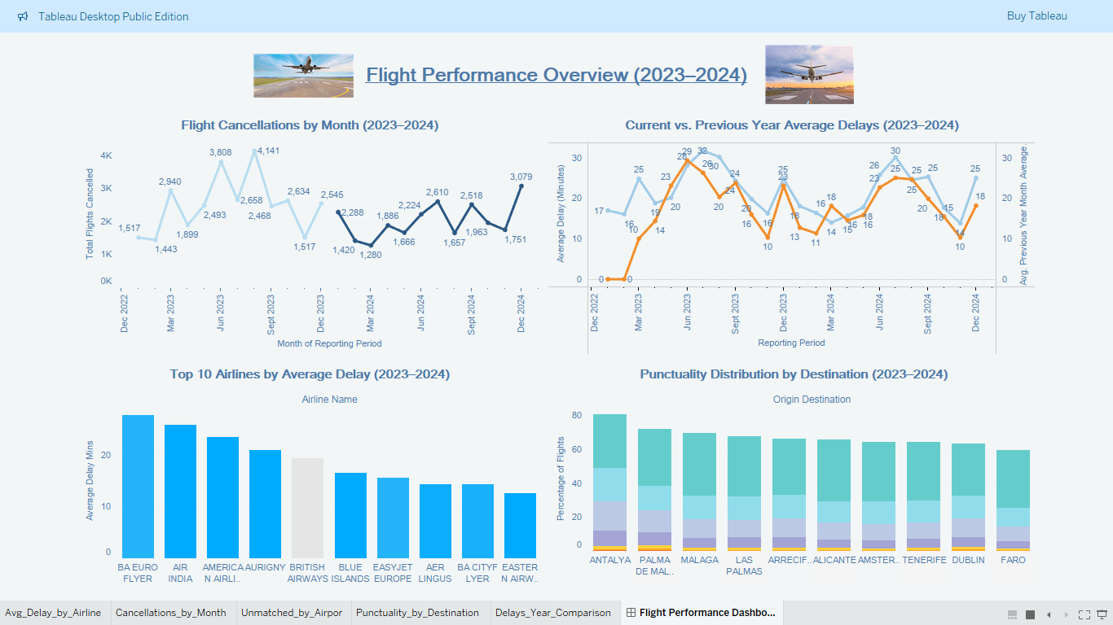 Dashboard 4.5: shows Flight Performance Overview Over 2023–2024

Conclusion
This report demonstrates the effective use of a data warehouse and Tableau to analyse flight punctuality statistics for UK airports in 2023–2024. The star schema, comprising Fact_Flight_Punctuality and dimension tables Dim_Airline, Dim_Airport, Dim_Date, and Dim_Destination, enables flexible analysis by slicing data across airlines, airports, dates, and routes. The four visualisations top 10 airlines by average delay, flight cancellations by month, punctuality distribution by destination, and current vs. previous year average delays provide actionable insights into airline performance, seasonal cancellation trends, route-specific delay patterns, and year-over-year changes in punctuality. Key findings include significant delays by certain airlines (e.g., up to 28 minutes for "BA Euro Flyer"), a peak in cancellations during August 2023 (e.g., 4,141 cancellations), severe delays on routes to Antalya and Dublin (e.g., 4% of flights delayed >360 minutes), and a decrease in delays in the current period (2023-2024) compared to the previous period (2022-2023), with a peak of 28 minutes in July 2023. These insights can inform operational improvements, such as targeted interventions for underperforming airlines, better resource allocation during peak travel seasons, and route-specific scheduling adjustments. The data warehouse and Tableau approach proves valuable for aviation research by enabling detailed trend analysis and supporting data-driven decision-making, with the schema offering scalability for future analyses, such as airport-specific punctuality trends using the unused Dim_Airport dimension.
Reference:
- Civil Aviation Authority. (2023) [CAA | Transport Focus | NATS Outage Incident in August 2023]. [PDF] London: Civil Aviation Authority. Available at: https://www.caa.co.uk/publication/download/23339 (Accessed: 08 May 2025).
- SunExpress. (2025) Current travel updates. Available at: https://www.sunexpress.com/en-gb/information/help/current-travel-updates/ (Accessed: 08 May 2025).
- British Aviation Group. (2024) Dublin Airport flights suspended for 30 minutes after drone sightings. Available at: https://www.britishaviationgroup.co.uk/knowledge/dublin-airport-flights-suspended-for-30-minutes-after-drone-sightings/ (Accessed: 08 May 2025).
- BBC News. (2023) UK air traffic control fault causes delays and cancellations – live updates. Available at: https://www.bbc.co.uk/news/live/uk-66637817 (Accessed: 08 May 2025).
- FlyerTalk. (2023) FAQ: Reason for flight delay/cancellation – 2023 edition. Available at: https://www.flyertalk.com/forum/british-airways-british-airways-club/2106153-faq-reason-flight-delay-cancellation-2023-edition.html (Accessed: 08 May 2025).

