# Machine Learning

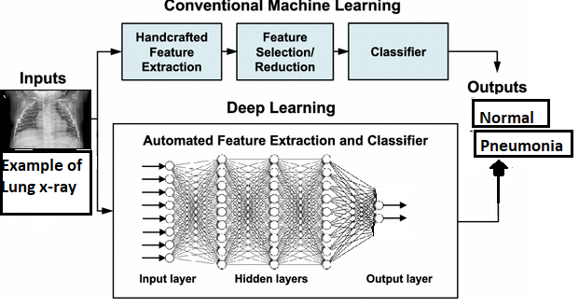

Conventional Programming is not a very advanced level, where decision making is based on IF-ELSE conditions. Therefore, many solutions cannot be modeled with it. One of the main reasons behind this is the variation of the input data variable, which increases the problem’s complexity. On the contrary, machine learning programming solves the problem by modeling the data with train data and test data. Based on these data and statistical models, machine learning predicts the result.

We are primarily working with images and we need a model to take in these images, process them and give us the desired output.

We choose these models conventional and deep learning as these take in the data (images of chest x-ray) process them well and predicts the images and classify them correctly as “normal” or “pneumonia”.