PROJECT REPORT
LuxuryStay HMS
Hotel Management System
A MERN-stack web application for hotel reservations, front-desk operations, billing, housekeeping, maintenance and management reporting

Submitted by
1 | Student1561115 | MUHAMMAD TALHA
2 | Student1561444 | RAJA HARIS
3 | Student1572235 | NIBRAS KHAN
4 | Student1547456 | AYESHA
5 | Student1550000 | MUHAMMAD AHMED
6 | Student1551197 | YASH RAJ

Academic submission
Institution | ________________________________
Department | ________________________________
Programme / course | ________________________________
Supervisor | ________________________________
Academic session | ________________________________
Submission date | ________________________________

Documentation prepared from the project source code and the running application, 14 October 2026.
Project Team and Declaration
Project team
No. | Student ID | Name | Signature
1 | Student1561115 | MUHAMMAD TALHA
2 | Student1561444 | RAJA HARIS
3 | Student1572235 | NIBRAS KHAN
4 | Student1547456 | AYESHA
5 | Student1550000 | MUHAMMAD AHMED
6 | Student1551197 | YASH RAJ

Declaration
We declare that this project report and the software it describes, LuxuryStay HMS — Hotel Management System, are our own work, carried out as part of our academic programme. The work of others, including open-source libraries and their documentation, is acknowledged in the text and the references. This work has not been submitted for any other award.
Date: ________________________________
This declaration is a template; adjust it to the wording your institution requires.
Acknowledgement and Abstract

Acknowledgement
We thank our supervisor, ______________________, and the faculty of the ______________________ department of ______________________ for their guidance, and the maintainers of the open-source tools on which LuxuryStay HMS is built.

Abstract
Hotels must keep reservations, room status, guest identity, payments and housekeeping in step. When these live in registers, spreadsheets and separate tools, rooms are double-booked, balances are missed and managers lack a reliable view of the business.
LuxuryStay HMS is a web-based hotel management system built on the MERN stack: MongoDB with Mongoose, Express 5 on Node.js, and a React 19 single-page application built with Vite. It provides a public website with live room availability, a guest portal for reservation requests with identity-document upload, and a staff workspace for the front desk, housekeeping, management and administration. Five roles are mapped to 29 named permissions enforced on every one of the 59 API endpoints. Double booking is prevented by a unique database index on each room-night, identity documents are encrypted with AES-256-GCM, and a local OCR engine compares a typed CNIC number with the uploaded image as a project-level check only — every online request is confirmed by staff.
The backend has 103 automated tests in 12 suites, run on an isolated database, and the main user journeys were tested end to end in a browser. This report describes the requirements, architecture, data model, roles, workflows and security of the system, how to install and run it, and the verified test results.
Keywords: hotel management system, MERN stack, role-based access control, reservations, room-night ledger
Table of Contents
1 Introduction and Objectives 1
1.1 Problem 1
1.2 Aim and objectives 1
2 Scope and Requirements 2
2.1 Scope 2
2.2 Functional requirements 2
2.3 Non-functional requirements 2
3 Technology Stack 3
4 System Architecture 4
5 User Roles and Permissions 6
6 Database Design 9
6.1 Integrity mechanisms 9
7 System Modules 11
8 Authentication, Authorization, Validation and Security 12
8.1 Authentication and authorization 12
8.2 Validation rules 12
8.3 Request, data and database protection 12
9 Core Hotel Workflows 14
10 API Structure 16
11 Testing and Results 17
11.1 Strategy 17
11.2 Results (15 October 2026) 17
12 Application Screenshots 19
13 Installation and Configuration 21
14 Known Limitations and Future Improvements 22
15 Conclusion and References 23
References 23
Appendix A API Endpoints 24

1 Introduction and Objectives
LuxuryStay HMS is a full-stack web application that supports the daily work of a single hotel, from a visitor's first look at the website to the guest's departure and review. It brings reservations, room status, guest records, identity documents, billing, housekeeping, maintenance and reporting into one system used through a browser by guests and by every member of staff.
The application has three parts: a public website that presents the room types with live prices and availability; a guest portal where a registered guest requests and manages stays; and a staff workspace whose screens and actions depend on the person's role.

1.1 Problem
- Rooms can be promised twice when availability is checked by reading a register or spreadsheet.
- Identity documents are checked inconsistently and copies are stored without protection.
- Folios — room charges, extras, discounts, tax and part-payments — are calculated by hand.
- Reception does not know when housekeeping has finished a room, and maintenance issues are forgotten.
- Managers have no live view of occupancy, revenue or guest satisfaction, and access is not controlled per person.

1.2 Aim and objectives
Aim: to design and implement a secure, role-based web application that manages a hotel's reservations, stays, billing, housekeeping, maintenance and reporting, with a public website and a guest portal.
- Present room types with real prices and availability for chosen dates.
- Let visitors register as guests and request reservations online with an identity document.
- Prevent double booking under concurrent requests by enforcing availability in the database.
- Support the front-desk cycle: desk reservations, review of requests, check-in, payments, charges, discounts, invoices and check-out.
- Connect check-out to housekeeping and track maintenance that takes rooms out of service.
- Give managers live dashboards and period reports.
- Restrict every action to the roles allowed to perform it, on the server.
- Protect accounts and personal data, and keep production, development and test data apart.
This report describes the system exactly as implemented; every technical statement was checked against the source code, and features that do not exist are listed as limitations.

2 Scope and Requirements

2.1 Scope
In scope: one hotel with three room categories (Serene Room, Signature Suite, Royal Residence); public website, guest portal and staff workspace; online and desk reservations with CNIC or passport; check-in and check-out; folios, payments and numbered invoices; housekeeping, maintenance, reviews, enquiries and in-app notifications; staff accounts, settings, dashboards and reports; password reset by email.
Out of scope: online card payments, official identity verification (NADRA or any government service), multiple properties or channel managers, restaurant and spa point-of-sale, and SMS or email notifications other than password reset.

2.2 Functional requirements
Table 2.1: Functional requirements (all implemented)
ID | Requirement
FR-1 | Show room types with prices, amenities and capacity from the database; check availability for dates and guests.
FR-2 | Register guest accounts; sign in and out; update profile and password; reset a forgotten password by email.
FR-3 | Lock an account for 15 minutes after 8 failed sign-ins; refuse deactivated accounts.
FR-4 | Guests request stays with an identity document (CNIC front and back, or passport); requests stay pending until staff decide.
FR-5 | Staff create confirmed reservations at the desk; confirm or reject requests (rejection needs a reason).
FR-6 | Change dates or room; guests may change only pending requests; cancel pending or confirmed reservations.
FR-7 | Never let two active reservations hold the same room on the same night.
FR-8 | Check in confirmed, verified reservations from the arrival day; check out when the folio is settled.
FR-9 | Maintain folios: room charges, extras, discount, tax, payments (cash, card, bank transfer); issue numbered invoices.
FR-10 | Manage rooms and room status; run the cleaning queue; report, start and complete maintenance.
FR-11 | Guests review completed stays; managers moderate reviews; staff handle website enquiries.
FR-12 | Dashboards and reports for 7, 30, 90 days or 12 months.
FR-13 | Administrators create, edit, activate and deactivate staff accounts and change hotel settings.

2.3 Non-functional requirements
Table 2.2: Non-functional requirements
Area | How it is met
Security | bcrypt password hashes; revocable JWT sessions; permission check on every protected endpoint; rate limits; strict input schemas; security headers; encrypted identity documents.
Integrity | Unique (room, night) index; optimistic concurrency on bookings; atomic invoice numbers; start-up checks of database name, indexes and ledger.
Usability and accessibility | Role-specific navigation; field-level validation messages; light and dark themes; reduced-motion support; layouts from 390 px phones to desktops.
Maintainability | Routes, middleware, services, models and utilities separated; one permission matrix; 12 automated test suites.

3 Technology Stack
Table 3.1: Technology stack (versions from package.json; runtime versions as tested)
Layer | Technologies
Runtime and database | Node.js 24.15.0; MongoDB 8.2.12 (standalone)
Backend | bcryptjs ^3.0.3, cors ^2.8.6, dotenv ^18.0.0, express ^5.2.1, express-rate-limit ^8.7.1, helmet ^8.3.0, jsonwebtoken ^9.0.3, mongoose ^9.10.1, multer ^2.4.0, nodemailer ^10.1.0, tesseract.js ^5.1.1, zod ^4.6.7
Frontend | axios ^1.20.0, framer-motion ^13.4.0, lucide-react ^1.47.0, react ^19.2.8, react-dom ^19.2.8, react-icons ^5.7.0, react-router-dom ^7.18.4
Tooling | @types/react ^19.2.18, @types/react-dom ^19.2.7, @vitejs/plugin-react ^6.1.1, oxlint ^1.81.0, vite ^8.3.0; nodemon ^3.1.14; Node test runner

axios and react-icons are declared in the client but not imported anywhere.

4 System Architecture
LuxuryStay HMS has three tiers. The React application runs in the browser and calls the Express API over HTTP with JSON; the API is the only component that reads or writes MongoDB, so every rule — who may act, which nights are free, how a folio is totalled — is enforced in one place (Figure 4.1).
- Client: App.jsx defines the public website (/, /rooms/:slug), authentication pages, the guest portal (/guest) and the staff workspace (/admin for administrators and managers, /staff for receptionists and housekeeping). A signed-in person opening another role's area is redirected to the same page in their own area. All requests go through lib/api.js.
- API: a fixed middleware pipeline — security headers, CORS, body limit, unsafe-key rejection, rate limits, database-ready guard — then authentication, permission check, schema validation and the handler. Shared business rules live in services/ (availability, identity ledger, OCR, invoices, notifications, settings).
- Data: MongoDB with 12 collections; identity-document images are stored encrypted in the upload folder. Separate databases are used for production (luxurystay), development (luxurystay_dev) and tests (<name>_test).
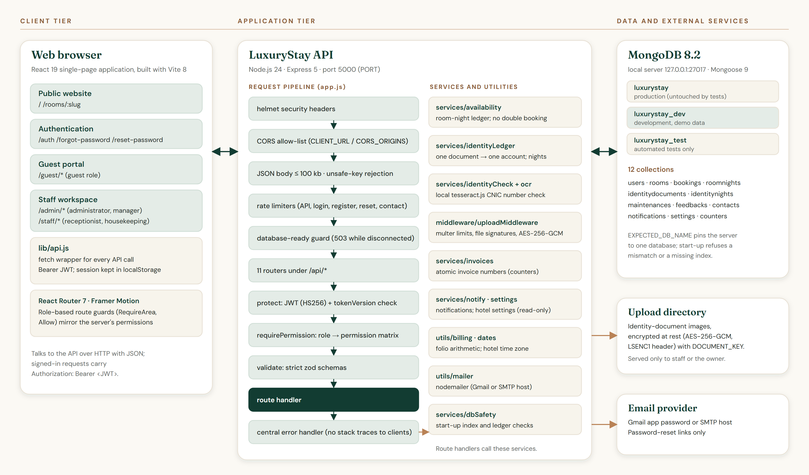
Figure 4.1: System architecture

5 User Roles and Permissions
Table 5.1: The five roles
Role | Workspace | Responsibilities
Administrator (admin) | /admin | Everything a manager can do, plus staff accounts, guest-account activation and hotel settings
Manager | /admin | Front desk and housekeeping operations, rooms, discounts, reports, reviews; can view the staff list
Receptionist | /staff | Reservations, identity review, check-in and check-out, payments and invoices, enquiries, guest directory
Housekeeping | /staff | Cleaning queue (rooms they start are marked as theirs), maintenance tasks; no guest, booking or billing data
Guest | /guest | Own reservations, invoices, reviews and profile

Registration always creates a guest. Staff accounts are created only by an administrator; nobody can change their own role or status, and the last active administrator cannot be removed. A legacy staff role remains for older accounts but cannot be assigned.
Table 5.2: Permission matrix (generated from server/config/permissions.js)
Permission | Meaning | admin | manager | receptionist | housekeeping | guest
staff:view | View staff accounts | ● | ●
staff:manage | Create and edit staff accounts | ●
guests:view | View the guest directory | ● | ● | ●
guests:manage | Activate or deactivate guest accounts | ●
rooms:view | View all rooms and their status | ● | ● | ● | ●
rooms:manage | Add, edit and retire rooms | ● | ●
rooms:status | Change a room's status | ● | ● | ●
housekeeping:manage | Work the cleaning queue | ● | ● |  | ●
maintenance:view | View maintenance tasks | ● | ● | ● | ●
maintenance:report | Report a maintenance issue | ● | ● | ● | ●
maintenance:update | Start and complete maintenance | ● | ● |  | ●
bookings:own | Make and manage own reservations |  |  |  |  | ●
bookings:view | View all reservations | ● | ● | ●
bookings:create | Create reservations at the desk | ● | ● | ●
bookings:review | Confirm or reject requests | ● | ● | ●
bookings:edit | Change reservation dates or room | ● | ● | ●
bookings:cancel | Cancel any reservation | ● | ● | ●
bookings:checkin | Check guests in | ● | ● | ●
bookings:checkout | Check guests out | ● | ● | ●
billing:view | View folios and invoices | ● | ● | ●
billing:payment | Record payments | ● | ● | ●
billing:charges | Add or remove extra charges | ● | ● | ●
billing:discount | Apply discounts | ● | ●
reports:view | View dashboard reports | ● | ●
frontdesk:view | View the front-desk summary | ● | ● | ●
feedback:own | Review own completed stays |  |  |  |  | ●
feedback:manage | Moderate guest reviews | ● | ●
contact:manage | Handle website enquiries | ● | ● | ●
settings:manage | Change hotel settings | ●

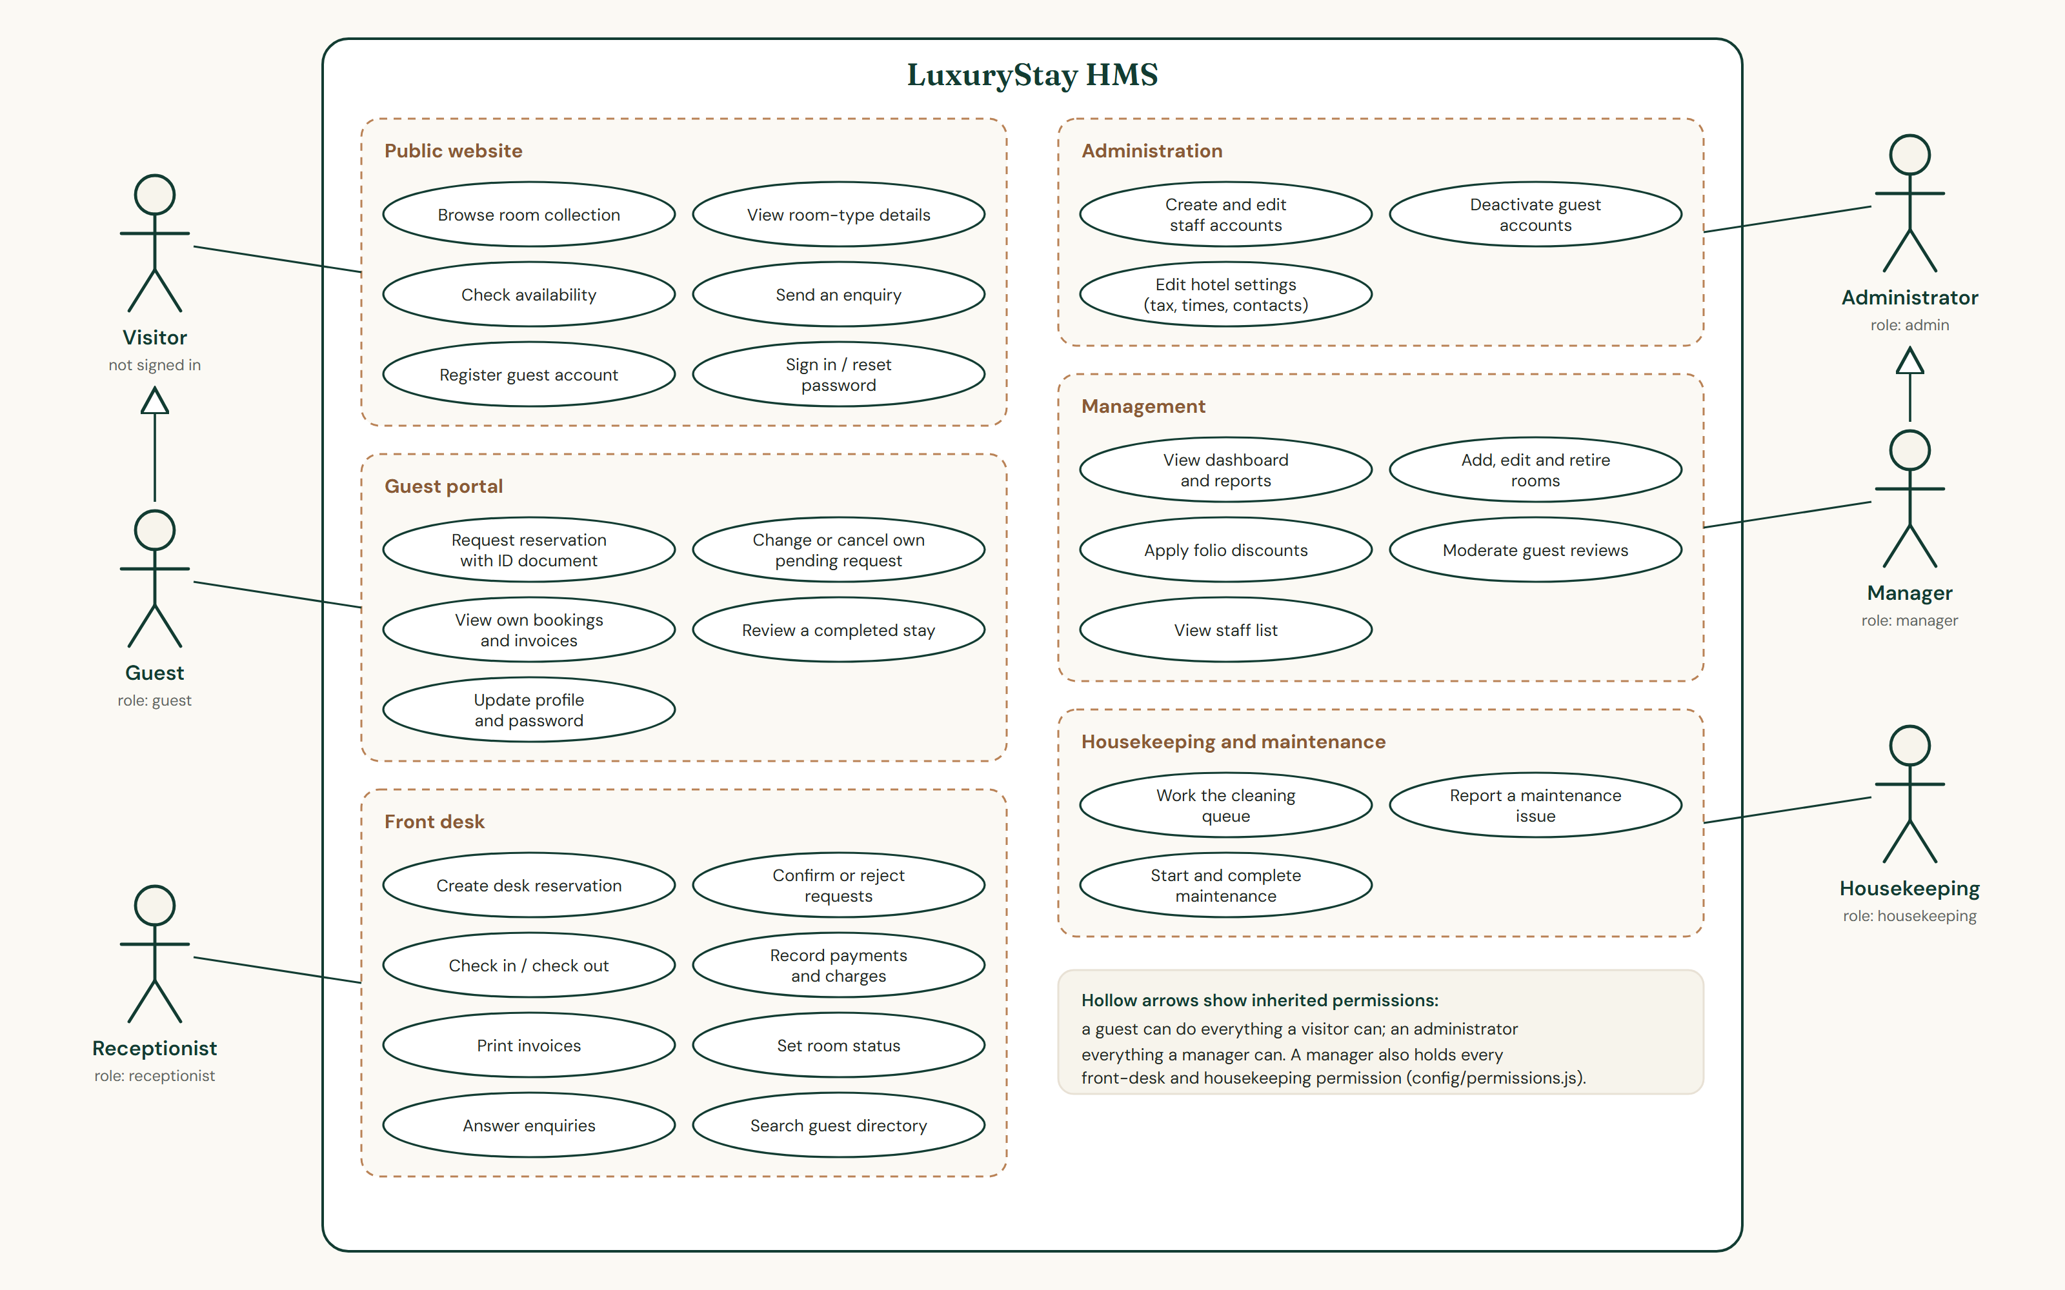
Figure 5.1: Use case diagram

6 Database Design
Each Mongoose model in server/models maps to one MongoDB collection; references are stored as ObjectIds (Figure 6.1).
Table 6.1: Collections
Collection | Purpose | Key constraints
users | Accounts, role, sign-in security fields | email unique
rooms | Room number, type, rate, capacity, status, housekeeping fields | roomNumber unique
bookings | Stay, guest details, identity check, folio (charges, payments), audit fields | invoiceNumber unique when set; version-checked saves
roomnights | One document per room per night held by an active booking | (room, night) unique
identitydocuments | Binds a normalised document number to one account | _id is the document key
identitynights | Nights held by a document | (key, night) unique
maintenances | Issues, priority, progress and resolution | one open task per room (checked in handler)
feedbacks | Reviews of completed stays | booking unique
contacts | Website enquiries | —
notifications | In-app notifications for a user or roles | expire after 60 days
settings | Hotel-wide settings | key unique
counters | Atomic invoice sequences | —

6.1 Integrity mechanisms
- Room-night ledger: an active reservation inserts one roomnights document per night; the unique index makes MongoDB refuse a second claim, so double booking cannot happen even under simultaneous requests and without transactions.
- Identity ledger: a document number belongs to one account and holds each night once, unless the front desk approves a second room for the same guest.
- Optimistic concurrency on bookings and atomic invoice numbers from counters.
- Start-up checks: the server verifies the database name (EXPECTED_DB_NAME), required indexes and ledger consistency before serving requests.
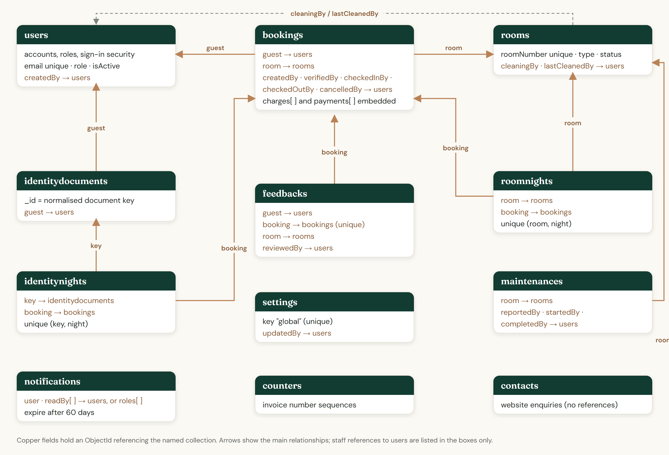
Figure 6.1: Collections and their references

7 System Modules
Table 7.1: Implemented modules
Module | What it does
Public website | Room types from GET /api/public/rooms (no room numbers or status exposed), availability search, room pages, enquiry form.
Accounts | Registration (guests only), sign-in, sign-out (token revoked), profile, password change, password reset by email.
Guest portal | Overview of the next stay; five-step booking (dates, room, details, identity, review); My bookings with details, invoices, changes or cancellation of pending requests, reviews.
Reservations | List with filters and search; detail drawer with the actions the role and status allow; desk reservations confirmed immediately.
Front desk | Arrivals and departures; check-in requires a verified booking, the arrival day and an available room; check-out requires a settled folio unless settings allow a balance; the room then goes to cleaning.
Billing | Folios with room charges, extras, manager discounts and tax; payments with method and reference (duplicate submissions applied once); printable invoices.
Rooms and housekeeping | Room inventory and status; cleaning queue where a housekeeper starts a room and marks it clean.
Maintenance | Issues with priority; reporting takes a room out of service (not while occupied); completion with a note returns it.
Reports | Dashboard and period reports: revenue, occupancy, reservations, average nightly rate, rating; printable.
Reviews and enquiries | One review per completed stay; moderation; enquiries marked read or resolved.
Administration | Staff accounts with search and role/status filters; guest-account activation; hotel settings.
Identity documents | CNIC or passport upload (JPG, PNG, WebP or PDF, 5 MB, 2 files), file-signature check, local OCR comparison for CNIC, AES-256-GCM encryption.

8 Authentication, Authorization, Validation and Security

8.1 Authentication and authorization
- Passwords hashed with bcrypt (12 rounds); never returned by the API.
- JWT (HS256, 12 h by default) carrying a token version: signing out, changing or resetting a password, a role change or deactivation ends every session; each request reloads the account.
- 8 failed sign-ins lock the account for 15 minutes; reset links are single-use, stored only as a hash and expire after 30 minutes; the reset response does not reveal whether an email exists.
- Every protected route names a permission; handlers also check ownership so a guest reaches only their own bookings, invoices and documents. Unauthorized requests receive 401 or 403 — hiding a button is never the only protection.

8.2 Validation rules
The client and the server apply the same rules; the server always validates again with strict zod schemas that reject unknown fields.
Table 8.1: Validation rules
Field | Rule
Account name (registration, profile, staff, create-admin) | 3–80 characters after trimming, starting with a letter; letters, numbers, spaces and . ' ’ - only. 1 or 2 characters, or only spaces, give “Name must be at least 3 characters.”
Guest name on a reservation, enquiry name | 2–80 characters, same character rule (real names can have two letters)
Email | Valid address, stored in lower case, unique per account (duplicate → 409)
Password | 8–72 characters with a letter and a number; confirmation must match (client)
Phone / CNIC / passport | 7–15 digits / 13 digits with or without dashes / 6–12 letters and digits
Stay | Check-out after check-in, not in the past, within the maximum stay and advance period and the room's capacity

There is no separate username: people sign in with their email address, and the Full name field is the account name. Before this release the account name accepted two characters; the three-character minimum was added on both the server (accountName schema) and the client (rules.accountName) with regression tests (Chapter 11).

8.3 Request, data and database protection
- Rate limits: 1,500 API requests, 10 failed sign-ins, 5 reset requests and 15 reset-token checks per 15 minutes; 10 registrations and 8 enquiries per hour.
- Security headers (helmet), CORS allow-list, 100 kb JSON limit, rejection of operator-injection keys, no stack traces in responses.
- Identity documents are encrypted with AES-256-GCM using DOCUMENT_KEY; without the key, uploads are refused (503) — nothing is stored unencrypted. Documents are served only to front-desk staff or the owner, and each viewing is logged without content.
- Secrets live only in server/.env, which is excluded from Git along with uploads and database exports.
- Maintenance scripts print the connected database and refuse the production and test databases; tests refuse any database whose name does not end in _test.
Identity checking
The CNIC check compares the typed number with the number read from the image by a local OCR engine. It is a project-level consistency check, is not connected to NADRA, never confirms a booking by itself, and approving a mismatch requires a staff note.

9 Core Hotel Workflows
- Online request: a guest requests a stay; the nights are held at once (pending); staff confirm after reviewing the document or reject with a reason.
- Desk reservation: staff book a walk-in or telephone guest; the document is inspected in person, so the reservation is confirmed and receives an invoice number.
- Stay: check-in from the arrival day marks the room occupied; extras, discounts and payments update the folio; check-out (balance settled) sends the room to cleaning.
- Housekeeping: the room is started (marked as that housekeeper's) and marked clean, which makes it available again.
- Cancellation: pending or confirmed reservations can be cancelled, releasing the nights; a guest cannot cancel once a payment is recorded.
Table 9.1: Room status changes
From | Event | To
available | Guest checks in | occupied
occupied | Guest checks out | cleaning
cleaning | Housekeeping marks the room clean | available
any except occupied | Maintenance issue reported | maintenance
maintenance | Maintenance completed | available

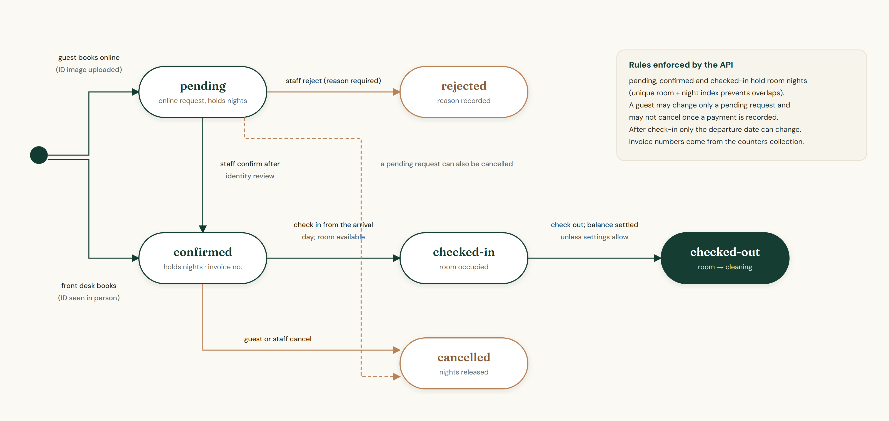
Figure 9.1: Reservation states and transitions

10 API Structure
The API exposes 59 endpoints under /api (plus GET /api/health) in 11 routers. Requests and responses are JSON, except reservation requests with documents (multipart). Signed-in requests send Authorization: Bearer <token>; errors return success: false with a message, and validation errors list the fields concerned. Appendix A lists every endpoint with its access rule.
Table 10.1: API routers
Base path | Endpoints | Responsibility
/api/auth | 9 | Registration, sign-in, profile, password change and reset
/api/bookings | 17 | Reservations, availability, check-in/out, payments, charges, discounts, invoices, documents
/api/contact | 3 | Website enquiries
/api/feedback | 4 | Guest reviews
/api/maintenance | 4 | Maintenance tasks
/api/notifications | 3 | In-app notifications
/api/public | 2 | Hotel details and room types for the website
/api/reports | 3 | Dashboard, front-desk and finance figures
/api/rooms | 8 | Rooms and housekeeping
/api/settings | 2 | Hotel settings
/api/users | 4 | Staff accounts and guest directory

11 Testing and Results

11.1 Strategy
- Automated backend tests (Node test runner): each suite starts the real Express application against a disposable database, creates its own data and checks responses and stored documents; OCR and email are replaced by test doubles. For this report the suite ran on lsverify_test, so neither luxurystay_test nor the development data was touched.
- Browser end-to-end tests (headless Microsoft Edge) on an isolated stack — frontend on port 5199, test API on port 5055, database lsverify_test seeded with fictional data — covering every role's main journeys and API refusals.
- Development-stack checks on luxurystay_dev: each role's demo account signed in; nothing else was written.
- Static checks: client lint (oxlint) and production build (Vite).
Table 11.1: Backend test suites
Suite | Tests | Covers
auth.test.js | 16 | Registration, sign-in, lockout, tokens, profile, security headers
bookings.test.js | 13 | Availability, overlap prevention, concurrency, folios
create-admin.test.js | 5 | Database guards of create-admin and the seed scripts
db-safety.test.js | 5 | Test-database naming, index and ledger checks, start-up refusal
identity.test.js | 15 | Uploads, OCR outcomes, encryption, staff review rules
ocr-engine.test.js | 1 | Real OCR on a fictional specimen card
operations.test.js | 14 | Check-in/out, housekeeping, maintenance, payments, invoices, reports
password-reset.test.js | 10 | Reset tokens, single use, rate limits, sign-out everywhere
public.test.js | 3 | Public hotel and room endpoints
rbac.test.js | 12 | Role permissions, IDOR, staff guard rails
registration.test.js | 5 | Account-name minimum of 3 characters, invalid names, duplicates
roles.test.js | 4 | Five roles, staff creation, permissions of new staff, filters

11.2 Results (15 October 2026)
Table 11.2: Verified results
Check | Result
Backend suite (npm test) on lsverify_test | 103 tests: 103 passed, 0 failed, 0 skipped. Document counts of luxurystay_dev and luxurystay_test identical before and after.
Registration regression tests | 5 of 5 passed: names of 1 and 2 characters and blank names rejected with the 3-character message; 3+ characters accepted and trimmed; invalid characters rejected; duplicate email → 409; profile and staff names use the same rule.
Browser: public site and accounts | Room pages and images load (no broken images); registration validation for 1, 2 and 3-character names, invalid characters, password mismatch and invalid email; registration, duplicate refusal, sign-in, wrong password, sign-out; password recovery refused safely with email switched off.
Browser: workflows | Guest booking with a passport image (stored encrypted, LSENC1), staff confirmation, desk reservation, check-in, payment, check-out, cleaning, maintenance completion, room creation, review moderation, enquiry handling, staff creation, edit and deactivation (sign-in then refused), settings change, guest review and cancellation — all completed with the expected messages. Three steps failed first because of wrong labels in the test script; they were corrected and passed.
Browser: authorization | Receptionist, housekeeping, manager and guest received 403 for every endpoint outside their permissions that was tried (staff, settings, reports, bookings, guests, housekeeping).
Responsive layout | 13 pages across four roles at 390 px and 820 px: no horizontal overflow, no console errors.
Data consistency after the tests | No missing indexes; room-night ledger complete; occupied rooms match in-house guests; payment totals consistent.
Client lint and build | 0 errors, 31 warnings (react set-state-in-effect); production build succeeded.

Not covered: Firefox, Safari and real phones; load testing; automated frontend unit tests.

12 Application Screenshots
Screenshots were captured from the running application with fictional demonstration data: development database luxurystay_dev (Figures 12.1–12.16) and the isolated test environment lsverify_test (Figures 12.17–12.20), at 1440 × 900 unless noted. Account lists are filtered to demonstration accounts; no passwords, tokens or real documents are shown.
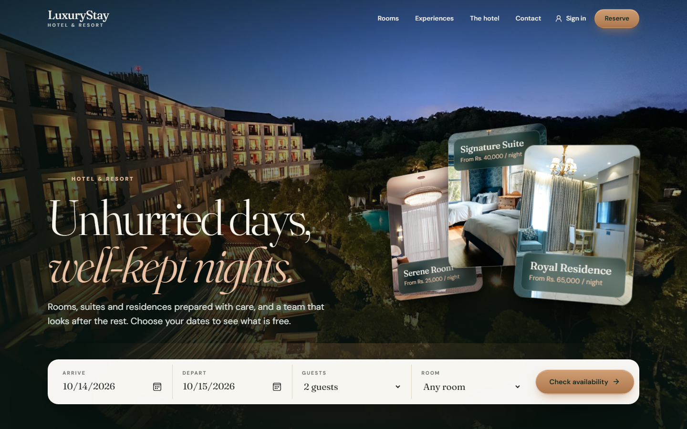  Figure 12.1: Public home page | 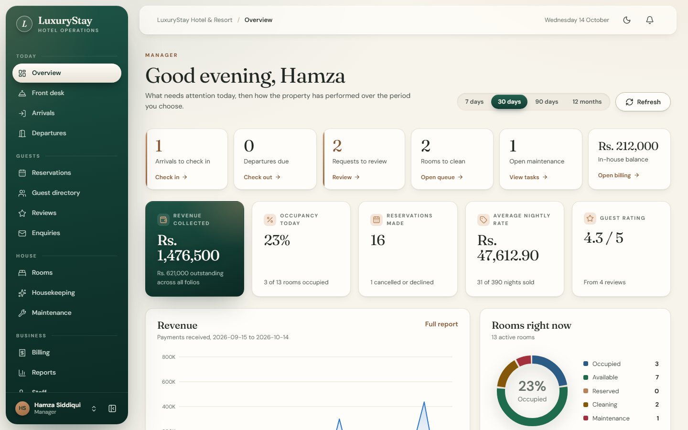  Figure 12.2: Management dashboard
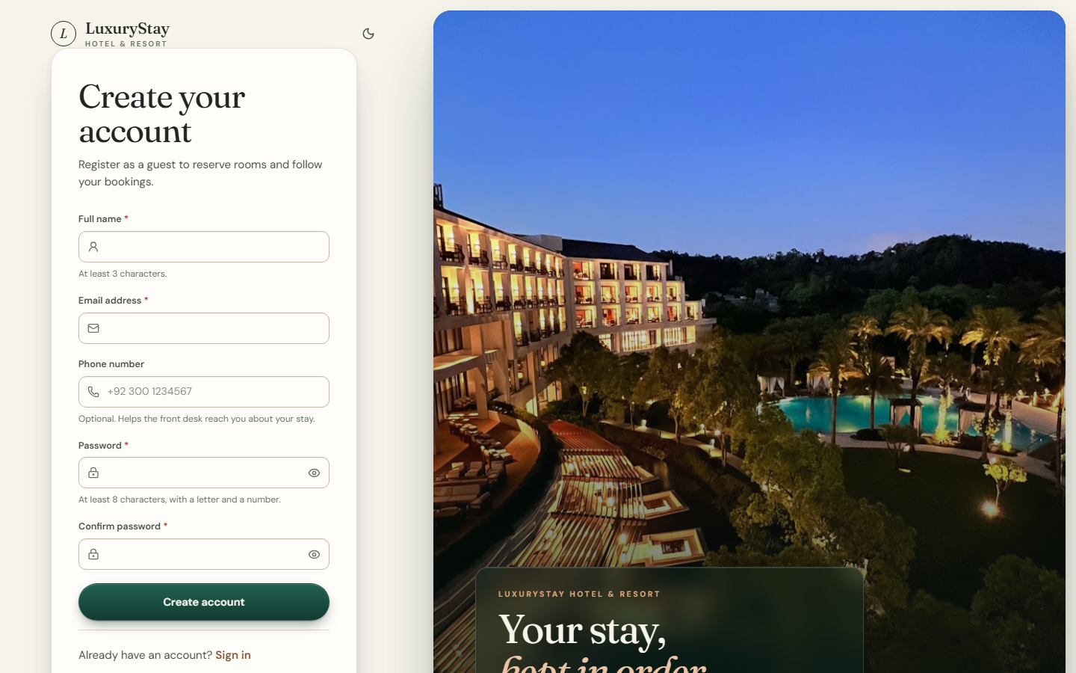  Figure 12.3: Guest registration | 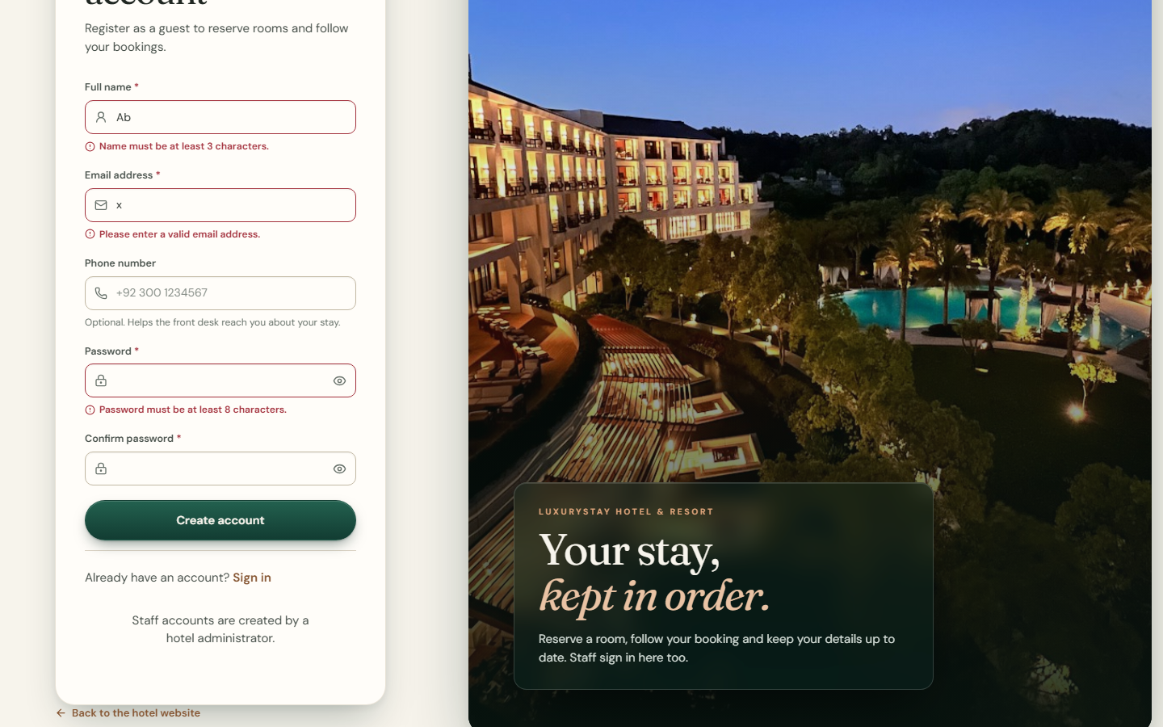  Figure 12.4: Registration validation: 3-character minimum
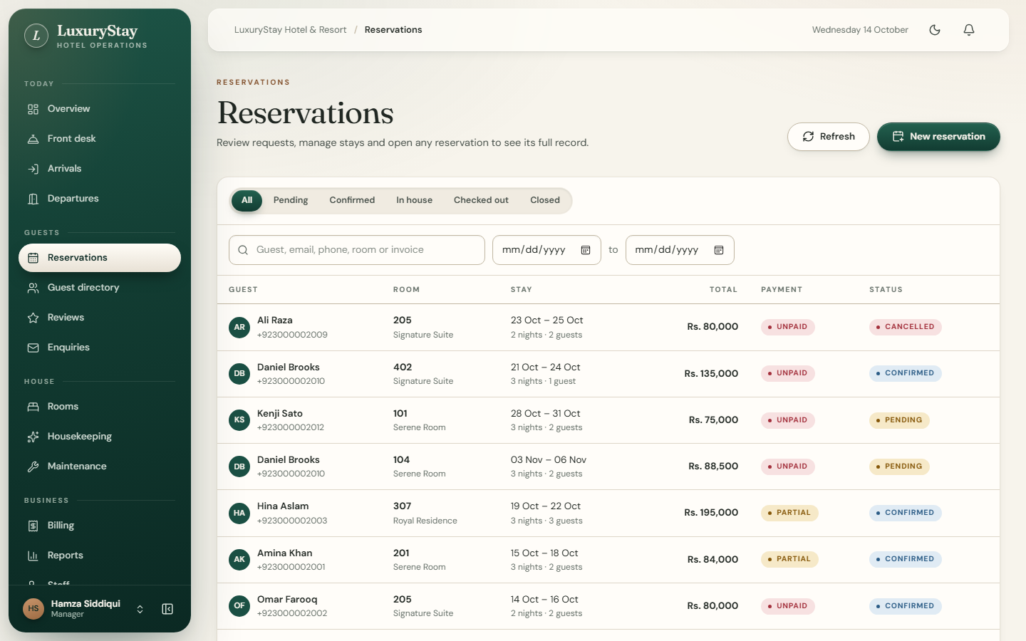  Figure 12.5: Reservations | 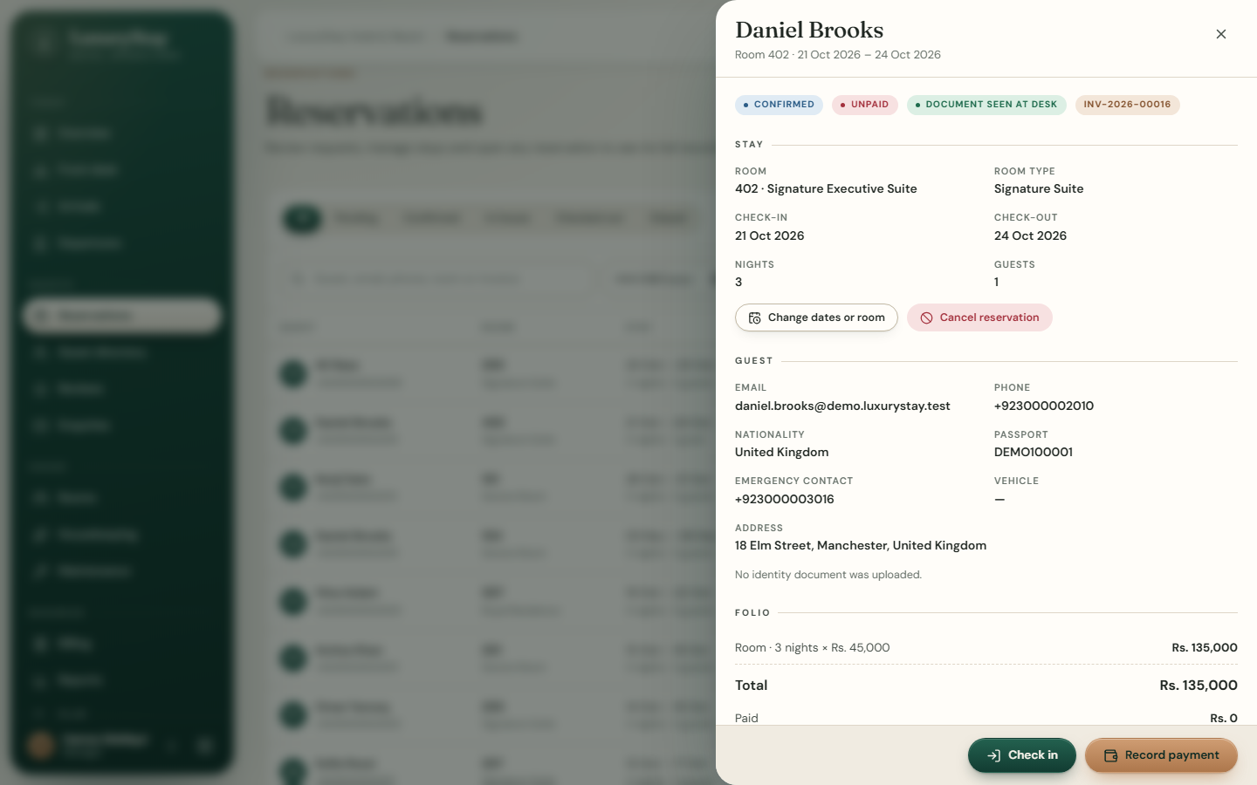  Figure 12.6: Reservation details and folio
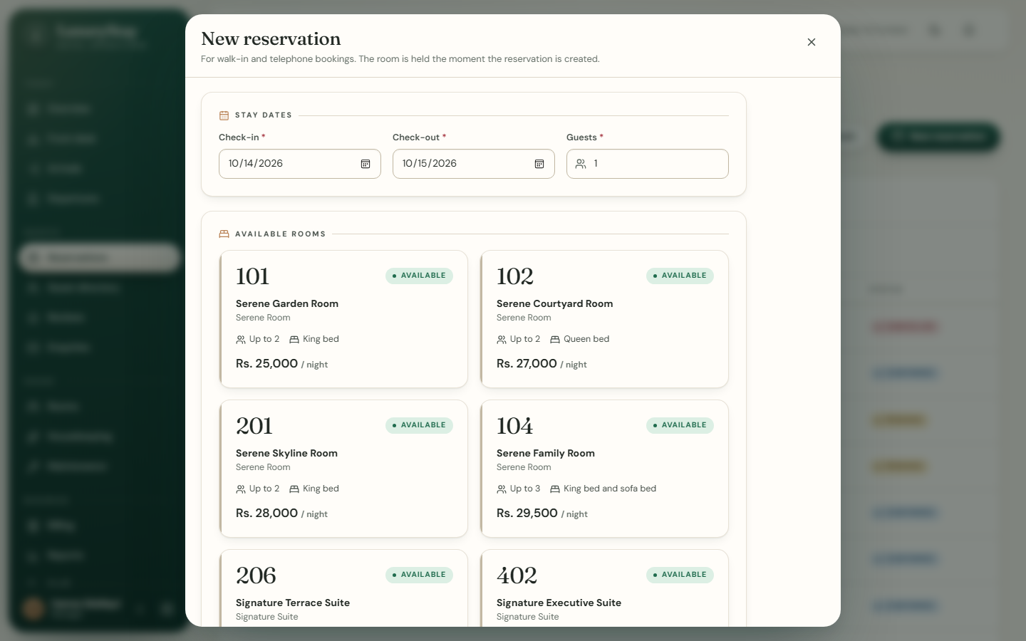  Figure 12.7: Desk reservation form | 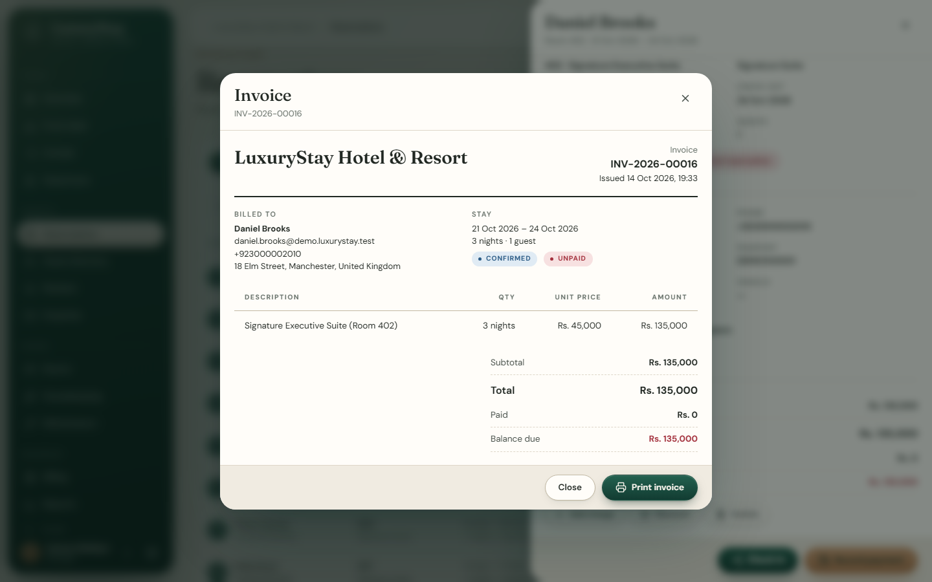  Figure 12.8: Invoice
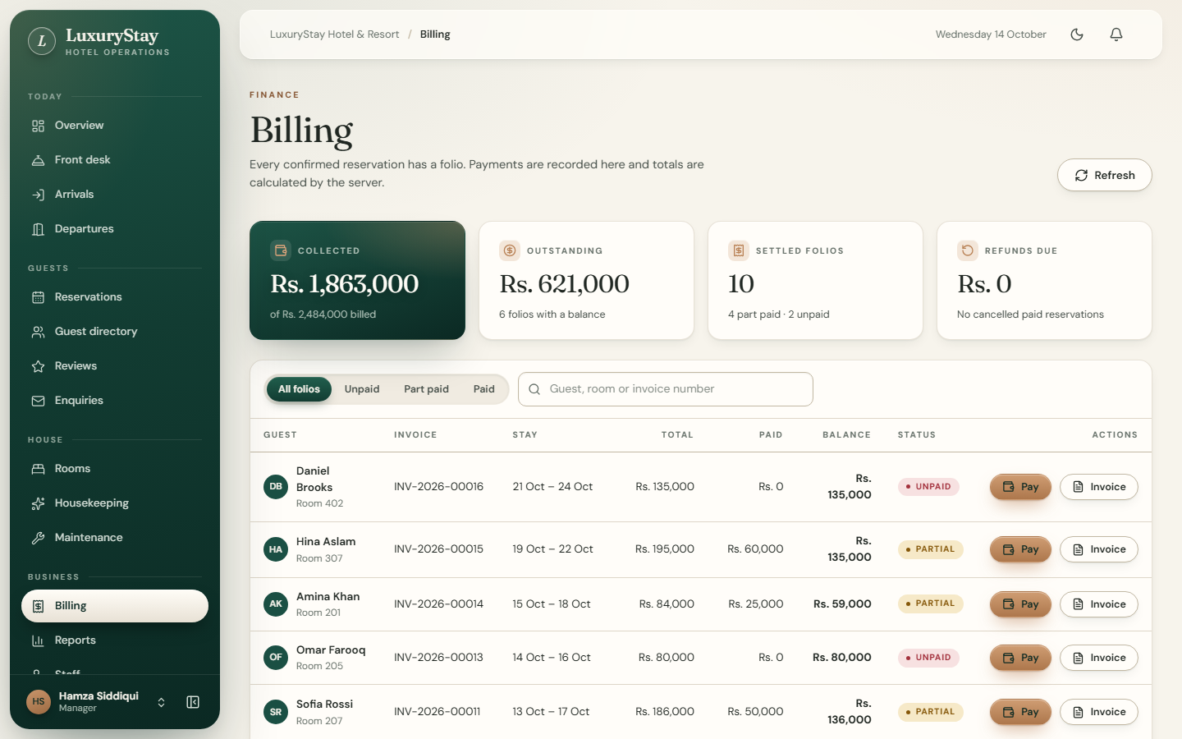  Figure 12.9: Billing | 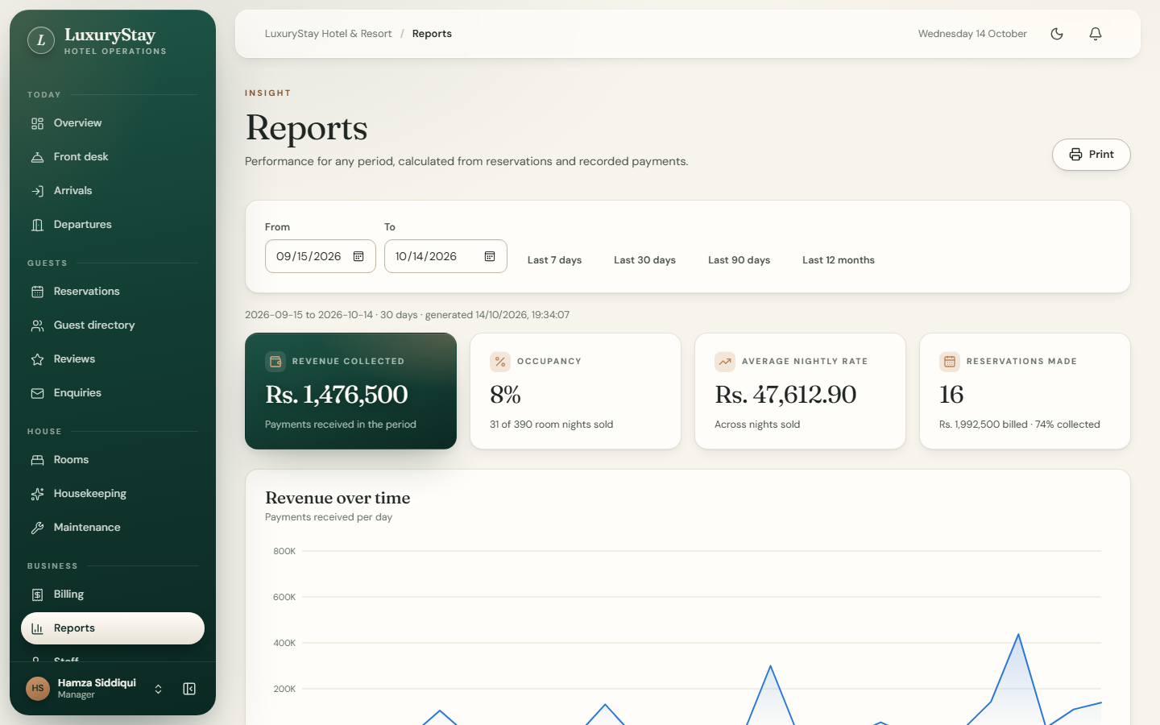  Figure 12.10: Reports
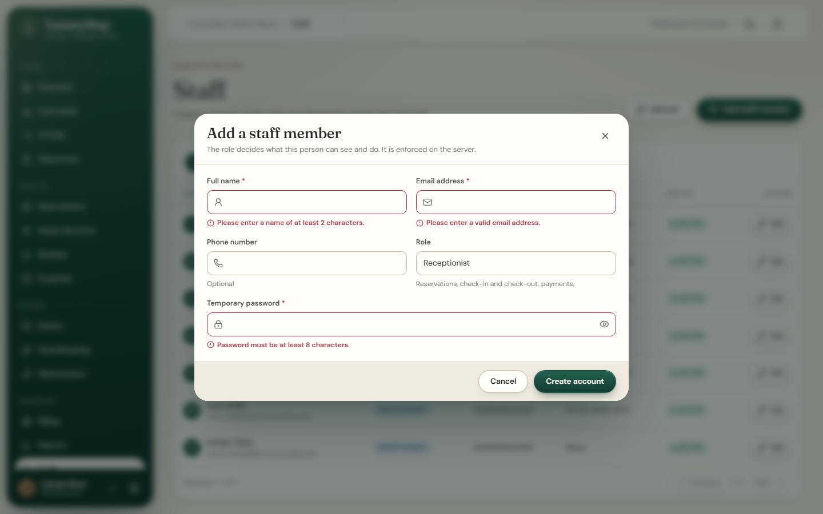  Figure 12.11: Add staff member (administrator) | 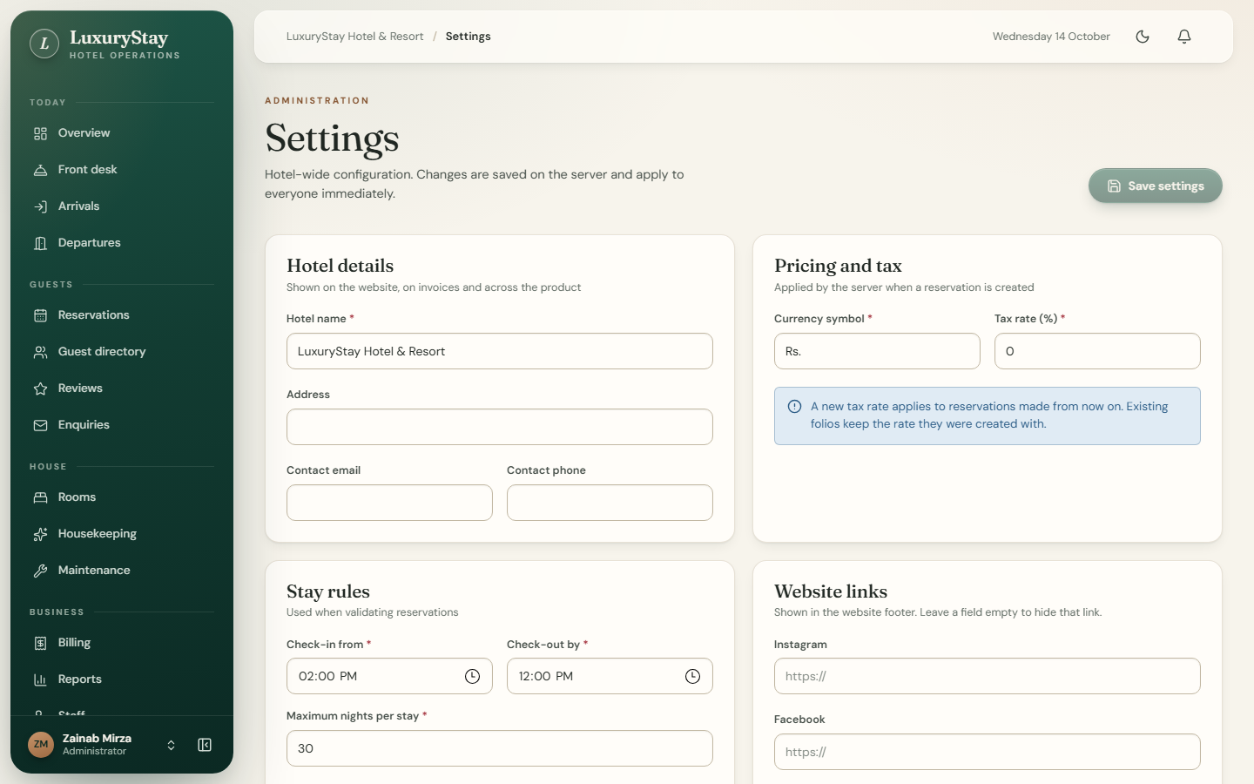  Figure 12.12: Hotel settings (administrator)
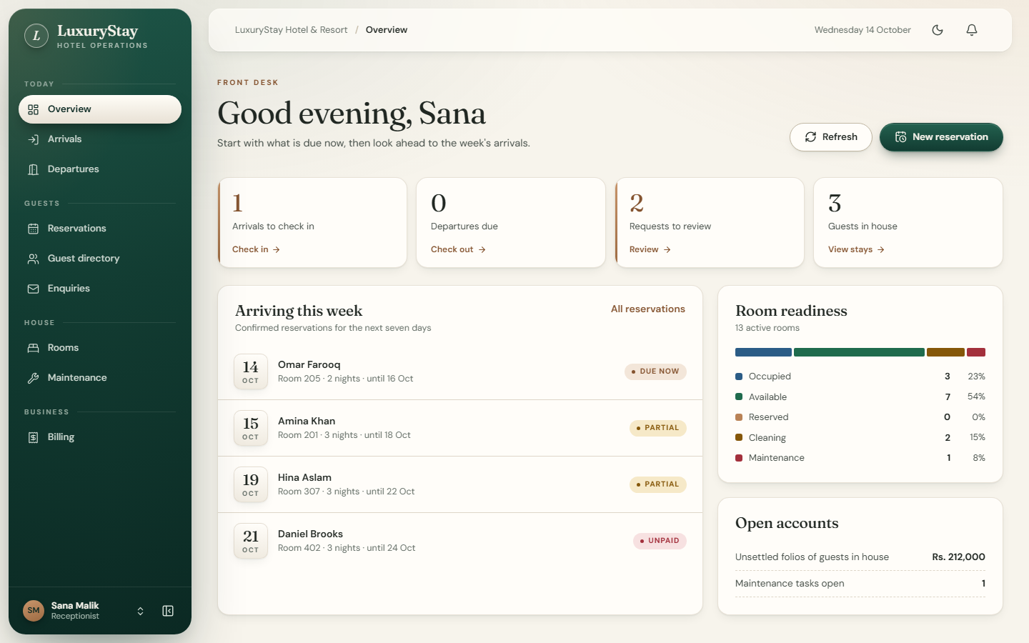  Figure 12.13: Receptionist overview | 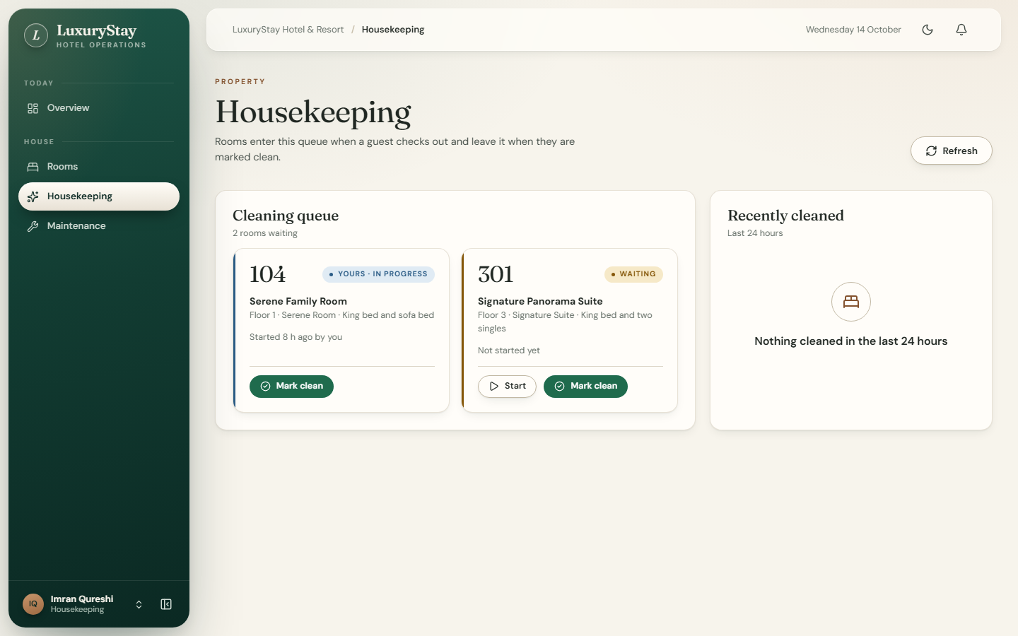  Figure 12.14: Housekeeping queue: “Yours”
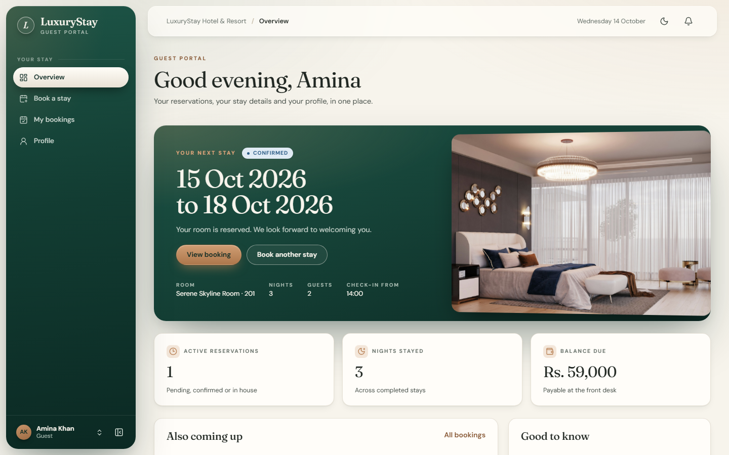  Figure 12.15: Guest overview | 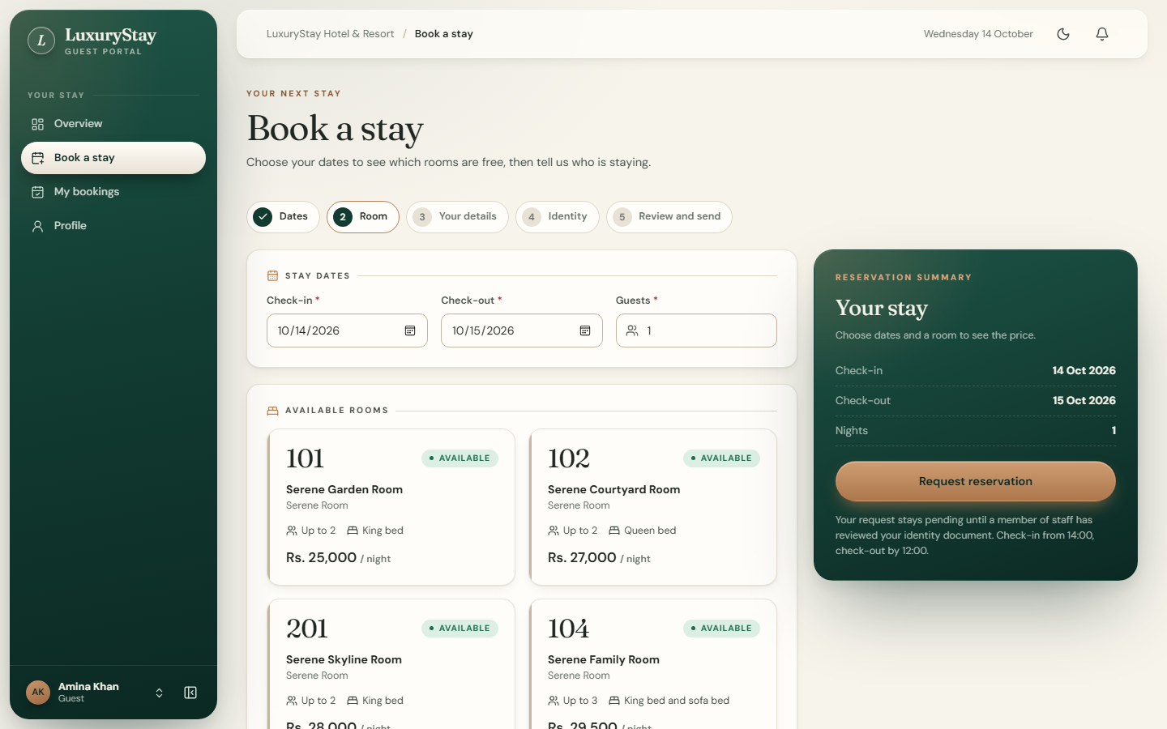  Figure 12.16: Guest booking flow
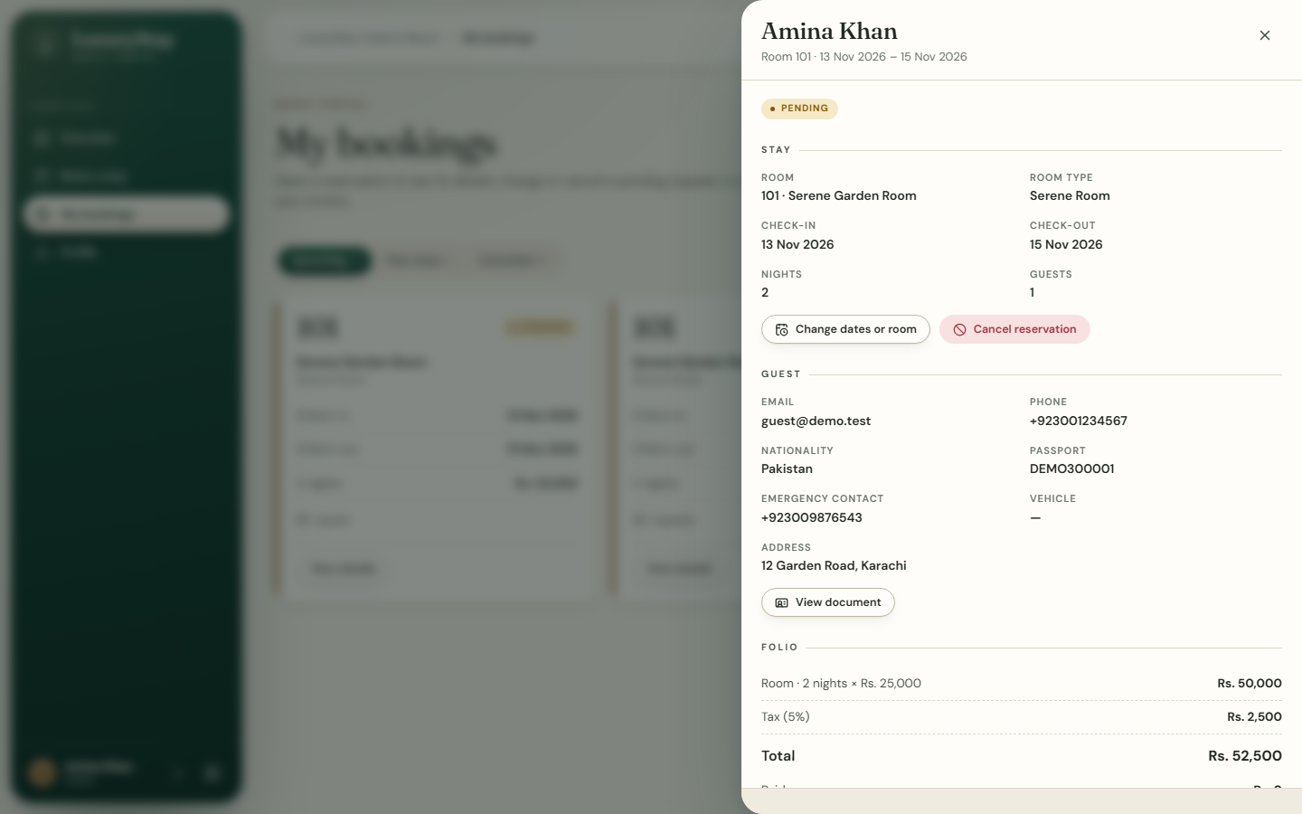  Figure 12.17: Guest request with uploaded document (test environment) | 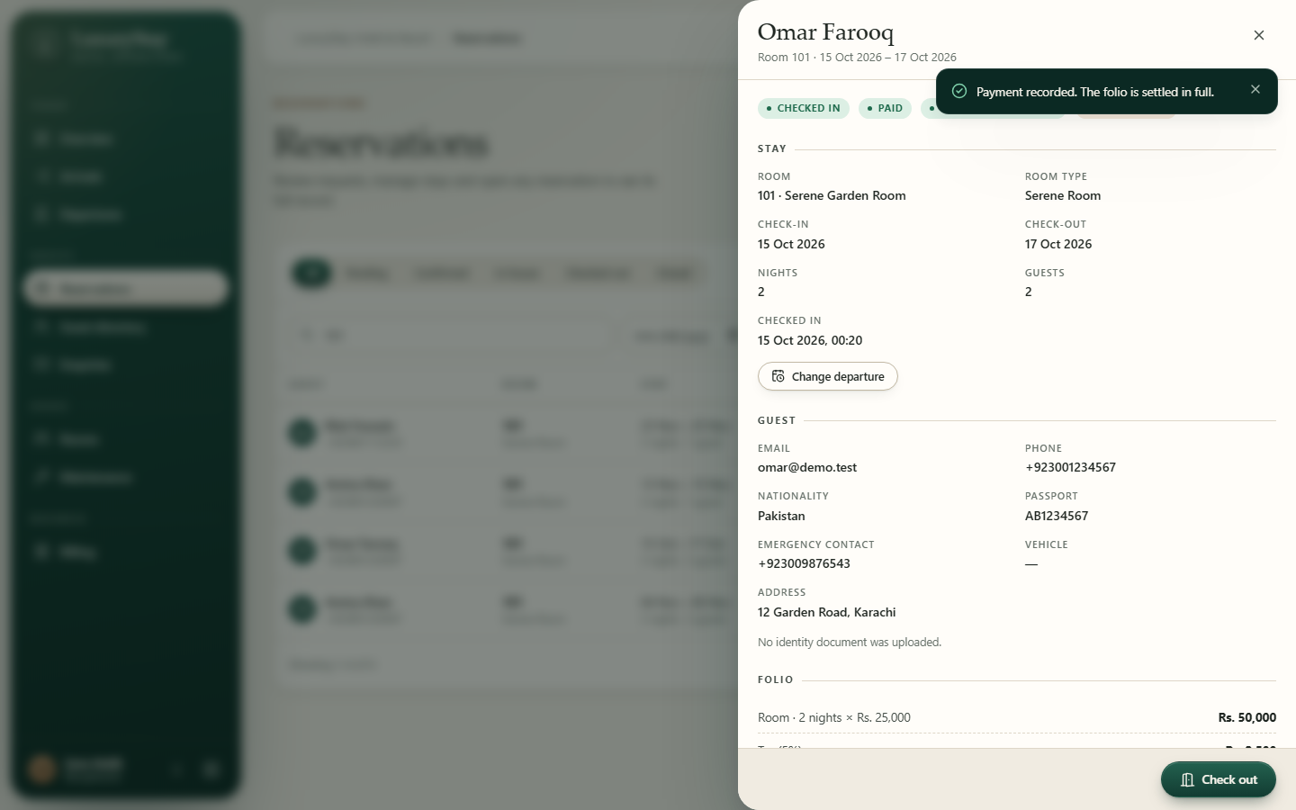  Figure 12.18: Payment recorded, folio settled (test environment)
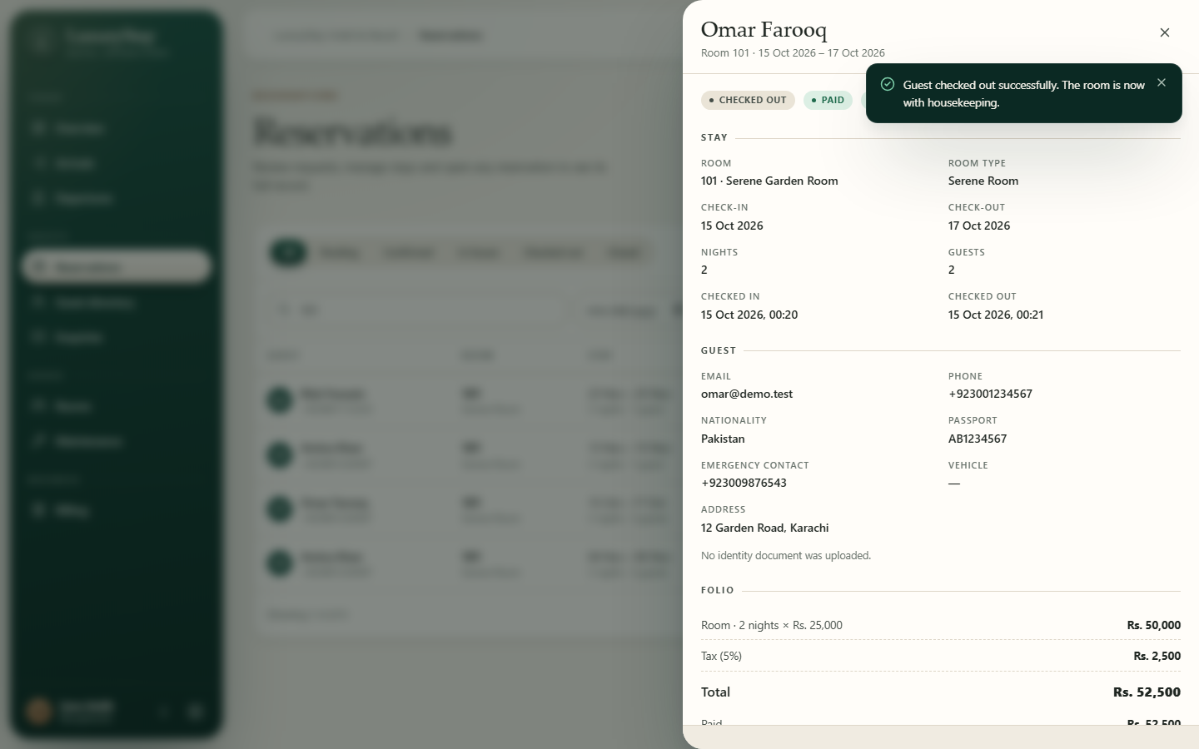  Figure 12.19: Guest checked out; room to housekeeping (test environment) | 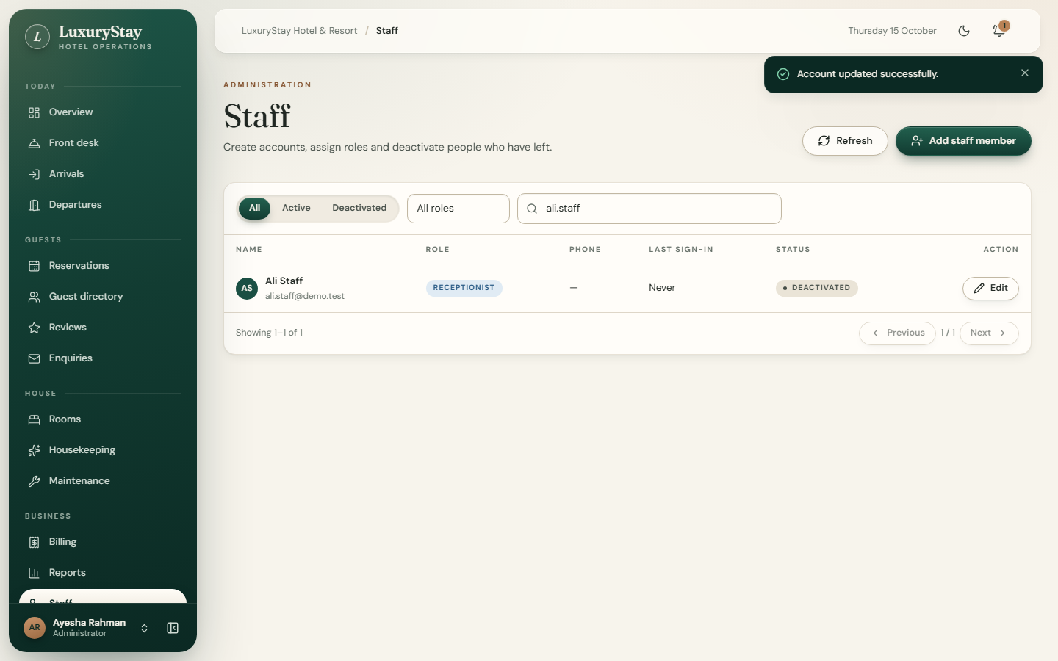  Figure 12.20: Staff account edited and deactivated (test environment)

13 Installation and Configuration
- Install Node.js 24 and MongoDB 8; run npm install in server and in client.
- Copy server/.env.example to server/.env and set MONGO_URI (with the database name, e.g. luxurystay_dev), EXPECTED_DB_NAME, a 32+ character JWT_SECRET, and optionally EMAIL_USER/EMAIL_APP_PASSWORD (password reset) and DOCUMENT_KEY (document uploads).
- Create the required indexes: npm run db:indexes -- --confirm=luxurystay_dev.
- Create the first administrator: set ADMIN_EMAIL, ADMIN_NAME and ADMIN_PASSWORD, then npm run create-admin (refuses the production and test databases).
- Optional demo data: set SEED_DEMO_PASSWORD and run npm run seed:dev-demo (development database only; adds missing records only).
- Start the API with npm run dev in server (http://localhost:5000) and the website with npm run dev in client (http://localhost:5173); GET /api/health reports the connected database.
- Run the tests on a throwaway database: $env:MONGO_URI = "mongodb://127.0.0.1:27017/lsverify"; npm test.
Secrets are generated with node -e "console.log(require('crypto').randomBytes(48).toString('hex'))" and kept only in server/.env. The root README.md gives the full variable list, the demo accounts and troubleshooting.

14 Known Limitations and Future Improvements
Table 14.1: Known limitations
Limitation | Effect or note
No payment gateway | Payments are recorded by staff.
Document uploads need DOCUMENT_KEY | Without it, online requests with documents are refused (503).
CNIC check compares numbers only | Cannot detect forged cards; PDFs are not read by OCR; first use downloads OCR data.
Email for password reset only | No booking or invoice emails, no SMS.
Pending requests do not expire | They hold their nights until staff decide; no no-show handling.
Housekeeping has no inspection step or manager assignment | Rooms are claimed by whoever starts them.
No walk-in enquiry form, no full audit log, no report export | Enquiries come from the website; the staff list shows last sign-in only; reports can be printed.
Single hotel and currency; shared photos per room type | Not suited to chains as is.
31 lint warnings; no frontend unit tests | Behaviour verified by browser tests.

Future improvements: payment gateway with refunds; confirmation emails and SMS; expiry of unanswered requests; housekeeping assignment and inspection; per-room photos and seasonal rates; report export; two-factor authentication for staff; automated frontend tests; deployment scripts and backups.

15 Conclusion and References
LuxuryStay HMS meets its aim of a secure, role-based web application for running a hotel. Visitors explore rooms and availability, guests request and manage stays, staff handle the full cycle from reservation to check-out, housekeeping and maintenance, and managers follow performance on live dashboards. Its key design decisions protect correctness and data: availability is enforced by a unique database index, sessions are revocable, every endpoint checks a named permission, identity documents are encrypted and never treated as officially verified, and production, development and test data are kept apart by enforced safeguards. The automated and browser tests reported in Chapter 11 support these claims, and the limitations in Chapter 14 point to clear next steps.

References
- Node.js documentation and test runner. https://nodejs.org/api/
- Express 5. https://expressjs.com/ — MongoDB manual. https://www.mongodb.com/docs/manual/ — Mongoose. https://mongoosejs.com/docs/
- React. https://react.dev/ — Vite. https://vite.dev/ — React Router. https://reactrouter.com/ — Motion. https://motion.dev/
- Zod. https://zod.dev/ — Helmet. https://helmetjs.github.io/ — express-rate-limit. https://express-rate-limit.mintlify.app/ — Multer. https://github.com/expressjs/multer
- Jones, M., Bradley, J. and Sakimura, N. (2015) JSON Web Token (JWT), RFC 7519. https://www.rfc-editor.org/rfc/rfc7519
- Tesseract.js. https://github.com/naptha/tesseract.js — Nodemailer. https://nodemailer.com/
- OWASP Cheat Sheet Series (Authentication, Password Storage, Forgot Password). https://cheatsheetseries.owasp.org/
- NIST FIPS 197 (AES) and SP 800-38D (GCM). https://csrc.nist.gov/

Appendix A API Endpoints
All 59 endpoints, extracted from the route files; GET /api/health is defined in app.js and is public. "Signed in" means the handler checks ownership or role itself.
Table A.1: API endpoints
Method | Path | Access
POST | /api/auth/register | public (rate limit: register)
POST | /api/auth/login | public (rate limit: login)
POST | /api/auth/logout | signed in
GET | /api/auth/me | signed in
PUT | /api/auth/me | signed in
PUT | /api/auth/change-password | signed in
POST | /api/auth/forgot-password | public (rate limit: passwordReset)
POST | /api/auth/reset-password/validate | public (rate limit: resetToken)
POST | /api/auth/reset-password | public (rate limit: resetToken)
GET | /api/bookings/availability | bookings:own or bookings:create or bookings:edit
POST | /api/bookings | bookings:own or bookings:create
GET | /api/bookings/my-bookings | bookings:own
GET | /api/bookings | bookings:view
GET | /api/bookings/:id | signed in
PATCH | /api/bookings/:id | bookings:own or bookings:edit
PATCH | /api/bookings/:id/confirm | bookings:review
PATCH | /api/bookings/:id/reject | bookings:review
PATCH | /api/bookings/:id/cancel | bookings:own or bookings:cancel
PATCH | /api/bookings/:id/check-in | bookings:checkin
PATCH | /api/bookings/:id/check-out | bookings:checkout
POST | /api/bookings/:id/payments | billing:payment
POST | /api/bookings/:id/charges | billing:charges
DELETE | /api/bookings/:id/charges/:chargeId | billing:charges
PATCH | /api/bookings/:id/discount | billing:discount
GET | /api/bookings/:id/invoice | signed in
GET | /api/bookings/:id/documents/:side | signed in
POST | /api/contact | public (rate limit: contact)
GET | /api/contact | contact:manage
PATCH | /api/contact/:id/status | contact:manage
POST | /api/feedback | feedback:own
GET | /api/feedback/my | feedback:own
GET | /api/feedback | feedback:manage
PATCH | /api/feedback/:id/review | feedback:manage
GET | /api/maintenance | maintenance:view
POST | /api/maintenance | maintenance:report
PATCH | /api/maintenance/:id/start | maintenance:update
PATCH | /api/maintenance/:id/complete | maintenance:update
GET | /api/notifications | signed in
PATCH | /api/notifications/read-all | signed in
PATCH | /api/notifications/:id/read | signed in
GET | /api/public/hotel | public
GET | /api/public/rooms | public
GET | /api/reports/overview | reports:view
GET | /api/reports/front-desk | frontdesk:view
GET | /api/reports/finance | billing:view
GET | /api/rooms | signed in
GET | /api/rooms/housekeeping | housekeeping:manage
PATCH | /api/rooms/housekeeping/:id/start | housekeeping:manage
PATCH | /api/rooms/housekeeping/:id/complete | housekeeping:manage
POST | /api/rooms | rooms:manage
PUT | /api/rooms/:id | rooms:manage
PATCH | /api/rooms/:id/status | rooms:status
DELETE | /api/rooms/:id | rooms:manage
GET | /api/settings | signed in
PUT | /api/settings | settings:manage
GET | /api/users/staff | staff:view
POST | /api/users/staff | staff:manage
GET | /api/users/guests | guests:view
PATCH | /api/users/:id | staff:manage or guests:manage

