
COMPUTER VISION
LAB MANUAL
Fundamentals of Computer Imaging
READ | TRANSFORM | ANALYZE | PRACTICE
Fall 2026 – Assessment 1
Course Title | Computer Vision | Credit Hours | 3(2,1)
Course Instructor/s | Muhammad Awais Shoukat | Program Name | BS-AI
Topic | Fundamentals of Computer Imaging | Max Marks | 10
Student’s Name |  | Reg. No.
Assessment Focus | Image processing revision + practical programming

Tasks Include:
01 Image Processing Revision  Review the core transformations used in OpenCV and NumPy.  Read → Rotate → Resize → Crop → Flip | 02 Practical Tasks  Apply the same operations to new images and produce visible results.  Blue channel • flips • center crop • rotate 180°
03 Assessment Questions  Solve automatic cropping, ROI extraction, and image enhancement problems.  Q1 • Q2 • Q3 | 04 Complete Workflow  Practice the end-to-end pipeline from image reading to border extraction.  Read → Gray → Binary → Split → Crop → Border → Show

1 | Revision of Image Processing  Core operations from the original manual, grouped into readable visual cards.

Core libraries
The source material uses OpenCV (cv2), NumPy (np), and Matplotlib (plt) for image reading, transformation, display, and analysis.
Load image  Read an image and convert OpenCV BGR order to RGB for Matplotlib display.  img = cv2.imread('image.png')  img_rgb = cv2.cvtColor(img, cv2.COLOR_BGR2RGB) | Rotate 90°  Rotate the image clockwise.  rotated = cv2.rotate(img_rgb, cv2.ROTATE_90_CLOCKWISE)
Reduce size  Halve the image dimensions using resizing or array slicing.  reduced = cv2.resize(img_rgb, None, fx=0.5, fy=0.5)  # OR: reduced = img_rgb[::2, ::2] | Crop  Remove a 50-pixel border from the image.  h, w, _ = img_rgb.shape  cropped = img_rgb[50:h-50, 50:w-50]
Vertical flip  Reverse the row order to flip the image vertically.  row_shift = img_rgb[::-1, ::-1, :]  # OR: cv2.flip(img_rgb, 0) | Horizontal flip  Reverse the column order to flip the image horizontally.  col_shift = img_rgb[:, ::-1, :]  # OR: cv2.flip(img_rgb, 1)
Display and enhancement operations
Show images  Display image results with Matplotlib.  plt.imshow(img_rgb)  plt.show() | Grayscale  Convert the input image to grayscale.  gray = cv2.cvtColor(img, cv2.COLOR_BGR2GRAY)
Gaussian blur  Apply Gaussian smoothing with an 11×11 kernel.  blur = cv2.GaussianBlur(img_rgb, (11,11), 0) | Edge detection  Detect edges with the Canny method.  edges = cv2.Canny(img, 100, 200)
Threshold  Convert grayscale into a binary image using a threshold of 127.  _, thresh = cv2.threshold(gray, 127, 255, cv2.THRESH_BINARY) | Brightness / contrast  Adjust brightness with beta and contrast with alpha.  bright = cv2.convertScaleAbs(img_rgb, alpha=1, beta=60)  contrast = cv2.convertScaleAbs(img_rgb, alpha=2, beta=0)
Draw shapes  Overlay a rectangle and circle on a copy of the image.  draw = img_rgb.copy()  cv2.rectangle(...)  cv2.circle(...) |  | Zoom  Scale the image by 1.5×.  zoom = cv2.resize(img_rgb, None, fx=1.5, fy=1.5)
Negative image  Invert image intensities.  negative = 255 - img_rgb |  | Red channel  Split BGR channels and display the red channel.  b, g, r = cv2.split(img)  plt.imshow(r, cmap='gray')
2 | Practical Task  Implement the following transformations and show the results.
Task to perform
Complete all five tasks below using the same image-processing tools introduced in Section 1.
- Convert the image to only the Blue channel and display it.
- Flip the image horizontally and vertically at the same time.
- Crop only the center part of the image.
- Reduce image size by skipping every 3rd pixel.
- Rotate the image by 180°.
Implementation map
Blue | Flip | Center Crop | Skip 3rd | Rotate 180°
3 |  | Assessment Questions  Apply automation and region-based image processing.

Q1 | Write a program to auto-crop the plain background around the object in an image.
Reference visual
Samples are provided in the source assessment. Use them as a visual check for the expected cropping behaviour.
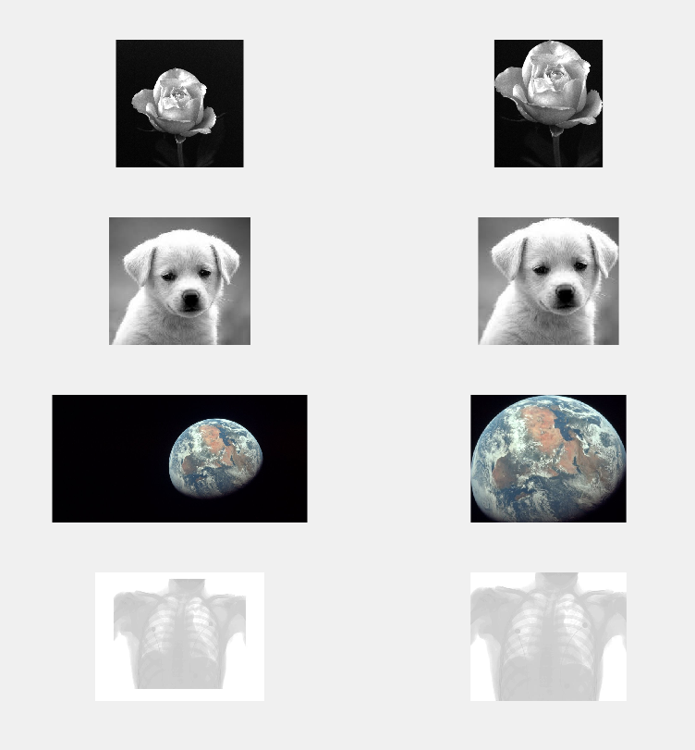
Sample images for automatic background cropping
Q2 | Given an image showing three incomplete disks (all are ROIs), extract the ROIs and show them as three different images.
Hint: Treat each disk as a region of interest and make the three extracted results visible separately.
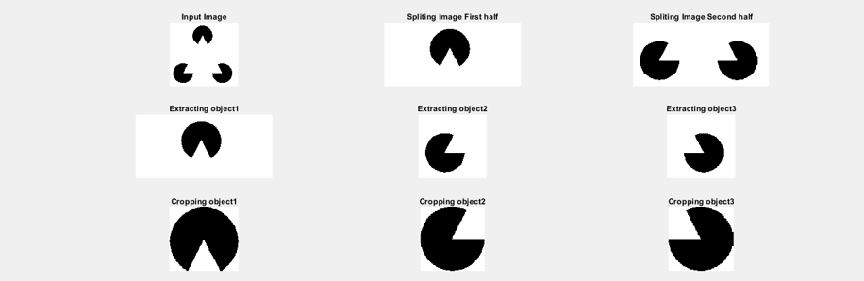
Q3 | Write a program that reads an image and performs the following automatically. Show the results of all steps.
a. Find the type of image: binary, gray, or RGB.
b. Find the issue in the image: over dark, over bright, low contrast, or normal. (Hint: histogram).
c. Resolve the issue, if any, and show the final image after enhancement.
d. Test the program on the following images.
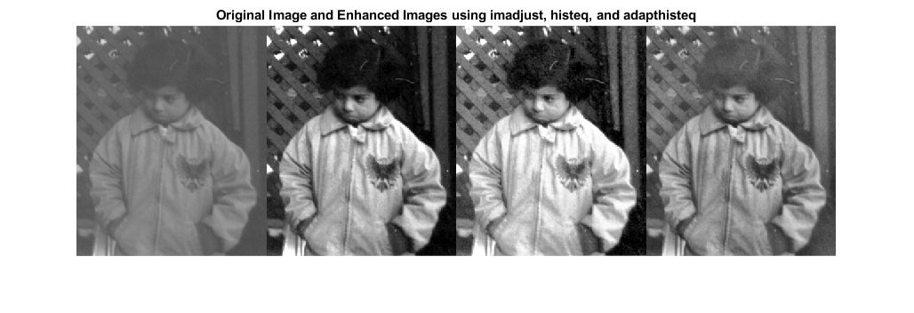
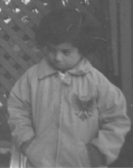  Low/gray image example | 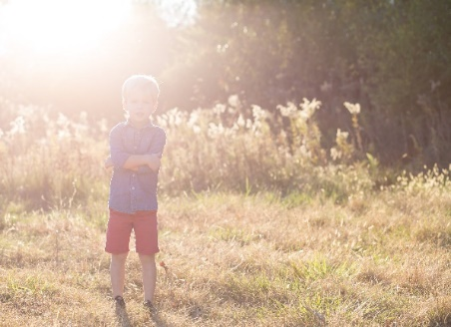  Bright image example | 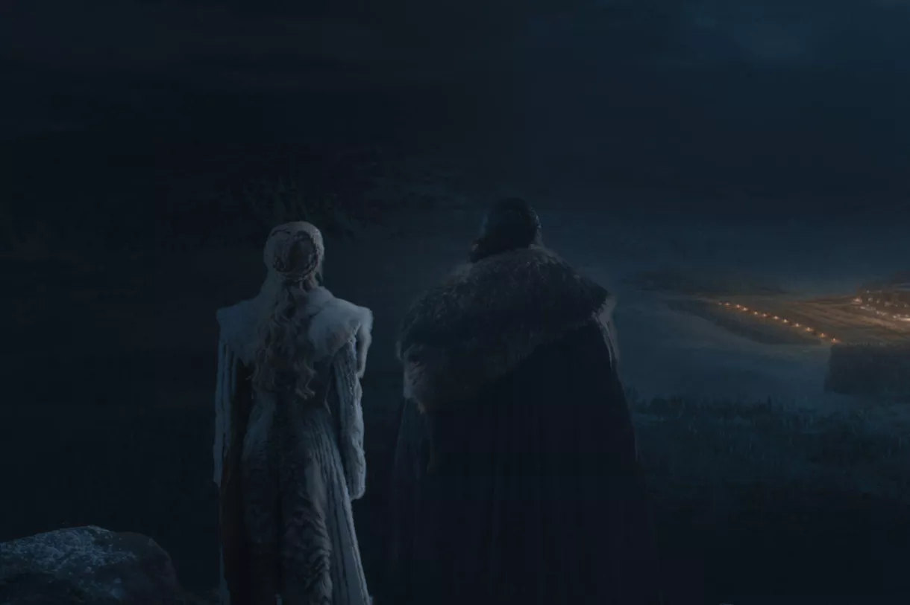  Dark image example
Practice: Read → Gray → Binary → Split → Crop → Border → Show
The complete workflow provided in the original manual, reformatted for easier lab use.
Read | Gray | Binary | Split | Crop | Border | Show
Import libraries
import cv2
import numpy as np
import matplotlib.pyplot as plt
Read and prepare the image
img = cv2.imread('image.png')
gray = cv2.cvtColor(img, cv2.COLOR_BGR2GRAY)
Convert to black & white
_, img_bin = cv2.threshold(gray, 0, 255,
cv2.THRESH_BINARY + cv2.THRESH_OTSU)
Get image size and split into 3 object regions
h, w = img_bin.shape
img1 = img_bin[0:h//2, :]
img2 = img_bin[h//2:h, 0:w//2]
img3 = img_bin[h//2:h, w//2:w]
Crop function
Crop the extra white area
def crop(img):
rows, cols = np.where(img == 0)
y_min, y_max = rows.min(), rows.max()
x_min, x_max = cols.min(), cols.max()
return img[y_min:y_max+1, x_min:x_max+1]
Border function
def border(img):
h, w = img.shape
edge = np.ones((h, w), dtype=np.uint8) * 255
for i in range(1, h-1):
for j in range(1, w-1):
if img[i, j] == 0 and (
img[i+1, j] != 0 or img[i-1, j] != 0 or
img[i, j+1] != 0 or img[i, j-1] != 0):
edge[i, j] = 0
return edge
Display results
titles = ['Obj1','Obj2','Obj3','Crop1','Crop2','Crop3','Border1','Border2','Border3']
images = [img1, img2, img3, img1_cropped, img2_cropped,
img3_cropped, img1_border, img2_border, img3_border]
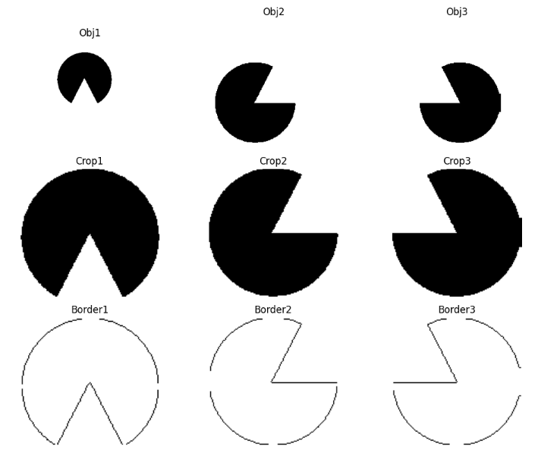
Expected visualization: objects, cropped objects, and borders

Additional operation
The source manual also includes a morphology-gradient example using a 17×17 kernel on a cropped object.
Morphological gradient
kernel = np.ones((17,17), np.uint8)
edges = cv2.morphologyEx(img1_cropped,
cv2.MORPH_GRADIENT, kernel)
plt.imshow(edges)
plt.axis('off')

