

**Faculty of Artificial Intelligence & Multimedia Gamming**

**Lab # 02**

**Submission Profile**

Name: Ayesha (ARI-F23-0059)

Instructor: Sir Abdul Ghafoor

Course Title : Data Structure and Algorithms

________________________________________________________________________________

**Task 1:**

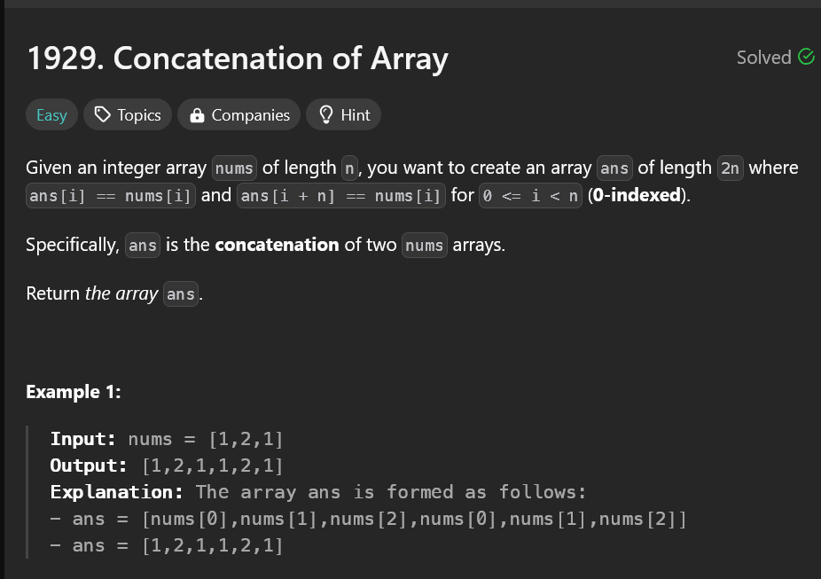

**Solution:**

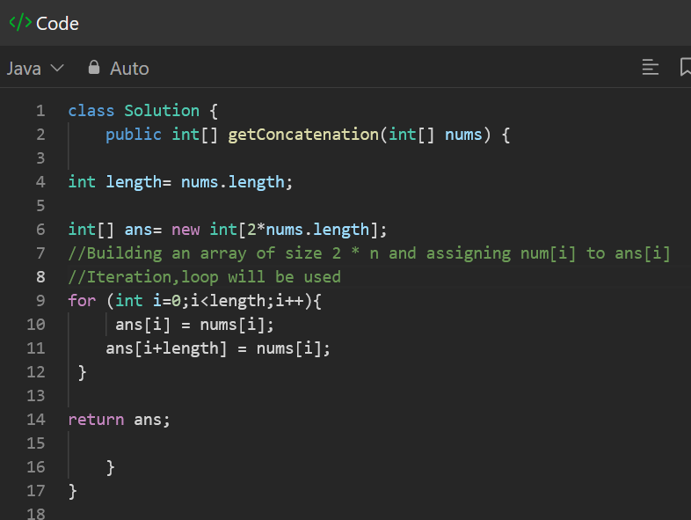

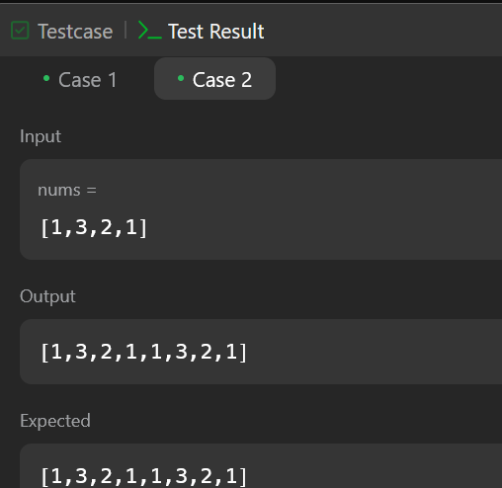

**Task 2:**

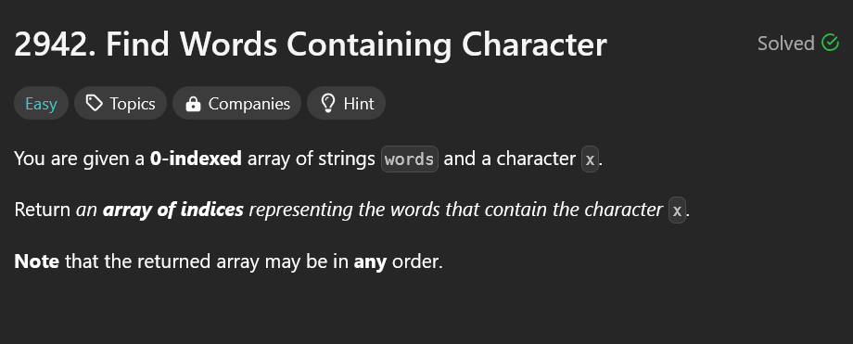

**Solution:**

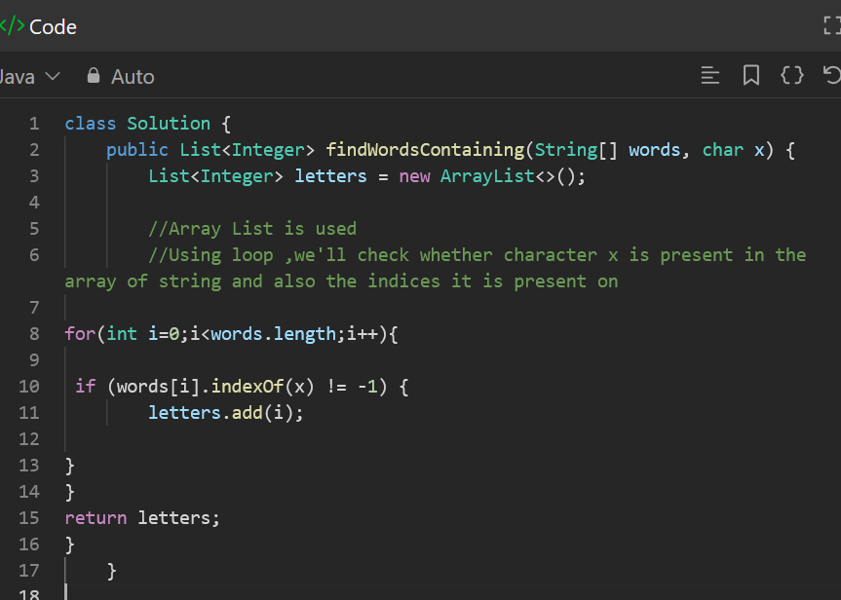

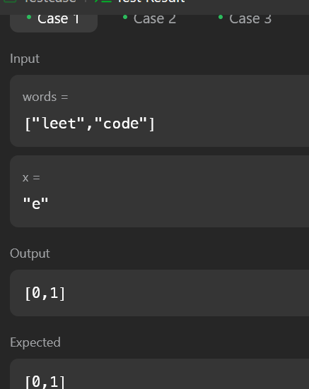

**Task 3:**

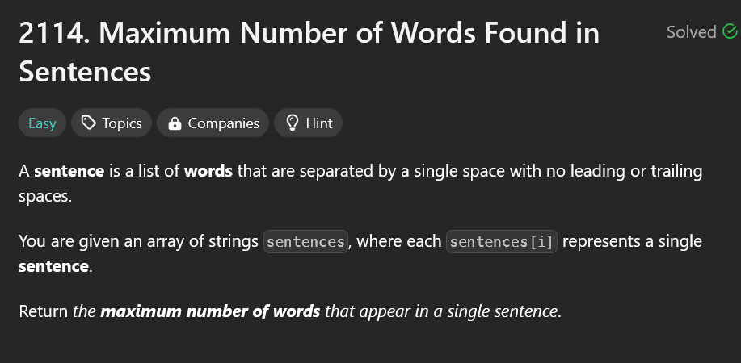

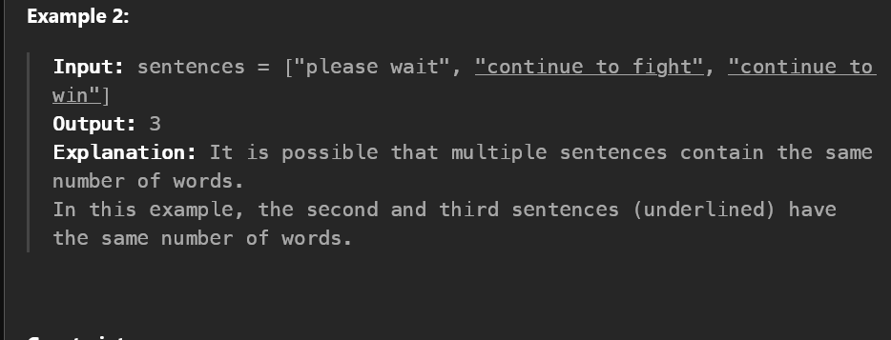

**Solution:**

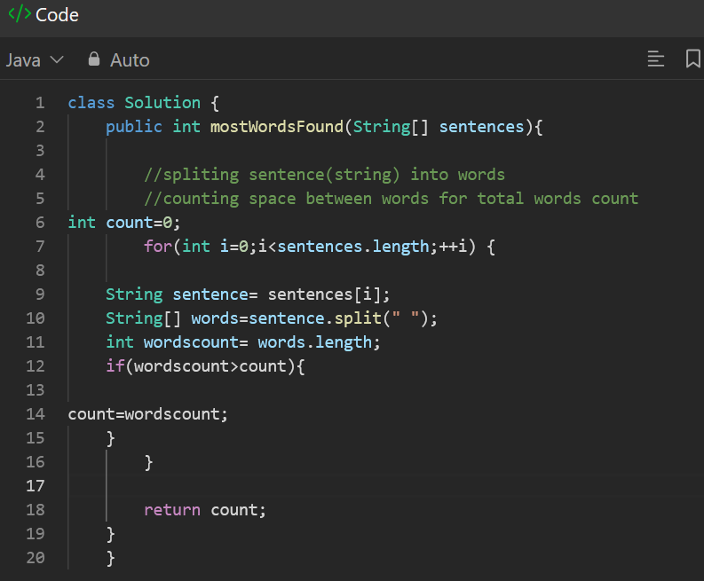

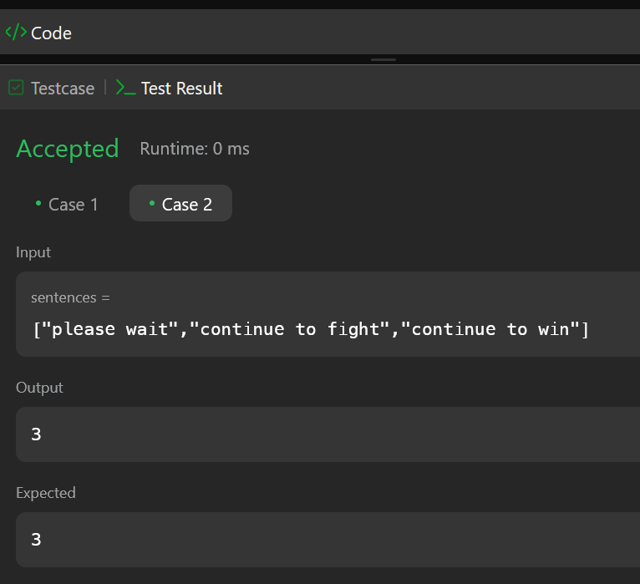

**Task 4:**

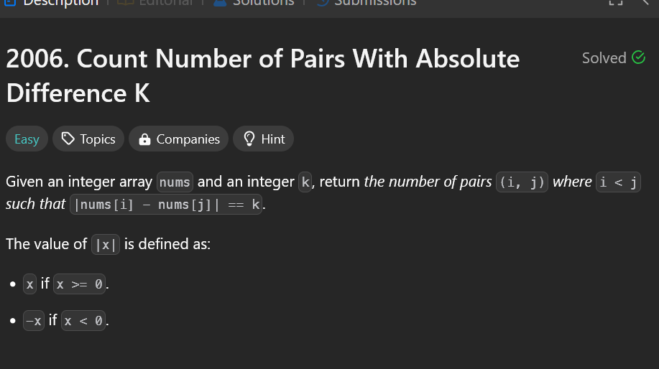

**Solution:**

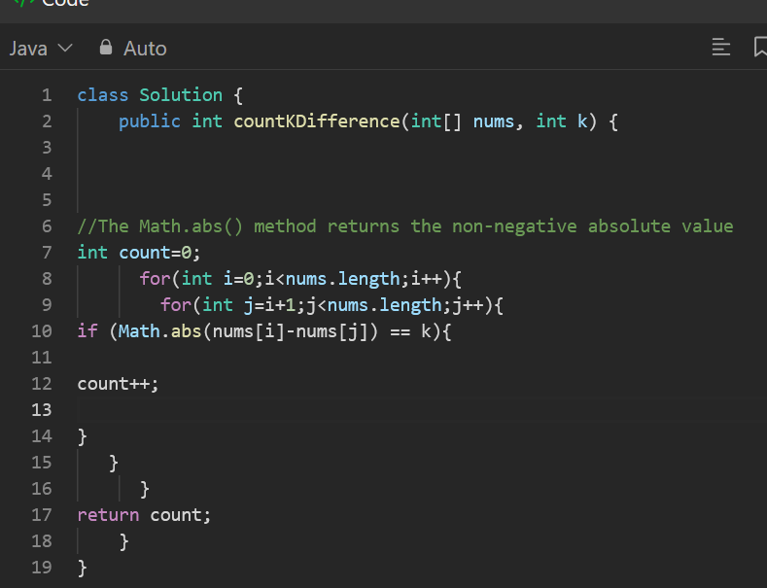

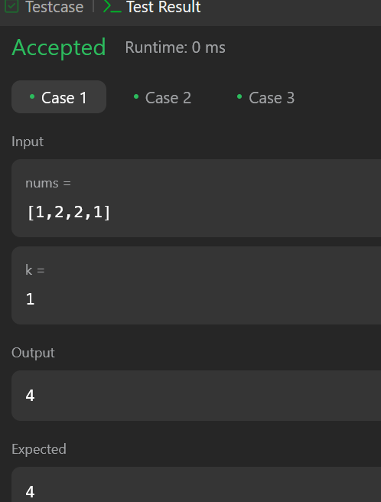

**Task 5:**

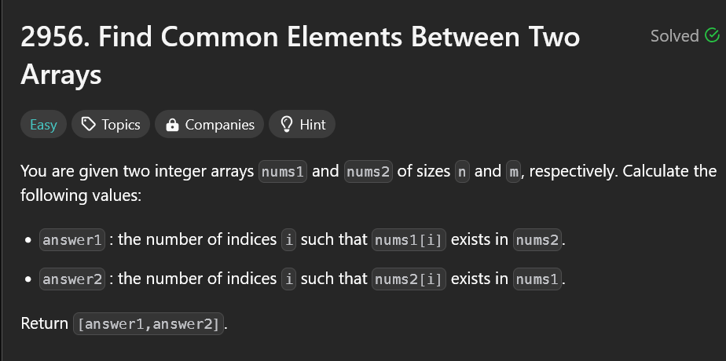

**Solution:**

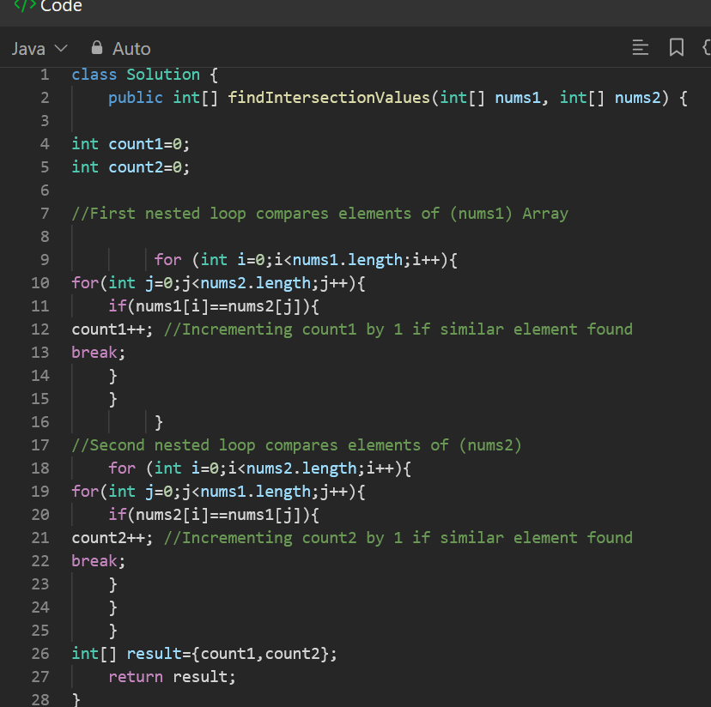

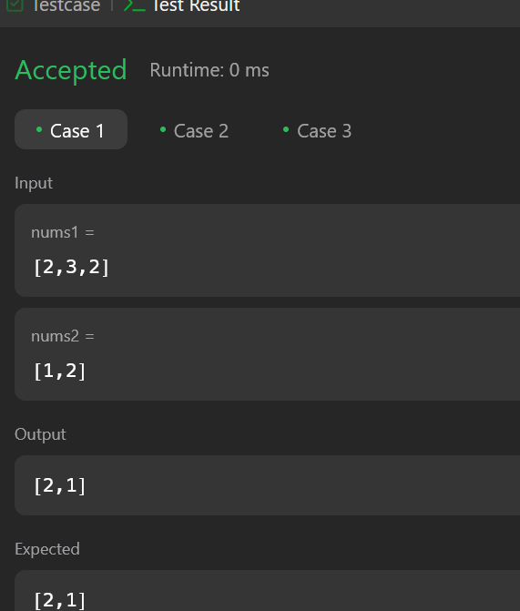

**Task 6:**

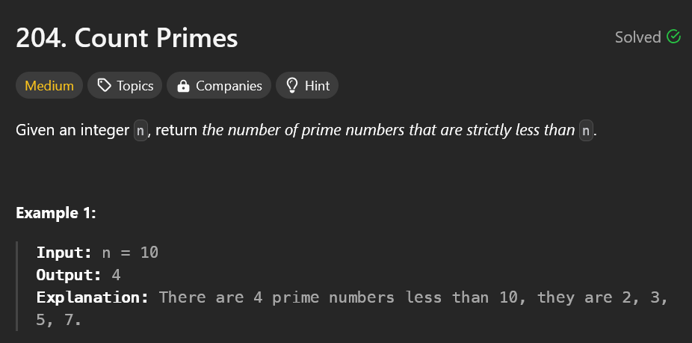

**Solution:**

