

**Faculty of Artificial Intelligence & Multimedia Gamming**

**Lab # 03**

**Submission Profile**

Name: Ayesha (ARI-F23-0059)

Instructor: Sir Abdul Ghafoor

Course Title : Data Structure and Algorithms

________________________________________________________________________________

**Lab Part 01**

**Linked List Class:**

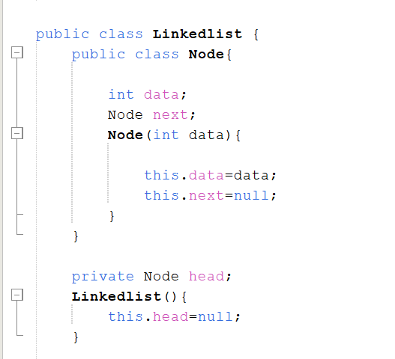

1. **Insertion Operations:**

Insert at Start:

Insert at End:

Insert at Position:

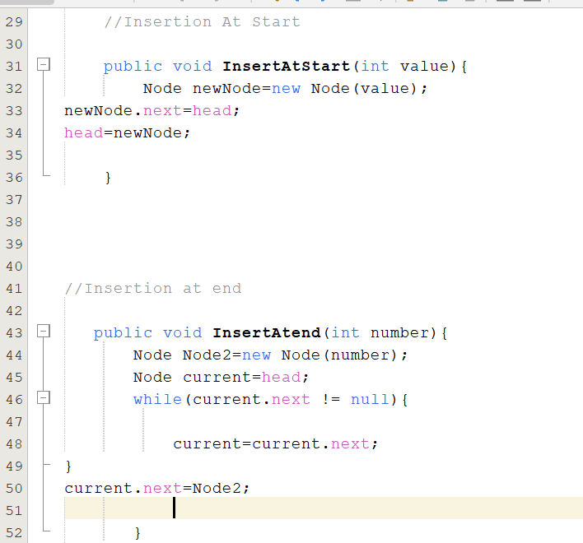

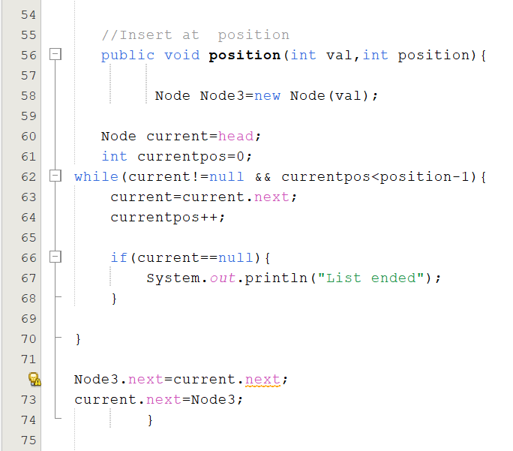

1. **Deletion Operations:**

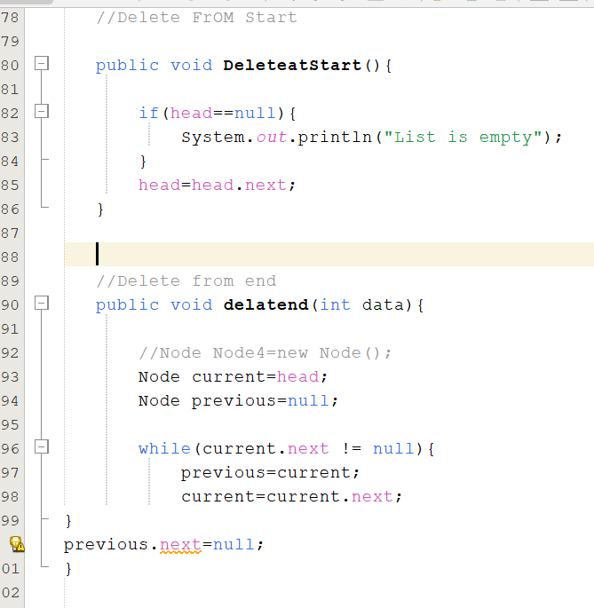

**Delete by Value:**

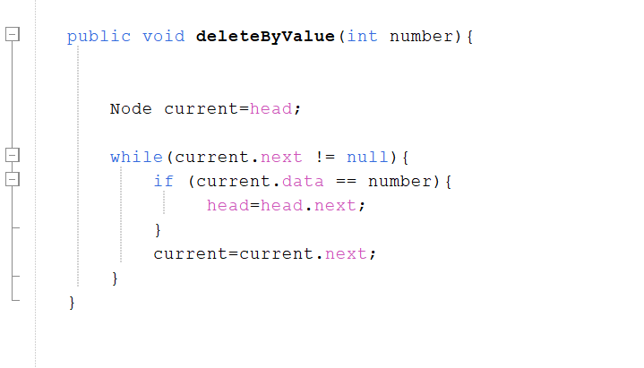

1. **Traversal Operations:**

**Display List:**

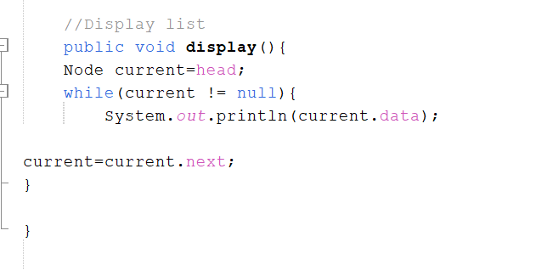

1. **Search Operation:**

**Search for a Value:**

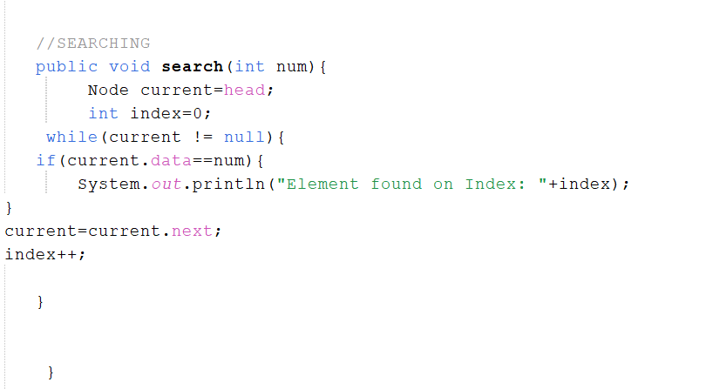

1. **Reverse the List:**

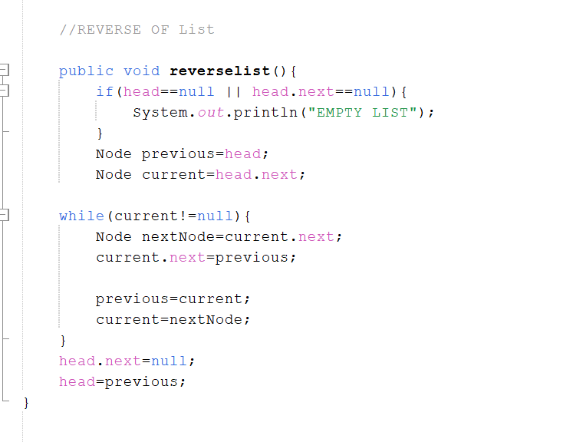

1. **Count Nodes:**

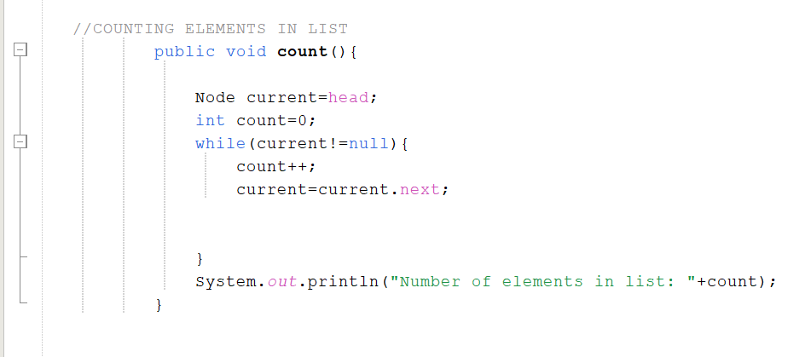

**Calling all the functions:**

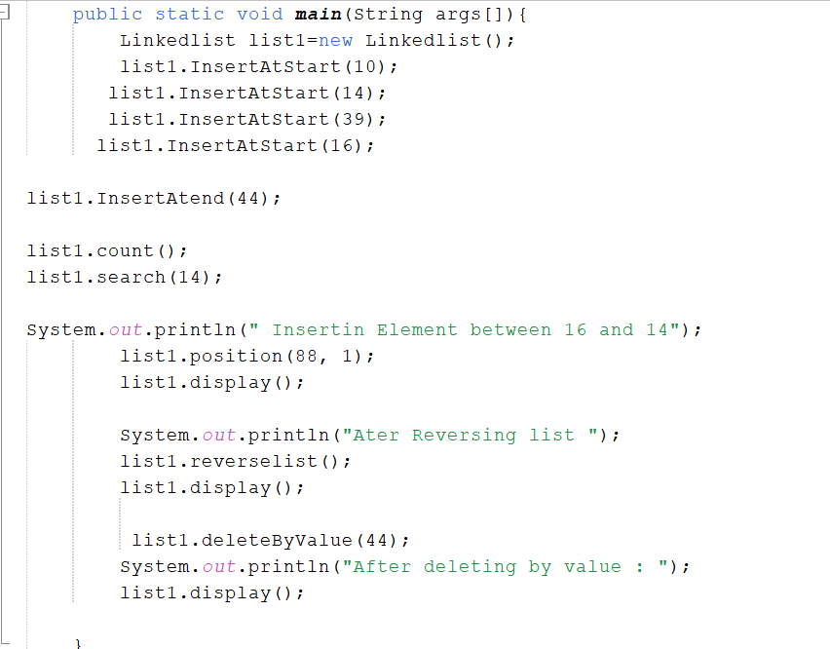

**Output:**

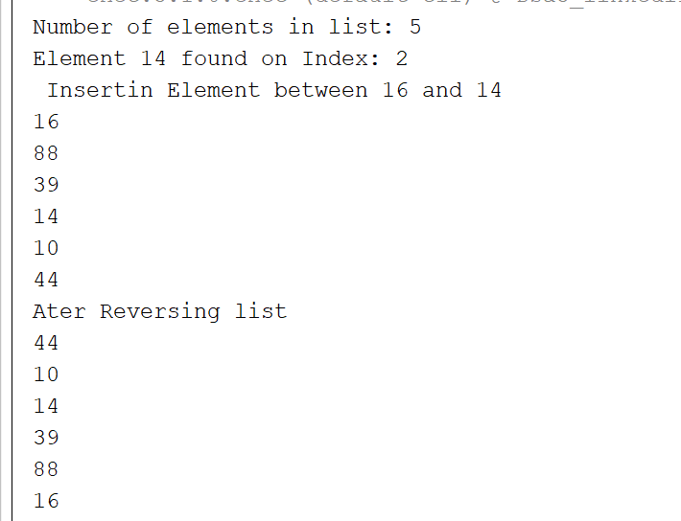

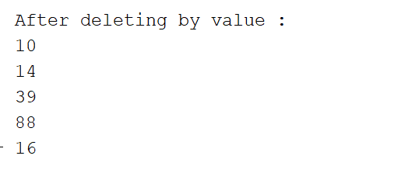

**Part Two:**

**TASK 1:**

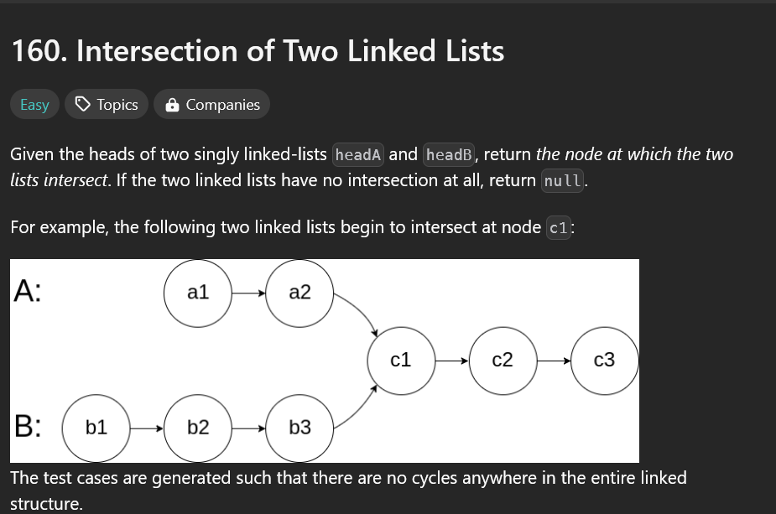

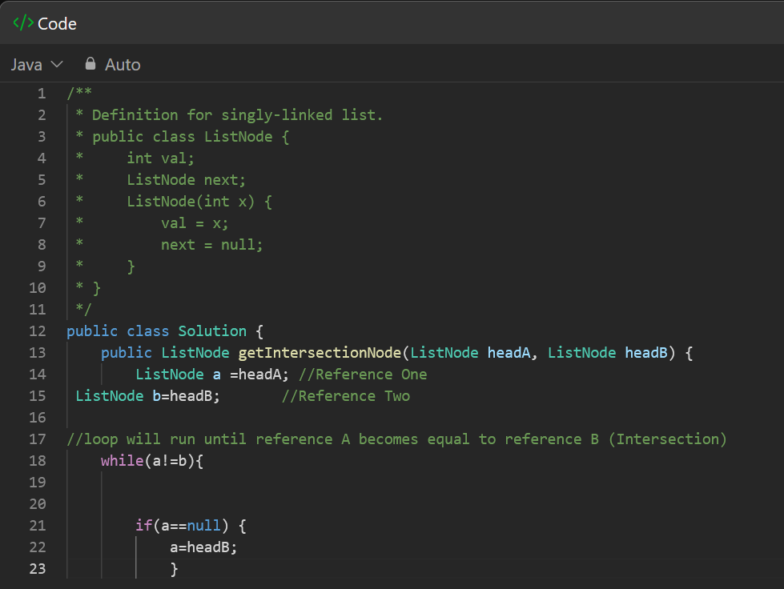

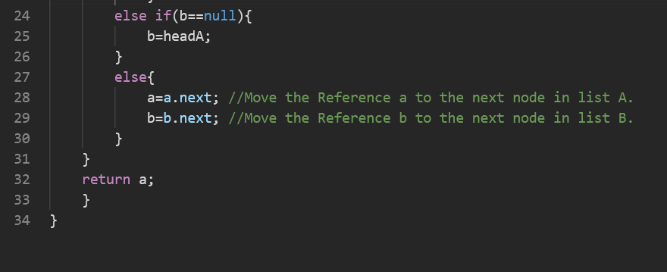

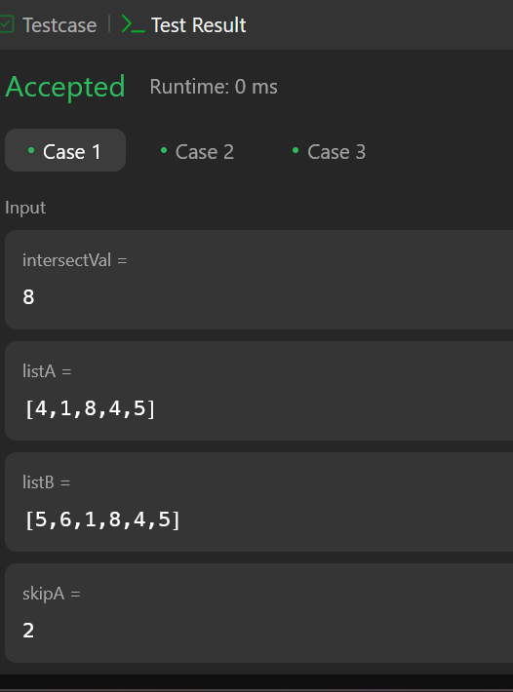

**TASK 2:**

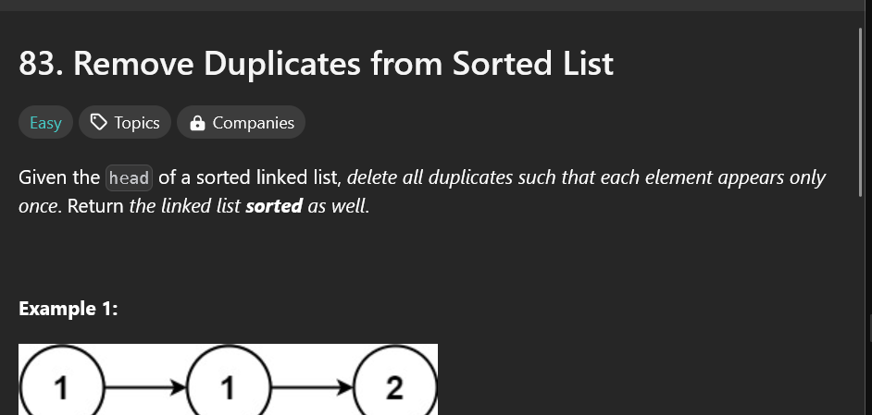

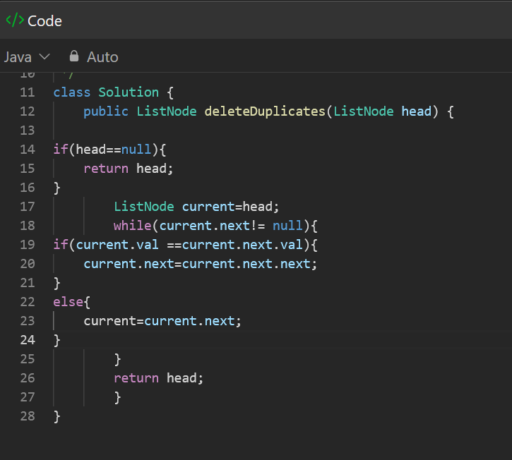

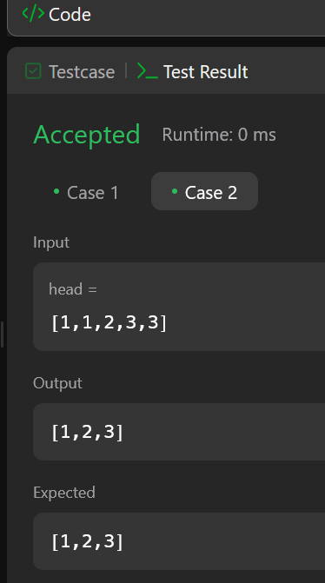

**TASK 3:**

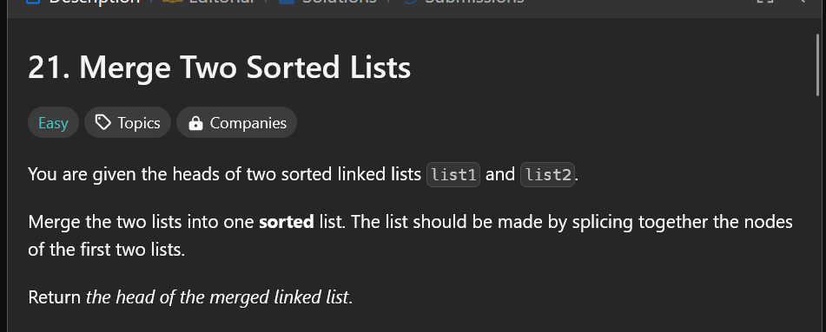

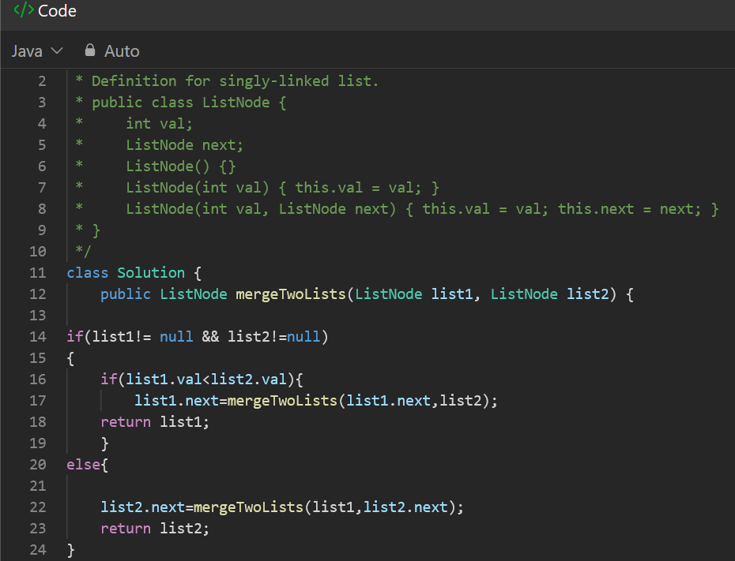

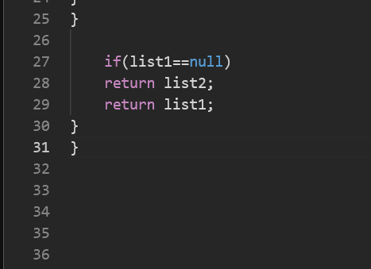

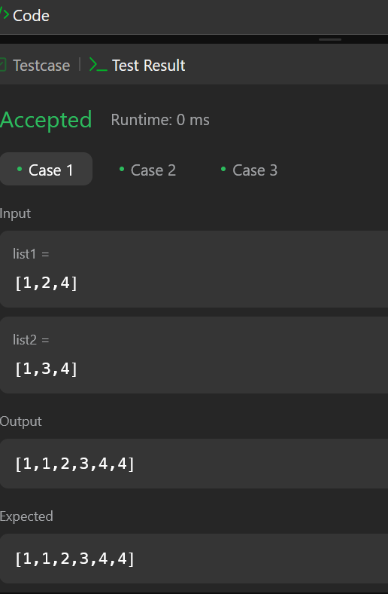

**TASK 4:**

