

**Faculty of Artificial Intelligence & Multimedia Gamming**

**Lab # 05**

**Submission Profile**

Name: Ayesha (ARI-F23-0059)

Instructor: Sir Abdul Ghafoor

Course Title : Data Structure and Algorithms

________________________________________________________________________________

**TASK 1:**

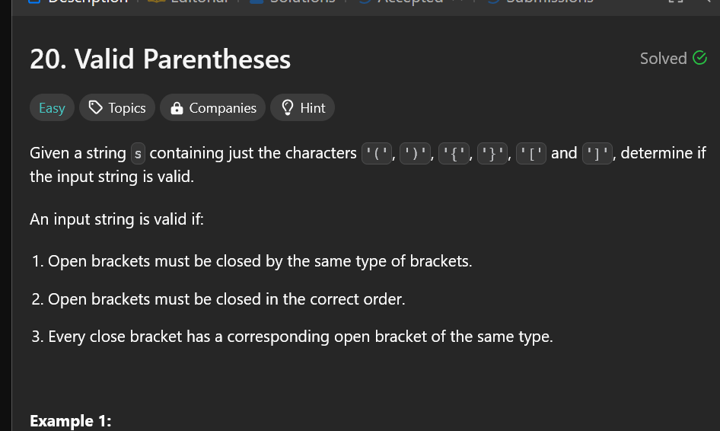

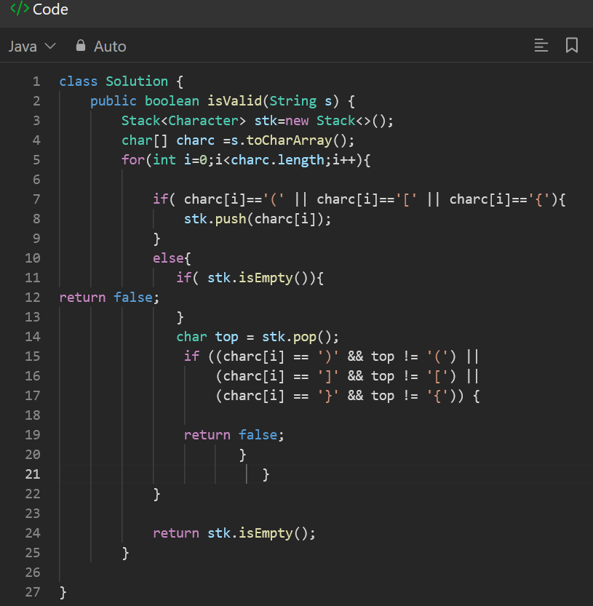

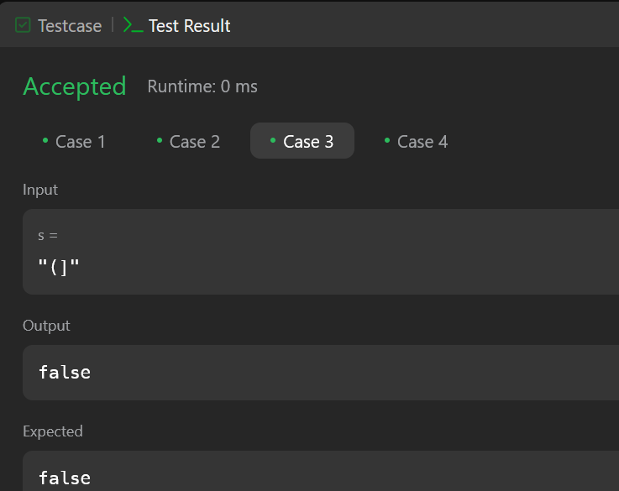

**TASK 2:**

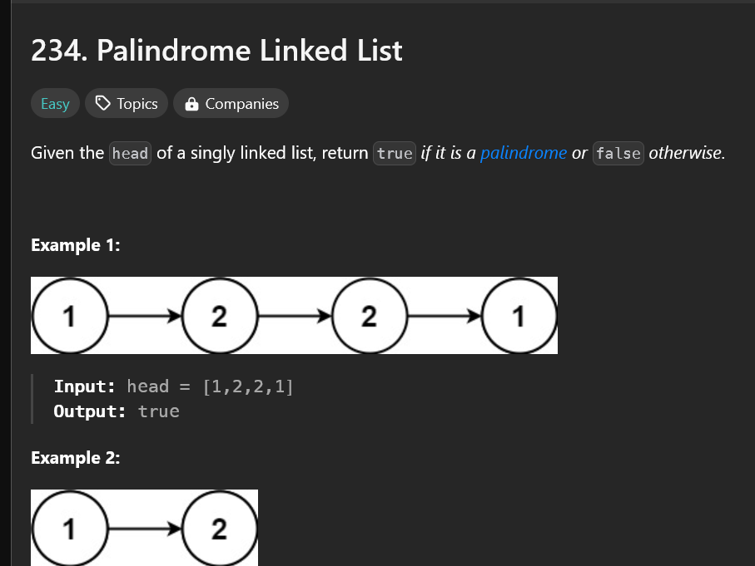

**CODE:**

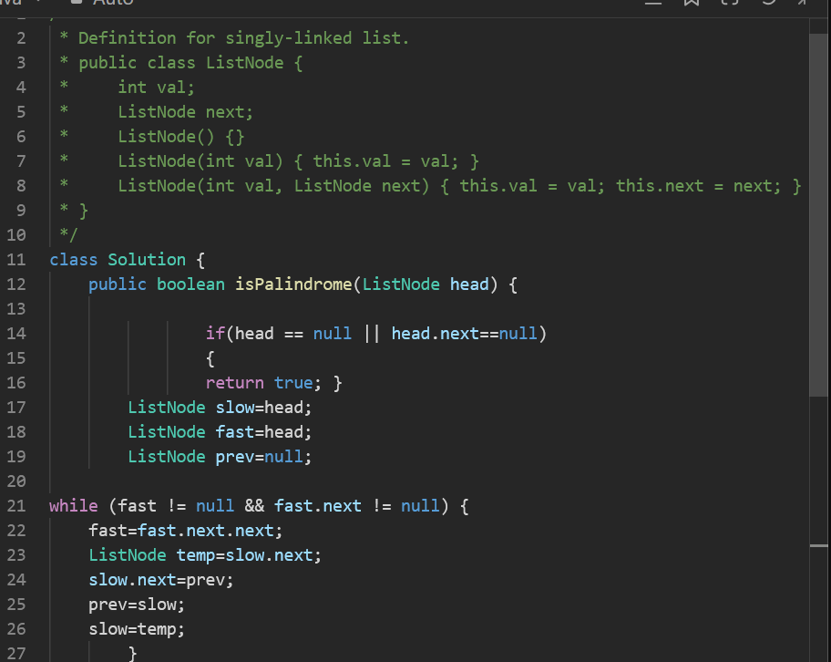

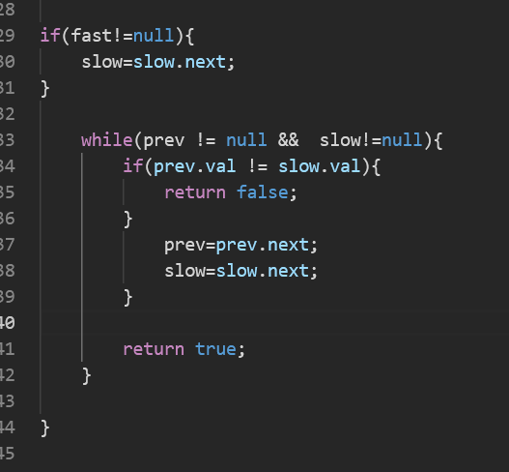

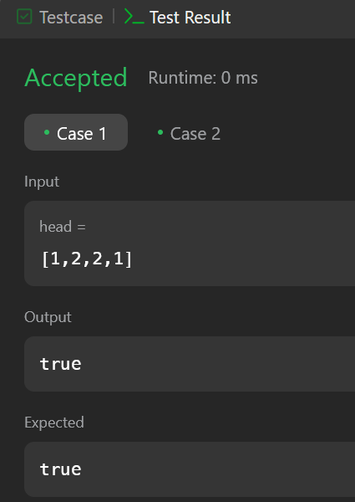

**TASK 3:**

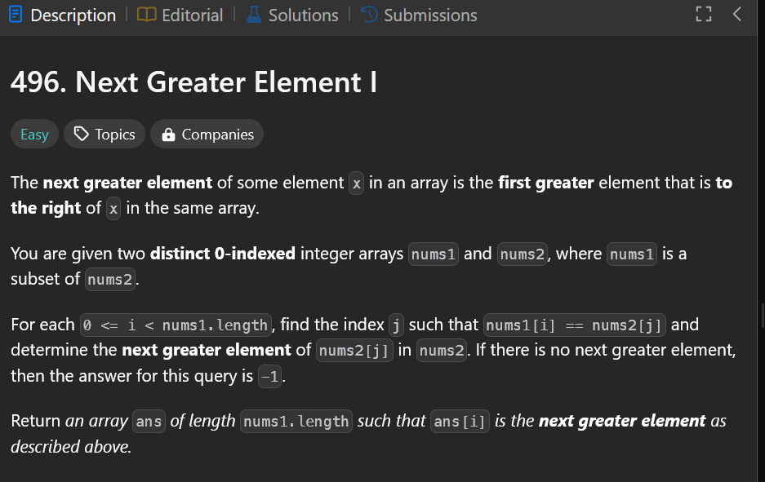

**CODE:**

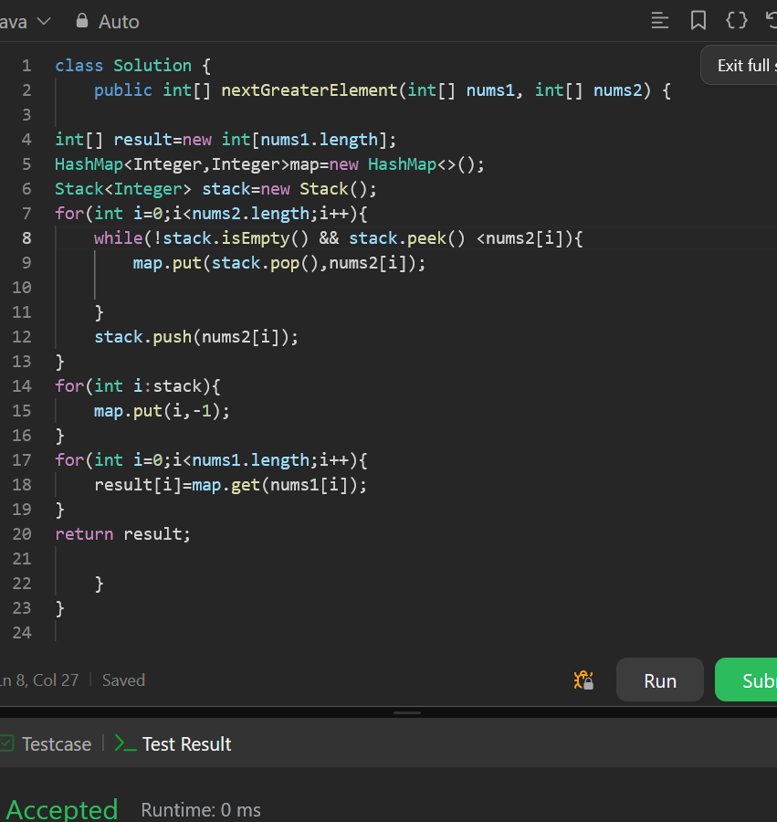

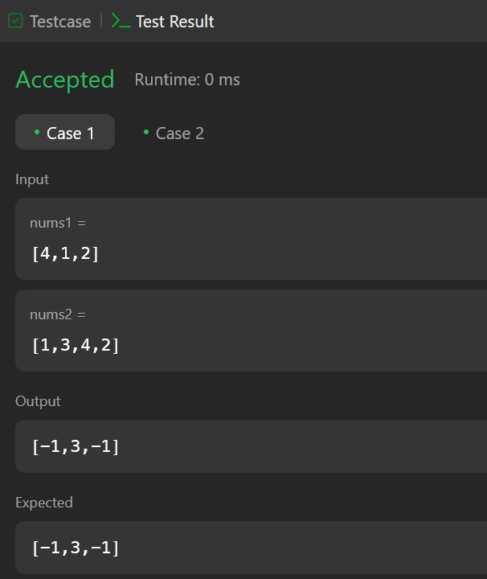

**TASK 4:**

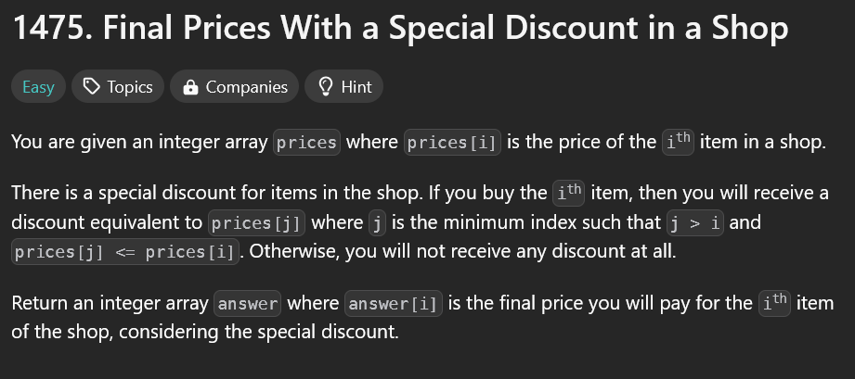

**CODE:**

