

**Faculty of Artificial Intelligence & Multimedia Gamming**

**Lab # 06**

**Submission Profile**

Name: Ayesha (ARI-F23-0059)

Instructor: Sir Abdul Ghafoor

Course Title : Data Structure and Algorithms

________________________________________________________________________________

**Lab Task 01:**

● Write a Java program to implement the Bubble Sort algorithm. Your task is to sort an

array of integers in ascending order using Bubble Sort.

● Define a method bubbleSort(int[] arr) that takes an array as input and sorts it using the

Bubble Sort algorithm

Input: 513462

Output: 123456

**Input Code:**

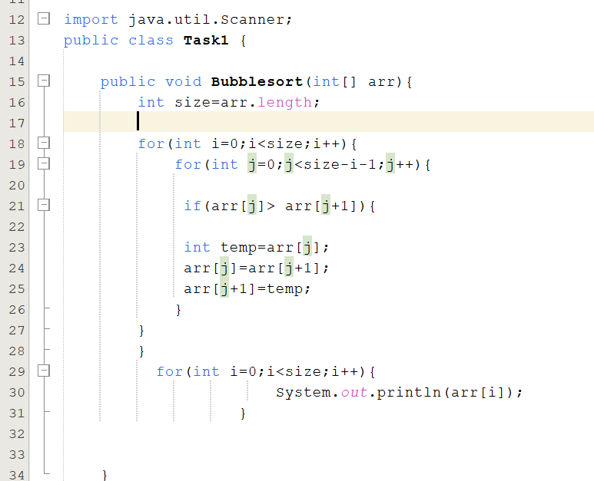

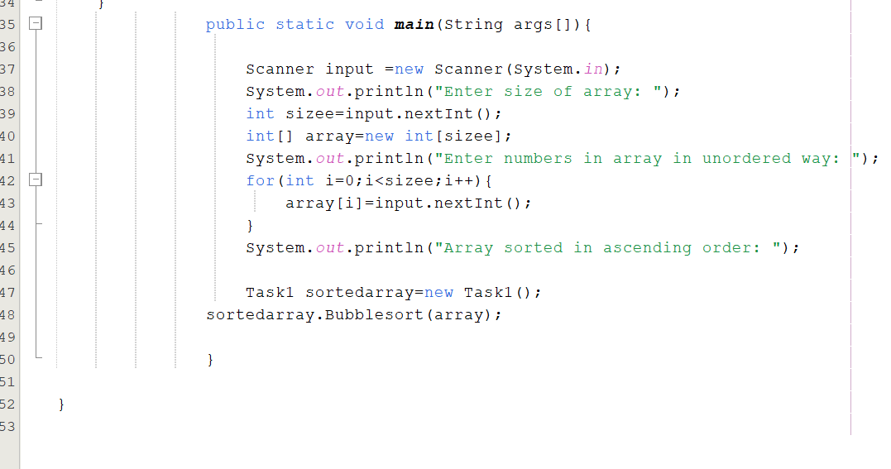

**OUTPUT:**

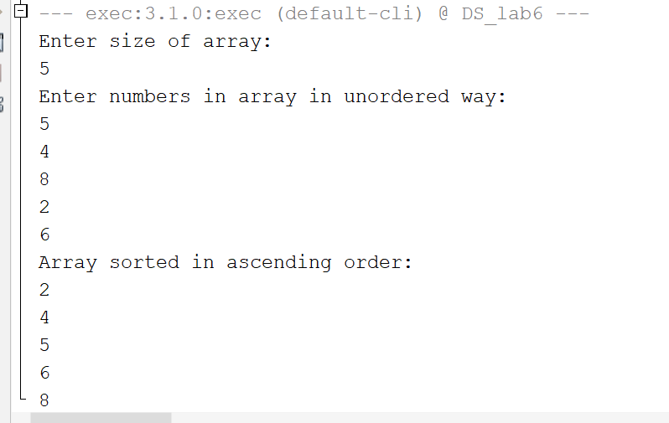

**Lab Task 02:**

Implement Optimized Bubble Sort with Early Stopping

● Write a Java program to implement an optimized version of the Bubble Sort algorithm

that stops early if the array is already sorted during any pass through the array.

● Define a method earlyStopBubbleSort(int[] arr) that implements Bubble Sort.

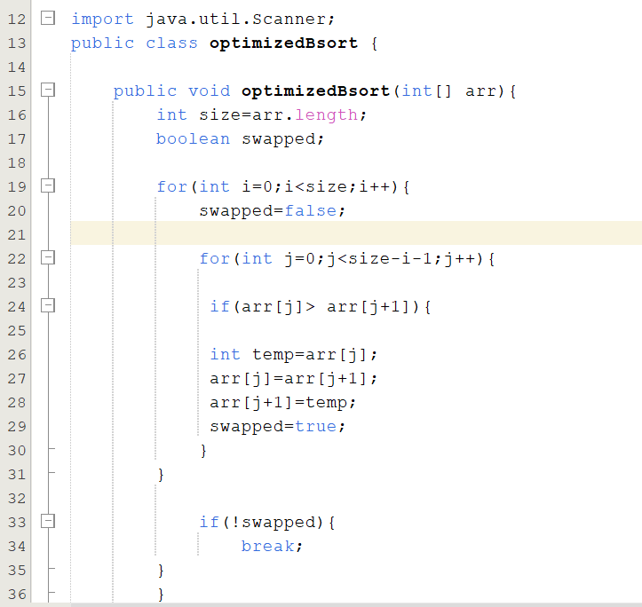

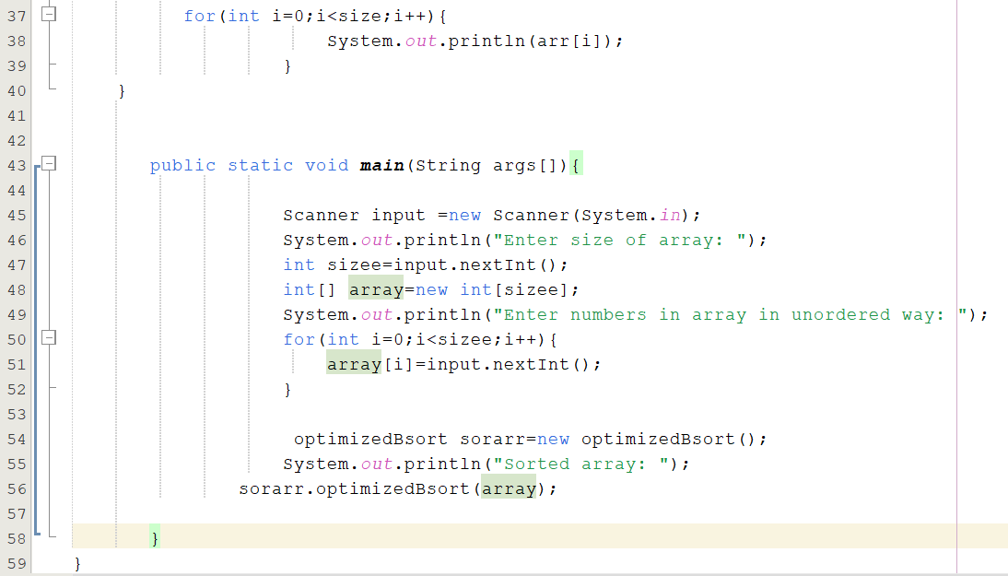

**OUTPUT:**

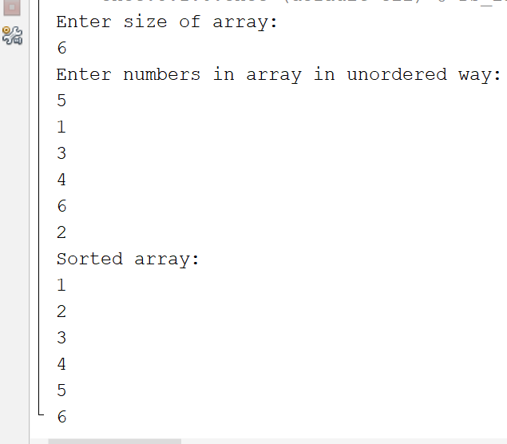

**Lab Task 03:**

Sort a List of Strings by Length

● Modify the Bubble Sort algorithm to sort a list of strings by their lengths in ascending

order.

Input: ["apple", "pie", "banana", "cat"]

Output: ["pie", "cat", "apple", "banana"]

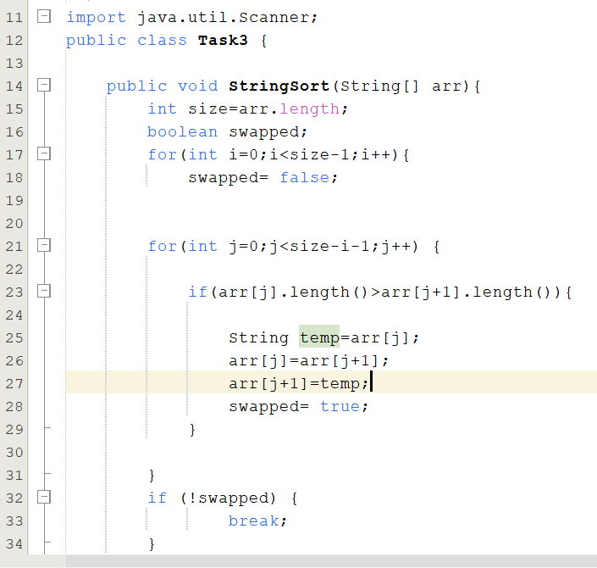

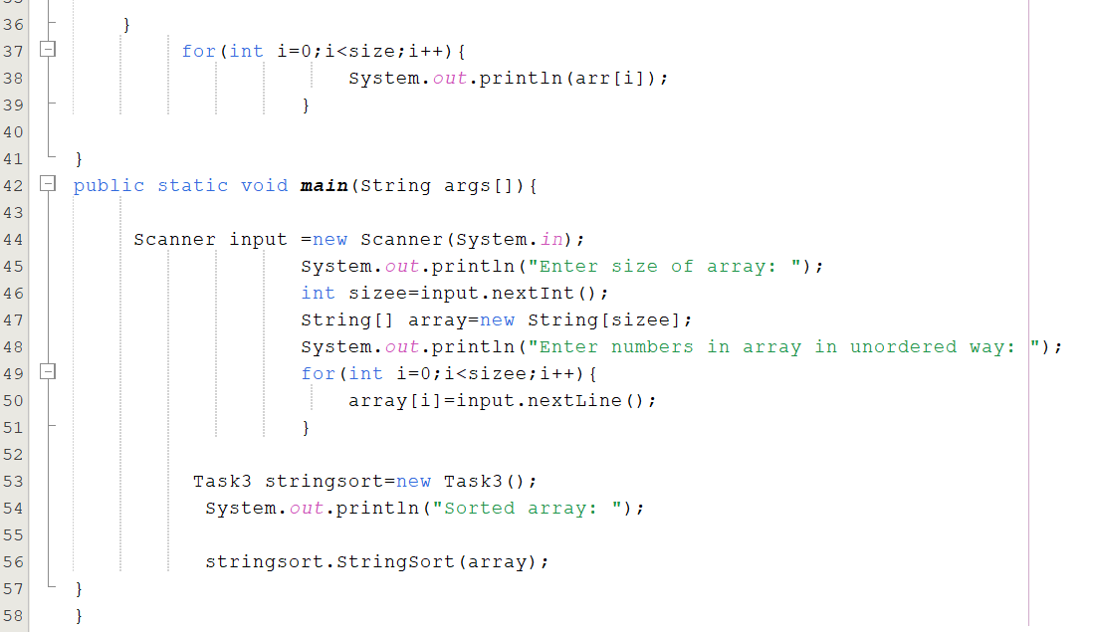

**OUTPUT:**

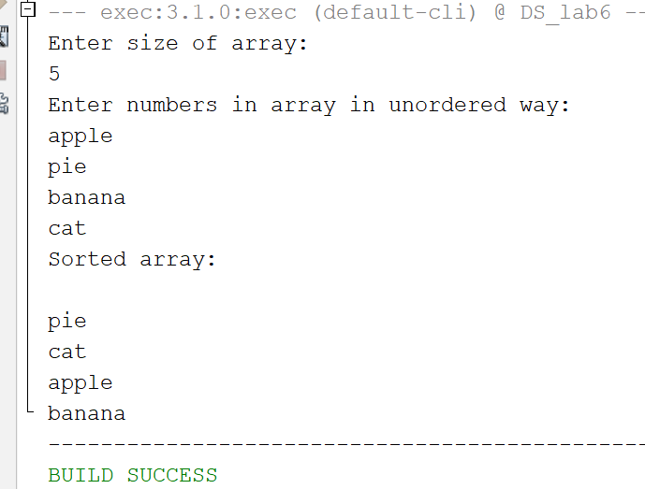

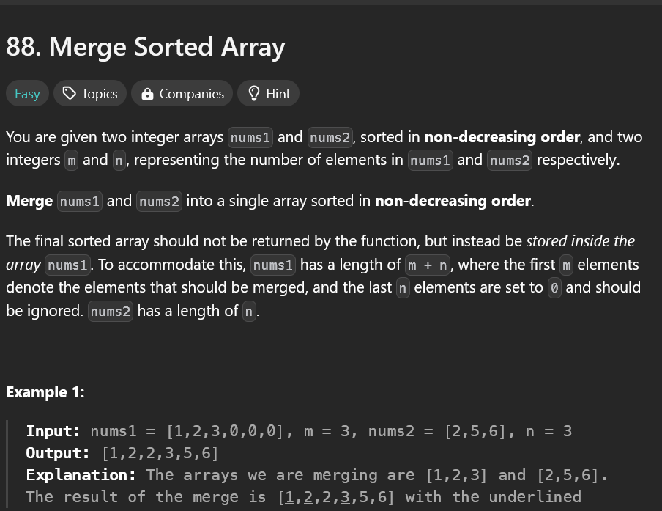

**SOLUTION:**

