

**Faculty of Artificial Intelligence & Multimedia Gamming**

**Lab # 8 BINARY SEARCH TREE**

**Submission Profile**

Name: Ayesha (ARI-F23-0059)

Instructor: Sir Abdul Ghafoor

Course Title : Data Structure and Algorithms

________________________________________________________________________________

NODE

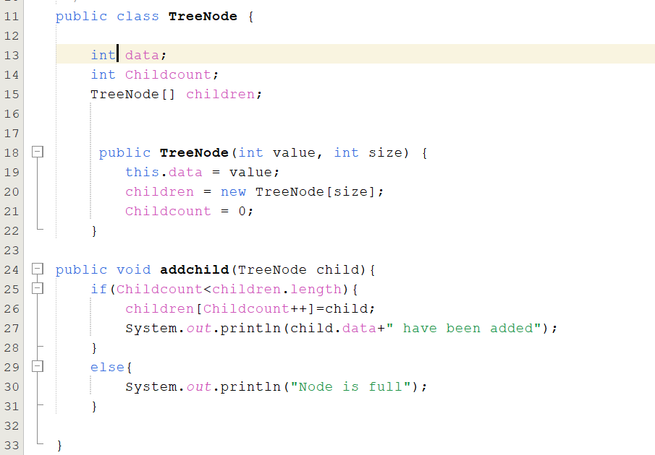

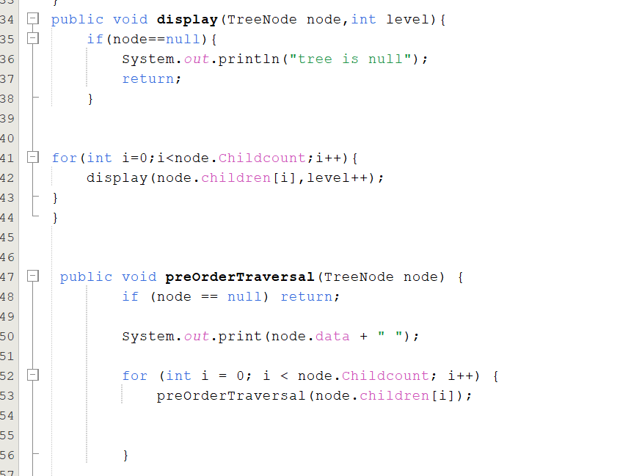

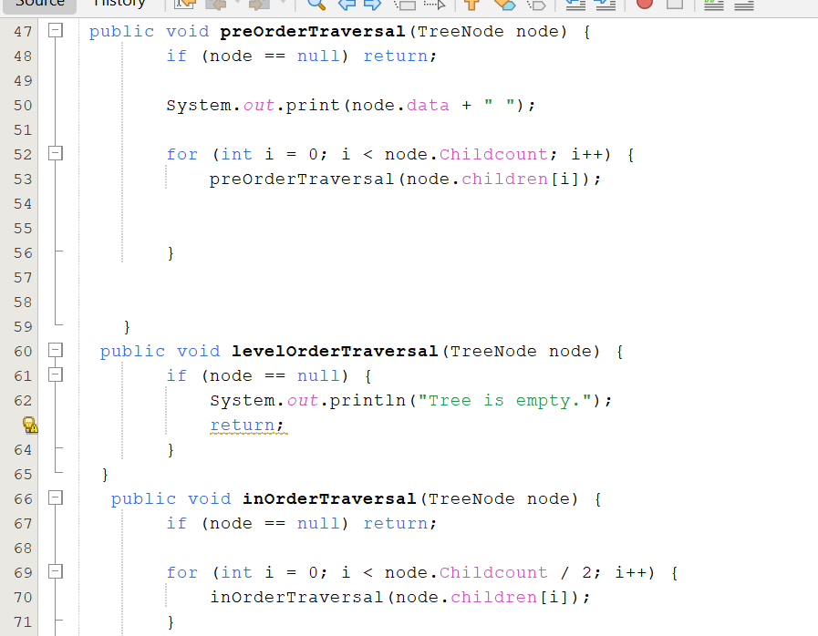

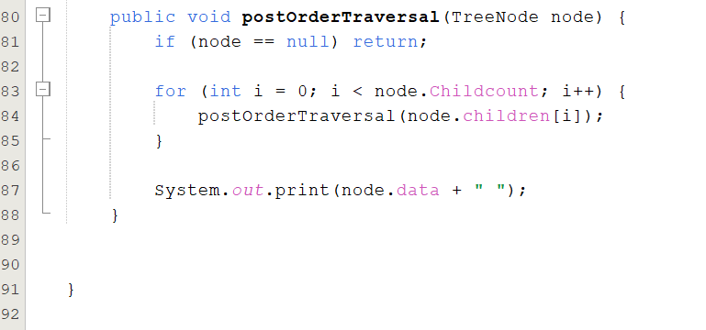

BINARY TREE CLASS:

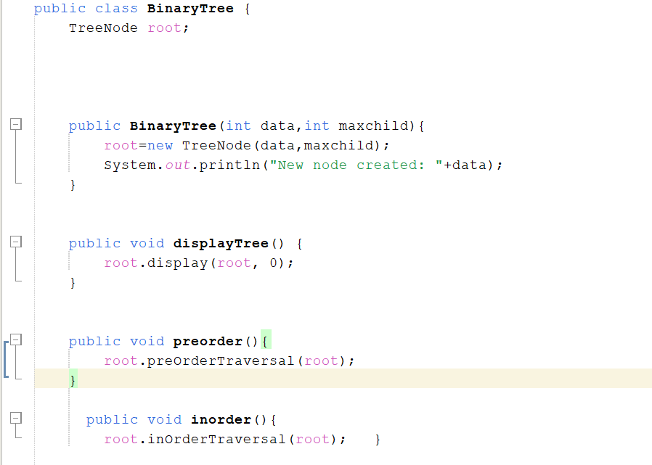

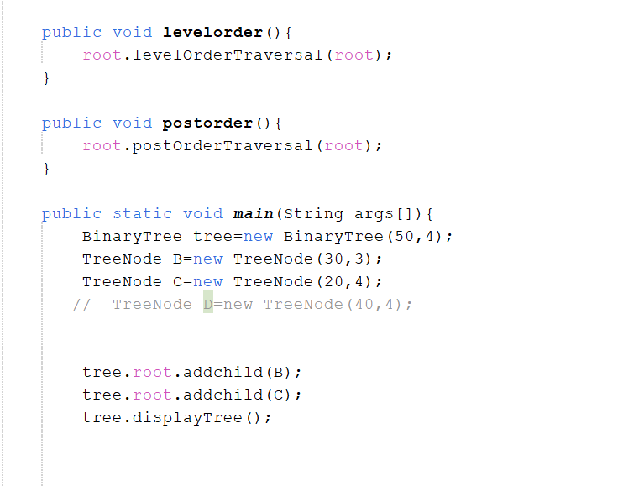

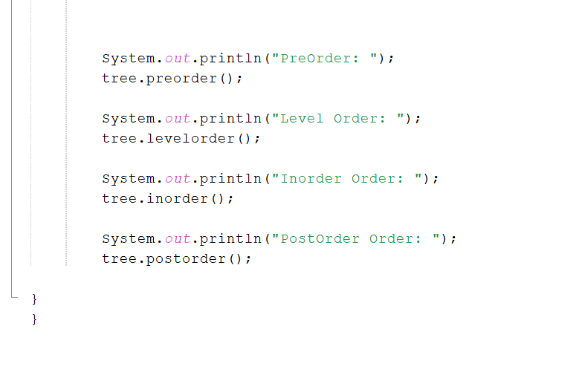

OUTPUT

