

**Faculty of Artificial Intelligence & Multimedia Gamming**

**Lab # 7 (DOUBLE LINKED LIST)**

**Submission Profile**

Name: Ayesha (ARI-F23-0059)

Instructor: Sir Abdul Ghafoor

Course Title : Data Structure and Algorithms

________________________________________________________________________________

**Lab Part 01**

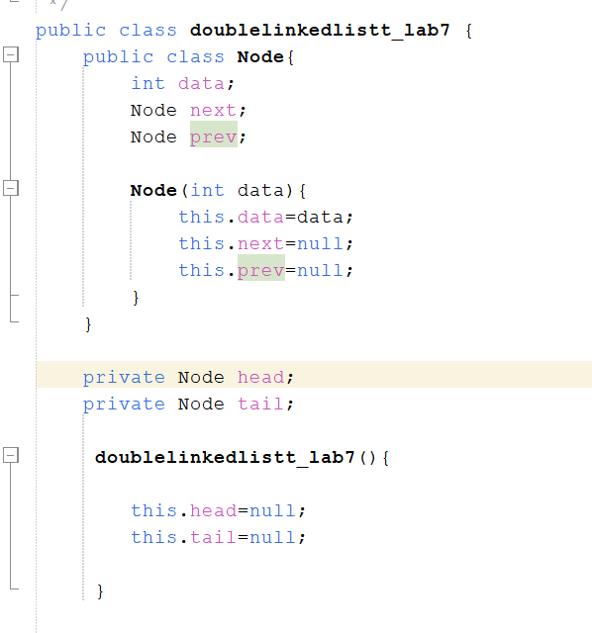

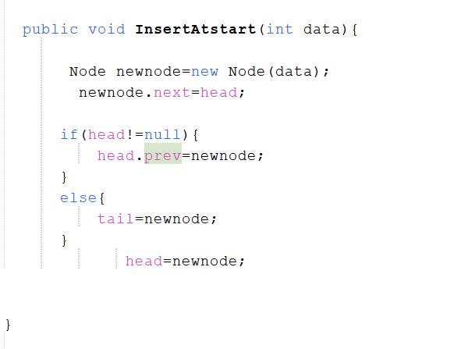

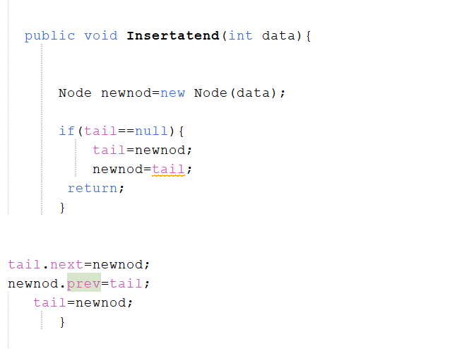

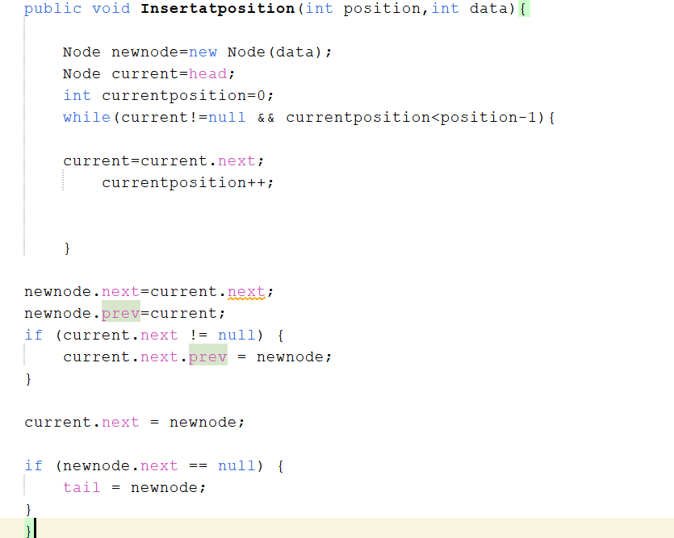

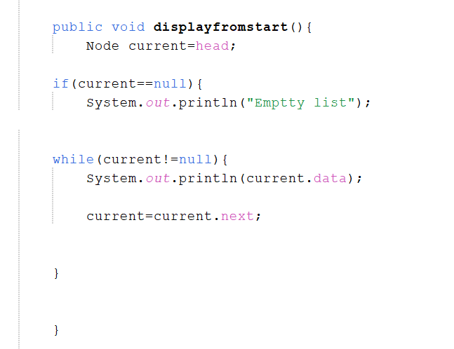

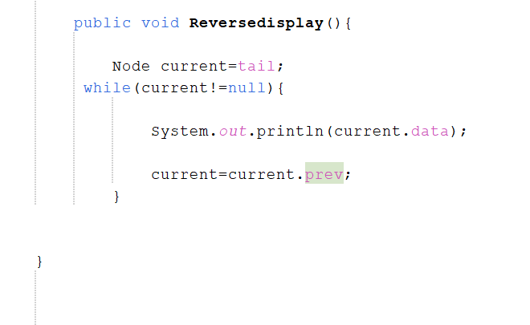

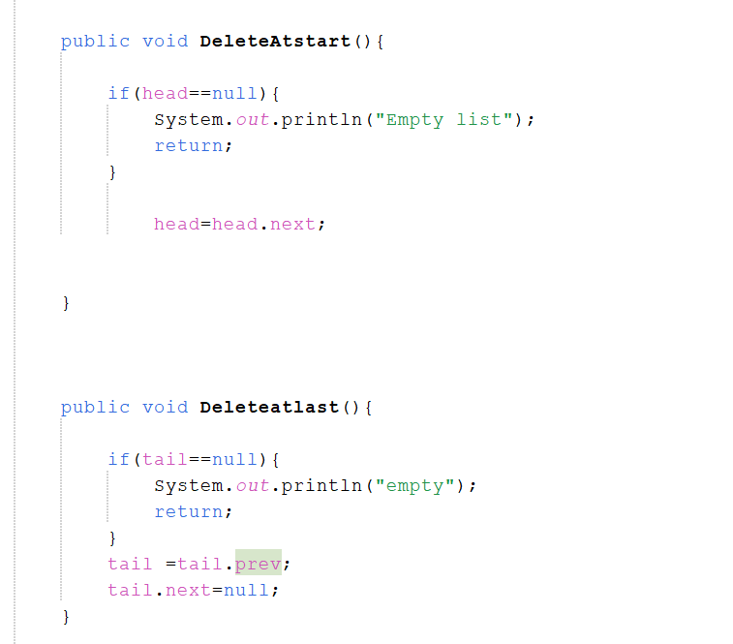

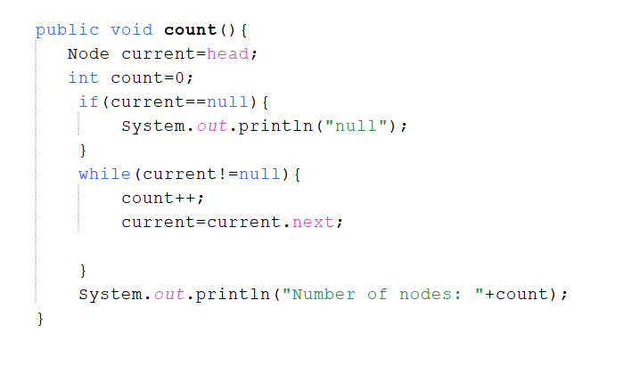

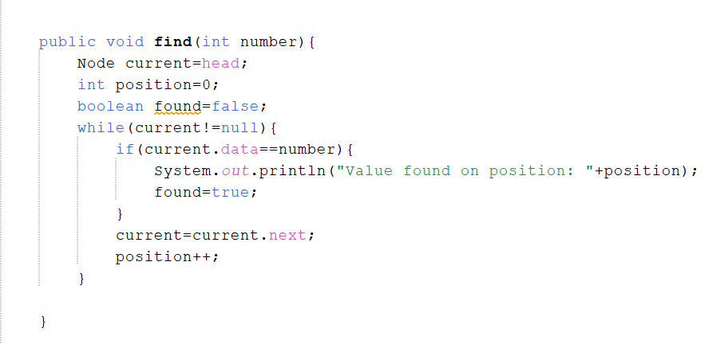

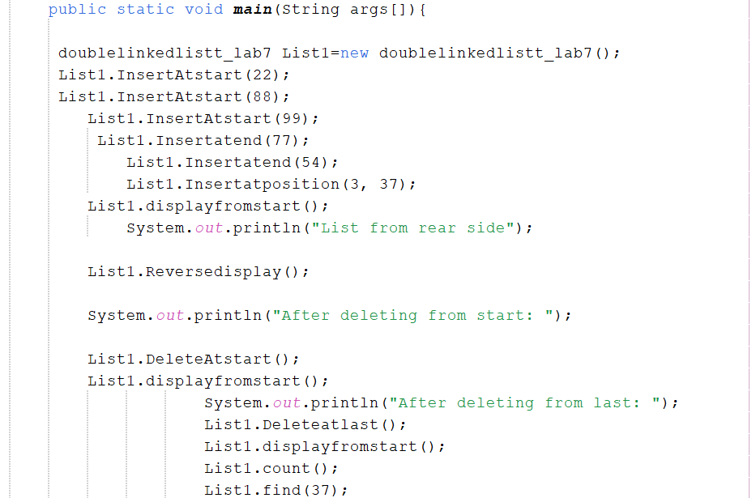

**OUTPUT:**

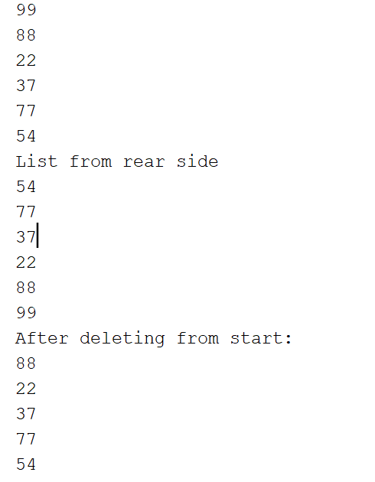

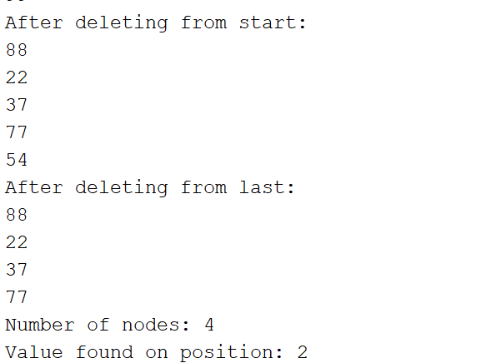

**Lab Part 02: LeetCode**

**TASK 1:**

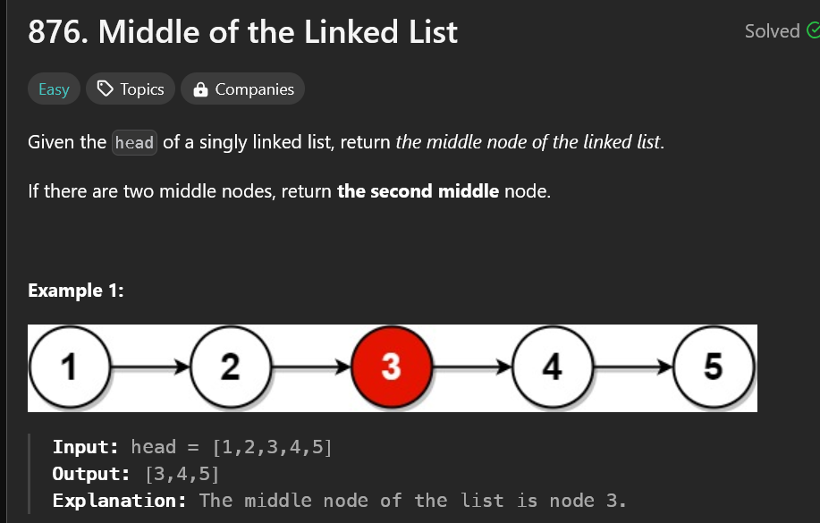

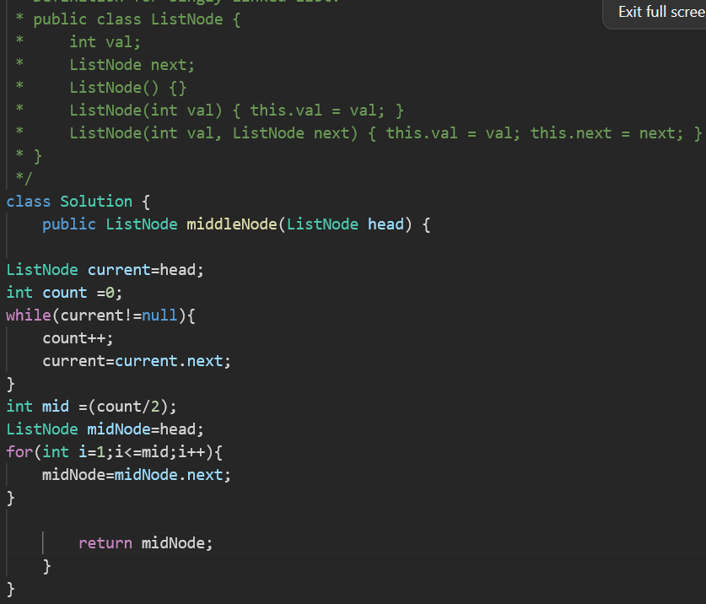

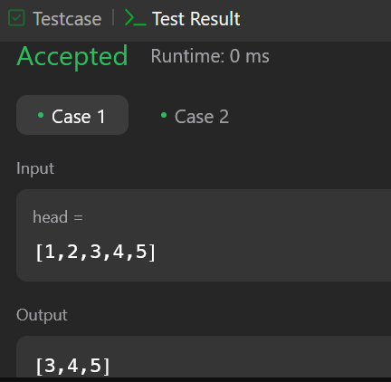

**TASK 2:**

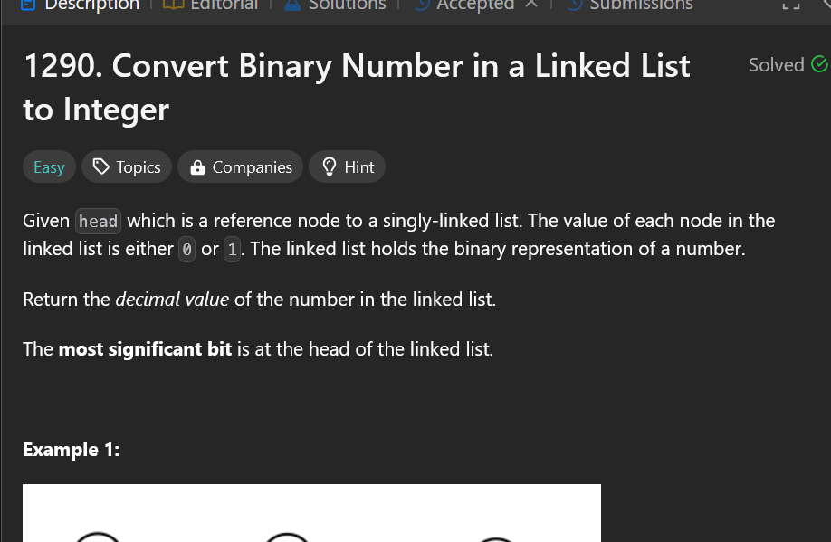

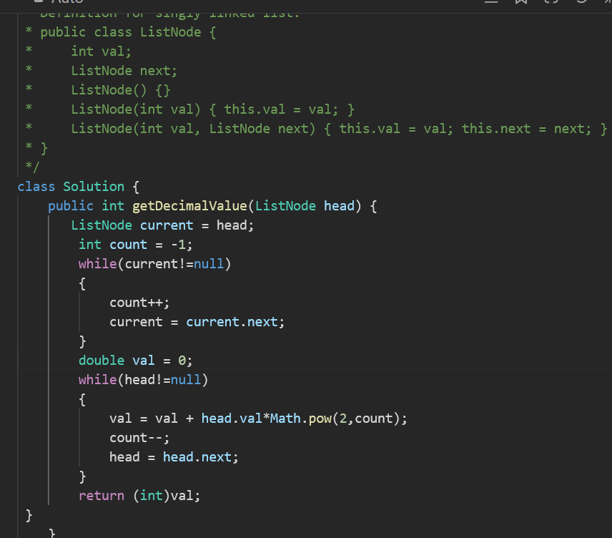

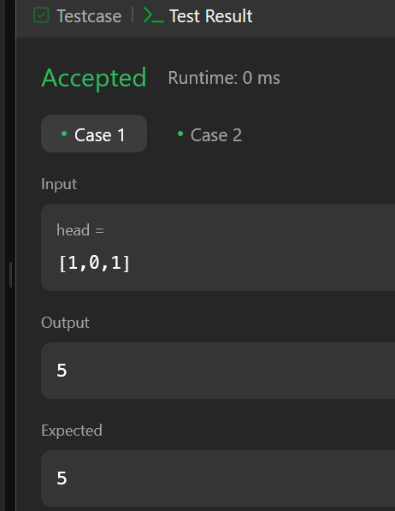

**TASK 3:**

