

**Faculty of Artificial Intelligence & Multimedia Gamming**

**Lab # 07 (Fundamentals of Queue using Array and LinkedList)**

**Submission Profile**

Name: Ayesha (ARI-F23-0059)

Instructor: Sir Abdul Ghafoor

Course Title : Data Structure and Algorithms

________________________________________________________________________________

**QUEUE USING LINKED LIST**

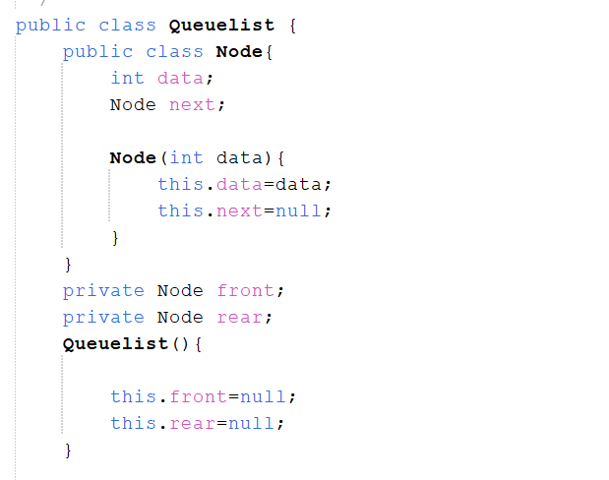

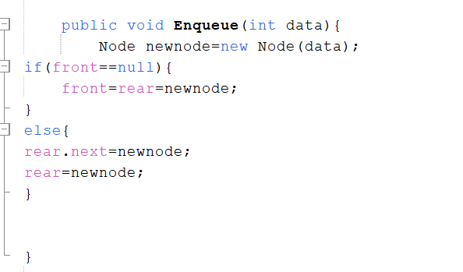

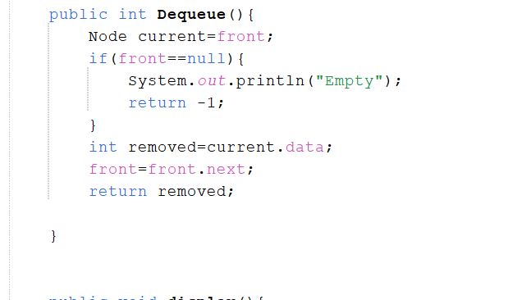

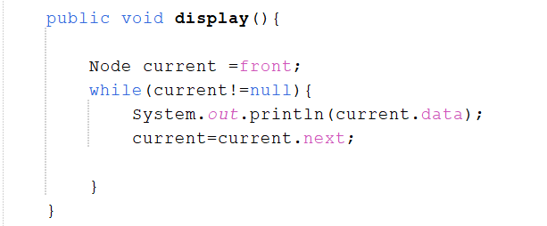

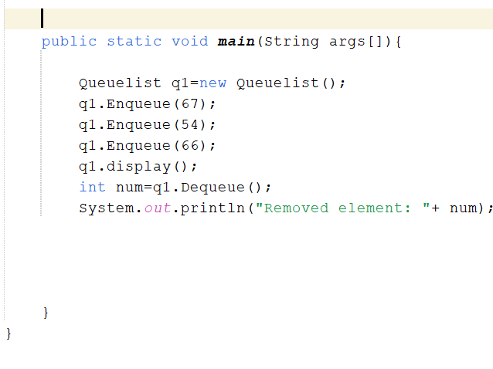

**OUTPUT:**

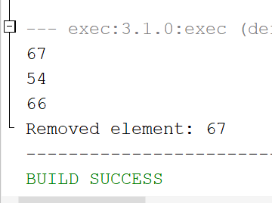

**QUEUE USING ARRAY**

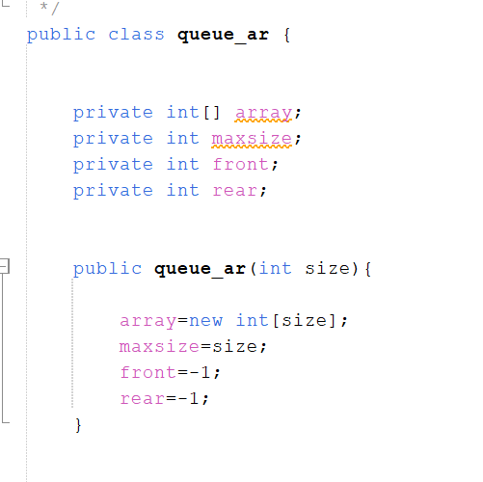

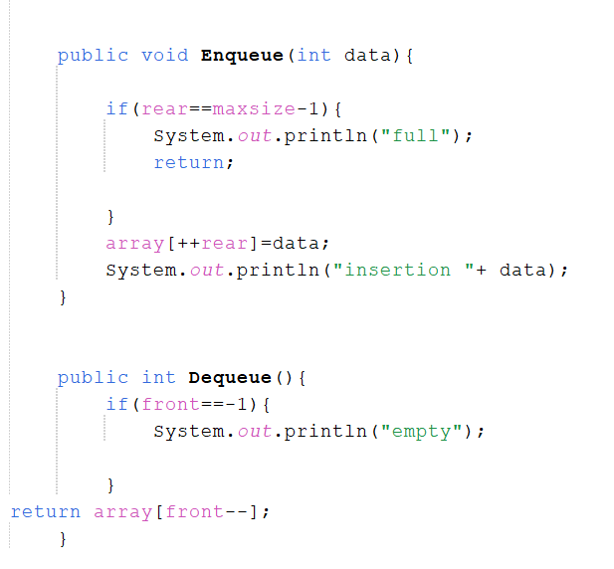

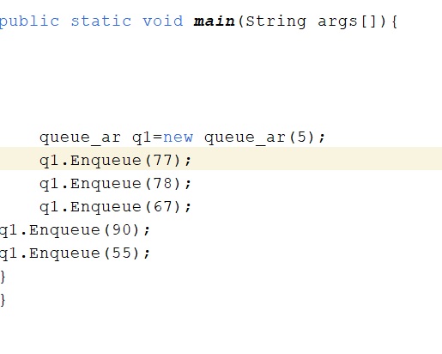

**OUTPUT:**

