House Price Prediction
ANN Regression vs. Linear Regression Baseline

1. Objective
Predict house prices from area-level demographic and structural features using a feedforward Artificial Neural Network regressor, and benchmark it against a classical Linear Regression baseline to test whether the added model complexity is actually justified.

2. Dataset
- Features: 5,000 records — Avg. Area Income, Avg. Area House Age, Avg. Area Number of Rooms, Avg. Area Number of Bedrooms, Area Population, and target Price.
- Data quality: No missing values across any column.
- Split strategy: 70/15/15 split into train, validation, and test sets — validation is used for early stopping.
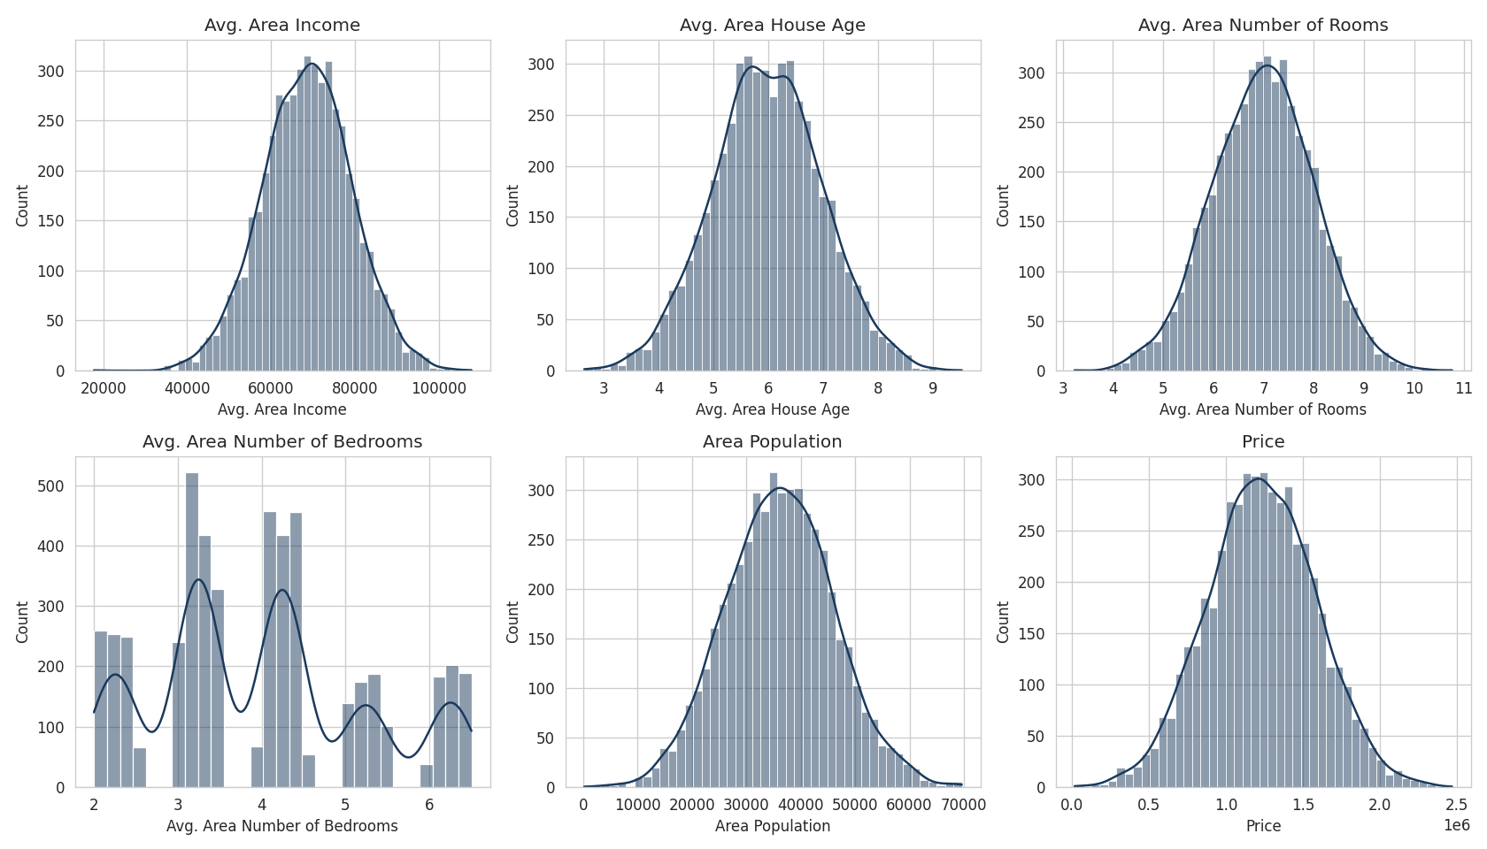
Figure 1: Distribution of each feature and the target variable (Price)
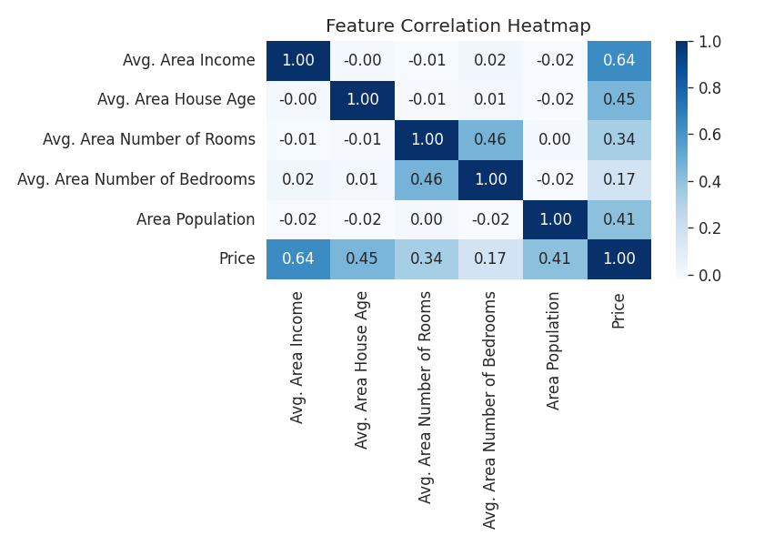
Figure 2: Feature correlation heatmap — Avg. Area Income correlates most strongly with Price

3. Methodology

3.1 Preprocessing
- Scaling: Standardized both features and target (zero mean, unit variance), fit only on the training set to avoid data leakage.
- Note: Predictions are inverse-transformed back to dollar values before computing RMSE/MAE/R² so metrics stay interpretable.

3.2 Baseline — Linear Regression
A standard Linear Regression model was trained on the scaled features as the benchmark the ANN needs to beat.

3.3 ANN Architecture
Input (5) → Linear(64) → ReLU → Dropout(0.2)
→ Linear(32) → ReLU → Dropout(0.2)
→ Linear(1) (regression output)
- Design choice: Only 5 input features, so a compact network (64 → 32) is sufficient — a larger network would simply overfit.
- Regularization: Dropout (0.2) + weight decay (1e-4) on Adam optimizer for regularization.
- Training setup: Trained up to 200 epochs with early stopping (patience = 15) on validation loss — training stopped at epoch 40.

4. Results
Model | RMSE | R² Score
Linear Regression | $100,663 | 0.9216
ANN Regressor | $101,947 | 0.9196

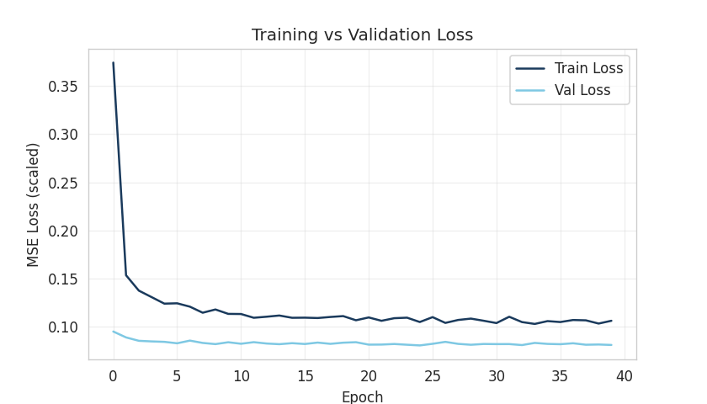
Figure 3: Training vs. validation loss — early stopping triggered at epoch 40
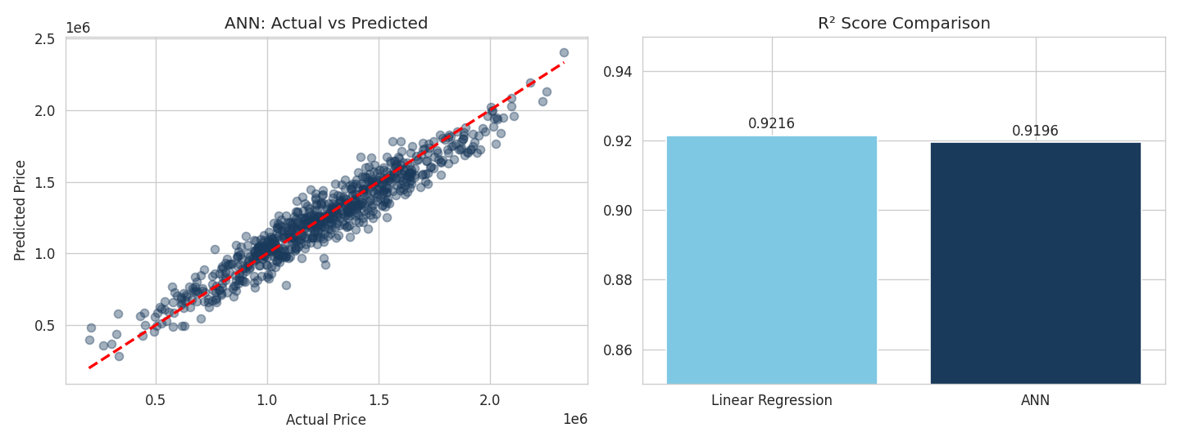
Figure 4: ANN predictions vs. actual price (left) and R² comparison against baseline (right)

5. Discussion & Conclusion
- Key finding: The ANN Regressor reaches R² = 0.9196, essentially matching the Linear Regression baseline (R² = 0.9216) — the ANN does not meaningfully outperform the simpler model here.
- Why: The correlation heatmap shows the feature-price relationship is close to linear, so the ANN has little non-linearity left to exploit — this is an honest, expected outcome rather than a shortcoming of the implementation.
- Takeaway: When a simpler model matches a more complex one, prefer the simpler model (Occam's Razor) — Linear Regression is also faster to train and easier to interpret for stakeholders.
- Future work: Test on a dataset with genuinely non-linear price drivers (e.g. King County House Sales with location, condition, renovation data) where an ANN would be expected to add real value.

