SMS Spam Detection
Using an Artificial Neural Network (ANN) with TF-IDF Features

1. Objective
Classify SMS text messages as Spam or Ham (legitimate) using a feedforward Artificial Neural Network trained on TF-IDF text features — a lightweight, transformer-free approach suitable for a classic NLP classification task.

2. Dataset
- Source: 5,572 SMS messages total — 4,825 ham (86.6%) and 747 spam (13.4%), sourced from the SMS Spam Collection dataset.
- Structure: Each record has a label (ham/spam) and raw message text; no missing values.
- Note: Class imbalance is typical of real-world spam data — evaluation therefore emphasizes F1/Precision/Recall alongside accuracy, not accuracy alone.
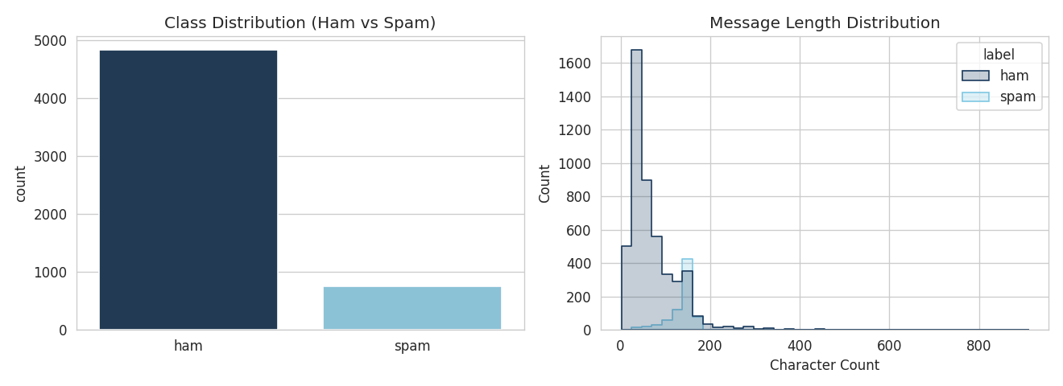
Figure 1: Class distribution and message length distribution by class

3. Methodology

3.1 Text Preprocessing
- Cleaning: Lowercased all text, stripped punctuation/special characters, and normalized whitespace with regex.
- Encoding: Labels mapped to numeric form (ham = 0, spam = 1).

3.2 Feature Extraction — TF-IDF
- Vectorizer: Converted cleaned text into 3,000-dimensional TF-IDF vectors using unigrams + bigrams (captures phrases like "free entry" or "call now").
- Split: 80/20 stratified train/test split to preserve the spam/ham ratio in both sets.

3.3 Model Architecture
Input (3000) → Linear(256) → ReLU → Dropout(0.3)
→ Linear(64) → ReLU → Dropout(0.3)
→ Linear(1) → Sigmoid (via BCEWithLogitsLoss)
- Design choice: Two hidden layers (256 → 64) to learn non-linear combinations of TF-IDF features.
- Regularization: Dropout (0.3) after each hidden layer, since TF-IDF vectors are high-dimensional and sparse — regularization prevents overfitting.
- Training setup: Adam optimizer, learning rate 1e-3, trained for 15 epochs, batch size 32.

4. Results
Metric | Score
Accuracy | 98.39%
F1 Score | 0.938
Precision | 0.965
Recall | 0.913

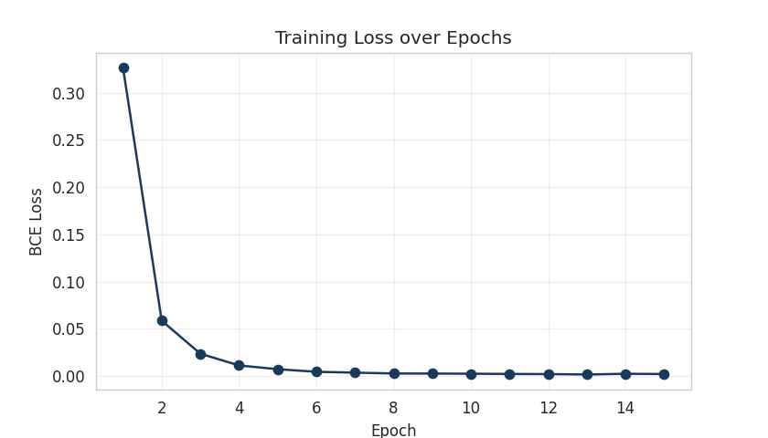
Figure 2: Training loss steadily decreasing over 15 epochs
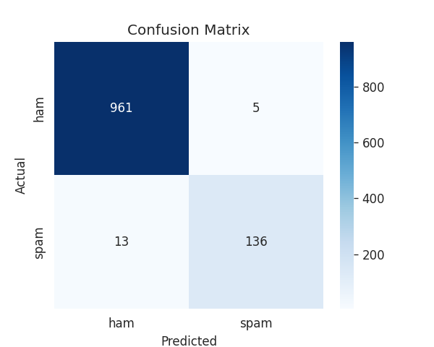
Figure 3: Confusion matrix — only 5 false positives and 13 false negatives out of 1,115 test messages

5. Discussion & Conclusion
- Key finding: The model correctly classified 1,097 of 1,115 test messages (98.4% accuracy), with a low false-positive rate (5 ham messages flagged as spam) — important in practice, since misclassifying real messages as spam is costlier than missing occasional spam.
- Takeaway: A simple ANN with TF-IDF features performs strongly on this task without needing transformer-based models like BERT.
- Future work: Word embeddings (Word2Vec/GloVe), sequence models (LSTM/GRU), or class-balancing techniques (SMOTE, class weights) could further improve recall on the minority spam class.

