AMAZON ECOMMERCE SALES ANALYSIS

# 1. PROJECT OVERVIEW

Objective:  
Analyze Amazon’s product and review data using SQL Server Management Studio to uncover pricing trends, discount strategies, product quality insights, and customer feedback patterns. The goal is to support better business decisions across sales, marketing, and customer engagement.  
  
Tools Used:  
• SQL Server Management Studio  
• ecommerce_sales_data table

# 2. KPI METRICS

## Total Products Listed

SQL Query:

SELECT COUNT(DISTINCT product_id) AS Total_Products FROM ecommerce_sales_data;

C:\Users\AYESHA\Pictures\Screenshots\Screenshot (213).png

Insight:  
Total number of unique products listed on Amazon.

## Average Discount Percentage

SQL Query:

SELECT ROUND(AVG(TRY_CAST(REPLACE(discount_percentage, '%', '') AS FLOAT)),2) AS Avg_Discount FROM ecommerce_sales_data;

C:\Users\AYESHA\Pictures\Screenshots\Screenshot (214).png

Insight:  
Average discount offered across all products.

## Top 5 Most Discounted Products

SQL Query:

SELECT TOP 5 product_name, discount_percentage FROM ecommerce_sales_data ORDER BY discount_percentage DESC;

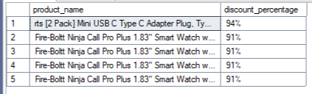

Insight:  
Highlights products with the highest discounts.

## Average Rating by Category

SQL Query:

SELECT category, ROUND(AVG(rating), 2) AS Avg_Rating FROM ecommerce_sales_data GROUP BY category;

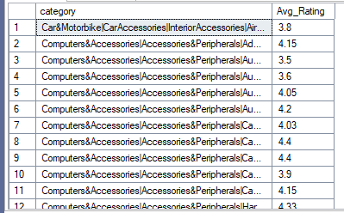

Insight:  
Shows average user rating per product category.

## Total Reviews Submitted

SQL Query:

SELECT COUNT(*) AS Total_Reviews FROM ecommerce_sales_data WHERE review_id IS NOT NULL;

C:\Users\AYESHA\Pictures\Screenshots\Screenshot (217).png

Insight:  
Number of reviews submitted by users.

## Top Rated Products (Min 100 Reviews)

SQL Query:

SELECT product_name, rating, rating_count FROM ecommerce_sales_data WHERE rating >= 4.5 AND rating_count >= 100 ORDER BY rating DESC;

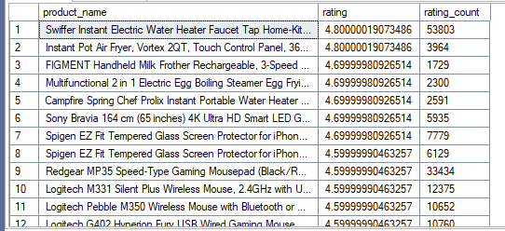

Insight:  
Identifies products with consistently high ratings and significant review volume.

# 3. GRANULAR ANALYSIS

## Product Count by Category

SQL Query:

SELECT category, COUNT(*) AS Product_Count FROM ecommerce_sales_data GROUP BY category ORDER BY Product_Count DESC;

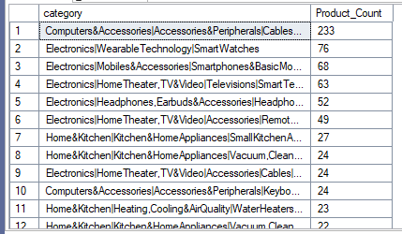

Insight:  
Breaks down inventory by category.

## Average Actual vs Discounted Price by Category

SQL Query:

SELECT category, ROUND(AVG(actual_price), 2) AS Avg_Actual_Price, ROUND(AVG(discounted_price), 2) AS Avg_Discounted_Price FROM ecommerce_sales_data GROUP BY category;

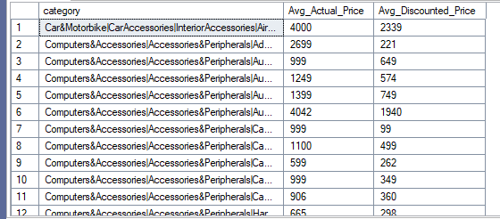

Insight:  
Compares original and discounted prices across categories.

## Most Reviewed Products

SQL Query:

SELECT product_name, rating_count FROM ecommerce_sales_data ORDER BY rating_count DESC;

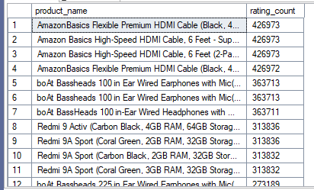

Insight:  
Shows products with the highest number of ratings.

## Frequent Reviewers (Top 10)

SQL Query:

SELECT user_name, COUNT(review_id) AS Review_Count FROM ecommerce_sales_data GROUP BY user_name ORDER BY Review_Count DESC;

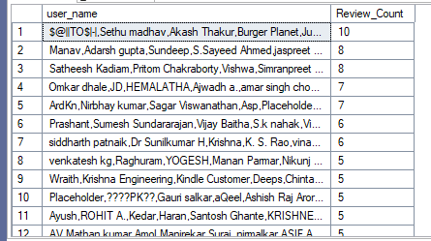

Insight:  
Identifies users who write the most reviews.

# 4. CONCLUSIONS

* The dataset includes a wide variety of products, with a substantial number of unique listings across multiple categories.
* The average discount percentage offered is significantly high, indicating aggressive pricing and marketing strategies.
* Categories like Electronics, Fashion, and Home Appliances dominate the product catalog, reflecting popular consumer interest areas.
* Products with the highest discount percentages tend to attract more attention but don’t always correlate with high ratings.
* The average customer rating per category highlights categories where product satisfaction is consistently high.
* Several products maintain strong ratings (4.5+) with more than 100 reviews, signaling high-quality and trusted offerings.
* A small group of users contribute a large number of reviews, indicating potential brand advocates or frequent buyers.

# 5. RECOMMENDATIONS

* **Optimize Pricing Strategy:** Focus on offering competitive but strategic discounts, especially in high-performing categories, to maximize profit margins.
* **Highlight High-Rated Products:** Promote top-rated products with high review volumes to build customer trust and boost conversions.
* **Category-Level Investment:** Invest more in categories with high average ratings and high engagement (e.g., Electronics or Books).
* **Track Reviewer Behavior:** Monitor frequent reviewers to identify brand ambassadors or detect patterns of review spam.
* **Enhance Product Descriptions:** For categories with lower ratings, improve product content and review customer feedback to drive improvements.
* **Targeted Promotions:** Use discount trends and review data to tailor marketing campaigns by product type and customer segment.