# Blinkit Sales Analysis Using SQL Server Management Studio

## **1. Project Overview**

### Objective:

To analyze Blinkit's sales data using SQL Server Management Studio in order to identify sales trends, customer preferences, and outlet performance. The goal is to derive insights that help optimize business decisions related to product sales, outlet operations, and customer satisfaction.

### Tools Used:

* SQL Server Management Studio
* blinkitdb database with table: blinkit_data

## **2. Data Cleaning**

Cleaning the Item_Fat_Content field ensures consistent and accurate analysis. Different variations like LF, low fat, and reg are standardized.

UPDATE blinkit_data

SET Item_Fat_Content =

CASE

WHEN Item_Fat_Content IN ('LF', 'low fat') THEN 'Low Fat'

WHEN Item_Fat_Content = 'reg' THEN 'Regular'

ELSE Item_Fat_Content

END;

Check cleaned values:

SELECT DISTINCT Item_Fat_Content FROM blinkit_data;

✅ **Cleaned values:** Low Fat, Regular 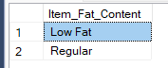

## **3. KPI Metrics**

### 1. Total Sales (in millions):

SELECT CAST(SUM(Total_Sales) / 1000000.0 AS DECIMAL(10,2)) AS Total_Sales_Million FROM blinkit_data;

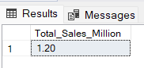

### 2. Average Sales:

SELECT CAST(AVG(Total_Sales) AS INT) AS Avg_Sales FROM blinkit_data;

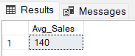

### 3. Number of Items:

SELECT COUNT(*) AS No_of_Orders FROM blinkit_data;

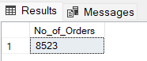

### 4. Average Rating:

SELECT CAST(AVG(Rating) AS DECIMAL(10,1)) AS Avg_Rating FROM blinkit_data;

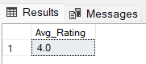

## **4. Granular Sales Analysis**

### A. Total Sales by Fat Content

SELECT Item_Fat_Content, CAST(SUM(Total_Sales) AS DECIMAL(10,2)) AS Total_Sales FROM blinkit_data

GROUP BY Item_Fat_Content;

**Insight:** Low Fat products generate higher revenue.

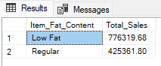

### B. Total Sales by Item Type

SELECT Item_Type, CAST(SUM(Total_Sales) AS DECIMAL(10,2)) AS Total_Sales FROM blinkit_data

GROUP BY Item_Type

ORDER BY Total_Sales DESC;

**Insight:** Some item types consistently perform better, indicating customer preference.

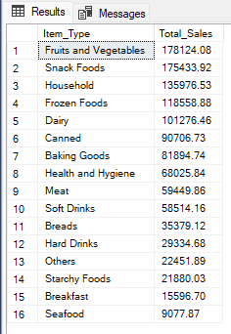

### C. Fat Content by Outlet for Total Sale

SELECT Outlet_Location_Type,

ISNULL([Low Fat], 0) AS Low_Fat,

ISNULL([Regular], 0) AS Regular

FROM (

SELECT Outlet_Location_Type, Item_Fat_Content,

CAST(SUM(Total_Sales) AS DECIMAL(10,2)) AS Total_Sales

FROM blinkit_data

GROUP BY Outlet_Location_Type, Item_Fat_Content

) AS SourceTable

PIVOT (

SUM(Total_Sales)

FOR Item_Fat_Content IN ([Low Fat], [Regular])

) AS PivotTable

ORDER BY Outlet_Location_Type;

**Insight:** Urban and Tier 1 outlets see more Low Fat sales.

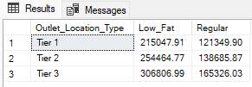

### D. Total Sales by Outlet Establishment Year

SELECT Outlet_Establishment_Year, CAST(SUM(Total_Sales) AS DECIMAL(10,2)) AS Total_Sales FROM blinkit_data

GROUP BY Outlet_Establishment_Year ORDER BY Outlet_Establishment_Year;

**Insight:** Older outlets generate higher cumulative sales.

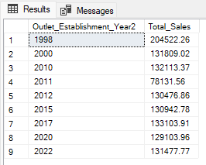

## **5. Outlet and Location Insights**

### A. Percentage of Sales by Outlet Size

SELECT Outlet_Size,

CAST(SUM(Total_Sales) AS DECIMAL(10,2)) AS Total_Sales,

CAST((SUM(Total_Sales) * 100.0 / SUM(SUM(Total_Sales)) OVER()) AS DECIMAL(10,2)) AS Sales_Percentage

FROM blinkit_data

GROUP BY Outlet_Size

ORDER BY Total_Sales DESC;

**Insight:** Medium-sized outlets contribute most to total sales.

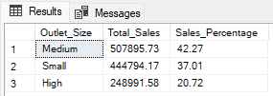

### B. Sales by Outlet Location

SELECT Outlet_Location_Type, CAST(SUM(Total_Sales) AS DECIMAL(10,2)) AS Total_Sales

FROM blinkit_data

GROUP BY Outlet_Location_Type

ORDER BY Total_Sales DESC;

**Insight:** Urban and Tier 1 locations dominate sales performance.

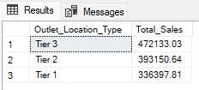

### C. All Metrics by Outlet Type

SELECT Outlet_Type,

CAST(SUM(Total_Sales) AS DECIMAL(10,2)) AS Total_Sales,

CAST(AVG(Total_Sales) AS DECIMAL(10,0)) AS Avg_Sales,

COUNT(*) AS No_Of_Items,

CAST(AVG(Rating) AS DECIMAL(10,2)) AS Avg_Rating,

CAST(AVG(Item_Visibility) AS DECIMAL(10,2)) AS Item_Visibility

FROM blinkit_data

GROUP BY Outlet_Type

ORDER BY Total_Sales DESC;

**Insight:** Supermarkets lead in sales, average rating, and visibility.

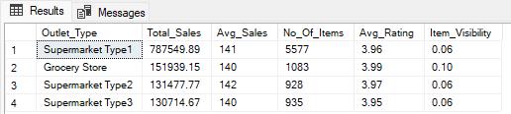

## **6. Conclusions**

* **Low Fat products** are more popular and generate higher sales.
* **Urban and Tier 1** areas show stronger performance across all metrics.
* **Medium-sized outlets** convert inventory to revenue most effectively.
* **Supermarkets** are the top-performing outlet type.
* **Older outlets** consistently achieve higher cumulative sales.

## **7. Recommendations**

* Boost inventory and promotions for **Low Fat** products.
* Focus expansion efforts in **Urban and Tier 1** markets.
* Prioritize **medium-sized** outlets for operational investment.
* Explore opportunities to **revitalize or support newer outlets**.