COURSERA COURSE DATA ANALYSIS

# 1. PROJECT OVERVIEW

Objective:  
Analyze Coursera's course dataset using SQL Server Management Studio to gain insights on course offerings, popularity, learner preferences, certification types, and partner performance.  
  
Tools Used:  
• SQL Server Management Studio  
• coursera_data table

# 2. KPI METRICS

## Total Courses

SQL Query:

SELECT COUNT(*) AS Total_Courses FROM coursera_data;



Insight:  
Total number of courses available on Coursera.

## Average Course Rating

SQL Query:

SELECT ROUND(AVG(rating), 2) AS Average_Rating FROM coursera_data WHERE rating IS NOT NULL;

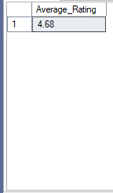

Insight:  
Measures average learner satisfaction across all courses.

## Most Reviewed Courses (Top 5)

SQL Query:

SELECT TOP 5 course, reviewcount FROM coursera_data ORDER BY reviewcount DESC;

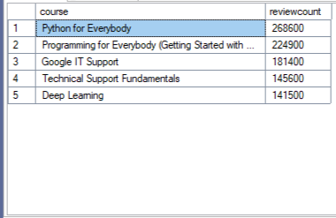

Insight:  
Identifies courses with the highest student engagement based on review count.

## Courses by Level

SQL Query:

SELECT level, COUNT(*) AS Course_Count FROM coursera_data GROUP BY level ORDER BY Course_Count DESC;

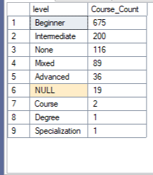

Insight:  
Shows how courses are distributed across Beginner, Intermediate, and Advanced levels.

## Courses with Credit Eligibility

SQL Query:

SELECT crediteligibility, COUNT(*) AS Course_Count FROM coursera_data GROUP BY crediteligibility;

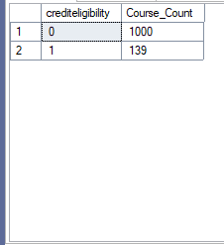

Insight:  
Number of courses eligible for academic or professional credit.

## Top Certification Types

SQL Query:

SELECT certificatetype, COUNT(*) AS Certificate_Count FROM coursera_data GROUP BY certificatetype ORDER BY Certificate_Count DESC;

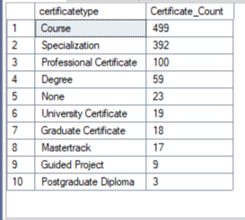

Insight:  
Shows how courses are distributed by certification type.

# 3. GRANULAR ANALYSIS

## Course Count by Partner

SQL Query:

SELECT partner, COUNT(*) AS Course_Count FROM coursera_data GROUP BY partner ORDER BY Course_Count DESC;

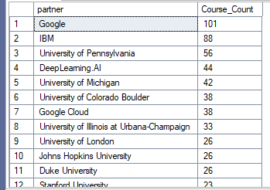

Insight:  
Shows how many courses are offered by each partner or institution.

## Average Rating by Partner

SQL Query:

SELECT partner, ROUND(AVG(rating), 2) AS Avg_Rating FROM coursera_data WHERE rating IS NOT NULL GROUP BY partner ORDER BY Avg_Rating DESC;

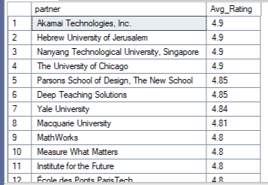

Insight:  
Evaluates the average course quality across partners.

## Top 10 Most Frequent Skills

SQL Query:

SELECT TOP 10 skills, COUNT(*) AS Frequency FROM coursera_data GROUP BY skills ORDER BY Frequency DESC;

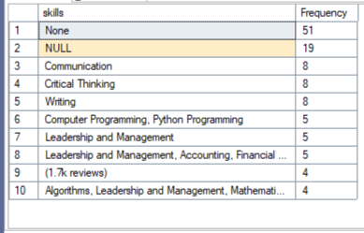

Insight:  
Identifies the most common skills taught across courses.

## Courses by Duration

SQL Query:

SELECT duration, COUNT(*) AS Course_Count FROM coursera_data GROUP BY duration ORDER BY Course_Count DESC;

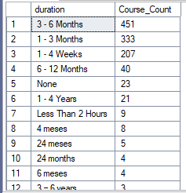

Insight:  
Groups courses by estimated completion time.

## Top Courses by Rating & Review Count

SQL Query:

SELECT TOP 10 course, rating, reviewcount FROM coursera_data WHERE rating IS NOT NULL AND reviewcount IS NOT NULL ORDER BY rating DESC, reviewcount DESC;

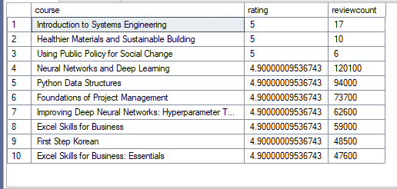

Insight:  
Highlights high-impact courses that are both top-rated and widely reviewed.

# 4. CONCLUSIONS

* The platform offers a diverse catalog of **Coursera courses**, with a wide range of **certification types** and **credit eligibility** options.
* The **average course rating** is consistently high, indicating strong learner satisfaction across the board.
* **Beginner-level courses** dominate the catalog, suggesting a focus on foundational skills for new learners.
* Courses offered by partners like **Google** and **IBM** lead in terms of both quantity and rating quality.
* The most frequent **skills taught** include Python, Data Analysis, Project Management, and Digital Marketing.
* Popular courses tend to have **high review counts and strong ratings**, indicating high user engagement and trust.
* Most courses fall under a **3–6 months** duration, balancing accessibility with depth of learning.

# 5. RECOMMENDATIONS

* **Partner Strategy:** Expand collaboration with high-performing partners to offer more top-rated courses.
* **Course Level Mix:** Introduce more Intermediate and Advanced courses to support learner progression beyond Beginner level.
* **Skill Focus:** Invest in new courses around trending or underrepresented skills identified through skill frequency gaps.
* **Certification Optimization:** Promote certification types with the highest learner completion and satisfaction rates.
* **Credit Eligibility Expansion:** Increase the number of credit-eligible courses to attract learners seeking formal accreditation.
* **Course Quality Monitoring:** Continuously track course ratings and review trends to maintain quality and relevance.