# LIBRARY USAGE ANALYSIS

## 1. PROJECT OVERVIEW

**Objective:**  
Analyze the library's book inventory and location tracking data using SQL Server Management Studio to understand book availability, category distribution, physical storage utilization, and signal strength for tracking. The goal is to derive actionable insights for optimizing library management and resource allocation.

**Tools Used:**

* SQL Server Management Studio
* librarydb database with table: library_data

## 2. DATA CLEANING & VALIDATION

Ensure consistent status values (Present, Issued, Missing, etc.) and confirm signal strength data integrity. Standardize any inconsistencies in status or category naming before analysis.

Example cleanup query (if needed):

UPDATE dbo.library_data

SET Status = CASE

WHEN Status IN ('available', 'Available') THEN 'Present'

WHEN Status IN ('lost', 'Missing') THEN 'Missing'

ELSE Status

END;

## 3. KPI METRICS

1. **Total Books**
   * **SQL Query:**

SELECT COUNT(*) AS TOTAL_BOOK_COUNT FROM dbo.library_data;

* + **Insight:**  
    Total number of books stocked in the library.

**C:\Users\AYESHA\Pictures\Screenshots\Screenshot (188).png**

1. **Books Available**
   * **SQL Query:**

SELECT COUNT(*) AS BOOKS_AVAILABLE FROM dbo.library_data WHERE Status = 'Present';

* + **Insight:**  
    Number of books currently available for borrowing.

C:\Users\AYESHA\Pictures\Screenshots\Screenshot (197).png

1. **Books Missing**
   * **SQL Query:**

SELECT COUNT(*) AS BOOKS_MISSING FROM dbo.library_data WHERE Status = 'Missing';

* + **Insight:**  
    Number of books reported missing or lost.

C:\Users\AYESHA\Pictures\Screenshots\Screenshot (190).png

1. **Average Signal Strength**
   * **SQL Query:**

SELECT AVG(Signal_Strength) AS AVG_SIGNAL_STRENGTH FROM dbo.library_data;

* + **Insight:**  
    Average signal strength indicates location tracking performance.

C:\Users\AYESHA\Pictures\Screenshots\Screenshot (198).png

1. **Book Count by Category**
   * **SQL Query:**

SELECT Category, COUNT(*) AS BOOK_COUNT

FROM dbo.library_data

GROUP BY Category

ORDER BY BOOK_COUNT DESC;

* + **Insight:**  
    Distribution of books across different categories or genres.

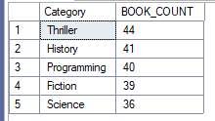

## 4. GRANULAR ANALYSIS

**A. Book Count by Category and Status**

SELECT Category, Status, COUNT(*) AS BOOK_COUNT

FROM dbo.library_data

GROUP BY Category, Status

ORDER BY Category, Status;

**Insight:**  
Identifies how many books per category are Issued, Available, or Missing. Useful for inventory control and category popularity tracking.

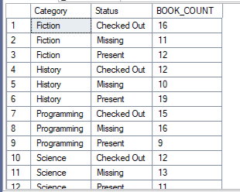

**B. Books by Physical Location (Cabinet, Rack, Row)**

SELECT Cabinet, Rack, Row, COUNT(*) AS BOOK_COUNT FROM dbo.library_data

GROUP BY Cabinet, Rack, Row ORDER BY Cabinet, Rack, Row;

**Insight:**  
Analyzes book storage density in different physical locations of the library to optimize shelving and reduce overcrowding.

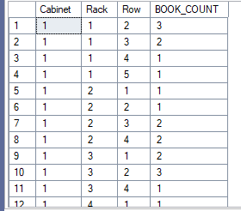

**C. Signal Strength by Location**

SELECT Cabinet, Rack, Row, AVG(Signal_Strength) AS AVG_SIGNAL_STRENGTH, COUNT(*) AS BOOK_COUNT

FROM dbo.library_data

GROUP BY Cabinet, Rack, Row

ORDER BY Cabinet, Rack, Row;

**Insight:**  
Measures signal quality variations across library sections to identify potential blind spots or interference affecting book tracking.

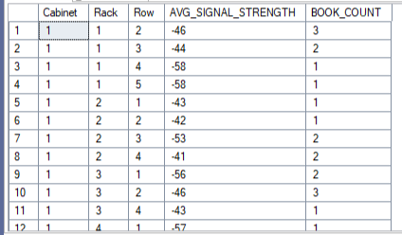

**D. Top Authors by Book Count**

SELECT Author, COUNT(*) AS BOOK_COUNT

FROM dbo.library_data

GROUP BY Author

ORDER BY BOOK_COUNT DESC;

**Insight:**  
Highlights most stocked authors, helping tailor procurement and stocking policies based on popularity.

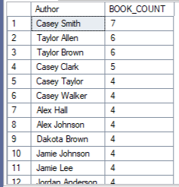

## 5. CONCLUSIONS

* The library houses a total of **200 books**, out of which **68 are currently available** for borrowing.
* Categories such as **Thriller, History, and Programming** make up a significant portion of the collection, reflecting user interests and demand patterns.
* A total of **62 books are reported missing**, indicating a need to enhance security and tracking procedures.
* The **average signal strength is -49**, suggesting moderate signal performance, with opportunities to improve tracking accuracy in certain library zones.
* Authors like **Casey Smith** and **Taylor Allen** are among the most stocked, pointing toward strong reader preferences that can guide future acquisitions.

## 6. RECOMMENDATIONS

* **Inventory Management:** Strengthen monitoring of missing books and initiate recovery or replacement procedures.
* **Category Focus:** Increase procurement of high-demand categories and popular authors.
* **Storage Optimization:** Rebalance shelving density in cabinets or racks with low utilization.
* **Signal Improvement:** Enhance tracking infrastructure in areas with low signal strength to improve location accuracy.
* **Data Quality:** Regularly clean and validate data to maintain reporting accuracy.