**Frontend Development with React.js**

**TEAM DETAILS**

|  |  |  |
| --- | --- | --- |
| **Team Leader** | **Ayesha Aamira.J** | **ayeshaamira05@gmail.com** |

**TEAM MEMBERS**

|  |  |  |
| --- | --- | --- |
| **MEMBERS** | **NAME** | **ROLE** |
| **Member 1** | **Ayesha Aamira.J** | **Voice-Demo Video** |
| **Member 2** | **Ashwini.S** | **Demo Video** |
| **Member 3** | **Divya.J** | **Code execution** |
| **Member 4** | **Divya.T** | **Documentation** |

**PROJECT TITLE**

InsightStream: **Navigate the News Landscape**

**INTRODUCTION**

In today’s digital era, information flows faster than ever before, and people are constantly surrounded by news updates from various platforms. While this abundance of information is valuable, it often creates challenges such as information overload, scattered sources, and difficulties in identifying reliable news. To address these issues, **InsightStream** has been developed as a smart, centralized platform that simplifies the way users consume and navigate through the news landscape.

InsightStream is designed to aggregate news from multiple trusted sources and present it in a well-structured and organized format. By categorizing content into diverse fields such as politics, business, technology, sports, and entertainment, the platform enables users to quickly access the topics that matter most to them. Unlike traditional news applications that may focus on a single publisher, InsightStream provides a broader perspective by combining multiple viewpoints, which helps in reducing bias and enhancing credibility.

The platform focuses strongly on **user experience**. With its clean and intuitive interface, readers can easily browse, filter, and search for articles based on their preferences. Features such as bookmarking, personalized dashboards, and category-based navigation allow users to stay engaged without feeling overwhelmed. In addition, real-time updates ensure that users are always connected to the latest developments as they happen.

Another important aspect of InsightStream is its vision for inclusivity and adaptability. Future enhancements like multi-language support, AI-driven recommendations, sentiment analysis, and accessibility options (such as dark mode and text-to-speech) are intended to make the platform more powerful and user-friendly. This makes InsightStream not just a news-reading tool, but a comprehensive information ecosystem that evolves with the needs of its audience.

Ultimately, InsightStream is more than just a news aggregator — it is a gateway to knowledge, awareness, and informed decision-making. By combining technology, usability, and reliability, it seeks to empower individuals with insights that are accurate, timely, and easy to navigate.

**PROJECT OVERVIEW**

**Purpose:**  
InsightStream is a news aggregation and analysis platform that helps users navigate the news landscape efficiently. It gathers articles from multiple sources, categorizes them into topics, and provides insights with trends and analytics.

**Our key goals include:**

User-Friendly Experience: Develop an interface that is intuitive and easy to navigate, ensuring users can effortlessly access, save, and share their preferred news articles. Comprehensive News Management: Provide robust features for organizing and managing news content, incorporating advanced search options for a personalized news experience. Technology Stack: Employ cutting-edge web development technologies, such as React.js, to ensure an efficient and enjoyable user interface.

**Objectives**

1. To create a platform where users can read and analyze news from multiple sources.
2. To provide topic-based categorization for quick navigation.
3. To help users identify credible sources and avoid misinformation.
4. To allow users to search and filter news articles efficiently.
5. To promote informed decision-making by presenting multiple viewpoints.

**Features**

* News Categorization – Articles organized by categories such as Politics, Technology, Sports, Entertainment, and Business.
* Search Functionality – Users can search for specific keywords or topics.
* Filter & Sort Options – Sort articles by date, relevance, or source.
* Multiple Source Integration – Aggregates news from various trusted outlets.
* Responsive Design – Works seamlessly across devices.
* User-Friendly Dashboard – Clean layout for easy navigation.

**TOOL & TECHOLOGIES USE**

* Frontend: HTML5, CSS3, JavaScript (React.js for advanced UI).
* Backend (optional): Node.js / Express.js (for API integration).
* Database (optional): MongoDB or MySQL (for saving user preferences).
* API: NewsAPI / Google News RSS feeds.
* Hosting: GitHub Pages / Vercel / Netlify.

**COMPONENT STRUCTURE**

* Dashboard → Real-time insights and key metrics
* Streams → Access live data streams
* Analytics → Tools for queries, visualizations, and reports
* Reports → Saved and scheduled reports
* Collaboration → Shared dashboards, comments, team
* workspaces Settings → Preferences, integrations, and security controls.

**STATE MANAGEMENT**

**Global state: Dashboards, streams, reports, authentication**

**Local state: Filters, export options, visualization settings**

**SETUP INSTRUCTION**

**Routing**

**Primary Navigation:** Dashboard, Streams, Analytics, Reports, Collaboration, Settings.

**Secondary Navigation:** Contextual menus inside modules.

**PREREQUISITES**

Here are the key prerequisites for developing a frontend application using React.js: Node.js and npm: Node.js is a powerful JavaScript runtime environment that allows you to run JavaScript code on the local environment. It provides a scalable and efficient platform for building network applications. Install Node.js and npm on your development machine, as they are required to run JavaScript on the server-side. Download: https://nodejs.org/en/download/

**INSTALLATION**

* Installation instructions: <https://nodejs.org/en/download/package-manager/>
* React.js: React.js is a popular JavaScript library for building user interfaces.
* It enables developers to create interactive and reusable UI components, making it easier to build dynamic and responsive web applications.
* Install React.js, a JavaScript library for building user interfaces.
* Create a new React app: npx create-react-app my-react-app Replace my-react-app with your preferred project name.
* Navigate to the project directory: cd my-react-app Running the React App: With the React app created, you can now start the development server and see your React application in action.
* Start the development server: npm start This command launches the development server, and you can access your React app at http://localhost:3000 in your web browser.
* HTML, CSS, and JavaScript: Basic knowledge of HTML for creating the structure of your app, CSS for styling, and JavaScript for client-side interactivity is essential. Version Control: Use Git for version control, enabling collaboration and tracking changes throughout the development process.
* Platforms like GitHub or Bitbucket can host your repository.
* Git: Download and installation instructions can be found at: <https://git-scm.com/downloads>
* Development Environment: Choose a code editor or Integrated Development Environment (IDE) that suits your preferences, such as Visual Studio Code, Sublime Text, or WebStorm.
* Visual Studio Code: Download from <https://code.visualstudio.com/download>
* Sublime Text: Download from <https://www.sublimetext.com/download>
* WebStorm: Download from <https://www.jetbrains.com/webstorm/>
* To clone and run the Application project from GitHub: Follow below steps Install Dependencies: Navigate into the cloned repository directory install libraries.
* install libraries: cd news npm install Start the development server.
* Development Server: To start the development server, execute the following command: npm start Access the App: Open your web browser and navigate to <http://localhost:3000>.

**RUNNING THE APPLICATION**

npm start

The app runs locally at: <http://localhost:3000>

**COMPONENT DOCUMENTATION**

**Key Components:**

Dashboard → Real-time insights

Streams → Monitor live data

Analytics → Visualizations and reporting tools

Reports → Saved/scheduled reports

Collaboration → Team discussions, shared dashboards

Settings → Preferences, integrations

**REUSABLE COMPONENTS**

**Navigation bar:**

The navigation bar (navbar) is the main control panel of a web app. It allows users to move between sections like Dashboard, Streams, Analytics, and Reports. In React, navbars are often reusable components with links or buttons that use React Router for navigation.

**Search filters:**

Search filters allow users to narrow down results based on certain conditions. They make large datasets manageable by letting users choose categories, keywords, time ranges, or tags.

**Charts & graphs:**

Charts and graphs visually represent data insights. Instead of raw numbers, they make trends, comparisons, and anomalies easier to understand. React apps often use libraries like Recharts, Chart.js, or D3.js.

**Notification popups:**

Notification popups (toast messages, alerts) provide real-time feedback to users. They can notify about new updates, warnings, errors, or success confirmations.

**METHEDLOGY**

1. The user visits the InsightStream application.

2. The system fetches real-time news from APIs or integrated sources.

3. The homepage displays top headlines and trending topics.

4. Users can navigate by categories (e.g., Politics, Tech, Sports).

5. Users can search and filter results for specific needs.

6. Articles are displayed with title, description, source, and publication date.

**STYLING**

**Styling Points for InsightStream**

1. **Consistent Color Palette**
   * Use a modern, minimal color scheme (e.g., white/gray background with accent colors for highlights).
   * Maintain consistency across all pages.
2. **Typography**
   * Choose clean, readable fonts (e.g., Sans-serif like *Roboto* or *Inter*).
   * Use font hierarchy (Headlines bold & large, subheadings medium, body text standard).
3. **Responsive Design**
   * Ensure layouts adapt seamlessly to mobile, tablet, and desktop.
   * Test different screen resolutions for alignment and readability.
4. **Whitespace & Spacing**
   * Adequate padding and margins to avoid clutter.
   * Use grid-based layouts for balance and flow.
5. **Visual Hierarchy**
   * Headlines and breaking news should stand out visually.
   * Secondary content (related articles, ads, recommendations) should be less dominant.
6. **Card-Based Layout**
   * Display news articles in neatly styled cards with shadows, rounded corners, and hover effects.
7. **Interactive Elements**
   * Buttons, filters, and navigation menus should have hover/active states.
   * Smooth animations for transitions (e.g., fade-in for news loading).
8. **Media Presentation**
   * Thumbnails should be sharp, proportionate, and aligned with text.
   * Maintain aspect ratios to avoid stretched images.
9. **Dark Mode Option**
   * Provide a toggle for light/dark themes to improve readability and user comfort.
10. **Accessibility Styling**

* High-contrast mode for visually impaired users.
* Proper color combinations to ensure readability for color-blind users.

1. **Consistent Branding**

* Logo placement, header style, and footer layout should stay the same across all pages.

1. **Micro-Interactions**

* Subtle animations (e.g., “bookmark” turning highlighted when saved).
* Loading spinners or skeleton screens for smooth user experience.

**ARCHITECTURE**

**Architecture Points for InsightStream**

1. **Client Layer (Frontend)**
   * Built with modern web technologies (e.g., React, Angular, or Vue).
   * Provides responsive UI for desktops, tablets, and mobile devices.
   * Features include category browsing, search, filters, bookmarks, and dashboards.
   * Communicates with the backend via REST APIs/GraphQL.
2. **Application Layer (Backend)**
   * Acts as the middleware between frontend and data sources.
   * Handles API requests, authentication, and business logic.
   * Aggregates news from multiple external sources and formats it for the client.
   * Implements caching mechanisms for faster response times.
3. **Data Layer**
   * Stores user-related data (profiles, preferences, bookmarks, history).
   * May use a relational database (e.g., MySQL/PostgreSQL) or NoSQL (e.g., MongoDB).
   * Includes data indexing for fast searching and filtering of news articles.
4. **Integration Layer (External APIs)**
   * Connects to third-party news APIs (e.g., NewsAPI, Google News RSS, custom feeds).
   * Normalizes and standardizes data received from multiple formats.
   * Includes error handling for downtime or broken feeds.
5. **Security Layer**
   * Ensures secure data transfer using HTTPS and encryption.
   * Provides user authentication and role-based access (if applicable).
   * Protects against vulnerabilities such as XSS, CSRF, and SQL injection.
6. **Performance & Scalability Layer**
   * Uses load balancing to manage high traffic.
   * Can be deployed in cloud environments (e.g., AWS, Azure, GCP) for elasticity.
   * Implements caching (Redis, CDN) for faster content delivery.
7. **Analytics & Monitoring**
   * Tracks user activity and engagement to improve personalization.
   * Monitors server performance, API response times, and error logs.
   * Provides insights for future enhancements and business intelligence.
8. **Optional Add-Ons (Future-Ready)**
   * AI-based recommendation engine for personalized news feeds.
   * Sentiment analysis and summarization of articles.
   * Offline mode for saving and reading articles without internet.

**FOLDER STRUCTURE**

**Folder Structure Points for InsightStream**

1. **Root Level**
   * package.json → Contains dependencies, scripts, and project metadata.
   * README.md → Documentation and setup instructions.
   * .gitignore → Specifies files/folders to ignore in Git.
2. **/src (Main Source Code)**
   * **/components** → Reusable UI components (e.g., Navbar, Footer, NewsCard, Sidebar).
   * **/pages** → Full-page views/screens (e.g., Home, Categories, About, Profile).
   * **/layouts** → Page structures/layout templates for consistency.
   * **/assets** → Static files (images, icons, fonts, CSS).
   * **/styles** → Global stylesheets, theme files (light/dark mode).
   * **/context** → React Context API for global state management (e.g., UserContext, ThemeContext).
   * **/hooks** → Custom React hooks (e.g., useFetchNews, useAuth).
   * **/utils** → Helper functions (API calls, formatters, validators).
   * **/services** → API integration logic (e.g., newsService.js, authService.js).
   * **/config** → Configuration files (API keys, environment settings).
   * **/tests** → Unit and integration test files.
3. **/public**
   * Contains index.html, favicon, and static assets directly served.
4. **Backend (if separate)**
   * **/server** → Node.js/Express backend (if applicable).
     + routes/ → API route handlers.
     + controllers/ → Business logic.
     + models/ → Database schemas.
     + middleware/ → Authentication, error handling, logging.
     + config/ → Database and server configs.
5. **Environment Files**
   * .env → Stores API keys, secrets (never push to GitHub).
   * .env.example → Template for environment variables.
6. **Testing & Deployment**
   * /tests or /__tests__ for test cases.
   * Dockerfile or docker-compose.yml (if containerized).
   * CI/CD configs (GitHub Actions, Jenkins, etc.).

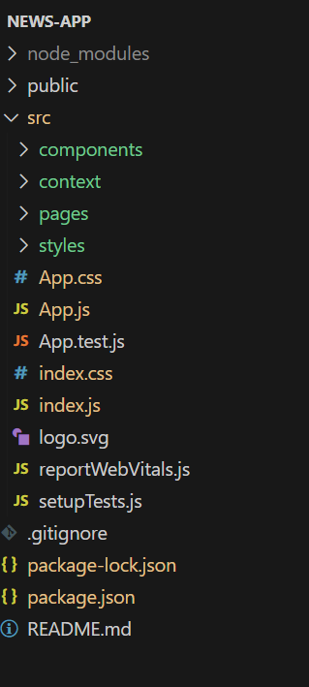

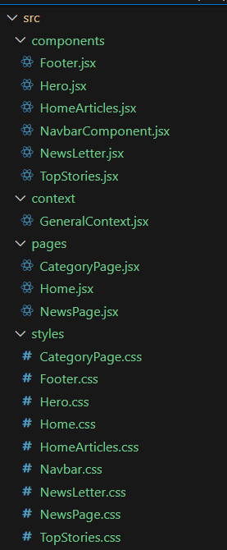

**TESTING**

**Testing Points for InsightStream**

1. **Functional Testing**
   * Verify that news articles load correctly from all integrated sources.
   * Check filtering by category (e.g., business, sports, technology).
   * Test search functionality with different keywords.
   * Ensure saved/bookmarked articles persist after logout/login.
   * Validate personalization features (if available).
2. **UI/UX Testing**
   * Ensure navigation menus, buttons, and links work properly.
   * Test responsiveness across devices (desktop, tablet, mobile).
   * Check for readability (fonts, colors, layouts).
   * Validate accessibility (screen readers, alt text for images).
3. **Performance Testing**
   * Test page load times under normal and heavy traffic.
   * Check how quickly new articles refresh in real-time.
   * Validate scalability with multiple concurrent users.
4. **Integration Testing**
   * Verify smooth integration with news APIs.
   * Check error handling when API is down or slow.
   * Validate social media or external sharing features.
5. **Security Testing**
   * Ensure user data (preferences, saved items) is stored securely.
   * Test login/logout sessions and password protection (if applicable).
   * Validate protection against common attacks (XSS, SQL Injection).
6. **Compatibility Testing**
   * Run on multiple browsers (Chrome, Edge, Firefox, Safari).
   * Test across different operating systems (Windows, macOS, Android, iOS).
7. **Usability Testing**
   * Conduct user feedback sessions to evaluate ease of navigation.
   * Test clarity of news categorization and search results.
8. **Error Handling Testing**
   * Check if meaningful error messages are displayed (e.g., “No results found,” “API unavailable”).
   * Validate fallback mechanisms when content fails to load.

**ADVANTAGES**

**Advantages of InsightStream**

1. **Centralized News Hub**
   * Aggregates news from multiple sources, saving time and effort for users.
2. **Real-Time Updates**
   * Provides the latest headlines and stories quickly.
3. **User-Friendly Navigation**
   * Simple, intuitive interface that makes it easy to browse by category or topic.
4. **Wide Coverage**
   * Covers multiple domains (politics, business, sports, technology, etc.) in one platform.
5. **Customizable Experience**
   * Users can filter or select categories based on their interests.
6. **Reliable Information Source**
   * By pulling from trusted APIs and outlets, users get credible and verified news.
7. **Time Efficiency**
   * Instead of visiting multiple websites, users get everything in one place.
8. **Accessibility**
   * Can be accessed across devices (desktop, tablet, mobile).
9. **Reduced Bias via Multi-Sourcing**
   * By presenting multiple perspectives, it helps users get a balanced view of current events.
10. **Engagement Features** *(if included)*
    * Options like bookmarking, saving, or sharing articles increase user interaction.

**LIMITATION**

**Possible Limitations of InsightStream**

1. **Data Dependency**
   * Relies heavily on external news APIs and data sources. Any downtime, changes in API policies, or inaccurate feeds can affect performance.
2. **Information Overload**
   * While providing multiple sources is useful, too much content without strong filtering can overwhelm users.
3. **Bias in Sources**
   * The platform only aggregates news — if sources are biased, the bias may carry into InsightStream unless advanced moderation is added.
4. **Real-Time Accuracy**
   * Breaking news updates may have delays depending on API refresh rates and integration limits.
5. **Limited Personalization (Current Stage)**
   * User preferences, recommendations, and AI-driven personalization may still be basic or under development.
6. **Scalability Challenges**
   * Handling a large user base simultaneously (heavy traffic, server load, etc.) may require scaling infrastructure.
7. **Search and Navigation Limits**
   * Complex queries or niche topics might not return accurate or comprehensive results.
8. **Language & Regional Coverage**
   * May be limited to English or a few languages, restricting global inclusivity.
9. **User Interface Limitations**
   * Depending on the current design, users may find navigation or content organization less intuitive.
10. **Privacy & Security**
    * If user data (preferences, saved articles, etc.) is collected, strong data protection measures are needed.

**SCREENSHOTS OR DEMO IMAGES**

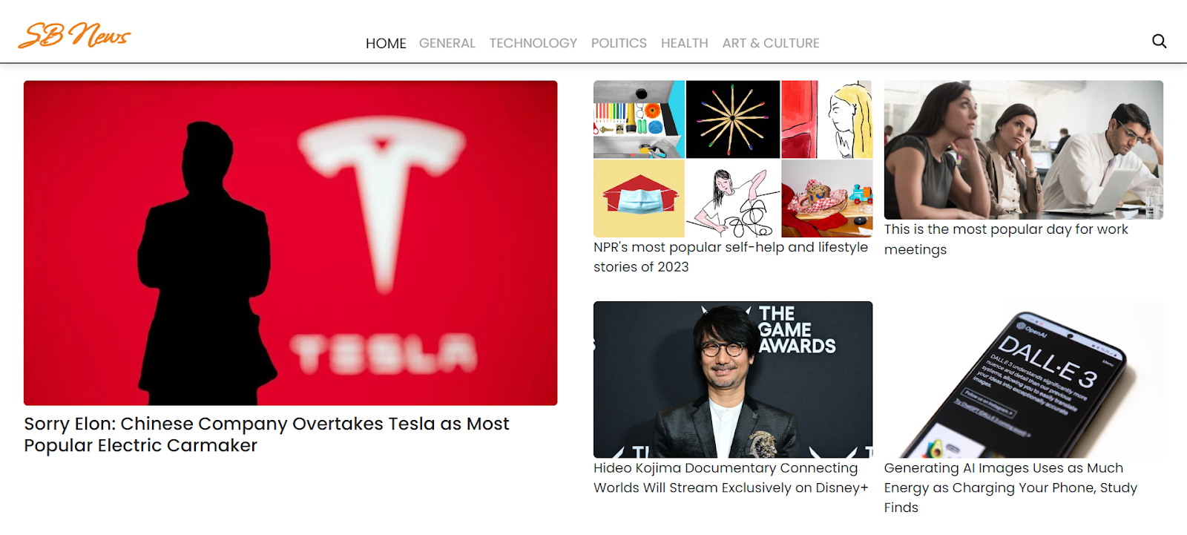

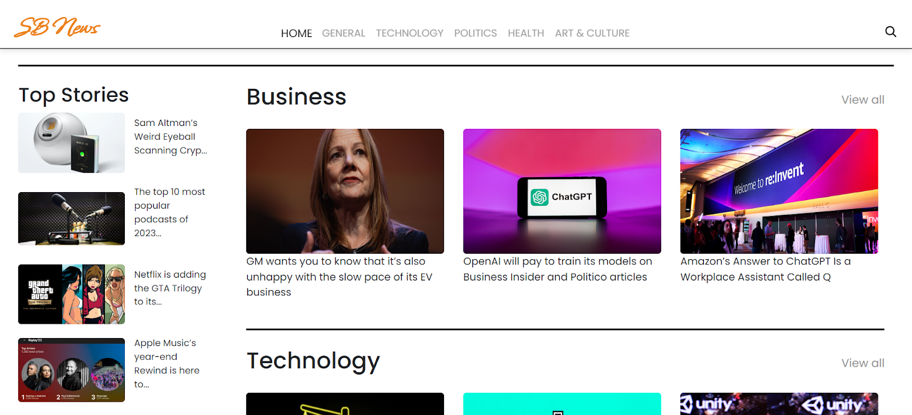

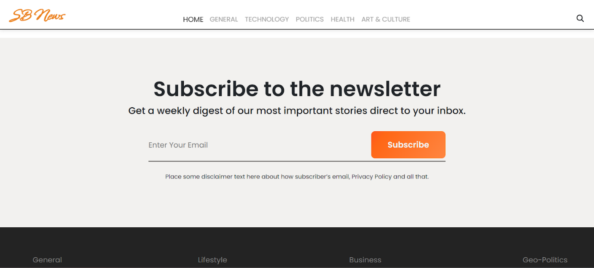

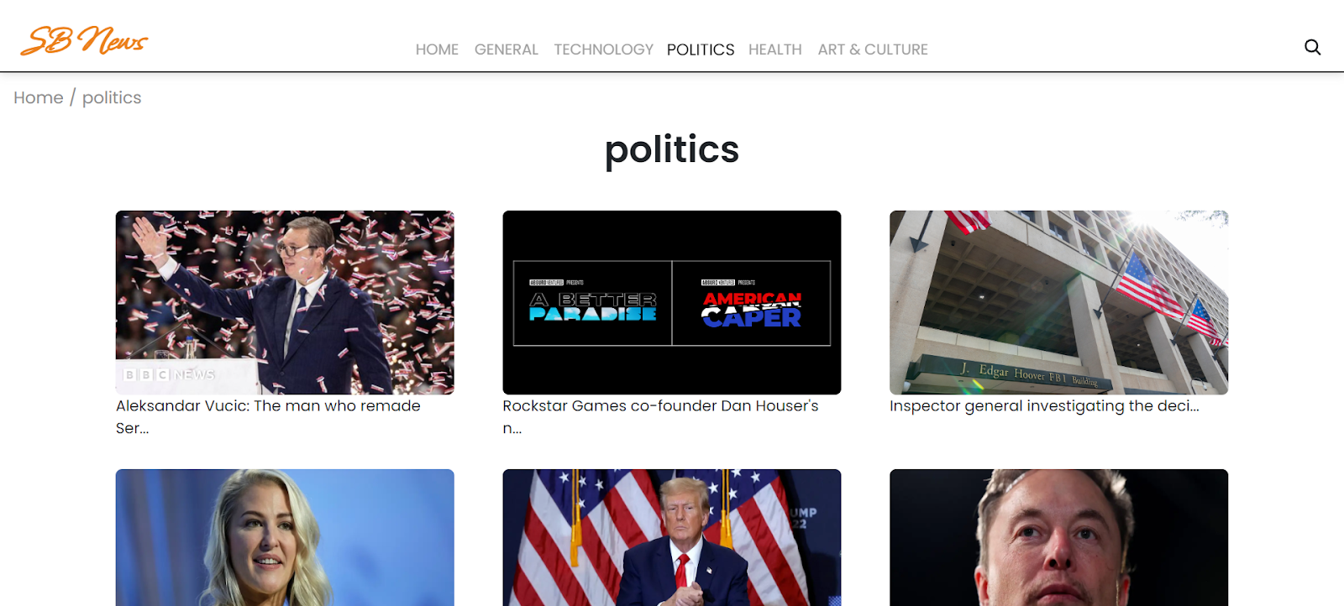



**KNOWN ISSUES**

1. Optimization needed for large-scale streaming.

2.Performance tuning for heavy analytics dashboard.

**FUTURE ENHANCEMENT**

**Future Enhancements for InsightStream**

1. **Advanced Personalization**
   * AI-driven recommendations based on user interests, reading habits, and sentiment preferences.
2. **Multi-Language Support**
   * Expanding coverage to regional and global languages for wider accessibility.
3. **Sentiment Analysis**
   * Adding AI-powered tone detection (positive, negative, neutral) to help users quickly gauge the nature of news.
4. **Fact-Checking Integration**
   * Automatic verification through trusted fact-checking databases to reduce misinformation.
5. **Offline Mode**
   * Ability to save articles for offline reading in low-connectivity areas.
6. **Voice Interaction & Text-to-Speech**
   * Voice search and audio summaries for hands-free news consumption.
7. **Collaborative Features**
   * Options to share, comment, and discuss articles within the platform for community engagement.
8. **Custom Dashboards**
   * Personalized dashboards where users can track categories like business, sports, or technology at a glance.
9. **Push Notifications & Alerts**
   * Real-time alerts for breaking news or topics marked as “priority” by the user.
10. **Integration with Social Media & Messaging Apps**
    * Easy sharing and cross-platform engagement to boost reach.
11. **Data Visualization**
    * Charts, timelines, and infographics to give quick visual insights into trending stories.
12. **Subscription & Premium Services**
    * Ad-free experience, exclusive analysis, or deep-dive reports for premium users.

**CONCLUSION**

InsightStream: Navigate the News Landscape provides a powerful solution for readers overwhelmed by today’s flood of digital information. By combining categorization, filtering, and trusted sources, it empowers users to stay informed, analyze trends, and develop balanced viewpoints. With further enhancements, it can evolve into a robust platform for modern news consumption.