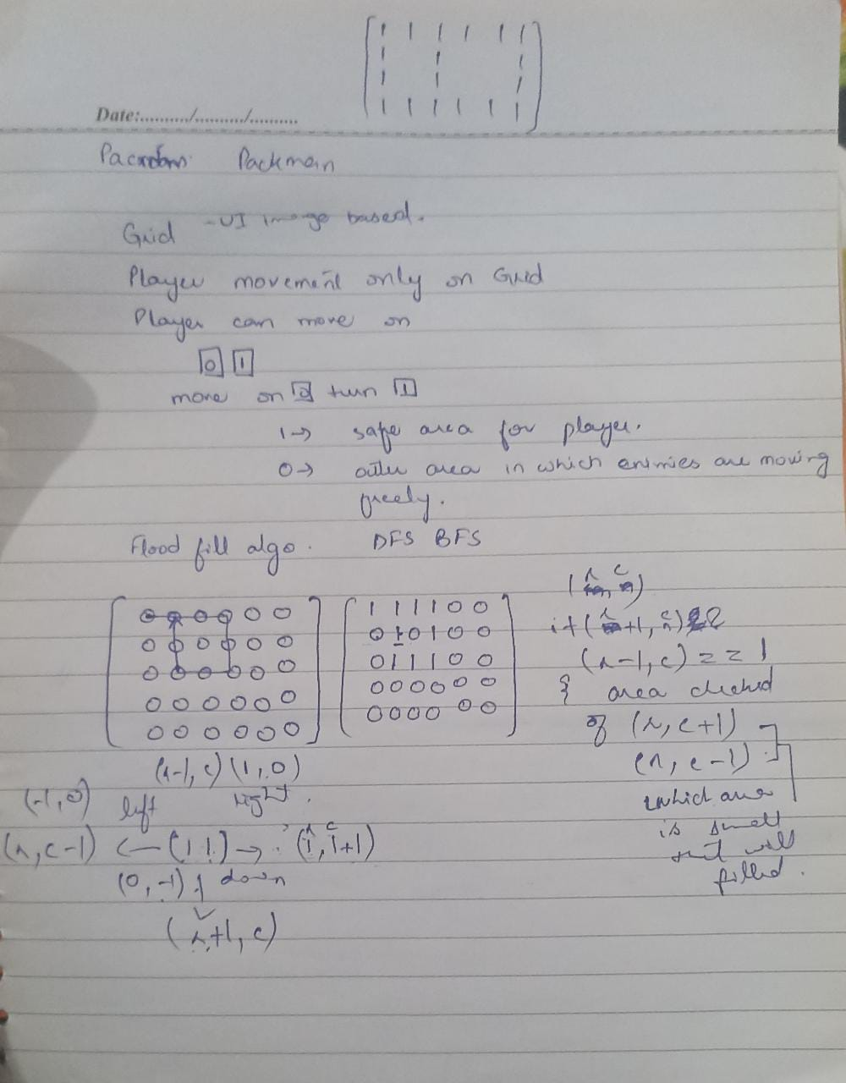

Player Movement:

Arrow Keys -> Left/Right/Up/Down

Filling:

On Vertical partition it fills right sliced side

On Horizontal partition it fills Upper sliced side.

Use Flood Fill Algo for filling.