[Date]

Event Management System Project Report

Ayesha Batool | BS-CS-F24-21
Aliya Khalid | BS-CS-F24-34
Aisha Nisar | BS-CS-F24-05
Ayesha Shafqaat | BS-CS-F24-13
Ruman | BS-CS-F24-33

Table of Contents
1. Introduction 2
2. Project Scenario 2
3. Objectives 2
4. Database Tables 2
5. Relationships 2
6. SQL Queries Implemented 3
7. Conclusion 3
8. ER Diagram 3
Future Roadmap 3

1. Introduction
The Event Management System is a database project designed to manage events, organizers, venues, participants, and registrations. The system stores and retrieves event-related information efficiently.

2. Project Scenario
Nowadays, managing events manually is a difficult and time-consuming task. Organizations, universities, and companies arrange different events, seminars, workshops, and conferences. Keeping records of event details, participants, organizers, venues, and registrations on paper can lead to errors, data loss, and inefficient management.
To solve this problem, an Event Management System has been developed. The system provides a centralized database where administrators can manage all event-related information efficiently. Organizers can create and update events, venues can be assigned to events, and participants can register for their desired events. The database stores all information securely and allows quick retrieval through SQL queries.
The system reduces manual work, improves accuracy, and helps users manage events effectively. It also provides reports about events, registrations, and participant details, making the management process more organized and reliable.

3. Objectives
- Manage event details
- Store organizer information
- Manage venue records
- Register participants
- Generate reports using SQL queries

4. Database Tables
- Organizer
- Venue
- Event
- Participant
- Registration

5. Relationships
- One Organizer can organize many Events.
- One Venue can host many Events.
- Participants register for Events through the Registration table.

6. SQL Queries Implemented
- All events with organizer and venue
- Participants in events
- Total participants per event
- Venue usage reporz

7. Conclusion
The Event Management System provides a structured solution for managing event data. It demonstrates database design concepts including primary keys, foreign keys, joins, and reports.

8. ER Diagram
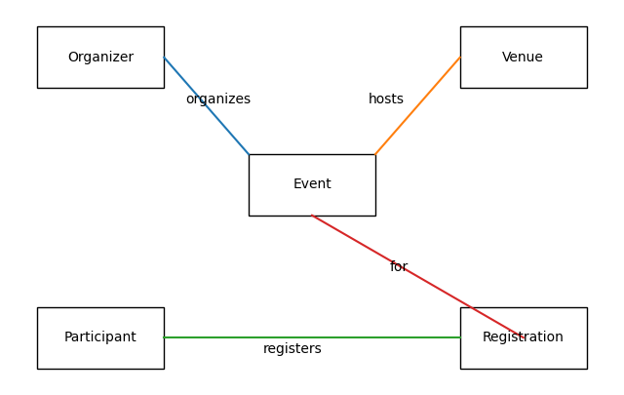

Future Roadmap
The current version of the Event Management System provides basic functionalities for managing events, organizers, venues, and participant registrations. In the future, the system can be enhanced with additional features to improve its usability and efficiency.
Future enhancements may include:
• Online event registration through a web or mobile application.
• Email and SMS notifications for registered participants.
• Online payment integration for paid events.
• Event attendance tracking using QR codes.
• Real-time event scheduling and calendar management.
• Dashboard and analytics for monitoring event performance.
• User authentication and role-based access control.
• Automatic report generation in PDF format.
• Integration with social media platforms for event promotion.
• Cloud database support for better scalability and data security.
These improvements will make the Event Management System more powerful, user-friendly, and suitable for large-scale organizations and institutions.

