PKCERT Summer Internship 2026
Task 04 – NumPy & Pandas for Data Analysis
Name: Ayesha Bhatti
Domain: AI & Software Development
Introduction
The objective of this task was to develop practical skills in NumPy and Pandas for numerical computing, data manipulation, and exploratory data analysis (EDA). NumPy was used to perform array operations and mathematical computations, while Pandas was used to organize, analyze, and visualize a public Loan Prediction dataset.
Part A – NumPy Fundamentals
Objective
To understand the fundamental concepts of NumPy and perform efficient numerical computations using arrays.

NumPy was used to create one-dimensional and multi-dimensional arrays using different methods. Array indexing, slicing, reshaping, and mathematical operations were performed to manipulate data efficiently. Broadcasting was demonstrated to perform operations on arrays of different shapes without manually resizing them, making the code faster and more efficient. Vectorized operations were compared with traditional loops, showing that vectorization improves performance and reduces code complexity. Linear algebra operations such as dot product, matrix multiplication, transpose, and inverse were also implemented.
Advantages of Broadcasting
- Reduces the amount of code.
- Improves execution speed.
- Uses memory efficiently.
- Simplifies mathematical operations on arrays.
Ouput:
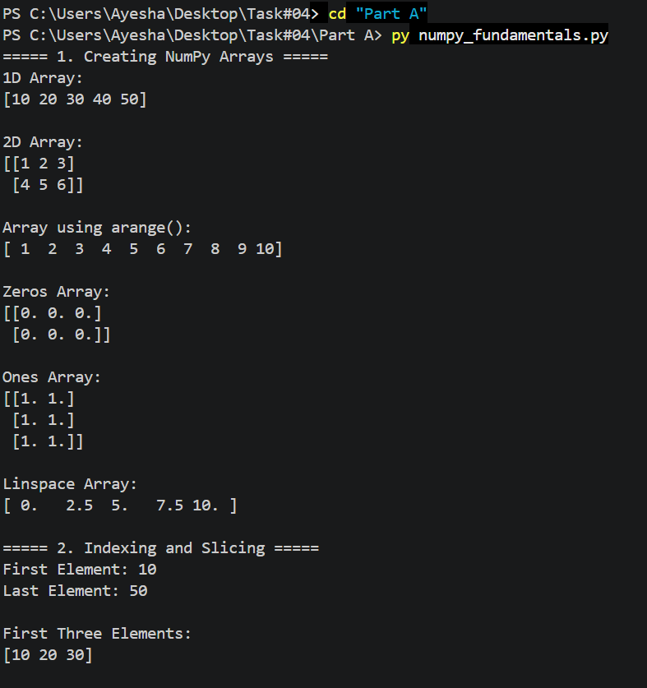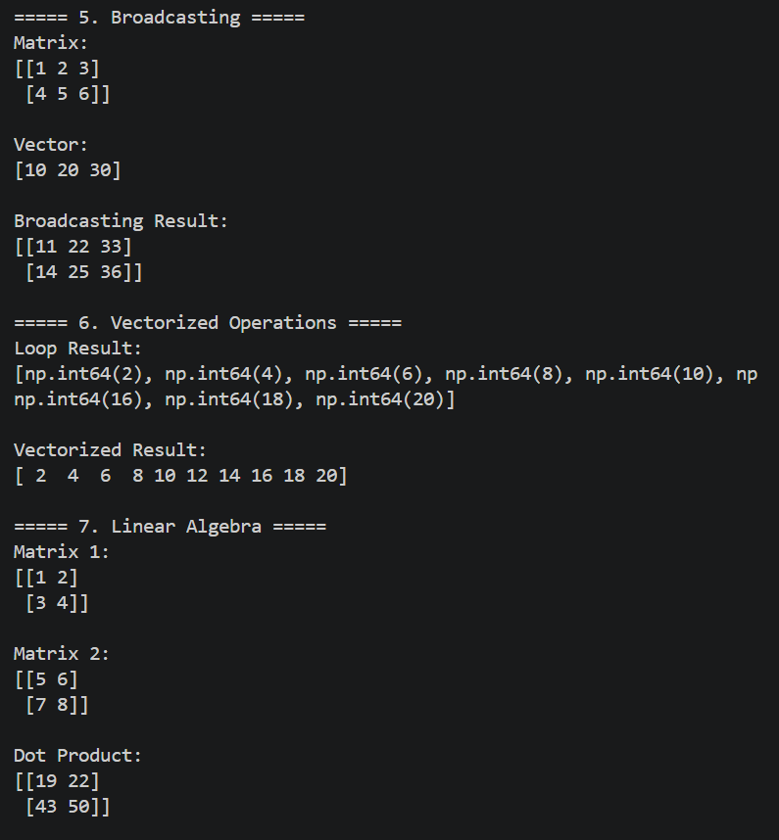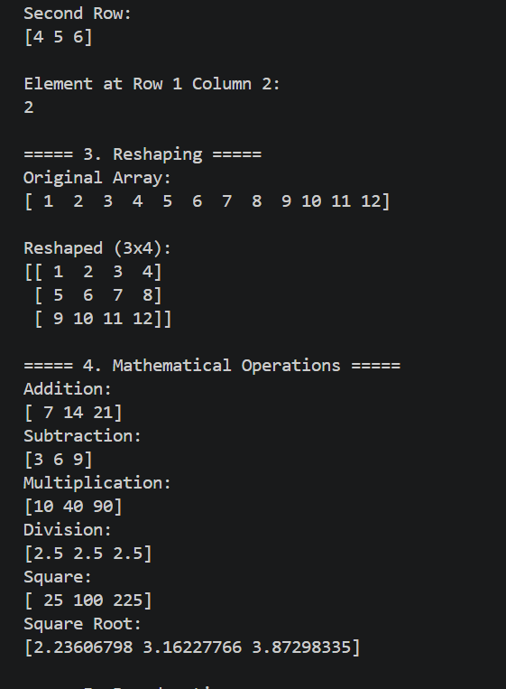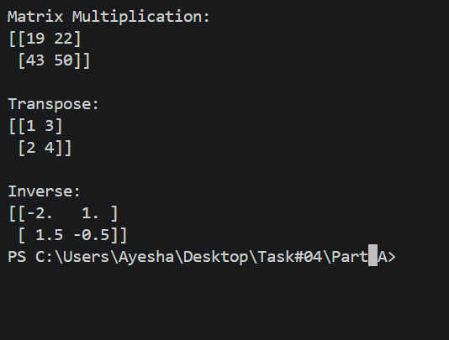

Part B – Pandas Fundamentals
Objective
To learn how to create, manipulate, and analyze structured data using the Pandas library.

Pandas was used to create and manipulate Series and DataFrames. Indexing, filtering, sorting, and selection operations were performed to access and organize data. GroupBy operations summarized the dataset, while merge and join operations combined multiple DataFrames. These features simplify data preprocessing and analysis.
Output:
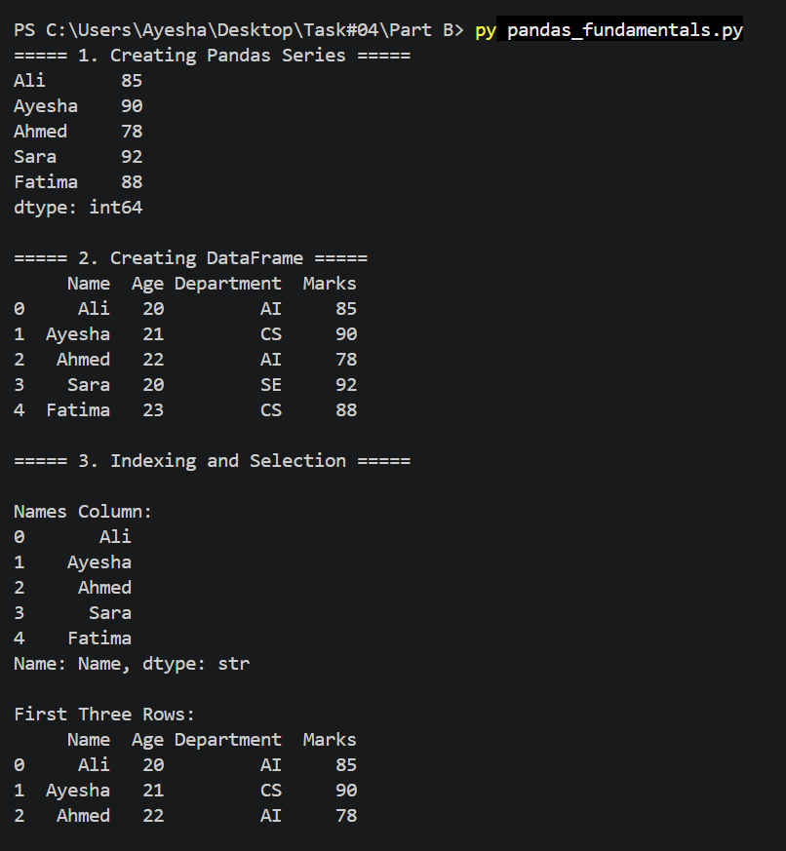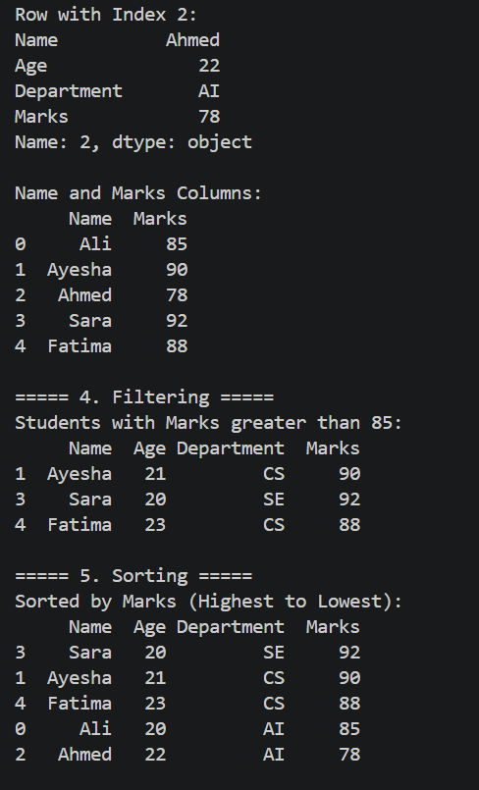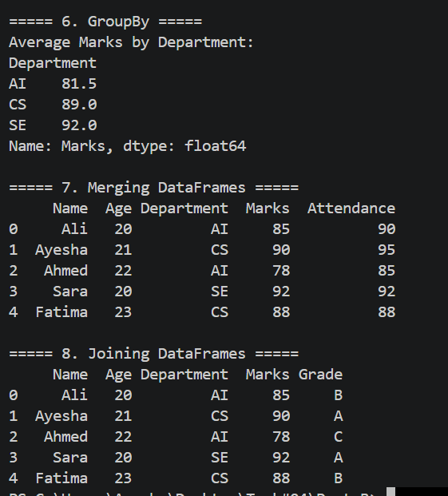

Part C – Data Analysis Mini Project
Objective
To perform exploratory data analysis on a public Loan Prediction dataset using Pandas.

A public Loan Prediction Dataset containing 45,000 records was analyzed using Pandas. The dataset was loaded from a CSV file, and missing values were checked using isnull().sum(). Since no missing values were found, no additional data cleaning was required. Summary statistics were generated using describe(), and exploratory data analysis was performed to examine applicant demographics, income, loan amount, credit score, and loan status. GroupBy, filtering, sorting, and Matplotlib visualizations were used to identify patterns and summarize the data.
Key Findings
- The dataset contains 45,000 loan application records.
- No missing values were found.
- GroupBy operations effectively summarized applicant information.
- Visualizations helped identify trends in income, education, loan amount, and loan status.
Output:
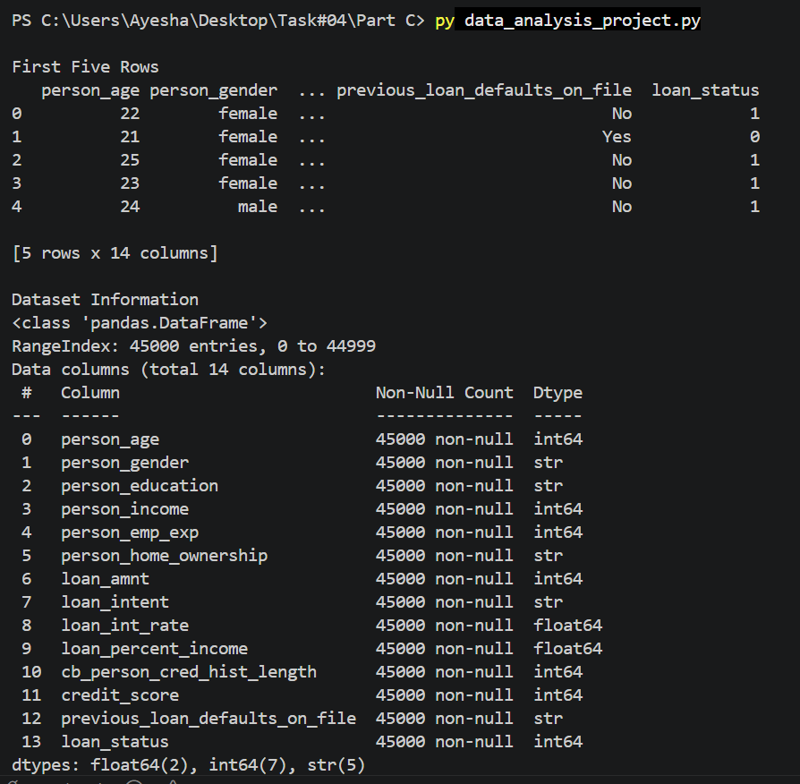

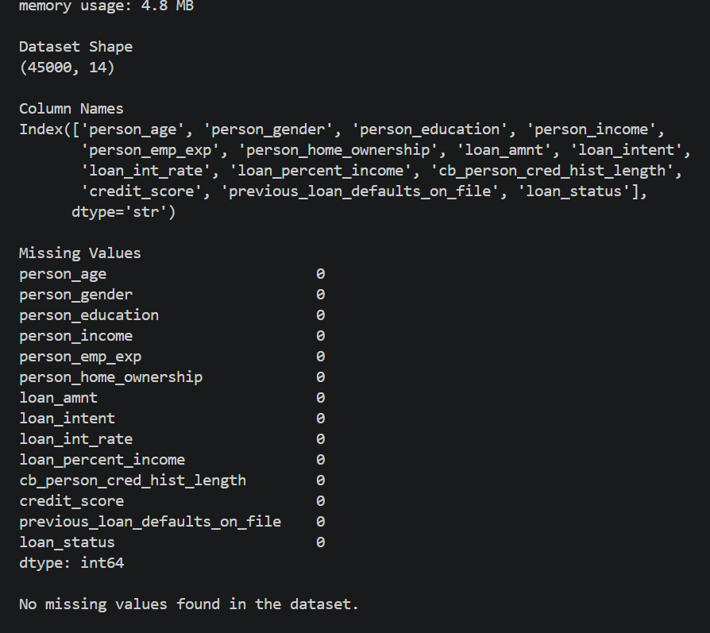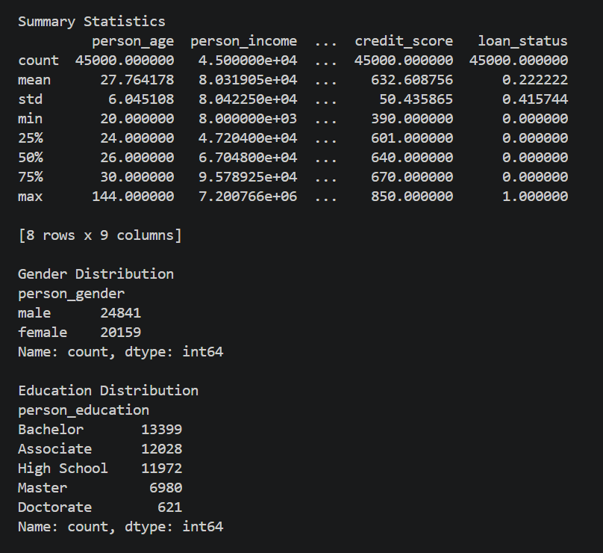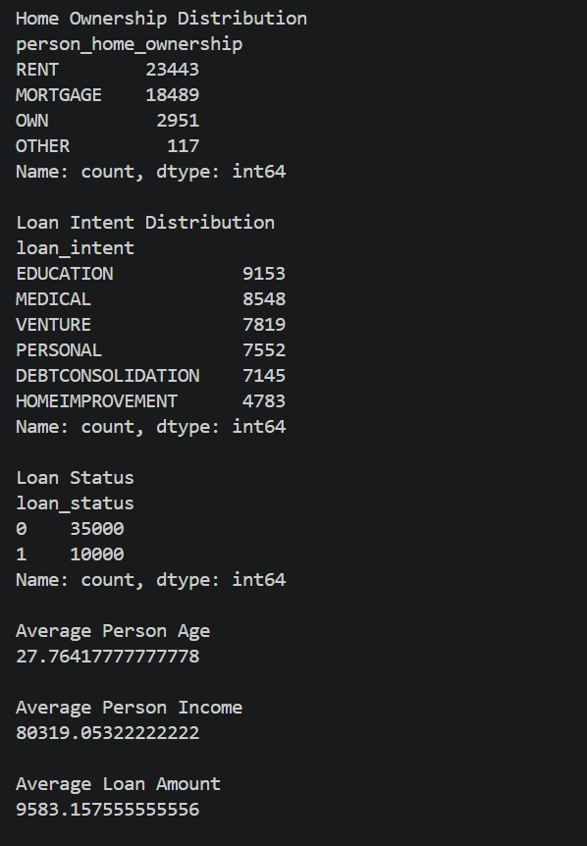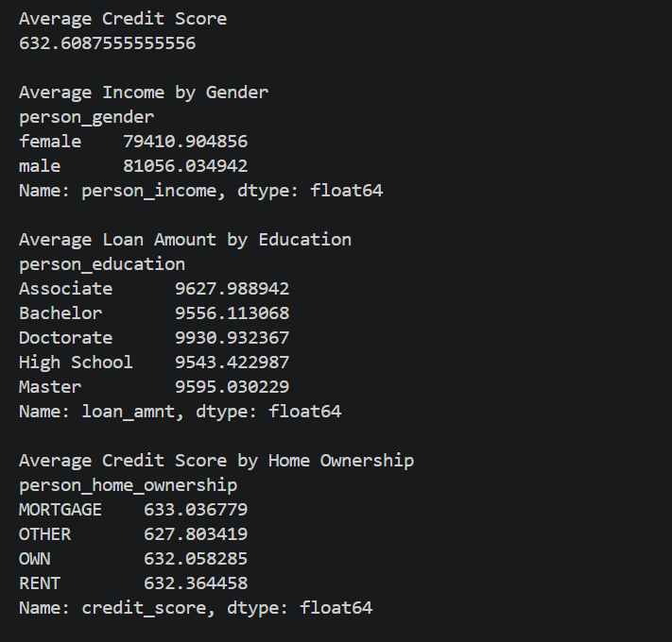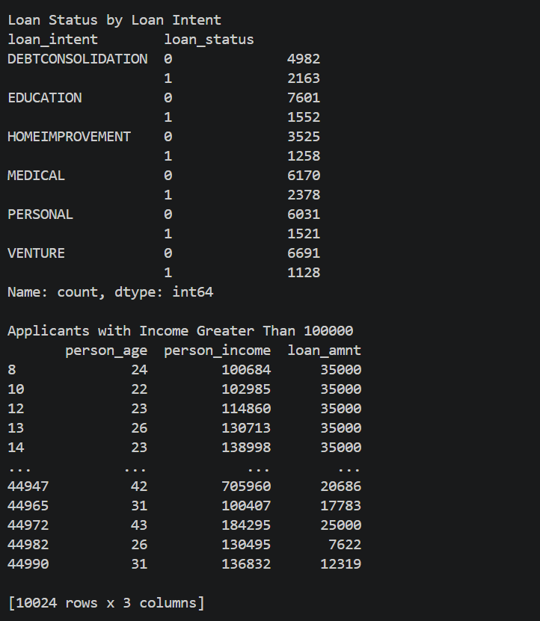
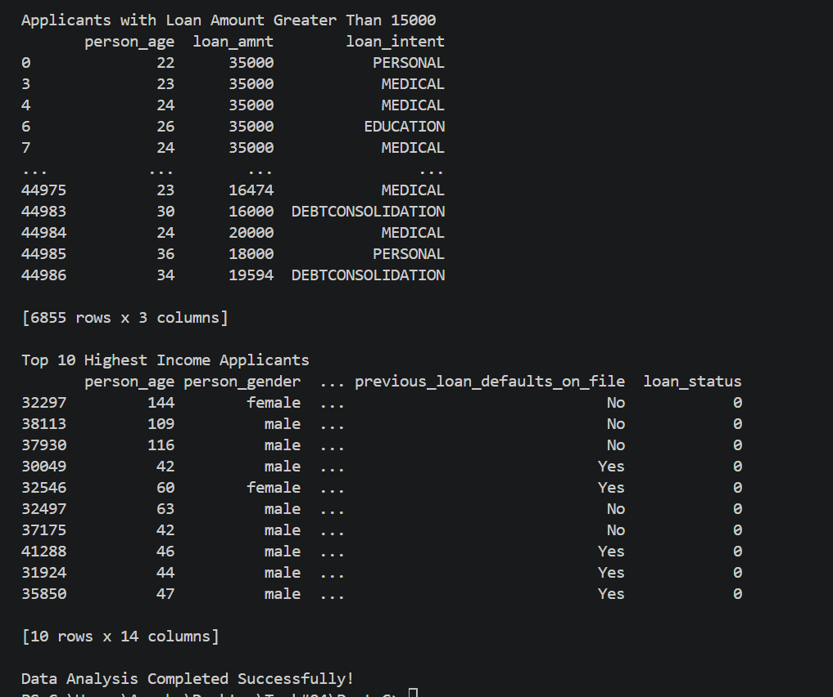

Graphs:
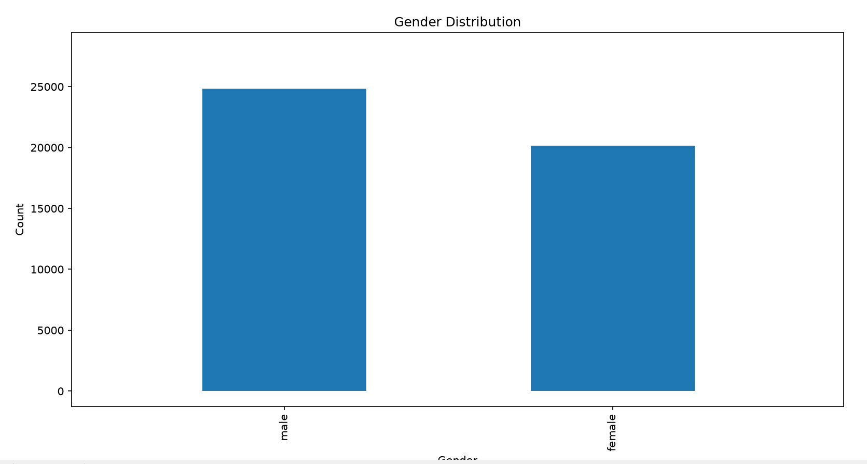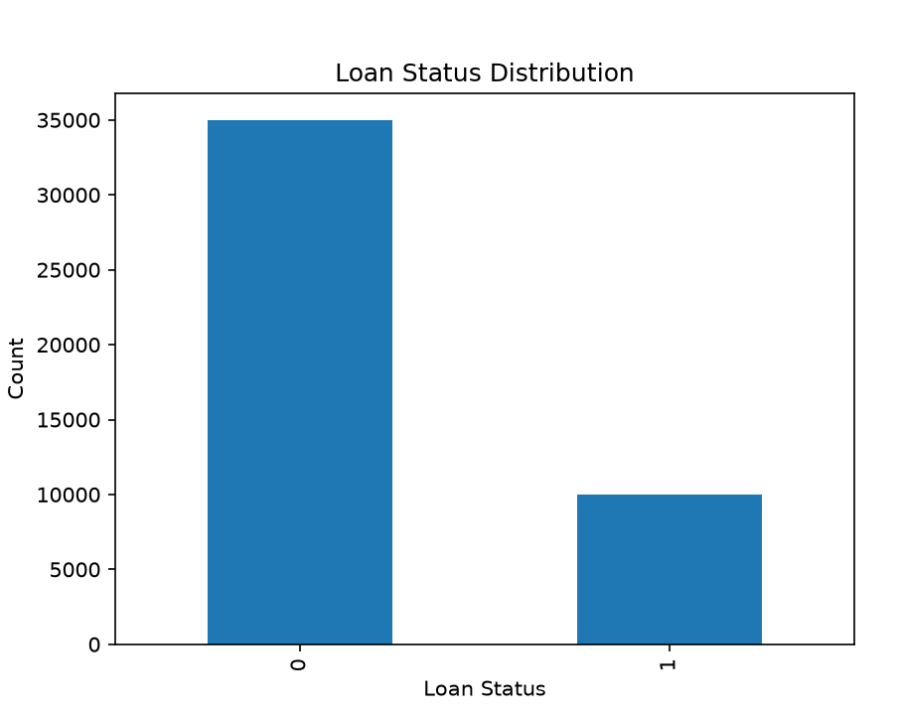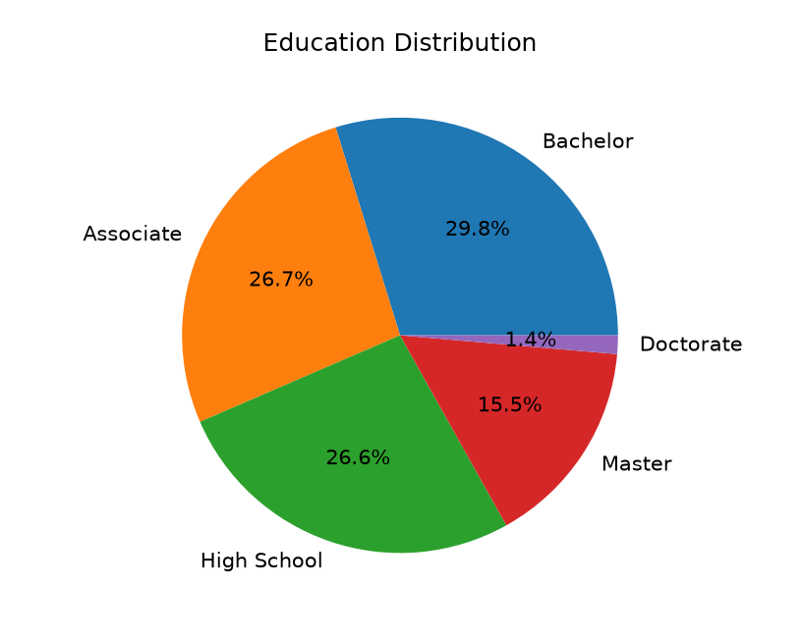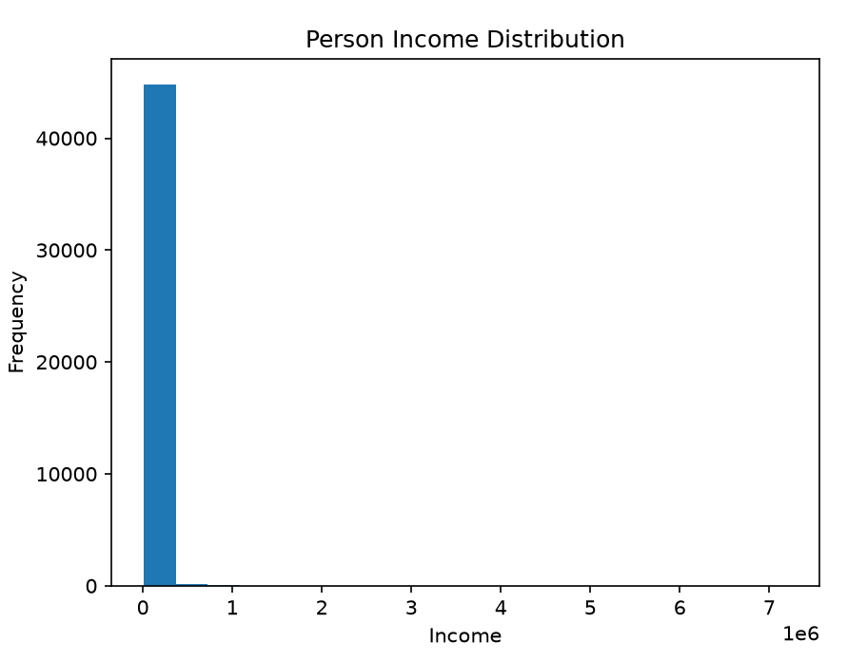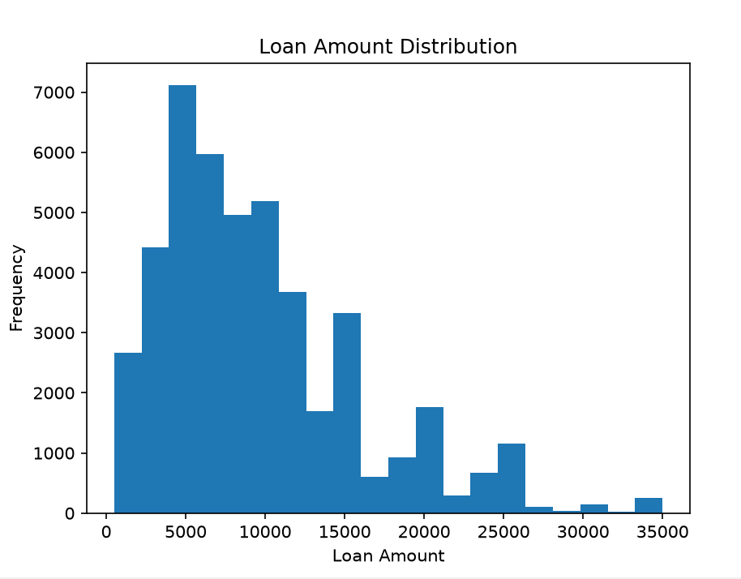
Conclusion
This task provided practical experience with NumPy and Pandas for numerical computing and data analysis. It improved understanding of array operations, data manipulation, exploratory data analysis, and visualization techniques, which are essential skills for artificial intelligence and data science.

GitHub Repository Link:

