COMPARATIVE ANALYSIS OF MODERN AI AGENTS
ChatGPT, Claude, DeepSeek and Google AI Studio

Course: Tools & Techniques in Data Science
Submitted by: Ayesha Chouhadry
Roll no: F24BDOCS1M01060
Section: 5th2M
Instructor: Mr. Omer Nazeer
Date: 15/09/2026

Contents
1 Introduction 3
2 ChatGPT 3
3 Claude 4
4 DeepSeek 5
5 Google AI Studio 6
6 Comparative Analysis 6
7 Conclusion 6

1 Introduction
This assignment provides a concise comparison of four modern AI platforms: ChatGPT, Claude, DeepSeek and Google AI Studio. The comparison focuses only on features visible to users on their main interfaces, based on the supplied course material.

2 ChatGPT
The following table summarizes selected visible interface features of ChatGPT, their basic functions, and common uses.
Visible Feature | What It Does | Common Use
New Chat | Starts a separate conversation. | Starting a new topic or task
Model Selection | Lets users select an available model or mode. | Choosing a mode suited to the task
Search | Searches the web for current information. | Recent facts, research and websites
Deep Research | Performs multi-step research and produces a structured result. | Detailed research and investigations
Image Generation | Creates images from text prompts. | Visual content and illustrations
File Upload | Allows supported documents and files to be uploaded. | PDFs, documents, spreadsheets and datasets
Data Analysis | Analyzes data using calculations and visualizations. | Statistics, trends and exploratory analysis
Study Mode | Guides learning through step-by-step explanations. | Exam preparation and difficult concepts
Voice | Supports speech-based interaction. | Hands-free questions and discussion
Projects | Organizes chats, files and instructions around a project. | Coursework, research and software projects

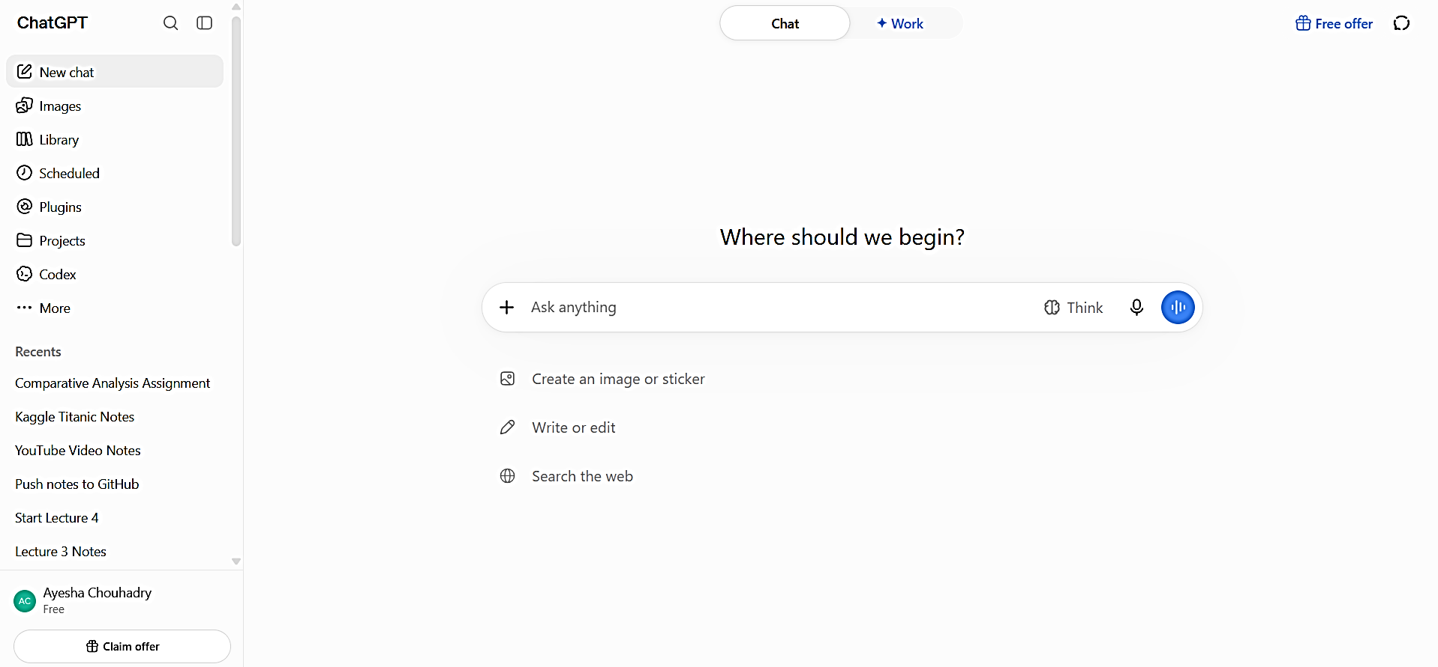
Figure 1:Chatgpt interface

3 Claude
The following table summarizes selected visible interface features of Claude, their basic functions, and common uses.
Visible Feature | What It Does | Common Use
New Chat | Starts a separate conversation. | Starting a new topic or task
Model Selection | Lets users choose an available Claude model. | Selecting a model for task complexity
Effort / Thinking | Controls how much effort Claude puts into a response. | Complex reasoning and coding
Web Search | Searches the internet for current information. | Recent information and research
Research | Performs multi-step searches and investigations. | Detailed research
File Upload | Allows supported documents and files to be uploaded. | PDFs, assignments, reports and datasets
Projects | Provides a workspace with chats, files, knowledge and instructions. | Long-term coursework and projects
Artifacts | Creates standalone content in a separate workspace. | Documents, code, diagrams and interactive tools
Image Understanding | Analyzes images supplied by the user. | Charts, diagrams and screenshots
Coding Assistance | Generates, explains, debugs and improves code. | Programming and technical problem-solving
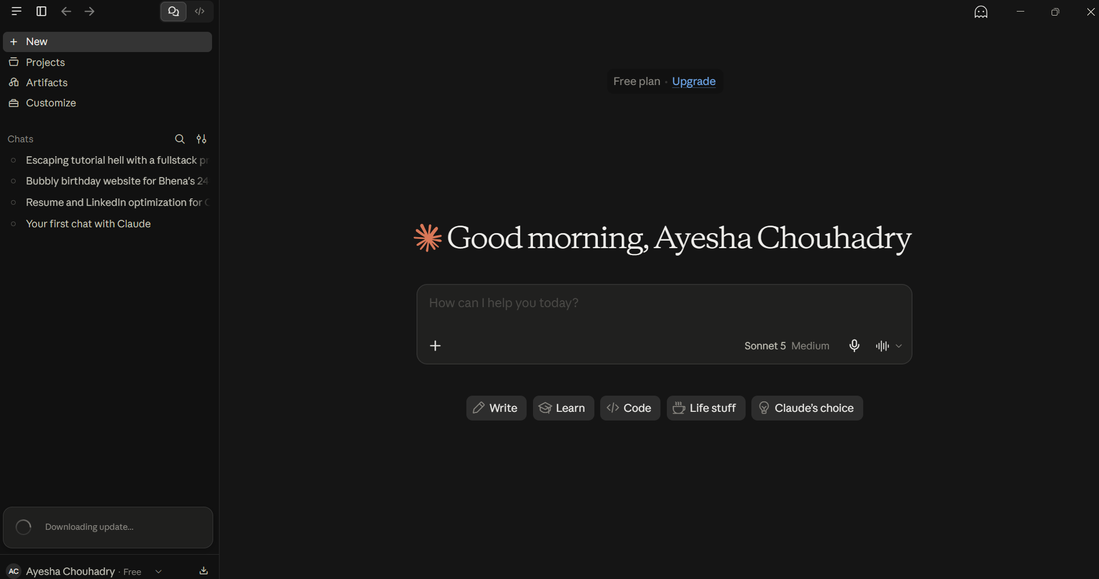
Figure 2:Claude Interface

4 DeepSeek
The following table summarizes selected visible interface features of DeepSeek, their basic functions, and common uses.
Visible Feature | What It Does | Common Use
New Chat | Starts a new conversation. | Starting a different topic or task
Chat / General AI | Provides conversational answers and content generation. | Questions, writing and learning
Instant Mode | Provides faster responses in a standard interaction mode. | Quick questions and everyday tasks
Expert Mode | Provides a more advanced mode for demanding tasks. | Complex questions and coding
DeepThink / Thinking | Uses deeper reasoning before producing an answer. | Mathematics, logic and complex problems
Web Search | Searches the internet for information. | Current events and changing facts
File Upload | Allows supported files to be uploaded for analysis. | Documents, assignments and reports
Image / Visual Input | Allows supported visual information to be analyzed. | Images, diagrams and screenshots
Coding Assistance | Generates, explains and helps debug code. | Programming and learning
Chat History | Keeps previous conversations available. | Returning to earlier work

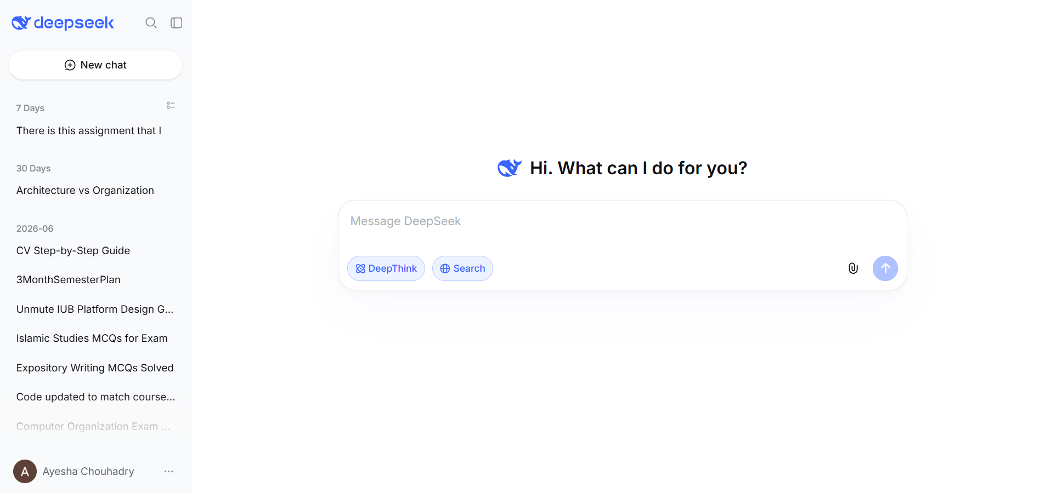
Figure 3:Deepseek Interface

5 Google AI Studio
The following table summarizes selected visible interface features of Google AI Studio, their basic functions, and common uses.
Visible Feature | What It Does | Common Use
New Prompt / Chat | Creates a new prompt-based interaction with Gemini. | New experiments, questions or tasks
Model Selection | Lets users choose from available Gemini models. | Comparing models for different needs
Prompt Playground | Provides a workspace for testing and refining prompts. | Prompt engineering and experimentation
System Instructions | Lets users define instructions guiding model behavior. | Controlling role, tone and format
Generation Settings | Controls aspects of response generation. | Experimenting with creativity and variation
Token / Usage Information | Shows prompt and token usage information. | Monitoring prompt size and model limits
Google Search Grounding | Allows Gemini to use Google Search for current information. | Recent facts and research
URL Context | Uses information from specified web pages. | Analyzing a particular webpage
File Upload | Provides files as input to Gemini. | Documents and code
Image / Audio / Video Input | Supports supported visual, audio and video inputs. | Multimodal analysis
Code Execution | Allows Gemini to execute code in supported environments. | Calculations and data analysis
Build Mode | Creates applications from natural-language descriptions. | Building prototypes and AI-powered applications

6 Comparative Analysis
Aspect | ChatGPT | Claude | DeepSeek | Google AI Studio
General Chat | Yes | Yes | Yes | Prompt-based
Web Search | Yes | Yes | Yes | Google Search Grounding
File Upload | Yes | Yes | Yes | Yes
Image / Visual Input | Yes | Yes | Yes | Yes
Reasoning Controls | Model/mode options | Effort/Thinking | Expert/DeepThink | Model/settings
Research Feature | Deep Research | Research | Web Search | Search Grounding
Coding Support | Yes | Yes | Yes | Code Execution / app building
Project / Workspace | Projects | Projects | Chat History | Prompt Playground / Build Mode
Distinctive Visible Feature | Study Mode & Data Analysis | Artifacts | DeepThink | Prompt Playground & Build Mode

7 Conclusion
All four platforms provide conversational AI and support several multimodal or file-based tasks. ChatGPT includes visible tools such as Study Mode, Data Analysis and Projects; Claude provides Projects and Artifacts; DeepSeek provides Instant, Expert and DeepThink modes; and Google AI Studio focuses on prompt experimentation, model selection, system instructions, code execution and application building. The appropriate platform depends on the task and the features available to the user.

