AYESHA FAISAL

- Profile Dashboard: A central hub to track your tasks, progress, and active projects at a glance.

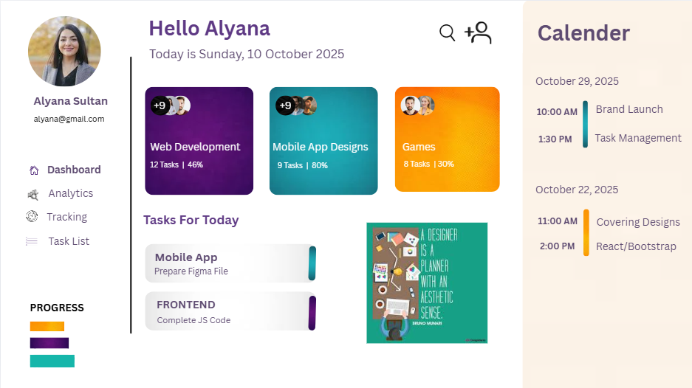

- Educational Landing Page: A welcoming gateway to discover courses and begin your learning journey.

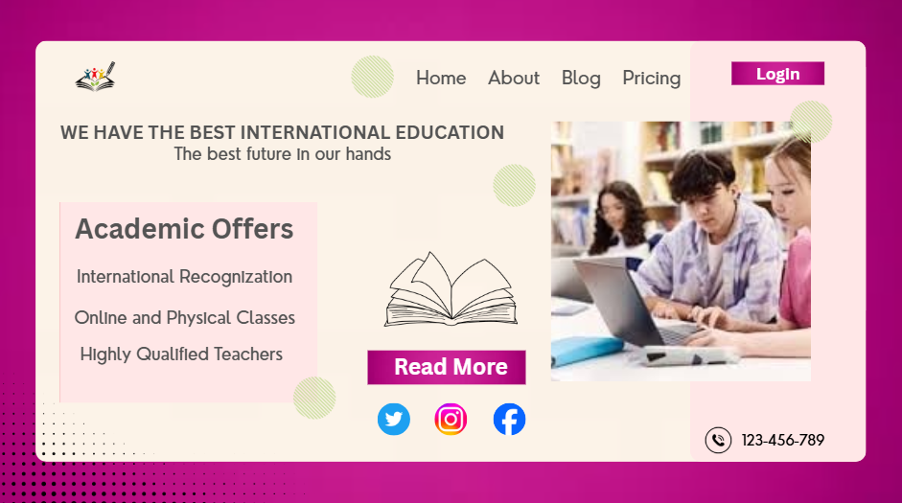

- Restaurant Ad: A visual appetizer designed to evoke craving and draw you in for a meal.

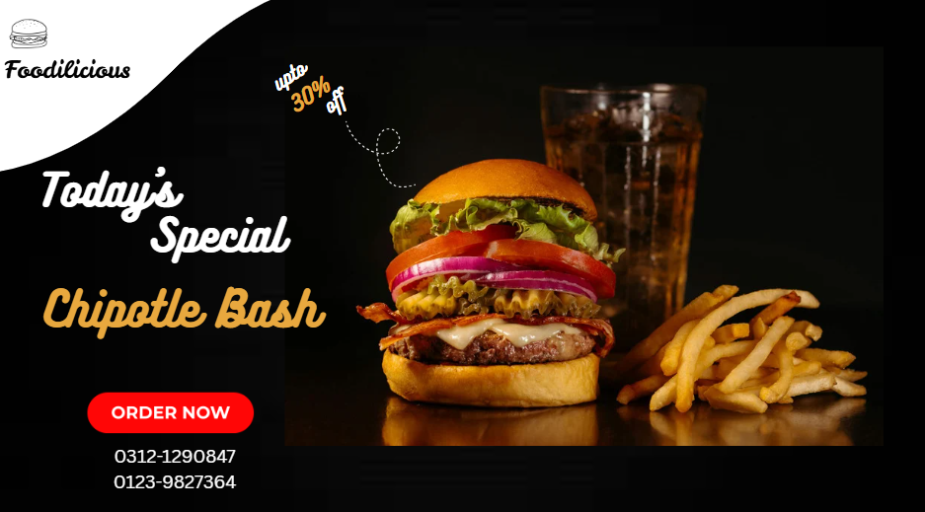

- Event Moodboard: A curated collection of visuals that defines the atmosphere and tone of the event.

