

VARIABLES FOR STRINGS

Assignment # 2

JAVASCRIPT

1. Declare a variable called ***username*.**

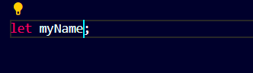

1. Declare a variable called ***myName*** & assign to it a string

that represents your Full Name.

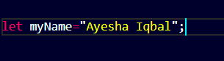

1. Write script to
   1. Declare a JS variable, titled ***message.***
   2. Assign “***Hello World***” to variable ***message***
   3. Display the message in alert box.

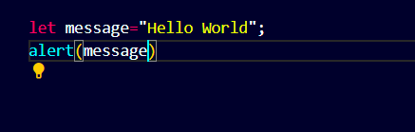

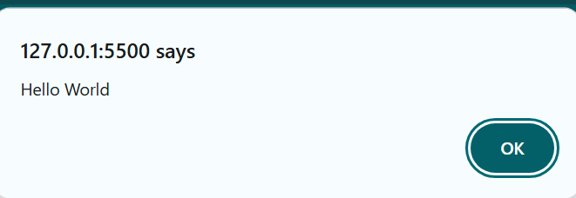

1. Write a script to save student’s bio data in JS variables and show the data in alert boxes.

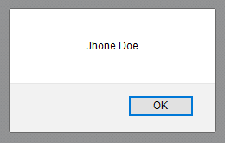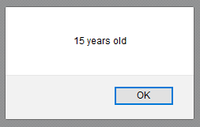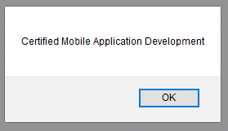

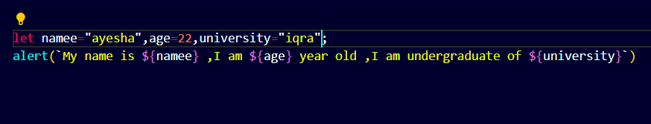

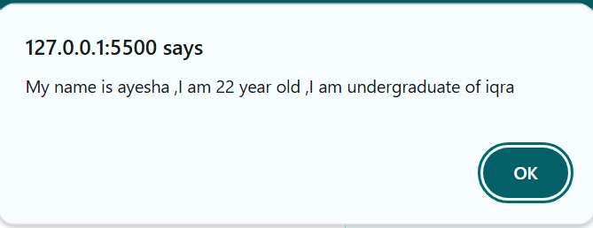

1. 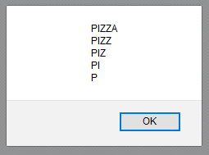Write a script to display the following alert using one JS variable:

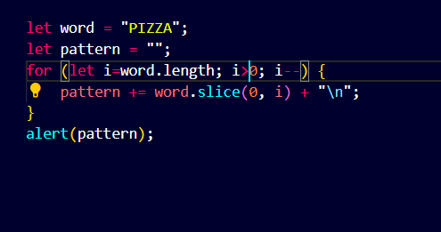

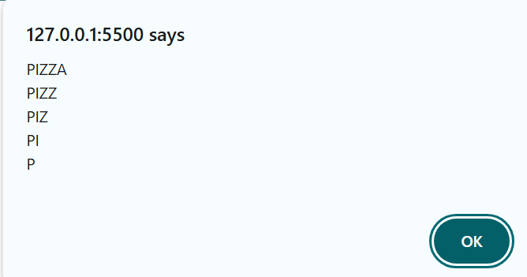

1. Declare a variable called ***email*** and assign to it a string that represents your Email Address(e.g. [example@example.com](mailto:example@example.com)). Show the blow mentioned message in an alert box.(Hint: use string concatenation)

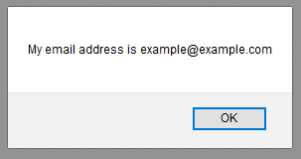

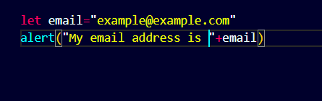

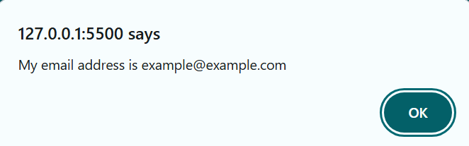

1. Declare a variable called book & give it the value “A

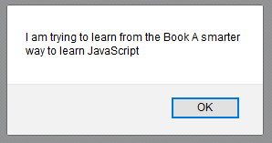smarter way to learn JavaScript”. Display the following message in an alert box:

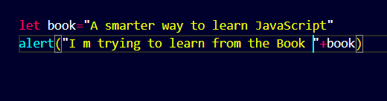

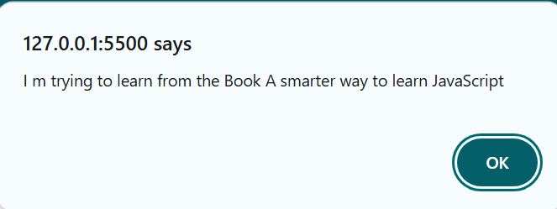

1. Write a script to display this in browser through JS

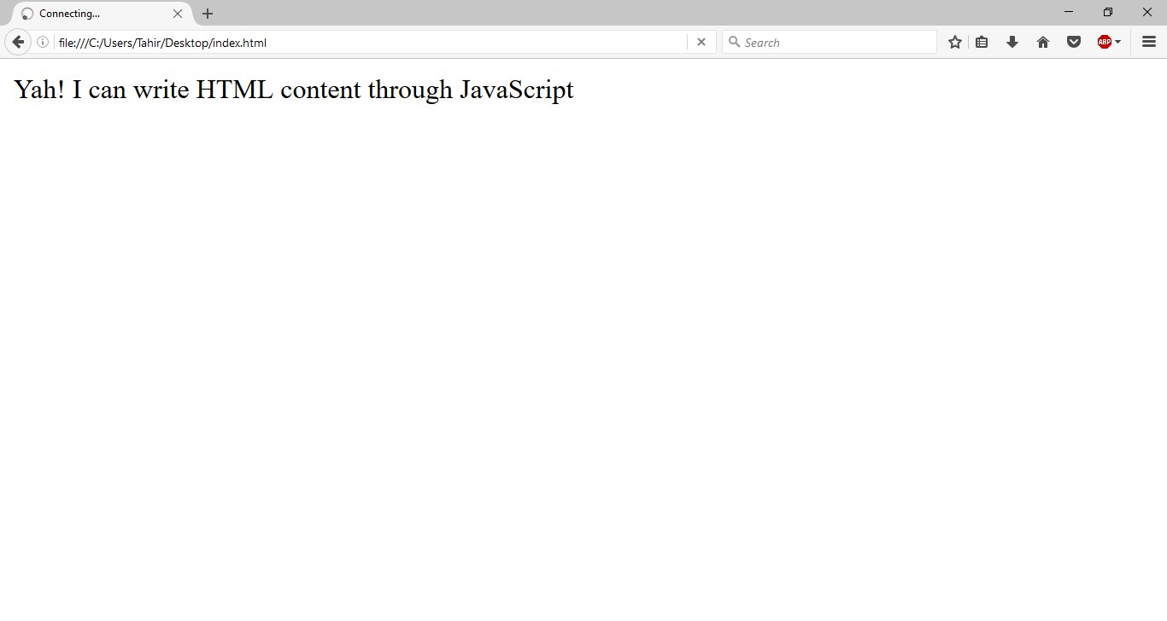

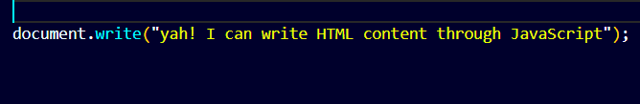

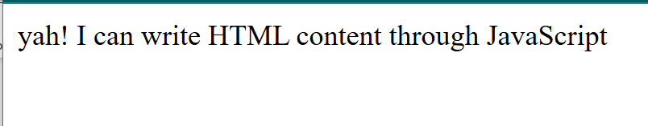

1. Store following string in a variable and show in alert and browser through JS

“▬▬▬▬▬▬▬▬▬ஜ۩۞۩ஜ▬▬▬▬▬▬▬▬▬”

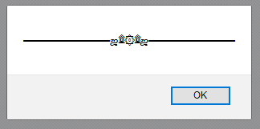

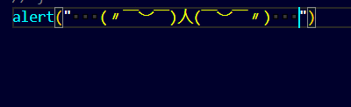

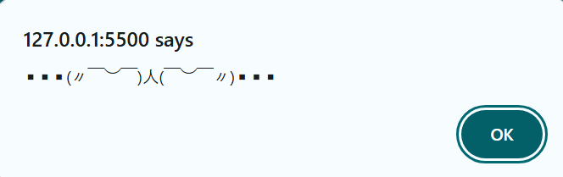

**-- END --**