

VARIABLES FOR NUMBERS

Assignment # 3

JAVASCRIPT

1. Declare a variable called ***age*** & assign to it your age. Show your age in an alert box.

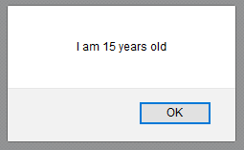

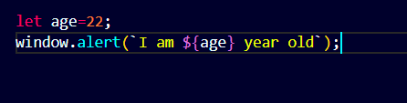

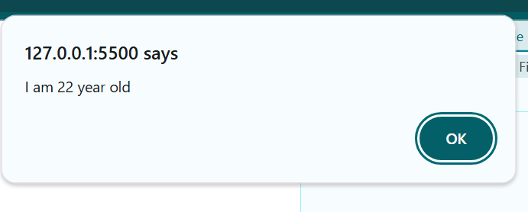

1. Declare & initialize a variable to keep track of how many times a visitor has visited a web page. Show his/her number of visits on your web page. For example: “You have visited this site N times”.

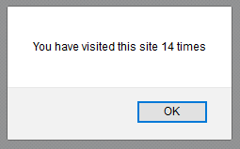

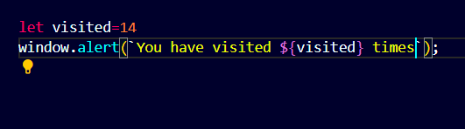

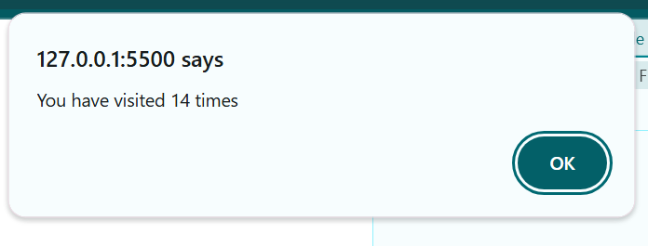

1. Declare a variable called ***birthYear*** & assign to it your birth year. Show the following message in your browser:

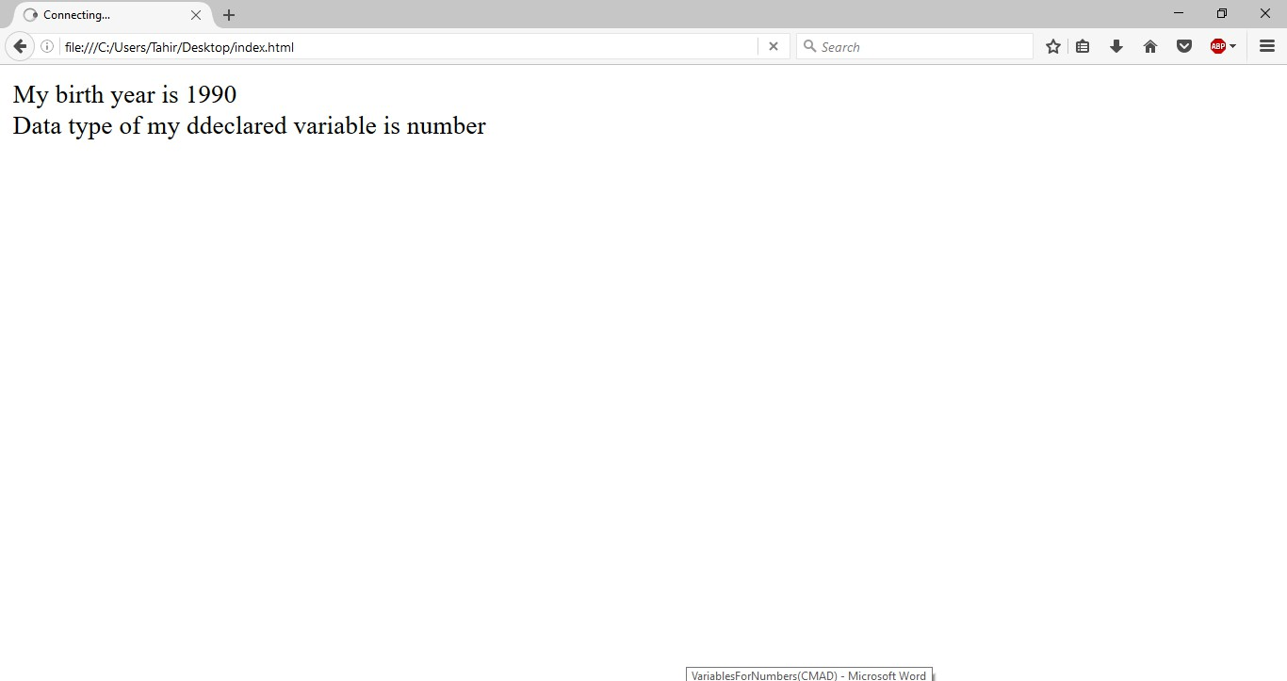

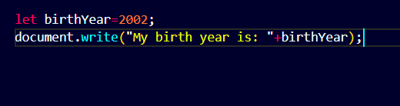

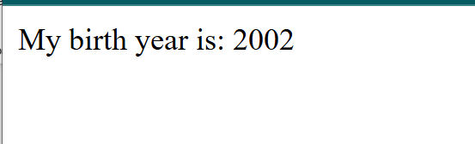

1. A visitor visits an online clothing store [www.xyzClothing.com](http://www.xyzClothing.com/) . Write a script to store in variables the following information:
   1. Visitor’s name
   2. Product title
   3. Quantity i.e. how many products a visitor wants to order

Show the following message in your browser: “**John Doe** ordered **5 T-shirt**(s) on XYZ Clothing store”.

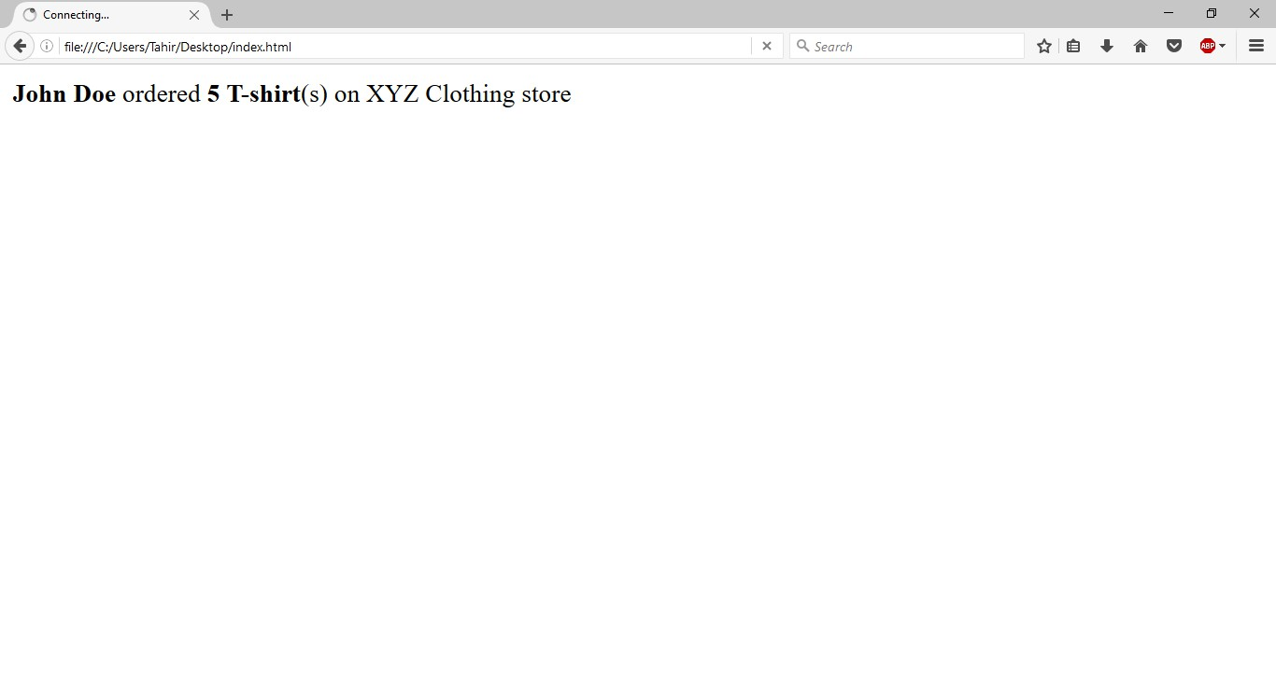

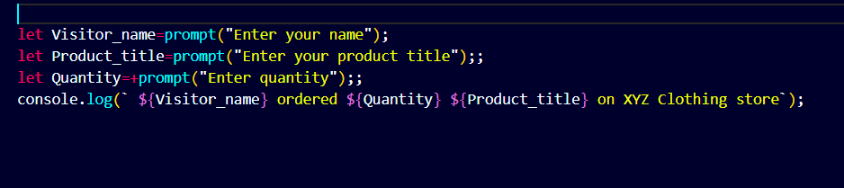

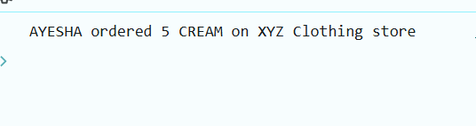

**-- END --**