1. Create an HTML page to validate Name and Email. (Use Bootstrap, JQuery wherever applicable)

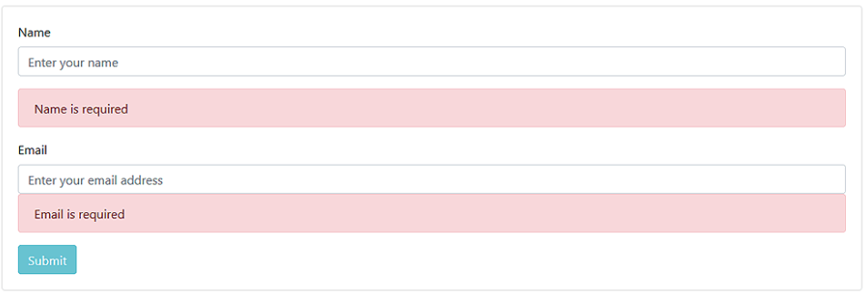

2. If the name and email entered are correct it should dynamically add the details to the below table. The table should look like below:

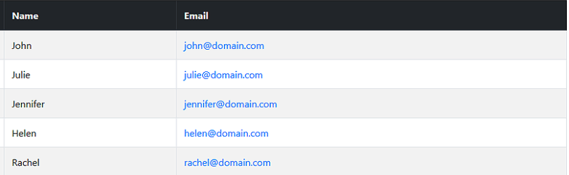

<html>

<head>

    <title>Welcome to DXC Form</title>

    <title>User Form</title>

    <link rel="stylesheet" href="Bootstrap/css/bootstrap.css">

    <link rel="stylesheet" href="https://stackpath.bootstrapcdn.com/bootstrap/4.3.1/css/bootstrap.min.css"

        integrity="sha384-ggOyR0iXCbMQv3Xipma34MD+dH/1fQ784/j6cY/iJTQUOhcWr7x9JvoRxT2MZw1T" crossorigin="anonymous">

    <script src="https://code.jquery.com/jquery-3.3.1.slim.min.js"

        integrity="sha384-q8i/X+965DzO0rT7abK41JStQIAqVgRVzpbzo5smXKp4YfRvH+8abtTE1Pi6jizo"

        crossorigin="anonymous"></script>

    <script src="https://cdnjs.cloudflare.com/ajax/libs/popper.js/1.14.7/umd/popper.min.js"

        integrity="sha384-UO2eT0CpHqdSJQ6hJty5KVphtPhzWj9WO1clHTMGa3JDZwrnQq4sF86dIHNDz0W1"

        crossorigin="anonymous"></script>

    <script src="https://stackpath.bootstrapcdn.com/bootstrap/4.3.1/js/bootstrap.min.js"

        integrity="sha384-JjSmVgyd0p3pXB1rRibZUAYoIIy6OrQ6VrjIEaFf/nJGzIxFDsf4x0xIM+B07jRM" crossorigin="anonymous">

        </script>

    <script type="text/javascript">

        function check() {

            var uname = document.getElementById("username").value;

            var email = document.getElementById("email").value;

            var usernameerror = document.getElementById("usernameerror");

            var emailerror = document.getElementById("emailerror");

            usernameerror.innerHTML = ""

            emailerror.innerHTML = ""

            if ((uname.length == 0 && email.length == 0)) {

                usernameerror.innerHTML = "<font >Please enter Username</font>"

                emailerror.innerHTML = "<font >Please enter email </font>"

                return false

            }

            else if (email.length == 0) {

                emailerror.innerHTML = "<font >Please enter email </font>"

                return false

            }

            else if (uname.length == 0) {

                usernameerror.innerHTML = "<font >Please enter Username</font>"

                return false

            }

            else {

                var NumOfRow = 1;

                var divSpace = document.getElementById("myDiv");

                //var newTable = document.createElement('table');

                //newTable.setAttribute('id', 'table1');

                var table = document.getElementById("oldTable");

                var newRow = document.createElement('tr');

                newRow.setAttribute('id', 'row1');

                var newData1 = document.createElement('td');

                newData1.setAttribute('id', 'newName');

                var newData2 = document.createElement('td');

                newData2.setAttribute('id', 'newEmail');

                newData1.innerHTML = uname

                newData2.innerHTML = email

                newRow.appendChild(newData1);

                newRow.appendChild(newData2);

                table.appendChild(newRow);

            }

        }

    </script>

    <style>

        th {

            background-color: black;

            color: white;

        }

        #newName,

        #newEmail {

            background-color: gray;

        }

        #newName {

            color: black;

        }

        #newEmail {

            color: blue;

        }

        #usernameerror,

        #emailerror {

            background-color:pink;

        }

    </style>

</head>

<body text="blue">

    <form class="form-group">

        <table cellspacing="10" cellpadding="10" align="center" class="text-center table-responsive">

            <tr align="center">

                <td>User Name </td>

                </td>

            </tr>

            <tr><td><input type="text" name="username" class="form-control" id="username"

                placeholder="Enter user name" /></tr>

            <tr>

                <td>

                    <div id="usernameerror"></div>

                </td>

            </tr>

            <br />

            <tr align="center">

                <td>Email </td>

            </tr>

            <tr><td><input type="text" name="email" id="email" class="form-control" placeholder="Enter email" /></td></tr>

            <tr>

                <td>

                    <div id="emailerror"></div>

                </td>

            </tr>

            <br />

            <tr align="center">

                <td align="center">

                    <input type="button" name="Submit" class="form-control btn-success" value="Submit" onclick="check()" />

                </td>

            </tr>

            <div id="myDiv">

            </div>

        </table>

        <table id="oldTable" cellspacing="10" cellpadding="10" border="1">

            <th>Name</th>

            <th>Email</th>

        </table>

    </form>

</body>

</html>

1. Create a user form like below and perform the validation as shown in the below images:

**Image - 1-4**

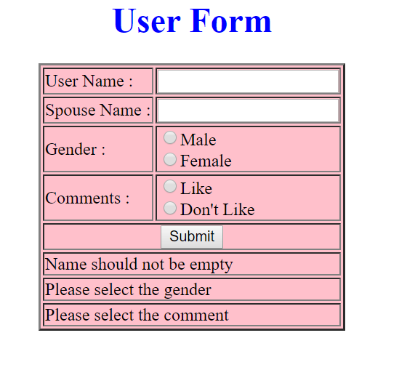

**Image - 2-4**

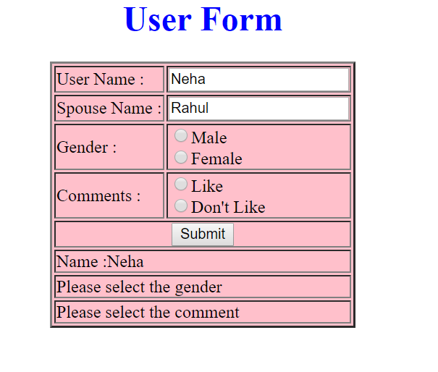

**Image - 3-4**

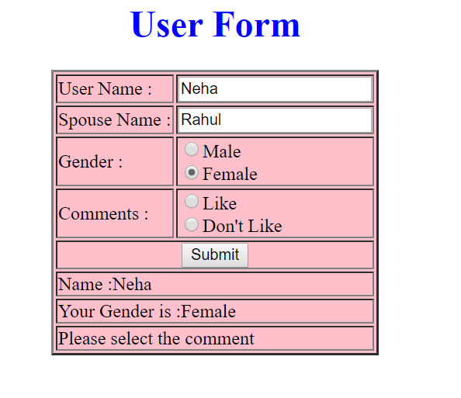

**Image - 4-4 (Success)**

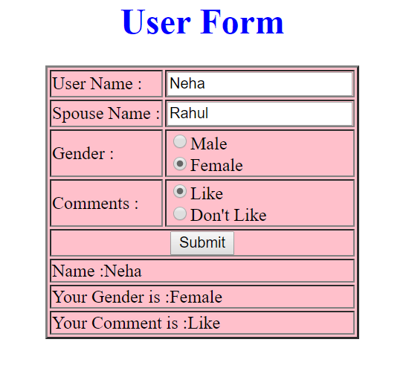

<html>

<head>

    <title>User Form</title>

    <link rel="stylesheet" href="Bootstrap/css/bootstrap.css">

    <link rel="stylesheet" href="https://stackpath.bootstrapcdn.com/bootstrap/4.3.1/css/bootstrap.min.css"

        integrity="sha384-ggOyR0iXCbMQv3Xipma34MD+dH/1fQ784/j6cY/iJTQUOhcWr7x9JvoRxT2MZw1T" crossorigin="anonymous">

    <script src="https://code.jquery.com/jquery-3.3.1.slim.min.js"

        integrity="sha384-q8i/X+965DzO0rT7abK41JStQIAqVgRVzpbzo5smXKp4YfRvH+8abtTE1Pi6jizo"

        crossorigin="anonymous"></script>

    <script src="https://cdnjs.cloudflare.com/ajax/libs/popper.js/1.14.7/umd/popper.min.js"

        integrity="sha384-UO2eT0CpHqdSJQ6hJty5KVphtPhzWj9WO1clHTMGa3JDZwrnQq4sF86dIHNDz0W1"

        crossorigin="anonymous"></script>

    <script src="https://stackpath.bootstrapcdn.com/bootstrap/4.3.1/js/bootstrap.min.js"

        integrity="sha384-JjSmVgyd0p3pXB1rRibZUAYoIIy6OrQ6VrjIEaFf/nJGzIxFDsf4x0xIM+B07jRM" crossorigin="anonymous">

        </script>

    <script type="text/javascript">

        function check() {

            var username = document.getElementById("username").value

            var male = document.getElementById("male").value

            var female = document.getElementById("female").value

            var comments1 = document.getElementByName("comments1").value

            var comments2 = document.getElementByName("comments2").value

            var nameError = document.getElementById("nameError").value

            var genderError = document.getElementById("genderError")

            var commentError = document.getElementById("commentError")

            if (username.length == 0) {

                nameError.innerHTML = "Please enter username";

            }

            else {

                nameError.innerHTML = "Name : " + username;

            }

            if((male.checked==false)&&(female.checked==false))

            {

                genderError.innerHTML = "Please Select gender1";

            }

            else{

                if(male.checked==true)

                {

                    genderError.innerHTML = "Gender : Male"

                }

                else

                {

                    genderError.innerHTML = "Gender : Female"

                }

            }

            if((comments1.checked==false)&&(comments2.checked==false))

            {

                commentError.innerHTML = "Please Select gender";

            }

            else{

                if(comments1.checked==true)

                {

                    commentError.innerHTML = "Comment : Like"

                }

                else

                {

                    commentError.innerHTML = "Comment : Dislike"

                }

            }

        }

    </script>

    <style>

        table {

            background-color: pink;

            border: double;

        }

    </style>

</head>

<body>

    <h2>

        <center>User Form</center>

    </h2>

    <form class="form-group" >

        <table border="20" cellspacing="10" cellpadding="10" align="center" class="table-bordered">

            <tr>

                <td>User Name:</td>

                <td><input type="text" name="username" id="username" class="form-control" /></td>

                <td><span id="errUserName"></span></td>

            </tr>

            <tr>

                <td>Spouse Name: </td>

                <td><input type="text" name="sposename" id="sposename" class="form-control" /></td>

                <td><span id="errsposename"></span></td>

            </tr>

            <tr>

                <td>Gender </td>

                <td>

                    <input type="radio" name="gender" id="male" value="male"/>Male

                    <input type="radio" name="gender" id="female" value="female" />Female

                </td>

            </tr>

            <tr>

                <td>Comments </td>

                <td>

                    <input type="radio" name="comments" id="comments1" value="Like" />Like

                    <input type="radio" name="comments" id="comments2" value="Don't Like" />Don't Like

                </td>

            </tr>

            <tr>

                <td align="center" colspan="2">

                    <input type="submit" value="Submit" onclick="check()"></td>

            </tr>

            <tr>

                <td colspan="2" id="nameError">Name Should not be empty</td>

            </tr>

            <tr>

                <td colspan="2" id="genderError">Please select gender</td>

            </tr>

            <tr>

                <td colspan="2" id="commentError">Please select comment</td>

            </tr>

        </table>

    </form>

</body>

</html>

4.

CyberShoppe, Inc. sells toys and books in the United States. It has three branches in different parts of the country. Currently, the three branches maintain data on their local computer systems. The IT manager at CyberShoppe has identified that a centralized data repository on the products sold through its   
e-commerce site is required. The data from all branches must be collated and housed in a centralized location. This data must be made available to the Accounts and Sales sections at the individual branches, regardless of the hardware and software platforms being used at the branches.

1. In addition, the sales personnel require access to the data using palmtops and cellular phones. The product details of CyberShoppe consist of the product name, a brief description, the price, and the available quantity on hand. A product ID uniquely identifies each product. Create a responsive web page to capture these details.
2. The various products at CyberShoppe are purchased from their suppliers through their branch offices. The purchase order details are sent to the head office to generate reports. To ensure that the data can be accessed across all hardware and software used at the head office, the branch offices. On receiving this data, the head office needs to verify that all branches have specified the required information in a consistent format.

The purchase order details sent by the branch offices include the product ID, order ID, date of the purchase order, name and address of the supplier, quantity ordered, and price per unit.

1. The product Id must start with P following by 5 digits
2. The order Id must start with OD followed by 4 digits
3. The remaining fields are mandatory.
4. The look and feel should be consistent throughout the website.

Use jQuery, Bootstrap, JavaScript .

<html>

<head>

    <link rel="stylesheet" href="Bootstrap/css/bootstrap.css">

    <link rel="stylesheet" href="https://stackpath.bootstrapcdn.com/bootstrap/4.3.1/css/bootstrap.min.css"

        integrity="sha384-ggOyR0iXCbMQv3Xipma34MD+dH/1fQ784/j6cY/iJTQUOhcWr7x9JvoRxT2MZw1T" crossorigin="anonymous">

    <script src="https://code.jquery.com/jquery-3.3.1.slim.min.js"

        integrity="sha384-q8i/X+965DzO0rT7abK41JStQIAqVgRVzpbzo5smXKp4YfRvH+8abtTE1Pi6jizo"

        crossorigin="anonymous"></script>

    <script src="https://cdnjs.cloudflare.com/ajax/libs/popper.js/1.14.7/umd/popper.min.js"

        integrity="sha384-UO2eT0CpHqdSJQ6hJty5KVphtPhzWj9WO1clHTMGa3JDZwrnQq4sF86dIHNDz0W1"

        crossorigin="anonymous"></script>

    <script src="https://stackpath.bootstrapcdn.com/bootstrap/4.3.1/js/bootstrap.min.js"

        integrity="sha384-JjSmVgyd0p3pXB1rRibZUAYoIIy6OrQ6VrjIEaFf/nJGzIxFDsf4x0xIM+B07jRM"

        crossorigin="anonymous"></script>

    <script type="text/javascript">

        function check() {

            var productid = document.getElementById("productid").value;

            var orderid = document.getElementById("orderid").value;

            var productiderror = document.getElementById("productiderror");

            var orderiderror = document.getElementById("orderiderror");

            productiderror.innerHTML = ""

            orderiderror.innerHTML = ""

            if ((productid.length == 0) && (orderid.length == 0)) {

                productiderror.innerHTML = "<font color=red>Please enter productid</font>"

                orderiderror.innerHTML = "<font color=red>Please enter orderid </font>"

                return false

            }

            else if (orderid.length == 0) {

                if ((productid.length > 5) && (productid.charAt(0) != P)) {

                    productiderror.innerHTML = "<font color=red>productid should be 5 digits and start with P</font>"

                    orderiderror.innerHTML = "<font color=red>Please enter orderid </font>"

                    return false

                }

                else if ((productid.length > 5)) {

                    productiderror.innerHTML = "<font color=red>productid should be 5</font>"

                    orderiderror.innerHTML = "<font color=red>Please enter orderid </font>"

                    return false

                }

                else if ((productid.charAt(0) != 'P')) {

                    productiderror.innerHTML = "<font color=red>start with P</font>"

                    orderiderror.innerHTML = "<font color=red>Please enter orderid </font>"

                    return false

                }

                else {

                    orderiderror.innerHTML = "<font color=red>Please enter orderid </font>"

                    return false

                }

            }

            else if (productid.length == 0) {

                if ((orderid.length > 4) && (orderid.charAt(0) == 'O') && (orderid.charAt(1) == 'D')) {

                    productiderror.innerHTML = "<font color=red>Please enter productid</font>"

                    orderiderror.innerHTML = "<font color=red>orderid should be 4 digits and it should start with OD</font>"

                    return false

                }

                else if ((orderid.charAt(0) == 'O') && (orderid.charAt(1) == 'D')) {

                    productiderror.innerHTML = "<font color=red>Please enter productid</font>"

                    orderiderror.innerHTML = "<font color=red>It should start with O</font>"

                    return false

                }

                else {

                    productiderror.innerHTML = "<font color=red>Please enter productid</font>"

                    return false

                }

            }

            else {

            }

        }

    </script>

</head>

<body>

    <h2>

        <center>product details of CyberShoppe</center>

    </h2>

    <form onsubmit="return check()">

        <table cellspacing="10" cellpadding="10" align="center">

            <tr align="center">

                <td>Product Id </td>

                <td><input type="text" name="productid" id="productid" /></td>

                <td><span id="productiderror"></span></td>

            </tr>

            <br />

            <tr align="center">

                <td>Order Id </td>

                <td><input type="text" name="orderid" id="orderid" /></td>

                <td><span id="orderiderror"></span></td>

            </tr>

            <tr align="center">

                <td align="center">

                    <input type="submit" name="Submit" value="Submit"  />

                </td>

            </tr>

        </table>

    </form>

</body>

</html>