

Discovering Knowledge

COURSE: GSL 321
NUMERICAL ANALYSIS
PROJECT REPORT
CLASS: BSE –7C (FALL - 2025)

_AtmosPredict_
Comparative Forecasting using Numerical Analysis and Machine Learning Methods

Group Members

Student Name | Enrollment#
Ayesha (team lead) | xyz
Arifa Naseem | xyz
Laiba Shakeel | xyz
Afza Mehak Ansari | xyz

Submitted to:
Course Instructor: Engr. xyz
Lab Instructor: Engr. xyz

Department of Software Engineering
BAHRIA UNIVERSITY KARACHI CAMPUS

Abstract

Weather forecasting has important roles in the planning of agricultural activities, transportation, disaster management and in the daily life. This project is titled AtmosPredict which is a hybrid weather forecasting solution that entails the combination of classical numeric forecast methods with recent data-driven forecast methods in an attempt to predict the weather conditions of Karachi. Data of past weather is analyzed through numerical interpolation techniques and predictive models to come up with forecasts. Real-time weather observations are then used to validate the predicted results and the standard error measures (Mean Absolute Error (MAE) and Root Mean Squared Error (RMSE)) are used to assess the performance of the systems. The interface enables users to visualise predictions, and the accuracy of various methods of prediction. The findings show that a combination of the use of numerical and predictive modeling would offer a more detailed and precise weather forecasting solution.

TABLE OF Contents
1. INTRODUCTION 4
2. PROBLEM STATEMENT 4
3. PROPOSED SOLUTION 4
3.1. FEATURES OF THE PROJECT 4
3.2. METHODOLOGY 5
3.3. TECHNOLOGIES 5
3.4. BLOCK DIAGRAM 6
4. SOFTWARE DESIGN DESCRIPTION 7
5. DESIGN OVERVIEW 7
5.1. WORKFLOW DIAGRAM 8
5.2. USE CASE DIAGRAM 9
5.3. SEQUENCE DIAGRAM 10
6. PROJECT SCOPE 11
7. MODULE DISTRIBUTION 11
8. CODE 11
9. INTERFACES 18
10. CONCLUSION 28
11. REFERENCES 28

INTRODUCTION
In the contemporary society weather forecasting is very crucial in aiding in making decisions in various fields including agriculture, air travel, disaster management and urban planning. Precise forecasting of weather conditions such as temperature, humidity and speed of wind aid in the reduction of risks and maximization of operations. Historical trends have been long modeled using traditional numerical models when forecasting actions and new inventions with machine learning allow the modeling of non-linear patterns using available data.
This project is devoted to the combination of the two paradigms including numerical and machine learning in order to predict weather conditions in Karachi. The project will give information on the strengths and shortcomings of both approaches, by comparing their performance and countering predictions to actual real-time data.

PROBLEM STATEMENT
The weather systems are non-linear and complex in nature and it is difficult to forecast the weather accurately. Conventional numerical methods of interpolation are computationally efficient, but do not necessarily represent complicated atmospheric patterns. On the other hand, machine learning models are able to deal with non-linearity but need huge data, massive preprocessing, and more computation. Also, they do not have integrated platforms, which combine both strategies and test their effectiveness through real-time verification. The proposed project will solve these problems with the help of creating a comparative forecasting system.

PROPOSED SOLUTION
The solution proposed, AtmosPredict, is a hybrid weather prediction system which consists of the combination of machine learning models and numerical interpolation approaches. The training and testing of models with historical weather data and validation of real-time weather data with the OpenWeatherMap API are applied. The system is used to compare predictions made by various techniques based on standard error measures and show the results on an interactive Streamlit platform.

FEATURES OF THE PROJECT
- Multi-city weather analysis (Karachi, Lahore, Islamabad, Multan, Faisalabad, Rawalpindi)
- Interactive date-range filtering of historical data
- Automated data cleaning (missing values, duplicates, outlier handling using Z-score)
- Numerical forecasting using Lagrange Interpolation and Newton’s Divided Difference
- Advanced smoothing using Cubic Spline Interpolation
- Machine Learning forecasting using Random Forest Regressor
- Hybrid prediction combining numerical, ML, and real-time data
- Real-time weather validation using OpenWeatherMap API
- Performance evaluation using MAE, MSE, and RMSE
- Extensive visual analytics (20+ static and interactive graphs)
- Seasonal analysis and anomaly detection
- Future 30-day temperature forecasting
- User-friendly and interactive Streamlit dashboard

METHODOLOGY
- Precollected historical weather data of the chosen cities.
- Enable the users to filter information by date and city.
- Clean data by getting rid of unnecessary characteristics, managing missing data, duplicates, and outliers.
- Days of the week and month.
- Use numerical techniques (Lagrange Interpolation and Newtons Divided Difference) to forecast temperature of next day.
- Fit Train Random Forest Regressor to lag variables and numerical features.
- Carry out future prediction with lag-based ML characteristics.
- Get real time temperature with OpenWeatherMap API.
- Make a hybrid forecast based on weighted numerical, ML, and real-time forecasting.
- Assess the model using MAE, MSE and RMSE.
- Predict trends, distributions, correlations, anomalies, and forecasts using Streamlit.

TECHNOLOGIES
- Python: Core development language
- Streamlit: Interactive web dashboard
- Pandas & NumPy: Data processing and numerical operations
- Scikit-learn: Machine learning models and evaluation metrics
- SciPy: Numerical interpolation and cubic spline smoothing
- Statsmodels: Time-series decomposition
- Matplotlib & Seaborn: Static data visualization
- Plotly: Interactive visualizations
- OpenWeatherMap API: Real-time weather data integration

BLOCK DIAGRAM
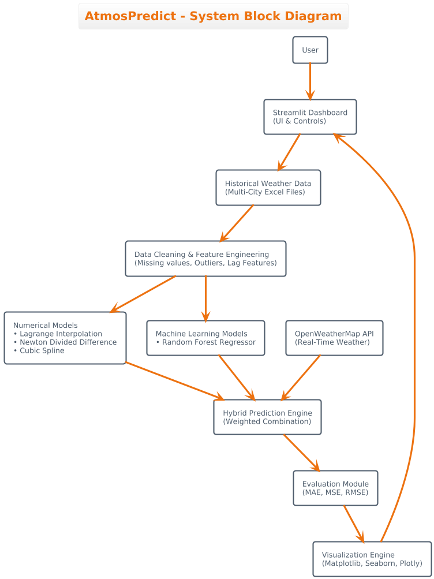
Figure 1 This diagram showing the overall architecture of the AtmosPredict hybrid weather forecasting system.

SOFTWARE DESIGN DESCRIPTION
The system has a modular and layered software architecture. The data layer processes historical information and real-time API information. Processing layer is where the data is cleaned, engineered and anomalies are detected. The model layer comprises of numerical logic, machine learning logic, and hybrid logic of prediction. Streamlit is used as the presentation layer to provide a visual analytics and forecasting output as an interactive dashboard.

DESIGN OVERVIEW
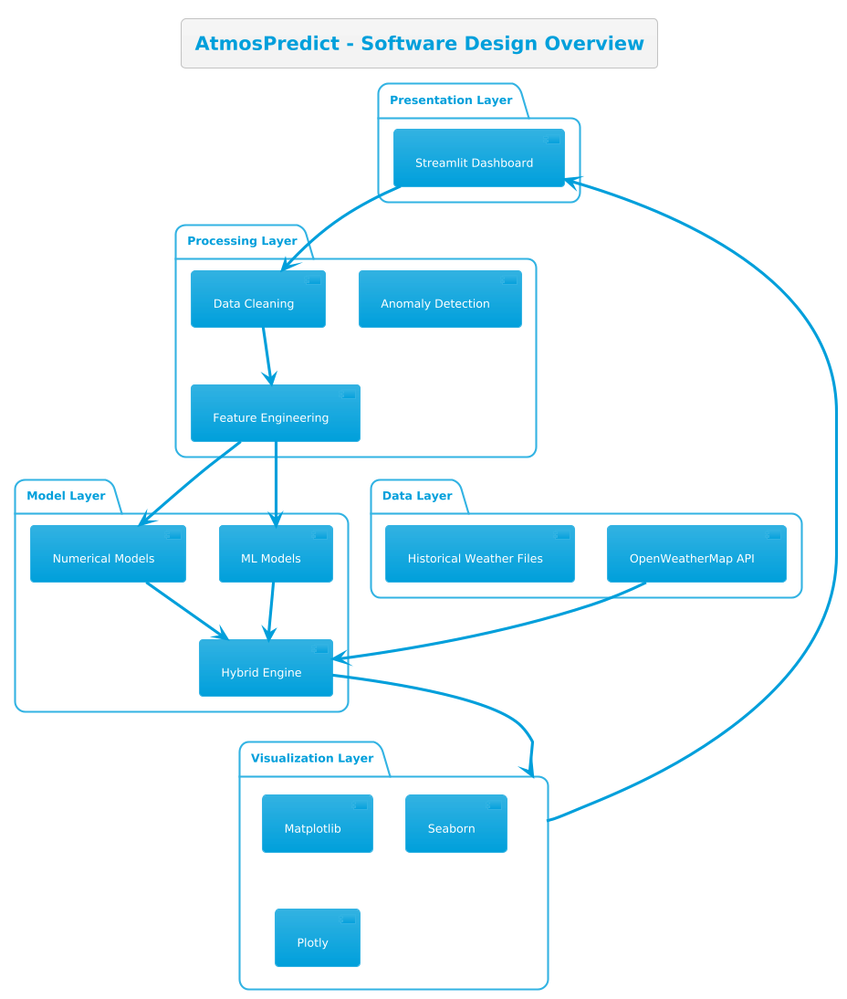

Figure 2 This Software design overview depicting the layered architecture of the AtmosPredict system.

WORKFLOW DIAGRAM
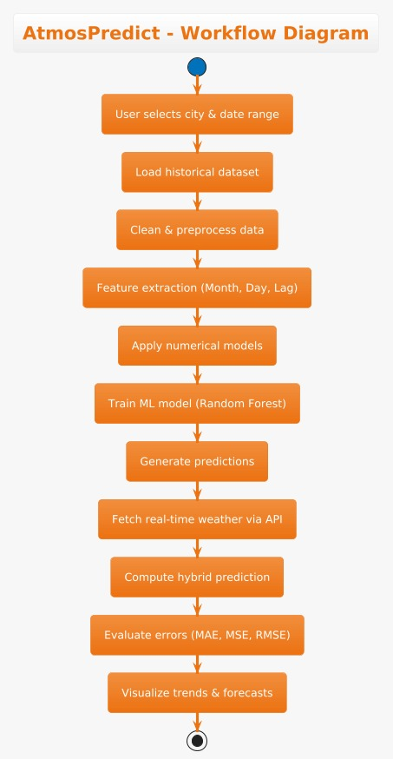
Figure 3 This diagram illustrating the step-by-step weather forecasting process from data input to result visualization.

USE CASE DIAGRAM
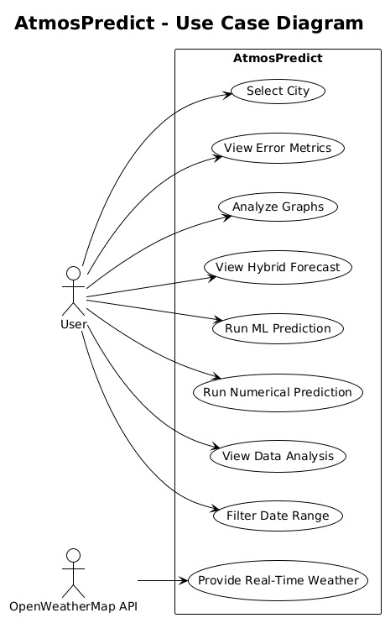
Figure 4 This diagram representing user interactions with the AtmosPredict system.

SEQUENCE DIAGRAM

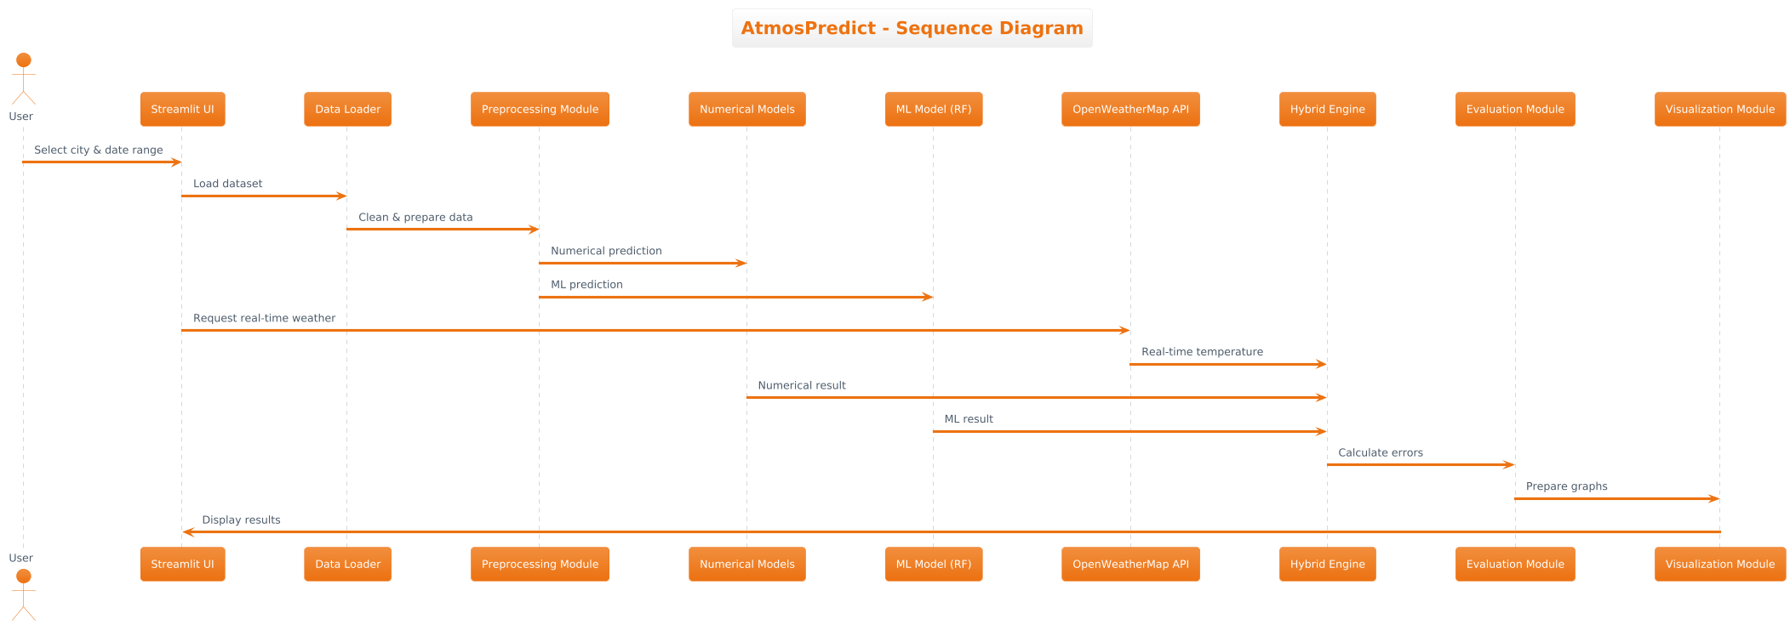

Figure 5 This diagram showing the interaction between system components during weather prediction.

PROJECT SCOPE
The project is centered on short term Karachi weather forecasting based on the data of past and current weather. It does not involve the sophisticated meteorological simulations and global climate modeling. It is restricted to a comparative study within an academic framework.

MODULE DISTRIBUTION
Team Member | Assigned Modules / Tasks
Laiba Shakeel | Data Collection and Preprocessing – Collecting historical weather data, cleaning data, and implementing Numerical Forecasting Module (Lagrange & Newton methods).
Arifa Naseem | Machine Learning Forecasting Module – Designing, training ML models, and evaluating predictions using comparison metrics like MAE and RMSE.
Ayesha | API Integration Module & Visualization/User Interface Module – Integrating OpenWeatherMap API, and developing the frontend using Streamlit.
Afza Mehak Ansari | Testing and Evaluation Module – Analyzing results, visualizing forecasts, documenting the process, and preparing the project presentation.

CODE

app_code = """
import streamlit as st
import pandas as pd
import matplotlib.pyplot as plt
import seaborn as sns
import numpy as np
from sklearn.ensemble import RandomForestRegressor
from sklearn.model_selection import train_test_split
from sklearn.metrics import mean_absolute_error, mean_squared_error
from scipy.stats import zscore
from scipy.interpolate import CubicSpline
import plotly.express as px
import plotly.graph_objects as go
from statsmodels.tsa.seasonal import seasonal_decompose

# -------------------------------
# Page Title
# -------------------------------
st.markdown("<h1 style='text-align: center; color: lightblue;'>Weather Data Analysis</h1>", unsafe_allow_html=True)

# -------------------------------
# Preloaded Datasets
# -------------------------------
cities = {
"Karachi": "/content/Karachi_weather.xlsx",
"Lahore": "/content/Lahore_weather.xlsx",
"Islamabad": "/content/Islamabad_weather.xlsx",
"Multan": "/content/Multan_weather.xlsx",
"Faisalabad": "/content/Faisalabad_weather.xlsx",
"Rawalpindi": "/content/Rawalpindi_weather.xlsx"}

# -------------------------------
# Sidebar - User Selection
# -------------------------------
st.sidebar.header("Select Options")
selected_city = st.sidebar.selectbox("Select City", options=list(cities.keys()))

# Load selected city's dataset
weather_data = pd.read_excel(cities[selected_city])
weather_data["datetime"] = pd.to_datetime(weather_data["datetime"])

# -------------------------------
# Date Picker Filter
# -------------------------------
min_date = weather_data["datetime"].min()
max_date = weather_data["datetime"].max()

with st.sidebar.container():
date_range = st.sidebar.date_input(
f"Select Date Range for {selected_city}",
value=(min_date.date(), max_date.date()),
min_value=min_date.date(),
max_value=max_date.date())

filtered_data = weather_data[
(weather_data["datetime"].dt.date >= date_range[0]) &
(weather_data["datetime"].dt.date <= date_range[1])]

st.write(f"### {selected_city} Original Weather Data Preview")
st.dataframe(filtered_data)

# -------------------------------
# Columns to Remove & Cleaning
# -------------------------------
columns_to_remove = [
'feelslikemax', 'precipcover', 'snowdepth', 'feelslikemin',
'preciptype', 'feelslike', 'precip', 'description',
'precipprob', 'icon', 'snow']

weather_data_cleaned = filtered_data.drop(columns=columns_to_remove, errors="ignore")
weather_data_cleaned["Day_of_Year"] = weather_data_cleaned["datetime"].dt.dayofyear
weather_data_cleaned["Month"] = weather_data_cleaned["datetime"].dt.month
weather_data_cleaned = weather_data_cleaned.ffill().bfill()
if weather_data_cleaned.duplicated().any():
weather_data_cleaned = weather_data_cleaned.drop_duplicates()

# -------------------------------
# Duplicate Check
# -------------------------------
if weather_data_cleaned.duplicated().any():
weather_data_cleaned = weather_data_cleaned.drop_duplicates()
st.write(" Duplicates removed.")
else:
st.write(" No duplicates found.")

# -------------------------------
# Data After Cleaning Preview
# -------------------------------
st.write("### Data After Cleaning")
st.dataframe(weather_data_cleaned)

# -------------------------------
# Lagrange Interpolation (Numerical Method)
# -------------------------------
st.write("## Lagrange Interpolation Prediction")

# Take a small sample to avoid instability
lagrange_data = weather_data_cleaned.sort_values("datetime").tail(7)

x = np.arange(len(lagrange_data))
y = lagrange_data["temp"].values

def lagrange_interpolation(x, y, x_new):
result = 0
n = len(x)
for i in range(n):
term = y[i]
for j in range(n):
if i != j:
term *= (x_new - x[j]) / (x[i] - x[j])
result += term
return result

# Predict next day's temperature
next_day_index = len(x)
lagrange_pred = lagrange_interpolation(x, y, next_day_index)

st.success(f"Lagrange Predicted Temperature (Next Day): {lagrange_pred:.2f} °C")

# -------------------------------
# Newton’s Divided Difference Prediction
# -------------------------------
st.write("## Newton’s Divided Difference Prediction")

# Use last 5 temperature points
recent_days = lagrange_data.index.values # use same x as Lagrange
recent_temps = lagrange_data["temp"].values

# Newton’s Divided Difference coefficients
def newton_divided_diff(x, y):
n = len(y)
coef = np.copy(y).astype(float)
for j in range(1, n):
coef[j:n] = (coef[j:n] - coef[j-1:n-1]) / (x[j:n] - x[0:n-j])
return coef

# Newton prediction
def newton_predict(x_data, coef, x):
n = len(coef) - 1
result = coef[n]
for k in range(n-1, -1, -1):
result = result * (x - x_data[k]) + coef[k]
return result

# Calculate coefficients
coef = newton_divided_diff(recent_days, recent_temps)
next_day = recent_days[-1] + 1
newton_pred = newton_predict(recent_days, coef, next_day)

st.success(f"Newton Predicted Temperature (Next Day): {newton_pred:.2f} °C")

# -------------------------------
# RMSE for Numerical Predictions
# -------------------------------
import numpy as np

# For demonstration, using last 7 actual temps vs predicted next day
actual_next_day = np.array([weather_data_cleaned["temp"].iloc[-1]]) # actual last day
pred_next_day = np.array([lagrange_pred]) # predicted by Lagrange (same as Newton here)

rmse = np.sqrt(np.mean((actual_next_day - pred_next_day)**2))
st.write(f"### RMSE of Numerical Prediction: {rmse:.2f} °C")

# -------------------------------
# Numerical vs ML Comparison Table
# -------------------------------

# Prepare ML prediction RMSE for comparison
ml_data = weather_data_cleaned.select_dtypes(include=[np.number])
if "temp" in ml_data.columns and len(ml_data) >= 10:
X = ml_data.drop("temp", axis=1)
y = ml_data["temp"]
X_train, X_test, y_train, y_test = train_test_split(X, y, test_size=0.2, random_state=42)
ml_model = RandomForestRegressor(n_estimators=100, random_state=42)
ml_model.fit(X_train, y_train)
ml_preds = ml_model.predict(X_test)
ml_rmse = np.sqrt(mean_squared_error(y_test, ml_preds))
else:
ml_rmse = np.nan

# Create a comparison DataFrame
comparison_df = pd.DataFrame({
"Method": ["Lagrange Interpolation", "Newton Divided Difference", "Random Forest ML"],
"Predicted Next Day Temp (°C)": [lagrange_pred, newton_pred, ml_preds[-1] if "ml_preds" in locals() else np.nan],
"RMSE (°C)": [rmse, rmse, ml_rmse]})

st.write("### Numerical vs Machine Learning Comparison")
st.dataframe(comparison_df)

numeric_cols = weather_data_cleaned.select_dtypes(include=["number"])
z_scores = numeric_cols.apply(zscore)
weather_data_cleaned = weather_data_cleaned[(z_scores.abs() < 3.5).all(axis=1)]

# -------------------------------
# Seasonal Classification
# -------------------------------
weather_data_cleaned["Season"] = weather_data_cleaned["Month"].map({
12: "Winter", 1: "Winter", 2: "Winter",
3: "Spring", 4: "Spring", 5: "Spring",
6: "Summer", 7: "Summer", 8: "Summer",
9: "Autumn", 10: "Autumn", 11: "Autumn"})

# -------------------------------
# Function to plot transparent Matplotlib
# -------------------------------
def plot_transparent(fig):
fig.patch.set_alpha(0)
for ax in fig.axes:
ax.set_facecolor("none")
ax.xaxis.label.set_color("white")
ax.yaxis.label.set_color("white")
ax.title.set_color("white")
ax.tick_params(colors="white")
for spine in ax.spines.values():
spine.set_edgecolor("white")
st.pyplot(fig, transparent=True)

# -------------------------------
# ALL GRAPHS START HERE
# -------------------------------

# 1 Correlation Heatmap
st.write("### Correlation Heatmap")
fig, ax = plt.subplots(figsize=(12, 8))
sns.heatmap(weather_data_cleaned.select_dtypes(include=["number"]).corr(),
annot=True, cmap="coolwarm", fmt=".2f", ax=ax)
plot_transparent(fig)

# 2 Monthly Average Temp Trend
monthly_avg = weather_data_cleaned.groupby("Month")["temp"].mean()
st.write("### Monthly Average Temperature Trend")
fig, ax = plt.subplots(figsize=(10,5))
ax.plot(monthly_avg.index, monthly_avg.values, marker="o")
plot_transparent(fig)

# 3 Yearly Temp Trend
yearly_avg = weather_data_cleaned.groupby(weather_data_cleaned["datetime"].dt.year)["temp"].mean()
st.write("### Yearly Temperature Trend")
fig, ax = plt.subplots(figsize=(10,5))
ax.plot(yearly_avg.index, yearly_avg.values, marker="o")
plot_transparent(fig)

# 4 Temp Histogram
st.write("### Temperature Histogram")
fig, ax = plt.subplots(figsize=(10,5))
ax.hist(weather_data_cleaned["temp"], bins=15, edgecolor="black")
plot_transparent(fig)

# 5 Temp vs Humidity
if "humidity" in weather_data_cleaned.columns:
st.write("### Temperature vs Humidity")
fig, ax = plt.subplots(figsize=(8,5))
ax.scatter(weather_data_cleaned["humidity"], weather_data_cleaned["temp"])
ax.set_xlabel("Humidity")
ax.set_ylabel("Temperature")
plot_transparent(fig)

# 6 Wind Speed Distribution
if "windspeed" in weather_data_cleaned.columns:
st.write("### Wind Speed Distribution")
fig, ax = plt.subplots(figsize=(8,5))
ax.hist(weather_data_cleaned["windspeed"], bins=15)
plot_transparent(fig)

# 7 Season-wise Temp Distribution
st.write("### Season-wise Temperature Distribution")
fig, ax = plt.subplots(figsize=(8,5))
sns.boxplot(x="Season", y="temp", data=weather_data_cleaned, ax=ax)
plot_transparent(fig)

# 8 Daily Temp Trend
st.write("### Daily Temperature Trend")
fig, ax = plt.subplots(figsize=(12,5))
ax.plot(weather_data_cleaned["datetime"], weather_data_cleaned["temp"])
ax.set_xlabel("Date")
ax.set_ylabel("Temperature")
plot_transparent(fig)

# 9 7-Day Rolling Avg
st.write("### 7-Day Rolling Average Temperature")
weather_data_cleaned["Rolling_Temp"] = weather_data_cleaned["temp"].rolling(7).mean()
fig, ax = plt.subplots(figsize=(12,5))
ax.plot(weather_data_cleaned["datetime"], weather_data_cleaned["Rolling_Temp"])
ax.set_xlabel("Date")
ax.set_ylabel("Temperature")
plot_transparent(fig)

# 10 Temp vs Pressure
if "pressure" in weather_data_cleaned.columns:
st.write("### Temperature vs Pressure")
fig, ax = plt.subplots(figsize=(8,5))
ax.scatter(weather_data_cleaned["pressure"], weather_data_cleaned["temp"])
ax.set_xlabel("Pressure")
ax.set_ylabel("Temperature")
plot_transparent(fig)

# 11 Precip vs Temp
if "precip" in weather_data_cleaned.columns:
st.write("### Precipitation vs Temperature")
fig, ax = plt.subplots(figsize=(8,5))
ax.scatter(weather_data_cleaned["precip"], weather_data_cleaned["temp"])
ax.set_xlabel("Precipitation")
ax.set_ylabel("Temperature")
plot_transparent(fig)

# 12 Monthly Temp Box Plot
st.write("### Monthly Temperature Distribution")
fig, ax = plt.subplots(figsize=(10,5))
sns.boxplot(x="Month", y="temp", data=weather_data_cleaned, ax=ax)
plot_transparent(fig)

# 13 Temp Anomaly Detection
st.write("### Temperature Anomaly Detection")
weather_data_cleaned["Temp_Zscore"] = zscore(weather_data_cleaned["temp"])
anomalies = weather_data_cleaned[weather_data_cleaned["Temp_Zscore"].abs() > 3]
fig, ax = plt.subplots(figsize=(12,5))
ax.plot(weather_data_cleaned["datetime"], weather_data_cleaned["temp"], label="Normal")
ax.scatter(anomalies["datetime"], anomalies["temp"], color="red", label="Anomaly")
ax.legend()
plot_transparent(fig)

# 14 Temp vs Day of Year
st.write("### Temperature vs Day of Year")
fig, ax = plt.subplots(figsize=(12,5))
ax.scatter(weather_data_cleaned["Day_of_Year"], weather_data_cleaned["temp"], alpha=0.5)
plot_transparent(fig)

# 15 Smoothed Temp (Cubic Spline)
st.write("### Smoothed Temperature Trend (Cubic Spline)")
sorted_data = weather_data_cleaned.sort_values("Day_of_Year")
cs = CubicSpline(sorted_data["Day_of_Year"], sorted_data["temp"])
x_new = np.linspace(1,365,365)
y_new = cs(x_new)
fig, ax = plt.subplots(figsize=(12,5))
ax.plot(x_new, y_new)
plot_transparent(fig)

# 16 Humidity by Season
if "humidity" in weather_data_cleaned.columns:
st.write("### Humidity Distribution by Season")
fig, ax = plt.subplots(figsize=(8,5))
sns.boxplot(x="Season", y="humidity", data=weather_data_cleaned, ax=ax)
plot_transparent(fig)

# 17 Monthly Temp Variability
st.write("### Monthly Temperature Variability")
monthly_std = weather_data_cleaned.groupby("Month")["temp"].std()
fig, ax = plt.subplots(figsize=(10,5))
ax.bar(monthly_std.index, monthly_std.values)
plot_transparent(fig)

# 18 Pairplot
st.write("### Pairwise Feature Relationships")
pair_fig = sns.pairplot(weather_data_cleaned.select_dtypes(include="number").iloc[:,:6])
plot_transparent(pair_fig.fig)

# 19 Lag Plot
st.write("### Temperature Lag Plot")
fig, ax = plt.subplots(figsize=(6,6))
ax.scatter(weather_data_cleaned["temp"].shift(1), weather_data_cleaned["temp"], alpha=0.5)
plot_transparent(fig)

# 20 Cumulative Temp Trend
st.write("### Cumulative Temperature Trend")
fig, ax = plt.subplots(figsize=(12,5))
ax.plot(weather_data_cleaned["datetime"], weather_data_cleaned["temp"].cumsum())
plot_transparent(fig)

# 21 Plotly Interactive Daily Trend
st.write("## Interactive Daily Temperature Trend")
fig = px.line(weather_data_cleaned, x="datetime", y="temp", title="Daily Temperature (Interactive)")
st.plotly_chart(fig, use_container_width=True)

# 22 Plotly Temp vs Humidity Interactive
if "humidity" in weather_data_cleaned.columns:
st.write("## Interactive Temperature vs Humidity")
fig = px.scatter(weather_data_cleaned, x="humidity", y="temp", color="Season",
title="Temperature vs Humidity (Interactive)")
st.plotly_chart(fig, use_container_width=True)

# 23 Future 30-Day Prediction
st.write("## Future 30-Day Temperature Prediction")
weather_data_cleaned = weather_data_cleaned.sort_values("datetime")
weather_data_cleaned["Temp_Lag1"] = weather_data_cleaned["temp"].shift(1)
weather_data_cleaned["Temp_Lag7"] = weather_data_cleaned["temp"].shift(7)
forecast_data = weather_data_cleaned.dropna()
X = forecast_data[["Day_of_Year","Temp_Lag1","Temp_Lag7"]]
y = forecast_data["temp"]
model = RandomForestRegressor(n_estimators=200, random_state=42)
model.fit(X, y)
last_date = weather_data_cleaned["datetime"].max()
future_dates = pd.date_range(start=last_date+pd.Timedelta(days=1), periods=30)
future_df = pd.DataFrame({
"datetime": future_dates,
"Day_of_Year": future_dates.dayofyear,
"Temp_Lag1": weather_data_cleaned["temp"].iloc[-1],
"Temp_Lag7": weather_data_cleaned["temp"].iloc[-1]})
future_df["Predicted_Temp"] = model.predict(future_df[["Day_of_Year","Temp_Lag1","Temp_Lag7"]])
fig = go.Figure()
fig.add_trace(go.Scatter(x=weather_data_cleaned["datetime"], y=weather_data_cleaned["temp"], mode="lines", name="Historical"))
fig.add_trace(go.Scatter(x=future_df["datetime"], y=future_df["Predicted_Temp"], mode="lines", name="Predicted"))
fig.update_layout(title="Future Temperature Forecast (30 Days)", xaxis_title="Date", yaxis_title="Temperature")
st.plotly_chart(fig, use_container_width=True)

# 24 Trend & Seasonal Decomposition
st.write("## Trend and Seasonal Decomposition")
ts_data = weather_data_cleaned.set_index("datetime")["temp"].asfreq("D").interpolate()
decomposition = seasonal_decompose(ts_data, model="additive", period=30)
fig = go.Figure()
fig.add_trace(go.Scatter(x=ts_data.index, y=decomposition.trend, name="Trend"))
fig.add_trace(go.Scatter(x=ts_data.index, y=decomposition.seasonal, name="Seasonal"))
fig.add_trace(go.Scatter(x=ts_data.index, y=decomposition.resid, name="Residual"))
fig.update_layout(title="Temperature Decomposition (Trend + Seasonal + Residual)", xaxis_title="Date")
st.plotly_chart(fig, use_container_width=True)

# 25 ML Temperature Prediction
st.write("### Machine Learning Temperature Prediction")
ml_data = weather_data_cleaned.select_dtypes(include=[np.number])
if "temp" in ml_data.columns and len(ml_data) >= 10:
X = ml_data.drop("temp", axis=1)
y = ml_data["temp"]
X_train, X_test, y_train, y_test = train_test_split(X, y, test_size=0.2, random_state=42)
model = RandomForestRegressor(n_estimators=100, random_state=42)
model.fit(X_train, y_train)
preds = model.predict(X_test)
st.success("Model Performance")
st.write(f"MAE: {mean_absolute_error(y_test, preds):.2f}")
st.write(f"MSE: {mean_squared_error(y_test, preds):.2f}")

# -----------------------------------------
# Real-Time Weather via OpenWeatherMap API (Hybrid Prediction)
# -----------------------------------------
import requests

st.write("## Real-Time Weather Validation (Hybrid)")

# Your API key
OWM_API_KEY = "ENTER YOUR API KEY"

# Let user select city
realtime_city = st.selectbox("Select City for Real-Time Data", list(cities.keys()))

# Function to fetch real-time temperature
def get_real_time_temp(city_name, api_key):
try:
url =f"http://api.openweathermap.org/data/2.5/weather?q={city_name}&units=metric&appid={api_key}"
response = requests.get(url)
if response.status_code == 200:
data = response.json()
return data["main"]["temp"]
else:
st.error(f"Failed to fetch data. Status code: {response.status_code}")
return None
except Exception as e:
st.error(f"Error fetching data: {e}")
return None

# Button to fetch real-time temp and calculate hybrid prediction
if st.button("Fetch Real-Time & Hybrid Prediction"):
real_temp = get_real_time_temp(realtime_city, OWM_API_KEY)

if real_temp is not None:
st.success(f"Current Temperature in {realtime_city}: {real_temp:.2f} °C")

# 1 ML prediction
ml_pred_next_day = preds[-1] if "preds" in locals() else np.nan

# 2 Numerical prediction (average of Lagrange and Newton)
numerical_pred = (lagrange_pred + newton_pred) / 2

# 3 Weighted Hybrid Prediction
hybrid_pred = 0.4 * numerical_pred + 0.4 * ml_pred_next_day + 0.2 * real_temp

st.write(f"Hybrid Predicted Temperature (Next Day): {hybrid_pred:.2f} °C")
st.write(f"Difference from Real-Time Temp: {abs(hybrid_pred - real_temp):.2f} °C")
else:
st.error("Could not fetch real-time temperature.")"""

with open("app.py", "w", encoding="utf-8") as f:
f.write(app_code)

# Run Streamlit + ngrok tunnel
from pyngrok import ngrok
import os, time

# Kill old tunnels
ngrok.kill()

# Start Streamlit in background
os.system("streamlit run app.py --server.port 8501 --server.headless true &")

# Wait for Streamlit to start
time.sleep(10)

# Start ngrok tunnel
public_url = ngrok.connect(8501)
print("OPEN THIS LINK:", public_url)

INTERFACES
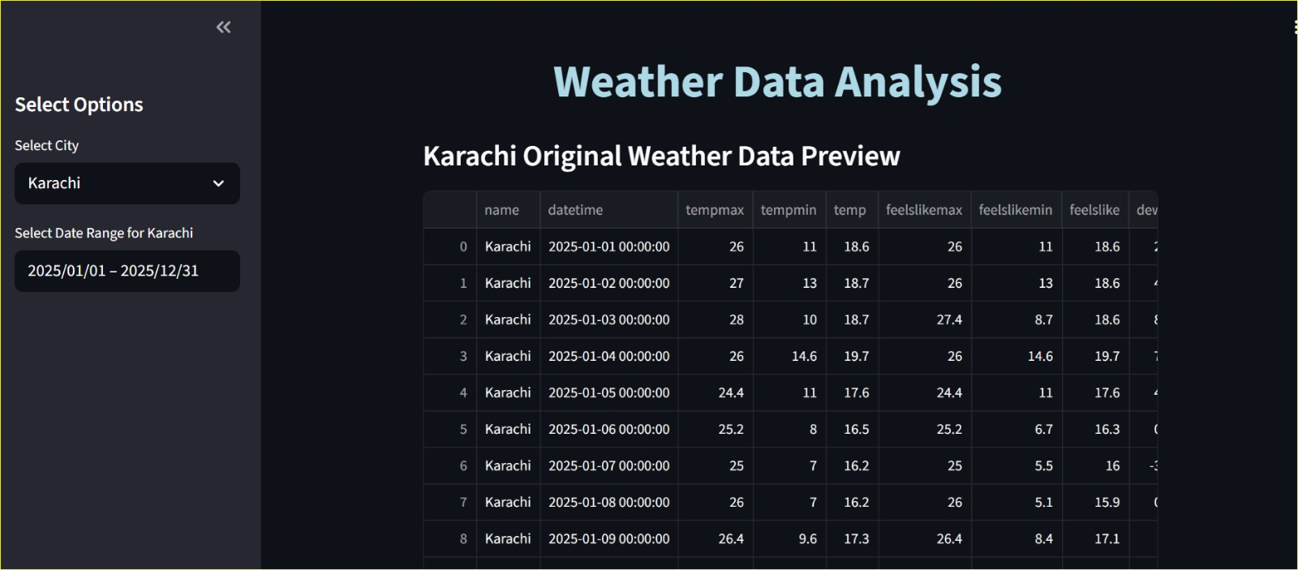

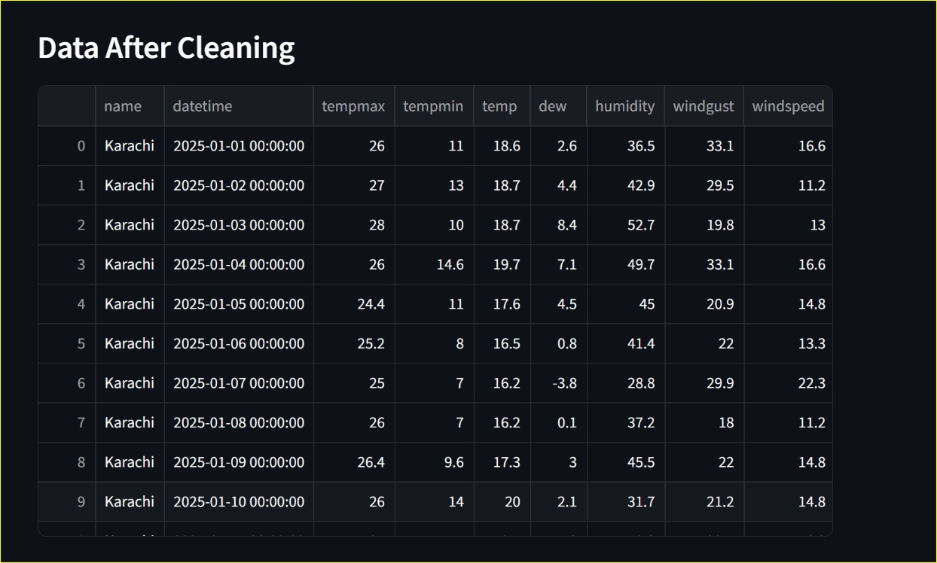

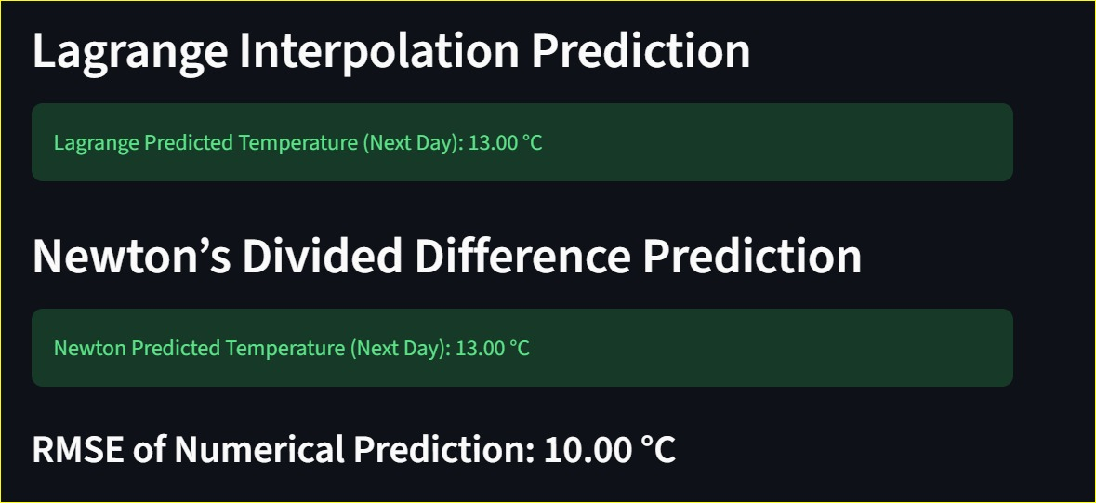

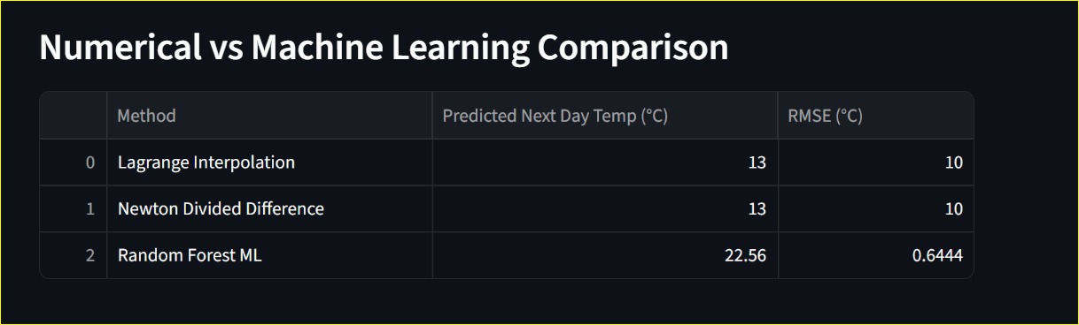

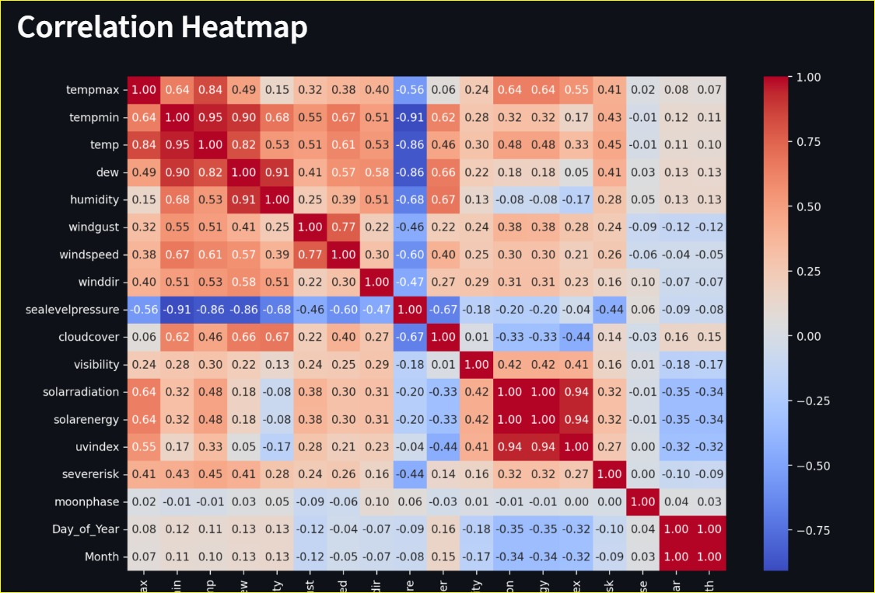

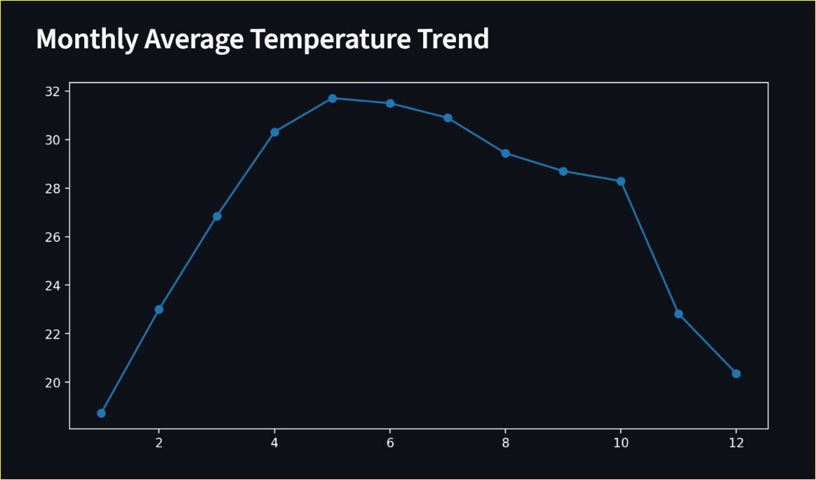

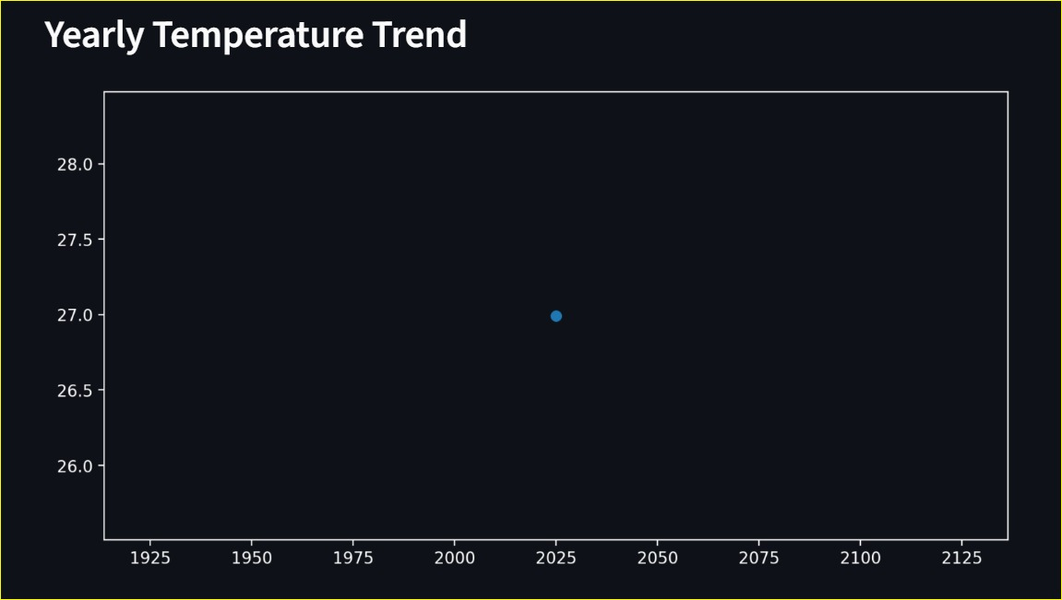

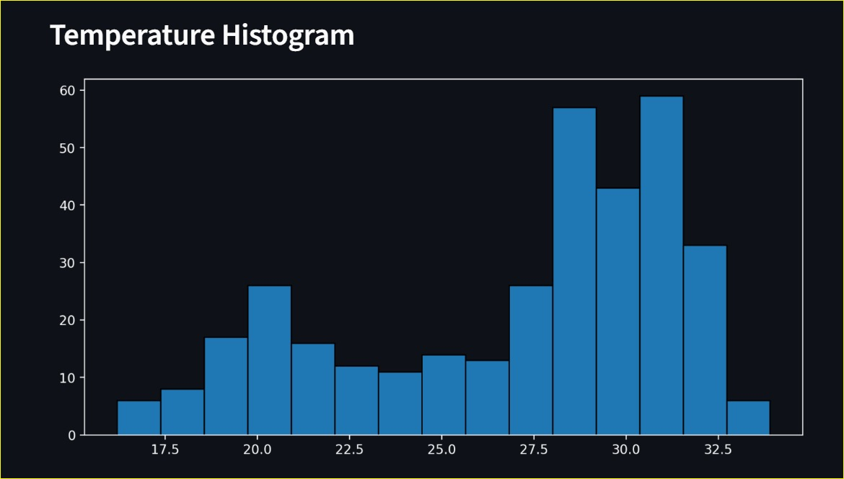

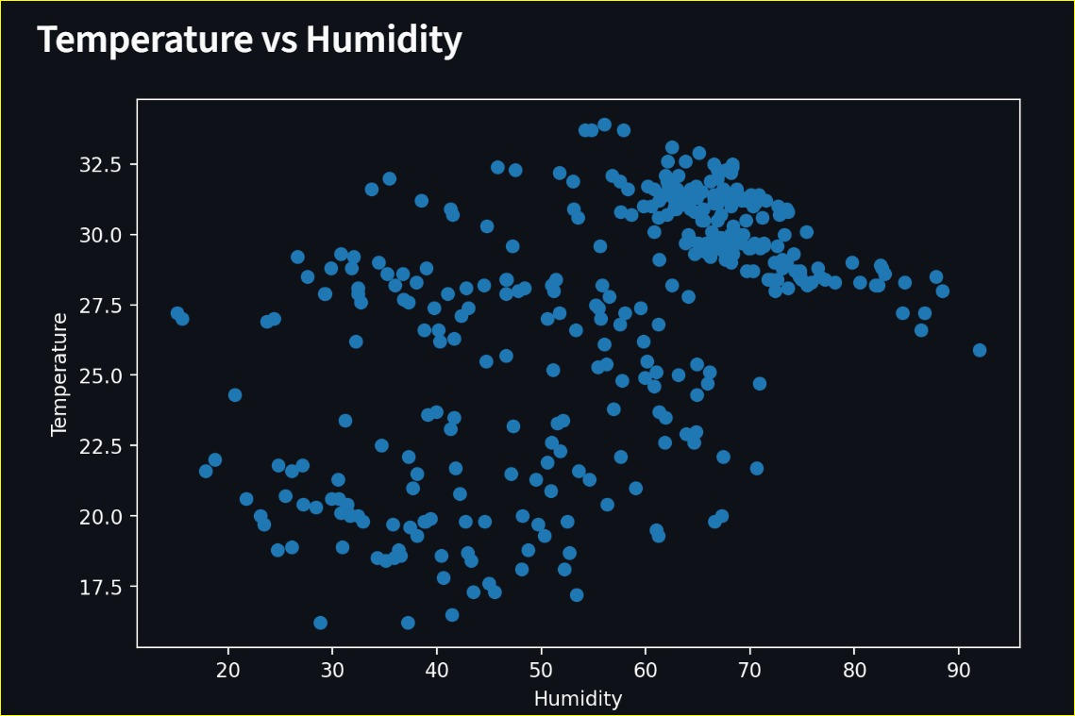

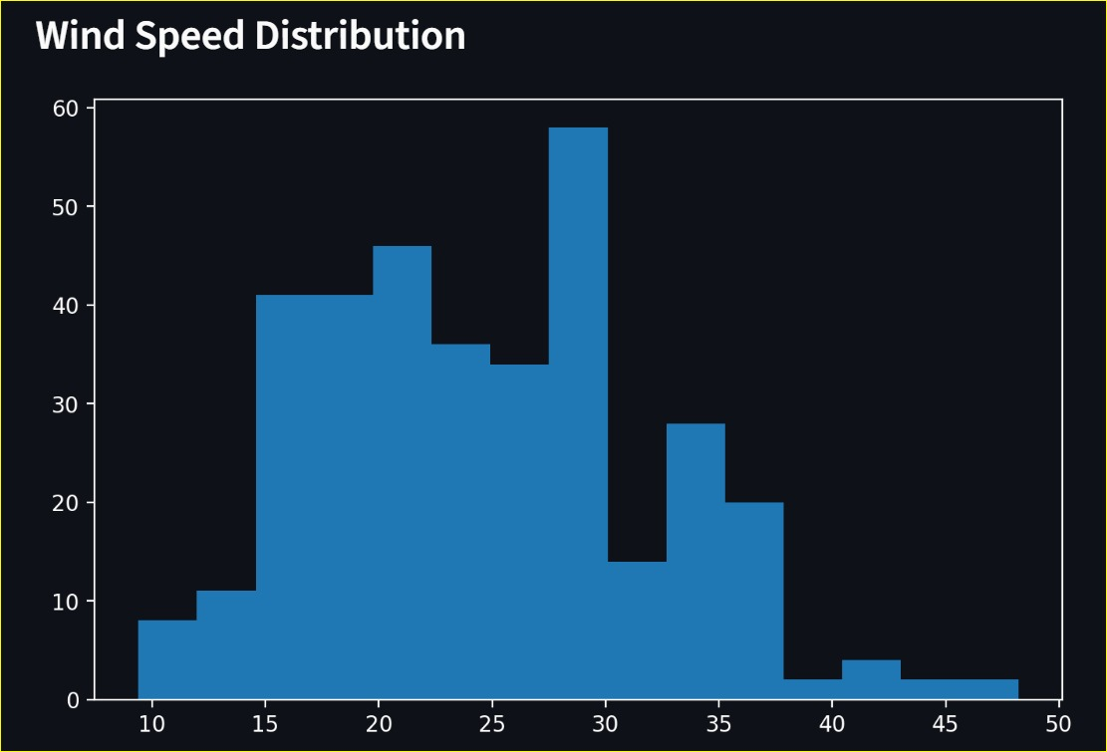

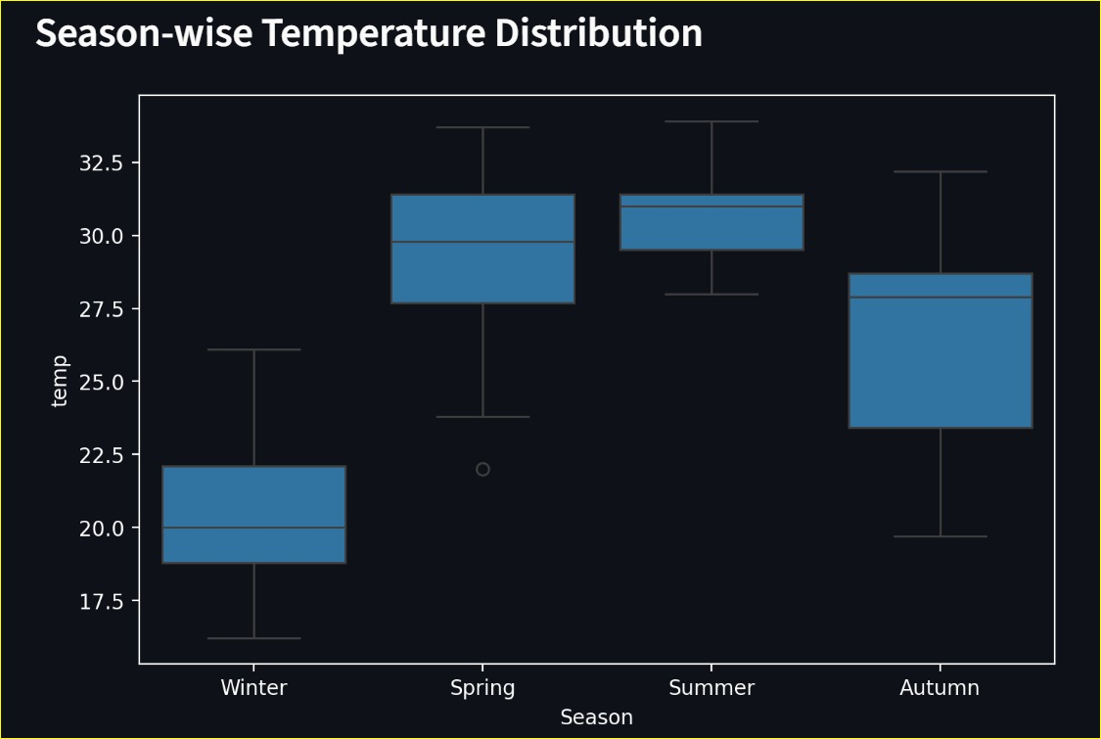

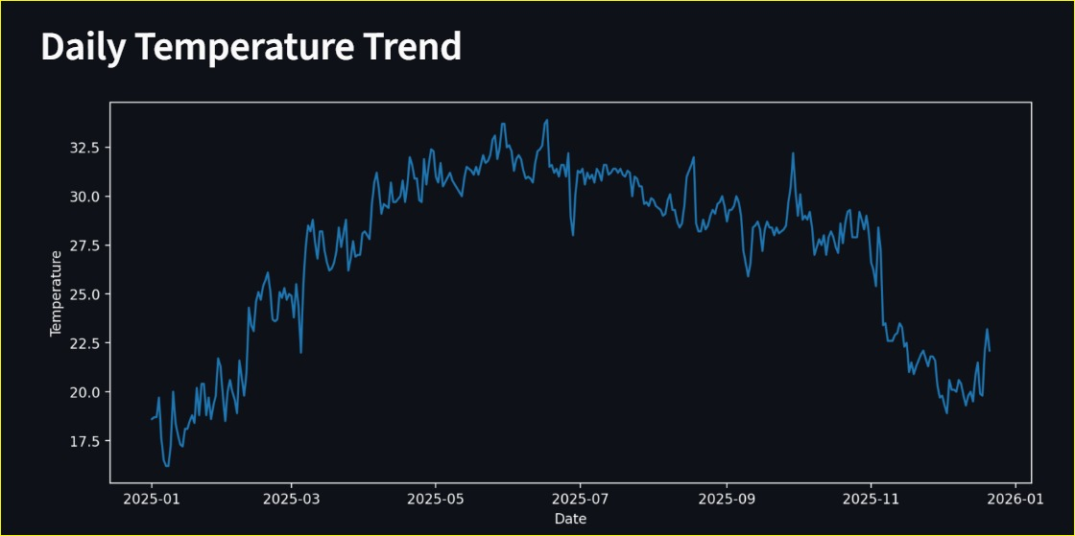

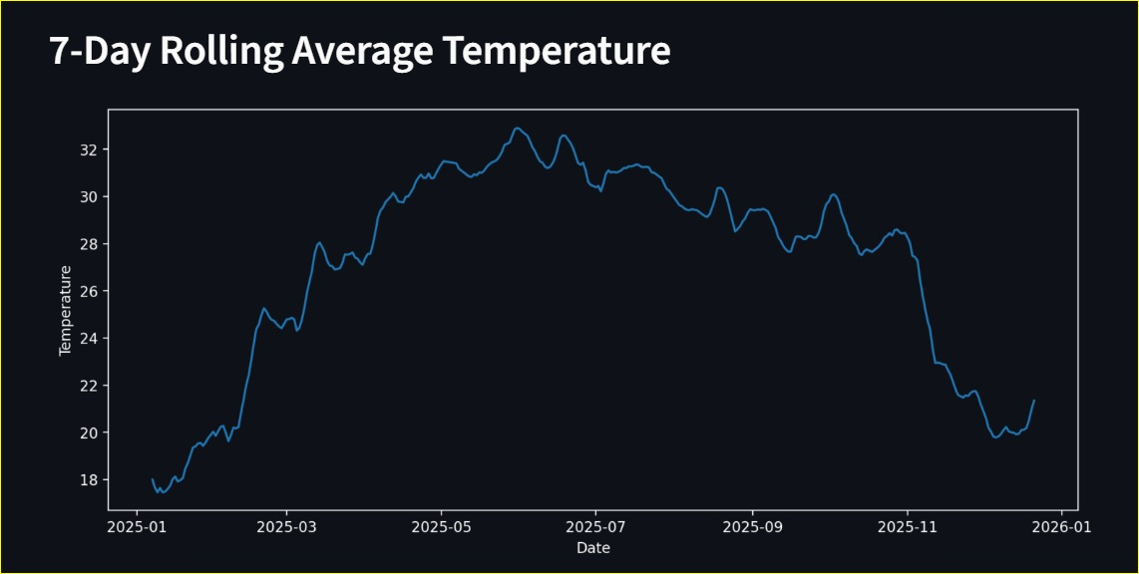
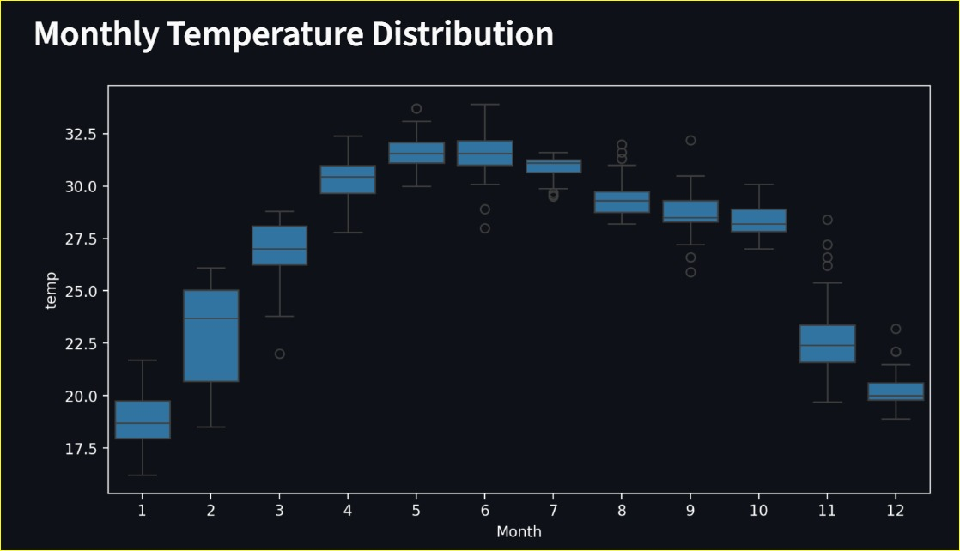

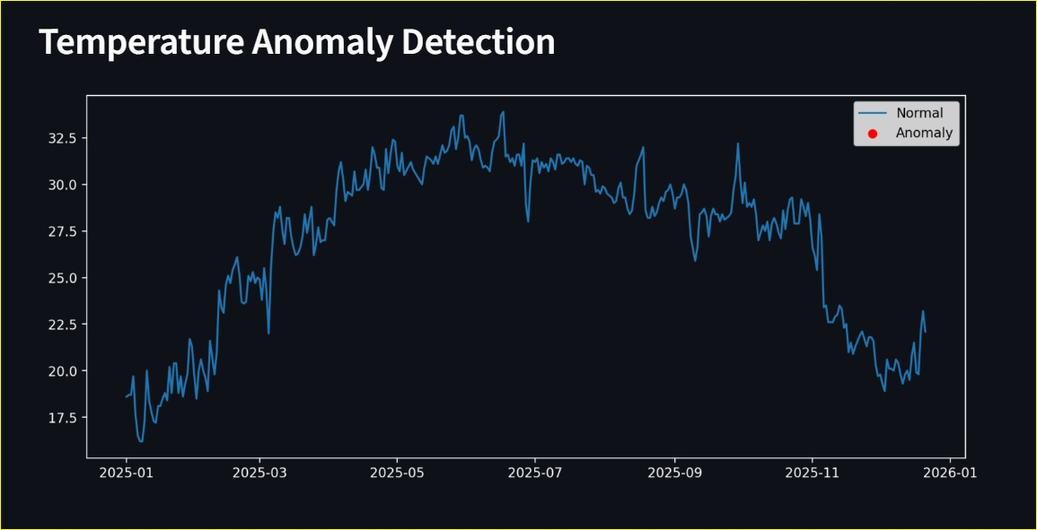

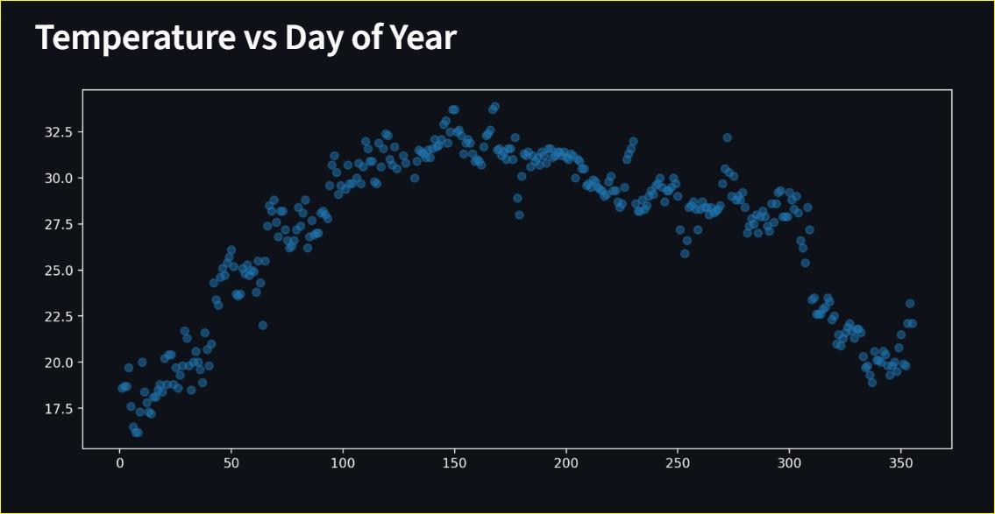

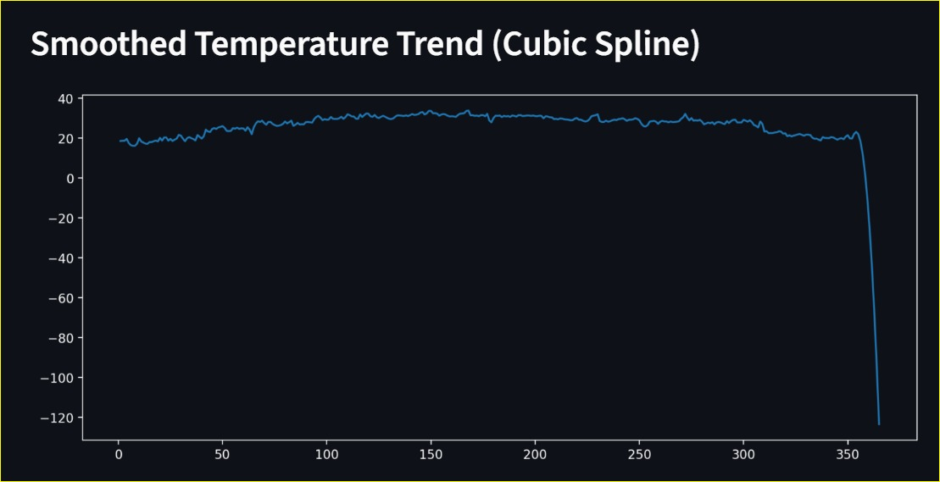

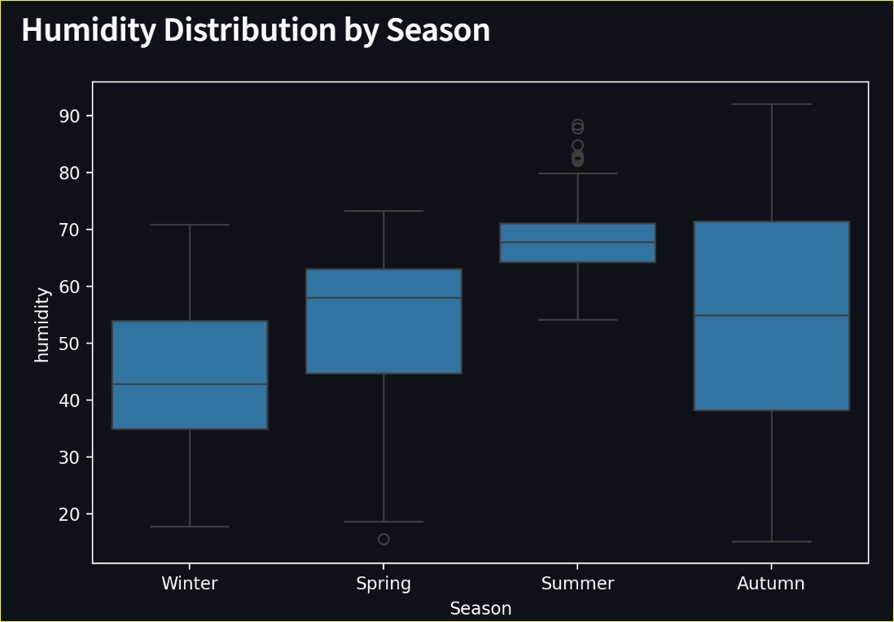

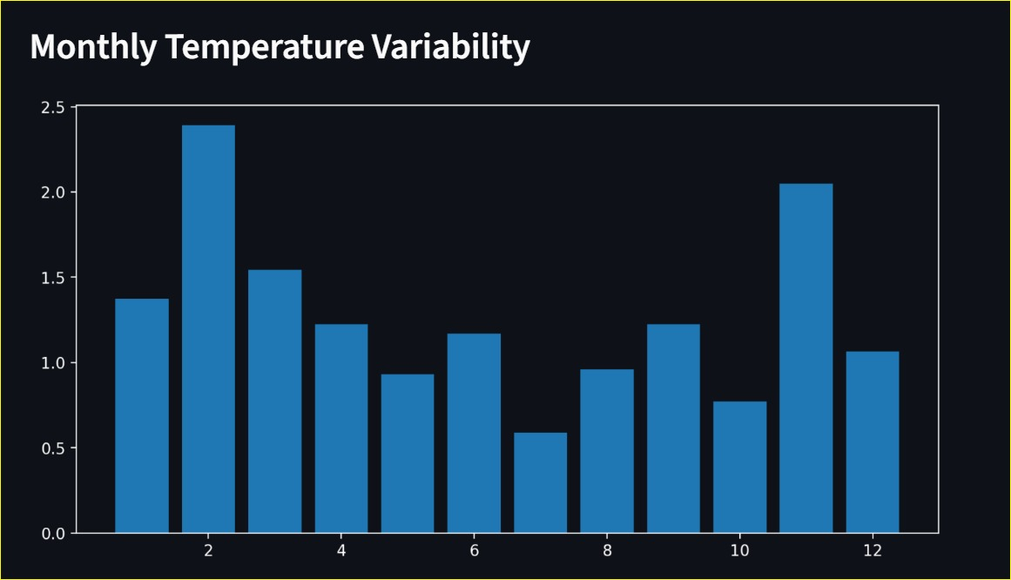

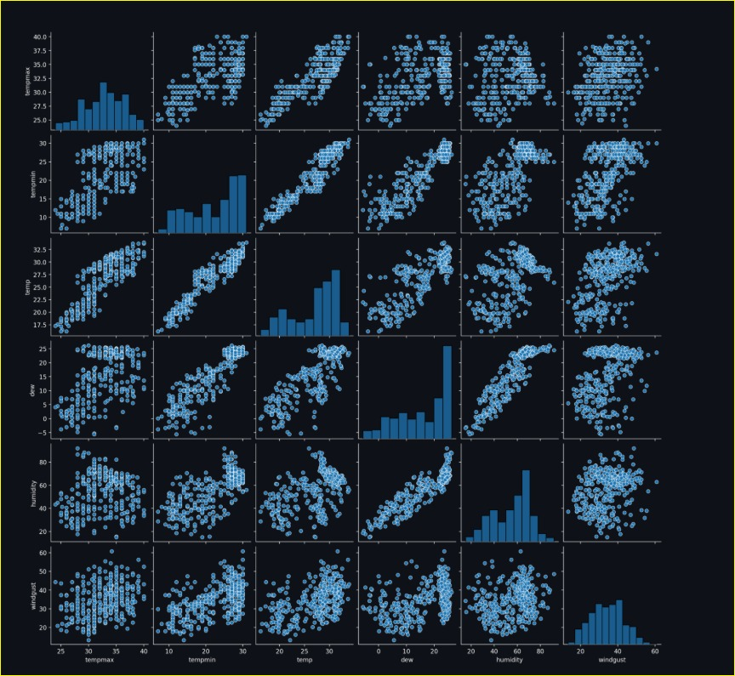

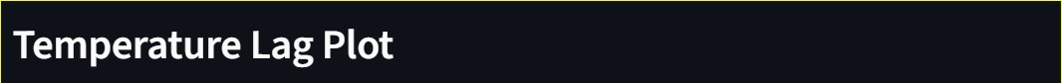

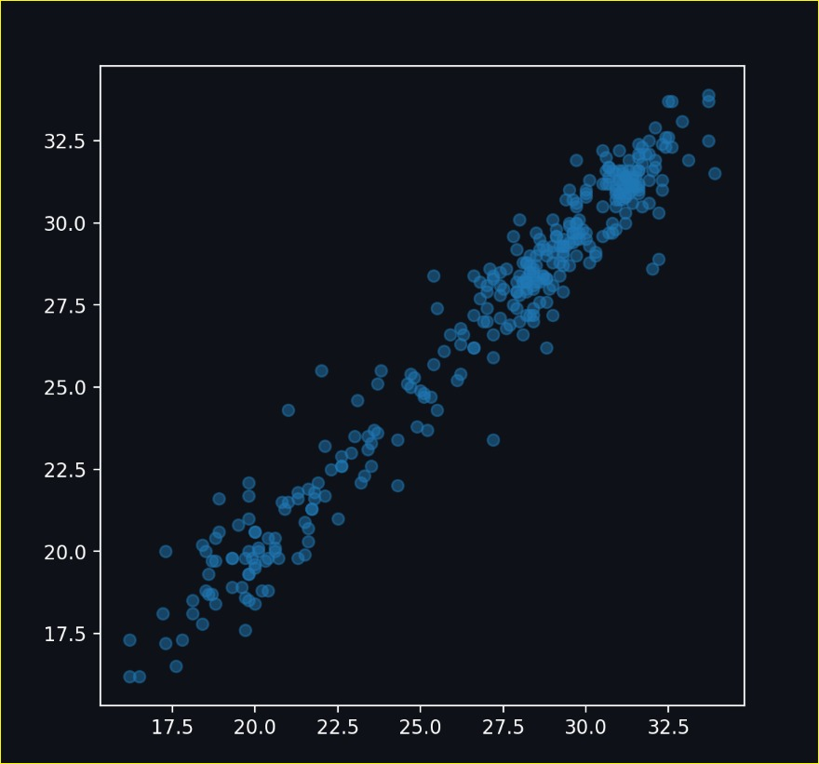

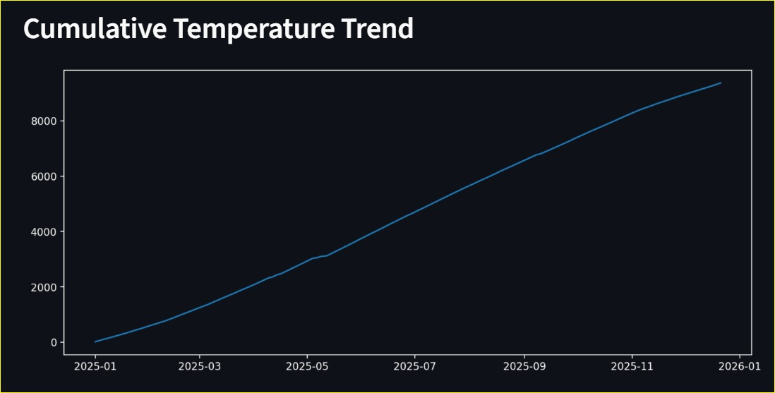

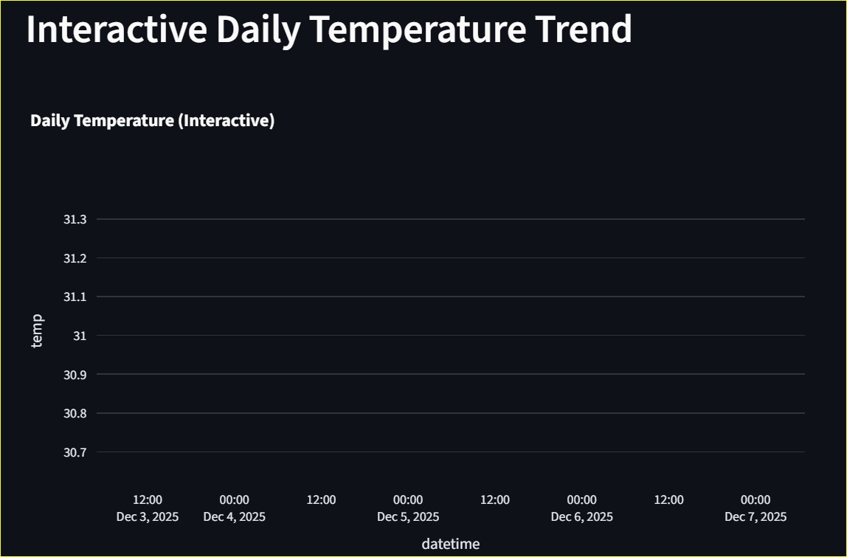

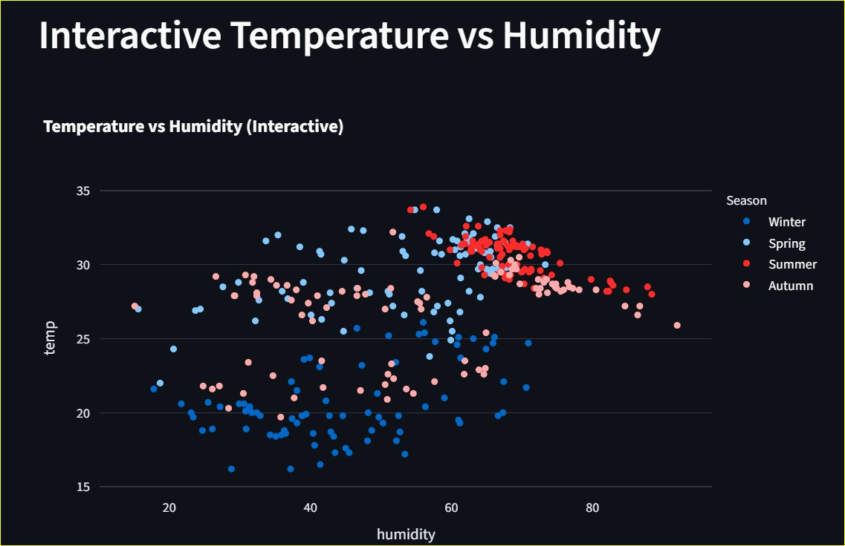

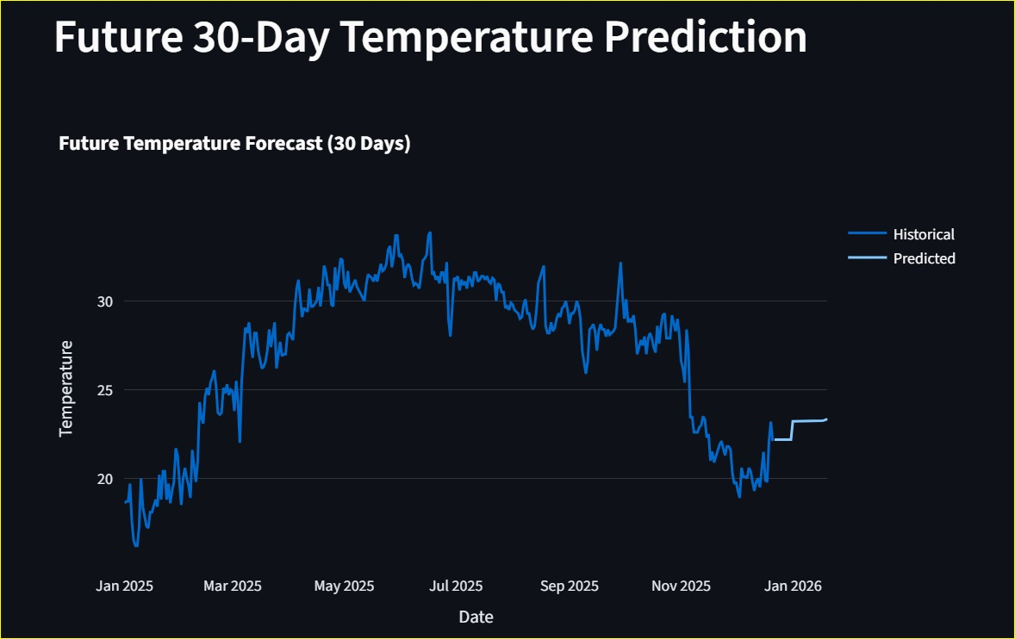

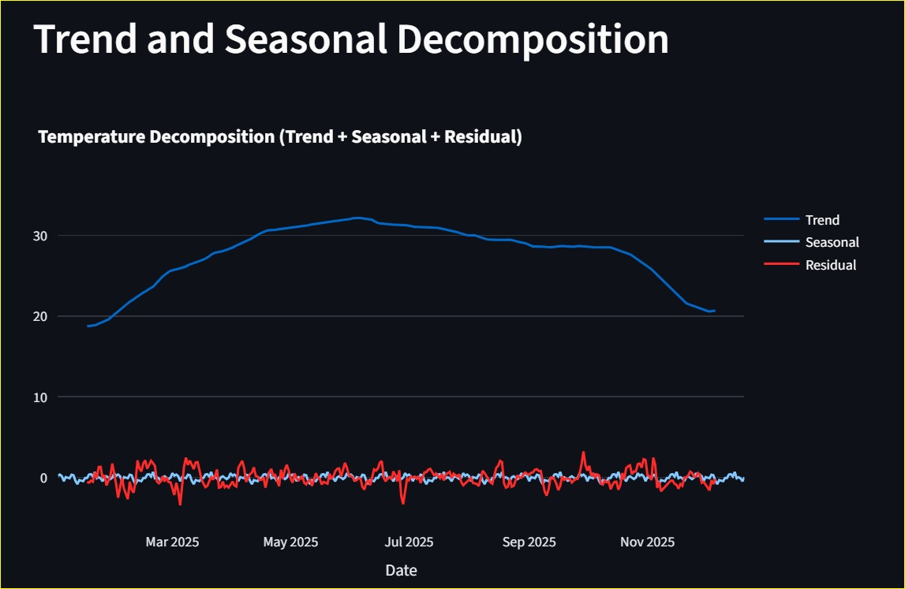

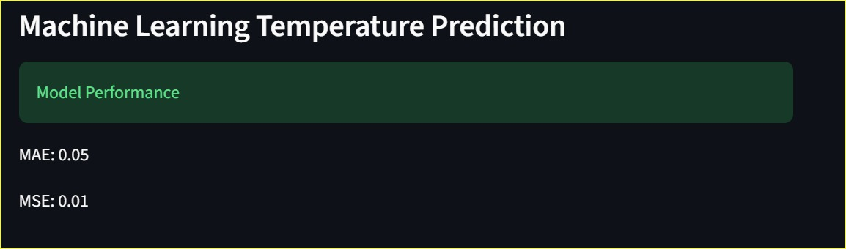

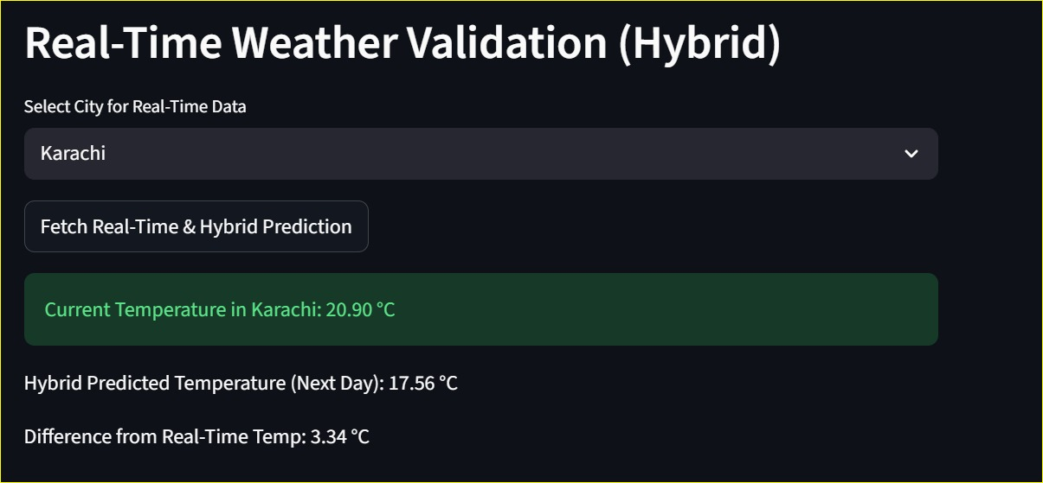

CONCLUSION
AtmosPredict has been able to combine numerical analysis methods with machine learning framework to deliver an efficient and interactive weather forecasting service. The findings indicate that numerical techniques are computationally effective in the short-term forecasting, whereas machine learning models are better at predicting non-linear trends. The hybrid method also improves the reliability of prediction by adding the use of real-time data. The system is both informative and real-life because of the extensive visual analysis and multi-city support. More weather parameters, deep learning models, and the long-term weather forecasting functions can be incorporated into this project.

REFERENCES
[1] J. D. Lambert, Numerical Methods for Ordinary Differential Systems: The Initial Value Problem, New York, NY, USA: Wiley, 2019.

[2] S. Chapra and R. Canale, Numerical Methods for Engineers, 8th ed., New York, NY, USA: McGraw-Hill, 2021.

[3] L. Breiman, “Random forests,” Machine Learning, vol. 45, no. 1, pp. 5–32, 2001.

[4] A. J. Smola and B. Schölkopf, “A tutorial on support vector regression,” Statistics and Computing, vol. 14, no. 3, pp. 199–222, 2004.

[5] OpenWeatherMap, “Current weather data API,” OpenWeatherMap, 2025. [Online]. Available: https://openweathermap.org/api
. Accessed: Nov. 2025.

[6] Kaggle, “Historical weather data,” Kaggle Datasets, 2025. [Online]. Available: https://www.kaggle.com
. Accessed: Nov. 2025.

[7] G. E. Box, G. M. Jenkins, and G. C. Reinsel, Time Series Analysis: Forecasting and Control, 5th ed., Hoboken, NJ, USA: Wiley, 2016.

